Detector-Conditioned Observability of Interference Under Coarse-Grained Measurement
Srikar R
DOI: https://doi.org/10.5281/zenodo.19353701
Supporting Record: https://zenodo.org/records/19338790

Abstract
Interference visibility is commonly treated as an intrinsic property of wave superposition. In practical systems, visibility is inferred through detector sampling and noise. We present a computational framework integrating propagation, detection, noise, and visibility estimation. We observe scaling B_min ∝ d^(-0.77), deviating from ideal Nyquist scaling.

1. Introduction
Interference is a fundamental signature of coherence. Real measurement systems introduce detector resolution limits, shot noise, and read noise, affecting observability. This work quantifies the resolution threshold required.

2. Methods
Simulation includes Fresnel propagation, pixel binning, shot and read noise, and visibility estimation with threshold V ≥ 0.75.

3. Experiment
Slit separation d ∈ [100, 500] µm. For each configuration, we simulate, bin, add noise, compute visibility, and extract maximum bin size preserving visibility across multiple runs.

4. Results
B_min ∝ d^(-0.77)
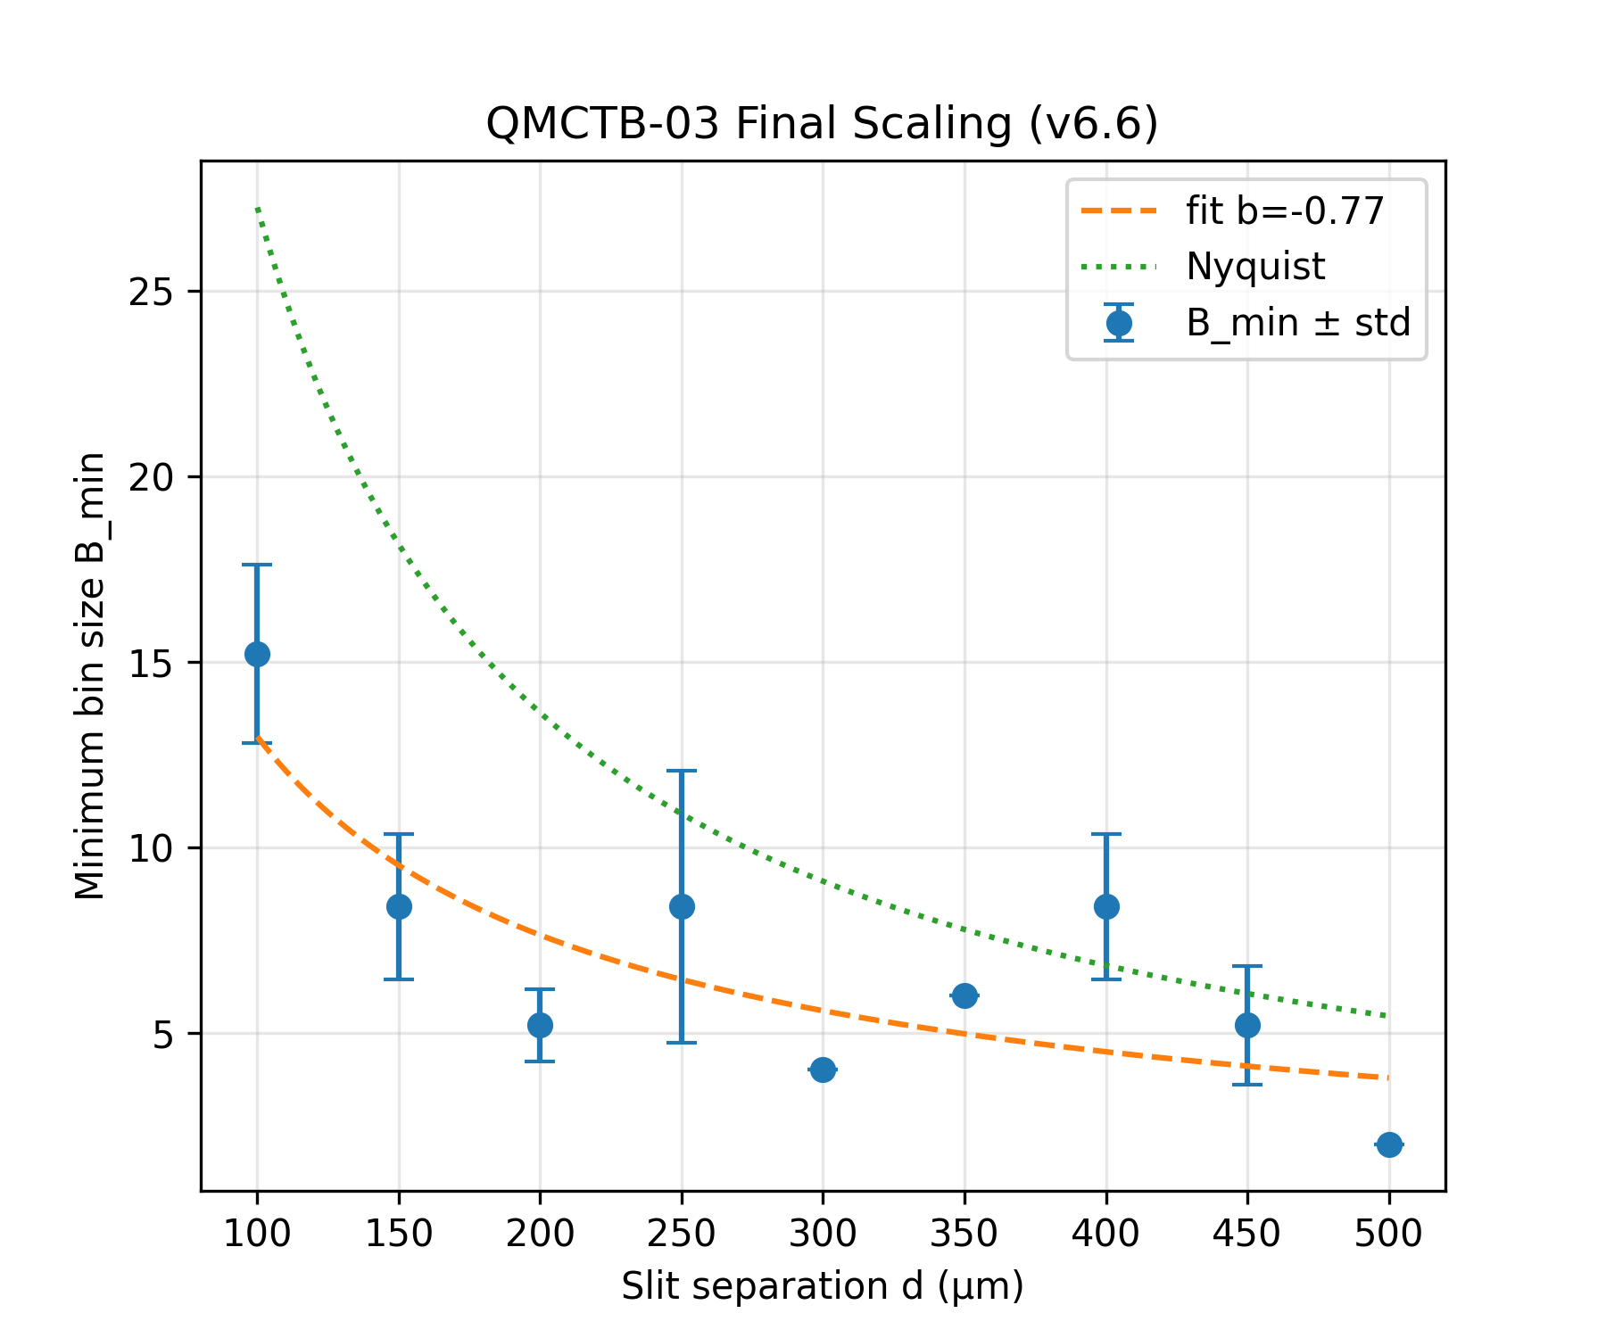
Figure 1. Minimum detector bin size (B_min) vs slit separation (d). Error bars show standard deviation. Dashed curve: fitted scaling (b ≈ -0.77). Dotted curve: Nyquist prediction.

5. Interpretation
Trade-off between resolution and noise leads to stochastic observability boundary.

6. Conclusion
Interference is measurement-conditioned. Detector resolution and noise jointly determine observability.

