QMS Platform: A Quantum Measurement Observability and Reconstruction-Assurance Framework with Initial Validation
Srikar R | Independent Research | 0009-0002-9398-0847
Preprint / Research Software Paper - QMS paper release candidate

Abstract
This paper presents QMS, a quantum measurement observability and reconstruction-assurance framework designed to determine whether a quantum measurement configuration contains sufficient information to support a reconstructed state, and to separate structural information loss from measurement-noise propagation. The current implementation is validated on two-qubit photonic tomography using KwiatLab reference data. The validation ladder includes raw-count normalization, Born-rule checks, linear inversion, physicality diagnostics, exact projection onto the density-matrix state space, maximum-likelihood estimation, controlled noise and background degradation, measurement-context removal, state-dependent context criticality, random-state observability testing, and noisy error decomposition. In 4,500 noiseless random-state/context-removal reconstructions, target null-space overlap matched reconstruction error to floating-point precision (Pearson correlation 1.0, slope 1.0, R-squared 1.0; maximum discrepancy 5.55e-16). Under additive measurement noise, the linear pseudoinverse error decomposition x_hat - x = -P_N(A)x + A^+epsilon was verified with residuals near 1e-15. These results establish QMS as an initially validated framework for measurement observability analysis and reconstruction assurance in the linear tomography regime. The present work does not claim universal detector coverage or universal quantum-platform validation; broader real experimental datasets and detector families are the next validation stage.
Keywords: quantum state tomography; measurement observability; quantum measurement assurance; density-matrix reconstruction; null space; pseudoinverse; maximum likelihood; photonic qubits

1. Introduction
Quantum experiments infer hidden physical states from finite, noisy, and sometimes incomplete measurements. Standard tomography and characterization tools answer the reconstruction question, but a separate practical question remains: was the measurement configuration itself capable of supporting the conclusion drawn from it? QMS is designed around that question.
The framework treats measurement sufficiency, reconstruction validity, and detector/noise effects as separate but connected layers. Rather than relying only on a final fidelity value, QMS exposes operator rank, null-space loss, physicality, estimator behavior, and noise propagation.

2. QMS framework
- Measurement ingestion and contextual normalization
- Measurement-operator construction
- Forward-model and Born-rule validation
- Linear and constrained state reconstruction
- Physicality checks and estimator comparison
- Measurement observability analysis
- Noise/background degradation analysis
- Machine-readable evidence and reproducible experiment outputs
For tomography, measurement probabilities are modeled as p_i = Tr(M_i rho). Vectorizing rho gives the linear inverse problem b = A x + epsilon.

3. Baseline reconstruction
The baseline uses the KwiatLab Quantum-Tomography two-qubit Bell-state reference dataset, containing 36 measurement outcomes across H/V, D/A, and R/L polarization bases. Counts are normalized within nine complete measurement contexts: XX, XY, XZ, YX, YY, YZ, ZX, ZY, and ZZ.
QMS-QST-001D metric | Result
Measurements | 36
Linear-system shape | 36 x 16
Rank | 16
Condition number | 3.0
Least-squares residual | 2.548776e-31
Trace | 1
Hermitian error | 0
Minimum eigenvalue | -4.185729e-16
Purity | 1.0
Bell-state fidelity | 1.0
Frobenius reconstruction error | 8.583984e-16
The reconstructed density matrix matched the ideal |Phi+> = (|HH> + |VV>)/sqrt(2) state to numerical precision. The Bell state was used only as a post-reconstruction reference, not as an input to the inverse solver.

4. Controlled degradation and reconstruction assurance
Poisson count-noise sweeps showed that unconstrained linear inversion can produce increasingly nonphysical density matrices. Adding background counts populates otherwise forbidden outcomes and produces genuine loss of Bell-state fidelity.
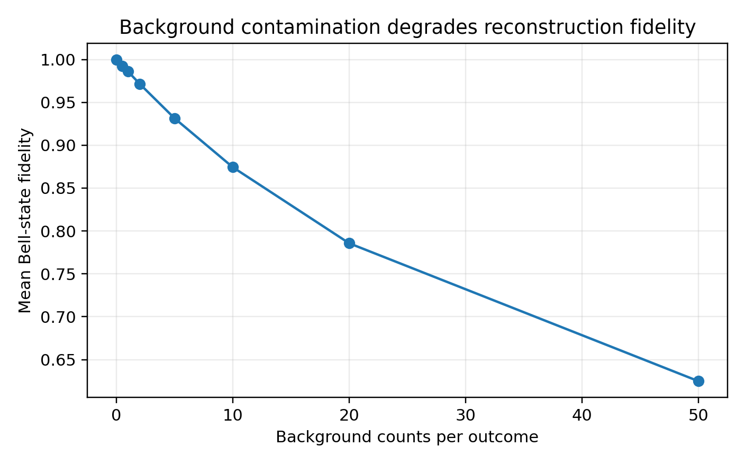
Figure 1. Bell-state fidelity under additive background contamination.
QMS compared unconstrained linear inversion, exact physical projection, and maximum-likelihood estimation (MLE). MLE parameterizes rho = T T-dagger / Tr(T T-dagger), enforcing positivity and unit trace during optimization.
bg | F_lin | F_proj | F_MLE | err_MLE | success
0.0 | 1.0 | 0.978416 | 0.998701 | 0.049101 | 50/50
0.5 | 0.992591 | 0.972508 | 0.99173 | 0.062082 | 50/50
1.0 | 0.986488 | 0.968246 | 0.985526 | 0.063365 | 50/50
2.0 | 0.97215 | 0.956678 | 0.970866 | 0.072257 | 50/50
5.0 | 0.930556 | 0.922064 | 0.929025 | 0.111611 | 50/50
10.0 | 0.873384 | 0.871124 | 0.872617 | 0.169405 | 50/50
20.0 | 0.783198 | 0.783171 | 0.783339 | 0.265842 | 50/50
50.0 | 0.62621 | 0.62621 | 0.626162 | 0.438178 | 50/50

5. Measurement observability
Removing measurement contexts converts the reconstruction from a fully determined problem into a rank-deficient inverse problem. With all nine contexts, the design matrix has rank 16 and reconstructs the reference state exactly. Removing one context reduces the rank to 15 and makes one operator direction unobservable.
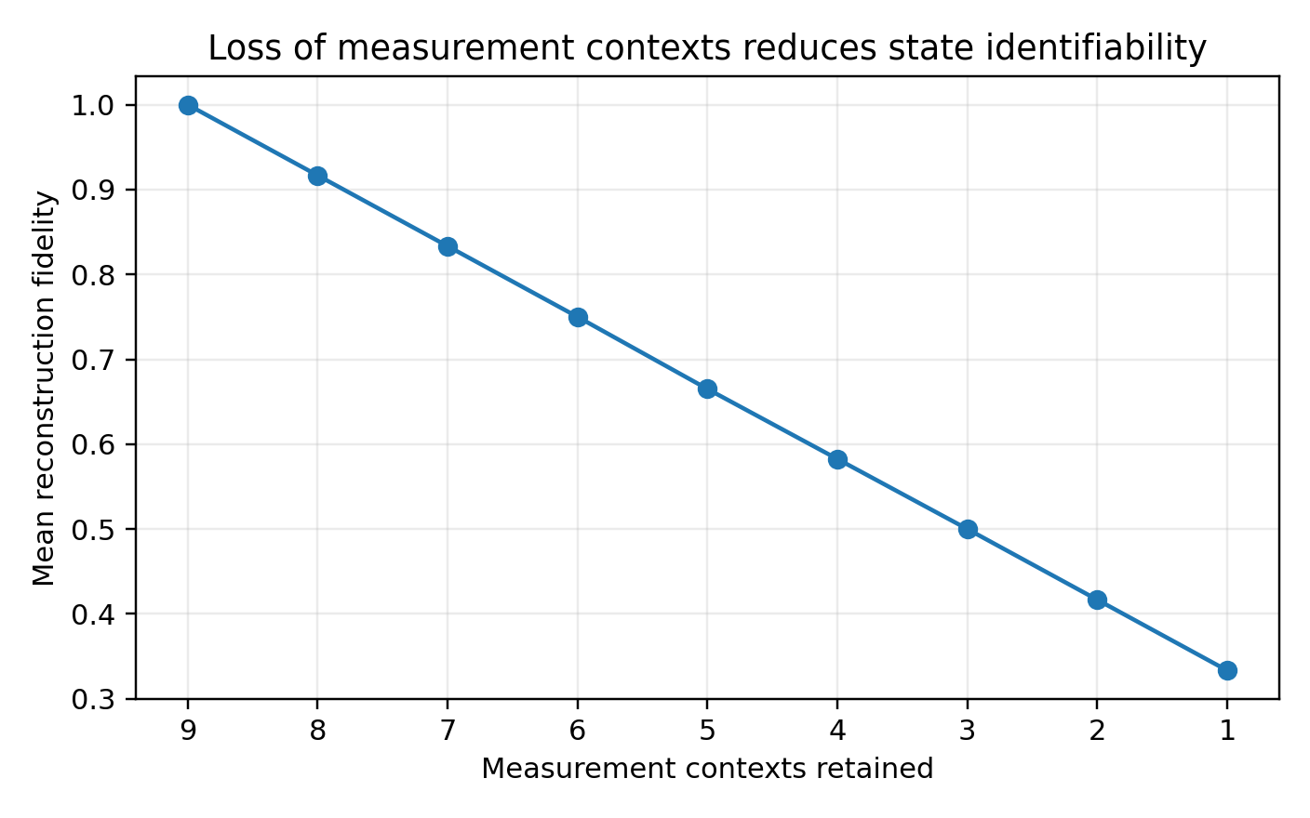
Figure 2. Mean fidelity versus number of retained measurement contexts.
Context criticality is state dependent. For |HH>, ZZ is critical; for |DD>, XX is critical; and for Bell states |Phi+> and |Psi->, XX, YY, and ZZ are critical. A generic nonsymmetric state distributes criticality across many contexts.

6. Null-space observability loss
For a rank-deficient measurement matrix A, QMS computes the component of the target state lying in the measurement null space. In the noiseless minimum-norm reconstruction, this target null-space overlap equals the unrecoverable reconstruction component.
L_obs(rho, A) = || P_N(A) vec(rho) ||_2
This relation was tested on 500 Haar-random two-qubit pure states with each of nine contexts removed, giving 4,500 reconstructions. The mean null-space overlap and reconstruction error were both 0.188639671083. The mean absolute difference was 1.07e-16 and the maximum difference was 5.55e-16. Pearson correlation, linear-fit slope, and R-squared were all 1.0 to displayed precision.
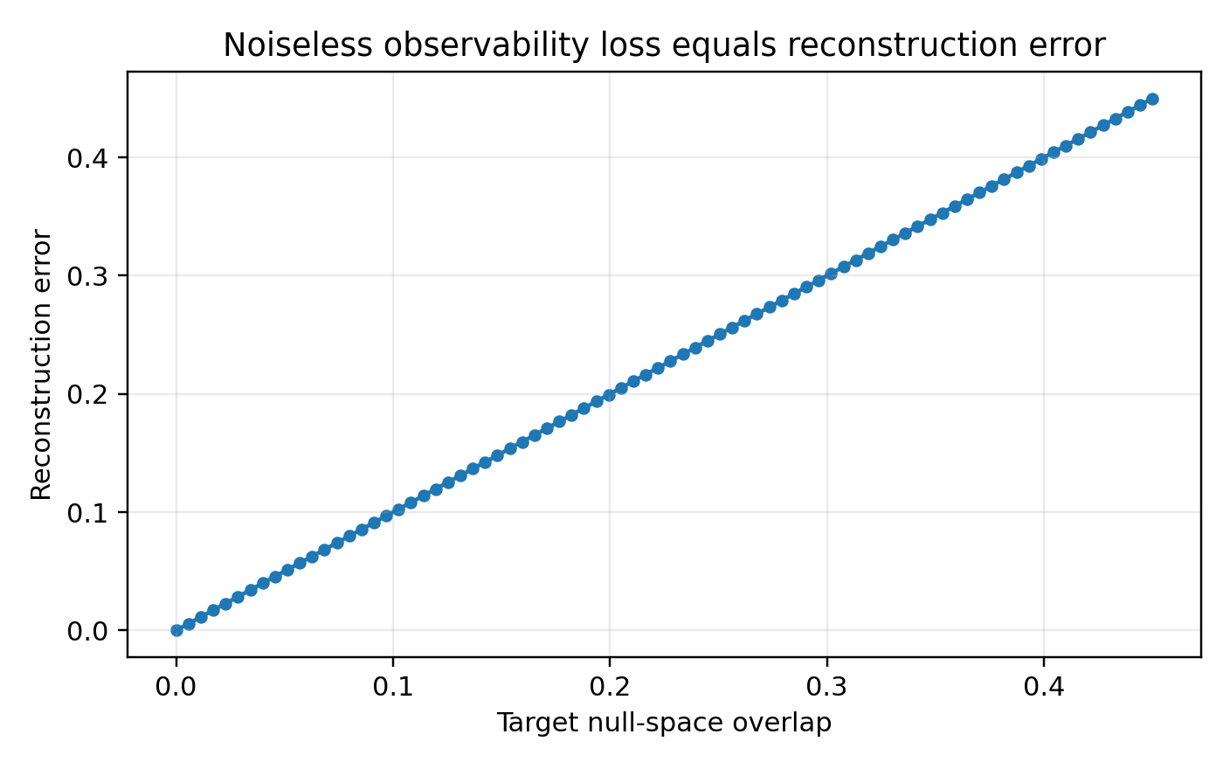
Figure 3. Noiseless random-state validation of null-space observability loss.

7. Noisy observability decomposition
For b = A x + epsilon and pseudoinverse reconstruction x_hat = A^+ b:
x_hat - x = -P_N(A)x + A^+epsilon
The first term is structural information loss. The second term is observable information corrupted by measurement noise and propagated through the pseudoinverse. QMS-QST-005A verified this decomposition numerically across random states and missing contexts for multiple Gaussian noise levels, with residuals near 1.5e-15.
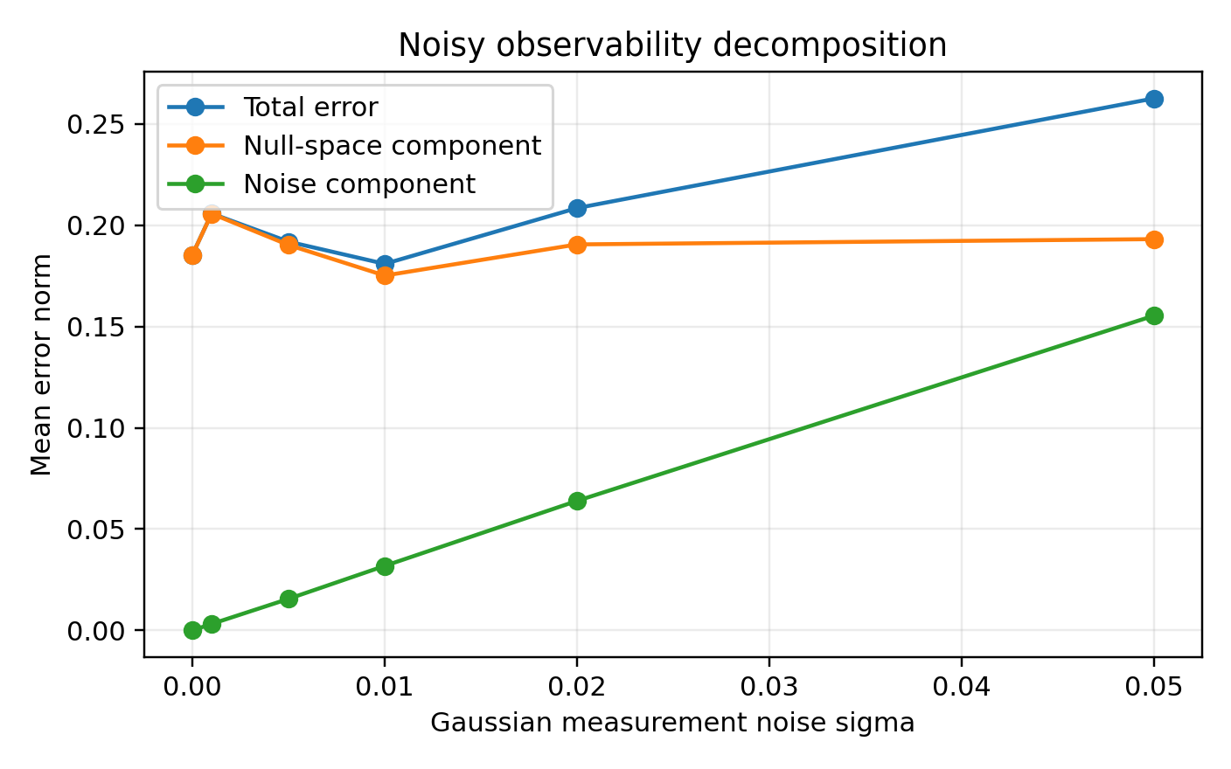
Figure 4. Structural observability loss and noise-propagated error.

8. Comparative analysis and practical utility
Approach | Primary output | Strength | QMS contribution
Linear inversion | rho estimate | Transparent and fast | Rank/null-space diagnosis; physicality warning
Physical projection | Nearest valid rho | Repairs nonphysical estimate | Projection distance as physicality diagnostic
Maximum likelihood | Physical rho estimate | Robust constrained estimation | Estimator comparison plus observability context
Fidelity-only reporting | Single score | Simple communication | Separates missing information from noise/estimator effects
QMS framework | Measurement-assurance evidence | Integrated diagnosis | Observability, reconstruction assurance, and root-cause structure
QMS is intended to add a measurement-assurance layer around reconstruction rather than replace standard estimators. It can identify whether degraded inference is driven by missing measurement directions, noise propagation, or estimator/physicality failure. State-conditioned context criticality also provides a basis for future measurement-selection and reacquisition guidance.

9. Limitations and potential extensions
The present validation is strongest for two-qubit photonic tomography and controlled computational degradation. The KwiatLab Bell-state reference data are used as a reproducible baseline. This release should therefore be described as initial validation rather than universal experimental validation.
- Independent real experimental datasets from multiple laboratories
- Additional detector families and detector-specific calibration/noise models
- Drift, crosstalk, accidental-count, and efficiency correction studies
- Generalization beyond two-qubit and linear tomography settings
- Measurement-design optimization and recommended reacquisition
- Digital measurement twin capabilities
- Later AI-assisted diagnostic and recommendation layers
- Quantum sensing and quantum communication workflows

10. Conclusion
QMS consolidates quantum measurement ingestion, state reconstruction, physicality assessment, estimator comparison, observability analysis, and noise decomposition into a reproducible validation framework. The current results establish an initially validated measurement-observability framework in the two-qubit linear tomography regime. The next stage is external validation across independent real detector datasets and additional detector families.

Data and software availability
Software repository: https://github.com/srikarr20/qms-platform
Paper release tag: v0.2.0-paper1 (to be created)
Zenodo software DOI: [TO BE MINTED]
Zenodo paper DOI: [TO BE MINTED]

References
- James, D. F. V., Kwiat, P. G., Munro, W. J., & White, A. G. (2001). Measurement of qubits. Physical Review A, 64, 052312. https://doi.org/10.1103/PhysRevA.64.052312
- KwiatLab. Quantum-Tomography: A comprehensive quantum tomography library. GitHub repository. https://github.com/KwiatLab/Quantum-Tomography
- QMS Platform. GitHub repository. https://github.com/srikarr20/qms-platform

