

**SNAG@JOB**

CS551 ASE Project Increment1 Report



February 25, 2015

UNIVERSITY OF MISSOURI-KANSAS CITY

CS551 ASE Project SP15

By

Surekha Dani-ID#12

Srikar Reddy Mallareddygari-ID#33

Lavanya Kumar Somu-ID#46

Sandesh Puppala-ID#42

Table of Contents

[Import Existing Services/API 2](#_Toc412670725)

[Detail Design of Services 4](#_Toc412670726)

[User Stories /Use Case (Using Scrum Do) 4](#_Toc412670727)

[Service description 6](#_Toc412670728)

[Sequence diagram 7](#_Toc412670729)

[Sequence Diagram Description 7](#_Toc412670730)

[Class diagram 8](#_Toc412670731)

[Class Diagram Description 8](#_Toc412670732)

[Design of Mobile Client Interface 9](#_Toc412670733)

[Implementation 10](#_Toc412670734)

[Implementation of REST services 10](#_Toc412670735)

[Implementation of user interface (Mobile Apps) 11](#_Toc412670736)

[Project Management 13](#_Toc412670737)

[Work completed 13](#_Toc412670738)

[Description 13](#_Toc412670739)

[Responsibility (Task, Person) 13](#_Toc412670740)

[Time taken 13](#_Toc412670741)

[Contributions (members/percentage) 13](#_Toc412670742)

[Work to be completed 13](#_Toc412670743)

[Description 13](#_Toc412670744)

[Responsibility (Task, Person) 14](#_Toc412670745)

[Time to be taken 14](#_Toc412670746)

[Scrum Do Link 14](#_Toc412670747)

[Summary 14](#_Toc412670748)

[Iteration1 14](#_Toc412670749)

[GitHub Link 14](#_Toc412670750)

[Source Code 14](#_Toc412670751)

[Documentation 14](#_Toc412670752)

[Issues/Concerns 14](#_Toc412670753)

[References 15](#_Toc412670754)

# Import Existing Services/API

**Screenshots for Google API integration**

* OAuth Access Application Access for Google+ Sign In

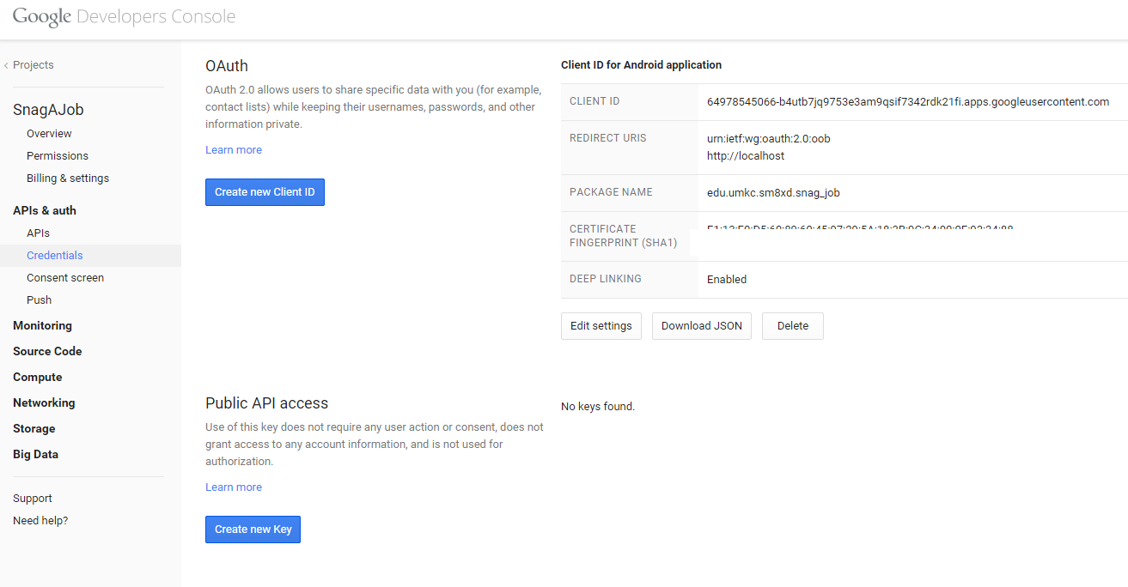

* Google Sign In Validation for Mobile App

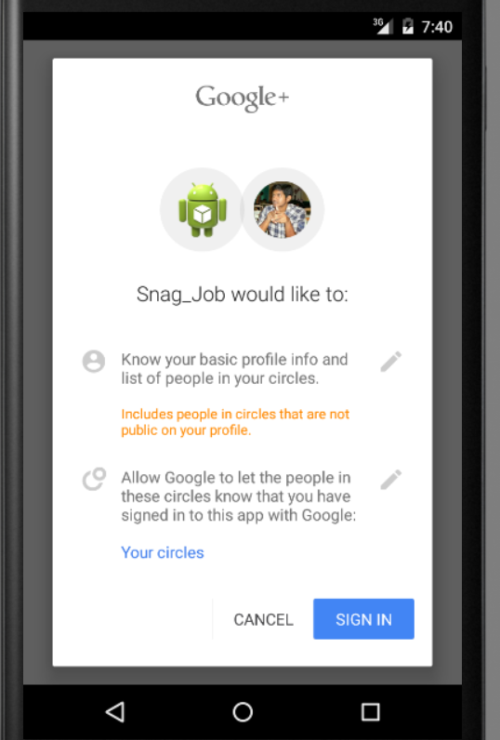

* Login Activity Class from Android Studio

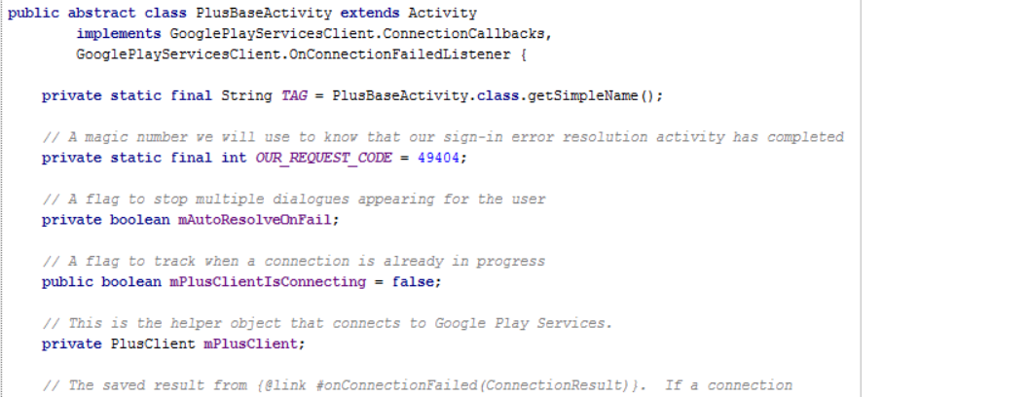

# Detail Design of Services

## User Stories /Use Case (Using Scrum Do)

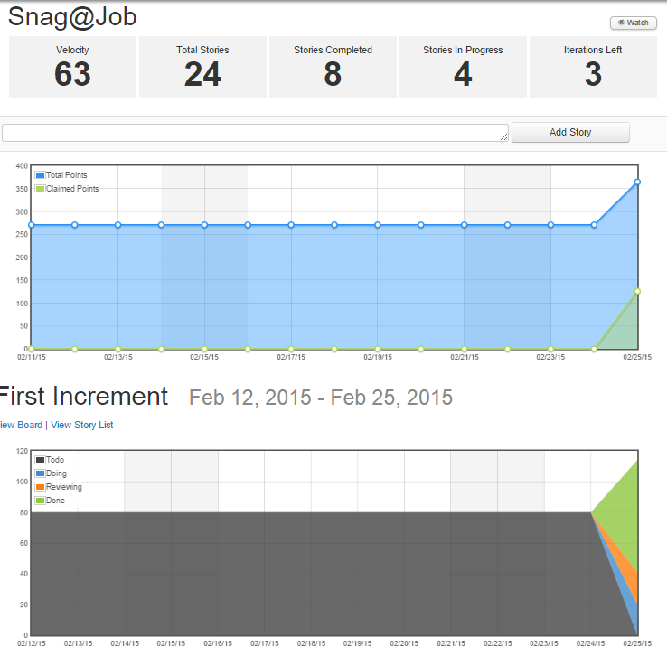

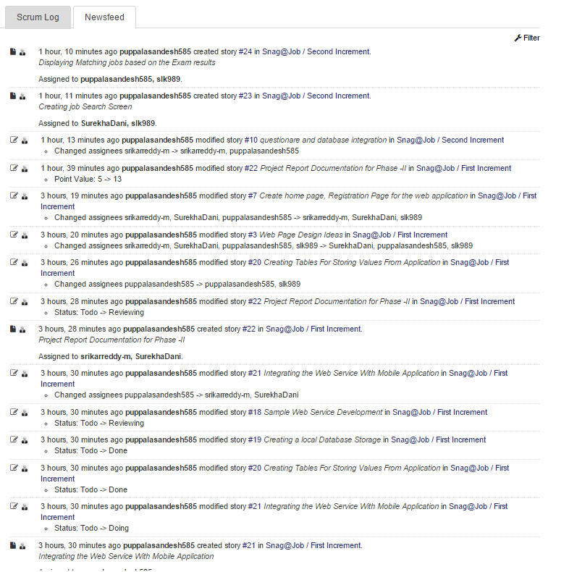

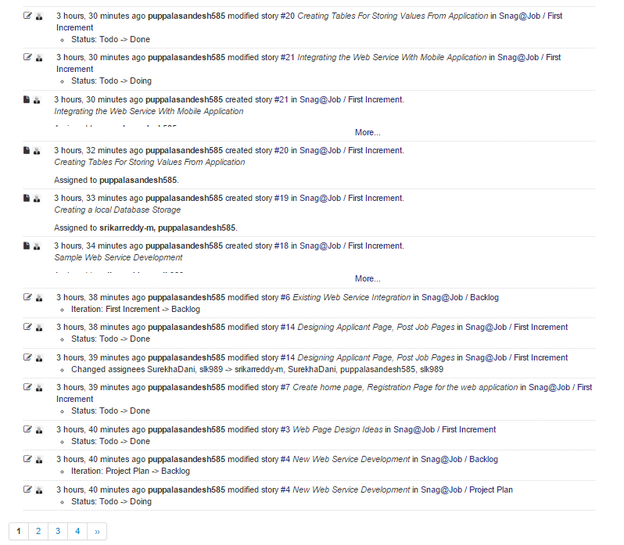

## Service description

* **Snag job Web service:** A REST Web service is created Using Microsoft Visual Studio. It consists of two namely
  + - **InsertUserDetails**
    - **RetrieveUserDetails**

These two classes are useful to perform user registration and user login activities on a mobile application.

*InsertUserDetails:* This class performs storing of the user profile details to the MySQL server 2008 database.

*RetrieveUserDetails:* This class is useful to retrieve the user profile details after successful validation of login credentials.

## Sequence diagram

**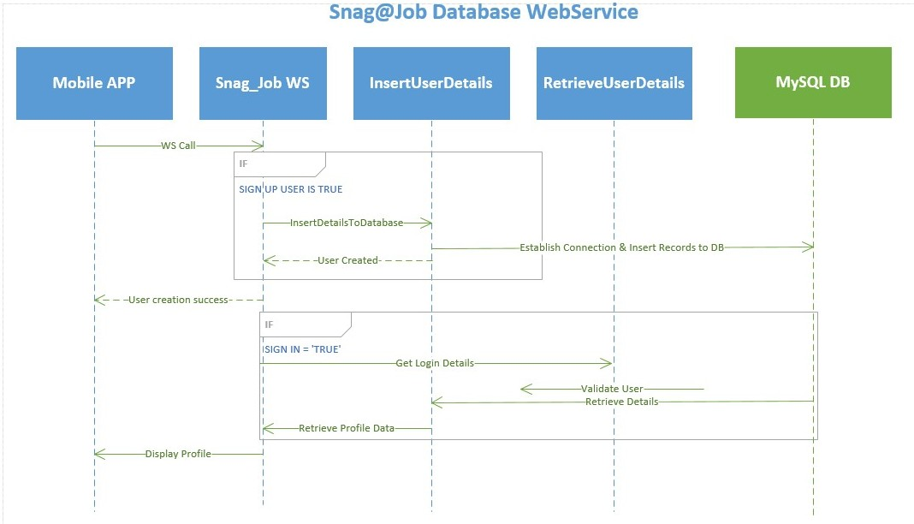**

## Sequence Diagram Description

* A Web service named Snag\_Job is developed to perform a user’s registration and retrieval of the users profile data.
* When a user tries to Sign up in to the mobile application, the user details will be stored in to the MySQL DB using a Web service call.

<http://localhost:60838/Service1.svc/insertUserDetails/>

* When user tries to login in to the application, User credentials are authenticated through a Web service call. For authenticated users corresponding profile data will be displayed to the presentation layer of the mobile application.

## Class diagramD:\ASE\Class Diagram_Cropped.jpg

## Class Diagram Description

* As shown in the above class diagram, we have implemented three different classes namely UserDetailsActivity, LoginDetailsActivity, SnagJobService.
* UserDetailsActivity class consists of various fields like first Name, last Name, phone, address, state, city and zip code along with their getter and setter methods.
* LoginDetailsActivity class consists fields email, password long with setter and getter methods.
* SnagJobService class contains two different methods of which once is responsible for insertion of user details while the other one is useful for the retrieval of details.

# Design of Mobile Client Interface

**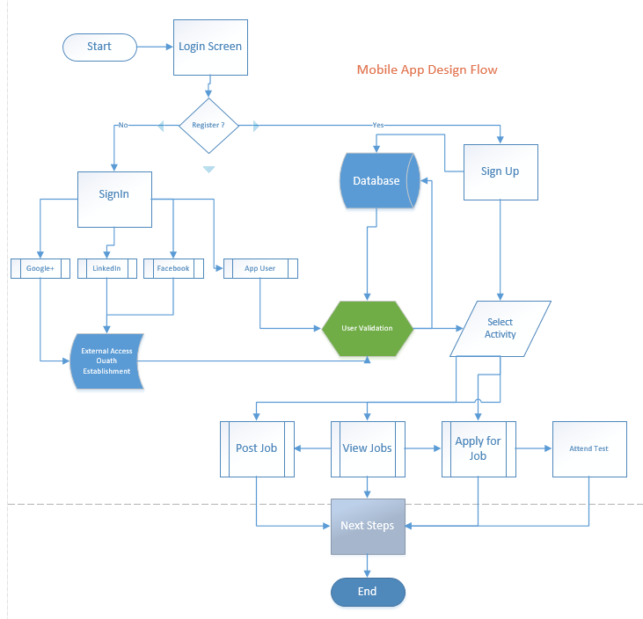**

# Implementation

## Implementation of REST services

* Web Service Call for insertuserdetails:

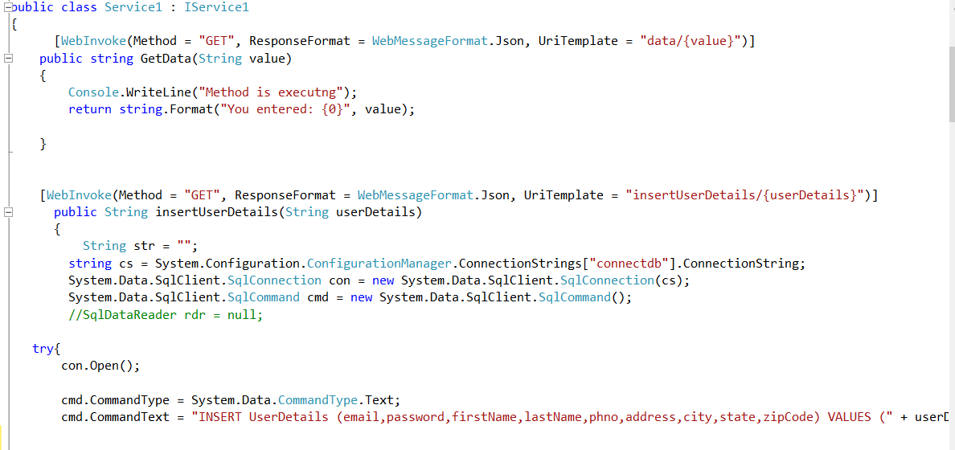

* Web Service Call for retrieveuserdetails

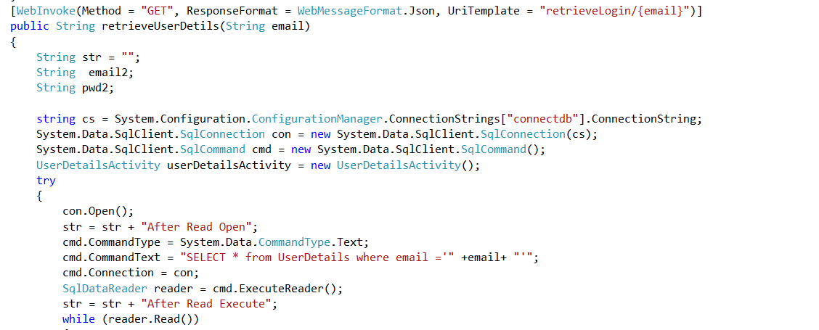

* Database Tables for storing Data

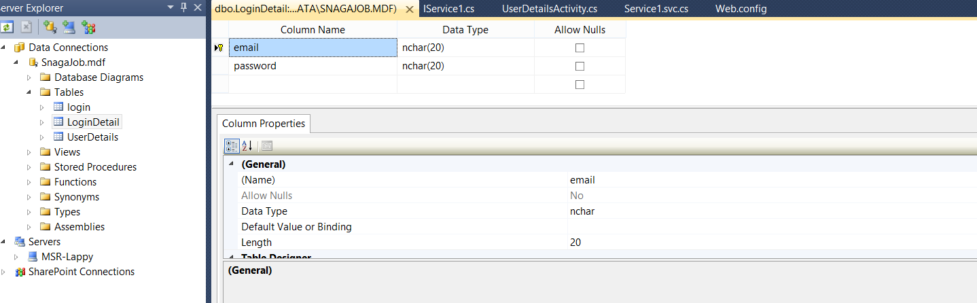

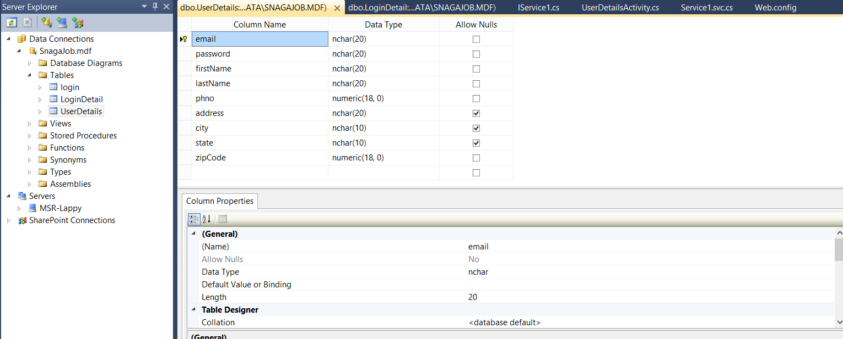

## Implementation of user interface (Mobile Apps)

* Login Activity:

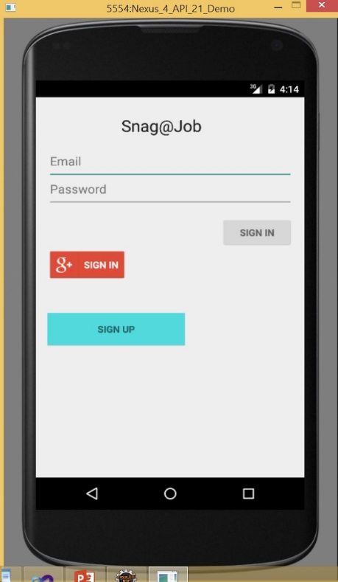

* This is the login screen of the mobile application.
* A user can sign in to the application using the google+ sign in, general sign in and a new user can sign up.
* A user require an email id and password to login to the application

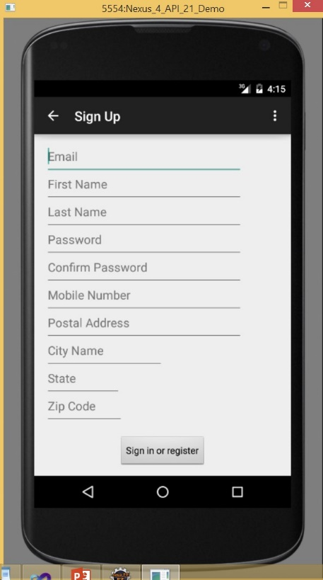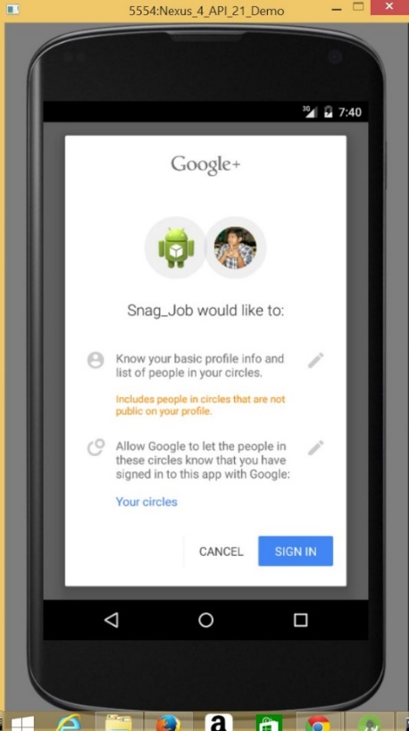

Sign up Screen of the User.

When a user tries to login with the google+ sign in tab.

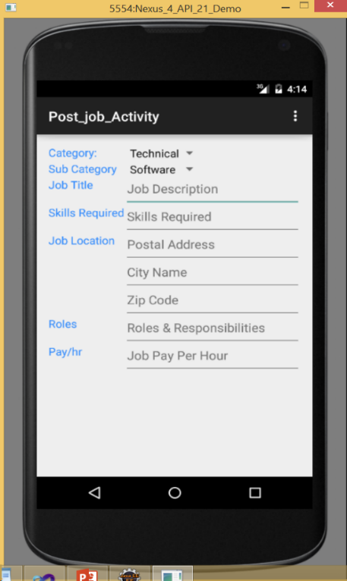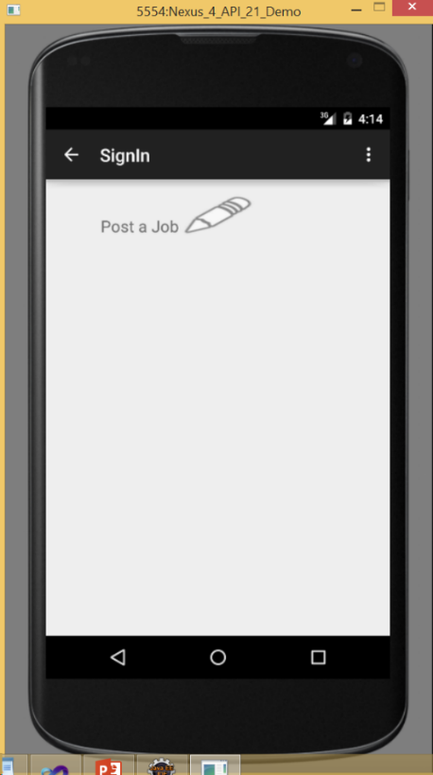

Post Job Screen

Post Sign in Screen

* Implementation of test cases

-TBD- (As of now, we have issues in accessing the project class code using nunit tool)

Project Management

## Work completed

### Description

* Successfully created a REST Web service which is useful for the insertion and retrieval of users profile data over Webservice calls.
* Successfully created database tables using Microsoft Visual Studio.
* Successfully developed the Login Screen, Signup Screen and Post job User Interfaces.

### Responsibility (Task, Person)

* Login Screen, user profile table, Web service call for data insertion – Srikar Reddy Mallareddygari
* Signup Screen, Webservice call for data insertion, Class Diagram, Documentation – Lavanya Kumar Somu
* Post Job Screen, login details table, Web service call for data retrieval, Documentation - Surekha Dani
* Database Connection, Webservice call for data retrieval, Sequence diagram – Sandesh Puppala

### Time taken

140 Man Hours

### Contributions (members/percentage)

Srikar Reddy Mallareddygari – 25%

Lavanya Kumar Somu - 25%

Surekha Dani - 25%

Sandesh Puppala – 25%

## Work to be completed

### Description

Task1: Submit the post job details to database using Webservice, Develop Job search screen.

Task2: Retrieve and display the job search results based on search criteria.

Task3: Develop Questionnaire, Develop screens to conduct exam, Retrieve exam questions based on selected technical job criteria.

Task 4: Evaluate the exam, Display and store the results in database.

### Responsibility (Task, Person)

Task 1: Srikar Reddy Mallareddygari

Task 2: Lavanya Kumar Somu

Task 3: Surekha Dani

Task 4: Sandesh Puppala

### Time to be taken

300 Man Hours

# Scrum Do Link

## Summary

<https://www.scrumdo.com/projects/project/snagjob1/summary>

## Iteration1

<https://www.scrumdo.com/projects/project/snagjob1/iteration/121673>

# GitHub Link

## Source Code

<https://github.com/srikarreddy-m/CS551-ASE/tree/src/Project/Snag%40Job/src/Iteration1>

## Documentation

<https://github.com/srikarreddy-m/CS551-ASE/tree/src/Project/Snag%40Job/documentation>

# Issues/Concerns

* Unable to add class Library under the snag job web service project. Currently we are working on this issue. If it gets resolved will add the test cases for the web services.
* Poor performance of android studio software
* Requires access to the centralized database for storing and retrieving data globally
* Slow performance of the web service call

# References

<https://developers.google.com/+/mobile/android/getting-started#step_1_enable_the_google_api>

<https://developer.linkedin.com/apis>

<https://social.msdn.microsoft.com/Search/en-US?query=how%20to%20insert%20into%20c%23&emptyWatermark=true&ac=5>

<https://developer.android.com/tools/studio/index.html>