

**SNAG@JOB**

CS551 ASE Project Plan



February 11, 2015

UNiversity of missouri-kansas city

Computer Science Department- SPRING 2015

By

Surekha Dani-ID#12

Srikar Reddy Mallareddygari-ID#33

Lavanya Kumar Somu-ID#46

Sandesh Puppala-ID#42

**Table of Contents**

Introduction 2

Project Goal and Objectives 2

Motivation and Goal 2

Specific Objectives 2

Significance 3

Project Background and Related Work 3

Proposed System 4

1. Requirement Specification 4

a. Functional: 4

b. Non-Functional 4

c. Business Requirements 4

**Business Process/Workflow Analysis** 5

**Technological and Architectural requirements** 8

2. Frame Work Specification 9

a. Overall System Model: 9

b. Assumptions and Principles 9

c. System Architecture Diagram 10

3. System Specification 10

a. Existing Services 10

b. New Services to be built 10

Plan by Services (Using ScrumDo) 11

Project Increments 11

Project Plan 11

First Increment 11

Second Increment 11

Third Increment 12

Fourth Increment 12

Risk Management 12

GitHub URL: 12

https://github.com/srikarreddy-m/CS551-ASE/tree/src/Project/Snag%40Job 12

Bibliography 12

# Introduction

Our Project provides a platform to search for short term jobs for U6 category labor workforce of USA. This platform provides the opportunity to job seekers who are looking for part time jobs to meet their financial requirements. On the other hand it is helpful to find for the people who need help in completing their activities like technical help, Tutoring, Store Management, Party coordination, pickup or drop rides and other household activities etc.

# Project Goal and Objectives

## Motivation and Goal

To earn income by efficiently using the skill set of people during unemployment period for livelihood in order to meet their financial expenses. To acquire short time jobs based their current skills to earn few bucks per hour.

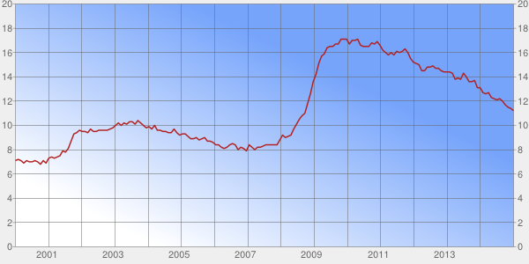

Fig 1: Unemployment Rate –U6

## Specific Objectives

This Web Application is useful to improve the job opportunities for U6 category workforce. It improves the overall productivity of workforce and reduces the unemployment rate.

Employers can directly connect with applicants and discuss their requirements for the task. People can accomplish their tasks easily and they can save money.

## Significance

According to United States Department of Labor Statistics, Labor workforce of USA is categorized as U1, U2, U3, U4, U5, and U6. U6 category labor workforce is a combination of U1 to U5 categories. In simple terms citizens who are not having full time employment are categorized under U6 labor workforce. Fig 1 gives us the graphical information of Unemployed U6 workforce from 2000 to 2014. Post-recession US economy improved significantly which reduces the U6 unemployed workforce from almost 17.1% to 11.2% by Dec 2014 statistics.

At present the labor force participation rate is fallen to 62.7% which is the lowest rate since 1978 as shown in fig 2. LFPR is the ratio of the labor force and overall size of labor force of the same age range. Lowest LFPR is not good for US Economy. Online job portal are significantly helpful in improving the labor force participation rate.

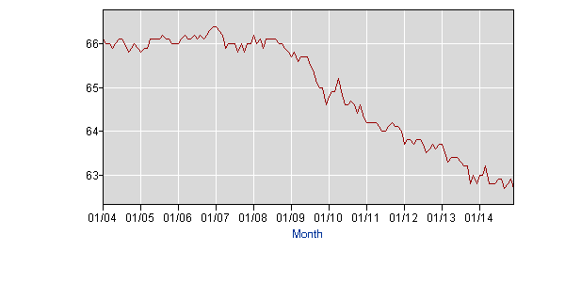

Fig 2: Labor force participation rate (LFPR)

# Project Background and Related Work

In the last semester, there is a project named JobAmigo to search for job. The scope of this project is limited for country based job search only. The scope of our project is search for a job based on the category or location. The job category includes technical and non-technical jobs.

In **employer’s perspective**, they can post the jobs. While posting a job, the employer has the flexibility to choose appropriate questionaries’ for applicants which would help them to estimate the skill set of the applicant.

In **applicant’s perspective,** they can search for a job based on category, pay scale and location. The scope of the job search is not only limited to technical jobs but also non-technical task such as household activities, mentoring, baby sitting, etc.

# Proposed System

## Requirement Specification

### Functional:

* Employer will be able to post the job.
* Review the list of applicants for a job.
* Applicant can be able to search the jobs based on location, category and pay grade category.
* Applicant can able to apply for posted jobs.
* Applicant will have the visibility to check the status of his application.
* A Mock test will be given for applicant to validate his skills based on the Job or function Category.
* A Score Report will be generated to employer to validate and select the candidate for the requirement.
* Category based Pay Scale for all the jobs posted and employer will have the flexibility to select the pay within certain limits.

### Non-Functional

* Login is required to access the Webpage.
* Easy interface to manage the webpage for post jobs or searching jobs.
* Web Page is available 24*7
* Compatible with almost all the leading browsers.

### Business Requirements

* Proposed system allows anyone to post a job requirement who are seeking for paid help in completing their household activities, Tutoring, Event Management, technical help etc.
* Once a user logs in to the system, He will be provided with various search criteria to identify the jobs in a tabular format and geographically plotted format.
* Search criteria mainly contains Interested Jobs Criteria, nearby my location, Start date & End Date, Amount of money he wants to earn etc.

### **Business Process/Workflow Analysis**

#### UML Class Diagram

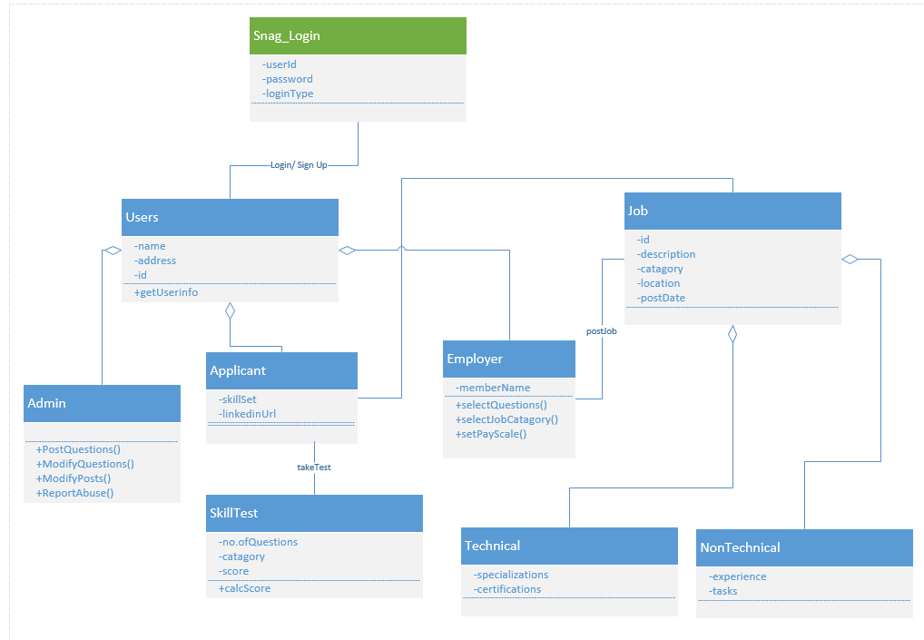

#### UML Activity Diagram

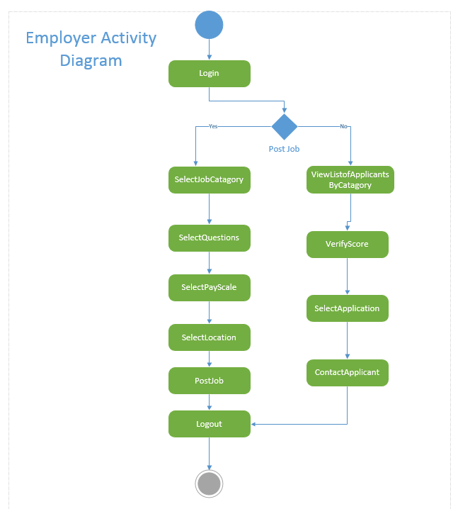

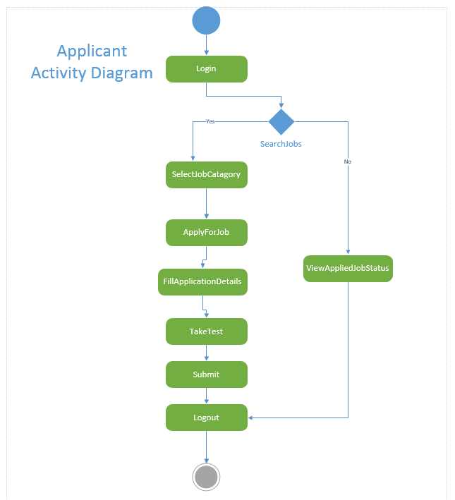

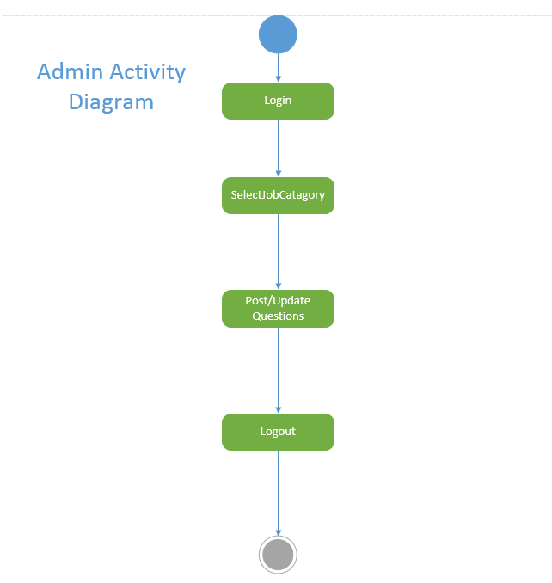

### **Technological and Architectural requirements**

* Eclipse JEE
* Microsoft Visio 2013
* Scrum Do Agile Development Techniques.
* Restful Web Service
* Java, HTML5, CSS3, JavaScript, jQuery
* Google API, LinkedIn Profile API, Google Maps API.

## Frame Work Specification

### Overall System Model:

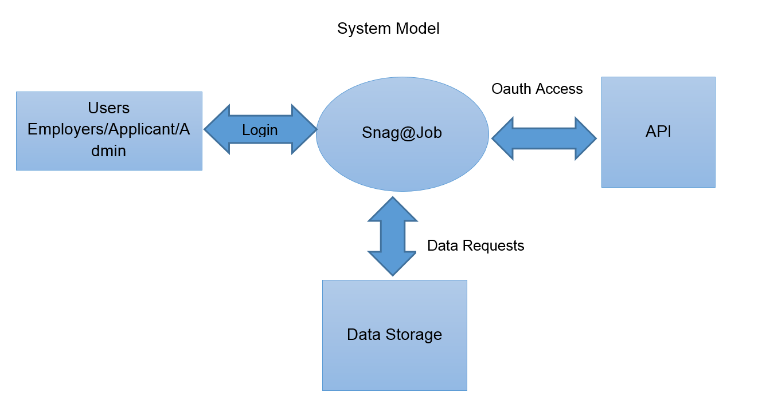

### Assumptions and Principles

* All the individuals will have the basic idea of using the web application & primary knowledge of using computer/laptop/smartphone.
* All the individuals are honest to the best of their knowledge.
* This application is used by the people who are in U6 category work force.

### System Architecture Diagram

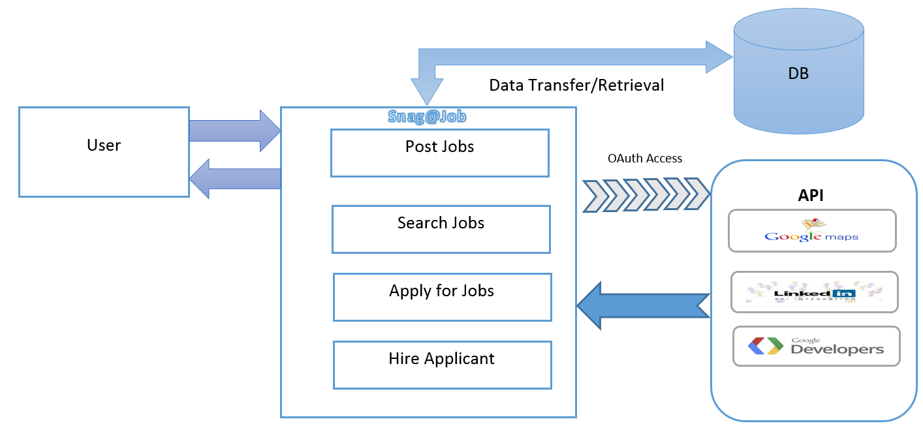

## System Specification

### Existing Services

* **Google Maps:** Google Mapshas an extensive array of APIs that enable to embed the robust functionality for everyday usefulness of Google Maps into webpages.

**URL:** <https://developers.google.com/maps/documentation/javascript/>

* **LinkedIn:** Leverage LinkedIn as an identity authority for application registration and sign in with benefits of simplifying the need for users to enter additional data. API enables to integrate for content creators to distribute content into the LinkedIn network updates stream.

**URL:** <http://api.linkedin.com/v1/people/~:(first-name,last-name,headline,picture-url)>

<http://api.linkedin.com/v1/people/~/connections>

### New Services to be built

<< TBD >>

# Plan by Services (Using ScrumDo)

## Project Increments

### Project Plan

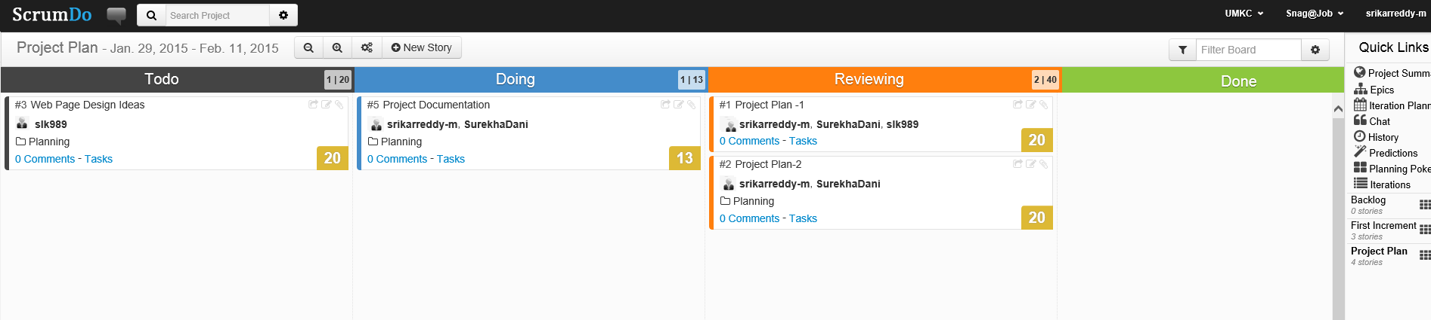

### First Increment

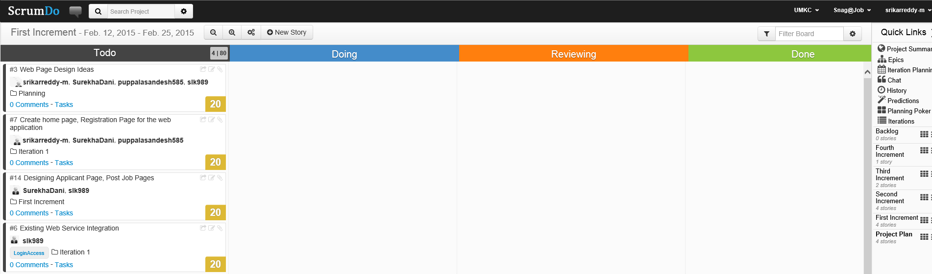

### Second Increment

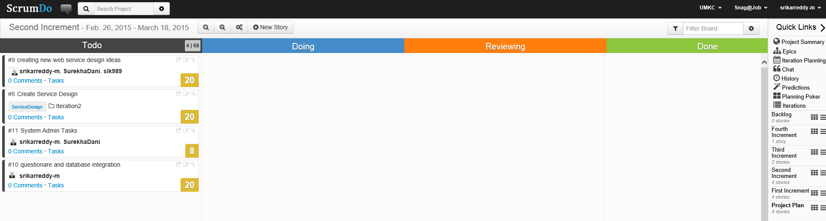

### Third Increment

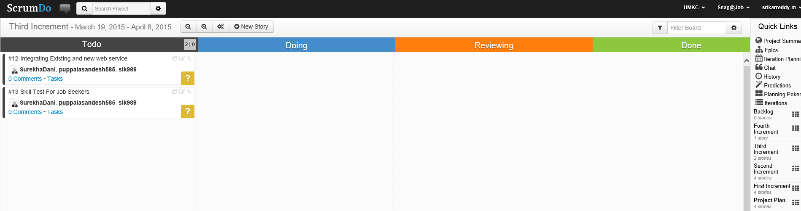

### Fourth Increment

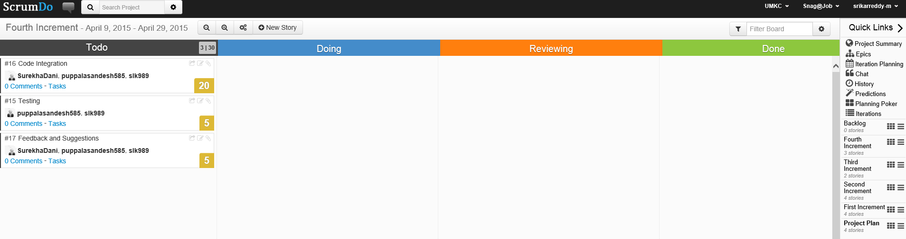

# Risk Management

* For all the transactions there will be a log files be generated, these are monitored by system admin.
* Any fault posts or suspicious transactions are quarantine by the admin to reduce the chance of loss of users’ data by hackers.
* There can be a chance of OAuth Connections failure to the external API, this can be mitigated by reset the connections for every regular intervals.
* Password of Users will be expired and prompted to change regularly for better security.

# GitHub URL:

# <https://github.com/srikarreddy-m/CS551-ASE/tree/src/Project/Snag%40Job>

# Bibliography

<http://www.businessinsider.com/labor-force-participation-rate-september-2014-2014-10>

<http://portalseven.com/employment/unemployment_rate_u6.jsp>

<http://www.bls.gov/news.release/empsit.t15.htm>

<https://developers.google.com/products/>

<https://developers.facebook.com/docs/facebook-login/login-flow-for-web/v2.2>

<http://www.programmableweb.com/api/geocoder>

<https://developer.linkedin.com/apis>

<https://developers.google.com/maps/documentation/javascript/>

<https://developers.facebook.com/docs/javascript>

<https://www.youtube.com/watch?v=xr1KYSDQMZc&feature=youtu.be>