**CS-5551: Advance Software Engineering**

**Project proposal**

Team Members : Somu.Lavanya Kumar, Surekha Dani

Srikar Reddy Mallareddygari, sandesh Puppala

**Main proposal: Snag@Job**

**Motivation and Goal**

The main aim of our project is to provide a platform to search for short term jobs for U6 category labor workforce of USA. This platform provides the opportunity to job seekers who are looking for part time jobs to meet their financial requirements. On the other hand it is helpful to find for the people who need help in completing their activities like Tutoring, Store Management, Party coordination, pickup or drop rides and other household activities etc.

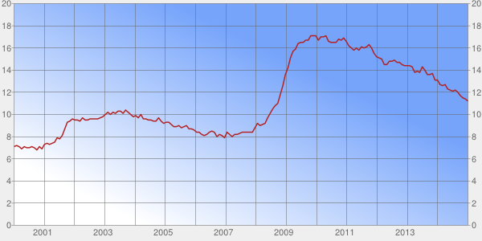

Fig 1: Unemployment Rate –U6

**Significance**

According to United States Department of Labor Statistics, Labor workforce of USA is categorized as U1, U2, U3, U4, U5, and U6. U6 category labor workforce is a combination of U1 to U5 categories. In simple terms citizens who are not having full time employment are categorized under U6 labor workforce. Fig 1 gives us the graphical information of Unemployed U6 workforce from 2000 to 2014. Post-recession US economy improved significantly which reduces the U6 unemployed workforce from almost 17.1% to 11.2% by Dec 2014 statistics.

At present the labor force participation rate is fallen to 62.7% which is the lowest rate since 1978 as shown in fig 2. LFPR is the ratio of the labor force and overall size of labor force of the same age range. Lowest LFPR is not good for US Economy. Online job portal are significantly helpful in improving the labor force participation rate.

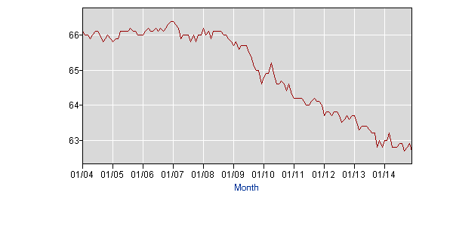

Fig 2: Labor force participation rate (LFPR)

**Objectives**

The main goal of this project is to develop a web application which helps to search part time jobs.

**System features**

* Proposed system allows anyone to post a job requirement who are seeking for paid help in completing their household activities, Tutoring, Event Management etc.
* Once a user logs in to the system, He will be provided with various search criteria to identify the jobs in a tabular format and geographically plotted format.
* Search criteria mainly contains Interested Jobs Criteria, Near by my location, Start date & End Date, Amount of money he wants to earn etc.

**Related work**

https://developers.google.com/products/

https://developers.facebook.com/docs/facebook-login/login-flow-for-web/v2.2

http://www.programmableweb.com/api/geocoder

**Bibliography**

http://www.businessinsider.com/labor-force-participation-rate-september-2014-2014-10

http://portalseven.com/employment/unemployment_rate_u6.jsp

http://www.bls.gov/news.release/empsit.t15.htm

**Back up proposal:**

Idea:

To develop an android application which can do the following activities:

* Suggesting the requirement of Thermals, Hand gloves, Umbrella, light weight clothes etc based on the weather notifications once the alarm got triggered.
* To trigger an alarm by displaying a predefined todo activity when reached to a preset geographic range of particular location.
* To automatically send a “safely reached” message to your family member / loved ones once you reached your destination.