**Object Detection and Recognition using OpenCV**

**Abstract:**

The modern world is enclosed with gigantic masses of digital visual information.

To analyze and understand this huge sea of visual information, there exist many

image analysis techniques.

Those methods that automatically recognize and detect the objects prove to be of great use and provide a significant help in modern applications and devices.

The semantic and syntactic contents of the images and videos can be recognized

and further processed to get the necessary information.The potential uses of the

image can be identified.

The important content of image is the objects in the image. There exists a

significant and essential need for object recognition techniques.

Recognition is an important task in image processing and computer vision. A set of

known tags can be used to identify what really the object is and help to extract

information.

**Purpose:**

The purpose behind this project is that it is something that will overdo all the

physical tasks.

Robotics and smart systems are buzzing around all over the world.

Object recognition and tracking reduces human efforts and provides efficiency.

It is of interest as it may help humans to be aware of minute information about

particular objects and reduce human tasks.

Automatic recognition and extraction adds to the smart systems used today.

**Methodology:**

Each of the methods that have been reviewed and analyzed require machine learning to be an integral part of it since no matter what the Trained image is, the detectors have to be trained for the objects to be recognized and to do this the machine needs to be trained.

So, this brings up the concept about Artificial Intelligence in terms of object recognition. The detectors basically keep on building their database by feature extraction or other attributes like color, shape and then these features are used to match with the objects in the input image

**MobileNet SSD**

MobileNet is a light-weight deep neural network architecture designed for mobiles and embedded vision applications.

Single Shot object detection or SSD takes one single shot to detect multiple objects within the image. The SSD approach is based on a feed-forward convolutional network that produces a fixed-size collection of bounding boxes and scores for the presence of object class instances in those boxes.

It’s composed of two parts:

1. Extract feature maps, and

2. Apply convolution filter to detect objects

SSD is designed to be independent of the base network, and so it can run on top of any base networks such as VGG, YOLO, MobileNet.

**Software and Hardware Used:**

**Software**:

Programming language: python

Machine Learning Packages:

1.OpenCV

2. Numpy

**Hardware**:

Simulated on Laptop (i5 8th generation, 8gb RAM, webcam)

Can be deployed on Raspberry Pi containing minimum of 4gb RAM and a pi camera.

**Technical Description:**

Image Classification: This is done by Predict the type or class of an object in an image.

Input: An image which consists of a single object, such as a photograph.

Output: A class label (e.g. one or more integers that are mapped to class labels).

Object Localization: This is done through, Locate the presence of objects in an image and indicatetheir location with a bounding box..

Object Detection: This is done through, Locate the presence of objects with a bounding box and types or classes of the located objects in an image.

**Process Diagram:**

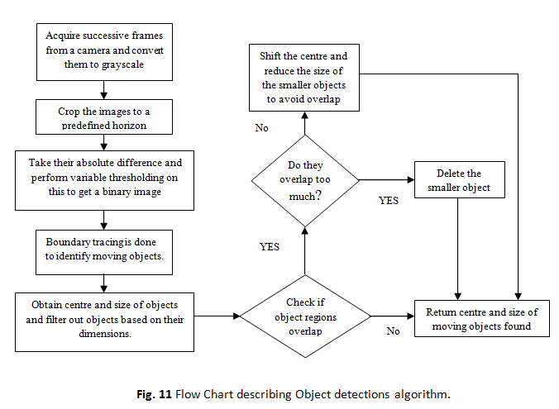

**Performance:**

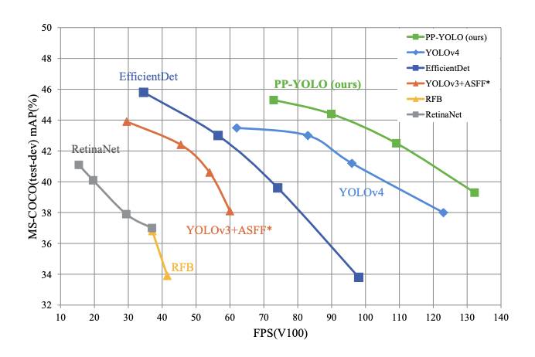

**Applications:**

1. Biometric recognition

2. Surveillance

3. Industrial inspection

4. Content-based image retrieval (CBIR)

5. Robotics

6. Medical analysis

7. Lane Detection

**Results:**

Object detection is one of the most widely used concept in the field of Artificial Intelligence.So it has a great scope in future for the development of the modern world

By:

SRIKAR RAVI

198W1A05B3

CSE - 2