Nama : Sri Kartini

Nim : 312110435

Mata Kuliah : Pemrograman Web 2

1. Melakukan Instalisasi XAMPP

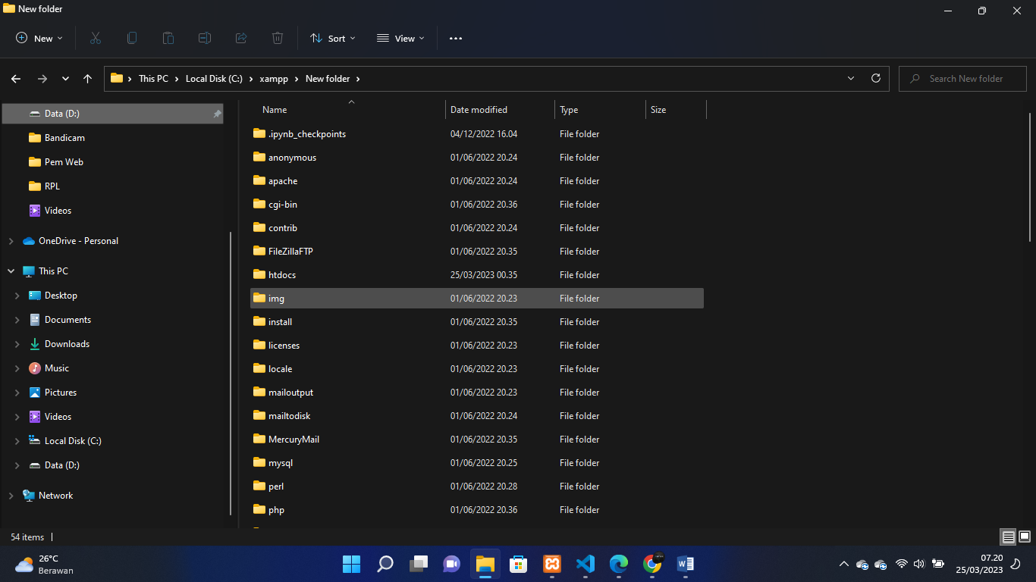

1. Menjalankan Web Server

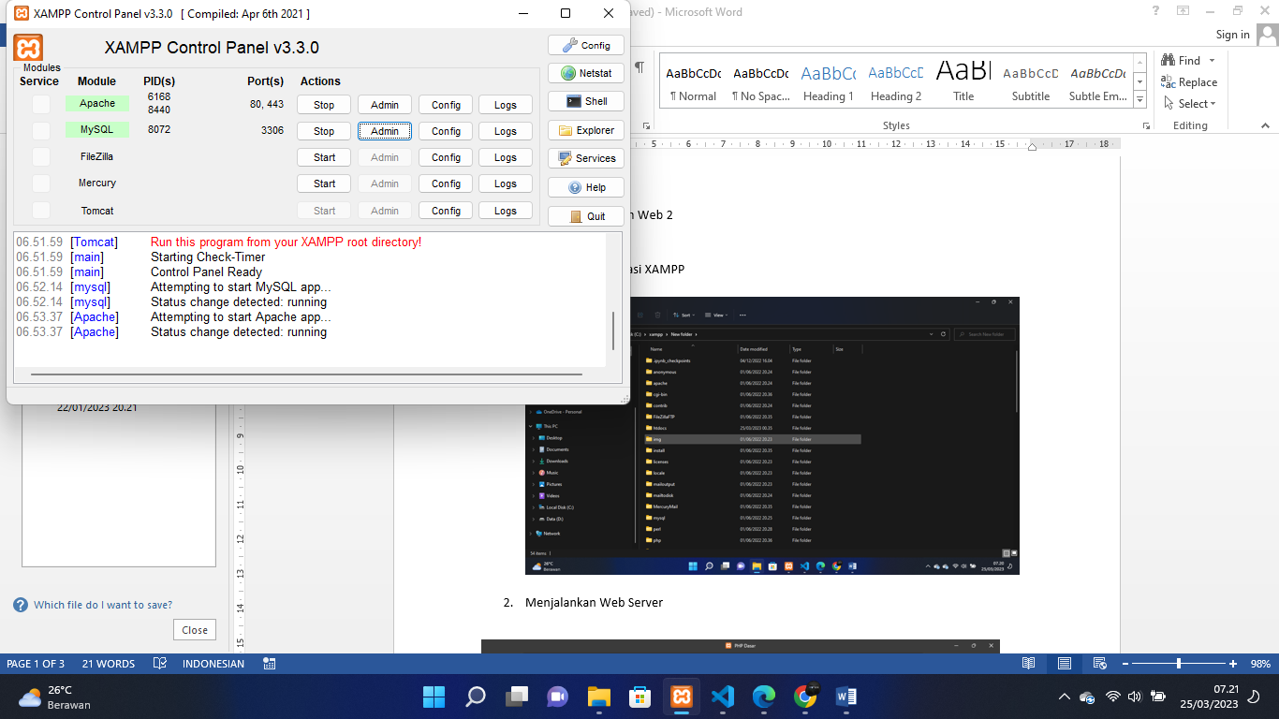

1. Memulai PHP

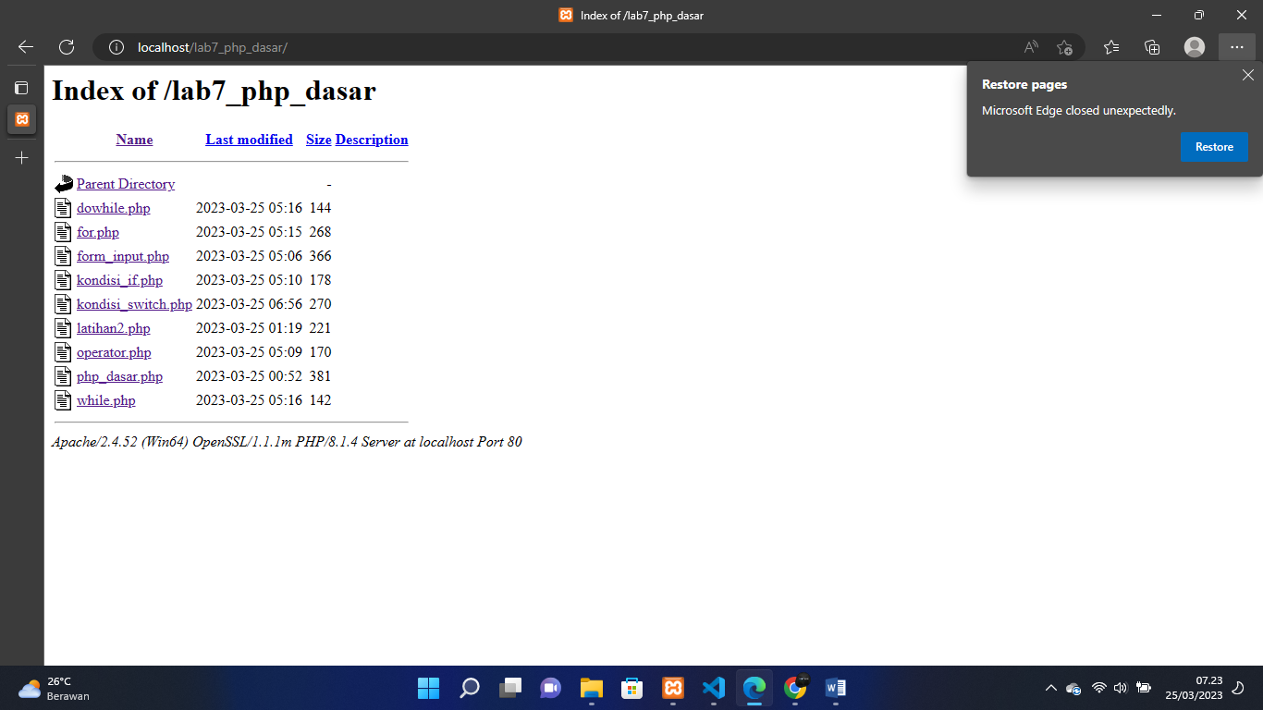

1. PHP Dasar

|  |
| --- |
| 1. <!DOCTYPE html> 2. <html lang="en"> 3. <head> 4. <meta charset="UTF-8"> 5. <title>PHP Dasar</title> 6. </head> 7. <body> 8. <h1>Belajar PHP Dasar</h1> 9. <?php   echo "Hello World"; 10. ?> 11. <h2>Menggunakan Variabel</h2> 12. <?php 13. $nim = "312110435"; $nama = 'Sri Kartini'; echo "NIM : " . $nim . "<br>"; echo "Nama : $nama"; 14. ?> 15. </body> 16. </html> |

Screenshoot Hasil

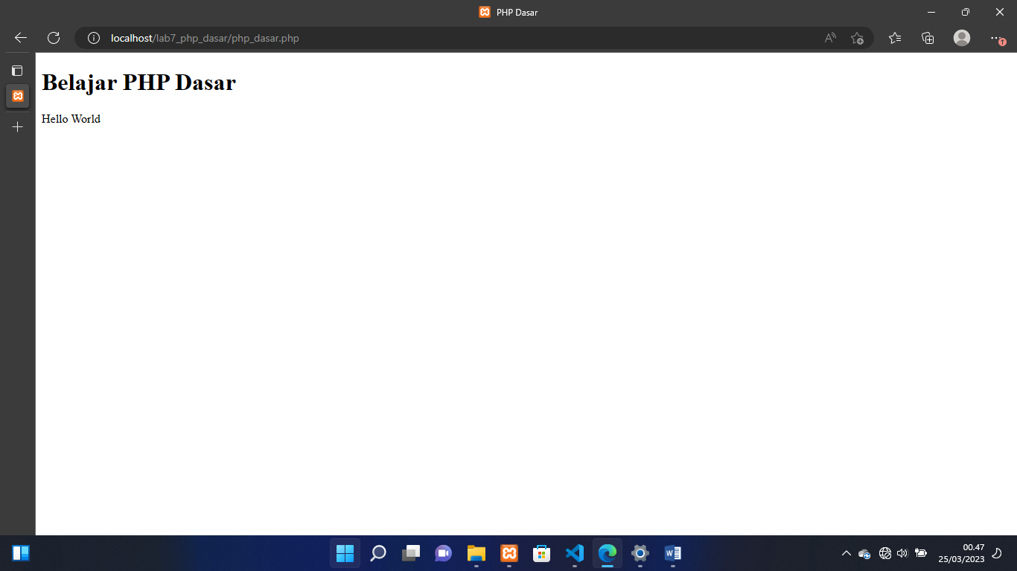

5. Variable PHP

|  |
| --- |
| <!DOCTYPE html>  <html lang="en">  <head>      <meta charset="UTF-8">      <title>PHP Dasar</title>  </head>  <body>      <h1>Belajar PHP Dasar</h1>      <?php   echo "Hello World";      ?>      <h2>Menggunakan Variabel</h2>      <?php  $nim = "312110435"; $nama = 'Sri Kartini'; echo "NIM : " . $nim . "<br>"; echo "Nama : $nama";          ?>  </body>  </html> |

Screenshoot Hasil

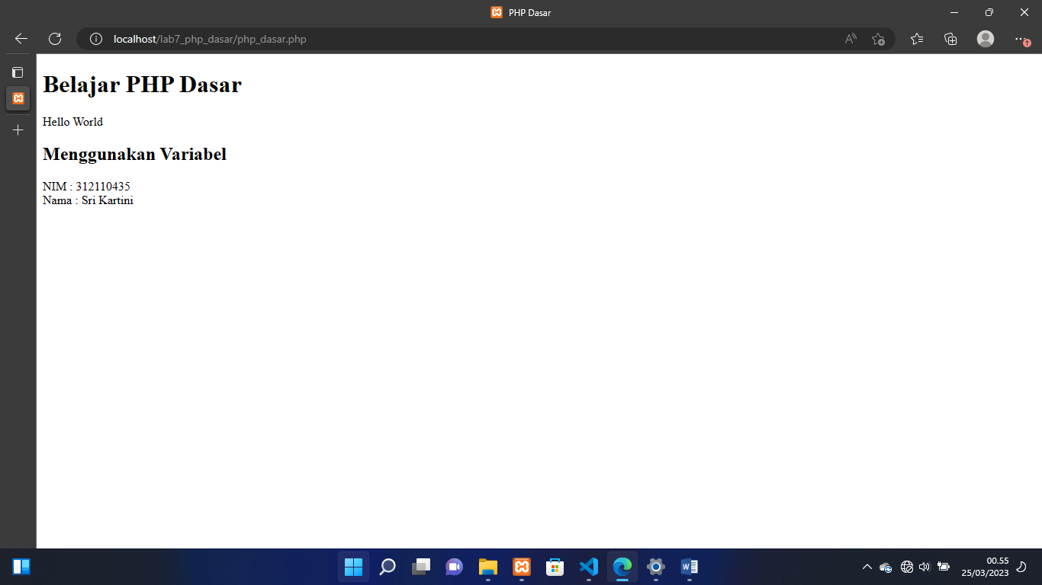

Variable Get

|  |
| --- |
| <!DOCTYPE html>  <html lang="en">  <head>      <body>      <meta charset="UTF-8">      <title>php dasar</title>      <h1>Predifine Variable</h1>  <?php  echo 'Selamat Datang  '. $_GET['nama'];  ?>  </body>  </html> |

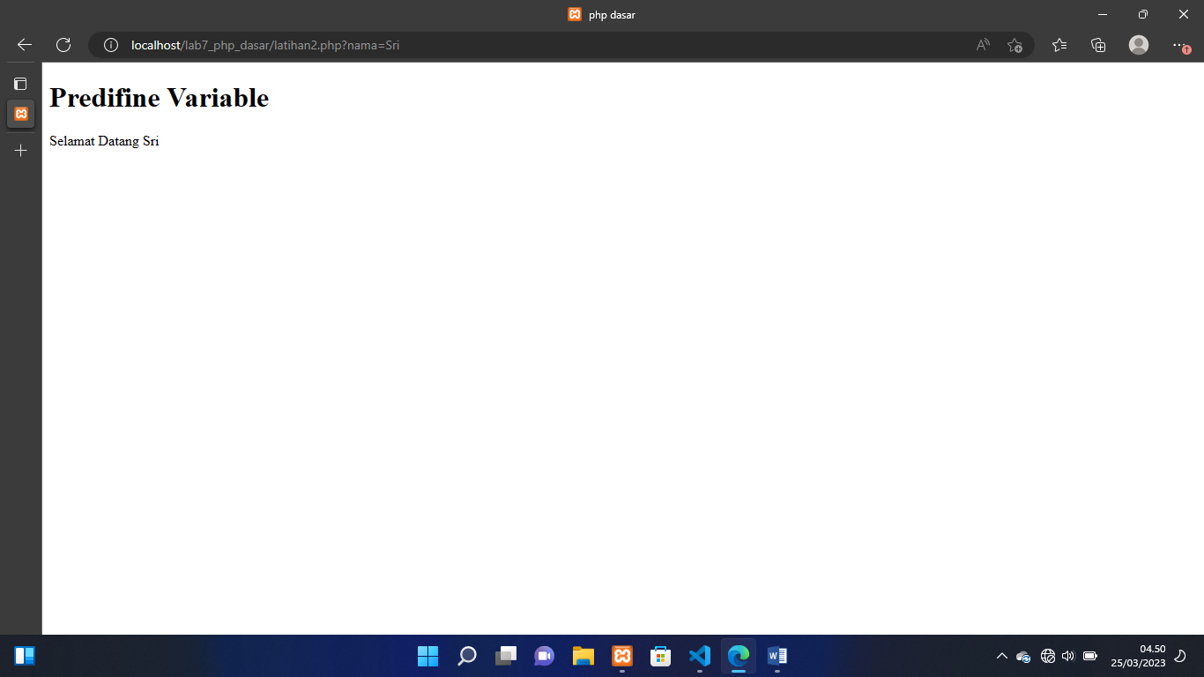

Membuat From Input

|  |
| --- |
| <!DOCTYPE html>  <html lang="en">  <head>      <meta charset="UTF-8">      <title>PHP Dasar</title>  </head>  <body>  <h2>Form Input</h2>  <form method="post">      <label>Nama: </label>      <input type="text" name="nama">      <input type="submit" value="Kirim">  </form>  <?php  echo 'Selamat Datang ' . $_POST['nama'];  ?>  </body>  </html> |
|  |
|  |

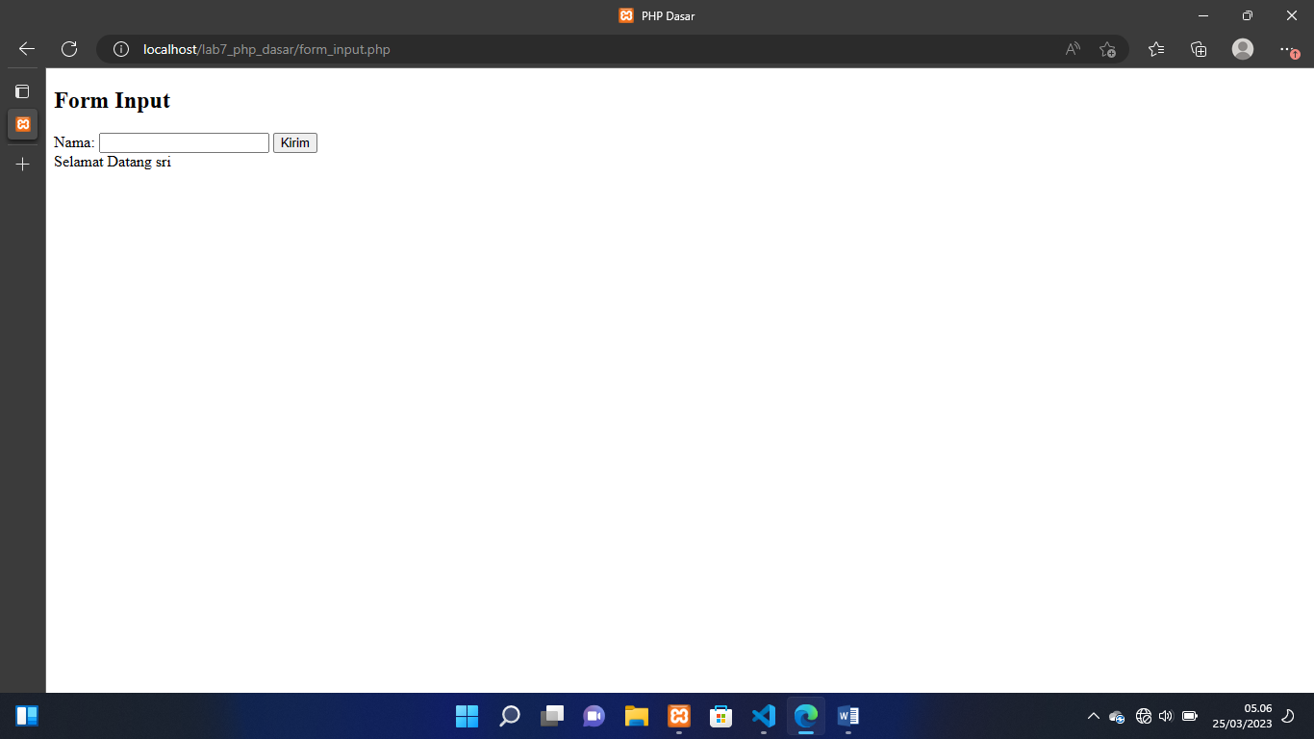

Operator

|  |
| --- |
| <?php  $gaji = 1000000;  $pajak = 0.1;  $thp = $gaji - ($gaji*$pajak); echo "Gaji sebelum pajak = Rp. $gaji <br>"; echo "Gaji yang dibawa pulang = Rp. $thp";  ?> |

Screenshoot Hasil

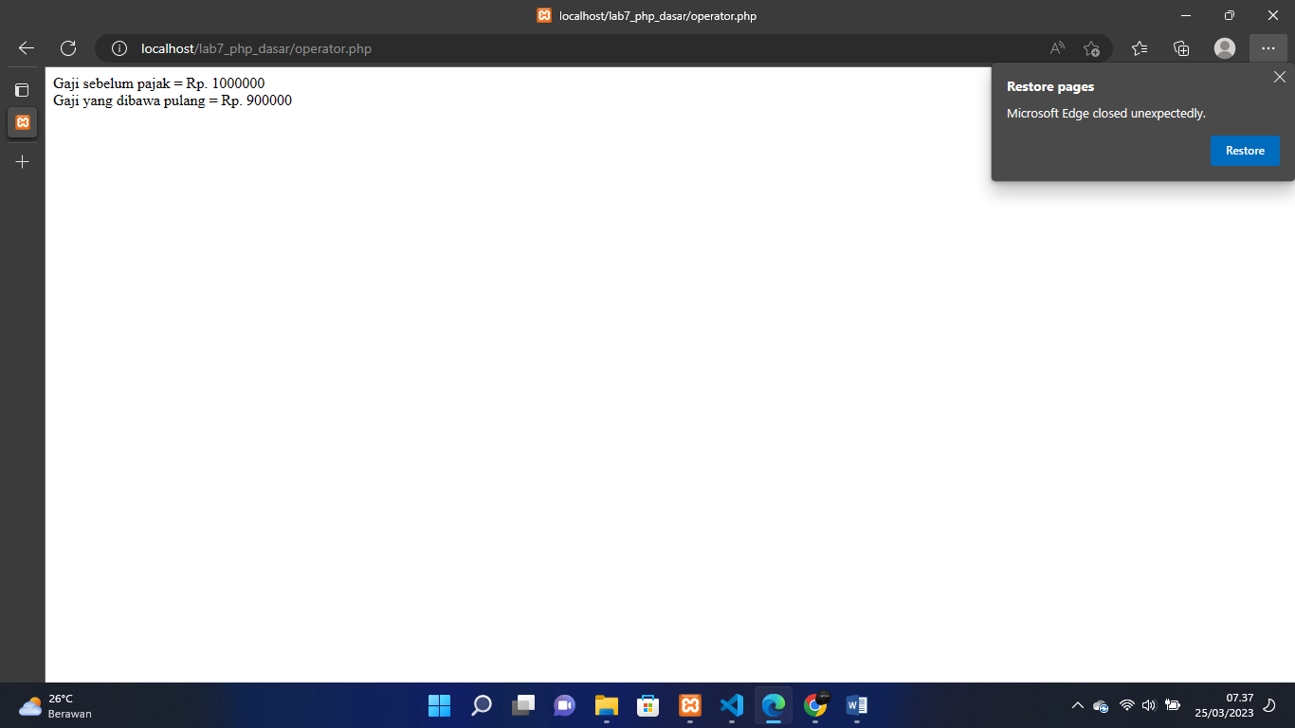

Kondisi If

|  |
| --- |
| <?php  $nama_hari = date("l"); if ($nama_hari == "Sunday") {     echo "Minggu";  } elseif ($nama_hari == "Monday") {     echo "Senin";  } else {      echo "Selasa";  }  ?> |

Screenshoot Hasil

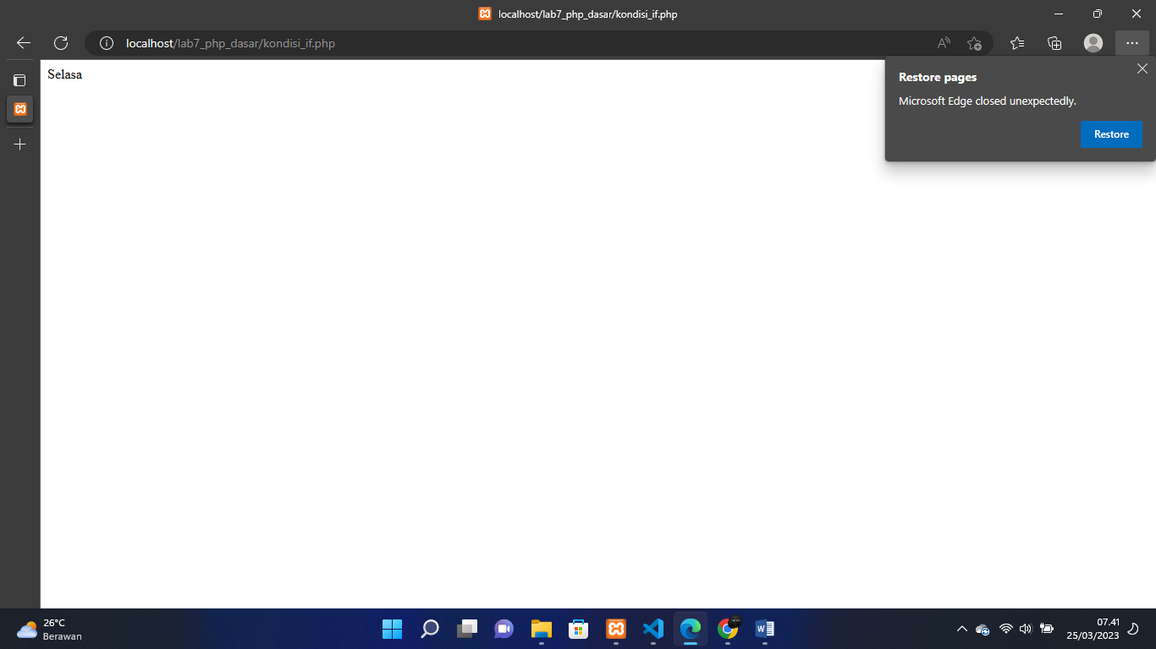

Kondisi Switch

|  |
| --- |
| <?php  $nama_hari = date("l"); switch ($nama_hari) {   case "Sunday":    echo "Minggu";  break;  case "Monday":   echo "Senin";  break;  case "Tuesday":   echo "Selasa";   break;   default: echo "Sabtu";  }   ?> |

Screenshoot Hasil

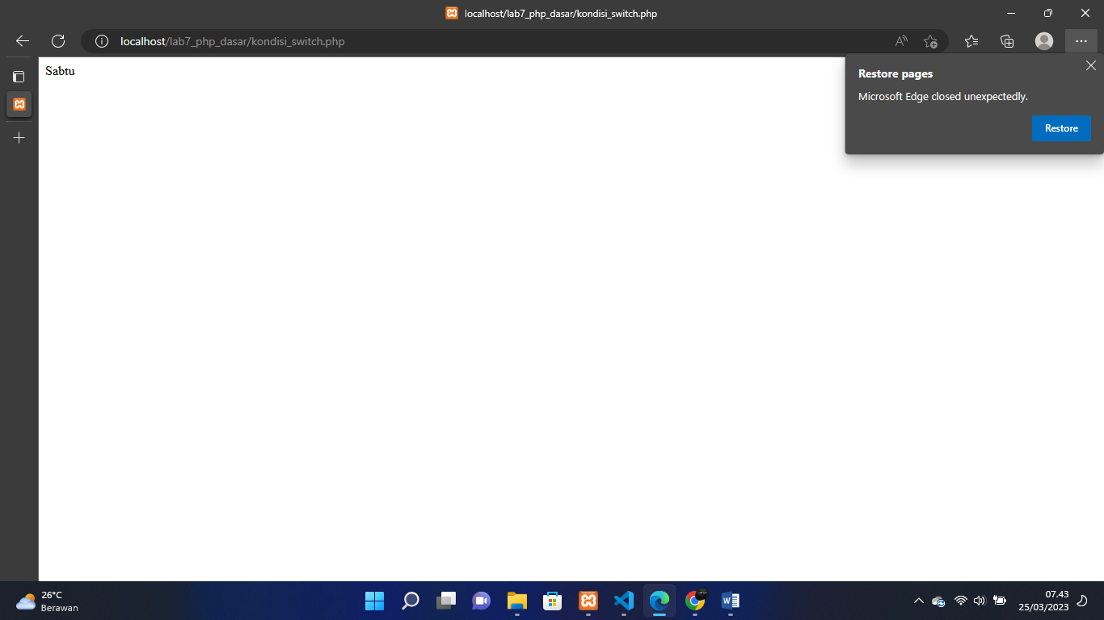

Perulangan For

|  |
| --- |
| <?php echo "Perulangan 1 sampai 10 <br />";  for ($i=1; $i<=10; $i++) {        echo "Perulangan ke: " . $i . '<br />';  }      echo "Perulangan Menurun dari 10 ke 1 <br />";  for ($i=10; $i>=1; $i--) {      echo "Perulangan ke: " . $i . '<br />';  }  ?> |

Screenshot Hasil

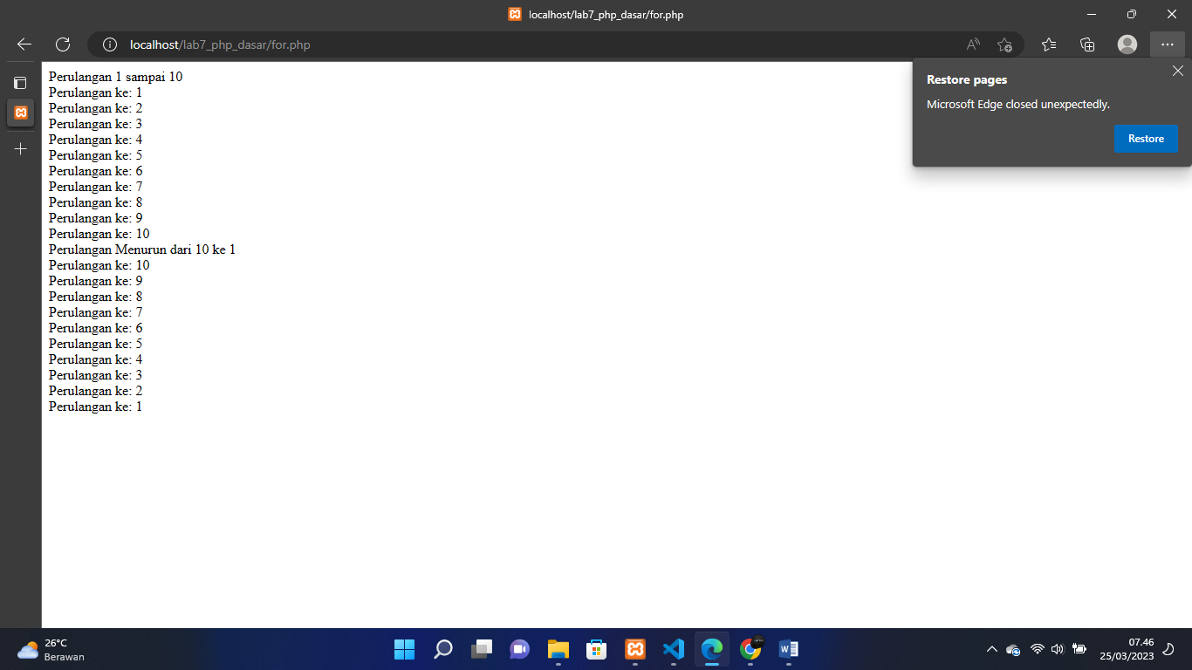

While

|  |
| --- |
| <?php echo "Perulangan 1 sampai 10 <br />";  $i=1; while ($i<=10) {      echo "Perulangan ke: " . $i . '<br />';      $i++;  }  ?> |

Screenshot Hasil

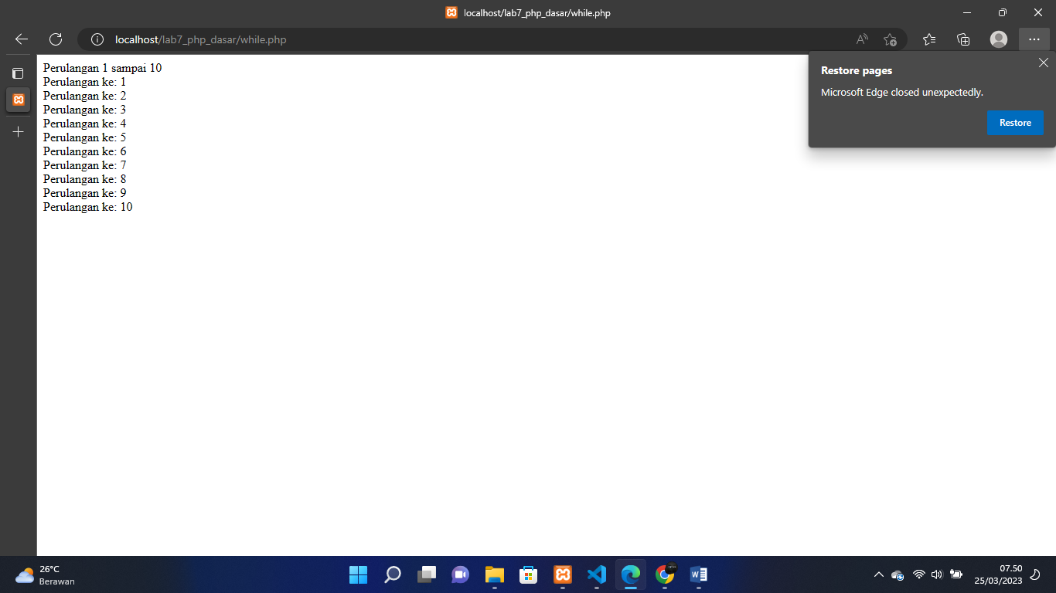

Dowhile

|  |
| --- |
| <?php  echo "Perulangan 1 sampai 10 <br />";  $i=1; do {      echo "Perulangan ke: " . $i . '<br />';      $i++;  } while ($i<=10);  ?> |

Screenshot Hasil

