Online Event Management System

# Abstract

The "Online Event Management System" is a comprehensive solution designed to simplify the complex process of event planning and management. By integrating essential modules such as User Authentication, Appointment Scheduling, Hall Availability, Booking Information, and Appointment Management, the system offers a seamless experience for both clients and organizers. The User Authentication and Registration module ensures secure access, while the Appointment Scheduling Interface streamlines the booking of appointments. Real-time updates on venue availability are made possible through the Hall Availability Management feature, and the Booking Information Management module acts as a centralized hub for all reservation details. The system's flexibility is further highlighted by the Appointment Management module, which allows for easy rescheduling and cancellations. A robust Notification System keeps all parties informed of event-related updates, and the Admin Dashboard provides administrators with a bird's-eye view of all system activities. Overall, this web application stands out as a user-friendly platform that enhances the event management experience by offering a cohesive set of tools for efficient and effective coordination.

# Project Explanation

The "Online Event Management System" is a testament to the power of digital solutions in streamlining complex processes. This user-friendly web application stands as a beacon of innovation, offering a suite of functionalities that cater to the dynamic needs of event management. At its core, the system champions accessibility through a robust User Authentication and Registration module, ensuring that each stakeholder's entry into the platform is secure and personalized. This gateway opens up to a world of efficiency with the Appointment Scheduling Interface, a tool designed for the modern user to book and manage appointments with unparalleled ease.

Further enhancing the user experience, the Hall Availability Management feature acts as a real-time beacon of venue occupancy, allowing for informed decision-making. Complementing this is the Booking Information Management module, a centralized hub that simplifies the reservation process and provides a clear overview of bookings. The system's agility is showcased through the Appointment Management module, which grants organizers the flexibility to adapt to changing circumstances by facilitating rescheduling and cancellations with minimal friction.

The Notification System is the pulse of the platform, keeping users abreast of updates and announcements, ensuring that all stakeholders are synchronized with the event's heartbeat. The culmination of these features is the Admin Dashboard, a strategic command center that provides administrators with a panoramic view of system activities, empowering them to maintain order and efficiency.

By weaving together these integral components, the Online Event Management System transcends traditional event planning. It encapsulates a seamless fusion of technology and user-centric design, delivering a harmonious orchestration of event management that resonates with both organizers and clients. In essence, this project is not just a tool but a partner in the event management journey, promising a smooth and enjoyable experience that elevates events to new heights of success.

# System Requirements

## Software requirements

1. **Python**: version 3.9
2. **Web Framework** : Django, Flask, and Pyramid.
3. **Database** : MySQL, SQLite.
4. **Integrated Development Environment (IDE)**: Visual Studio Code, PyCharm.
5. **Version Control**: GitHub.

## Hardware Requirements

1. **Computer**
2. **Memory (RAM)**: At least 4GB of RAM
3. **Storage**
4. **Network Connection**

# UML Diagrams

## Class Diagram

## 

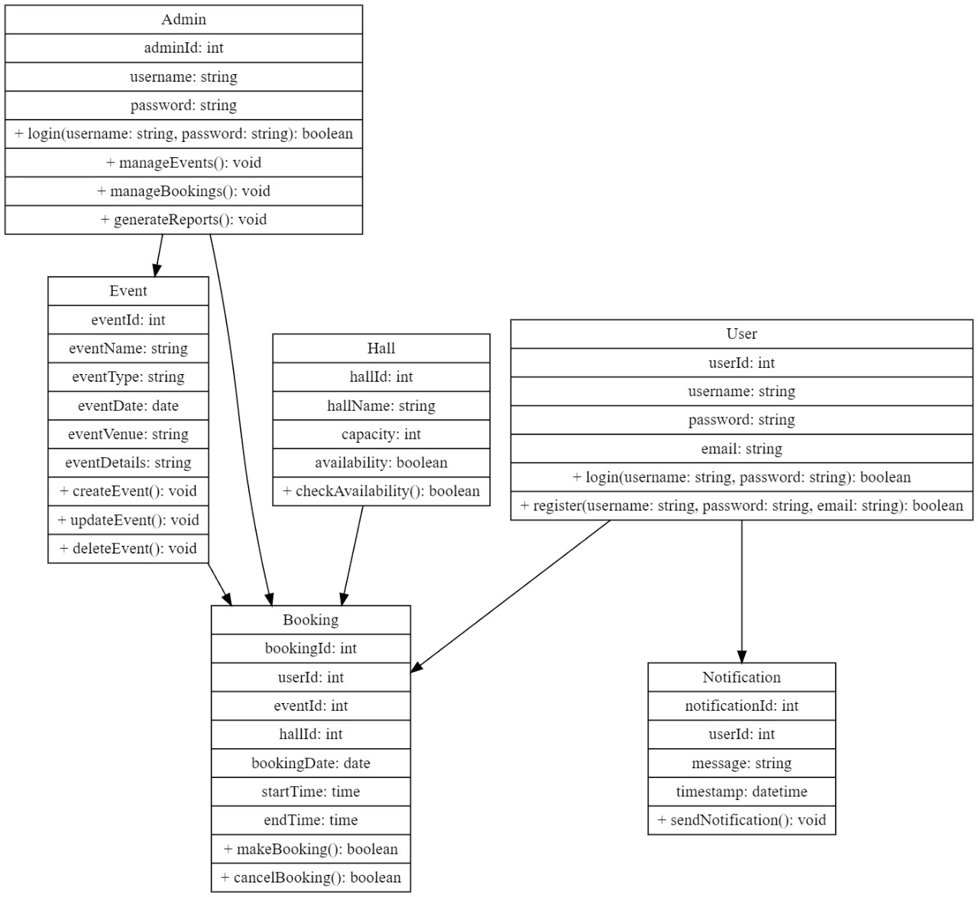

## Sequence Diagram

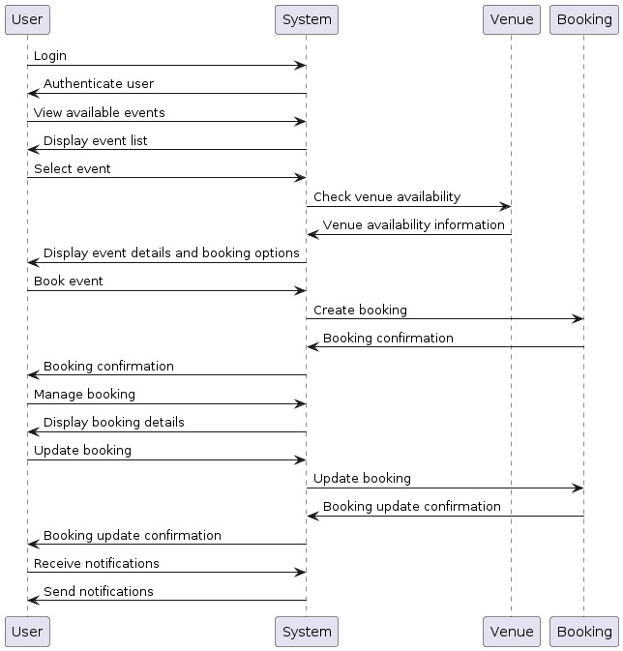

## Data Flow Diagram

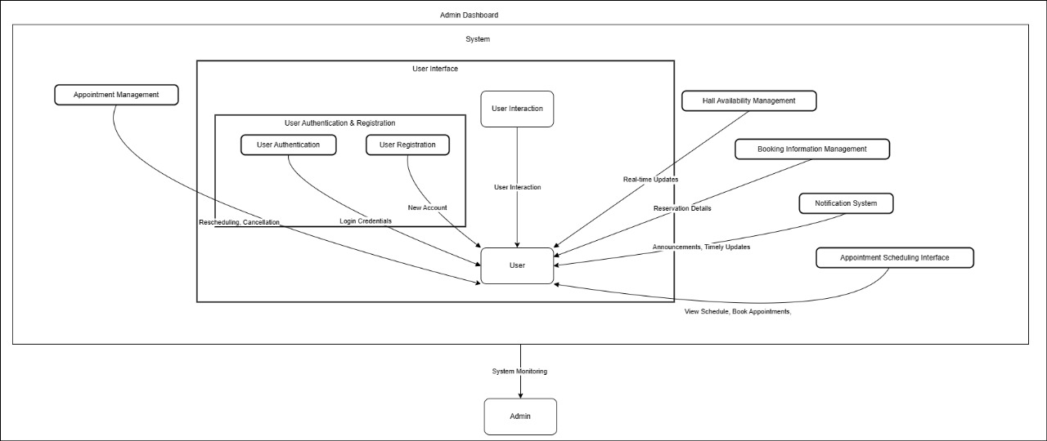

## By

Tripurari Venkata Srikar

Adivishnu Sri sai Keerthi

Karan Tomar

Aashish sahu

Kumar Harsh