**MintegraX using Machine Learning**

*A Mini Project Report Submitted*

In partial fulfillment of the requirement for the award of the degree of

## *Bachelor of Technology*

***In***

***Computer Science and Engineering -Artificial Intelligence and Machine Learning***

**By**

## 

Under the Guidance of

**D. Chandra Sekhar Reddy**

**Assoc. Professor**

**Department of Computational Intelligence**

**MRCET**



**DEPARTMENT OF COMPUTATIONAL INTELLIGENCE**

**MALLA REDDY COLLEGE OF ENGINEERING AND TECHNOLOGY**

(Affiliated to JNTU, Hyderabad)

**ACCREDITED by AICTE-NBA**

**Maisammaguda, Dhulapally post, Secunderabad-500014.**

**2020-2024**

**DECLARATION**

## I hereby declare that the project entitled “MintegraX using Machine Learning” submitted to Malla Reddy College of Engineering and Technology, affiliated to Jawaharlal Nehru Technological University Hyderabad (JNTUH) for the award of the degree of Bachelor of Technology in Computer Science and Engineering- Artificial Intelligence and Machine Learning is a result of original research work done by me.

It is further declared that the project report or any part thereof has not been previously submitted to any University or Institute for the award of degree or diploma.

By



**CERTIFICATE**

This is to certify that this is the bonafide record of the project titled **“MintegraX using Machine Learning”** submitted by **XYZ** of B.Tech in the partial fulfillment of the requirements for the degree of **Bachelor of Technology** in **Computer Science and Engineering - Artificial Intelligence and Machine Learning**, Dept. of CI during the year 2023-2024. The results embodied in this project report have not been submitted to any other university or institute for the award of any degree or diploma.

**D. Chandra Sekhar Reddy Dr. D. Sujatha**

Assoc. Professor

**INTERNAL GUIDE HEAD OF THE DEPARTMENT**

**EXTERNAL EXAMINER**

# **ACKNOWLEDGEMENT**

We feel honored and privileged to place our warm salutation to our college Malla Reddy College of Engineering and technology (UGC-Autonomous), our Director ***Dr. VSK Reddy*** who gave us the opportunity to have experience in engineering and profound technical knowledge.

We are indebted to our Principal ***Dr. S. Srinivasa Rao*** for providing us with facilities to do our project and his constant encouragement and moral support which motivated us to move forward with the project.

We would like to express our gratitude to our Head of the Department ***Dr. D. Sujatha*** for encouraging us in every aspect of our system development and helping us realize our full potential.

We would like to thank our application development guide as well as our internal guide

**D. Chandra Sekhar Reddy (Assoc. Professor),** for his structured guidance and never-ending encouragement. We are extremely grateful for valuable suggestions and unflinching co-operation throughout application development work.

We would also like to thank all supporting staff of department of CI and all other departments who have been helpful directly or indirectly in making our application development a success.

We would like to thank our parents and friends who have helped us with their valuable suggestions and support has been very helpful in various phases of the completion of the application development.

By

**ABSTRACT**

MintegraX, short for "Motion-Facial Integration Excellence system," stands as a pioneering project positioned at the forefront of the technological landscape, ingeniously combining motion and face recognition technologies. This visionary initiative strives to seamlessly integrate these domains, unleashing a multitude of transformative applications. The ubiquity of motion recognition across diverse fields, coupled with the paramount importance of face recognition in biometric authentication, underscores the significance of MintegraX's mission.

The primary goal of MintegraX is to propel advancements in online proctoring, ushering in a new era of integrity by thwarting cheating through the deployment of sophisticated recognition algorithms. Beyond the realm of proctoring, MintegraX aspires to elevate user authentication by harmoniously integrating facial and motion recognition technologies, creating a robust and multi-layered security apparatus.

Furthermore, MintegraX aims to revolutionize surveillance solutions, offering unparalleled accuracy through the fusion of motion and facial recognition. This has profound implications for ensuring the integrity of various environments, particularly in academic and professional settings. The project extends its impact to enhance human-computer interaction, envisioning interfaces that are not only intuitive but also responsive, providing users with a more immersive and efficient interaction with digital devices.

In essence, MintegraX transcends the conventional boundaries of technology by synergizing motion and face recognition, with a strategic focus on improving online proctoring, fortifying user authentication, providing precise surveillance solutions, and redefining human-computer interaction. This initiative promises not only technological innovation but also a fundamental shift in how we approach security, authentication, and digital interaction in diverse applications.

**TABLE OF CONTENTS**

**S.No. Topic Page No.**

CHAPTER 1: INTRODUCTION ----------------------------------------------------------------- 1-3

1.1: Purpose

1.2: Background of project

1.3: Scope of project

1.4: Project features

CHAPTER 2: SYSTEM REQUIREMENTS----------------------------------------------------- 3

2.1 H/W Requirements

2.2 S/W Requirements

CHAPTER 3: LITERATURE SURVEY--------------------------------------------------------- 3-5

3.1 Existing System

3.2 Proposed System

CHAPTER 4: SYSTEM DESIGN ---------------------------------------------------------------- 6-10

4.1 System Architecture

4.2 UML Diagrams

CHAPTER 5: IMPLEMENTATION ------------------------------------------------------------ 11-13

5.1 Source Code

5.2 Output Screens

CHAPTER 6: CONCLUSION-------------------------------------------------------------------- 14

BIBLIOGRAPHY ----------------------------------------------------------------------------------- 15

**1. INTRODUCTION**

**1.1 Purpose:**

MintegraX aims to revolutionize online proctoring, enhance user authentication, and provide accurate surveillance solutions by seamlessly integrating motion and facial recognition technologies. With a focus on improving digital security and human-computer interaction, MintegraX seeks to set new standards in the dynamic intersection of these technologies, contributing to technological innovation in diverse applications...

**1.2 Background of project:**

MintegraX represents a visionary response to the dynamic interplay between technology and contemporary challenges. Against the canvas of a rapidly evolving technological landscape, the project takes root in the convergence of motion and facial recognition technologies, recognizing their transformative potential. With a nuanced understanding of the diverse applications of these technologies, MintegraX aspires to seamlessly intertwine them. This visionary initiative envisions a future where the integrity of online gaming is fortified against cheating, user authentication attains unprecedented security levels, surveillance solutions achieve heightened accuracy, and human-computer interaction unfolds as a more intuitive and engaging experience.

At its core, MintegraX emerges as a proactive solution, addressing the pervasive need for advanced recognition algorithms. These algorithms play a pivotal role in preventing malpractices in online gaming, bolstering security in user authentication, ensuring precision in surveillance applications, and redefining digital interactions through interfaces that are not just efficient but also intuitive. The project is more than a response to contemporary challenges; it is a strategic move toward shaping a technologically advanced, user-centric future where the seamless integration of motion and facial recognition technologies forms the cornerstone of innovation and progress. As MintegraX unfolds, it weaves a narrative of adaptability, resilience, and foresight, positioning itself at the forefront of technological endeavors that transcend existing boundaries to meet the evolving needs of a dynamic digital landscape.

**1.3 Scope of project:**

MintegraX boasts a broad scope, aiming to revolutionize online gaming integrity, user authentication, surveillance solutions, and human-computer interaction. In the realm of online gaming, the project targets cheating prevention through advanced recognition algorithms. It extends its impact to user authentication across sectors, emphasizing heightened security. MintegraX envisions accurate surveillance by fusing motion and facial recognition for real-time tracking. Additionally, the project ambitiously seeks to transform human-computer interaction with intuitive interfaces, enhancing efficiency and engagement. Overall, MintegraX's scope spans crucial facets of technology, promising advancements in digital security, authentication, and interaction paradigms across diverse applications.

**1.4 Project Features­­­:**

The system features are as follows:

* Advanced Cheating Prevention: MintegraX incorporates state-of-the-art recognition algorithms to prevent cheating in online gaming, ensuring fair play and maintaining the integrity of gaming environments.
* Facial and Motion Recognition Integration: The project seamlessly integrates facial and motion recognition technologies, creating a robust and multi-layered security system for user authentication. This integration enhances the precision and reliability of user identification.
* Real-time Surveillance Solutions: MintegraX provides accurate surveillance solutions by fusing motion and facial recognition. This enables precise real-time tracking of users during various activities, ensuring the security and integrity of monitored environments.
* Intuitive Human-Computer Interaction: The project aims to transform human-computer interaction by introducing intuitive interfaces that respond to gestures and facial expressions. This feature enhances user engagement and efficiency in digital interactions.
* Versatile Applications: MintegraX's features extend across diverse applications, ranging from online gaming to user authentication, surveillance, and interactive interfaces. This versatility highlights the adaptability of the project to different domains and scenarios.

# **2.SYSTEM REQUIREMENTS**

**2.1 Hardware Requirements:**

* High-quality cameras for capturing motion and facial data.
* Sufficient CPU/GPU power
* Adequate RAM
* Storage space for storing databases

**2.2 Software requirements:**

* A compatible OS for running the system.
* Databases or cloud storage for storing reference
* A user-friendly interface

**3.LITERATURE SURVEY**

**3.1 Existing System:**

Online proctoring, while providing a solution for remote examination monitoring, has its share of flaws that may impact user experience and the integrity of assessments. However, comparing it directly to MintegraX requires understanding the specific features and capabilities of MintegraX, which are not explicitly detailed. Below are common flaws associated with online proctoring, and a hypothetical discussion on how MintegraX might address or improve upon them:

**Flaws of Online Proctoring:**

**1. Privacy Concerns:** Online proctoring often involves intrusive measures like video and audio monitoring, raising privacy concerns among users.

**2. Technical Glitches:** Online proctoring systems may encounter technical glitches such as network issues, software malfunctions, or hardware failures.

**3. False Positives:** Online proctoring systems may generate false positives, flagging legitimate behavior as suspicious and leading to unwarranted interventions.

**4. Limited Accessibility:** Some online proctoring solutions may be inaccessible to users with specific disabilities or those facing technical challenges.

**3.2 Proposed System:**

The proposed system, MintegraX, envisions a cutting-edge integration of motion and facial recognition technologies, establishing a cohesive platform that harnesses the synergies between these two domains. At the core of the proposal is a multi-layered security paradigm for user authentication, where facial and motion recognition seamlessly collaborate to fortify identity verification and curtail unauthorized access. Real-time monitoring and surveillance solutions, achieved through the fusion of motion and facial recognition, emerge as pivotal aspects, ensuring accurate tracking and surveillance in contexts such as online proctoring. The proposed system further distinguishes itself with the incorporation of advanced recognition algorithms, aimed at elevating the integrity of online gaming by detecting and preventing cheating through precise analyses.

**1.** **Seamless Integration of Recognition Technologies:** MintegraX proposes the seamless integration of motion and facial recognition technologies, creating a unified system that leverages the strengths of both to enhance various applications.

**2.** **Multi-Layered Security for User Authentication:** The proposed system aims to establish a multi-layered security approach for user authentication, combining facial and motion recognition to fortify identity verification and prevent unauthorized access.

**3. Real-time Monitoring and Surveillance:** The system proposes real-time monitoring and surveillance solutions by fusing motion and facial recognition. This ensures accurate tracking and monitoring of users, particularly relevant in scenarios like online proctoring or secure environments.

**4. Advanced Recognition Algorithms:** MintegraX proposes the use of advanced recognition algorithms to achieve a higher level of accuracy in detecting and preventing cheating in online gaming, contributing to the integrity of gaming experiences.

**5.** **Intuitive Interfaces for Enhanced Interaction:** The proposed system includes the introduction of intuitive interfaces, responding to gestures and facial expressions. This feature aims to enhance human-computer interaction, making digital interfaces more user-friendly, engaging, and efficient.

**6.** **Versatility Across Different Domains:** MintegraX is designed to be versatile, with the capability to adapt to various applications such as online gaming, user authentication, surveillance, and interactive interfaces. This versatility underscores the system's applicability across diverse domains.

**7.** **Comprehensive Testing and Evaluation:** The proposed system emphasizes comprehensive testing across different scenarios and datasets to evaluate the effectiveness of recognition methods under diverse conditions, ensuring robust performance.

**4. SYSTEM DESIGN**

**4.1 System Architecture**

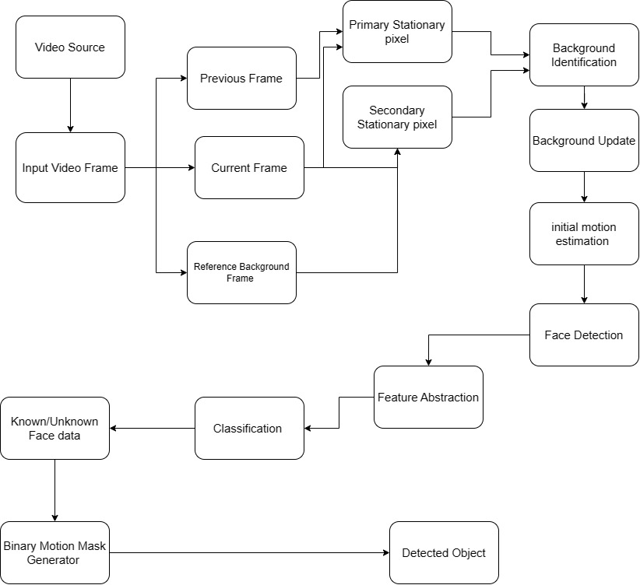

**Fig 4.1**

**4.2 UML Diagrams**

#### **4.2.1 Use case diagram**

#### 

Use Case during requirement elicitation and analysis to represent the functionality of the system. Use case describes a function by the system that yields a visible result for an actor. The identification of actors and use cases result in the definitions of the boundary of the system i.e., differentiating the tasks accomplished by the system and the tasks accomplished by its environment.

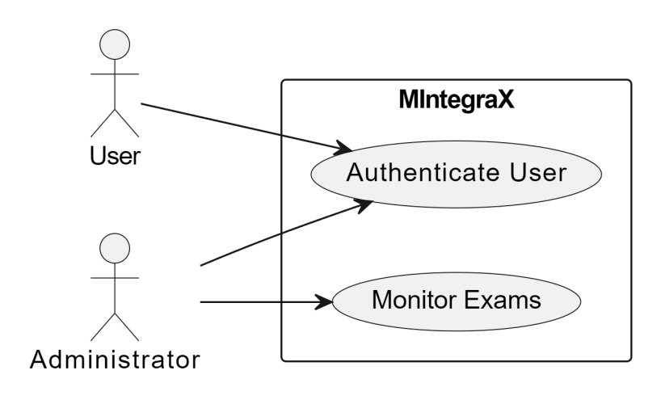

**Fig 4.2 (a)**

#### **4.2.2 Class Diagram**

#### 

Class diagrams model class structure and contents using design elements such as classes, packages and objects. Class diagram describe the different perspective when designing a system-conceptual, specification and implementation. Classes are composed of three things: name, attributes, and operations. Class diagram also display relationships such as containment, inheritance, association etc. The association relationship is most common relationship in a class diagram. The association shows the relationship between instances of classes.

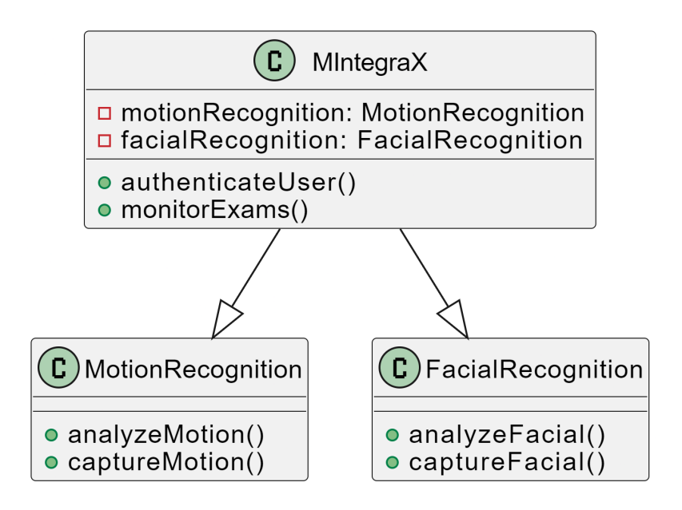

**Fig 4.2 (b)**

#### **4.2.3 Sequence Diagram**

#### 

Sequence diagram displays the time sequence of the objects participating in the interaction. This consists of the vertical dimension (time) and horizontal dimension (different objects).

Objects: An object can be thought of as an entity that exists at a specified time and has a definite value, as well as a holder of identity. A sequence diagram depicts item interactions in chronological order. It illustrates the scenario's objects and classes, as well as the sequence of messages sent between them in order to carry out the scenario's functionality. In the Logical View of the system under development, sequence diagrams are often related with use case realizations. Event diagrams and event scenarios are other names for sequence diagrams. A sequence diagram depicts multiple processes or things that exist simultaneously as parallel vertical lines (lifelines), and the messages passed between them as horizontal arrows, in the order in which they occur. This enables for the graphical specification of simple runtime scenarios.

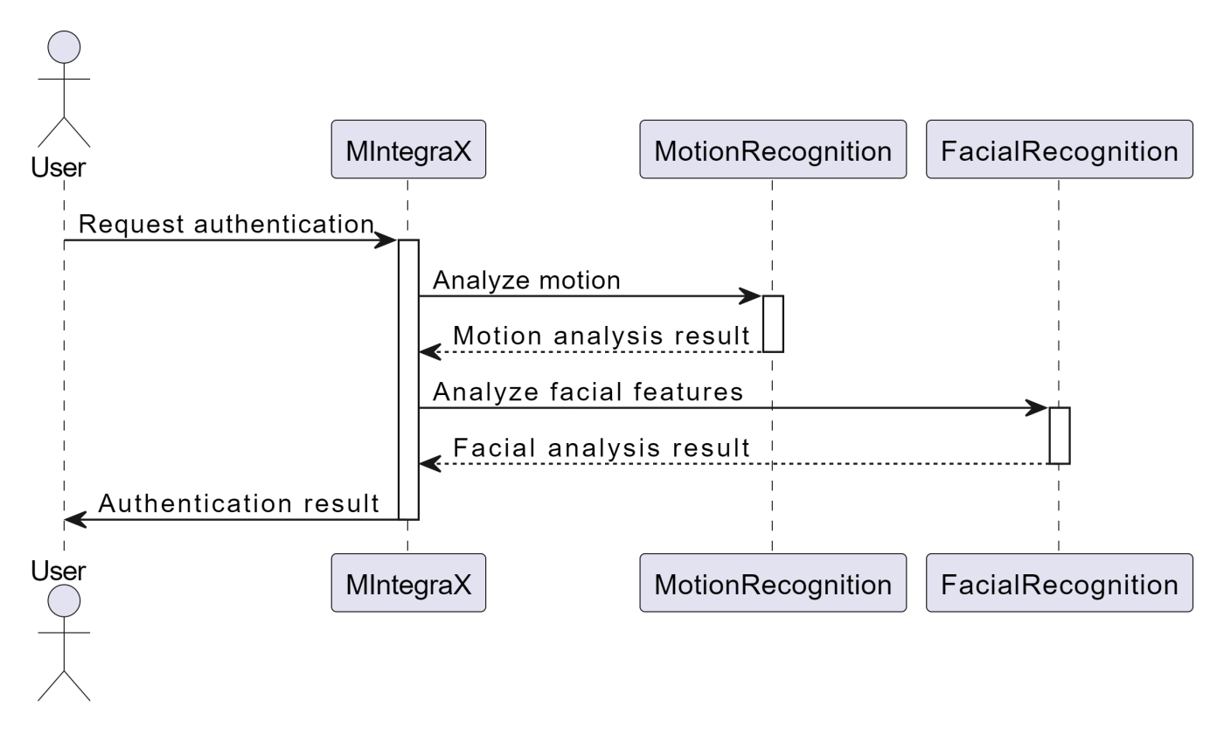

**Fig 4.2 (c)**

#### **4.2.4 Activity Diagram**

The process flows in the system are captured in the activity diagram. Similar to a state diagram, an activity diagram also consists of activities, actions, transitions, initial and final states, and guard conditions.

#### 

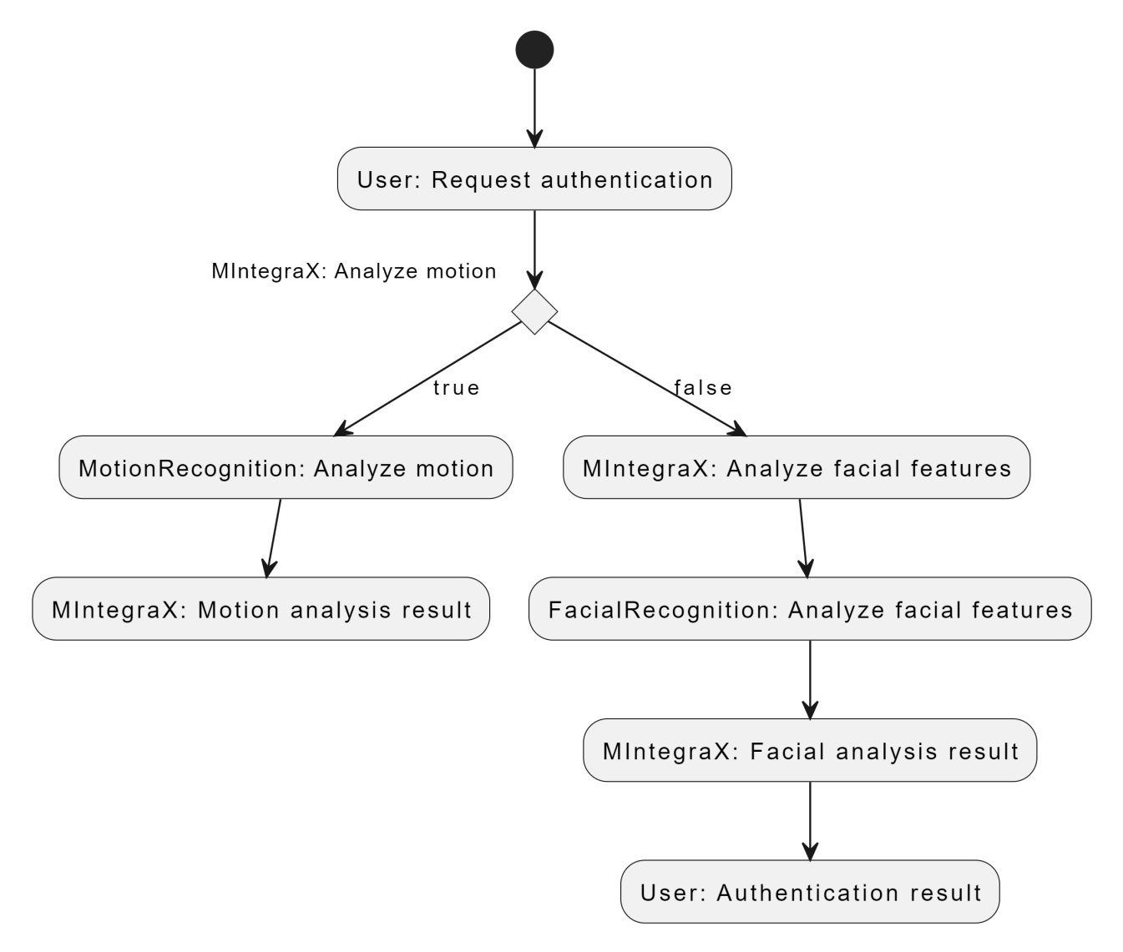

**Fig 4.2 (d)**

#### 

#### 

1. **IMPLEMENTATION**

**5.1: Code**

**Module-1:**

import cv2

import motion

import imutils

from face_recognition1 import recognize_faces

capture = cv2.VideoCapture(0)

capture.set(cv2.CAP_PROP_FRAME_HEIGHT, 720)

capture.set(cv2.CAP_PROP_FRAME_WIDTH, 1280)

motion_detected = False

prev_frame = None

global writer

while True:

ret, frame = capture.read()

if not ret:

break

frame = imutils.resize(frame, width=1280)

prev_frame = None

motion_detected = None

if motion.motion_detection(frame, prev_frame):

motion_detected = True

video_writer = cv2.VideoWriter_fourcc('m', 'p', '4', 'v')

writer1 = cv2.VideoWriter("recording.mp4", video_writer, 30.0, (1280, 720))

if motion_detected:

frame = recognize_faces(frame)

writer1.write(frame)

motion_release = False

cv2.imshow("MintegraX", frame)

prev_frame = frame.copy()

if cv2.waitKey(1) & 0xFF == ord("q"):

break

capture.release()

writer1.release()

cv2.destroyAllWindows()

#### **Module-2:**

import cv2

def motion_detection(frame, prev_frame):

motion_detected = None

gray_frame = cv2.cvtColor(frame, cv2.COLOR_BGR2GRAY)

gray_frame = cv2.GaussianBlur(gray_frame, (21, 21), 0)

if prev_frame is None:

prev_frame = gray_frame

diff_frame = cv2.absdiff(prev_frame, gray_frame)

threshold_frame = cv2.threshold(diff_frame, 50, 255, cv2.THRESH_BINARY)[1]

threshold_frame = cv2.dilate(threshold_frame, None, iterations=2)

contours, a1 = cv2.findContours(threshold_frame, cv2.RETR_EXTERNAL, cv2.CHAIN_APPROX_SIMPLE)

motion_detected = any(cv2.contourArea(cnt) < 500 for cnt in contours)

return motion_detected

#### **Module-3:**

import cv2

import face_recognition

def recognize_faces(frame):

rgb_frame = cv2.cvtColor(frame, cv2.COLOR_BGR2RGB)

face_locations = face_recognition.face_locations(rgb_frame)

for (top, right, bottom, left) in face_locations:

cv2.rectangle(frame, (left, top), (right, bottom), (0, 255, 0), 2)

return frame

**5.2: Output Screens:**

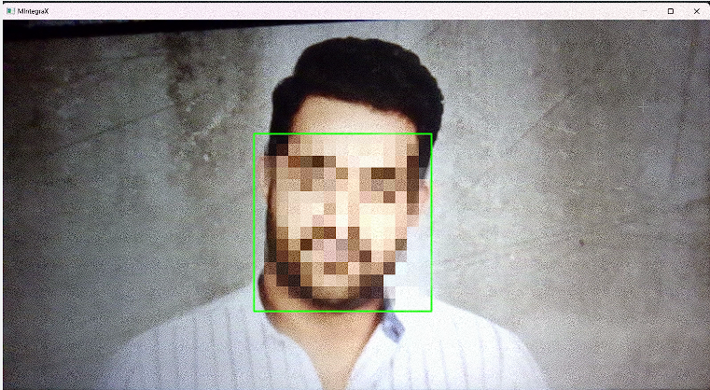

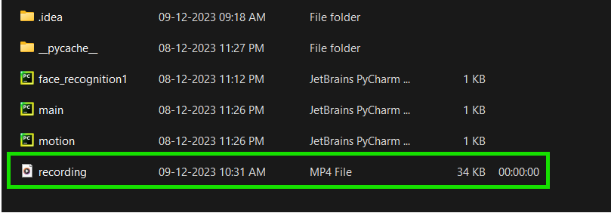

**6. CONCLUSION & FUTURE SCOPE:**

In conclusion, MintegraX stands at the forefront of innovation by seamlessly integrating motion and facial recognition technologies to address diverse challenges and enhance user experiences across various applications. The project's commitment to preventing cheating in online gaming through advanced recognition algorithms marks a significant stride in ensuring fairness and integrity. The multi-layered security approach for user authentication, combining facial and motion recognition, promises heightened precision and reliability.

Real-time surveillance solutions, achieved by fusing motion and facial recognition, not only contribute to secure environments but also hold potential applications in contexts like online proctoring. The introduction of intuitive interfaces for human-computer interaction reflects a dedication to user-friendly and engaging digital experiences.

Versatility is a defining feature, as MintegraX adapts seamlessly to different domains, showcasing its applicability in online gaming, user authentication, surveillance, and interactive interfaces. Rigorous testing across diverse scenarios underscores the system's robustness, and adaptive security measures position MintegraX to evolve proactively against dynamic cyber threats.

In essence, MintegraX emerges not merely as a project but as a comprehensive solution poised to redefine standards in security, authentication, and digital interaction. As technology continues to evolve, MintegraX paves the way for a more secure, intuitive, and integrated future across various domains and applications.

The future scope of MintegraX, with its integration of motion and face recognition technologies, holds immense potential for advancement and widespread adoption. The integration of MintegraX with Internet of Things (IoT) devices is foreseeable. Smart homes, for example, could leverage motion and face recognition for personalized automation, security, and user-specific device interactions. MintegraX may play a pivotal role in bolstering security measures beyond traditional access control.

## 7. BIBILOGRAPHY

[1] Jin-Chul Kim, Min-Hyun Kim, Han-Enul Suh, Muhammad Tahir Naseem and Chan-Su Lee, “Hybrid Approach for Facial Expression Recognition Using Convolutional Neural Networks and SVM,” April 2022.

<https://doi.org/10.3390/app12115493>

[2] Tejaswi Potluri, Venkatramaphanikumar S and Venkata Krishna Kishore K, “An automated online proctoring system using attentive-net to assess student mischievous behavior,” February 2023.

https://link.springer.com/article/10.1007/s11042-023-14604-w

## 