Documentation

1. Assignment/ 9. Task

28th March 2023

Kollipara Srihitha

F85A8I

[f85a8i@inf.elte.hu](mailto:f85a8i@inf.elte.hu)

Group 5

**Task**

*Implement the bag type which contains integers. Represent the bag as a sequence of (element, frequency) pairs. Implement as methods: inserting an element, removing an element, returning the frequency of an element, returning the most frequent element from the bag (suggestion: store the most frequent element and update it when the bag changes), printing the bag. Lecture code cannot be submitted.*

**Bag Type**

**Set of values**

Element = (Elem ∊ Z, Frequency ∊ N)

Bag(n) = {a ∊ | ∀ i ∊ [1..n] }

**Operations**

1. Inserting an element

Inserting an element at the $i^{th}$ index of the Bag.

Formally :

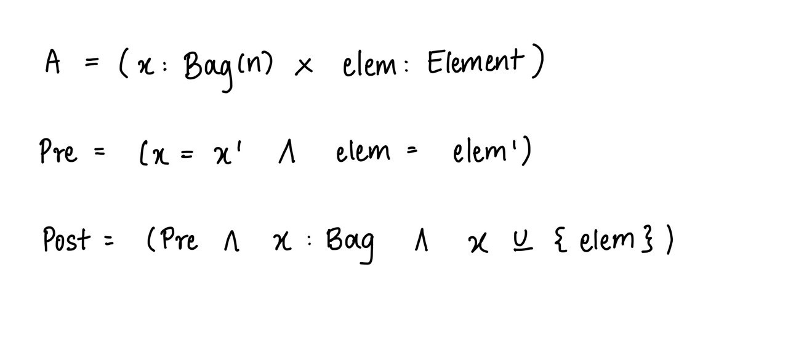

This operation needs any action only if the input was not an integer, otherwise, it outputs that the element was added to the bag.

2. Removing an element

Removing an element from the $i^{th}$ index of the Bag

Formally :

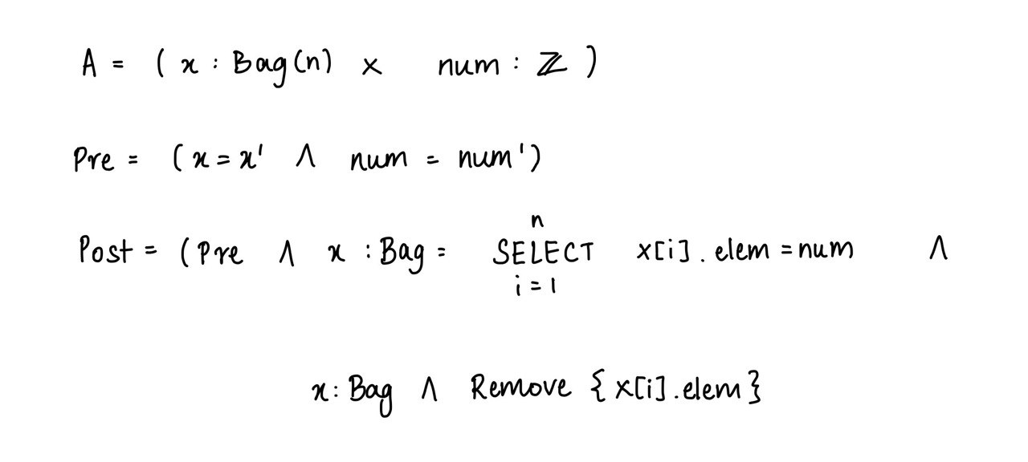

This operation needs any action if there are no elements in the bag or if the given input is not an element inside the bag.

3. Frequency of an element

Calculating the frequency of a number in the bag

Formally:

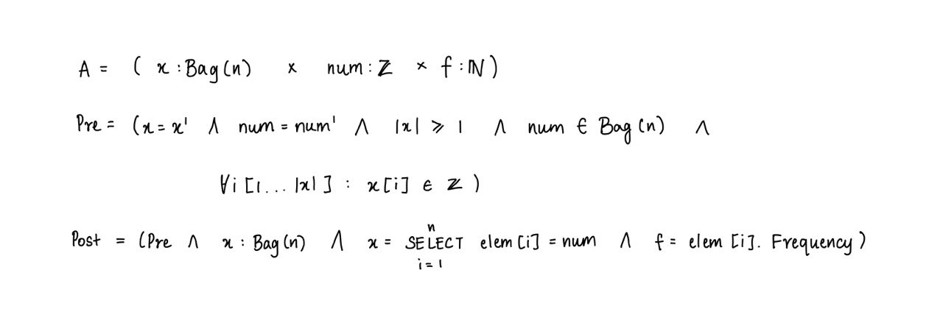

This operation needs any action if the number given is not present in the bag or if there are no elements in the bag otherwise it outputs the frequency.

4. Print

Printing the elements of the bag

Formally:

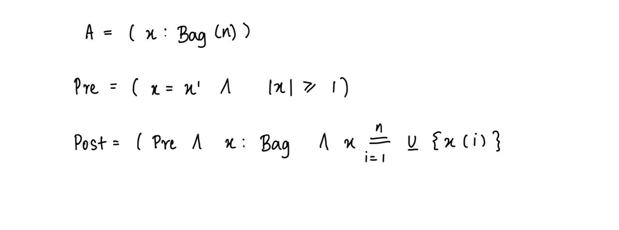

This operation needs any action if the bag is empty, otherwise, it prints the elements in the bag.

5. Elements that only occur once

Counting the number of elements from the bag that only have one occurrence

Formally:

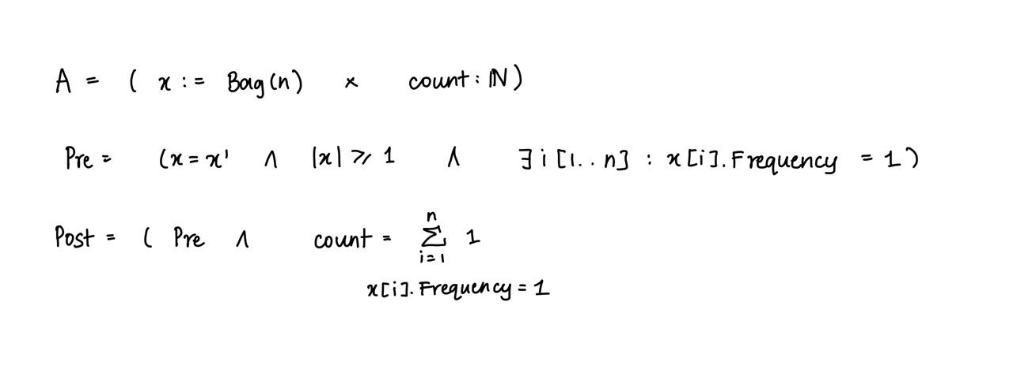

This operation needs any action if there are no elements with only one occurrence or no elements at all.

**Representation**

A Bag is a vector of elements.

x : Bag() = < e1, e2, e3, e4 ….>

e1, e2, … are of class Element.

Element = (elem, Frequency)

**Implementation**

1. Inserting an element

Adding an element to the list. If the list already contains the number entered then the frequency of it will be increased by 1. The bag is represented by x, and n stands for the length of the Bag. The element inserted into the bag is represented by e.

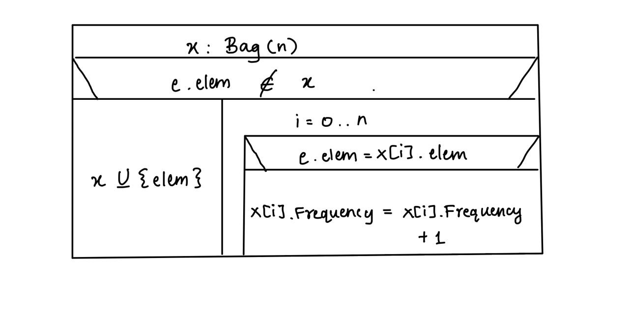

2. Removing an element

Removing an element from the bag. Taking in an integer num as input and checking if it equals any element in the bag, then removing it from the bag. If the frequency of that element is more than one then decrease the frequency by 1. The function is implemented by,

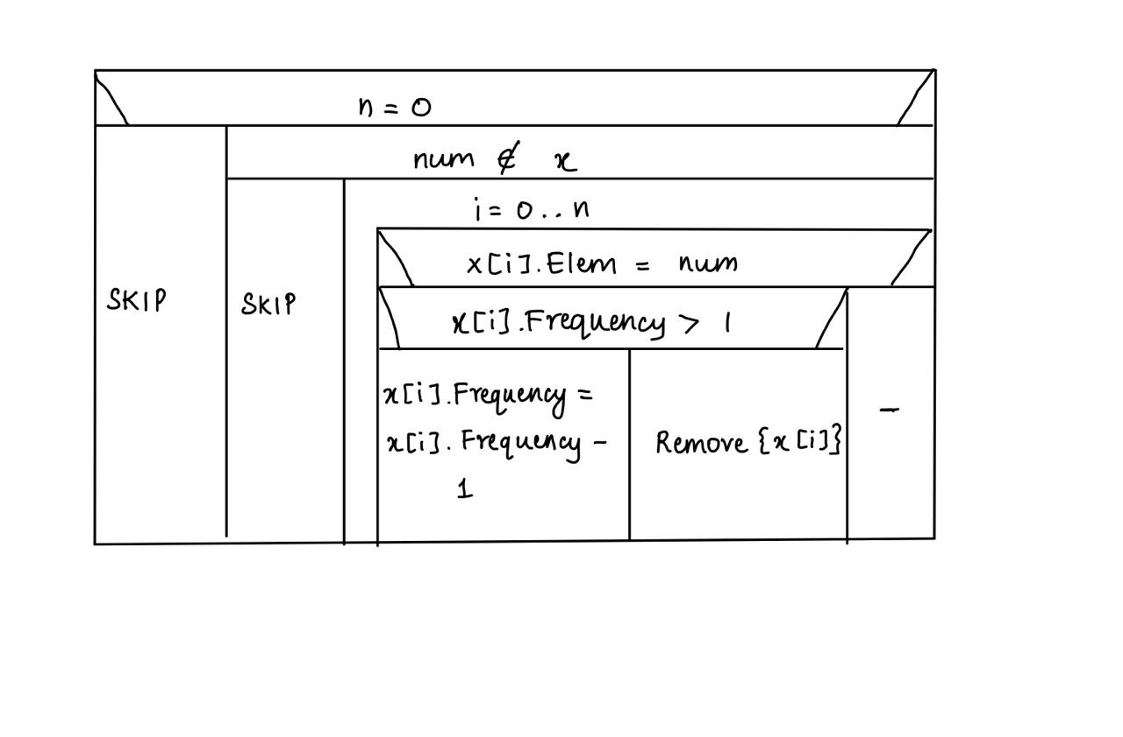

3. Frequency of an element

Taking in integer num as input, and then checking if it equals any element from the bag and returning the frequency of that element. It is implemented by,

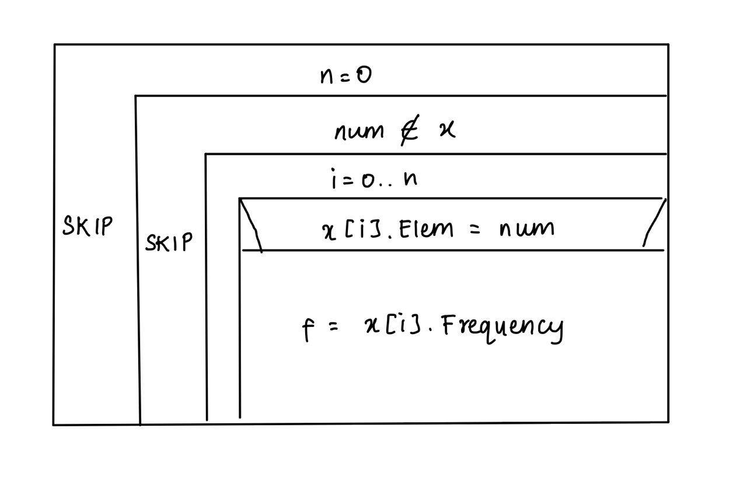

4. Printing the bag

Printing all the elements present in the bag.

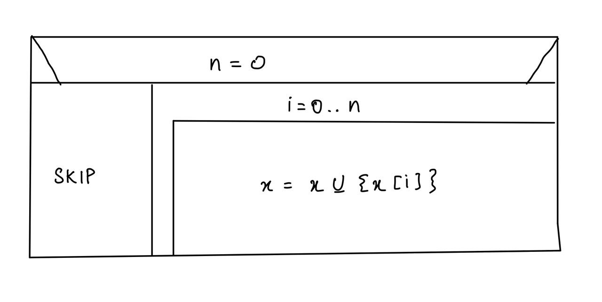

5. Counting number of elements that occur once

Checking the frequency if all the elements in the bag, if it equals one the printing that element

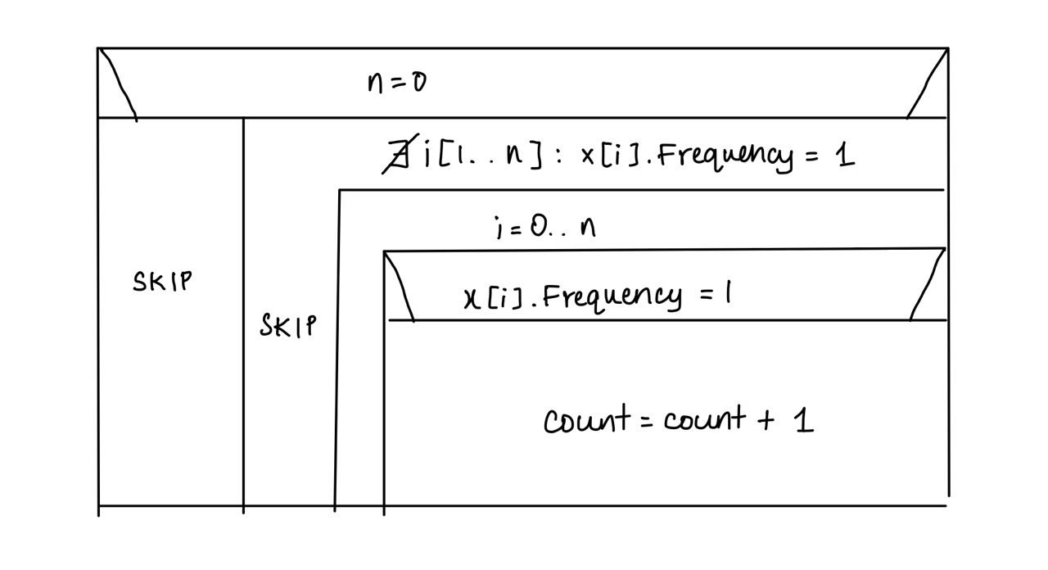

**Testing**

Testing the operations

1. Inserting an element

1. Wrong input, trying to insert a string

2. Removing an element

1. Removing an element from an empty bag
2. Removing an element that doesn’t exist in the bag
3. Adding elements into the bag and trying to remove them

3. Frequency of an element

1. Getting frequency from an empty bag
2. Getting frequency of an element that doesn’t exist in the bag
3. Inserting elements into the bag and checking if it outputs the correct frequency

4. Printing the bag

1. Printing an empty bag

5. Counting elements with one occurrence

1. Counting from an empty bag
2. Counting when there are no elements with one occurrence in the bag
3. Inserting elements into the bag and checking if the output is correct