A
Project Report On

“UnicomTIC Management System”
Miss.S.Srikopiya.
UT010115

Guidance of Mr.Kathir
Date: 24.06.2025

Table of Contents
• Introduction
• Acknowledgement
• Current system
• Problem definition
• Customer requirements
• Technology used and feasibility studies • Project schedule
• ER diagram
• Code screen shot and explanation
• References
• Conclusion

Introduction
The UnicomTIC Management System is a desktop-based application developed using C# (Windows Forms) and SQLite to streamline academic and administrative tasks within an educational institution. The system is designed to support role-based access for different users such as administrator, students, lecturers and staff allowing them to access only the features relevant to their specific roles.
This project aims to improve efficiency in handling student records, exam mark entries, timetable management, and subject/course allocation. By automating these processes, the system reduces manual errors, improves data accuracy, and saves time. The userfriendly interface ensures that all users can interact with the system easily without requiring advanced technical skills.
The application is built following object-oriented programming principles and adopts a modular architecture using the MVC (Model-View-Controller) design pattern. This structure ensures better code organization, scalability, and ease maintenance, making the system suitable for real-world deployment in academic environments.

Acknowledgement
I owe a great many thanks to a great many people who helped and supported me, during the Making of this Project.
Firstly, I am truly grateful to my project supervisor, Mr. Kathir, for his constant support, clear instructions, and valuable feedback throughout the development of this system. His guidance helped me understand both theoretical and practical aspects of software development, and his encouragement kept me motivated at every stage. I also extend my appreciation to the administrative staff and lab instructors for providing the necessary resources, infrastructure, and learning environment that played a crucial role in the success of this project.
Special thanks go to my classmates and friends for their input and support during testing and brainstorming phases. Lastly, I am deeply thankful to my family for their unwavering support, patience, and encouragement during the entire duration of this project. I would also thank the Institution and the faculty members without whom this project would have been a distant reality. I also extend my heartfelt thanks to well-wishers
Current System
Currently, many educational institutions manage student, staff, and academic information manually using tools such as paper records, Excel spreadsheets, or disconnected software systems. These traditional methods are often time-consuming, error-prone, and inefficient.
For instance, exam results are recorded manually, timetables are shared through printed notices or informal channels, and student details are maintained in scattered files. This leads to several issues.
Students often face challenges in checking their marks, attendance, or class schedules without approaching administrative staff directly. Likewise, lecturers and administrative personnel spend excessive time managing routine academic tasks, which affects productivity.
This project was undertaken to address these challenges and introduce an efficient, centralized, and user-friendly system that digitizes and simplifies academic operations. So, I aimed to build a system that reduces manual effort and enhances the overall academic management process.

Problem Definition

Most educational institutions still use manual methods or spreadsheets to manage students, staff, exams, and timetables. This leads to:
• Data entry errors
• Delays in accessing information
• No role-based access control
• Difficulty for students to view marks or timetables
• Poor data security
To solve these issues, an automated system is needed that offers secure, role-based access, faster data handling, and easy access to academic information.

The UnicomTIC Management System is designed to meet this need efficiently.

Customer Requirements
To ensure the UnicomTIC Management System effectively serves its users, the following requirements were identified:
- Functional Requirements
▪ Secure Login & Role Assignment
• Each user (Admin, Lecturer, Staff, Student) must log in using a username and password.
• Users are granted access based on their assigned roles.
▪ Customized Dashboards
• Admin: Full access to manage users, subjects, courses, marks, exams, timetables, and rooms.
• Lecturer: Can view and manage only their assigned subjects and class schedules.
• Staff: Access to specific administrative data relevant to their duties.
• Student: Limited access to their own marks, room allocation and timetable.

▪ Data Management Features
• Ability to add, update, delete, and view information for:
• Students, Staff, Lecturers
• Courses and Subjects
• Exam Marks and Timetables
• Staff and Lecturer profiles include essential fields like name, role, ID, and contact info.
• Restricted Access Views
• Students and Lecturers can only view (not edit) academic data assigned to them.

- Non-Functional Requirements
▪ Security
• Role-based access control to protect data and prevent unauthorized actions.
▪ System Performance
• The system should respond quickly and perform smoothly even when multiple users are logged in simultaneously.
Technology Used
Components | Technology
Language | C#
Framework | .NET(WinForms)
Database | SQLite
Architecture | MVC(Model View Controller)
Tools | Visual Studio, DB for SQLite

Feasibility Study

- Technical Feasibility
• Developed using C# (WinForms) and SQLite.
• Tools are easy to use, available, and wellsupported.
• Suitable for building desktop-based applications.

- Economic Feasibility
• No extra cost for software or tools.
• Uses free/open-source platforms.
• Affordable for academic project needs.
- Operational Feasibility
• Simple and user-friendly interface.
• Role-based access makes it easy to use for all users.
• Requires minimal training for students and staff. 4. Schedule Feasibility
• Project completed within the academic timeframe.
• All modules were delivered as per planned schedule.
•Time management was effective throughout development.

Project Schedule
The development of the UnicomTIC Management System was planned and completed in the following stages:
- Requirement Analysis
• Duration: 4-5 days
• Activities: Understanding user needs, defining system features, and identifying key modules.

- System Design
• Duration: 1 Day
•Activities: Designing database structure, UI layout, and module flow using the MVC model.

- Development
• Duration: 2–3 Weeks
▪ Activities:
• Coding login and user roles
• Implementing student, lecturer, course, subject, and timetable modules
• Database connection and CRUD operations
- Testing
• Duration: 5 Days
• Activities: Debugging, validating inputs, fixing issues, and improving user experience.
5. Final Report
• Duration: 3 Days
•Activities: Preparing documentation, screenshots, viva questions

ER Diagram (Text Version)
Entities and Attributes
• User
▪ UserID (PK)
▪ UserName
▪ Password
▪ Role
• Student
▪ StudentID (PK)
▪ StudentName
▪ StudentAddress
▪ StudentStream

• Staff
▪ StaffID (PK)
▪ StaffName
▪ StaffAddress
▪ StaffEmail

• Course
▪ CourseID (PK)
▪ CourseName
▪ StartDate
▪ EndDate
• Lecture
▪ LectureID (PK)
▪ LectureName
▪ Address
• Exam
▪ ExamID (PK)
▪ ExamName
▪ SubjectID (FK)
• Room
▪ RoomID (PK)
▪ RoomName
▪ RoomType
• Marks
▪ SubjectID(PK)+ExamID (PK)
▪ StudentID (FK)
▪ ExamType (FK)
▪ MarkObtained
• Timetable
▪ TimetableID (PK)
▪ SubjectID (FK)
▪ RoomID (FK)
▪ Timeslot
• Subject
▪ SubjectID (PK)
▪ SubjectName
▪ CourseID (FK)

Code Screenshots and Explanation
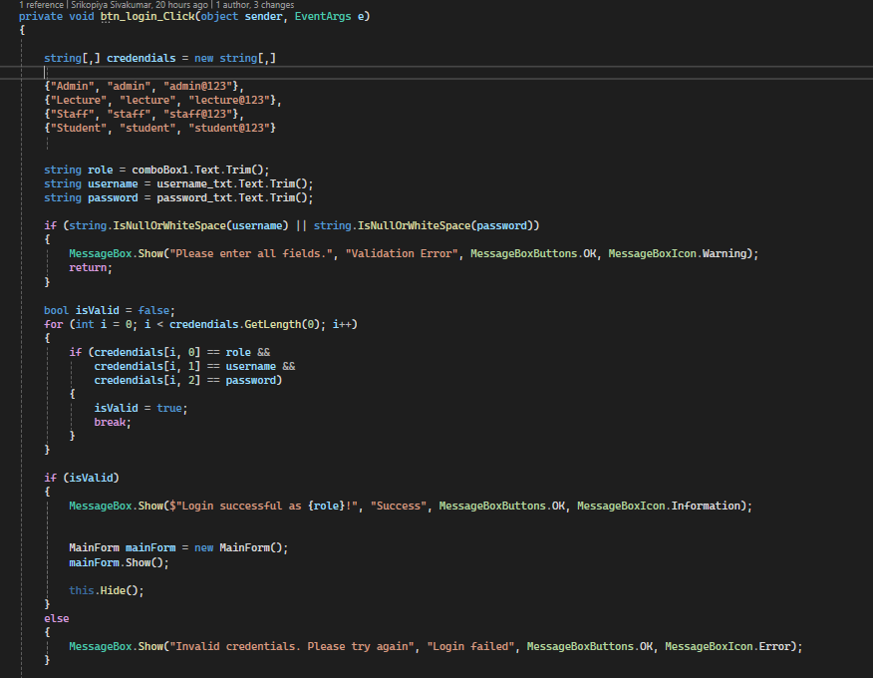
• Login Form.cs

Role Selection: Users choose their role from a dropdown (comboBox_role).
Input Validation: Ensures the username and password are not empty.
Error Handling: Displays messages for invalid credentials or login failed attempts.

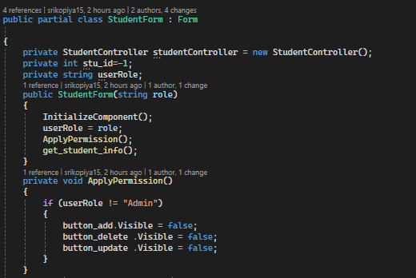
- Student Form.cs

Specific visible :
In this form, role-based access is implemented. If the logged-in user’s role is not "Admin", then the Add, Delete, and Update buttons are hidden using the ApplyPermission() method.
This ensures students can only view data, not modify it. The role is passed through the constructor and stored in userRole.
So, the students can only view all the details because of this.

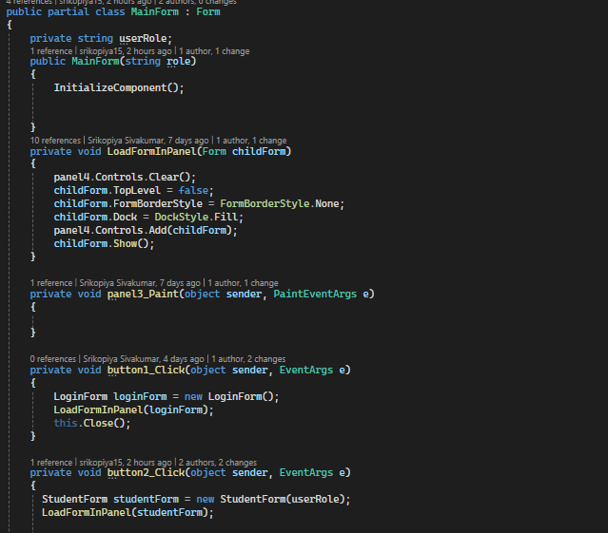
- Main Form.cs
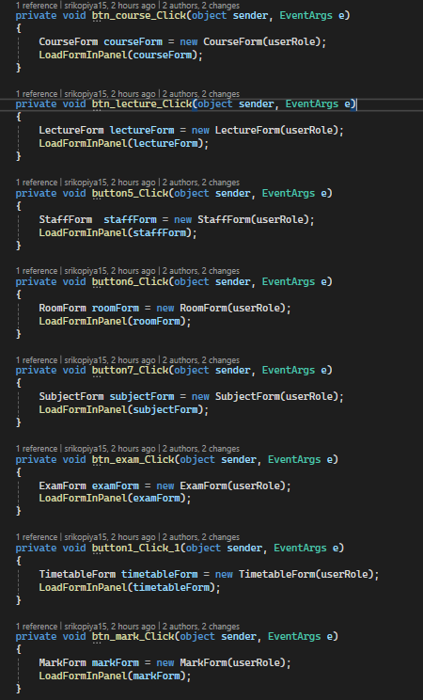

Default View: When the form loads, the (MainForm) is displayed in the (mainPanel) by default. Dynamic Form Loading:
• The (LoadForm) method removes any existing content in the (mainPanel) and embeds a specified form.
• Ensures only one form is displayed at a time.
Button Actions: Each button corresponds to a specific management task:
• Manage Students: Loads (StudentForm) for managing student data.
• Manage Lectures: Loads (LectureForm) for managing lecture information.
• Manage Courses: Loads (CourseForm) for managing course details.
• Similar actions for Timetables, Exams, Marks, Rooms, Subjects, and Staff.
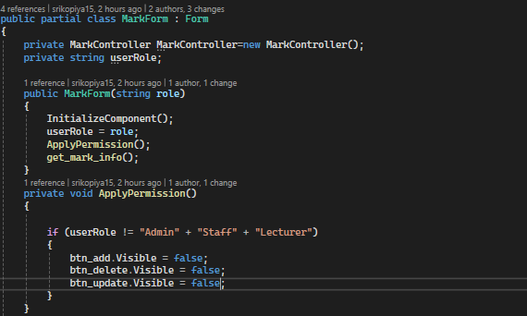
- Mark Form.cs

Visibility: This code in MarkForm.cs controls which roles can edit marks.
In the ApplyPermission() method, if the user role is not Admin, Staff, or Lecturer, then the Add, Delete, and Update buttons will be hidden.
Also Exam Form.cs.
So, for example, a Student can only view the marks, not modify them.

Conclusion
The UnicomTic Management System effectively addresses the challenges faced by educational institutions in managing academic operations such as session scheduling, lecture and lab hall allocation, and subject management. By digitizing these processes, the system reduces manual effort, minimizes human errors, and ensures data consistency across departments.
Built using C# with a WinForms interface and SQLite as the backend, the system offers a userfriendly platform that allows Admins, Lecturers, and Students to access and manage relevant information according to their roles. The modular design and role-based access control improve both usability and security.
Through this project, we demonstrated how automation can improve the efficiency and transparency of university academic planning. The system is scalable and can be enhanced in the future with additional features like attendance analytics, notification systems, and mobile app integration, making it a comprehensive solution for university management needs.

