As extension work i added concept to take user directly to browse given interested page.

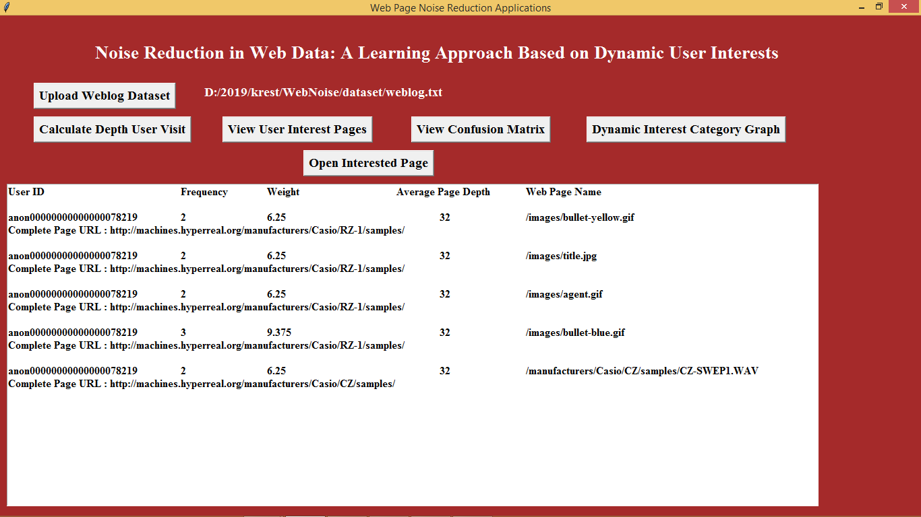

From above screen copy complete URL and then click on ‘Open Interested Page’ and paste copied URL in the dialog box to open that web page

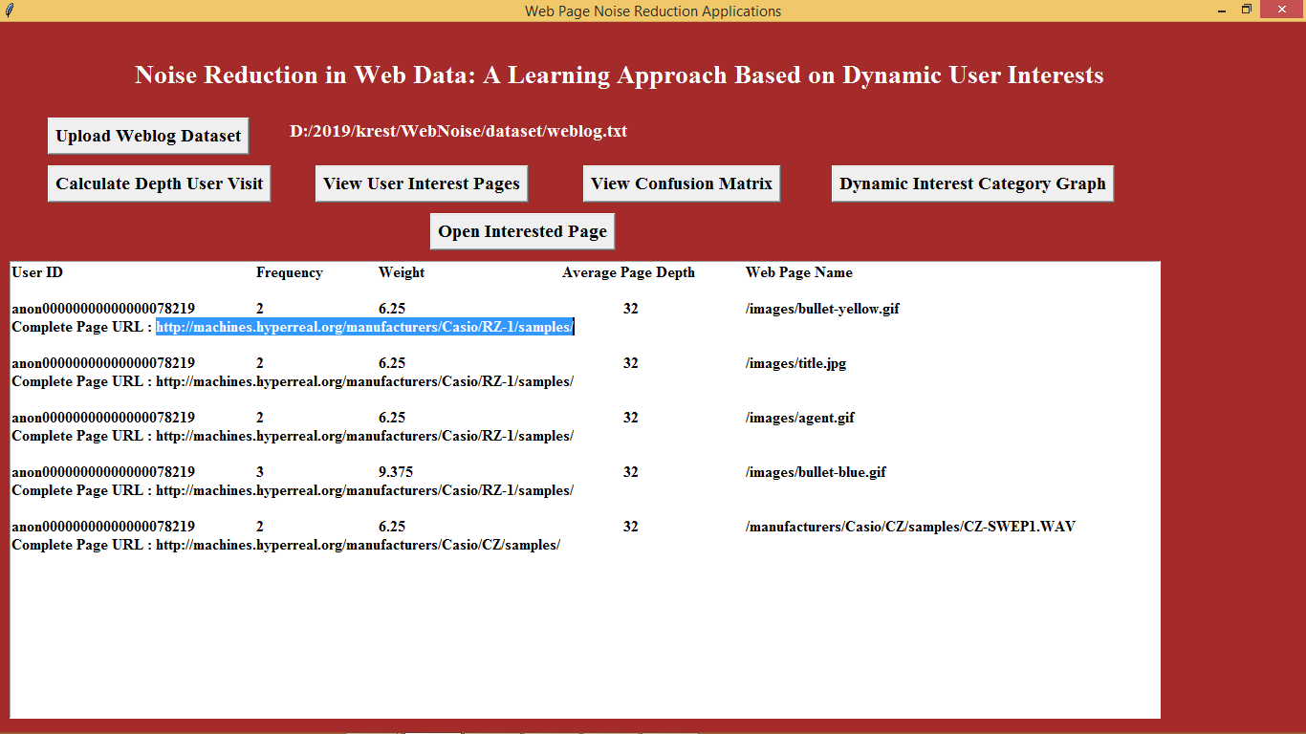

In above screen i copied complete URL of interested page and then click on ‘Open Interested Page’

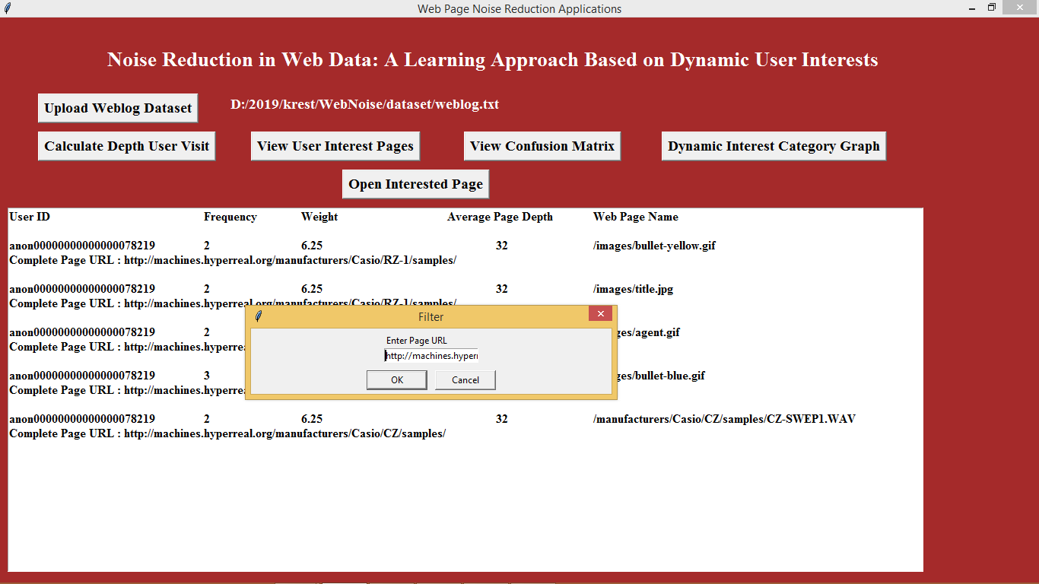

In above screen paste copied URL to dialog box and click ok to open that page in browser like below screen

