• **Set up an Amazon S3 Bucket**:

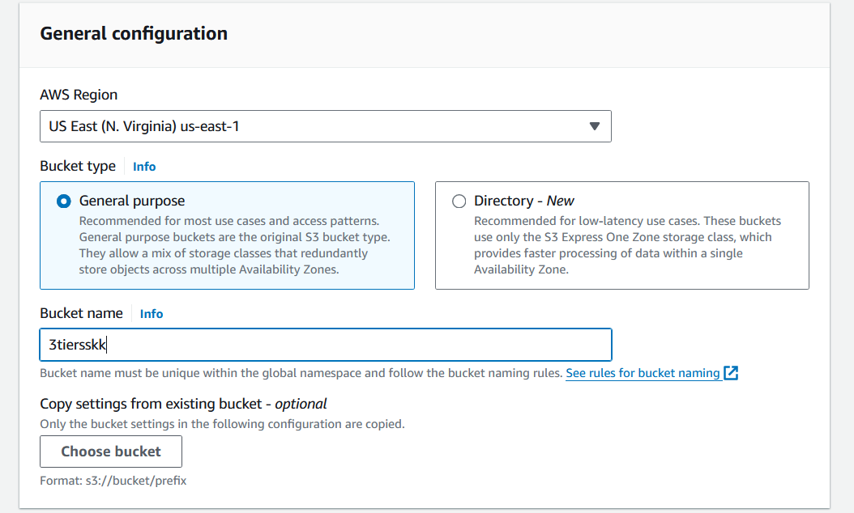

• **Enable Static Website Hosting**:

* Select your S3 bucket and navigate to the "Properties" tab.
* Click on "Static website hosting" and choose "Use this bucket to host a website".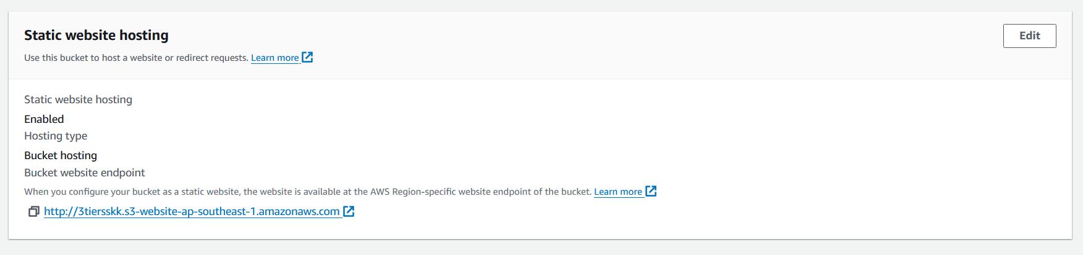
* Enter the index document and error document names (e.g., index.html and error.html). 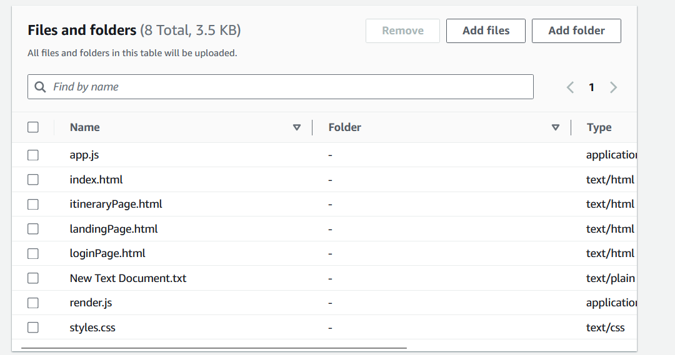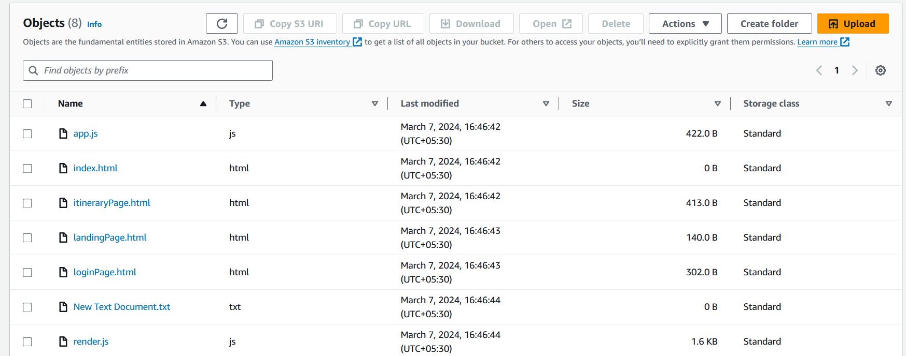
* Note down the endpoint URL provided (e.g., http://your-bucket-name.s3-website-your-region.amazonaws.com). http://3tiersskk.s3-website-ap-southeast-1.amazonaws.com

• **Configure CORS (Cross-Origin Resource Sharing)**:

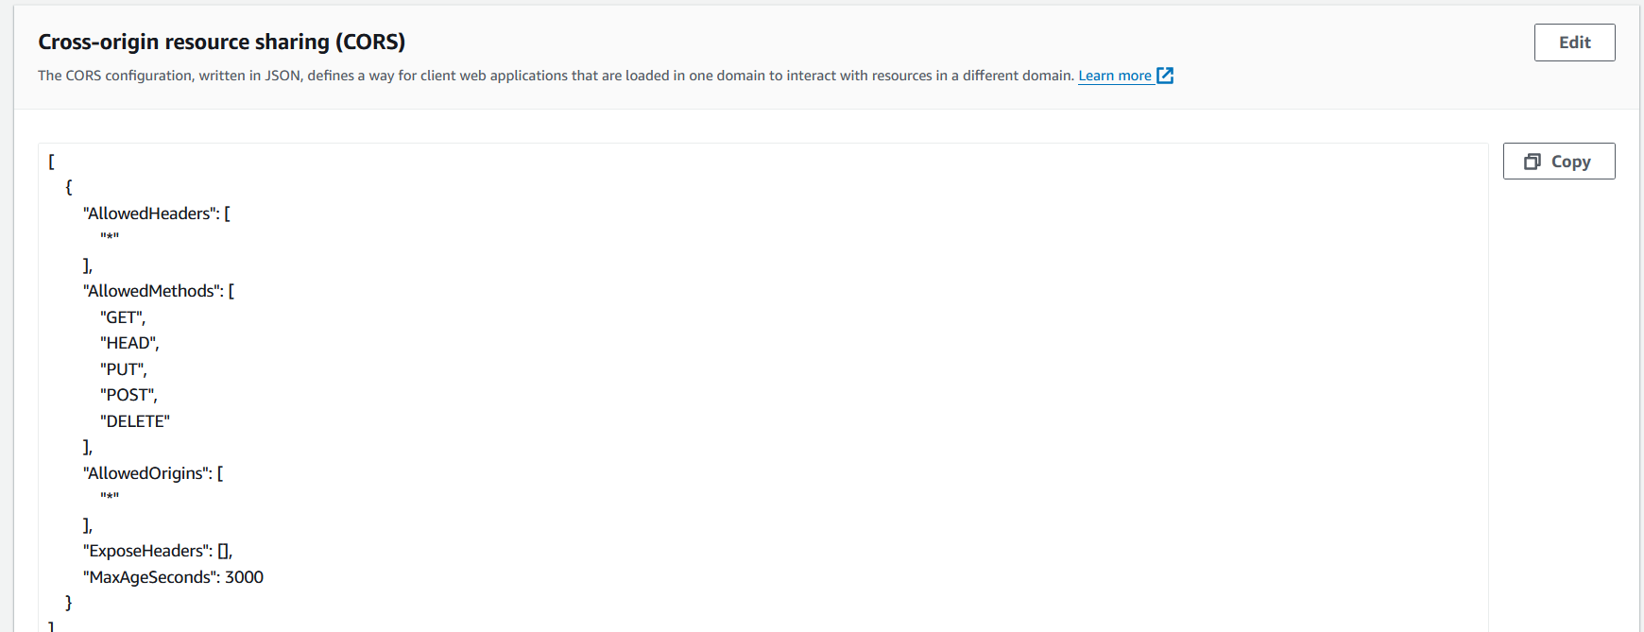

* In the "Permissions" tab of your S3 bucket, click on "CORS configuration".
* Add the following CORS configuration to allow your website to interact with AWS Amplify:

• **Set up AWS Cognito**:

* Navigate to the AWS Cognito service in the AWS Management Console.

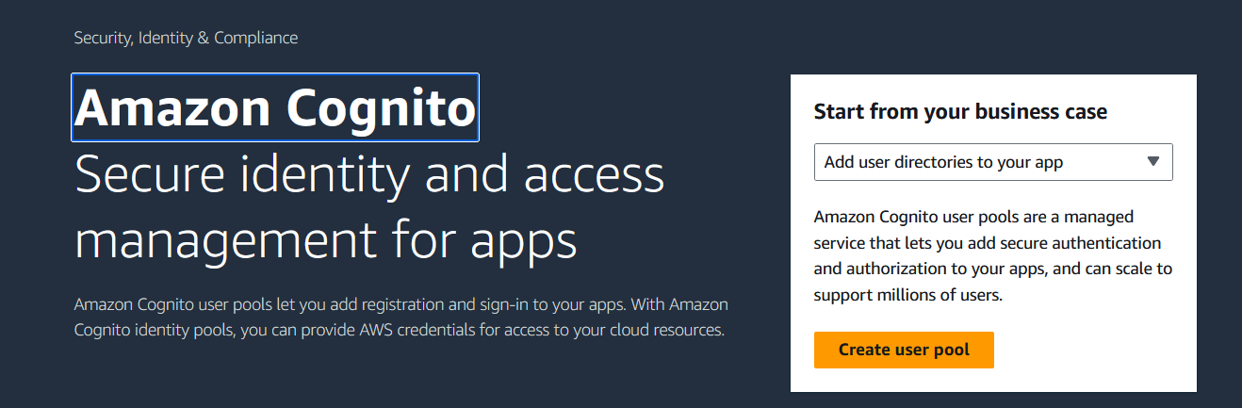

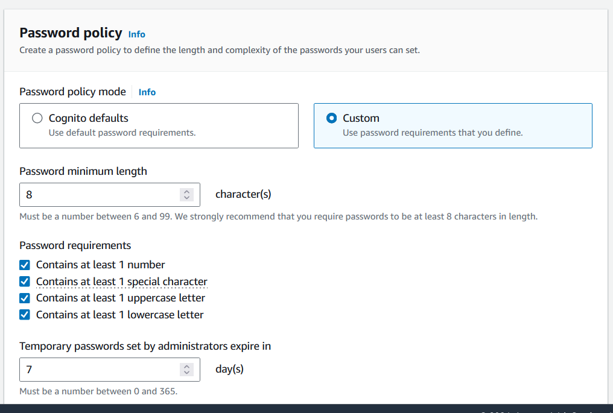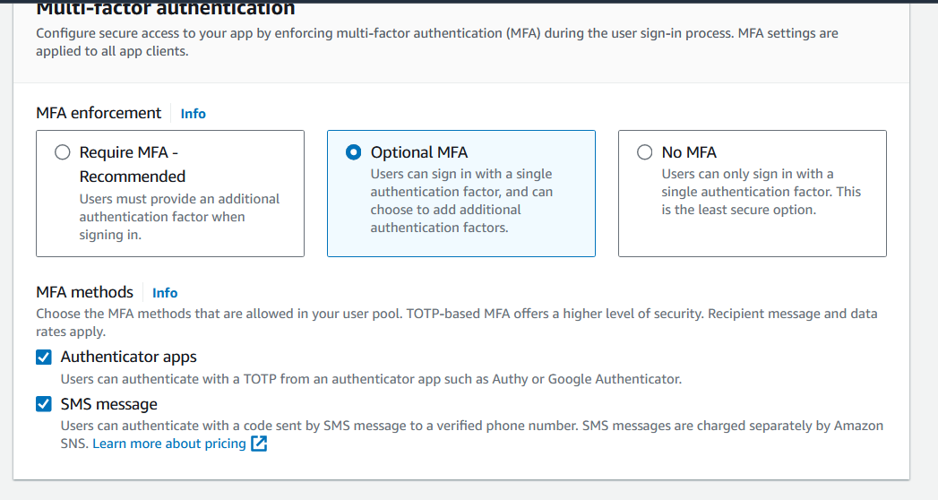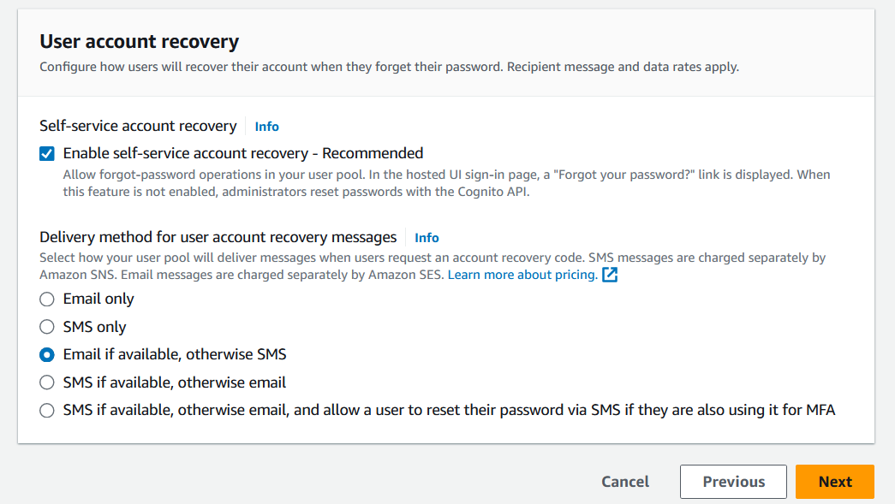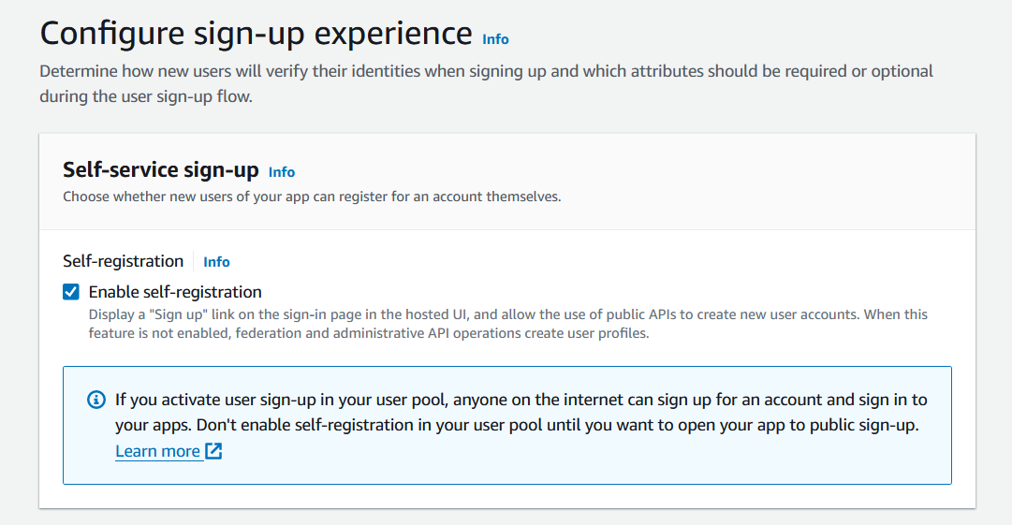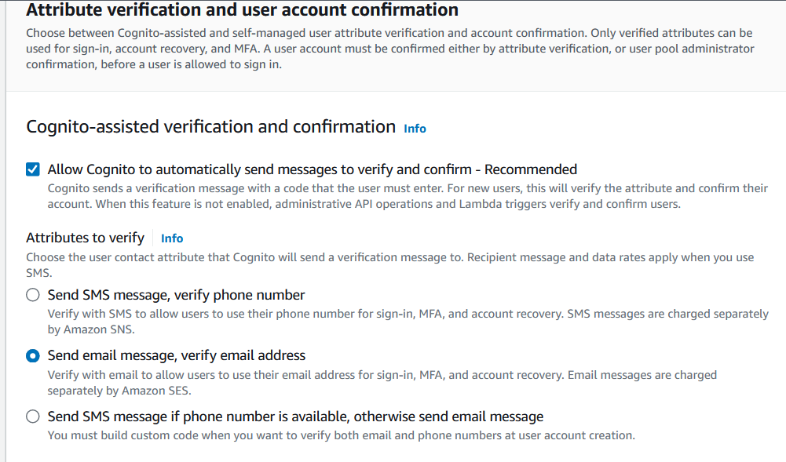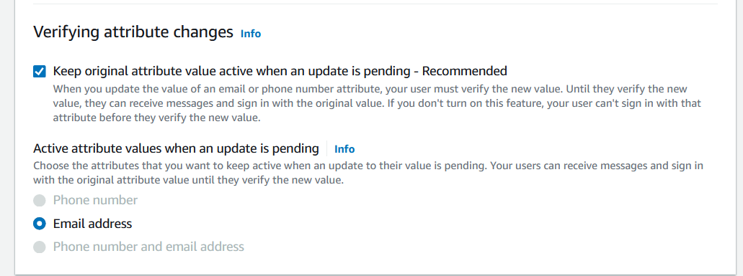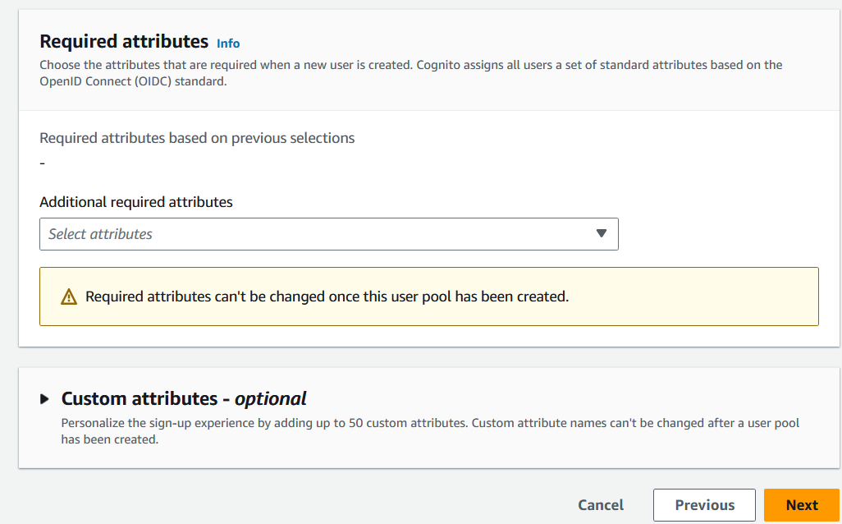

* Create a user pool to manage your user identities and authentication.
* Configure your user pool settings, including attributes, policies, and MFA (Multi-Factor Authentication) if needed.
* Note down your user pool ID and app client ID.

• **Configure AWS Amplify**:

* Install AWS Amplify in your project if you haven't already done so:

bash

npm install aws-amplify

* Configure AWS Amplify in your JavaScript code with your AWS Cognito settings and S3 bucket endpoint: