**Create separate directories** for each game, e.g., rock-paper-scissors and hangman.

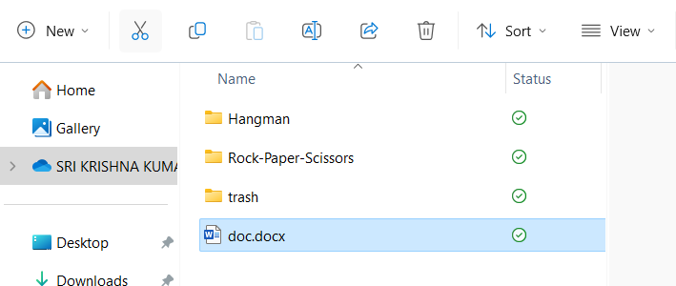

project/

│

├── rock-paper-scissors/

│ ├── Dockerfile

│ ├── index.html

│ ├── script.js

│ └── styles.css

│

├── hangman/

│ ├── Dockerfile

│ ├── index.html

│ ├── script.js

│ └── styles.css

│

└── docker-compose.yml

**Write Dockerfiles** for each game to define the environment and dependencies needed to run the game.

**rock-paper-scissors/Dockerfile:**

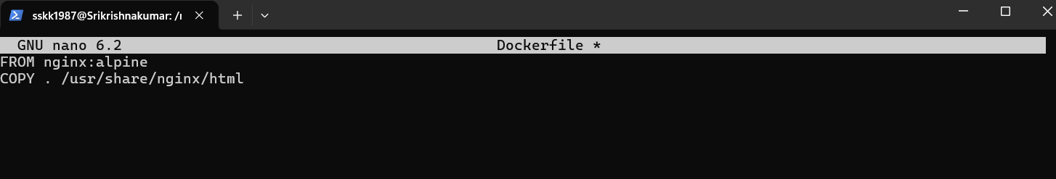 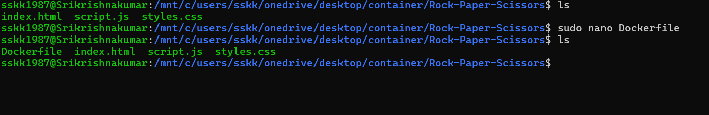

**hangman/Dockerfile:**

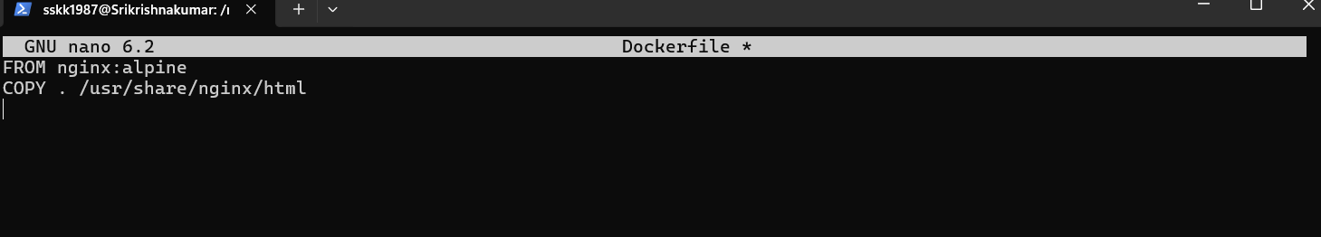

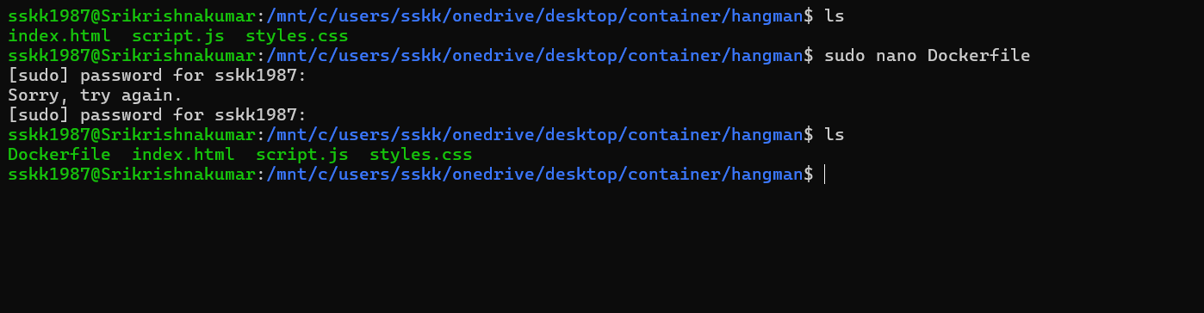

**Build Docker images** from the Dockerfiles.

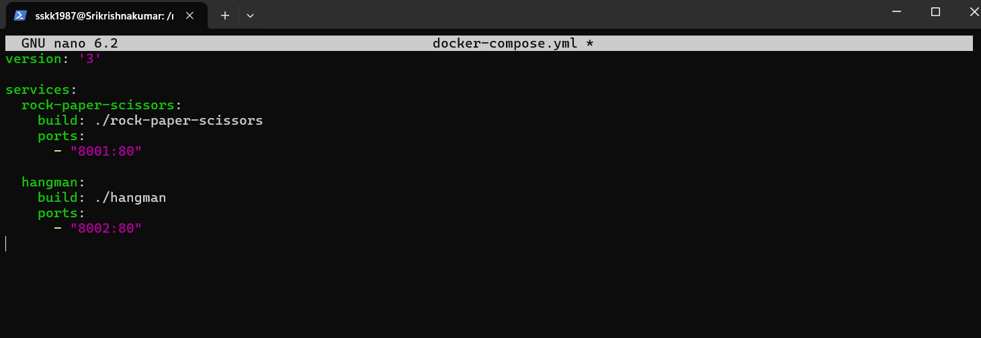 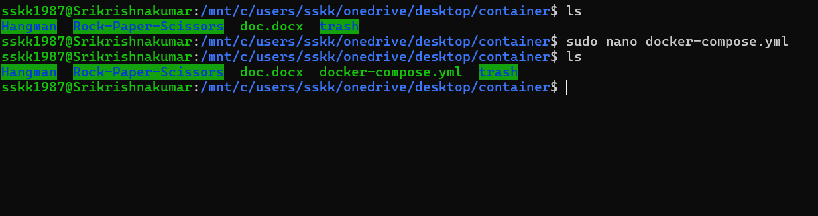 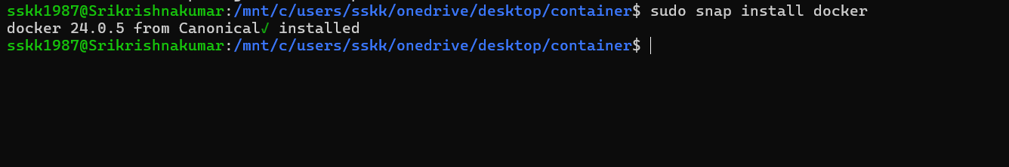

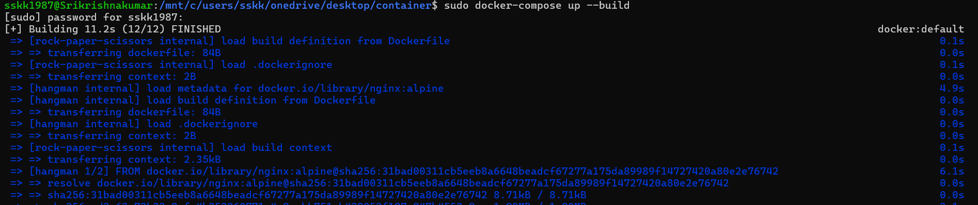

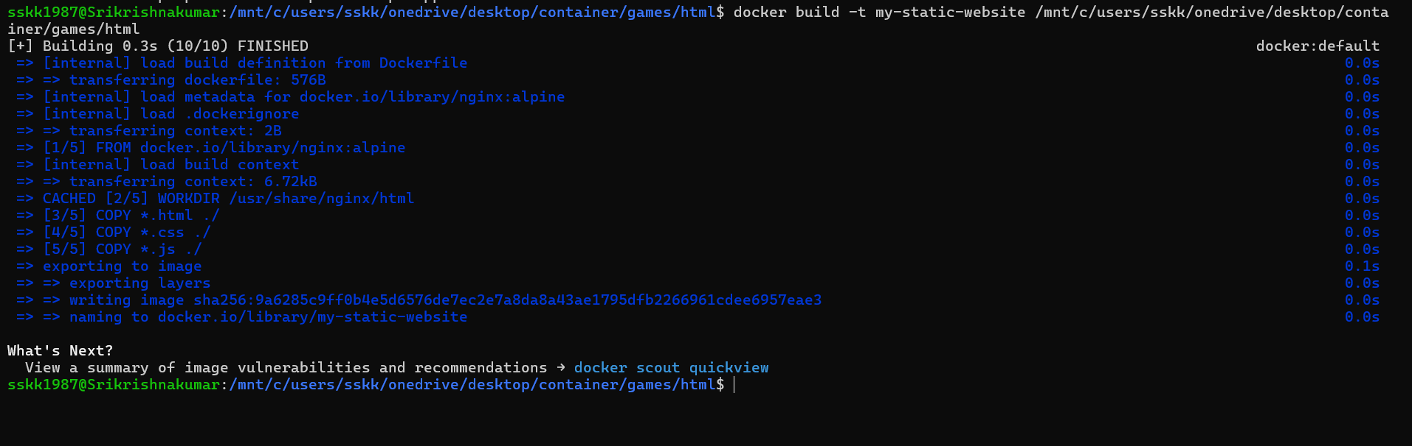

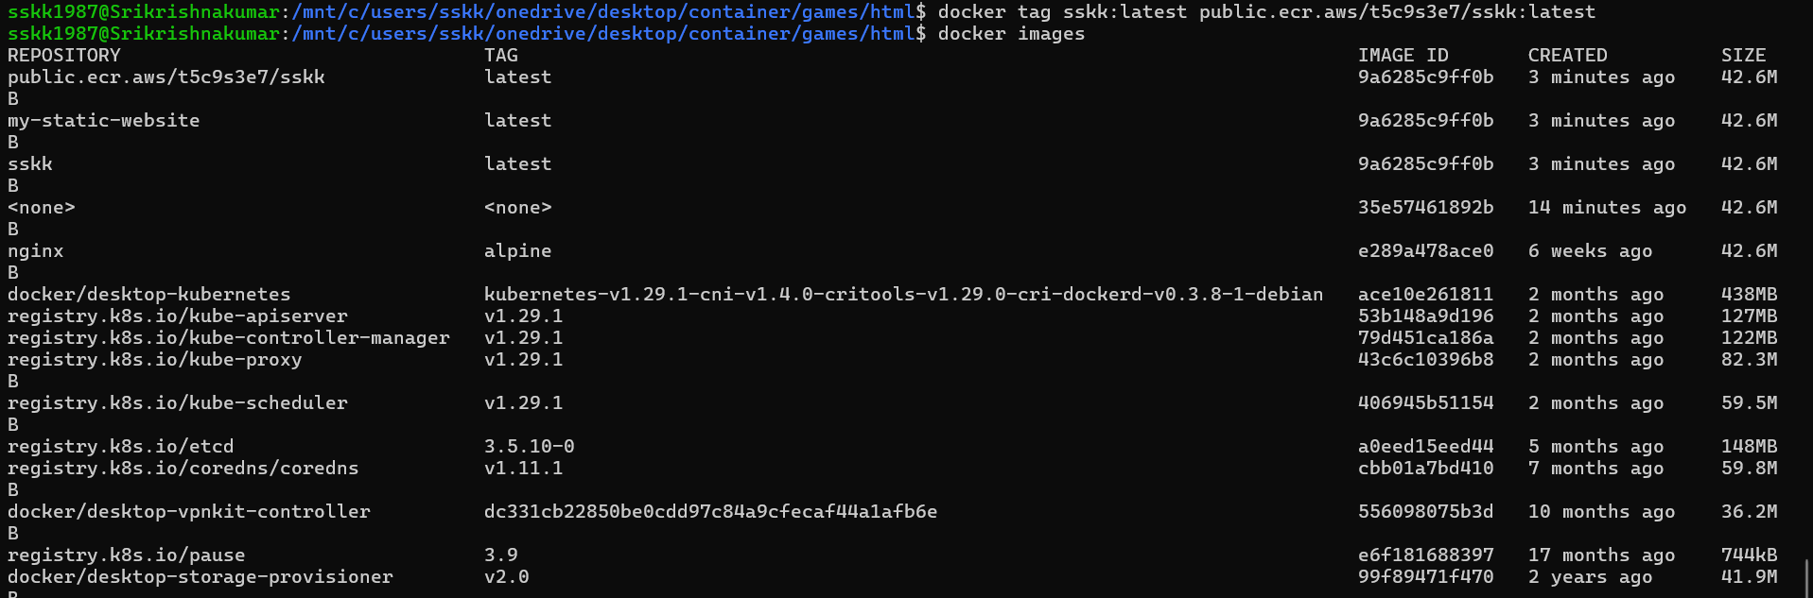

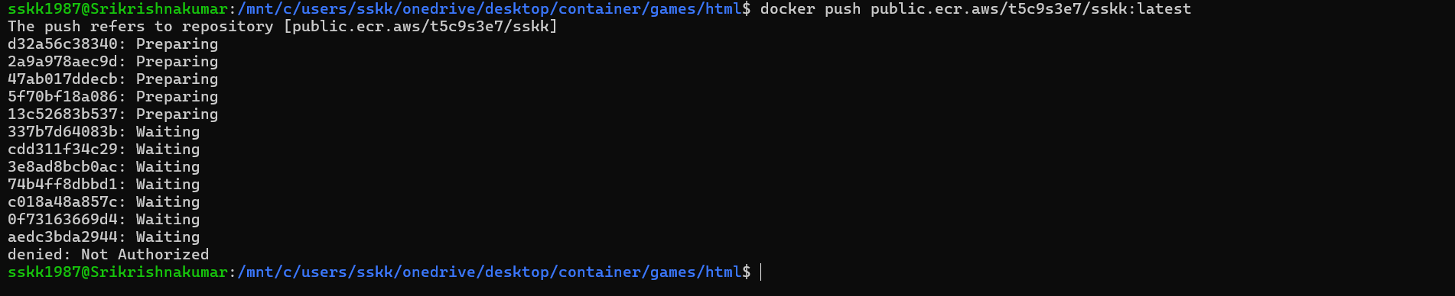

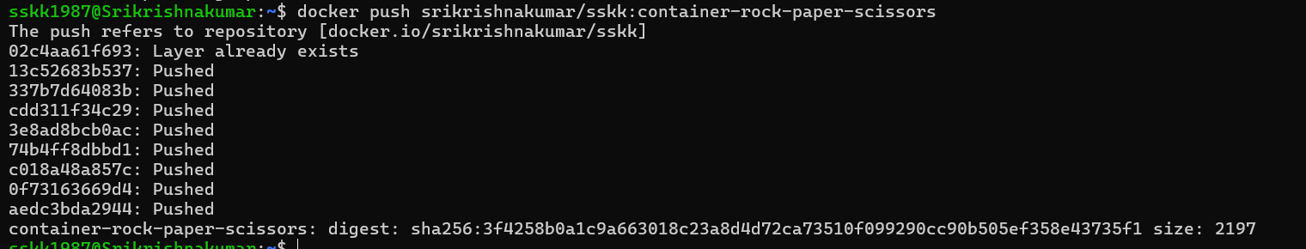

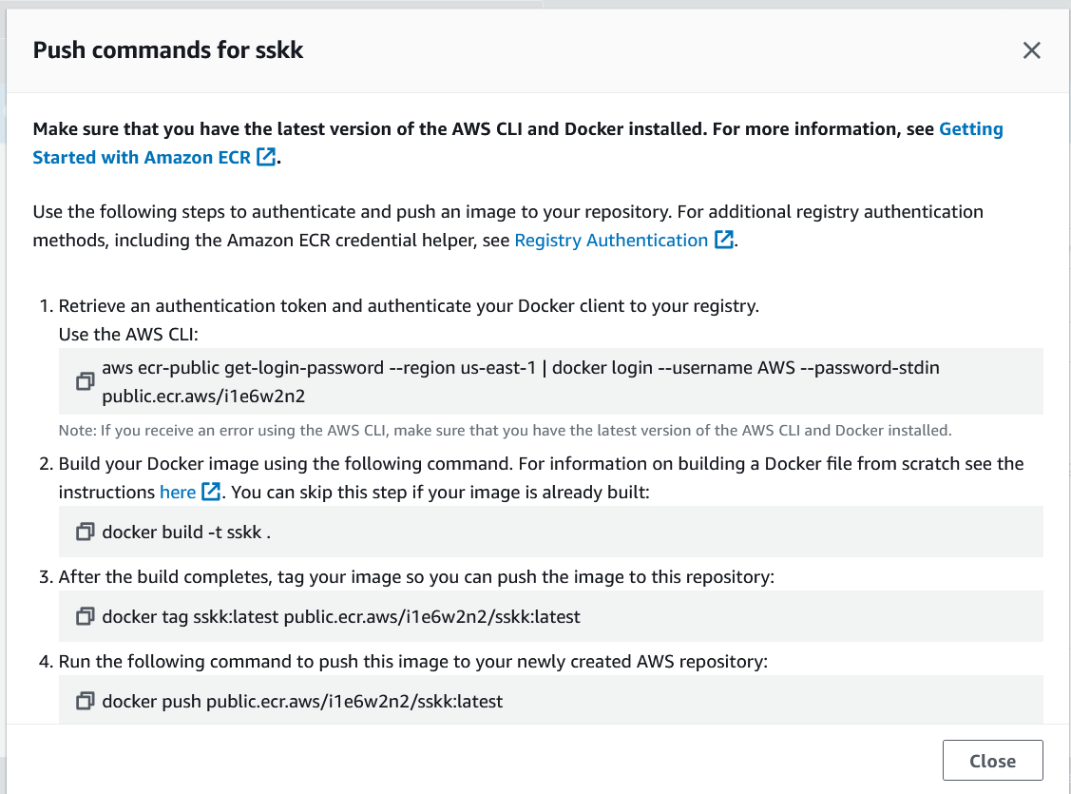

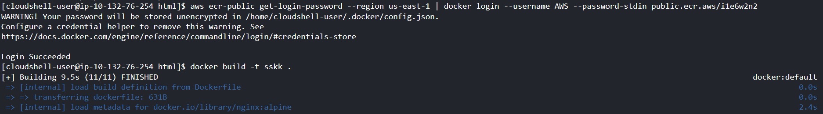 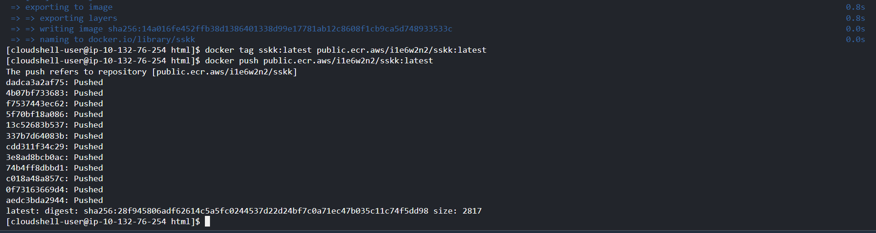

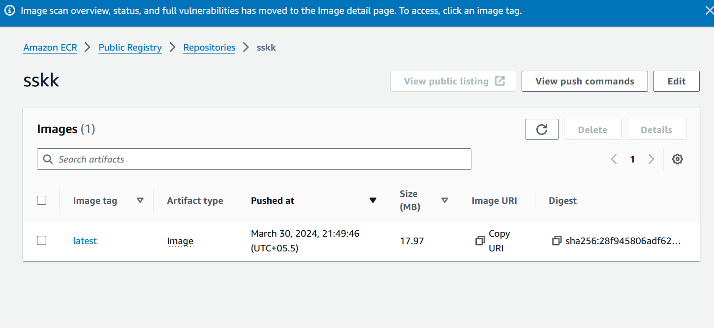

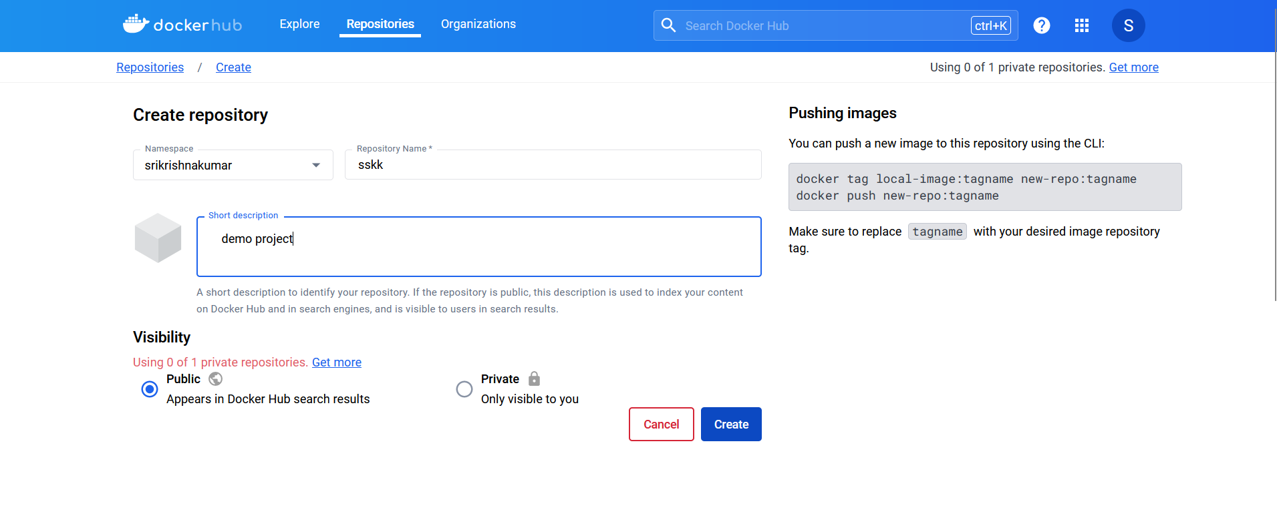

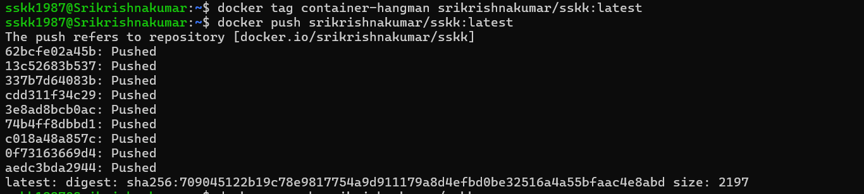

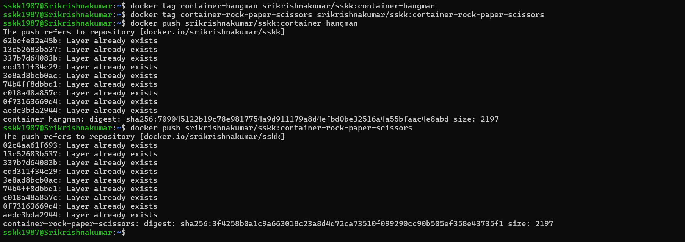

• **Create an Amazon EKS Cluster:**

* Log in to the AWS Management Console.
* Navigate to the Amazon EKS service.

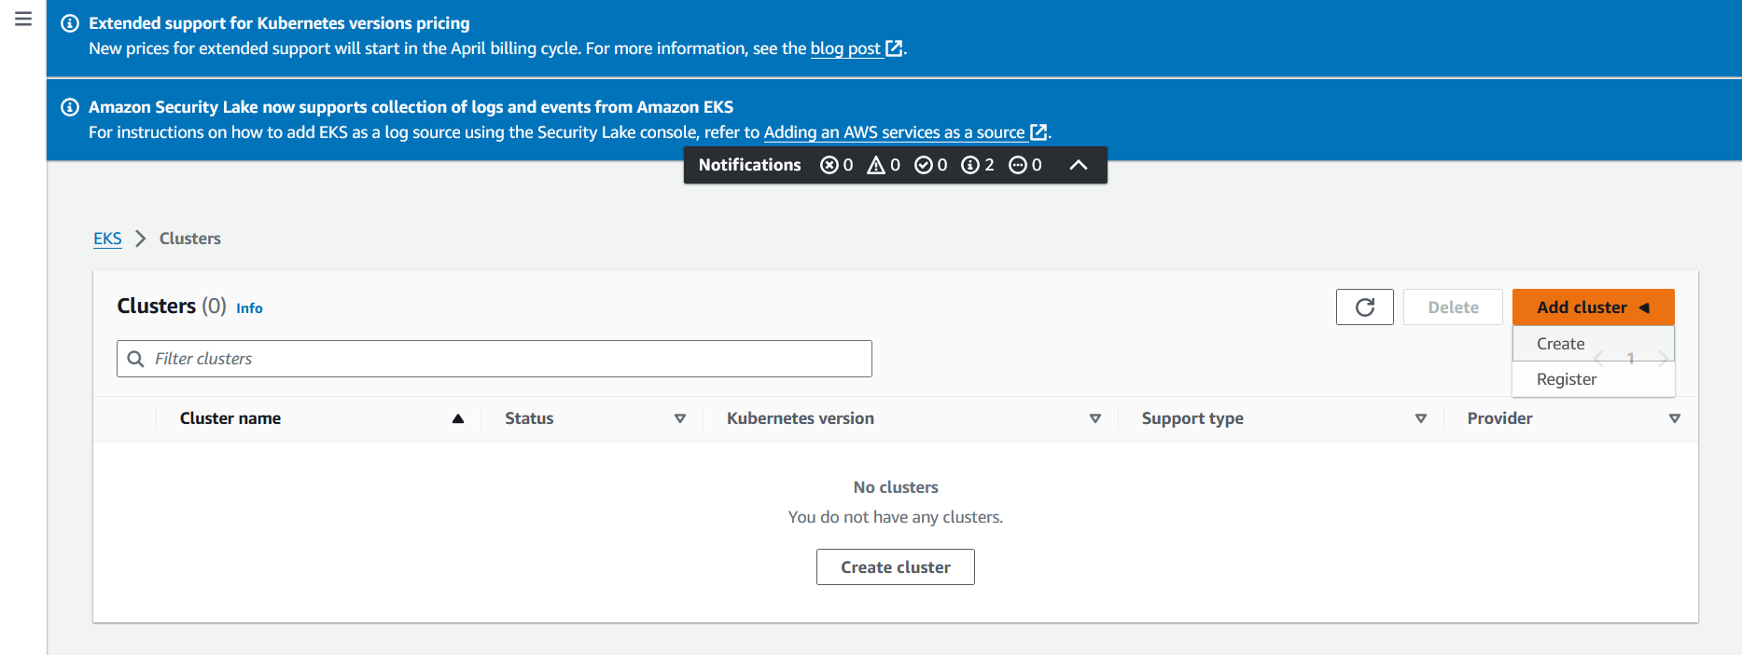

* Click on "Create cluster" and follow the wizard to configure your EKS cluster.

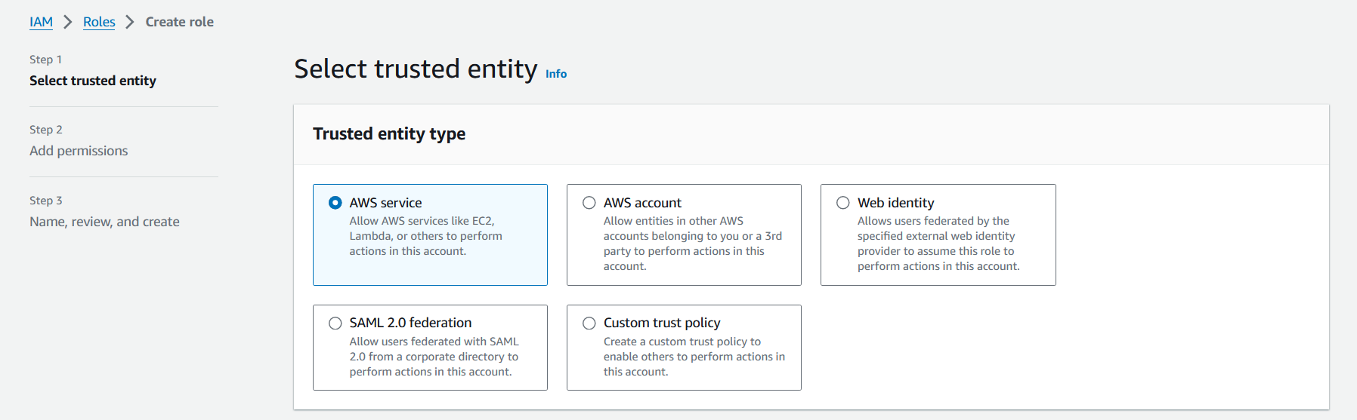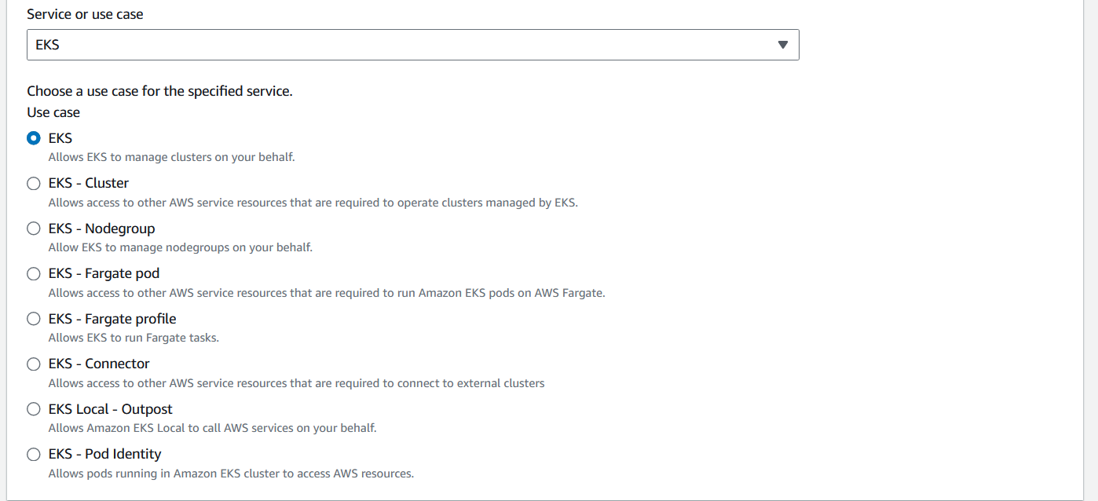

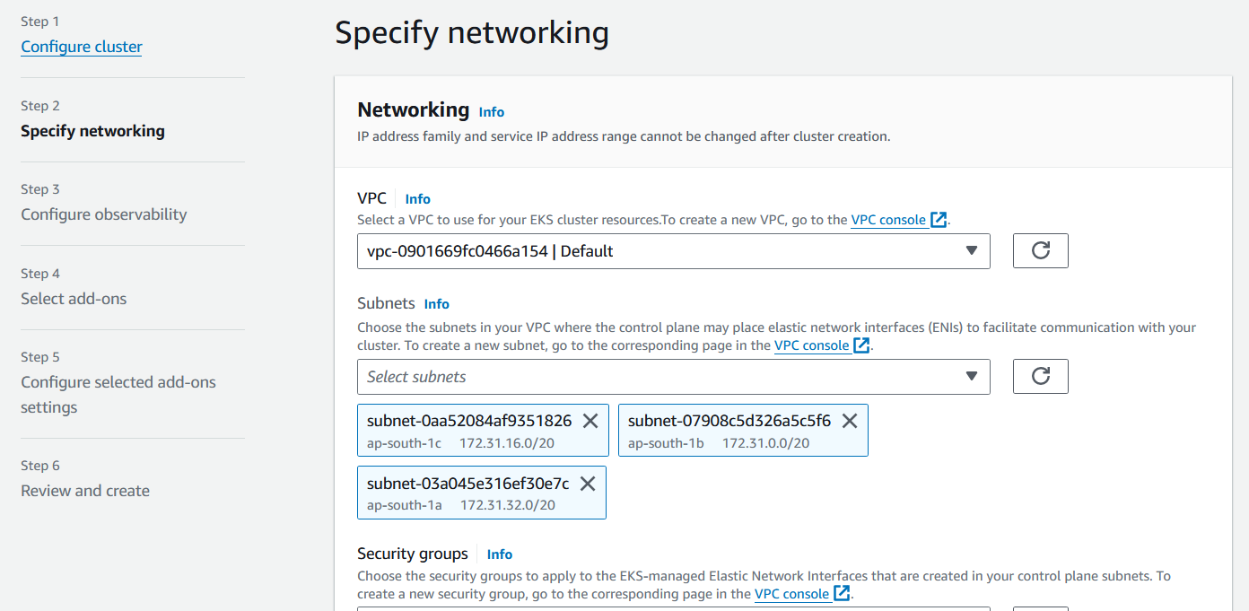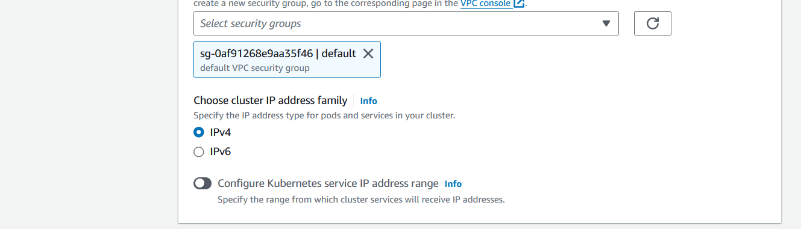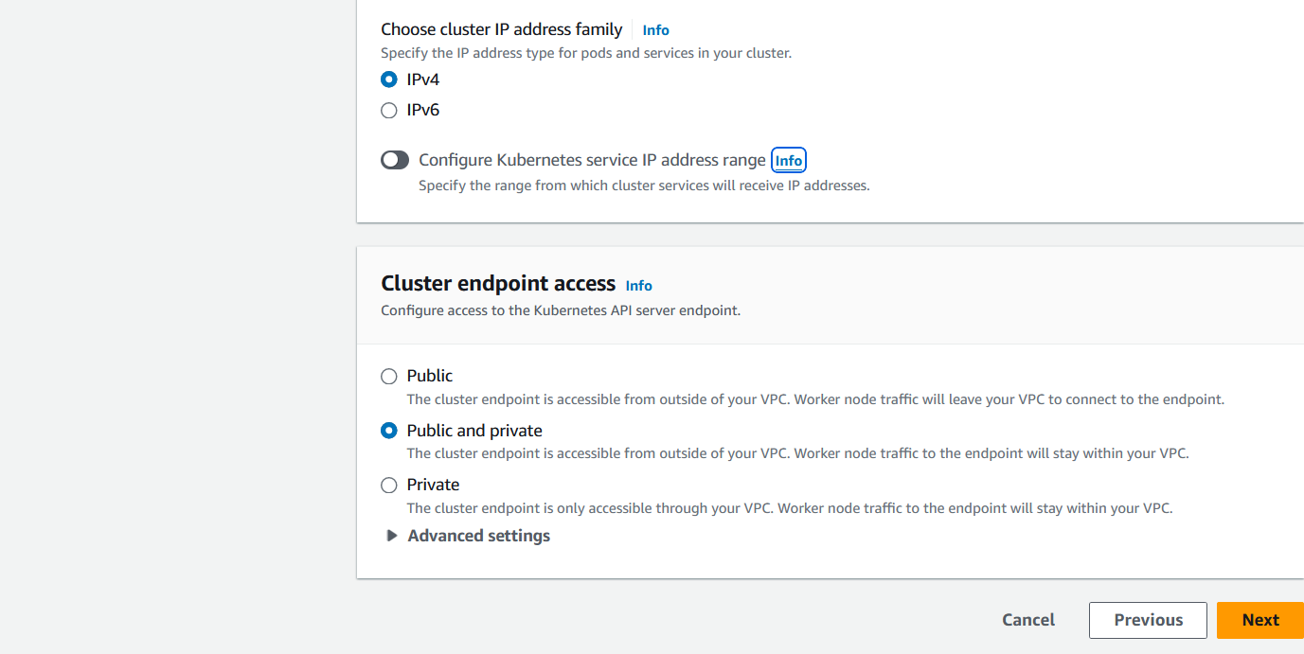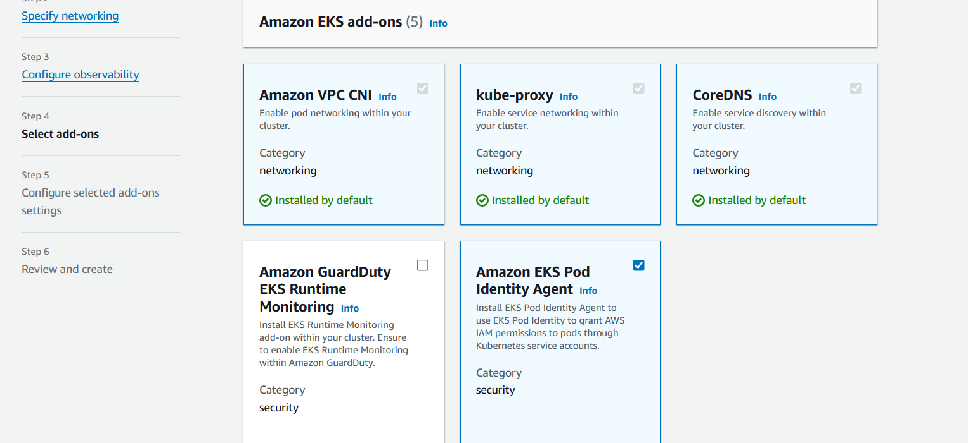

* Choose a name for your cluster and select the Kubernetes version.
* Configure networking options, such as VPC and subnets.
* Choose an IAM role that grants necessary permissions to the EKS service to manage resources on your behalf.
* Select the desired instance types and the number of nodes for your worker nodes.
* Review the configuration and click on "Create" to create your EKS cluster.

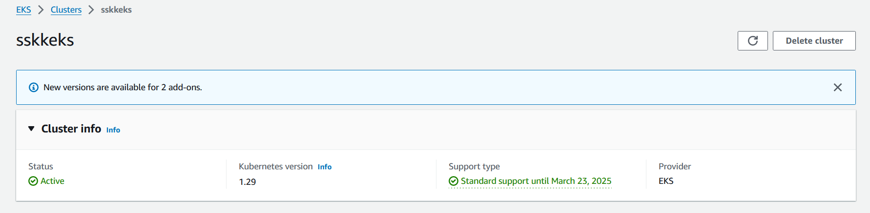

**Configure kubectl Authentication:**

* Install and configure the AWS CLI on your local machine if you haven't already.
* Run the aws eks update-kubeconfig command to create or update your kubeconfig file with the authentication details for your EKS cluster.

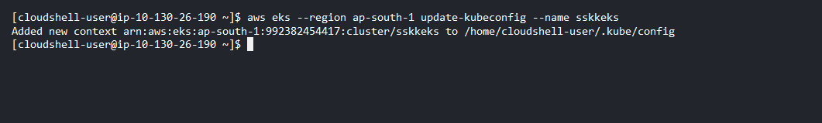

**Verify Cluster Creation:**

* Run kubectl get svc to verify that kubectl is configured correctly and can communicate with your EKS cluster.

