Questions: https://github.com/rvsp/database/blob/master/mongodb/product-queries.txt



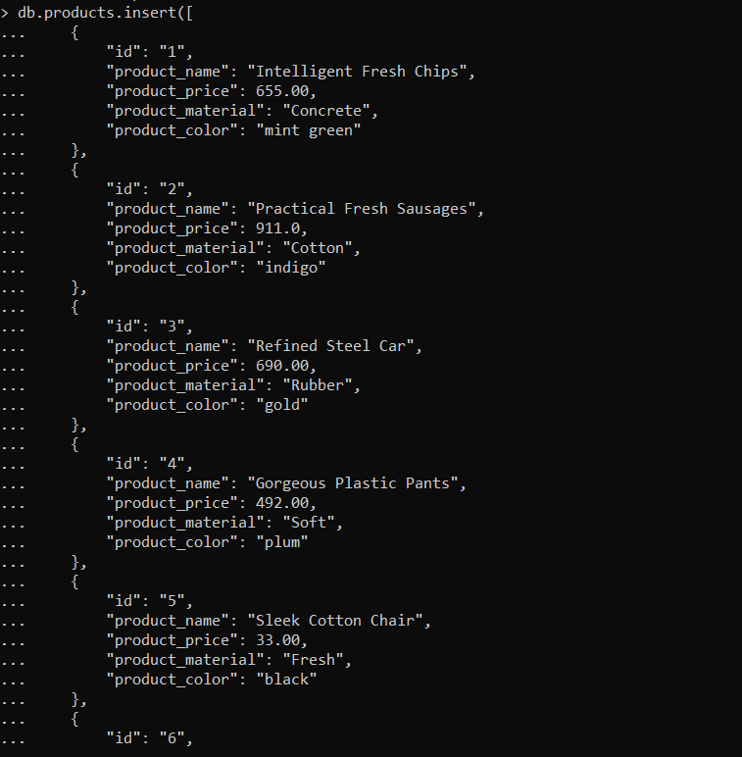

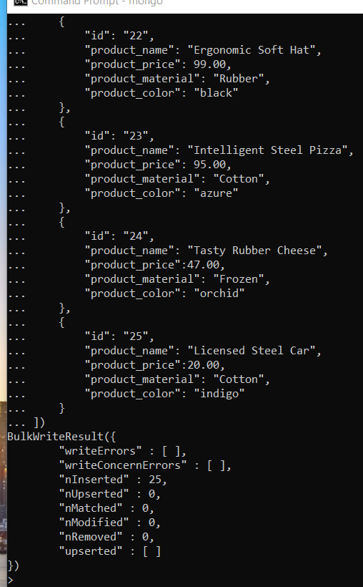

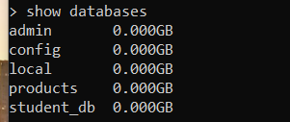

1. Find all the information about each products

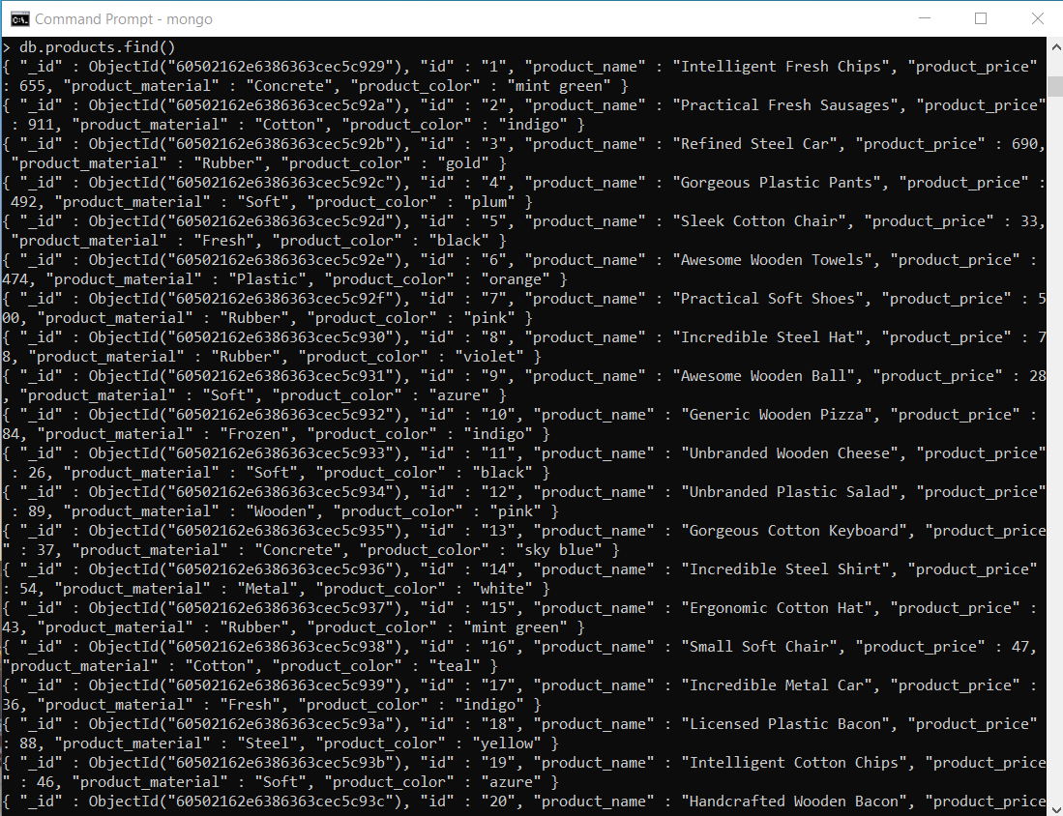

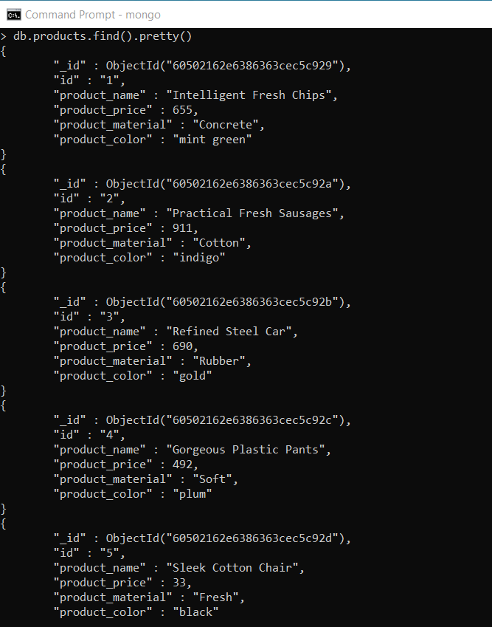

Find the product price which are between 400 to 800

> db.products.find({$and:[{"product_price":{$gte:400}}, {"product_price":{$lt:800}}]}).pretty()

{

"_id" : ObjectId("60502162e6386363cec5c929"),

"id" : "1",

"product_name" : "Intelligent Fresh Chips",

"product_price" : 655,

"product_material" : "Concrete",

"product_color" : "mint green"

}

{

"_id" : ObjectId("60502162e6386363cec5c92b"),

"id" : "3",

"product_name" : "Refined Steel Car",

"product_price" : 690,

"product_material" : "Rubber",

"product_color" : "gold"

}

{

"_id" : ObjectId("60502162e6386363cec5c92c"),

"id" : "4",

"product_name" : "Gorgeous Plastic Pants",

"product_price" : 492,

"product_material" : "Soft",

"product_color" : "plum"

}

{

"_id" : ObjectId("60502162e6386363cec5c92e"),

"id" : "6",

"product_name" : "Awesome Wooden Towels",

"product_price" : 474,

"product_material" : "Plastic",

"product_color" : "orange"

}

{

"_id" : ObjectId("60502162e6386363cec5c92f"),

"id" : "7",

"product_name" : "Practical Soft Shoes",

"product_price" : 500,

"product_material" : "Rubber",

"product_color" : "pink"

}

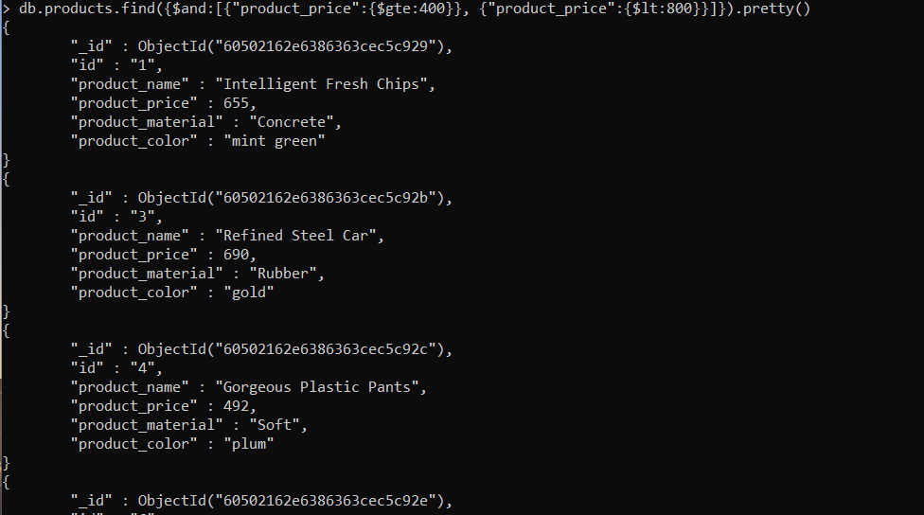

//ref: <https://jojozhuang.github.io/programming/using-mongodb-in-shell>

Find the product price which are not between 400 to 600

> db.products.find({$or:[{"product_price":{$gte:800}}, {"product_price":{$lt:400}}]}).pretty()

{

"_id" : ObjectId("60502162e6386363cec5c92a"),

"id" : "2",

"product_name" : "Practical Fresh Sausages",

"product_price" : 911,

"product_material" : "Cotton",

"product_color" : "indigo"

}

{

"_id" : ObjectId("60502162e6386363cec5c92d"),

"id" : "5",

"product_name" : "Sleek Cotton Chair",

"product_price" : 33,

"product_material" : "Fresh",

"product_color" : "black"

}

{

"_id" : ObjectId("60502162e6386363cec5c930"),

"id" : "8",

"product_name" : "Incredible Steel Hat",

"product_price" : 78,

"product_material" : "Rubber",

"product_color" : "violet"

}

{

"_id" : ObjectId("60502162e6386363cec5c931"),

"id" : "9",

"product_name" : "Awesome Wooden Ball",

"product_price" : 28,

"product_material" : "Soft",

"product_color" : "azure"

}

{

"_id" : ObjectId("60502162e6386363cec5c932"),

"id" : "10",

"product_name" : "Generic Wooden Pizza",

"product_price" : 84,

"product_material" : "Frozen",

"product_color" : "indigo"

}

{

"_id" : ObjectId("60502162e6386363cec5c933"),

"id" : "11",

"product_name" : "Unbranded Wooden Cheese",

"product_price" : 26,

"product_material" : "Soft",

"product_color" : "black"

}

{

"_id" : ObjectId("60502162e6386363cec5c934"),

"id" : "12",

"product_name" : "Unbranded Plastic Salad",

"product_price" : 89,

"product_material" : "Wooden",

"product_color" : "pink"

}

{

"_id" : ObjectId("60502162e6386363cec5c935"),

"id" : "13",

"product_name" : "Gorgeous Cotton Keyboard",

"product_price" : 37,

"product_material" : "Concrete",

"product_color" : "sky blue"

}

{

"_id" : ObjectId("60502162e6386363cec5c936"),

"id" : "14",

"product_name" : "Incredible Steel Shirt",

"product_price" : 54,

"product_material" : "Metal",

"product_color" : "white"

}

{

"_id" : ObjectId("60502162e6386363cec5c937"),

"id" : "15",

"product_name" : "Ergonomic Cotton Hat",

"product_price" : 43,

"product_material" : "Rubber",

"product_color" : "mint green"

}

{

"_id" : ObjectId("60502162e6386363cec5c938"),

"id" : "16",

"product_name" : "Small Soft Chair",

"product_price" : 47,

"product_material" : "Cotton",

"product_color" : "teal"

}

{

"_id" : ObjectId("60502162e6386363cec5c939"),

"id" : "17",

"product_name" : "Incredible Metal Car",

"product_price" : 36,

"product_material" : "Fresh",

"product_color" : "indigo"

}

{

"_id" : ObjectId("60502162e6386363cec5c93a"),

"id" : "18",

"product_name" : "Licensed Plastic Bacon",

"product_price" : 88,

"product_material" : "Steel",

"product_color" : "yellow"

}

{

"_id" : ObjectId("60502162e6386363cec5c93b"),

"id" : "19",

"product_name" : "Intelligent Cotton Chips",

"product_price" : 46,

"product_material" : "Soft",

"product_color" : "azure"

}

{

"_id" : ObjectId("60502162e6386363cec5c93c"),

"id" : "20",

"product_name" : "Handcrafted Wooden Bacon",

"product_price" : 36,

"product_material" : "Concrete",

"product_color" : "lime"

}

{

"_id" : ObjectId("60502162e6386363cec5c93d"),

"id" : "21",

"product_name" : "Unbranded Granite Chicken",

"product_price" : 90,

"product_material" : "Metal",

"product_color" : "gold"

}

{

"_id" : ObjectId("60502162e6386363cec5c93e"),

"id" : "22",

"product_name" : "Ergonomic Soft Hat",

"product_price" : 99,

"product_material" : "Rubber",

"product_color" : "black"

}

{

"_id" : ObjectId("60502162e6386363cec5c93f"),

"id" : "23",

"product_name" : "Intelligent Steel Pizza",

"product_price" : 95,

"product_material" : "Cotton",

"product_color" : "azure"

}

{

"_id" : ObjectId("60502162e6386363cec5c940"),

"id" : "24",

"product_name" : "Tasty Rubber Cheese",

"product_price" : 47,

"product_material" : "Frozen",

"product_color" : "orchid"

}

{

"_id" : ObjectId("60502162e6386363cec5c941"),

"id" : "25",

"product_name" : "Licensed Steel Car",

"product_price" : 20,

"product_material" : "Cotton",

"product_color" : "indigo"

}

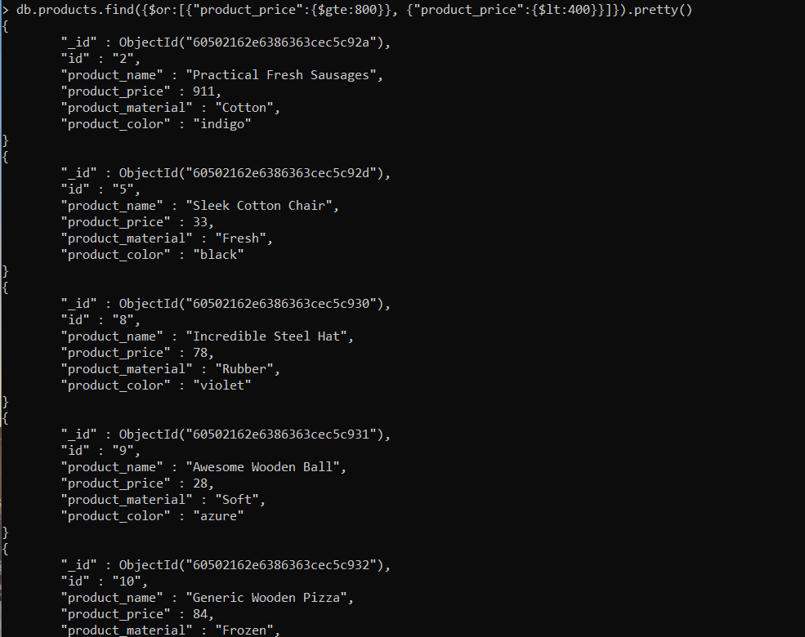

List the four product which are greater than 500 in price

> db.products.find({"product_price":{$gte:500}}).limit(4).pretty()

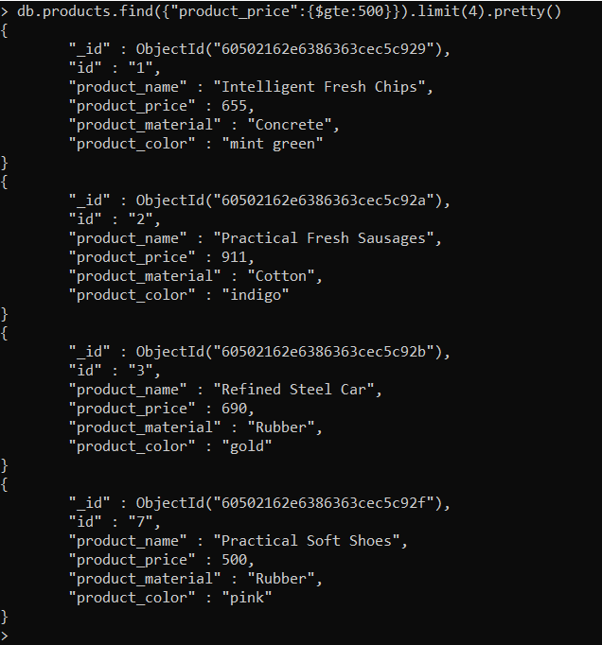

Find the product name and product material of each products

> db.products.find({}, {id:0,_id:0,product_price:0,product_color:0});

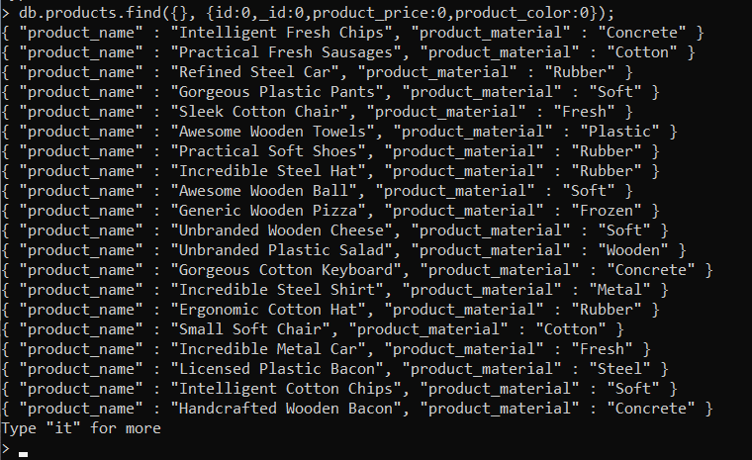

Find the product with a row id of 10

> db.products.find({ "id":"10" }).pretty()

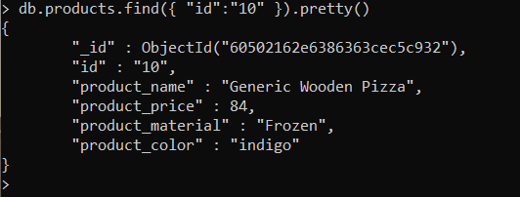

Find only the product name and product material

> db.products.find({}, {id:0,_id:0,product_price:0,product_color:0});



Find all products which contain the value of soft in product material

> db.products.find({ "product_material":"Soft" }).pretty()

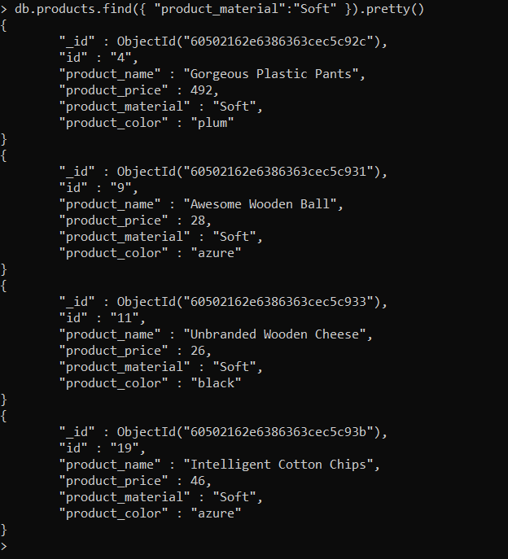

Find products which contain product color indigo and product price 492.00

> db.products.find({"product_price": 492.00}, {"product_color":"indigo"})

{ "_id" : ObjectId("60502162e6386363cec5c92c"), "product_color" : "indigo" }



Delete the products which product price value are same