WEBSITE DEVELOPMENT PROPOSAL
Online Catalogue & Booking Enquiry Platform
Prepared for: Stage Decoration Services
Prepared by
Vishnu Jayakumar _{Devops Engineer}
Puducherry, India

Client Details
Field | Detail
Business name | Sri Kubera Decor & Events (Kubera Decoration)
Proprietor | Saravanan
Phone / WhatsApp | 7373876879, 9486064769
Address | No. 80, Manjini Nagar, Bachanai Madam Street, Muthiyal Pettai, Puducherry
Services offered | Wedding Decoration, Birthday Decoration, Surprise Parties, Corporate Events
Tagline | We Decor Your Dreams

1. Project Overview
This document describes the website proposed for your stage decoration business. The website will serve as an online catalogue of your decoration designs and a simple enquiry system, allowing customers to browse your work, select a design they like, and reach out to you directly to confirm a booking.
The platform is built to be clean, fast, and easy to use on both mobile phones and computers, giving customers a professional first impression while keeping day-to-day management simple for you.

2. Objectives
- Present your decoration work professionally with a high-quality photo gallery.
- Allow customers to browse designs by occasion (wedding, reception, birthday, housewarming, and others).
- Let customers register, select a design, and raise an enquiry with a unique reference number.
- Give you full control to add, update, or remove designs, services, and business details without needing a developer.
- Keep the system simple: no online payment is involved. The website handles catalogue browsing and enquiries only — final confirmation happens directly between you and the customer.

3. How the Website Works

For Customers
- Create an account with basic details (name, phone number, email, gender, address, pincode).
- Browse the design gallery, filtered by occasion type.
- Select a preferred design and raise an enquiry.
- Receive a unique enquiry reference number (for example, A1203) along with a confirmation on screen.
- Contact you directly by phone or WhatsApp, quoting the reference number.
- View the status of their enquiries at any time (pending, contacted, confirmed, or declined).

For You (Business Owner)
- Log in to a private admin area, separate from the customer-facing site.
- Add new designs with photos, titles, descriptions, and occasion categories.
- Search any enquiry using its reference number to see the customer's details and the design selected.
- Update the status of each enquiry as you follow up with the customer.
- Edit your services, business description, contact number, WhatsApp number, and address at any time.
- View a complete list of registered customers and their enquiry history.

4. Website Structure
The website is organised into three areas:
Section | Purpose
Public Pages | Home, Gallery, Services, About, Contact — visible to all visitors, no login required
Customer Account | Sign up, log in, browse and enquire about designs, track enquiry status, manage own profile
Admin Panel | Private area for the business owner to manage designs, categories, services, enquiries, and site details

A full page-by-page layout (21 screens in total) has been planned and is available on request.

5. Key Features
Feature | Description
Design Gallery | Photos organised by occasion, with a clean, modern browsing experience
Customer Accounts | Secure sign-up and login for every customer
Enquiry System | One-click enquiry on any design, generating a unique reference number
Enquiry Receipt | A downloadable PDF summary of the enquiry for the customer's reference
Email Notification | Automatic email confirmation sent to the customer after an enquiry
WhatsApp Contact | One-tap WhatsApp message option pre-filled with the enquiry details
Admin Dashboard | Centralised control of designs, services, enquiries, and business information
Mobile Friendly | Fully usable on phones, tablets, and computers

6. Reliability and Security
- All customer and business data is stored securely with password protection.
- Customers can only see and manage their own information; only you can see all enquiries and customer records.
- Photos are automatically optimised for fast loading without losing visual quality.
- The website is served securely (HTTPS) with an encrypted connection on every page.

7. Scope Clarification
- No online payment collection is included on the website itself. Payment and final booking confirmation are handled directly between you and the customer, as per your current process.
- WhatsApp messages are sent via a one-tap link that opens WhatsApp with the message ready; it is not fully automatic, to avoid ongoing messaging service costs.

8. Investment and Payment Terms
Item | Amount
Website development (design, build, testing, and delivery) | Rs. 6,000
Domain name registration (yearly, billed separately) | Rs. 6,000
Hosting and database | Rs. 6,000

Payment Schedule
- 50% advance (Rs. 3,000) to begin development.
- 50% balance (Rs. 3,000) on completion, before the website goes live.
- Domain renewal is an annual cost, payable by you directly to the domain registrar each year.
- Payment can be made via UPI or bank transfer.

9. Information and Documents Required from You
To begin development, the following details and materials are needed from you:
- Business name and logo (received: Sri Kubera Decor & Events).
- Catalogue photos, sorted by occasion (wedding, reception, birthday, housewarming, surprise party, corporate event, and so on).
- For every photo sent, the following is needed before it can be published on the website:
  - A name or title for the design (for example, "Golden Mandap Setup")
  - A short description of the design
  - The price for that design
  - What is included in the decoration (for example: lights, artificial or fresh flowers, leaves/greenery, cloth drapes, backdrop, props)
- Without these details, a design photo cannot be added to the live gallery.
- A list of your services with a short description for each.
- Contact phone number and WhatsApp number to be shown on the website.
- Business address and the areas you provide service to.
- A short write-up about your business for the About page (experience, specialty, years in business).
- Any existing social media links (Instagram, Facebook) to be linked from the site, if available.
- Two to three preferred domain name options (for example, yourbusinessname.com).
- Any colour or style preference for the website, if you have one. Otherwise a professional theme will be chosen for you.

10. Architecture Diagram
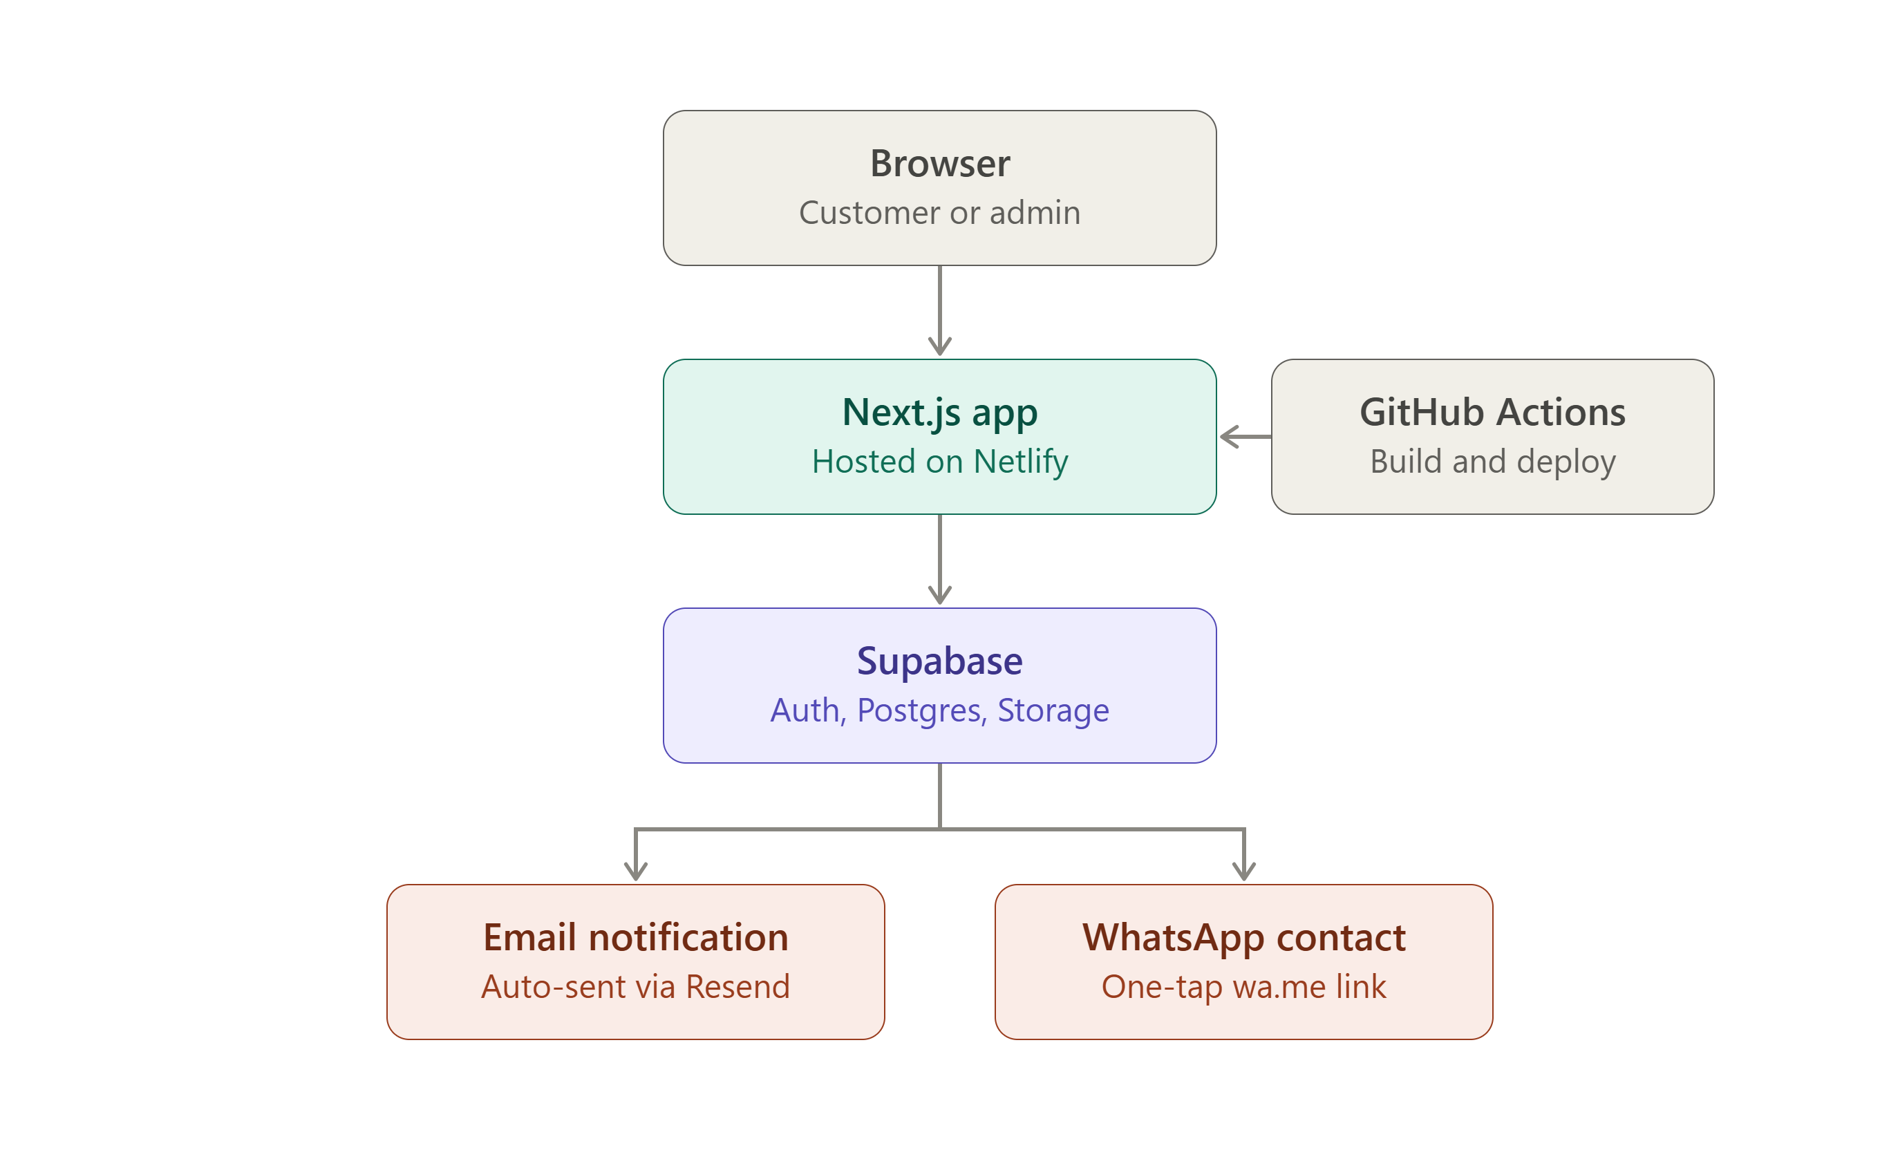

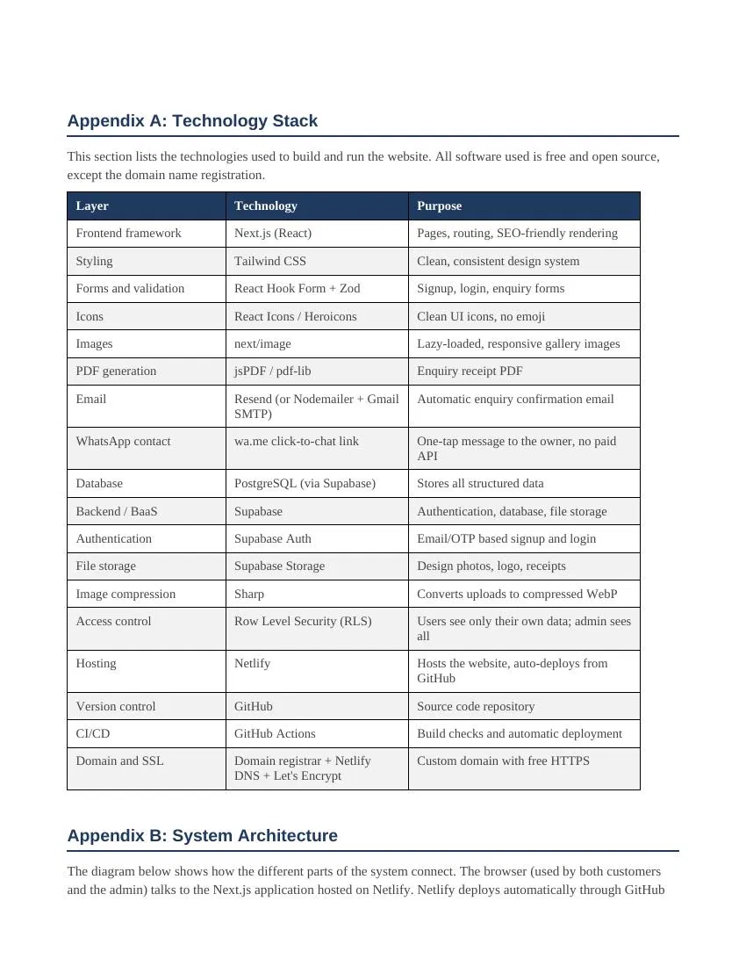

11. Next Steps
- Collect the above information and documents from you.
- Development and testing of the website.
- Review of the completed site with you before it goes live.
- Advance payment to begin; balance payment on delivery.
- Website goes live on your chosen domain.
