Java

Execution of a Java Program
Before jumping into the internals of Java, let’s understand how a Java source file is executed.
- We write the Java source code in Simple.Java file using an editor or IDE (integrated development environment) e.g. Eclipse or IntelliJ Idea.
- Program has to be compiled into bytecode. Java compiler (javac) compiles the sourcecode to Simple.class file.
- This class file can be executed in any platform/OS by JVM (Java virtual machine).
- JVM translates bytecode into native machine code which machines can execute.

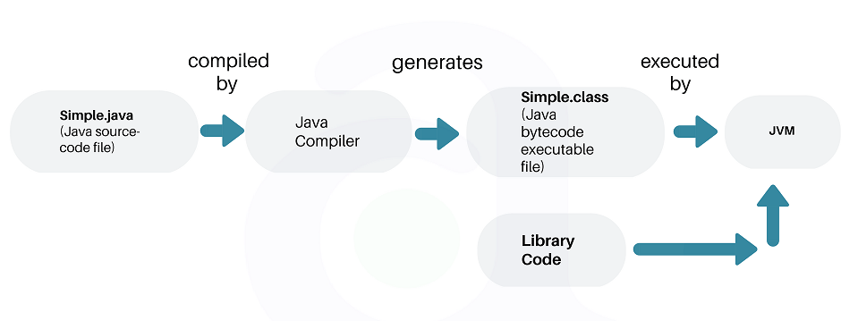

JDK

JVM Architecture

Referring-URL:- https://howtodoinjava.com/java/basics/jdk-jre-jvm/
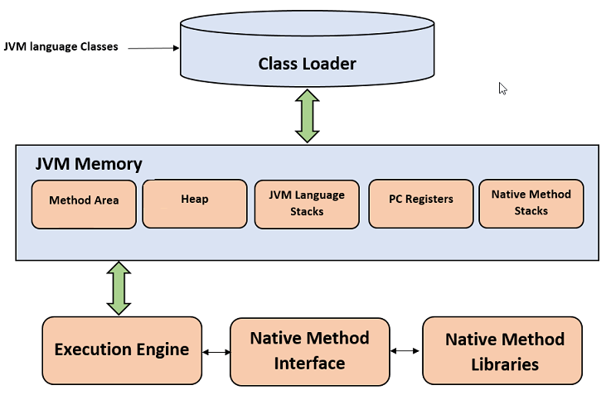

Class Loader
The class loader is a subsystem used for loading class files. It performs three primary functions, i.e. class loading, linking, and initialization.
- Loading
  - To load classes, JVM has 3 kind of class loaders. Bootstrap, extension and application class loader.
  - When loading a class file, JVM finds out a dependency for some arbitrary class XYZ.class.
  - First bootstrap class loader tries to find the class. It scans the rt.jar file in JRE lib folder.
  - If class is not found then extension class loader searches the class file in inside jre\lib\ext folder.
  - Again if class is not found then application classloader searches all the Jar files and classes in CLASSPATH environment variable of system.
  - If class is found by any loader then class is loaded by class loader; else ClassNotFoundException is thrown.
- Linking
After class is loaded by the classloader, linking is performed. A bytecode verifier will verify whether the generated bytecode is proper or not. If verification fails we will get a verification error. It also performs the memory allocation to static variables and methods found in the class.
- Initialization
This is the final phase of class loading, here all static variable will be assigned with the original values, and the static blocks will be executed.

JVM Memory Areas
The memory area inside JVM is divided into multiple parts to store specific pieces of application data.
- Method Area stores class structures like metadata, the constant runtime pool, and the code for methods.
- Heap stores all objects that are created during application execution.
- Stacks store local variables, and intermediate results. All such variables are local to the thread by which they are created. Each thread has its own JVM stack, created simultaneously as the thread is created. So all such local variable are called thread-local variables.
- PC register store the physical memory address of the statements which is currently executing. In Java, each thread has its separate PC register.
- Java supports and uses native code as well. Many low level code is written in languages like C and C++. Native method stacks hold the instruction of native code.

JVM Execution Engine
All code assigned to JVM is executed by an execution engine. The execution engine reads the byte code and executes one by one. It uses two inbuilt interpreter and JIT compiler to convert the bytecode to machine code and execute it.
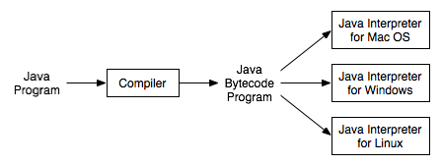Platform Specific Interpreters
With JVM, both interpreter and compiler produce native code. The difference is in how they generate the native code, how optimized it is as well how costly the optimization is.

Interpreter
A JVM interpreter pretty much converts each byte-code instruction to corresponding native instruction by looking up a predefined JVM-instruction to machine instruction mapping. It directly executes the bytecode and does not perform any optimization.

JIT Compiler
To improve performance, JIT compilers interact with the JVM at runtime and compile appropriate bytecode sequences into native machine code. Typically, the JIT compiler takes a block of code (not one statement at a time as interpreter), optimizes the code, and then translates it to optimized machine code.
The JIT compiler is enabled by default. You can disable the JIT compiler, in which case the entire Java program will be interpreted. Disabling the JIT compiler is not recommended except to diagnose or workaround JIT compilation problems.

What is JRE?
The Java Runtime Environment (JRE) is a software package which bundles the libraries (jars) and the Java Virtual Machine, and other components to run applications written in the Java. JVM is just a part of JRE distributions.
To execute any Java application, you need JRE installed in the machine. It’s the minimum requirement to run Java applications on any computer.
JRE bundles the following components –
- DLL files used by the Java HotSpot Client Virtual Machine.
- DLL files used by the Java HotSpot Server Virtual Machine.
- Code libraries, property settings, and resource files used by the Java runtime environment. e.g. rt.jar and charsets.jar.
- Java extension files such as localedata.jar.
- Contains files used for security management. These include the security policy (java.policy) and security properties (java.security) files.
- Jar files containing support classes for applets.
- Contains TrueType font files for use by the platform.
JREs can be downloaded as part of JDKs, or you can download them separately. JREs are platform dependent. It means that based on the type of machine (OS and architecture), you will have to select the JRE bundle to import and install.
For example, you cannot install a 64-bit JRE distribution on 32-bit machine. Similarly, JRE distribution for Windows will not work in Linux; and vice-versa.

What is JDK?
JDK is a superset of JRE. JDK contains everything that JRE has along with development tools for developing, debugging, and monitoring Java applications. You need JDK when you need to develop Java applications.
Few important components shipped with JDKs are as follows:
- appletviewer – this tool can be used to run and debug Java applets without a web browser
- apt – the annotation-processing tool
- extcheck – a utility that detects JAR file conflicts
- javadoc – the documentation generator, which automatically generates documentation from source code comments
- jar – the archiver, which packages related class libraries into a single JAR file. This tool also helps manage JAR files
- jarsigner – the jar signing and verification tool
- javap – the class file disassembler
- javaws – the Java Web Start launcher for JNLP applications
- JConsole – Java Monitoring and Management Console
- jhat – Java Heap Analysis Tool
- jrunscript – Java command-line script shell
- jstack – utility that prints Java stack traces of Java threads
- keytool – tool for manipulating the keystore
- policytool – the policy creation and management tool
- xjc – Part of the Java API for XML Binding (JAXB) API. It accepts an XML schema and generates Java classes
Same as JREs, JDKs are also platform dependent. So take care when you download the JDK package for your machine.

Difference between JDK, JRE and JVM
Based on the above discussions, we can draw a relationship between these three as below –
JRE = JVM + libraries to run Java application.
JDK = JRE + tools to develop Java Application.
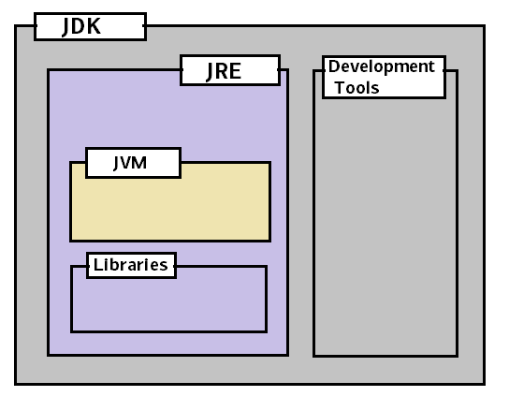

JDK vs. JRE vs. JVM
In short, if you are a Java application developer who writes code, you will need JDK installed in your machine. But, if you only want to run applications built in Java, you only need JRE installed into your computer.

Interview questions related to JDK, JRE and JVM
If you understood whatever we have discussed so far in this post, then facing any interview question will not be difficult. Still, be prepared to answer questions like below:

How many types of class loaders are in Java?
There are 3 class loaders. Bootstrap, extension and application class loaders.

How class loader works in Java?
Class loaders scan their pre-defined locations for jar files and classes. They scan all those class files in the path and look for the required class. If found, they load, link, and initialize the class file.

Difference between JRE and JVM?
JVM is the specification for a runtime environment that executes the Java applications. Hotspot JVM is such one implementation of the specification. It loads the class files and uses the interpreter and JIT compiler to convert bytecode into machine code and execute it.

Difference between interpreter and JIT compiler?
The interpreter interprets the bytecode line by line and executes it sequentially. It results in poor performance. JIT compiler add optimization to this process by analyzing the code in blocks and then prepare more optimized machine code.

Oops

Java Classes and Objects
Referring-URLS:- https://www.geeksforgeeks.org/classes-objects-java/ and https://howtodoinjava.com/java/basics/java-classes-objects/
Classes are the basic units of programming in the object-oriented programming. A class is a user defined blueprint or prototype from which objects are created. It represents the set of properties or methods that are common to all objects of one type. In general, class declarations can include these components, in order:
- Modifiers: A class can be public or has default access.
- Class keyword: class keyword is used to create a class.
- Class name: The name should begin with an initial letter (capitalized by convention).
- Super class (if any): The name of the class’s parent (superclass), if any, preceded by the keyword extends. A class can only extend (subclass) one parent.
- Interfaces (if any): A comma-separated list of interfaces implemented by the class, if any, proceeded by the keyword implements. A class can implement more than one interface.
- Body: The class body surrounded by braces, { }.

Object is a basic unit of Object-Oriented Programming and represents the real life entities. A typical Java program creates many objects, which as you know, interact by invoking methods.
An object consists of:
- State: It is represented by attributes of an object. It also reflects the properties of an object.
- Behavior: It is represented by methods of an object. It also reflects the response of an object with other objects.
- Identity: It gives a unique name to an object and enables one object to interact with other objects.

Java Class vs. Object:-
In Java, objects are containers like data structure which have state and behavior. Objects represent the actors in the system or the application.
For example, in a Human Resource application, the main actors are Employee, Manager, Department, or Reports, etc.
An object is an instance of a class.
The classes are the template that describes the state and behavior of its objects. A class can be used to create multiple objects. Which are similar in structure but can have different states?

How to create an immutable class in Java?
https://www.journaldev.com/129/how-to-create-immutable-class-in-javahttps://www.journaldev.com/60/java-clone-object-cloning-java/
https://www.geeksforgeeks.org/deep-shallow-lazy-copy-java-examples/
To create an immutable class in Java, you have to do the following steps.
- Declare the class as final so it can’t be extended.
- Make all fields private so that direct access is not allowed.
- Don’t provide setter methods for variables.
- Make all mutable fields final so that its value can be assigned only once.
- Initialize all the fields via a constructor performing deep copy.
- Perform cloning of objects in the getter methods to return a copy rather than returning the actual object reference.

Differences between Interface and Abstract Class:-
- If you are designing the API then use Interfaces if you are abstracting both stage and behavior then use an abstract class.
- An abstract class can maintain a state but the interface cannot.
- An abstract class can also have a Constructor that is not allowed inside the Interface even in Java8.

Runtime polymorphism (Dynamic Method Dispatch/ Dynamic binding/ Method Overriding) and Compile time polymorphism (Static binding/ Method Overloading)
If you overload a static method in Java, it is an example of compile-time polymorphism.
Method invocation is determined by the JVM, not the compiler, it is known as runtime polymorphism.

Association, Composition, and Aggregation in Java:-
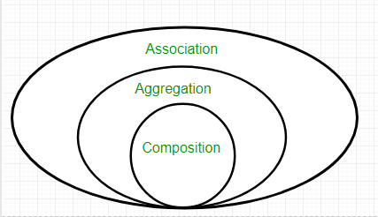
Association: - Association is relation between two separate classes which establishes through their Objects. Association can be one-to-one, one-to-many, many-to-one, and many-to-many.
In Object-Oriented programming, an Object communicates to other Object to use functionality and services provided by that object. Composition and Aggregation are the two forms of association.
Two separate classes Bank and Employee are associated through their Objects. Bank can have many employees, so it is a one-to-many relationship.
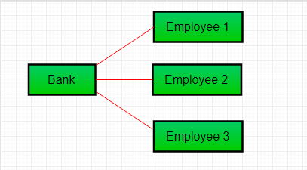

Aggregation:-
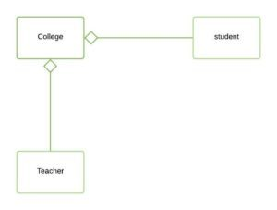
It is a special form of Association where:-
- It represents Has-A relationship.
- It is a unidirectional association i.e. a one way relationship. For example, department can have students but vice versa is not possible and thus unidirectional in nature.
- In Aggregation, both the entries can survive individually which means ending one entity will not affect the other entity
- In this example, there is an Institute which has no. of departments like CSE, EE. Every department has no. of students. So, we make a Institute class which has a reference to Object or no. of Objects (i.e. List of Objects) of the Department class. That means Institute class is associated with Department class through its Object(s). And Department class has also a reference to Object or Objects (i.e. List of Objects) of Student class means it is associated with Student class through its Object(s).
It represents a Has-A relationship.
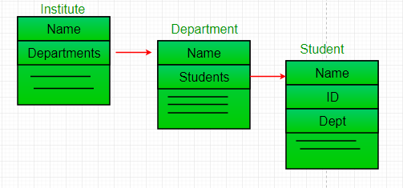
- When do we use Aggregation??
Code reuse is best achieved by aggregation.

Composition:-
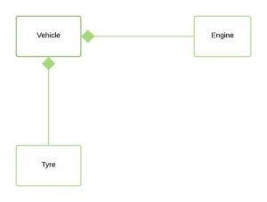
Composition is a restricted form of Aggregation in which two entities are highly dependent on each other.
- It represents part-of relationship.
- In composition, both the entities are dependent on each other.
- When there is a composition between two entities, the composed object cannot exist without the other entity.
Let’s take example of Library.

a library can have no. of books on same or different subjects. So, If Library gets destroyed then All books within that particular library will be destroyed. I.e. book cannot exist without library. That’s why it is composition.

Aggregation vs. Composition:-
- Dependency: Aggregation implies a relationship where the child can exist independently of the parent. For example, Bank and Employee, delete the Bank and the Employee still exist. Whereas Composition implies a relationship where the child cannot exist independent of the parent. Example: Human and heart, heart don’t exist separate to a Human
- Type of Relationship: Aggregation relation is “has-a” and composition is “part-of” relation.
- Type of association: Composition is a strong Association whereas Aggregation is a weak Association.

Recursion vs. Iteration: - The Recursion and Iteration both repeatedly execute the set of instructions. Recursion is when a statement in a function calls itself repeatedly. The iteration is when a loop repeatedly executes until the controlling condition becomes false. The primary difference between recursion and iteration is that recursion is a process, always applied to a function and iteration is applied to the set of instructions which we want to get repeatedly executed.

Recursion:-
- Recursion uses selection structure.
- Infinite recursion occurs if the recursion step does not reduce the problem in a manner that converges on some condition (base case) and Infinite recursion can crash the system.
- Recursion terminates when a base case is recognized.
- Recursion is usually slower than iteration due to the overhead of maintaining the stack.
- Recursion uses more memory than iteration.
- Recursion makes the code smaller.

Example:-
public class RecursionExample {
public static void main(String args[]) {
RecursionExample re = new RecursionExample();
int result = re.factorial(4);
System.out.println("Result:" + result);
}
public int factorial(int n) {
if (n==0) {
return 1;
}
else {
return n*factorial(n-1);
}
}
}

Output:-
Result: - 24

Iteration:-
- Iteration uses repetition structure.
- An infinite loop occurs with iteration if the loop condition test never becomes false and infinite looping uses CPU cycles repeatedly.
- Iteration terminates when the loop condition fails.
- Iteration does not use the stack so it's faster than recursion.
- Iteration consumes less memory.
- Iteration makes the code longer.

Example:-
public class IterationExample {
public static void main(String args[]) {
for(int i = 1; i <= 5; i++) {
System.out.println(i + " ");
}
}
}

Output:-
1
2
3
4
5

Java Exceptions
Checked vs. Unchecked:-
- Checked Exception: - The classes which directly inherit Throwable class except RuntimeException and Error are known as checked exceptions e.g. IOException, SQLException etc. Checked exceptions are checked at compile-time.

Unchecked Exception: - The classes which inherit RuntimeException are known as unchecked exceptions e.g. ArithmeticException, NullPointerException, ArrayIndexOutOfBoundsException etc. Unchecked exceptions are not checked at compile-time, but they are checked at runtime.

Error: - Error is irrecoverable e.g. OutOfMemoryError, VirtualMachineError, AssertionError etc.
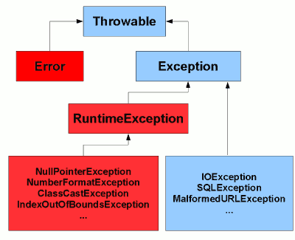

Java Asynchronous and synchronous exceptions:-
Normally Java differentiates the exceptions in two categories on basis of “timing” when they are discovered. These categories are checked and unchecked exceptions.
Similarly, on the basis of place of occurrence, Java exceptions can be divided further in two categories.
- Synchronous exceptions
- Asynchronous exceptions

1. Synchronous exception: - Synchronous exceptions happen at a specific program statement, no matter, how many times we run a program in similar execution environment.
Example of synchronous exceptions are what we care for in our daily life as developer i.e. NullPointerException or ArrayIndexOutOfBoundsException etc.
For example, we run a Java program ‘N’ times with same input. If NullPointerException occur at line number ‘M’ then they will occur at a same line number every time. This is example of synchronous exception in Java.

2. Asynchronous exception: - Asynchronous exceptions can raise practically anywhere. It follows that asynchronous exception handling can’t be required by the compiler. They are also difficult to program with.
Examples of naturally asynchronous events include pressing Ctrl-C to interrupt a program, or receiving a signal such as “stop” or “suspend” from another thread of execution. For example, if you press ‘CTRL + C’ N times during application execute on, no one can guarantee the line number on which the application will end.
Java Custom Exception: - If you are creating your own Exception that is known as custom exception or user-defined exception. Java custom exceptions are used to customize the exception according to user need. By the help of custom exception, you can have your own exception and message.
class InvalidAgeException extends Exception{
InvalidAgeException(String s){
super(s);
}
}
class TestCustomException{
static void validate(int age)throws InvalidAgeException{
if(age<18)
throw new InvalidAgeException("not valid");
else
System.out.println("welcome to vote");
}
public static void main(String args[]){
try{
validate(13);
}catch(Exception m){System.out.println("Exception occured: "+m);}
System.out.println("rest of the code...");
}

}

Java Concurrency

Concurrency vs. Parallelism:-
Concurrency means multiple tasks which start, run and complete in overlapping time periods, in no specific order. Parallelism is when multiple tasks OR several part of a unique task literally run at the same time, e.g. on a multi-core processor. Concurrency and parallelism are NOT the same thing.

Concurrency
Concurrency is essentially applicable when we talk about minimum of two tasks or more. When an application is capable of executing two tasks virtually at the same time, we call it concurrent application. Though here tasks run looks like simultaneously, but essentially they MAY not. They take advantage of the CPU time-slicing feature of the operating system where each task run part of its task and then go to a waiting state. When the first task is in a waiting state, the CPU is assigned to the second task to complete its part of the task.
Operating system based on priority of tasks, thus, assigns CPU and other computing resources e.g. memory; turn by turn to all tasks and give them chance to complete. To end user, it seems that all tasks are running in parallel. This is called concurrency.

Parallelism
Parallelism does not require two tasks to exist. It literally physically run parts of tasks OR multiple tasks, at the same time using multi-core infrastructure of CPU, by assigning one core to each task or sub-task.
Parallelism requires hardware with multiple processing units, essentially. In single core CPU, you may get concurrency but NOT parallelism.

Differences between concurrency vs. parallelism
- Concurrency is when two tasks can start, run, and complete in overlapping time periods. Parallelism is when tasks literally run at the same time, e.g. on a multi-core processor.
- Concurrency is the composition of independently executing processes, while parallelism is the simultaneous execution of (possibly related) computations.
- Concurrency is about dealing with lots of things at once. Parallelism is about doing lots of things at once.

Thread Safety:-
Referring-URL:-
- https://howtodoinjava.com/java/multi-threading/what-is-thread-safety/
- https://www.geeksforgeeks.org/thread-safety-and-how-to-achieve-it-in-java/
- https://howtodoinjava.com/java/multi-threading/compare-and-swap-cas-algorithm/
- https://www.geeksforgeeks.org/java-program-to-implement-cas-compare-and-swap-algorithm/
- https://www.geeksforgeeks.org/atomicinteger-compareandset-method-in-java-with-examples/
As we know Java has a feature, Multithreading, which is a process of running multiple threads simultaneously. When multiple threads are working on the same data, and the value of our data is changing, that scenario is not thread-safe and we will get inconsistent results. When a thread is already working on an object and preventing another thread on working on the same object, this process is called Thread-Safety.
A class is thread-safe when it continues to behave correctly when accessed from multiple threads.

How to achieve Thread Safety:-
There are four ways to achieve Thread Safety in Java. These are:
- Using Synchronization.
- Using Volatile Keyword.
- Using Atomic Variable.
- Using Final Keyword.

Using Synchronization:-
Synchronization is the process of allowing only one thread at a time to complete the particular task. It means when multiple threads executing simultaneously, and want to access the same resource at the same time, then the problem of inconsistency will occur. So synchronization is used to resolve inconsistency problem by allowing only one thread at a time.
Synchronization uses a synchronized keyword. Synchronized is the modifier that creates a block of code known as a critical section.

Using Volatile keyword:-
A volatile keyword is a field modifier that ensures that the object can be used by multiple threads at the same time without having any problem.
Volatile is one good way of ensuring that the Java program is thread-safe. a volatile keyword can be used as an alternative way of achieving Thread Safety in Java.

Using Atomic Variable:-
Using an atomic variable is another way to achieve thread-safety in java. When variables are shared by multiple threads, the atomic variable ensures that threads don’t crash into each other.

Using Final keyword:-
Final Variables are also thread-safe in java because once assigned some reference of an object It cannot point to reference of another object.

Java Program to Implement CAS (Compare and Swap) Algorithm:-
Compare and swap is a technique used when designing concurrent algorithms. The approach is to compare the actual value of the variable to the expected value of the variable and if the actual value matches the expected value, then swap the actual value of the variable for the new value passed in.
For understanding the algorithm, one must have the basic knowledge of Concurrency and Multithread in Java.

Working of the Algorithm:-
It is like we know that this variable should be 1, and we want to change it to 2. Since this is a multithreaded environment, we know that others might be working on the same variable. So we should first check if the value of the variable is 1 as we thought and if yes, then we change it to 2. If we see that the variable is 3 now, then that means someone else is working on it and so let us not touch it at this time.

Check then Act approach:-
The most common condition for concurrency problems is the “check then act” approach. The “check then act” occurs when the code first checks the value of a variable and then acts based on that value. Here is a simple example:
public boolean lock() {
if(!locked) {
lock = true;
return true;
}
return false;
}
Above, pseudo code Implies that, if it is already locked, you don’t need to lock again. So you first check and only if required, act.
The above code is not safe as If two or more threads might have access to lock() function and do the check at the same time , then above lock() function would not be guaranteed to work because all thread would lock the resource and use it as its own.

Let’s elaborate it: -
There is Thread A and Thread B, thread B may check locked at any time between thread A has checked locked and seen it to be false then, both thread A and thread B may see locked as being false, and both will then act based on that information.
The above problem can be resolved by making the entire block of code as synchronized. Then only one thread (thread A or thread B) going to the check and act at one time, Only after the thread that got into the code completes its check, and it’s an act then another thread gets to try. Now there will be no misunderstanding between threads.
Example for synchronized code:-
class GFG {
private boolean locked = false;
public synchronized boolean lock() {
if(!locked) {
locked = true;
return true;
}
return false;
}
}
Now the lock() method is synchronized so only one thread can execute it at a time on the same lock() function.
Atomic Operation:-
After Java 5, we don’t have to implement or write a synchronized block with the check and act code anymore, Java 5 offers this support via java.util.concurrent.atomic: a toolkit of classes used for lock-free, thread-safe programming on single variables.
AtomicBoolean makes sure that only one thread can read it at a time.

Here is an example showing how to implement the lock() method using AtomicBoolean :

public static class MyLock {
private AtomicBoolean locked = new AtomicBoolean(false);
public boolean lock() {
return locked.compareAndSet(false, true);
}
}
Notice how the locked variable is no longer a boolean but an AtomicBoolean. This class has a compareAndSet() function which will compare the value of the AtomicBoolean instance to an expected value, and if has the expected value, it swaps the value with a new value. In this case it compares the value of locked to false and if it is false it sets the new value of the AtomicBoolean to true.
The compareAndSet() method returns true if the value was swapped, and false if not.
So there is many other Atomic Variables like:-
- AtomicInteger: This variable lets you update an int value atomically.
- AtomicLong: Long with thread-safe “Compare and Swap” functionality.
- AtomicReference: This variable provides an object reference variable which can be read and written atomically.
- AtomicIntegerArray, AtomicLongArray, and AtomicReferenceArray

Example of Atomic Integer:-
// Java Program to demonstrates
// the compareAndSet() function

import java.util.concurrent.atomic.AtomicInteger;
public class GFG {
public static void main(String args[])
{
// Initially value as 0
AtomicIntegerval = new AtomicInteger(0);

// Prints the updated value
System.out.println("Previous value: "
+ val);
// Checks if previous value was 0
// and then updates it
boolean res = val.compareAndSet(0, 6);

// Checks if the value was updated.
if (res)
System.out.println("The value was"
+ " updated and it is "
+ val);
else
System.out.println("The value was "
+ "not updated");
}
}

Output:-
Previous value: 0
The value was updated and it is 6
When multiple threads attempt to update the same variable simultaneously using CAS(Compare and Swap) algorithm, one wins and updates the variable’s value, and the rest lose. But the losers are not punished by suspension of thread. They are free to retry the operation or simply do nothing.

AtomicIntegercompareAndSet() method in Java with examples:-
The java.util.concurrent.atomic.AtomicInteger.compareAndSet() is an inbuilt method in java that sets the value to the passed value in the parameter if the current value is equal to the expected value which is also passed in the parameter. The function returns a boolean value which gives us an idea if the update was done or not.

When to use AtomicInteger in Java
In real life uses, we will need AtomicInteger in two cases:
- As an atomic counter which is being used by multiple threads concurrently.
- In compare-and-swap operations to implement non-blocking algorithms.

Syntax:-
public final booleancompareAndSet(int expect, int val)
Parameters: The function accepts two mandatory parameters which are described below:
- expect: which specifies the value that the atomic object should be.
- val: which specifies the value to be updated if the atomic integer is equal to expect.
Return value: The function returns a boolean value, it returns true on success else false.

Program below demonstrates the function:
Program:-
// Java Program to demonstrates
// the compareAndSet() function

import java.util.concurrent.atomic.AtomicInteger;

public class GFG {
public static void main(String args[])
{

// Initially value as 0
AtomicIntegerval = new AtomicInteger(0);

// Prints the updated value
System.out.println("Previous value: "
+ val);

// Checks if previous value was 0
// and then updates it
boolean res = val.compareAndSet(0, 6);

// Checks if the value was updated.
if (res)
System.out.println("The value was"
+ " updated and it is "
+ val);
else
System.out.println("The value was "
+ "not updated");
}
}
Output:
Previous value: 0
The value was updated and it is 6

Benefits of using Concurrency classes (pakgjava.util.concurrent.atomic) for atomic operation is:-
- Using the AtomicInteger is equally faster and more readable than performing the same using synchronization.
- Atomic variables have features that minimize synchronization and help avoid memory consistency errors.
- we don’t need to worry about synchronization. This improves code readability and chance of errors are reduced. Also atomic operation concurrency classes are assumed to be more efficient that synchronization which involves locking resources.

Difference between lock and monitor:-
Referring-URL:- https://howtodoinjava.com/java/multi-threading/multithreading-difference-between-lock-and-monitor/

Locks:-
A lock is kind of data which is logically part of an object’s header on the heap memory. Each object in a JVM has this lock (or mutex) that any program can use to coordinate multi-threaded access to the object. If any thread want to access instance variables of that object; then thread must “own” the object’s lock (set some flag in lock memory area). All other threads that attempt to access the object’s variables have to wait until the owning thread releases the object’s lock (unset the flag).
Once a thread owns a lock, it can request the same lock again multiple times, but then has to release the lock the same number of times before it is made available to other threads. If a thread requests a lock three times, for example, that thread will continue to own the lock until it has “released” it three times.
Please note that lock is acquired by a thread, when it explicitly ask for it. In Java, this is done with the synchronized keyword, or with wait and notify.

Monitors:-
Monitor is a synchronization construct that allows threads to have both mutual exclusion (using locks) and cooperation i.e. the ability to make threads wait for certain condition to be true (using wait-set).
In other words, along with data that implements a lock, every Java object is logically associated with data that implements a wait-set. Whereas locks help threads to work independently on shared data without interfering with one another, wait-sets help threads to cooperate with one another to work together towards a common goal e.g. all waiting threads will be moved to this wait-set and all will be notified once lock is released. This wait-set helps in building monitors with additional help of lock (mutex).

Deadlock and Starvation in Java:-
Referring-URL:- https://www.geeksforgeeks.org/deadlock-starvation-java/
Deadlock:- Deadlock is a situation when two threads are waiting for each other and the waiting is never ends. Here both threads cant completes their tasks.
// Java program to illustrate Deadlock situation
class DeadlockDemo extends Thread {
static Thread mainThread;
public void run()
{
System.out.println("Child Thread waiting for" +
" main thread completion");
try {

// Child thread waiting for completion
// of main thread
mainThread.join();
}
catch (InterruptedException e) {
System.out.println("Child thread execution" +
" completes");
}
}
public static void main(String[] args)
throws InterruptedException
{
DeadlockDemo.mainThread = Thread.currentThread();
DeadlockDemo thread = new DeadlockDemo();

thread.start();
System.out.println("Main thread waiting for " +
"Child thread completion");

// main thread is waiting for the completion
// of Child thread
thread.join();

System.out.println("Main thread execution" +
" completes");
}
}
Starvation:- In Starvation, threads are also waiting for each other. But here waiting time is not infinite after some interval of time, waiting thread always gets the resources whatever is required to execute thread run() method.
// Java program to illustrate Starvation concept
class StarvationDemo extends Thread {
static int threadcount = 1;
public void run()
{
System.out.println(threadcount + "st Child" +
" Thread execution starts");
System.out.println("Child thread execution completes");
threadcount++;
}
public static void main(String[] args)
throws InterruptedException
{
System.out.println("Main thread execution starts");

// Thread priorities are set in a way that thread5
// gets least priority.
StarvationDemo thread1 = new StarvationDemo();
thread1.setPriority(10);
StarvationDemo thread2 = new StarvationDemo();
thread2.setPriority(9);
StarvationDemo thread3 = new StarvationDemo();
thread3.setPriority(8);
StarvationDemo thread4 = new StarvationDemo();
thread4.setPriority(7);
StarvationDemo thread5 = new StarvationDemo();
thread5.setPriority(6);

thread1.start();
thread2.start();
thread3.start();
thread4.start();

// Here thread5 have to wait beacause of the
// other thread. But after waiting for some
// interval, thread5 will get the chance of
// execution. It is known as Starvation
thread5.start();

System.out.println("Main thread execution completes");
}
}

JAVA-8

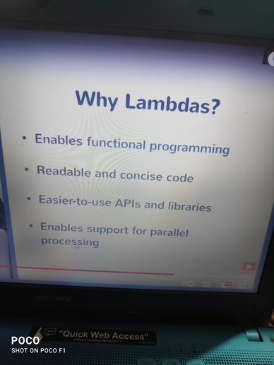

SQL /Database/NoSQL

https://www.guru99.com/sql-interview-questions-answers.html
https://www.interviewbit.com/sql-interview-questions/

What is DBMS?
A Database Management System (DBMS) is a program that controls creation, maintenance and use of a database. DBMS can be termed as File Manager that manages data in a database rather than saving it in file systems.
DBMS is a system software responsible for the creation, retrieval, updation and management of the database. It ensures that our data is consistent, organized and is easily accessible by serving as an interface between the database and its end users or application software’s.

What is RDBMS?
RDBMS stands for Relational Database Management System. RDBMS store the data into the collection of tables, which is related by common fields between the columns of the table. It also provides relational operators to manipulate the data stored into the tables.
The key difference here, compared to DBMS, is that RDBMS stores data in the form of a collection of tables and relations can be defined between the common fields of these tables. Most modern database management systems like MySQL, Microsoft SQL Server, Oracle, IBM DB2 and Amazon Redshift are based on RDBMS.

What is SQL?
SQL stands for Structured Query Language , and it is used to communicate with the Database. This is a standard language used to perform tasks such as retrieval, updation, insertion and deletion of data from a database.
It is the standard language for relational database management systems. It is especially useful in handling organized data comprised of entities (variables) and relations between different entities of the data.
Standard SQL Commands are Select.

What are Tables and Fields?
A table is an organized collection of data stored in the form of rows and columns. Columns can be categorized as vertical and rows as horizontal. The columns in a table are called fields while the rows can be referred to as records.
A table is a set of data that are organized in a model with Columns and Rows. Columns can be categorized as vertical, and Rows are horizontal. A table has specified number of column called fields but can have any number of rows which is called record.
Example:-
Table: Employee.
Field:- Emp ID, Emp Name, Date of Birth.
Data:- A1VEF924, Abhishek, 10/10/1990.

What are Constraints in SQL?
Constraints are used to specify the rules concerning data in the table. Constraint can be used to specify the limit on the data type of table. Constraint can be specified while creating or altering the table statement.It can be applied for single or multiple fields in an SQL table during creation of table or after creation using the ALTER TABLE command. The constraints are:-
- NOT NULL - Restricts NULL value from being inserted into a column.
- CHECK - Verifies that all values in a field satisfy a condition.
- DEFAULT - Automatically assigns a default value if no value has been specified for the field.
- UNIQUE - Ensures unique values to be inserted into the field.
- INDEX - Indexes a field providing faster retrieval of records.
- PRIMARY KEY - Uniquely identifies each record in a table.
- FOREIGN KEY - Ensures referential integrity for a record in another table.

What is a Primary Key?
The PRIMARY KEY constraint uniquely identifies each row in a table. It must contain UNIQUE values and has an implicit NOT NULL constraint.
A table in SQL is strictly restricted to have one and only one primary key, which is comprised of single or multiple fields (columns).
A primary key is a combination of fields which uniquely specify a row. This is a special kind of unique key, and it has implicit NOT NULL constraint. It means, Primary key values cannot be NULL.
CREATETABLE Students ( /* Create table with a single field as primary key */
ID INTNOTNULL
Name VARCHAR(255)
PRIMARYKEY (ID)
);

CREATETABLE Students ( /* Create table with multiple fields as primary key */
ID INTNOTNULL
LastNameVARCHAR(255)
FirstName VARCHAR(255) NOTNULL,
CONSTRAINTPK_Student
PRIMARYKEY (ID, FirstName)
);

ALTERTABLE Students /* Set a column as primary key */
ADDPRIMARYKEY (ID);

ALTERTABLE Students /* Set multiple columns as primary key */
ADDCONSTRAINTPK_Student /*Naming a Primary Key*/
PRIMARYKEY (ID, FirstName);

What is a unique key?
A Unique key constraint uniquely identified each record in the database. This provides uniqueness for the column or set of columns.
A Primary key constraint has automatic unique constraint defined on it. But not, in the case of Unique Key.There can be many unique constraint defined per table, but only one Primary key constraint defined per table.
A UNIQUE constraint ensures that all values in a column are different. This provides uniqueness for the column(s) and helps identify each row uniquely. Unlike primary key, there can be multiple unique constraints defined per table. The code syntax for UNIQUE is quite similar to that of PRIMARY KEY and can be used interchangeably.

CREATETABLE Students ( /* Create table with a single field as unique */
ID INTNOTNULLUNIQUE
Name VARCHAR(255)
);

CREATETABLE Students ( /* Create table with multiple fields as unique */
ID INTNOTNULL
LastNameVARCHAR(255)
FirstName VARCHAR(255) NOTNULL
CONSTRAINTPK_Student
UNIQUE (ID, FirstName)
);

ALTERTABLE Students /* Set a column as unique */
ADDUNIQUE (ID);

ALTERTABLE Students /* Set multiple columns as unique */
ADDCONSTRAINTPK_Student /* Naming a unique constraint */
UNIQUE (ID, FirstName);

Difference between Primary key and Unique key:-
https://www.geeksforgeeks.org/difference-between-primary-key-and-unique-key/
Parameter | PRIMARY KEY | UNIQUE KEY
Basic | Used to serve as a unique identifier for each row in a table. | Uniquely determines a row which isn’t primary key.
NULL value acceptance | Cannot accept NULL values. | Can accept one NULL value.
Number of keys that can be defined in the table | Only one primary key | More than one unique key
Index | Creates clustered index | Creates non-clustered index
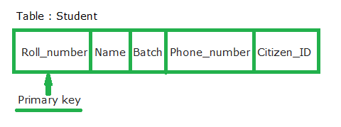

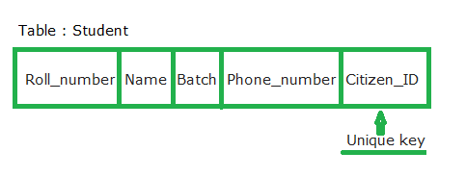

What is a Foreign Key?
A FOREIGN KEY comprises of single or collection of fields in a table that essentially refer to the PRIMARY KEY in another table. Foreign key constraint ensures referential integrity in the relation between two tables.
The table with the foreign key constraint is labelled as the child table, and the table containing the candidate key is labelled as the referenced or parent table.
A foreign key is one table which can be related to the primary key of another table. Relationship needs to be created between two tables by referencing foreign key with the primary key of another table.

CREATETABLE Students ( /* Create table with foreign key - Way 1 */
ID INTNOTNULL
Name VARCHAR(255)
LibraryIDINT
PRIMARYKEY (ID)
FOREIGN KEY (Library_ID) REFERENCES Library(LibraryID)
);

CREATETABLE Students ( /* Create table with foreign key - Way 2 */
ID INTNOT NULL PRIMARY KEY
Name VARCHAR(255)
LibraryIDINTFOREIGN KEY (Library_ID) REFERENCES Library(LibraryID)
);

ALTERTABLE Students /* Add a new foreign key */
ADDFOREIGNKEY (LibraryID)
REFERENCES Library (LibraryID);

Difference between Primary Key and Foreign Key:-
https://www.geeksforgeeks.org/difference-between-primary-key-and-foreign-key/?ref=lbp
Example: Refer the figure –
STUD_NO in STUDENT_COURSE is a foreign key to STUD_NO in STUDENT relation.
Figure:-
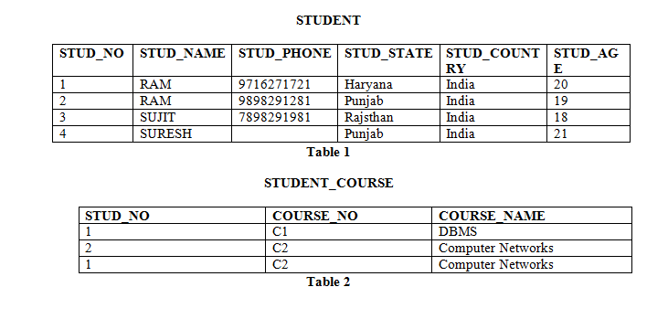

Let’s see the difference between Primary Key and Foreign Key:-
S.NO. | PRIMARY KEY | FOREIGN KEY
1 | A primary key is used to ensure data in the specific column is unique. | A foreign key is a column or group of columns in a relational database table that provides a link between data in two tables.
2 | It uniquely identifies a record in the relational database table. | It refers to the field in a table which is the primary key of another table.
3 | Only one primary key is allowed in a table. | Whereas more than one foreign key are allowed in a table.
4 | It is a combination of UNIQUE and Not Null constraints. | It can contain duplicate values and a table in a relational database.
5 | It does not allow NULL values. | It can also contain NULL values.
6 | Its value cannot be deleted from the parent table. | Its value can be deleted from the child table.
7 | It constraint can be implicitly defined on the temporary tables. | It constraint cannot be defined on the local or global temporary tables.

What is a Join? List its different types:-
The SQL Join clause is used to combine records (rows) from two or more tables in a SQL database based on a related column between the two.There are various types of join which can be used to retrieve data and it depends on the relationship between tables.

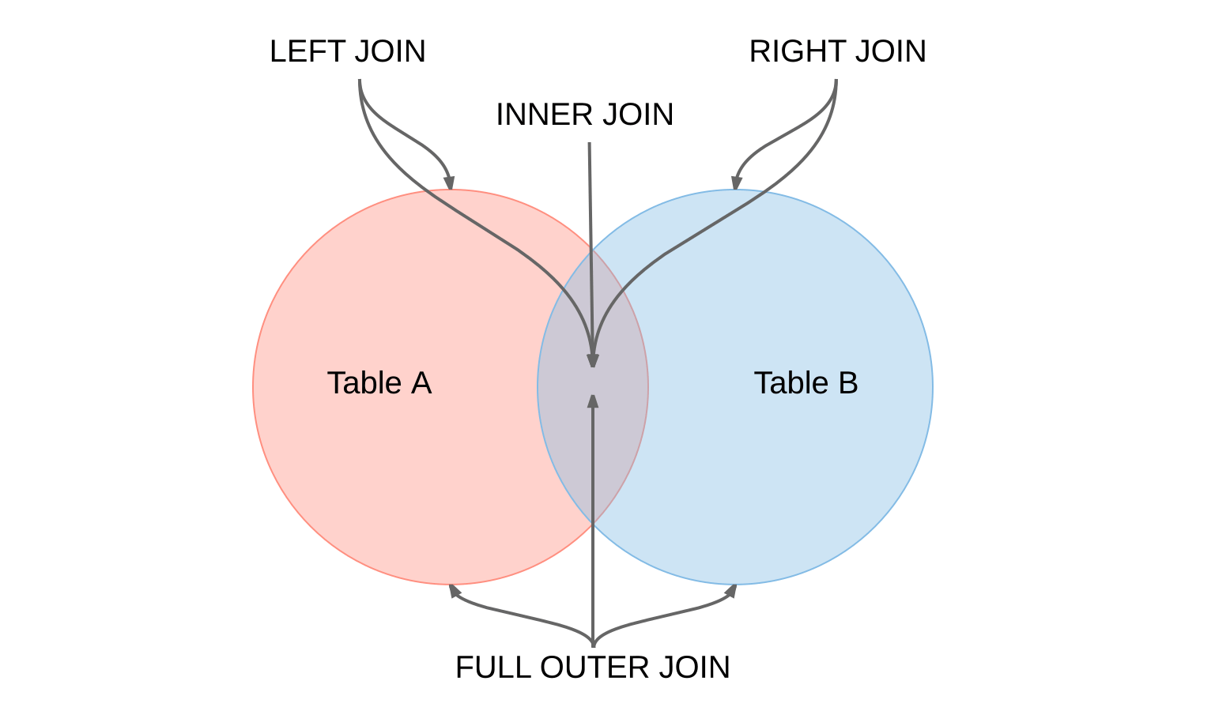
There are four different types of JOINs in SQL:-
(INNER) JOIN:- Retrieves records that have matching values in both tables involved in the join. This is the widely used join for queries.
SELECT*
FROMTable_A
JOINTable_B;

SELECT*
FROMTable_A
INNER JOINTable_B;

LEFT (OUTER) JOIN:- Retrieves all the records/rows from the left and the matched records/rows from the right table.
SELECT*
FROMTable_A A
LEFT JOINTable_B B
ONA.col=B.col;

RIGHT (OUTER) JOIN:- Retrieves all the records/rows from the right and the matched records/rows from the left table.
SELECT*
FROMTable_A A
RIGHT JOINTable_B B
ONA.col=B.col;

FULL (OUTER) JOIN:- Retrieves all the records where there is a match in either the left or right table.
SELECT*
FROMTable_A A
FULL JOINTable_B B
ONA.col=B.col;

What is a Self-Join?
A self-JOIN is a case of regular join where a table is joined to itself based on some relation between its own column(s). Self-join uses the INNER JOIN or LEFT JOIN clause and a table alias is used to assign different names to the table within the query.

SELECTA.emp_idAS"Emp_ID",A.emp_nameAS"Employee",
B.emp_idAS"Sup_ID",B.emp_nameAS"Supervisor"
FROM employee A, employee B
WHEREA.emp_sup=B.emp_id;

What is a Cross-Join?
Cross join can be defined as a cartesian product of the two tables included in the join. The table after join contains the same number of rows as in the cross-product of number of rows in the two tables. If a WHERE clause is used in cross join then the query will work like an INNER JOIN.
SELECT stu.name, sub.subject
FROM students ASstu
CROSSJOIN subjects AS sub;
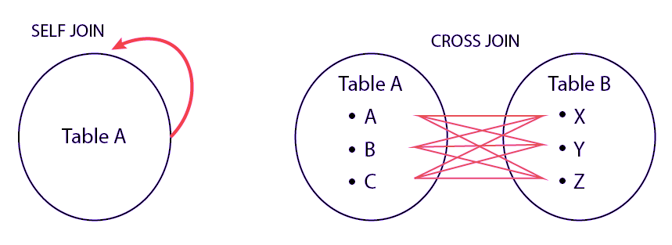

What is an Index? Explain its different types.
A database index is a data structure that provides quick lookup of data in a column or columns of a table. It enhances the speed of operations accessing data from a database table at the cost of additional writes and memory to maintain the index data structure.
CREATEINDEXindex_name/* Create Index */
ONtable_name (column_1, column_2);

DROPINDEXindex_name; /* Drop Index */

There are different types of indexes that can be created for different purposes:-
- Unique and Non-Unique Index:
Unique indexes are indexes that help maintain data integrity by ensuring that no two rows of data in a table have identical key values. Once a unique index has been defined for a table, uniqueness is enforced whenever keys are added or changed within the index.
CREATEUNIQUEINDEXmyIndex
ON students (enroll_no);
Non-unique indexes, on the other hand, are not used to enforce constraints on the tables with which they are associated. Instead, non-unique indexes are used solely to improve query performance by maintaining a sorted order of data values that are used frequently.
- Clustered and Non-Clustered Index:
Clustered indexes are indexes whose order of the rows in the database correspond to the order of the rows in the index. This is why only one clustered index can exist in a given table, whereas, multiple non-clustered indexes can exist in the table.
The only difference between clustered and non-clustered indexes is that the database manager attempts to keep the data in the database in the same order as the corresponding keys appear in the clustered index.
Clustering index can improve the performance of most query operations because they provide a linear-access path to data stored in the database.

What is the difference between Clustered and Non-clustered index?
As explained above, the differences can be broken down into three small factors -
- Clustered index modifies the way records are stored in a database based on the indexed column. Non-clustered index creates a separate entity within the table which references the original table.
- Clustered index is used for easy and speedy retrieval of data from the database, whereas, fetching records from the non-clustered index is relatively slower.
- In SQL, a table can have a single clustered index whereas it can have multiple non-clustered indexes.

Data Structure
Array
https://www.geeksforgeeks.org/array-data-structure/
https://www.geeksforgeeks.org/must-do-coding-questions-for-product-based-companies/#Array
https://www.geeksforgeeks.org/must-do-coding-questions-for-companies-like-amazon-microsoft-adobe/#arrays
https://howtodoinjava.com/java-arraylist/
Arrays.copyOfRange(Object[] src, int from, int to);

System.arraycopy(Object[] src, int srcStartIndex, Object[] dest, int dstStartIndex, int lengthOfCopiedIndices);

SpringFramework

