**Chapter 0**

*"Unless mankind redesigns itself by changing our DNA through altering our genetic makeup, computer-generated robots will take over our world", this is the current scenario of robotics which is one of the most improving fields of technology. It is the branch of technology that deals with the design, construction, operation, structural disposition, manufacture and application of robots. Due to its massive developmental improvement it tends to replace men in most of the scenarios. The most important rules of robotics as stated by Isaac Asimov is as follows:*

1. *A robot may not injure a human being, or, through inaction, allow a human being to come to harm.*
2. *A robot must obey the orders given it by human beings except where such orders would conflict with the First Law.*
3. *A robot must protect its own existence as long as such protection does not conflict with the First or Second Laws.*

*As a part of our degree completion we have tried our best to incorporate all the knowledge that has been inculcated to us such in the fields of mechanical, electrical, electronics and computer engineering. Being students of Information Technology it has been a challenging job to take up this idea as it not only involves the coding knowledge on which we are trained but also involves concepts from all other branches of engineering. Trying our hands in the most growing field of technology, Robotics it is not that easy to invent new things as it is a matter of cost and time. Hence we have taken an ultimatum effort to use many motors and sensors with a basic developer board in 8051’s family called as ATMEL 89S52 to perform all the hyper actions. Thus our humanoid bipedal robot with ODMTS poses an economical method for devising a robot. This is extremely essential, because as for now robots are created on a massive cost which the main reason for why these humanoid robots can’t be used on a large scale to help people. Hence our method overrides this discrepancy as it provides a best and an economical method for robots to be fabricated.*



**SWG VERTICAL VIEW INNOVATORS**

Obviously everyone wants to be successful, but we wanted to be looked back on as being very innovative, very trusted, and ethical and ultimately  
making a big difference in the world. This led to our SWG group to emerge as vertical innovators where each and everything has to be observed in a different  
way. The number one benefit of information technology is that it empowers people to do what they want to do. It lets people be creative. It lets people to be  
productive. It lets people learn things which they would have not thought they could learn before, and so in a sense it is all about potential. So we have put in our knowledge  
gained from the IT field to all other fields of engineering. We did not want to restrict ourselves to code programs but to implement a real time system that  
works according to our commands. Hence it is just a start to our career and we are also focusing to build this project on R&D basis. “Never before in history has innovation offered promise of so much to so many in so short time”, hence we are proud for our humanoid robot which was designed in a very short period of time.

**ELECTRONICS PLATFORM RESEARCH LABS**

Electronics Platform Research Labs is a Research and Development organization incorporated to provide fantastic platforms for students and embedded engineers round the globe. Our products are enhanced to make users aware of the embedded technology and instill a confidence that immensely inspires them to innovate and create, all by themselves, in a short period of time. EPRLABS has created a new trend in designing high-class micro controller boards for people ranging from an amateur to a professional. Our products have created a new benchmark in embedded platform development domain. we have also made new standards in designing the sub-platforms making the users feel more comfortable in developing their products. We offer a wide range of products for a wide range of customers. We also provide support for our customers in choosing the right platforms.

**OVERVIEW OF SWG DREAMS ROBOT**

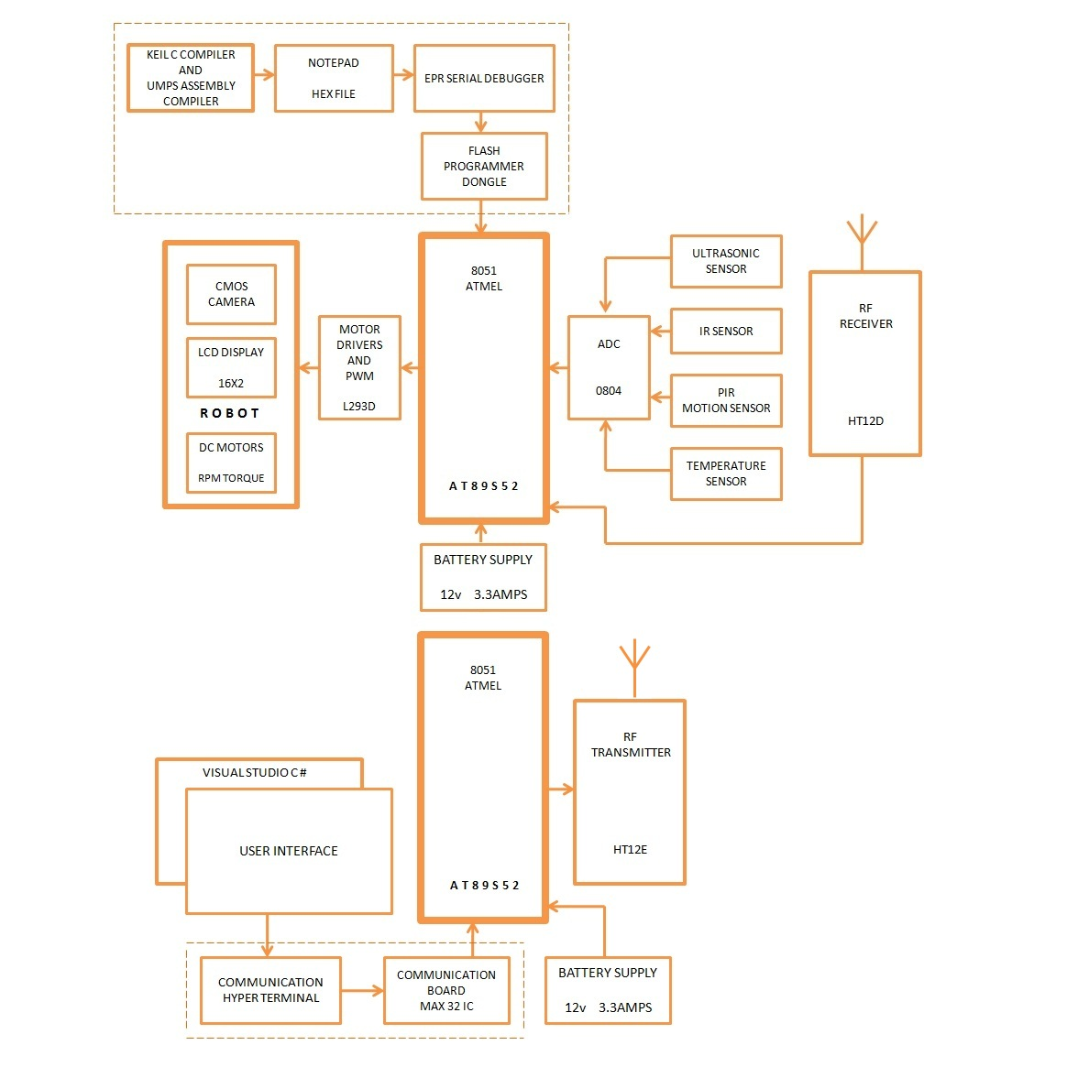

*Fig 0.1 Overview block of SWG Dreams Robot*

**MODULES OVERVIEW**

All the modules are split up into chapters

**Chapter 1** covers the mechanical module which briefs about the structure, design and mechanisms involved in it.

**Chapter 2** deals with electronics which briefs about the circuit design the, controller boards used several sensors modules and also the interfacing techniques.

**Chapter 3** deals with the RF module which tells about the RF circuits used for transmission and reception their design and techniques for effective signal passing.

**Chapter 4** covers the test case modules of our project and the test certification from the embedded platform research labs