**Chapter 2**



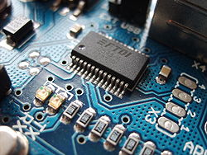

*The history of electronics is a story of the twentieth century and three key components—the* [*vacuum tube*](http://science.jrank.org/pages/7139/Vacuum-Tube.html)*, the* [*transistor*](http://science.jrank.org/pages/6925/Transistor.html)*, and the* [*integrated circuit*](http://science.jrank.org/pages/3619/Integrated-Circuit.html)*. In 1883, Thomas Alva Edison discovered that electrons will flow from one metal conductor to another through a* [*vacuum*](http://science.jrank.org/pages/7137/Vacuum.html)*. This discovery of conduction became known as the Edison effect. In 1904, John Fleming applied the Edison effect in inventing a two-element* [*electron*](http://science.jrank.org/pages/2374/Electron.html) *tube called a* [*diode*](http://science.jrank.org/pages/2101/Diode.html)*, and Lee De Forest followed in 1906 with the three-element tube, the triode. These vacuum tubes were the devices that made manipulation of electrical* [*energy*](http://science.jrank.org/pages/2491/Energy.html) *possible so it could be amplified and transmitted.*  
*This chapter deals with the detailed description and the contribution of electronics in robotics.*

Outline:

2.0 PC to Microcontroller Communication

2.1 Interfacing L293D with AT 89S52

2.1.0 Skeleton Code for motor access using Drivers

2.2 Sensors

2.2.0 Interfacing Sensor with AT89S52 using ADC 0804

2.2.1 Interfacing LCD with AT89S52

2.2.2 Ultrasonic Sensor, Working Principle, Circuit

2.2.3 PIR Sensor, Working Principle, Circuit

2.2.4 IR Sensor, Working Principle, Circuit

2.2.5 Touch Plate, Working Principle, Circuit

2.2.6 Temperature Sensor, Working Principle, Circuit

2.3 Power Supply

2.3.0 Why is Battery Capacity Specified in Ampere-Hour?

2.3.1Calculating Voltage-Ampere-Hrs

*Appendices B. References*

**2.0 PC TO MICROCONTROLLER COMMUNICATION**

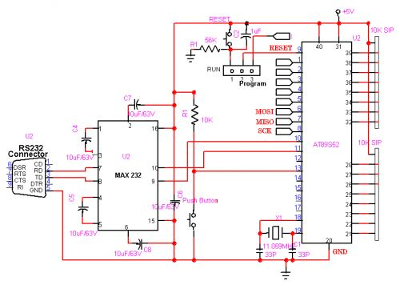.

*Fig 2.0 Basic Circuit Diagram for PC to Microcontroller Communication*

Using the Serial Port [1]8051 provides a transmit channel and a receive channel of serial communication. The transmit data pin (TXD) is specified at P3.1, and the receive data pin (RXD) is at P3.0. The serial signals provided on these pins are TTL signal levels and must be boosted and inverted through a suitable converter (MAX232) to comply with RS232[2] standard. All modes are controlled through SCON[3], the Serial control register. The SCON bits are defined as SM0, SM1, SM2, REN, TB8, RB8, TI and RI from MSB to LSB. The timers are controlled using TMOD, the Timer MOD e register, and TCON, the Timer control register.

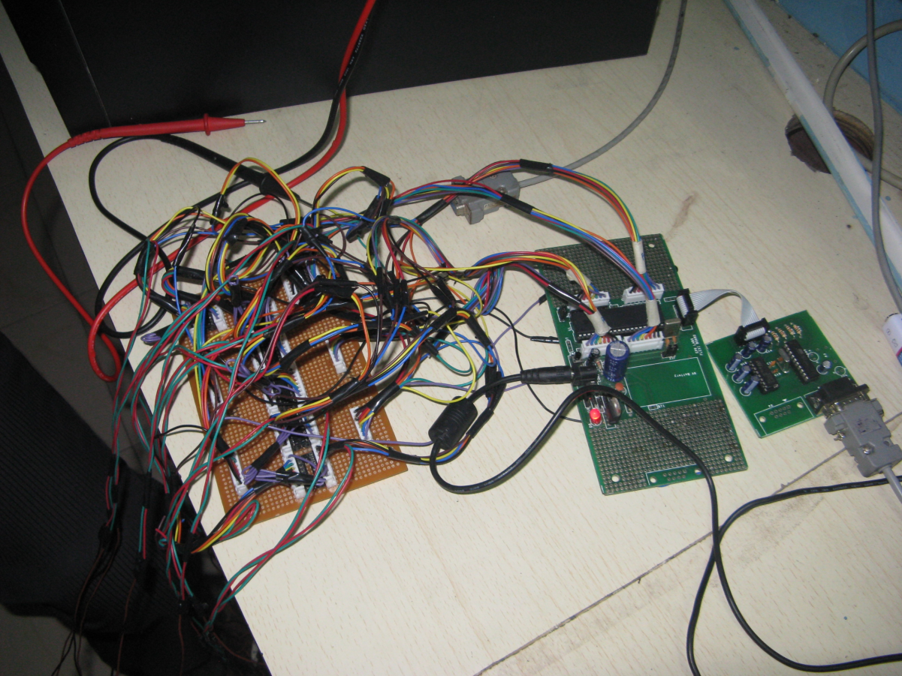

**2.1 INTERFACING L293D[4][5] WITH AT89S52[6]**

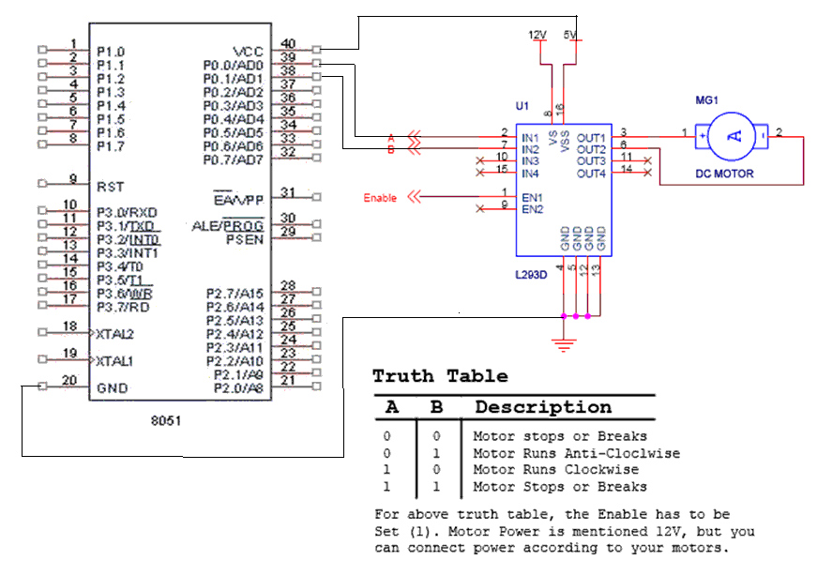

*Fig2.1 Interfacing L293D with AT89S52*

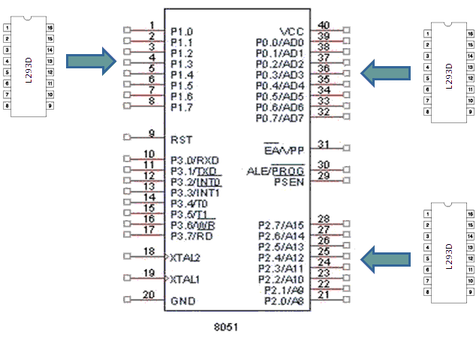

**2.1.0 Skeleton Code for motor access using Drivers**

//header_files AT89S52

#include <REGX51.H>

//delay

void wait(const unsigned int d)

{

for(a=0;a<d;a++)

{

for(a=0;a<d;a++);

}

}

//main_function

void main()

{

//repeat_fivetimes

for (i=0; i<10; i++)

{

stop_head();

stop_hands();

stop_joints();

stop_joint_right();

stop_joint_left();

stop_hips();

stop_knees();

stop_foots();

head_left();

stop_head();

lefthand_backward();

stop_hands();

lefthip_up();

leftknee_up();

leftfoot_forward();

stop_hips();

stop_knees();

stop_foots();

head_right();

stop_head();

righthand_forward();

stop_hands();

righthip_up();

lefthip_down();

rightknee_up();

leftknee_down();

rightfoot_forward();

righthip_down();

rightknee_down();

stop_hips();

stop_knees();

stop_foots();

}

while(1)

{

stop_head();

stop_hands();

stop_joints();

stop_joint_right();

stop_joint_left();

stop_hips();

stop_knees();

stop_foots();

}

}

**2.2 SENSORS**

A **sensor** is a device that measures a physical quantity and converts it into a signal which can be read by an observer or by an instrument. For example, a [mercury-in-glass thermometer](http://en.wikipedia.org/wiki/Mercury-in-glass_thermometer) converts the measured temperature into expansion and contraction of a liquid which can be read on a calibrated glass tube. A [thermocouple](http://en.wikipedia.org/wiki/Thermocouple) converts temperature to an output voltage which can be read by a [voltmeter](http://en.wikipedia.org/wiki/Voltmeter).

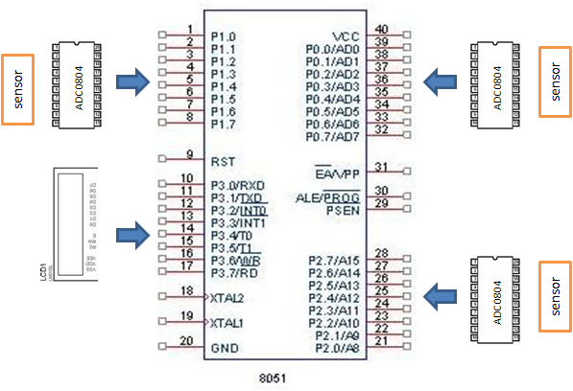**2.2.0 Interfacing Sensor with AT89S52 using ADC 0804**[7]

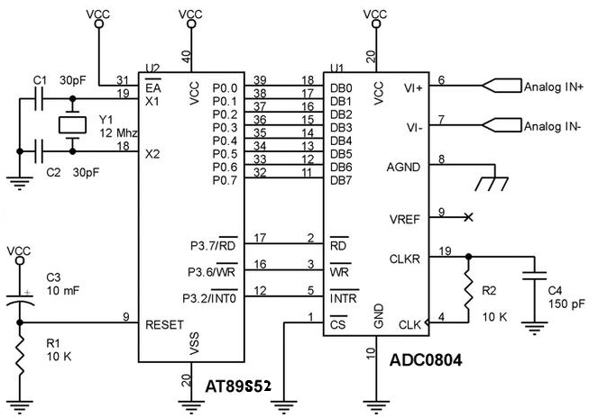

*Fig 2.2 Interfacing Sensor with AT89S52 using ADC 0804*

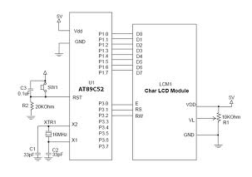**2.2.1 Interfacing LCD[8] with AT89S52**

*Fig 2.3 Interfacing LCD with AT89S52*

**2.2.2 Ultrasonic Sensor, Working Principle, Circuit**

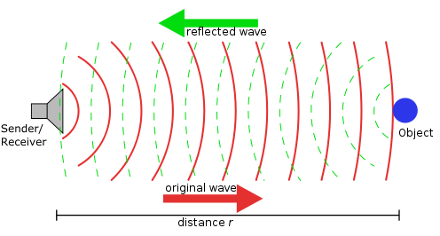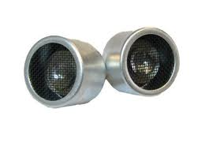Ultrasonic sensors (also known as transceivers when they both send and receive) work on a principle similar to radar or sonar which evaluate attributes of a target by interpreting the echoes from radio or sound waves respectively. Ultrasonic sensors generate high frequency sound waves and evaluate the echo which is received back by the sensor. Sensors calculate the time interval between sending the signal and receiving the echo to determine the distance to an object.

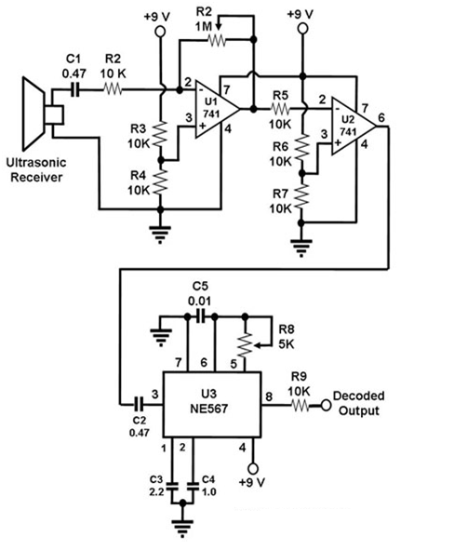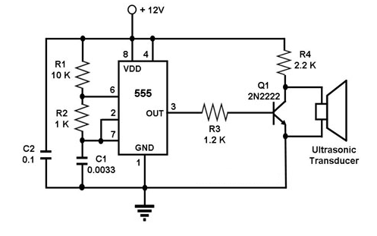

*Fig 2.4 Circuit diagram for ultrasonic Sensor*

**2.2.3 PIR Sensor, Working Principle, Circuit**

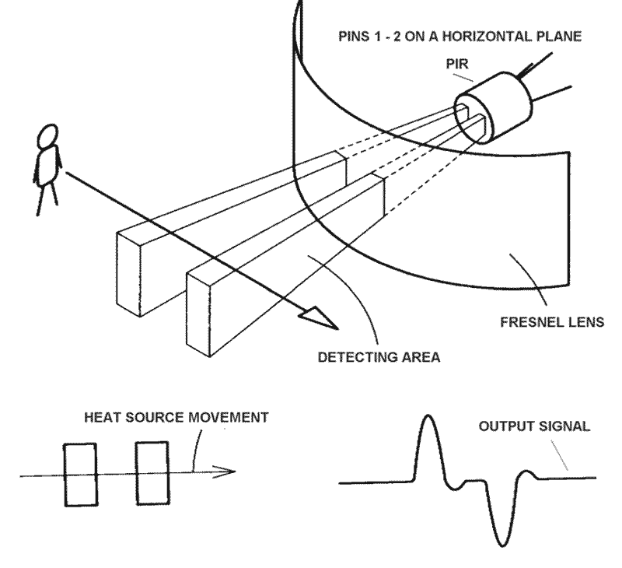[9]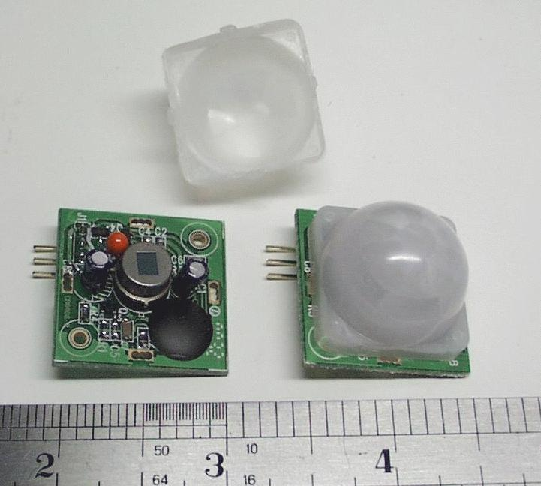A Passive Infrared sensor (PIR sensor) is an [electronic device](http://en.wikipedia.org/wiki/Electronic_device) that measures [infrared](http://en.wikipedia.org/wiki/Infrared) (IR) light radiating from objects in its field of view. PIR sensors are often used in the construction of PIR-based [motion detectors](http://en.wikipedia.org/wiki/Motion_detector) (see below). Apparent motion is detected when an infrared source with one [temperature](http://en.wikipedia.org/wiki/Temperature), such as a [human](http://en.wikipedia.org/wiki/Human), passes in front of an infrared source with another temperature, such as a [wall](http://en.wikipedia.org/wiki/Wall).

All objects above [absolute zero](http://en.wikipedia.org/wiki/Absolute_zero) emit energy in the form of radiation. It is usually infrared radiation that is invisible to the [human eye](http://en.wikipedia.org/wiki/Human_eye) but can be detected by electronic devices designed for such a purpose.

The term passive in this instance means that the PIR device does not emit an infrared beam but merely passively accepts incoming infrared radiation.

“Infra” meaning below our ability to detect it visually, and “Red” because this color represents the lowest energy level that our eyes can sense before it becomes invisible.

Thus, infrared means below the energy level of the color red, and applies to many sources of invisible energy.

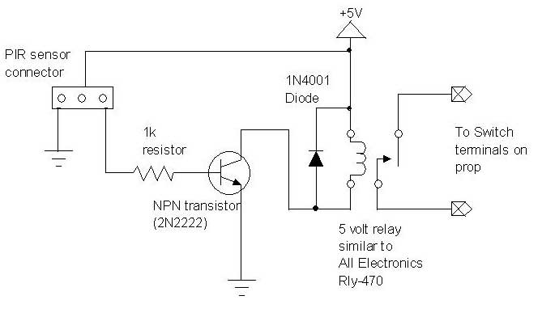

*Fig 2.5 Circuit diagram for PIR sensor*

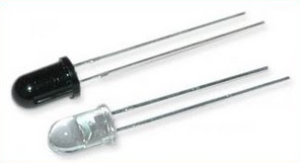**2.2.4 IR Sensor, Working Principle, Circuit**

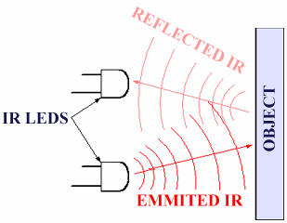It is the same principle in ALL Infra-Red proximity sensors. The basic idea is to send infra red light through IR-LEDs, which is then reflected by any object in front of the sensor. Then all you have to do is to pick-up the reflected IR light. For detecting the reflected IR light, we are going to use a very original technique: we are going to use another IR-LED, to detect the IR light that was emitted from another led off the exact same type. This is an electrical property of Light Emitting Diodes (LEDs) which is the fact that a led produces a voltage difference across its leads when it is subjected to light. As if it was a photo-cell, but with much lower output current. In other words, the voltage generated by the led’s can't be - in any way - used to generate electrical power from light, It can barely be detected. That is why as you will notice in the schematic, we are going to use an Op-Amp (operational Amplifier) to accurately detect very small voltage changes.

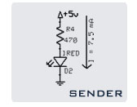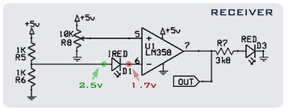

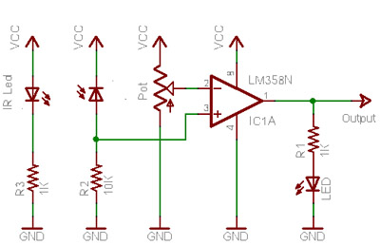[10]

*Fig 2.6 Circuit diagram for IR sensor*

**2.2.5 Touch Plate, Working Principle, Circuit**

In the Touch Switch two leads must be shorted together by your finger touching them. In the Touch Plate only one plate needs to be touched. The Touch Switch only needs a battery to activate it butte Touch Plate requires a mains power supply.

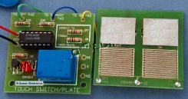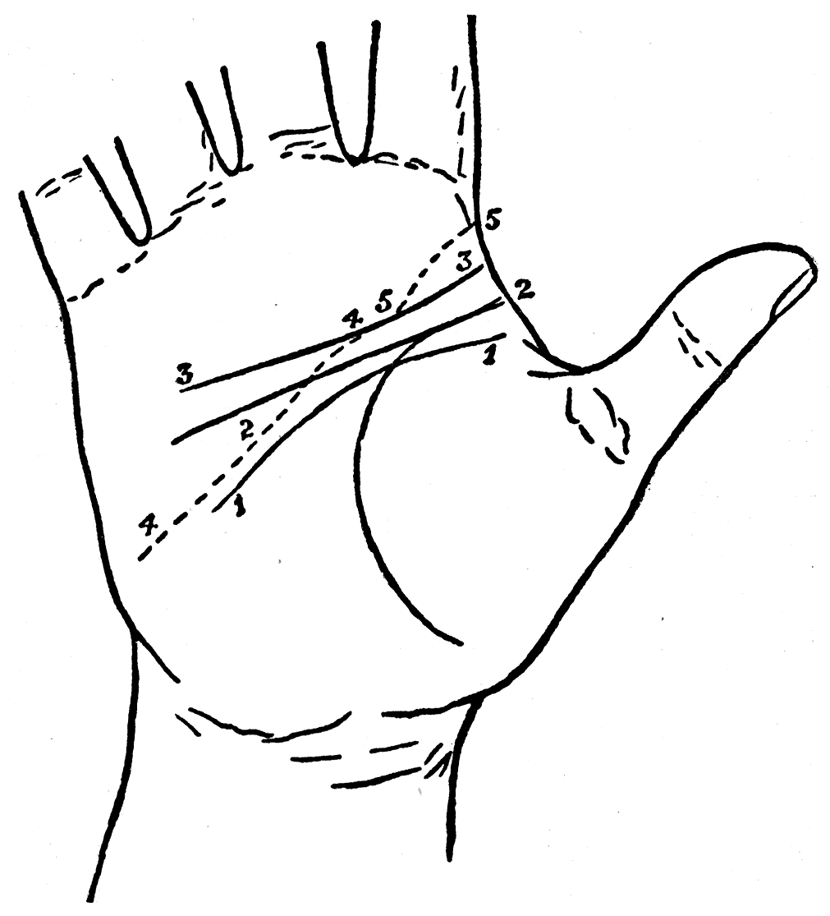

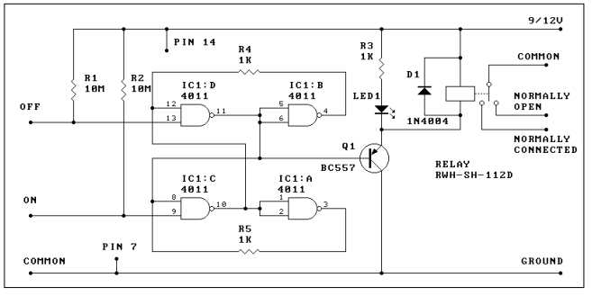

*Fig 2.7 Circuit diagram for touch sensor*

**2.2.6 Temperature Sensor, Working Principle, Circuit**

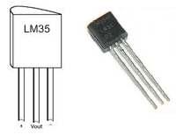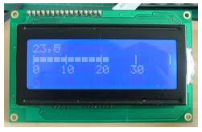A temperature sensor is a device that gathers data concerning the temperature from a source and converts it to a form that can be understood either by an observer or another device. Temperature sensors come in many different forms and are used for a wide variety of purposes, from simple home use to extremely accurate and precise scientific use. They play a very important role almost everywhere that they are applied; knowing the temperature helps people to pick their clothing before a walk outside just as it helps chemists to understand the data collected from a complex [chemical](http://www.wisegeek.com/what-is-a-chemical.htm) reaction.

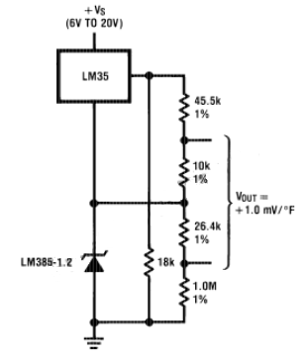[11]

*Fig 2.8 Circuit diagram for Temperature sensor*

**2.3 POWER SUPPLY**

A power supply is a device that supplies [electrical](http://en.wikipedia.org/wiki/Electrical) [energy](http://en.wikipedia.org/wiki/Energy) to one or more [electric loads](http://en.wikipedia.org/wiki/External_electric_load). The term is most commonly applied to devices that convert one form of electrical energy to another, though it may also refer to devices that convert another form of energy (e.g., mechanical, chemical, solar) to electrical energy. A [regulated power supply](http://en.wikipedia.org/wiki/Regulated_power_supply) is one that controls the output voltage or current to a specific value; the controlled value is held nearly constant despite variations in either load current or the voltage supplied by the power supply's energy source.

**Electrical Battery**

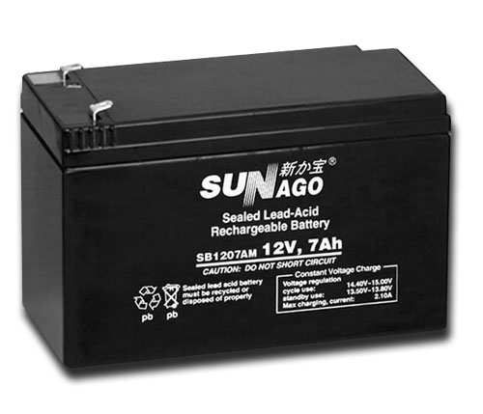An electrical battery is one or more [electrochemical cells](http://en.wikipedia.org/wiki/Electrochemical_cell) that convert stored chemical [energy](http://en.wikipedia.org/wiki/Energy) into electrical energy.  There are two types of batteries: [primary batteries](http://en.wikipedia.org/wiki/Primary_battery) (disposable batteries), which are designed to be used once and discarded, and [secondary batteries](http://en.wikipedia.org/wiki/Secondary_battery) (rechargeable batteries), which are designed to be recharged and used multiple times. Batteries come in many sizes; from miniature cells used to power [hearing aids](http://en.wikipedia.org/wiki/Hearing_aid) and wristwatches to battery banks the size of rooms that provide standby power for telephone and computer [data centers](http://en.wikipedia.org/wiki/Data_center).

## 2.3.0 Why is Battery Capacity Specified in Ampere-Hour?

An ampere is a unit for measurement for the amount of electricity current flowing through a circuit. One ampere is the same as one coulomb of electric charge flowing past any point per second. It is also the same as current produced by one volt of electricity applied across a 1-ohm resistance. One ampere-hour is equal to a current of one ampere flowing for one hour. So, if you have a two ampere-hour battery, then it has the capacity to flow a two-ampere current for one hour. Or you can use the same battery to flow a one-ampere current for two hours. Therefore, a larger Ah always specifies higher capacity.

**2.3.1Calculating Voltage-Ampere-Hrs**

Watt = amp * volt *(hours)

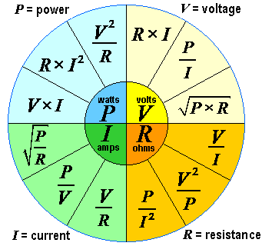

1. *Serial port is a*[*serial communication*](http://en.wikipedia.org/wiki/Serial_communication)*physical interface through which information transfers in or out one*[*bit*](http://en.wikipedia.org/wiki/Bit)*at a time.*
2. *RS-232 (Recommended Standard 232) is the traditional name for a series of standards for*[*serial*](http://en.wikipedia.org/wiki/Serial_communications)*binary ended data and*[*control*](http://en.wikipedia.org/wiki/Control_signal)*signals connecting between a DTE (*[*Data Terminal Equipment*](http://en.wikipedia.org/wiki/Data_Terminal_Equipment)*) and a DCE (*[*Data Circuit-terminating Equipment*](http://en.wikipedia.org/wiki/Data_circuit-terminating_equipment)*).*
3. *The serial port is full duplex, meaning it can transmit and receive simultaneously. It is also receive-buffered, meaning it can commence reception of a second byte before a previously received byte has been read from the register.*
4. \**IC: integrated circuit (also known as IC, microcircuit, microchip, silicon chip, or chip) is a miniaturized electronic circuit (consisting mainly of semiconductor devices, as well as passive components) that has been manufactured in the surface of a thin substrate of semiconductor material.*
5. *L293D is a dual H-Bridge motor driver, So with one IC we can interface two DC motors which can be controlled in both clockwise and counter clockwise direction and if you have motor with fix direction of motion the you can make use of all the four I/Os to connect up to four DC motors.* 
6. *ATMEL 89S52 is microcontroller with 40 pins of 8051 family.*

   *For detailed description refer appendix B*
7. *The ADC0801, ADC0802, ADC0803, ADC0804 and ADC0805 are CMOS 8-bit successive approximation A/D converters that use a differential potentiometer ic ladder-similar to the 256R products. These converters are designed to allow operation with the NSC800 and INS8080A derivative control bus with TRI-STATE output latches directly driving the data bus. These A/Ds appear like memory locations or I/O ports to the microprocessor and no interfacing logic is needed.*

   *\* RESISTOR: A resistor is a two-terminal electrical or electronic component that resists an electric current by producing a voltage drop between its terminals in accordance with Ohm's law R = V/I*
8. *Liquid crystal display (LCD) is a thin, flat*[*electronic visual display*](http://en.wikipedia.org/wiki/Electronic_visual_display)*that uses the light modulating properties of*[*liquid crystals*](http://en.wikipedia.org/wiki/Liquid_Crystals)*(LCs). LCs do not emit light directly.*

   *For detailed description refer appendix B*

   *\* Capacitor: A capacitor is an electrical device that can store energy in the electric field between a pair of closely spaced conductors (called 'plates'). When current is applied to the capacitor, electric charges of equal magnitude, but opposite polarity, build up on each plate.* C=Q/V
9. *\*LED: A light-emitting diode (LED) is a semiconductor device that emits incoherent narrow-spectrum light when electrically biased in the forward direction of the p-n junction. This effect is a form of electroluminescence.*
10. *\*TRANSISTOR: A transistor is a semiconductor device, commonly used as an amplifier or an electrically controlled switch. The transistor is the fundamental building block of the circuitry that governs the operation of computers, cellular phones, and all other modern electronics.*

    * *DIODE: diode is a component that restricts the direction of flow of charge carriers. Essentially, it allows an electric current to flow in one direction, but blocks it in the opposite direction. Thus, the diode can be thought of as an electronic version of a check valve. Circuits that require current flow in only one direction typically include one or more diodes in the circuit design.*
11. *RELAY: *When a coil of wire is wound on a non magnetic material such as plastic, paper etc. ,it is called a air-core solenoid or simply a solenoid .if a soft iron core is inserted into the coil, it becomes an electromagnet. This electromagnet is the basic component for relay and many other electromechanical devices such as electric bell, circuit breaker etc...*