**Chapter 3**

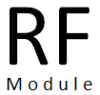

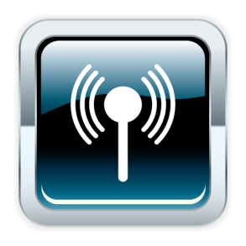

*.*

*Radio Frequency remote controller is a device used to transmit the wireless signal from one point to another. The remote controllers are classified based on the type of signals that is used to transmit data (information).*

*This chapter deals with the detailed description and the contribution of RF Module in robotics.*

Outline:

3.0 Radio Frequency Remote Controller

3.1 Remote Controller Types and Basics

3.1.1 RF remote

3.1.2 Designing RF remote using Encoder and Decoder

3.1.3 Designing RF Using UART

3.2 Skeleton code for receiver side

3.3 Skeleton code for transmitter side

*Appendices C. References*

**3.0 Radio Frequency Remote Controller**

Radio Frequency remote controller is a device used to transmit the wireless signal from one point to another. The remote controllers are classified based on the type of signals that is used to transmit data (information).

**3.1 Remote Controller Types and Basics**

Remote controllers are classified based on the types of signals that are used in transmission and reception. So the property and application of remote controller depends on the characteristics or nature of the signal which is used in the remote.

Before going through the various remotes controllers available, let us see back ground of all signals present in this universe which we call as spectrum.

*Radio – Microwave – Infrared – Visible – Ultraviolet – X-ray –Gamma Ray*

**3.1.1 RF [1]remote**

Uses RF (Radio Pulses) signal, radio part of the electromagnetic spectrum, Range 100 feet. It can go through walls and around corners.

RF remote uses Radio Frequency signals to transmit data.

RF remote can be considered,

1. If the operating device range is around 100 feet
2. If the signal has to penetrate the walls.

**3.1.2 Designing RF remote using Encoder [2]and Decoder[3]**

RF Transmitter module and RF Receiver module are used for transmitting and receiving the data respectively. RF modules are used to transmit the RF signal using ASK modulation technique and also it can be tuned to work at 433 MHz

It can operate from 3 volt to 12 volts. We can generate and receive the different signals (data) using encoder at the transmitting side and decoder at the receiving side respectively.   
Encoders are used to transmit the parallel data (Various Keys) into serial data which the RF transmitter can understand and transmit it to the RF receiver.  RF receiver receives the serial data and gives it to decoders, which in turn converts the serial data from RF receiver to the Device which is getting controlled.



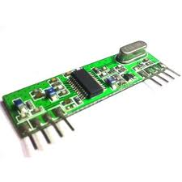

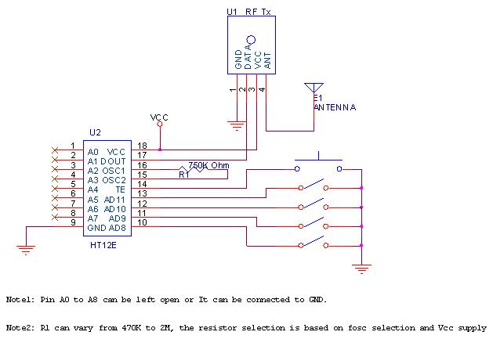

*Fig 3.0 Interfacing Transmitter with HT12E [4]Encoder*

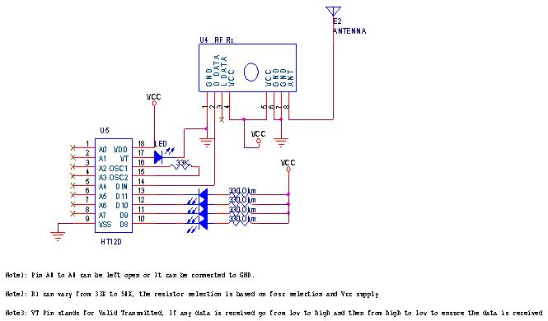

*Fig 3.1 Interfacing Receiver with HT12D [5]Decoder*

**3.1.3 Designing RF Using UART**

Instead of Encoder and Decoder we can also use with UART[6] Tx pin for RF transmitter and UART Rx pin for RF receiver in microcontroller. If we need to control more than 100 devices we need to rely on encoder and decoder with 100 data lines which will be very costly. To control more than 100 devices we can choose microcontroller function as encoder in the transmission side and another microcontroller to function as decoder in the receiver side.

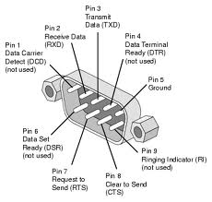

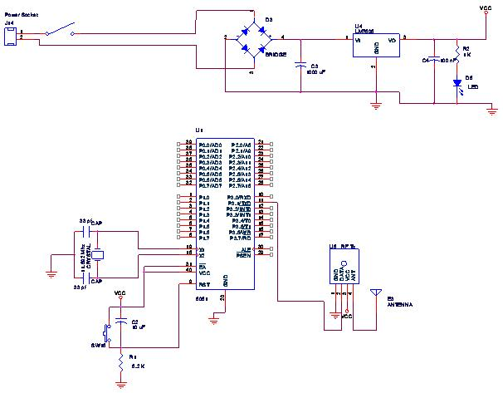

*Fig 3.2 Interfacing Transmitter with ATMEL IC using UART*

This is basic circuit of remote control transmitter, we can add more number of keys to the microcontroller in matrix form please see the diagram below; in this circuit we connected 16 keys. We can connect up to 256 keys if we use all the ports.

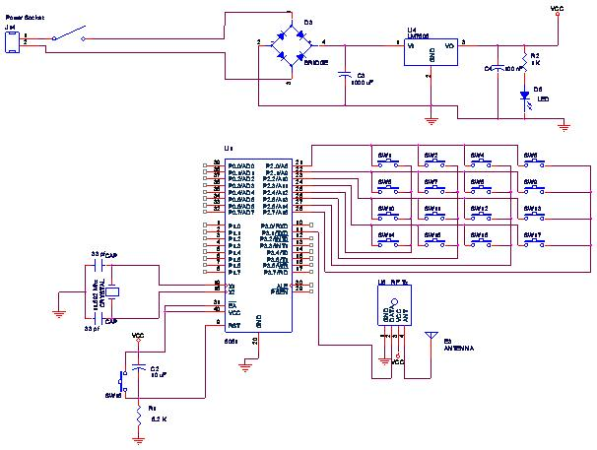

The basic circuit for remote control receiver is shown below, if we need to control more of devices either we can use port expander or we can go-ahead and choose the microcontroller which has more number of ports, provided it should have UART support.

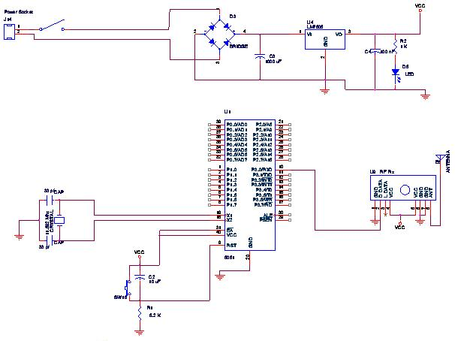

*Fig 3.4: Interfacing Receiver with ATMEL IC*

We have shown the receiver connected with 16 led’s. For each key press the transmitter side, we can assign unique LED to glow in the receiver.

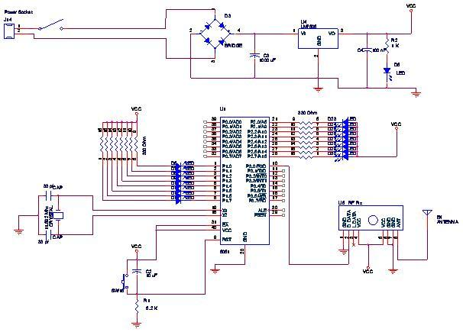

*Fig 3.3 Interfacing Receiver with ATMEL IC using UART*

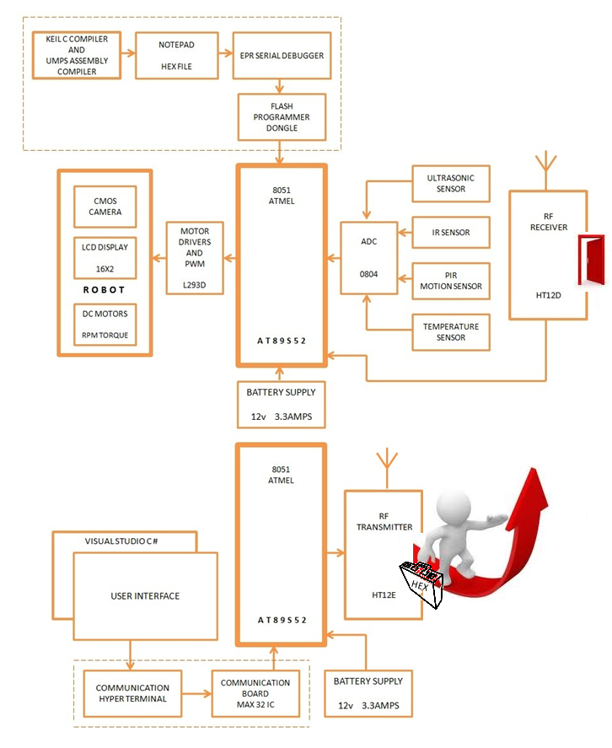

**3.2 Skeleton code for receiver side**

#include<reg52.h>

void main()

{

serial_init();

serial_write('O');

serial_write('K');

while(1)

{

a = serial_read();

switch (a)

{

case 48://1

{

break; //walk front()

}

case 49://2

{

break;//move left()

}

case 50://3

{

break;//stop()

}

case 51://4

{

break;//move right()

}

case 52://5

{

break;//move back()

}

case 53://6

{

break;//handshake()

}

case 54://7

{

break;//skate()

}

case 55://8

{

break;//speak()

}

default://0

{

break;//stop()

}

}

}

**3.3 Skeleton code for transmitter side**

#include<reg52.h>

void main()

{

serial_init();

serial_write('O');

serial_write('K');

while(1)

{

a = serial_read();

switch (a)

{

case '0':

{

serial_write(48); break; //walk front()

}

case ‘1’:

{

serial_write(49); break; move left()

}

Case’2’: {

serial_write(50); break; stop()

}

case ‘3’:

{

serial_write(51); break; move right()

}

case ‘4’:

{

serial_write(52); break; move back()

}

case ‘5’:

{

serial_write(53); break; //handshake()

}

case ‘6’:

{

serial_write(54); break; //skate()

}

case ‘7’:

{

serial_write(55); break; //speak()

}

default://0

{

serial_write(50); break; //stop()

}

}

}

}

1. *Radio frequency (RF) is a rate of oscillation in the range of about 3*[*kHz*](http://en.wikipedia.org/wiki/KHz)*to 300*[*GHz*](http://en.wikipedia.org/wiki/Gigahertz)*, which corresponds to the*[*frequency*](http://en.wikipedia.org/wiki/Frequency)*of*[*radio waves*](http://en.wikipedia.org/wiki/Radio_waves)*, and the*[*alternating currents*](http://en.wikipedia.org/wiki/Alternating_current)*which carry radio signals.*
2. *An****encoder****is a device, circuit, transducer, software program, algorithm or person that*[*converts*](http://en.wikipedia.org/wiki/Encoding)*information from one format or*[*code*](http://en.wikipedia.org/wiki/Code)*to another, for the purposes of standardization, speed, secrecy, security, or saving space by shrinking size.*
3. *A decoder is a device which does the reverse of an*[*encoder*](http://en.wikipedia.org/wiki/Encoder)*, undoing the encoding so that the original information can be retrieved. The same method used to encode is usually just reversed in order to decode*
4. HT12E

   Refer Appendix C for detailed description
5. HT12D

   Refer Appendix C for detailed description
6. *A universal asynchronous receiver/transmitter, abbreviated UART), is a type of "asynchronous receiver/transmitter", a piece of computer*[*hardware*](http://en.wikipedia.org/wiki/Hardware)*that translates data between*[*parallel*](http://en.wikipedia.org/wiki/Parallel_communication)*and*[*serial*](http://en.wikipedia.org/wiki/Serial_communication)*forms. UARTs are commonly used in conjunction with communication standards such as*[*EIA*](http://en.wikipedia.org/wiki/Electronic_Industries_Alliance)[*RS-232*](http://en.wikipedia.org/wiki/RS-232)*,*[*RS-422*](http://en.wikipedia.org/wiki/RS-422)*or*[*RS-485*](http://en.wikipedia.org/wiki/RS-485)*. The universal designation indicates that the data format and transmission speeds are configurable and that the actual electric signaling levels and methods (such as*[*differential signaling*](http://en.wikipedia.org/wiki/Differential_signaling)*etc) typically are handled by a special driver circuit external to the UART.*