**Chapter 5**

Trying our hands in the most growing field of technology, Robotics it is not that easy to invent new things as it is a matter of cost and time. Hence we have taken an ultimatum effort to use many motors and sensors with a basic developer board in 8051’s family called as ATMEL 89S52 to perform all the hyper actions. Thus our humanoid bipedal robot with ODMTS poses an economical method for devising a robot. This is extremely essential, because as for now robots are created on a massive cost which the main reason for why these humanoid robots can’t be used on a large scale to help people. Hence our method overrides this discrepancy as it provides a best and an economical method for robots to be fabricated.

Thus it’s been a great experience for us working on this project. We are indeed very proud as we have implemented all the ideas that we had during the initial stage. Working on this project has also taught us a lot of new concepts and technologies. It has made us to be open to the amazing changes which are occurring in the field that interested us. It is also a great privilege to us because our project can be claimed as a green project as it can be recycled without any harm. Not giving it a pause with this implementation work we have planned to focus this idea on a research basis.

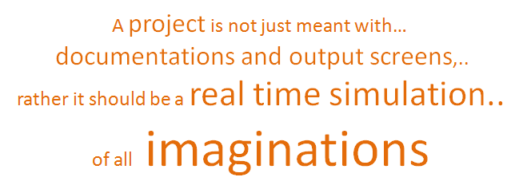

***Let the dreams continue . . .***

