**APPENDIX A**

**MECHANICAL**

**Literature Survey**

**A Unified Control Frame for Stable Bipedal Walking**

A unified control frame to regulate possible undesired motions, which may occur throughout a bipedal walking motion. The proposed frame is based on the combination of orientation control, ZMP control and upper body motion regulation to be able to cope with distinct restriction factors and maintain dynamic balance in a feasible way. It can be plugged into one mass model based trajectory generation methods with inverse kinematics solutions. In order to validate our proposed control frame, we used ZMP based trajectory generation approach and performed several simulations and experiments. In conclusion, we obtained reasonable amounts of decreases in undesired yaw moment, orientation error and ZMP error.

**Bipedal Walking Pattern Generation**



**Development of a Bipedal Humanoid Robot** **Control Method of Whole Body Cooperative Dynamic Biped Walking**

The bipedal humanoid robot expected to play an active role in human living space, through studies on an anthropomorphic biped walking robot. As the first stage of developing a bipedal humanoid robot, the authors developed the human-size 35 active DOF bipedal humanoid robot “WABIAN” and the Human-size 41 active DOF bipedal humanoid robot “WABIAN-R”. The authors also proposed a basic control method of whole body cooperative dynamic biped walking that uses trunk or trunk-waist cooperative motion to compensate for three-axis (pitch, roll and yaw-axis) moment generated not only by the motion of the lower-limbs planned arbitrarily but by the time trajectory of the hands planned arbitrarily. Using these systems and the control method, normal biped walking forward and backward), dynamic dance waving arms and hip, dynamic carrying of a load using its arms, and trunk-waist cooperative dynamic walking are achieved.

**Walking control method: Outline of the walking control method**

The authors previously developed the control method of dynamic biped walking for biped walking robots as follows.

(1) Model based walking control (ZMP and yaw axis moment control)

(2) Robust walking using the compensation mechanism of the model deviation

(3) Model deviation compensative control.

(4) Real-time control of ZMP and yaw axis moment

(External force compensative control)

**Real-Time Estimation Algorithm for the Center of Mass of a Bipedal**

**Robot with Flexible Inverted Pendulum Model**

A closed-loop observer to extract the center of mass (CoM) of a bipedal robot is suggested. Comparing with the simple conversion equation of using just joint angle

measurements, it enables to get more reliable estimates by using both joint angle measurements and F/T sensor outputs at the ankle joint. First, a nonlinear type observer is constructed in the extended Kalman filter framework to estimate the

flexible rotational motion of biped. It is based on the inverted pendulum model with flexible beam which is to simply address the flexible behavior of a biped, specifically in the single support phase. Then, the predicted estimates of CoM by the flexible motion observer are combined with the outputs of the CoM conversion equation and the final estimates will be determined according to the weighting value which penalizes the flexible motion model and the CoM conversion equation. Simulation results are followed to show the effectiveness of the proposed scheme**.**

**Walking simulations**





**Honda’s walking assistance device**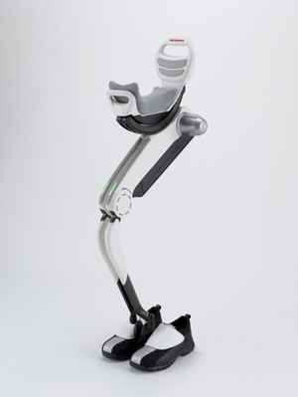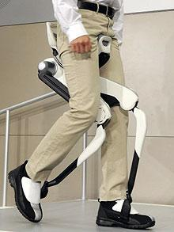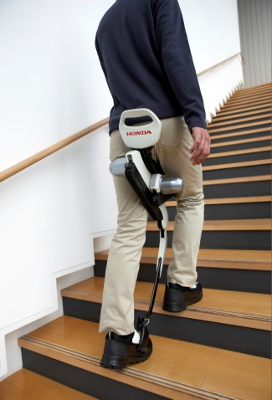

**Honda unveils leg assist machine for elderly**

Nov 7, 2008 (Honda website – Official press release)

TOKYO (AFP) — Honda Motor, a pioneer of humanoid robots, on Friday unveiled a new walking assist machine designed to make it easier for the elderly to climb stairs and help factory workers. The computerised leg device is the latest addition to walking technology developed by the Japanese automaker, which announced the world's first two-legged walking robot, ASIMO, in 2000.

The 6.5 kilogramme (14.3-pound) device -- consisting of a saddle, leg-like frames and shoes -- can reduce the load on users' legs while walking or climbing and descending stairs by supporting bodyweight, Honda said. Honda said the motor-powered machine is still at an experimental stage, but elderly people and people undergoing rehabilitation who need support for their leg muscles and joints are the main target. The device is also expected to help assembly workers to keep a crouching position, Honda said, adding that it plans to test the device at one of its factories north of Tokyo. Like with a unicycle, users ride on the seat sustained by frames that can bend and extend like knees with two motors controlled by signals from sensors inside the shoes. "We used ASIMO's technology for developing the walking assist device," Masato Hirose, a senior engineer at Honda Research and Development, told AFP. "ASIMO is designed to be used as a tool, but the walking assist device is designed to complement real human bodies," he said. "Both will exist for the sake of people." ASIMO, which resembles a child in an astronaut suit, has been used as a receptionist and master of ceremonies at home and overseas, while dancing and singing with musicians at concerts. Honda has yet to decide on further details such as when the latest device will go on sale and at what price, but the company sees a market for it in Japan, which has an ageing population. "First, we hope to have visible results in rehabilitation and other medical fields," Hirose said. "Then we will look at welfare as another target." Last year, Honda unveiled its first walking assist device with a stride management system, which can help users move their thighs back and forth.