**APPENDIX B**

**ELECTRONICS**

**Microcontroller versus Microprocessor**

By microprocessor is meant the general purpose Microprocessors such as Intel's X86 family (8086, 80286, 80386, 80486, and the Pentium) or Motorola's 680X0 family (68000, 68010, 68020, 68030, 68040, etc). These microprocessors contain no RAM, no ROM, and no I/O ports on the chip itself. For this reason, they are commonly referred to as general-purpose Microprocessors.

A system designer using a general-purpose microprocessor such as the Pentium or the 68040 must add RAM, ROM, I/O ports, and timers externally to make them functional. Although the addition of external RAM, ROM, and I/O ports makes these

Systems bulkier and much more expensive, they have the advantage of versatility such that the designer can decide on the amount of RAM, ROM and I/O ports needed to fit the task at hand. This is not the case with Microcontrollers.

A Microcontroller has a CPU (a microprocessor) in addition to a fixed amount of RAM, ROM, I/O ports, and a timer all on a single chip. In other words, the processor, the RAM, ROM, I/O ports and the timer are all embedded together on one chip; therefore, the designer cannot add any external memory, I/O ports, or timer to it. The fixed amount of on-chip ROM, RAM, and number of I/O ports in Microcontrollers makes them ideal for many applications in which cost and space are critical.

In many applications, for example a TV remote control, there is no need for the computing power of a 486 or even an 8086 microprocessor. These applications most often require some I/O operations to read signals and turn on and off certain bits.

**Micro controllers**  
A microcontroller (also MCU or  µC) is a functional computer system-on-a-chip. It contains a processor core, memory, and programmable input/output peripherals. A

microcontroller is a programmable integrated circuit with built-in RAM, ROM, timers, input and output ports

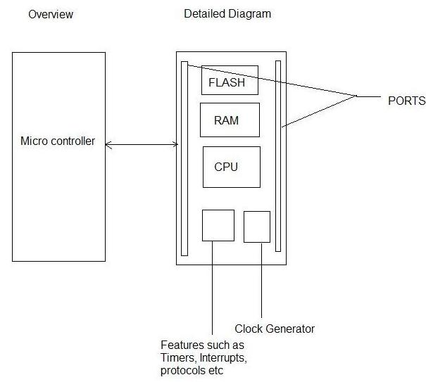

**Why 8051?**

* Standard
* Compatibility
* Ease of use
* Cost effective

**Features**

* Basic 8051 microcontrollers have ROM up to 8K, RAM up to 256 bytes, 32 I/O interface pins
* 1 UART
* 2 External interrupts
* 2 timers
* Speed 3 to 33 MHz
* Compatible with MCS®-51 Products
* 8K Bytes of In-System Programmable (ISP) Flash Memory – Endurance: 10,000 Write/Erase Cycles

**Basic Hardware Blocks**

         The bringing process is said to be complete when the hardware and software contributing the system is working properly.



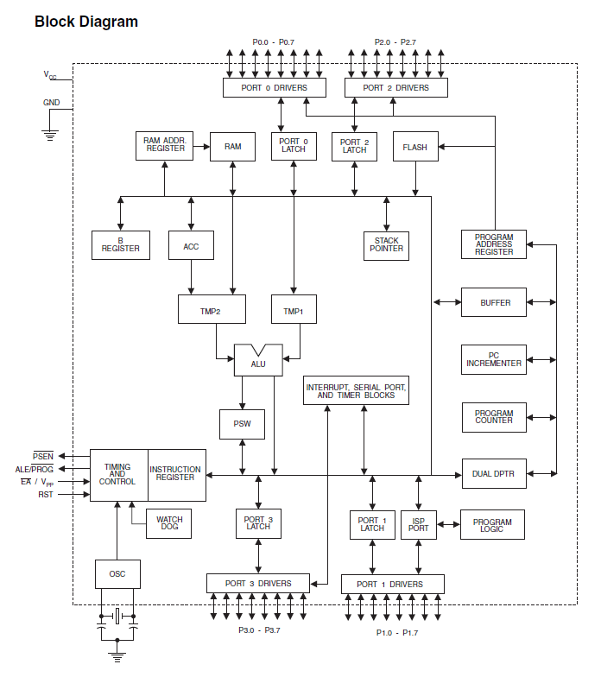

**Complete Circuit Details**

* Connect +5 Volt to Pin Number: 40 and 31
* Connect GND to Pin Number: 20
* Connect Power on Reset logic to Pin Number: 9
* Connect Crystal Oscillator to Pin Number: 18 and 19

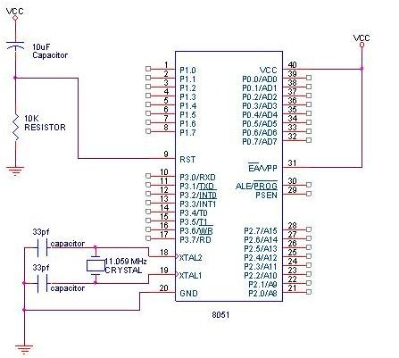

**Basic Software Blocks**

        Software block must have following routines  
        1. Interrupt vector tables  
        2. Reset Handler  
        3. Interrupt Handler  
        4. Infinite routine  
        5. Start and end directives

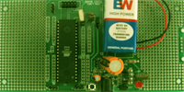**Flexible Boards**

* Compatible with standard AT89XXX interface
* Basic interface routed for external peripherals
* Parallel port downloading interface
* Debugging
* Serial port downloading interface
* Serial port debugging interface
* Pull up/pull down support for Powerful and sensitive devices
* Hardware / Software upgrading option
* User friendly and flexible

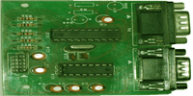

**Serial Port Dongle**

* Compatible to standard AT89XXX interface
* Serial port downloader
* Serial port debugger
* Compact Size

**8051 Flash Programmer**

Now we have to introduce the most important part of your tool chest. Whether you use Simulator, Debugger or IDE or not, you definitely need a kind of programming facility to fuse your microcontroller with the target code. Only then you can watch how your design works. If you have an expanded design, then you may need to program the EPROM with the program code. Sometimes, you may keep a part of application code in the Flash/EPROM version of the 8031 and remaining part in an EPROM (in an expanded system).  
Time has come to introduce another useful tool, 8051 Programmer. This Programmer supports the devices in the 8031 family of Atmel, AT89SXX, and its AVR microcontroller AT90SXXXX series Controllers. The programmer supports both parallel and SPI programming for your convenience. A powerful window's based GUI facility makes your programming task an easy one.  
The  circuit  diagram  of  the  stand-alone  spi  programmer, the  power  to  the  interface  is provided  by  the PC USB  port  which can supply a  max of 100mA  current. Get a cheap USB cable, cut the cable other end connector and attach a crimp shell connector to this end, red wire is 5V and black is 0V.  
The 74HCT541 ic isolate and buffer the parallel port signals. It is necessary to use the HCT type ic in order to make sure the programmer should also work with 3V type parallel port. For the u-controller a 40 pin ZIF socket can be used.  
This programmer circuit can be use to program the 89S series devices and the AVR series devices which are pin compatible to 8051, like 90S8515.  For other AVR series devices the user can make an adapter board for 20, 28 and 40 pin devices. The pin numbers shown in brackets correspond to PC parallel port connector.

**Circuit Diagram**

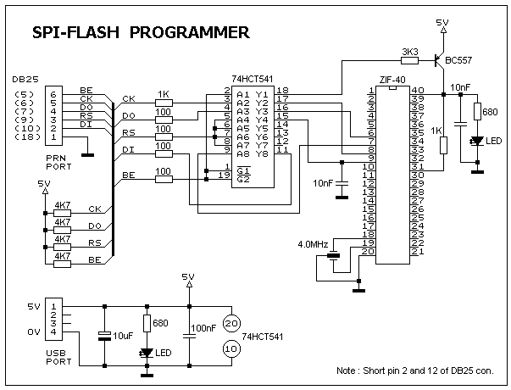

**DC Motors**

What is a DC Motor?

A DC motor is an [electric motor](http://en.wikipedia.org/wiki/Electric_motor) that runs on [direct current](http://en.wikipedia.org/wiki/Direct_current) (DC) electricity. The [brushed DC electric motor](http://en.wikipedia.org/wiki/Brushed_DC_electric_motor) generates torque directly from DC power supplied to the motor by using internal commutation, stationary permanent magnets, and rotating electrical magnets. Like all electric motors or generators, torque is produced by the principle of [Lorentz force](http://en.wikipedia.org/wiki/Lorentz_force), which states that any current-carrying conductor placed within an external magnetic field experiences a torque or force known as Lorentz force. Advantages of a brushed DC motor include low initial cost, high reliability, and simple control of motor speed. Disadvantages are high maintenance and low life-span for high intensity uses. Maintenance involves regularly replacing the brushes and springs which carry the electric current, as well as cleaning or replacing the [commutator](http://en.wikipedia.org/wiki/Commutator_(electric)). These components are necessary for transferring electrical power from outside the motor to the spinning wire windings of the rotor inside the motor.

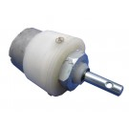**Types of DC Motors based on torque and speed**

**Gear motor-Helical gear**

* 10RPM T0 1000RPM 12V DC geared motors
* Very easy to use and available in standard size.
* Nut and threads on shaft to easily connect Wheel
* 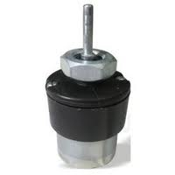10RPM 12V DC motors with Gearbox
* 6mm shaft diameter with internal hole
* 125gm weight
* Same size motor available in various rpm
* 5kgcm torque
* No-load current = 60 mA(Max),
* Load current = 300 mA(Max)

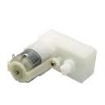**Toy motor**

* 12V DC TOY motors for Low Torque applications
* Very easy to use and available in standard size.

**Gear motor-Helical gear**

* 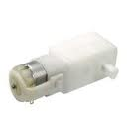10RPM T0 1000RPM 12V DC geared motors for robotics applications
* Very easy to use and available in standard size.
* Nut and threads on shaft to easily connect Wheel
* 10RPM 12V DC motors with Gearbox
* 6mm shaft diameter with internal hole
* 125gm weight
* Same size motor available in various rpm
* 5kgcm torque
* No-load current = 60 mA(Max), Load current = 300 mA(Max)

**Side shaft gear motor**

* 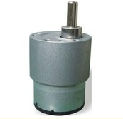10RPM T0 500 RPM 12V DC geared motors for robotics applications
* Very easy to use and available in standard size.
* Nut and threads on shaft to easily connect Wheel
* 10RPM 12V DC motors with Gearbox
* 6mm shaft diameter with internal hole Max 10Kg torque**.**

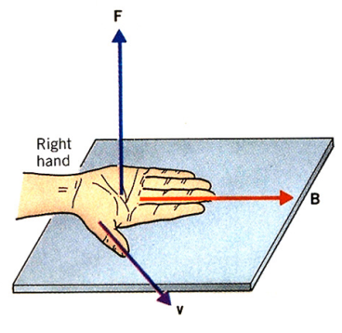**Working Principle of DC Motor**

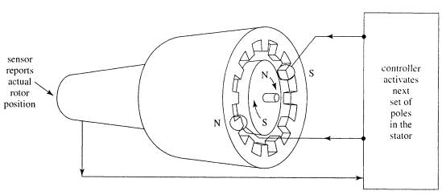The direct current (DC) motor is one of the first machines devised to convert electrical power into mechanical power. Permanent magnet (PM) direct current convert electrical energy into mechanical energy through the interaction of two magnetic fields. One field is produced by a permanent magnet assembly; the other field is produced by an electrical current flowing in the motor windings. These two fields result in a torque which tends to rotate the rotor. As the rotor turns, the current in the windings is commutated to produce a continuous torque output. The stationary electromagnetic field of the motor can also be wire-wound like the armature (called a wound-field motor) or can be made up of permanent magnets (called a permanent magnet motor).

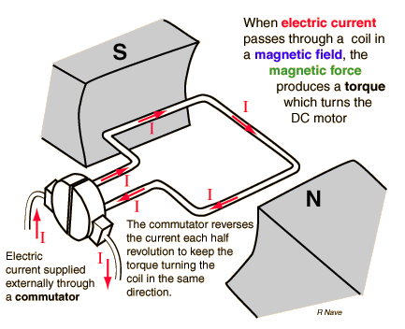

**Torque Speed Relation**

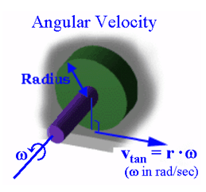**Calculating Torque**

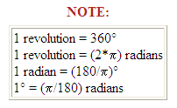Torque is the force that produces rotation. It causes an object to rotate. Torque consist of a force acting on distance. Torque, like work, is measured is pound-feet (lb-ft). However, torque, unlike work, may exist even though no movement occurs.

**To calculate torque,**

**T = F x D**

**Where T = torque (in lb-ft) F = force (in lb) D = distance (in ft)**

**Example:** What is the torque produced by a 60 lb force pushing on a 3' lever arm?

**T = F x D T = 60 x 3 T = 180 lb ft**

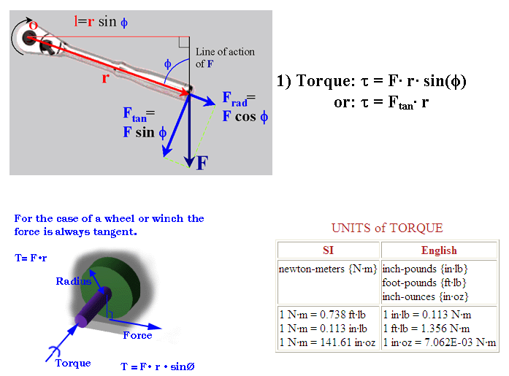

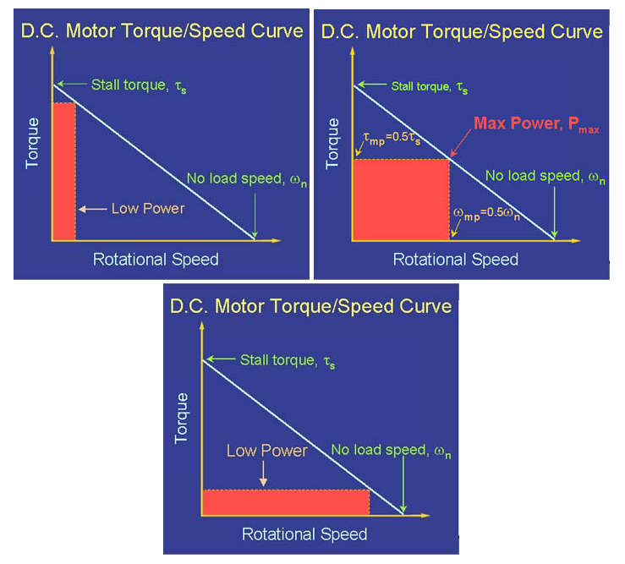

**Motor Drivers**

Push-Pull Four Channel Driver

**Features**

Output Current 1A Per Channel (600mA for L293D)

• Peak Output Current 2A Per Channel (1.2A for L293D)

• Inhibit Facility

• High Noise Immunity

• Separate Logic Supply

• Over-Temperature Protection

**Description**

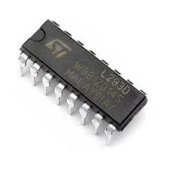The L293 and L293D are quad push-pull drivers capable of delivering output currents to 1A or 600mA per channel respectively. Each channels controlled by a TTL-compatible logic input and each pair of drivers (full bridge) is equipped with an inhibit input which turns off all four transistors. A separate supply input is provided for the logic so that it may be run off a lower voltage to reduce dissipation. Additionally the L293D includes the output clamping diodes within the IC for complete interfacing with inductive loads. Both devices are available in 16-pin Batwing DIP packages. They are also available in Power S0IC and Hermetic DIL packages.

**ADC 0804**

**General Description**

The ADC0801, ADC0802, ADC0803, ADC0804 andADC0805 are CMOS 8-bit successive approximation A/D converters that use a differential potentiometric ladder similar to the 256R products. These converters are de-signed to allow operation with the NSC800 and INS8080Aderivative control bus with TRI-STATEÉ output latches directly driving the data bus. These A/Ds appear like memory locations or I/O ports to the microprocessor and no interfacing logic is needed. Differential analog voltage inputs allow increasing the common-mode rejection and offsetting the analog zero input voltage value. In addition, the voltage reference input can be adjusted to allow encoding any smaller analog voltage span to the full 8 bits of resolution.

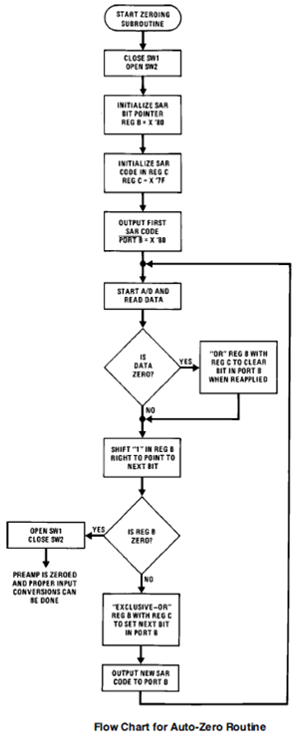

**Liquid Crystal Displays**

The RCM2034R is a reflective TN type liquid crystal module with a built-in controller / driver LSI and a display capacity of 16 characters 1 line.

**Features**

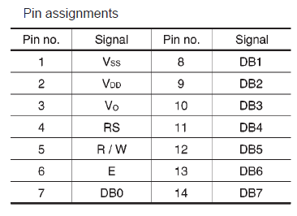 Wide viewing angle and high contrast, 5_7 dot character matrix with cursor, Interfaces with 4-bit or 8-bit MPUs, Displays up to 226 characters and special symbols, Custom character patterns are displayed with the character RAM, Abundant instruction set including clear display, cursor on /off, and character blinking, Compact and light weight for easy assembly to the host instrument, Operable on single 5 V power supply, Low power consumption.





