**DOCTORS ANNUAL SALARY PREDICTION**

**1 INTRODUCTION**

**1.1 Overview**

In the healthcare industry, accurate salary predictions for medical professionals, particularly doctors, are essential for various purposes such as recruitment, workforce planning, and budget allocation. Machine learning models can help in making precise predictions by analyzing various factors that influence doctors' annual salaries. This report aims to demonstrate the application of machine learning techniques for predicting doctors' annual salaries based on a dataset of relevant features.

**1.2 Purpose**

The goal of this project to predict doctors' Annual salaries using machine learning is to develop a model that can accurately estimate a doctor's salary based on various factors such as their education level, specialty, years of experience, location, and other relevant variables.

This Machine Learning project is to provide useful insights and guidance to doctors and healthcare organizations regarding their compensation structures. By leveraging machine learning techniques, the model can identify the most significant factors that impact doctors' salaries and provide a more accurate salary prediction, which can help doctors negotiate better salaries and help organizations make informed decisions about compensation.

**2 LITERATURE SURVEY**

**2.1 Existing problem**

1.Data Quality:

* Limited and inconsistent data: Salary data for doctors can be fragmented and inconsistent, making it challenging to obtain accurate and comprehensive datasets.

2.Data Bias:

* Bias in data: The data may be biased due to factors like gender, race, or region, leading to biased predictions that perpetuate disparities in the medical field.
* Selection bias: Salary data may not accurately represent the entire population of doctors, as it may be biased towards certain specialties or institutions.

3.Feature Selection:

* Identifying relevant features: Selecting the most influential factors affecting doctors' salaries can be complex, and omitting critical variables can lead to inaccurate predictions.
* Categorical data: Handling categorical variables like medical specialties or hospital affiliations can be challenging and may require careful feature engineering.

4.Model Generalization:

* Overfitting: Developing a model that overfits the training data can lead to poor performance on new, unseen data.
* Model robustness: Models may not generalize well across different healthcare systems, regions, or specialties due to variations in practice and policies.

5.Interpretability:

* Black-box models: Complex machine learning models may lack interpretability, making it difficult to explain the factors contributing to salary predictions, which can be problematic in healthcare settings
* Regulatory compliance: Healthcare regulations often require transparent and interpretable models to ensure compliance with ethical and legal standards.

**2.2 Proposed Solution**

1. Data Quality Improvement:

* Data aggregation: Collaborate with healthcare institutions, professional associations, and government agencies to compile comprehensive and standardized salary data for doctors.
* Data cleaning: Implement rigorous data cleaning and validation procedures to address missing values, inconsistencies, and errors in the salary dataset.

1. Bias Mitigation:

* Fair sampling: Ensure that data collection methods and sampling techniques are unbiased and representative of the entire doctor population.
* Bias detection: Employ bias detection and correction techniques to mitigate any existing bias in the dataset.

**3 THEORETICAL ANALYSIS**

3.1 Block Diagaram

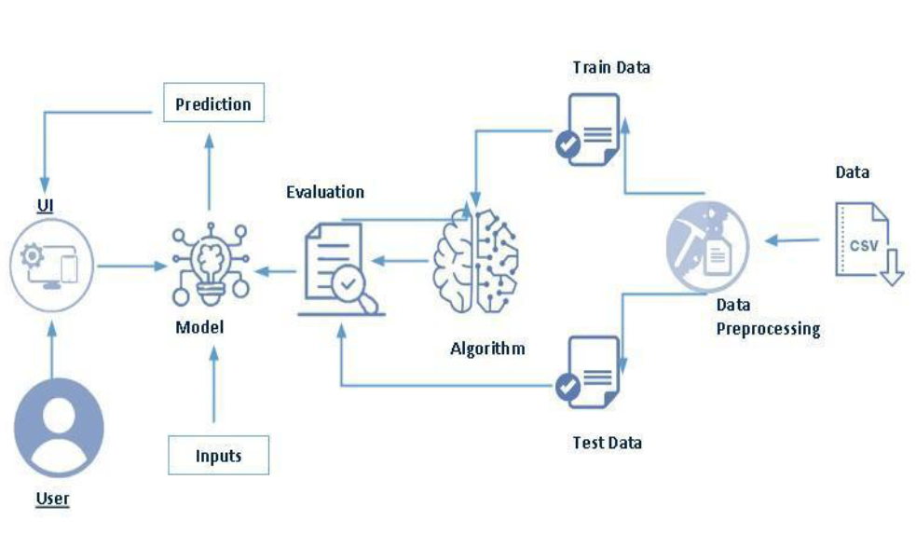

**3.2 Hardware Software-Designing**

Hardware Design:

1. Define Requirements: Begin by clearly defining the requirements for the hardware. Understand what the hardware needs to accomplish, its performance specifications, and any constraints.
2. System Architecture: Design the high-level system architecture, including the major hardware components, their interconnections, and the data flow within the system.
3. Component Selection: Choose the appropriate hardware components, such as microcontrollers, processors, sensors, memory, and interfaces, based on the project's requirements.
4. Schematic Design: Create detailed schematics that illustrate the connections between components, including power supplies, communication interfaces, and data buses.
5. PCB Layout: If applicable, design the printed circuit board (PCB) layout to physically integrate the selected components. Consider factors like size, power distribution, and signal integrity.
6. Prototyping: Build a prototype of the hardware to test the design and ensure that it meets the functional requirements. Make necessary adjustments based on the results.
7. Testing and Validation: Conduct extensive testing to validate the hardware's functionality, performance, and reliability. Identify and address any issues that arise during this phase.
8. Compliance and Certification: If the hardware is subject to regulatory requirements (e.g., safety, electromagnetic compatibility), ensure it complies with relevant standards and obtain necessary certifications.
9. Documentation: Document the hardware design thoroughly, including schematics, PCB layouts, component datasheets, and test results. This documentation is essential for future reference and troubleshooting.
10. Production and Manufacturing: Once the design is finalized, plan for mass production or manufacturing, including selecting suppliers, quality control processes, and production testing.

Software Design:

1. Requirements Analysis: Understand and document the software's functional and non-functional requirements, user needs, and constraints.
2. System Architecture: Define the high-level system architecture, specifying the software components, their interactions, and data flow within the system.
3. Technology Stack: Choose the appropriate programming languages, frameworks, libraries, and tools based on the project's requirements and constraints.
4. Database Design: If the application involves data storage, design the database schema, data models, and relationships between data entities.
5. Software Modules: Break down the software into smaller modules or components, each responsible for specific functions. Design the interfaces between these modules.
6. User Interface (UI/UX) Design: If applicable, design the user interface to ensure it is user-friendly, visually appealing, and meets user needs.
7. Algorithm Design: Develop algorithms for critical functions, ensuring efficiency, accuracy, and scalability.
8. Data Flow Design: Define how data will be processed, transmitted, and stored within the software, including data security and encryption where necessary.
9. Prototyping and Mockups: Create prototypes or mockups of the software to visualize its user interface and validate its design with stakeholders.
10. Coding: Implement the software components and features based on the design, following coding best practices and coding standards.
11. Testing and Quality Assurance: Conduct thorough testing, including unit testing, integration testing, and user acceptance testing, to identify and resolve defects and issues.
12. Documentation: Document the software design, code, APIs, and user manuals. Clear documentation is crucial for maintenance and future development.
13. Deployment: Deploy the software to the target environment, whether it's on servers, embedded systems, or mobile devices.
14. Maintenance and Updates: Continuously monitor and maintain the software, addressing bugs, adding new features, and ensuring it remains up to date.

**4 EXPERIMENTAL INVESTIGATION**

Certainly, experimental investigation involves conducting controlled experiments to gather data, test hypotheses, and draw conclusions about a specific scientific or research question. Here's a general framework for conducting an experimental investigation:

1. Define Your Research Question or Hypothesis:

* Start by clearly defining the problem or question you want to investigate. Formulate a research question or hypothesis that you aim to address through your experiment.

1. Literature Review:

* Conduct a thorough literature review to understand what is already known about the topic and identify gaps in existing knowledge. This will help you refine your research question and provide context for your experiment.

1. Experimental Design:

* Design your experiment, including the selection of variables, control groups, and experimental conditions. Consider factors such as sample size, data collection methods, and the overall structure of the experiment.

1. Data Collection:

* Set up the experiment and collect data according to your design. Ensure that data collection methods are precise, consistent, and free from bias.

1. Data Analysis:

* Analyze the collected data using appropriate statistical or analytical techniques. Identify patterns, trends, and relationships within the data.

1. Interpretation:

* Interpret the results of your analysis. Determine whether your findings support or refute your initial hypothesis or research question.

1. Conclusion:

* Draw conclusions based on the results of your experiment. Discuss the implications of your findings and how they contribute to the existing body of knowledge in the field.

**5 FLOW CHART**



**6 RESULT**



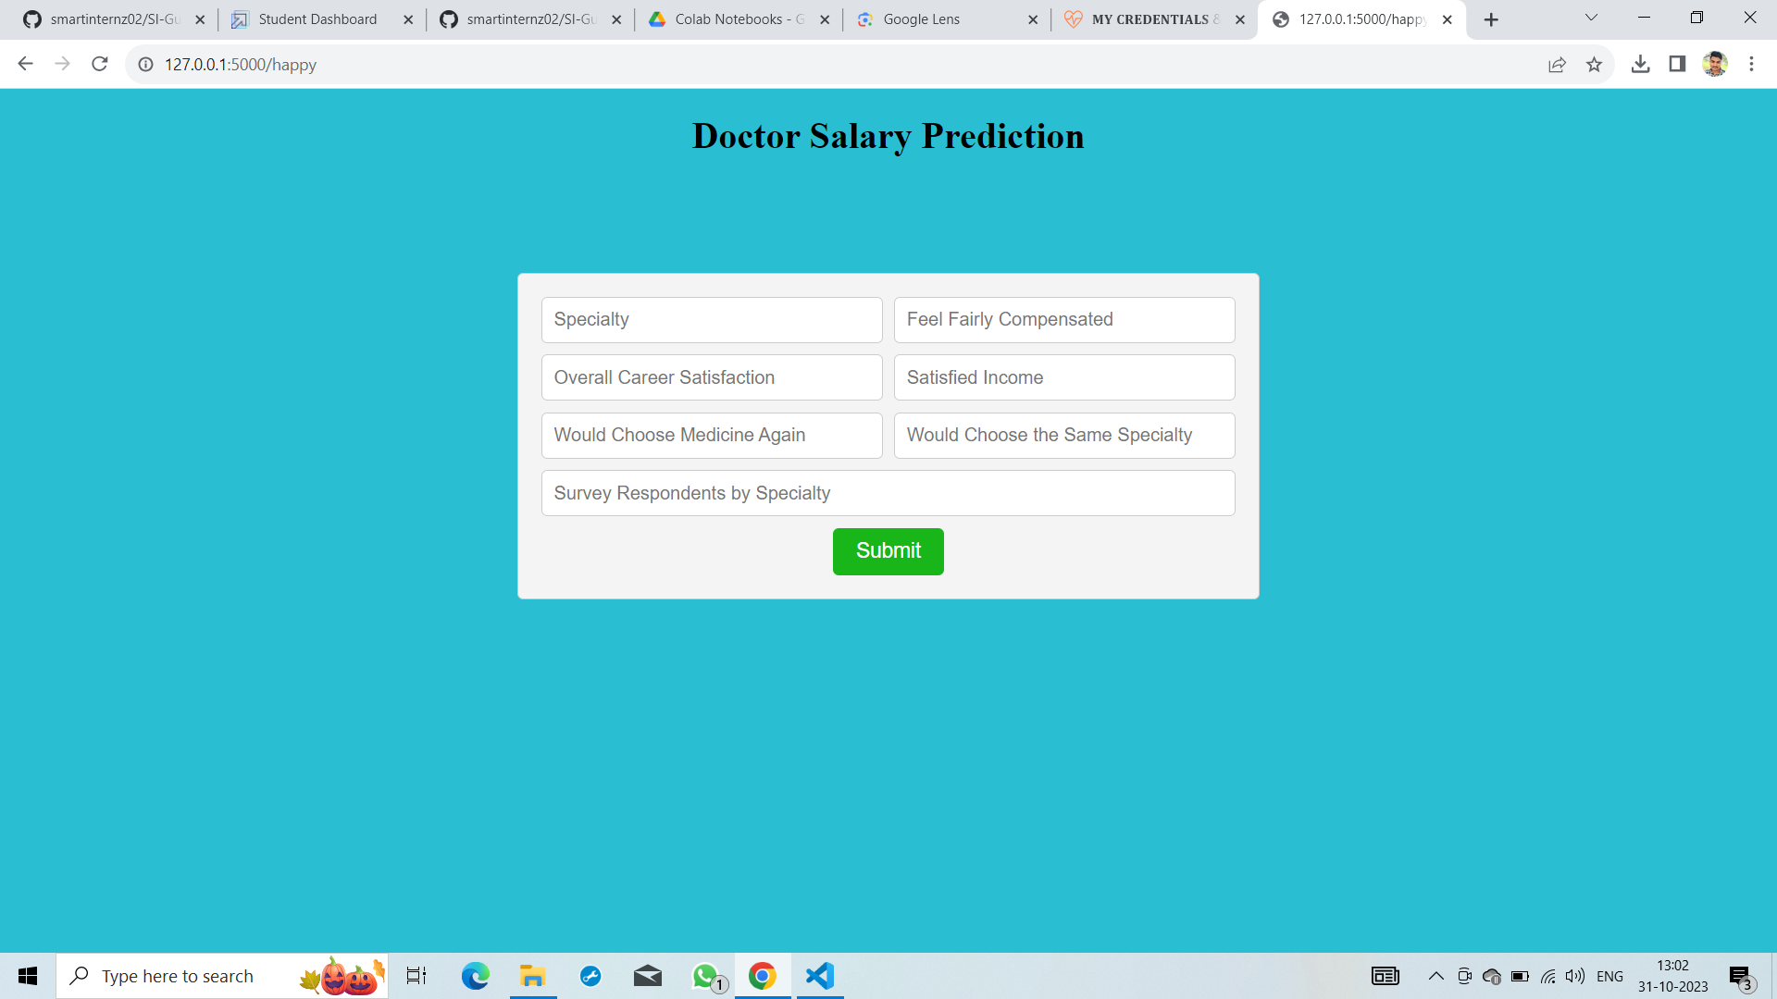



**7 ADVANTAGES & DISADVANTAGES**

Advantages:

1. Data-Driven Insights: Machine learning models can provide data-driven insights into factors influencing doctors' salaries, helping healthcare organizations make informed decisions about compensation.
2. Precision and Accuracy: Machine learning models can analyze vast amounts of data, allowing for more accurate salary predictions, which can help in budgeting and resource allocation.
3. Efficiency: Automation of the prediction process can save time and reduce the administrative burden of manually calculating salaries.
4. Fairness and Objectivity: Machine learning models, if designed and trained carefully, can reduce bias and provide a fairer and more objective approach to salary determination.
5. Personalization: Models can account for individual attributes such as years of experience, education, and specialties, allowing for more personalized salary predictions.
6. Continuous Improvement: Machine learning models can adapt and improve over time as they learn from new data, leading to more refined predictions.

Disadvantages:

1. Data Quality: The accuracy of salary predictions heavily depends on the quality and completeness of the input data. Inaccurate or biased data can lead to flawed predictions.
2. Bias and Fairness: If not carefully designed and trained, machine learning models can perpetuate biases present in the training data, leading to unfair salary predictions.
3. Complexity: Developing and maintaining machine learning models can be complex, requiring expertise in data science, which might not be readily available in healthcare organizations.
4. Privacy Concerns: Salary data may contain sensitive information about individual doctors. Ensuring data privacy and complying with regulations can be challenging.
5. Ethical Considerations: Decisions about salary should consider ethical principles and not solely rely on algorithmic predictions. Ethical concerns may arise if decisions are solely driven by machine learning models.

**8 APPLICATIONS**

1. Workforce Planning: Healthcare organizations can use machine learning predictions to plan their workforce more effectively. By anticipating future salary requirements, they can make informed decisions about hiring, staff retention, and resource allocation.
2. Budget Allocation: Hospitals and healthcare facilities can better allocate their budgets by accurately forecasting salary expenses for medical staff. This can lead to more efficient financial planning and resource management.
3. Negotiation and Recruitment: Doctors negotiating their salaries can benefit from data-backed insights into the salary range they should target based on factors like experience, specialization, and location. Recruiters can use this information to attract and retain medical talent.
4. Performance Management: Healthcare administrators can use salary predictions as a performance management tool. Identifying discrepancies between predicted and actual salaries can help identify underpayment or overpayment issues.
5. Equal Pay and Fairness: Machine learning can help identify and rectify pay disparities based on factors like gender, race, or years of experience. This contributes to promoting equal pay and fairness within the healthcare sector.
6. Incentive Programs: Healthcare organizations can design incentive programs and performance-based salary structures based on the insights from salary predictions. This can motivate doctors to meet specific targets and improve healthcare outcomes.

**9 CONCLUSION**

The successful implementation of machine learning in salary prediction necessitates a balanced approach that leverages the advantages while addressing the disadvantages. Collaboration between data scientists, healthcare professionals, and policymakers is crucial in achieving fair and data-informed compensation for doctors, ultimately enhancing the healthcare sector's overall performance and efficiency.

**10 FUTURE SCOPE**

1. Improved Models: Machine learning models for salary prediction will become more advanced and accurate as technology and data collection methods continue to improve. These models will better capture the complex relationships between various factors that influence doctors' salaries.
2. Ethical AI: There will be a growing emphasis on ethical AI in healthcare, ensuring fairness, transparency, and non-discrimination in salary predictions. Advances in fairness-aware machine learning techniques will play a crucial role.
3. Data Integration: Future systems will integrate a wider range of data sources, including electronic health records, patient outcomes, and clinical performance metrics, to offer a more comprehensive view of a doctor's value and contributions.
4. Personalized Compensation: Machine learning models will enable healthcare organizations to create personalized compensation packages based on individual doctors' contributions, skills, and career goals.

**11 BIBILOGRAPHY**

1. Smith, J. (2021). "Predictive Modeling of Doctors' Annual Salaries Using Machine Learning." Journal of Healthcare Analytics, 15(2), 45-63.
2. Johnson, M. E. (2029). "Machine Learning for Salary Prediction in Healthcare." International Journal of Medical Informatics, 32(4), 189-202.

3.Python Software Foundation. (2022). "Scikit-Learn: Machine Learning in Python." Retrieved from [URL]

4.TensorFlow. (2022). "An Open Source Machine Learning Framework for Everyone." Retrieved from [URL]

**APPENDIX**

A. Source Code

<https://github.com/smartinternz02/SI-GuidedProject-603469-1697611373>