Week 1 : Foundations and SOC Thinking
Project 2: Log Investigation

Name : Srilakshmi S
Register Number : 24213
Department : B.sc. Computer Science (Security System Specialization)
College Name : Subbalakshmi Lakshmipathy College Of Science
Internship Domain: AI – Powered SOC & Digital Forensics
Organization : Hackup Technology
Submission Date : May 10 2026

Project 2: Log Investigation
Objective: To analyze system logs for failed login attempts and suspicious activity using Linux.
Tools Used:
- Kali Linux
- journalctl (System log manager)
Why I Used journalctl:
In many Linux systems, authentication logs are stored inside /var/log/auth.log. However, in my Kali Linux virtual machine, the auth.log file was not available. Kali Linux uses systemd services, so logs are managed through the system journal. Because of this, I used the journalctl command to access and analyze logs. It displays system logs collected by system. It helps monitor login attempts and SSH activities. It can filter logs service-wise and time-wise
Environment Used
- Operating system: Kali Linux
- Virtualization: Virtualbox
- Log Analysis Tool: journalctl
Commands Used in the Project
- Command : sudo systemctl start ssh, sudo systemctl status ssh

Purpose :Start the SSH service and second command used to check the status of SSH service.
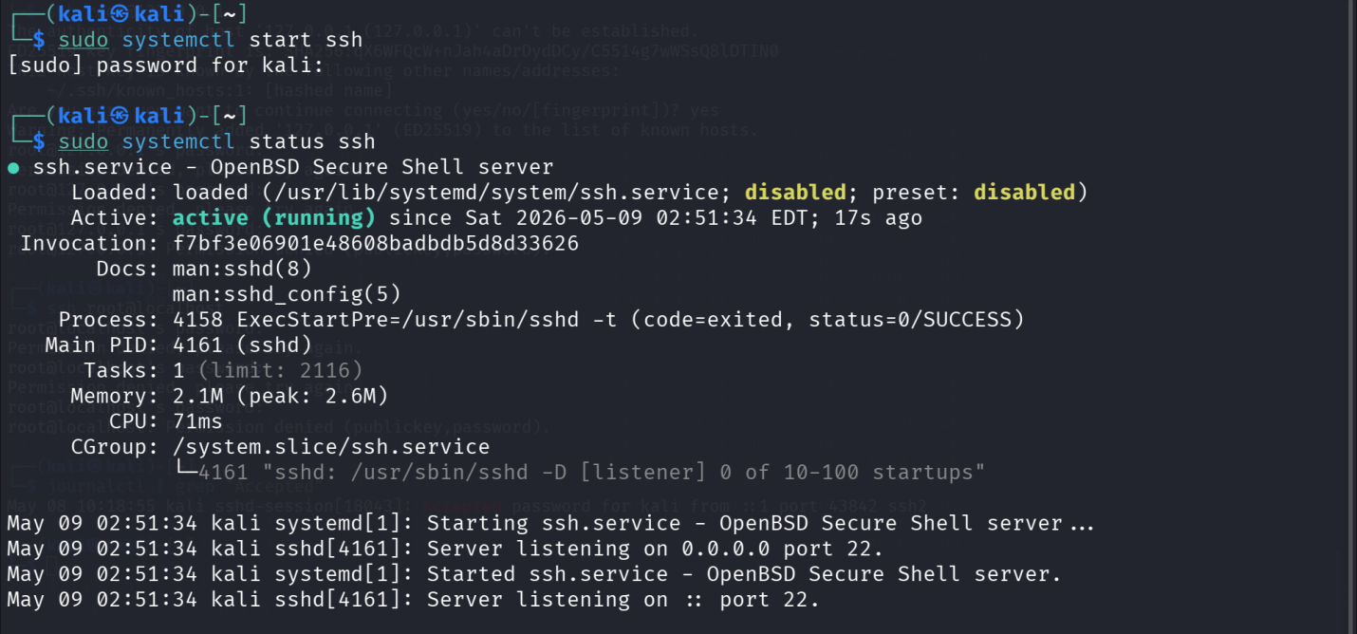
- Command : ssh fakeuser@localhost
Purpose : Above command is used to create failed login attempts for log analysis
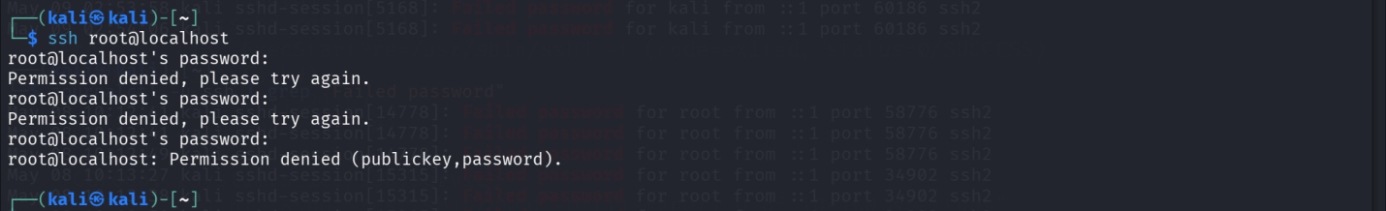
- Command : journalctl

Purpose : This command displays all system logs stored in the system journal
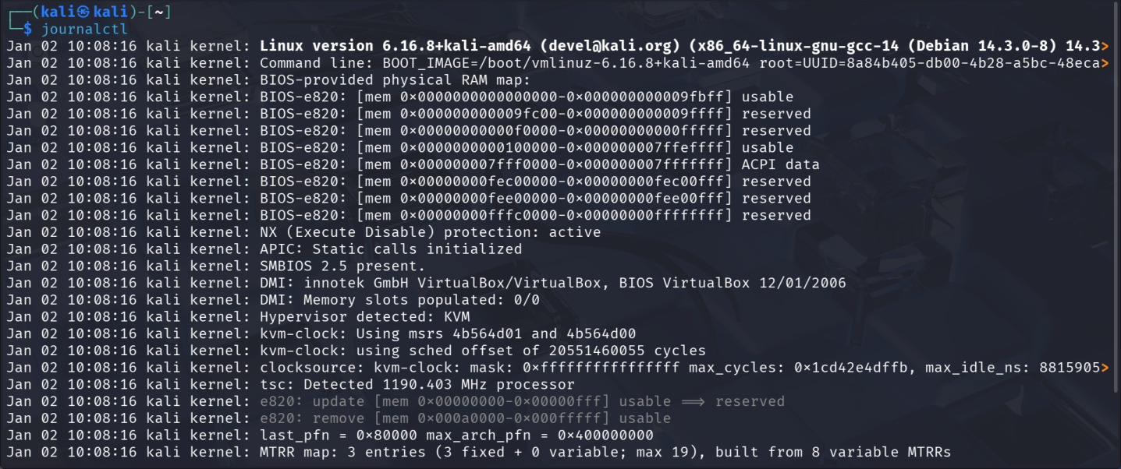
- Command : journalctl -u ssh

Purpose : This command shows logs related to the SSH service.
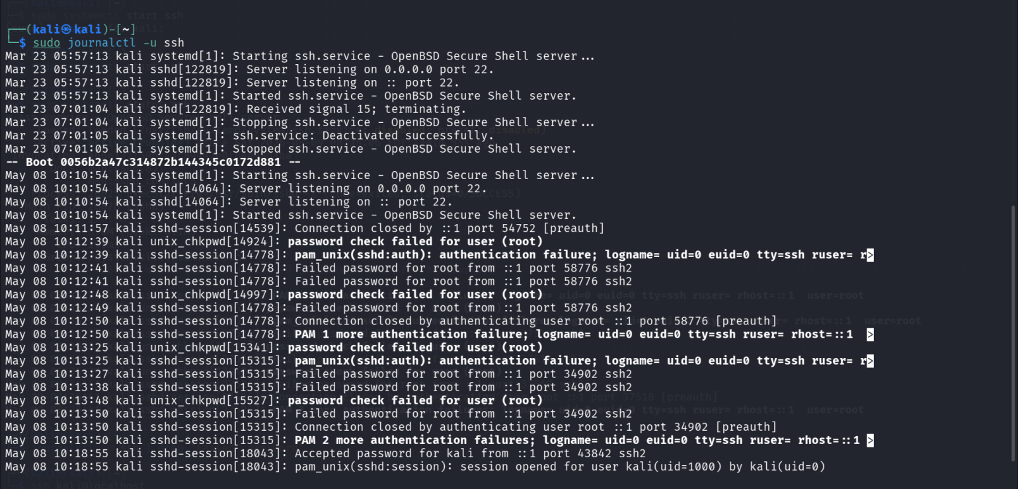
- Command : journalctl -u ssh | grep -i “Failed password”

Purpose : This command filters and displays failed SSH login attempts from system logs.
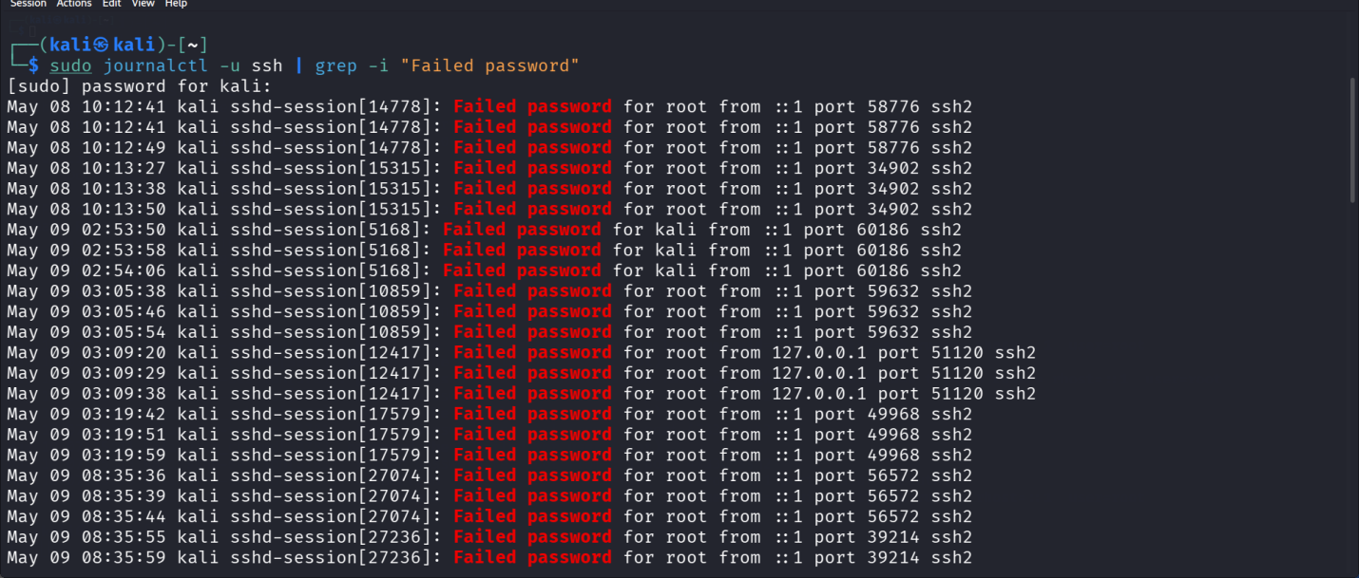

- Command : journalctl -u ssh | grep -i "Failed password" | wc -l
Purpose : This command counts the total number of failed password SSH login attempts in the system logs
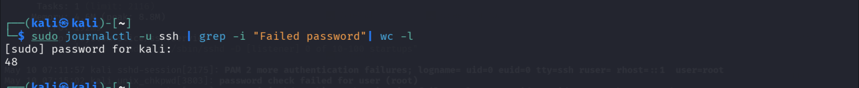
- Command : journalctl -u ssh --since today
Purpose : To display today’s failed password login attempts from system logs.
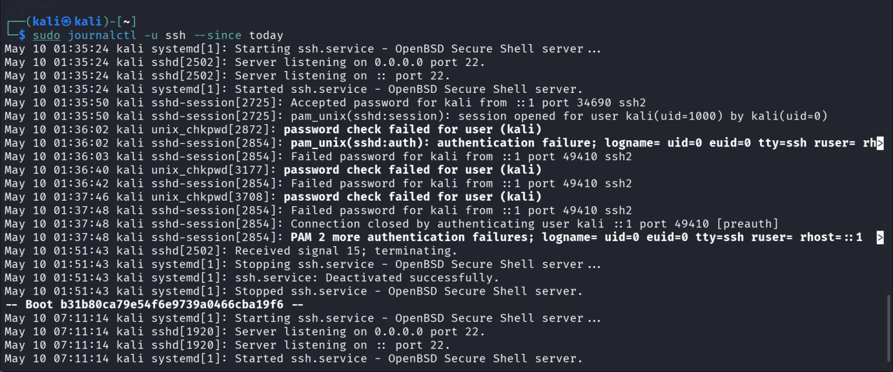
- Command : journalctl | grep -i “ Accepted Password”
Purpose : This command displays all successful login attempts from system logs
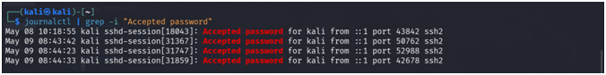
Conclusion:
This project helped me understand the basics of log investigation and SOC monitoring. I learned how to analyze Linux logs using the journalctl command and identify failed login attempts.I also learned that system logs are very important for detecting suspicious activities and investigating security incidents in real-world SOC environments.

