Basic Scan

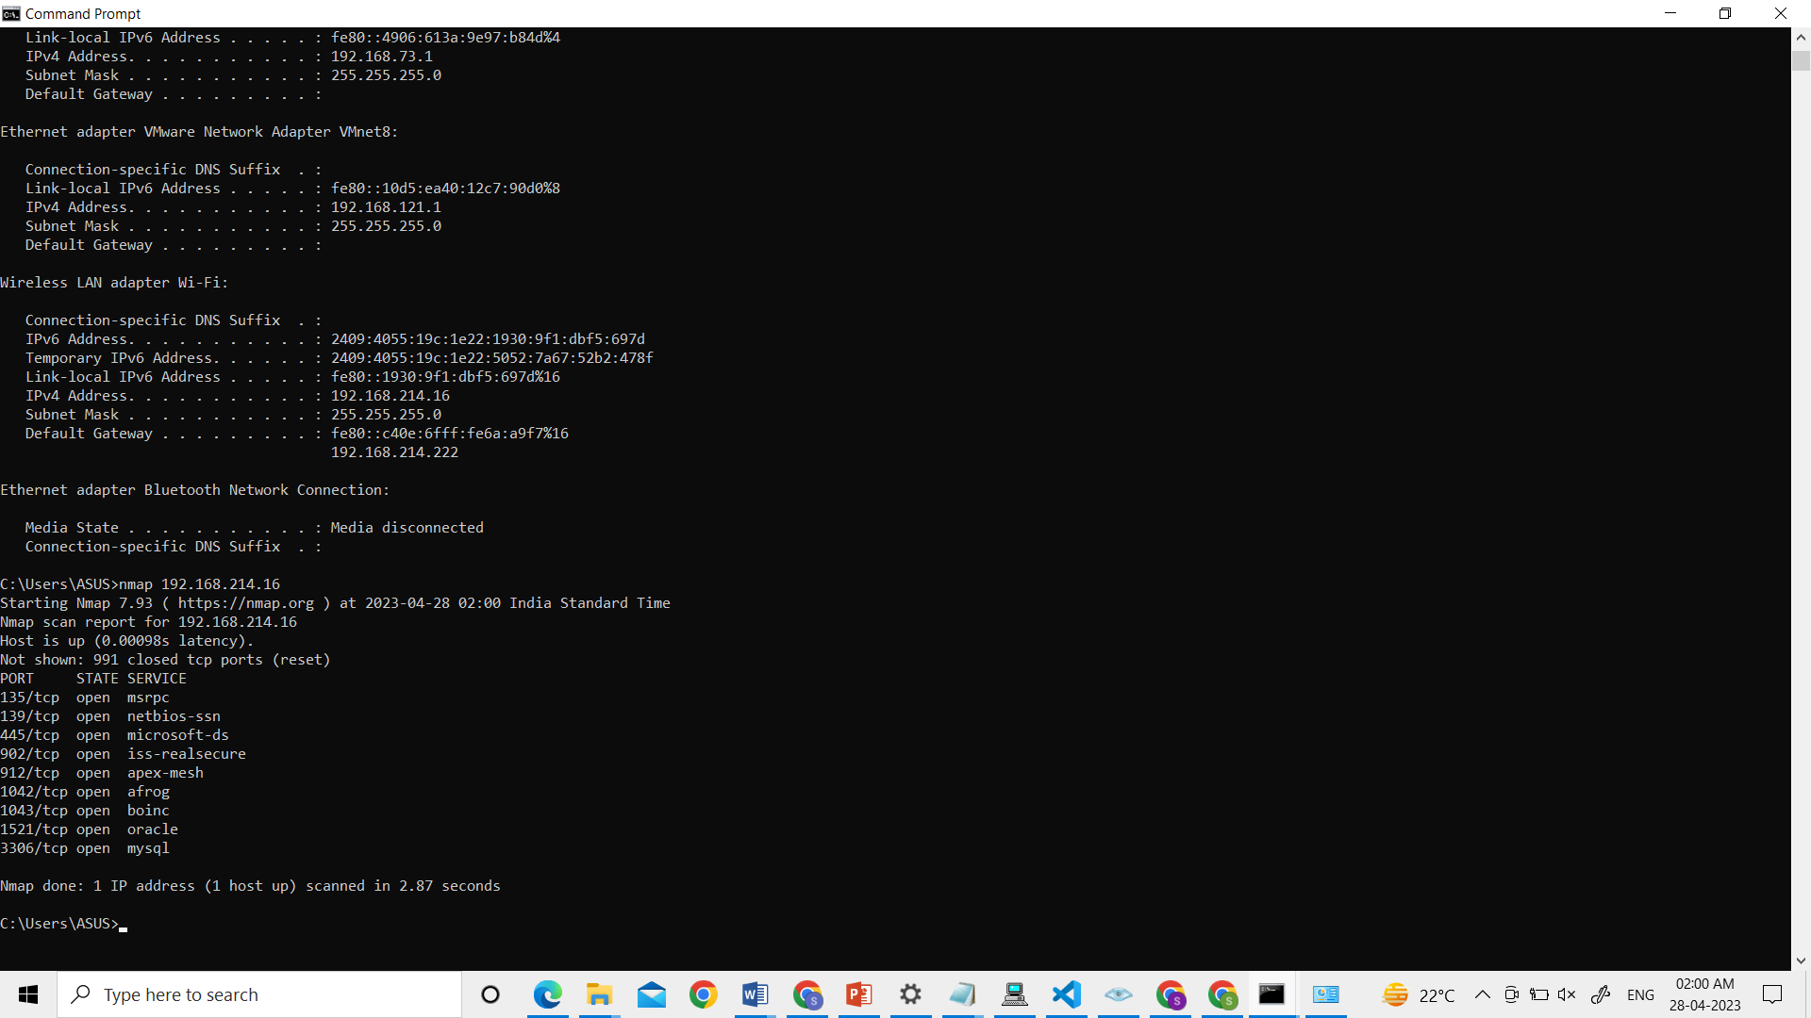nmap 192.168.214.16

scan of specific ports

nmap -p 3306 192.168.214.16

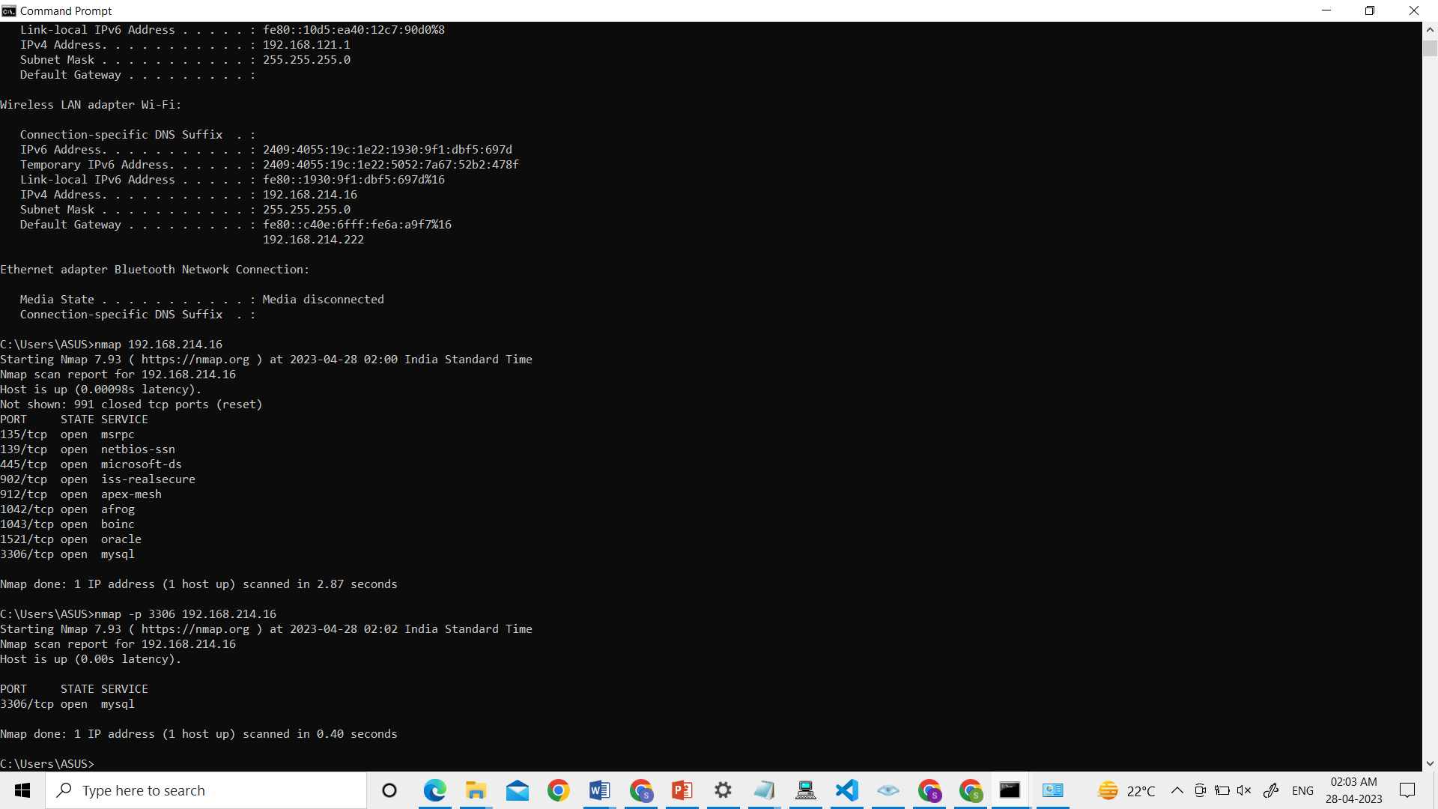

OS Detection

Nmap –O 192.168.214.16

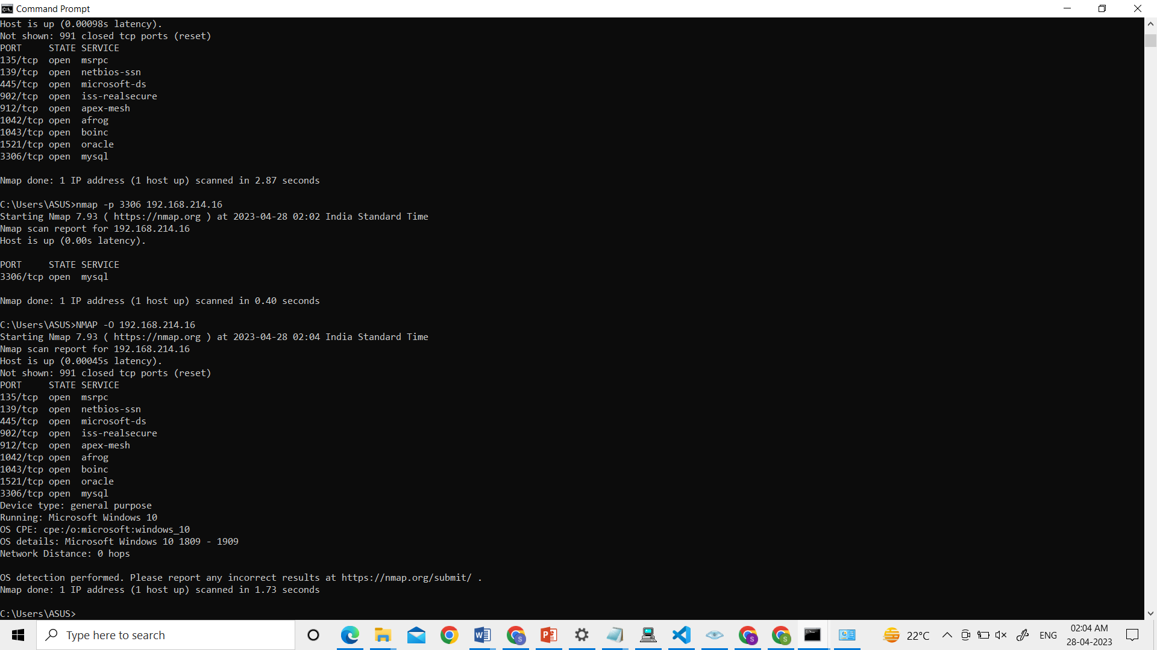

Services and version Detection

nmap –Sv 192.168.214.16

