WEEK-11—Amazon LEX

Step 1: Open Amazon Lex
- Login to AWS Console
- Search Amazon Lex
- Click Create bot
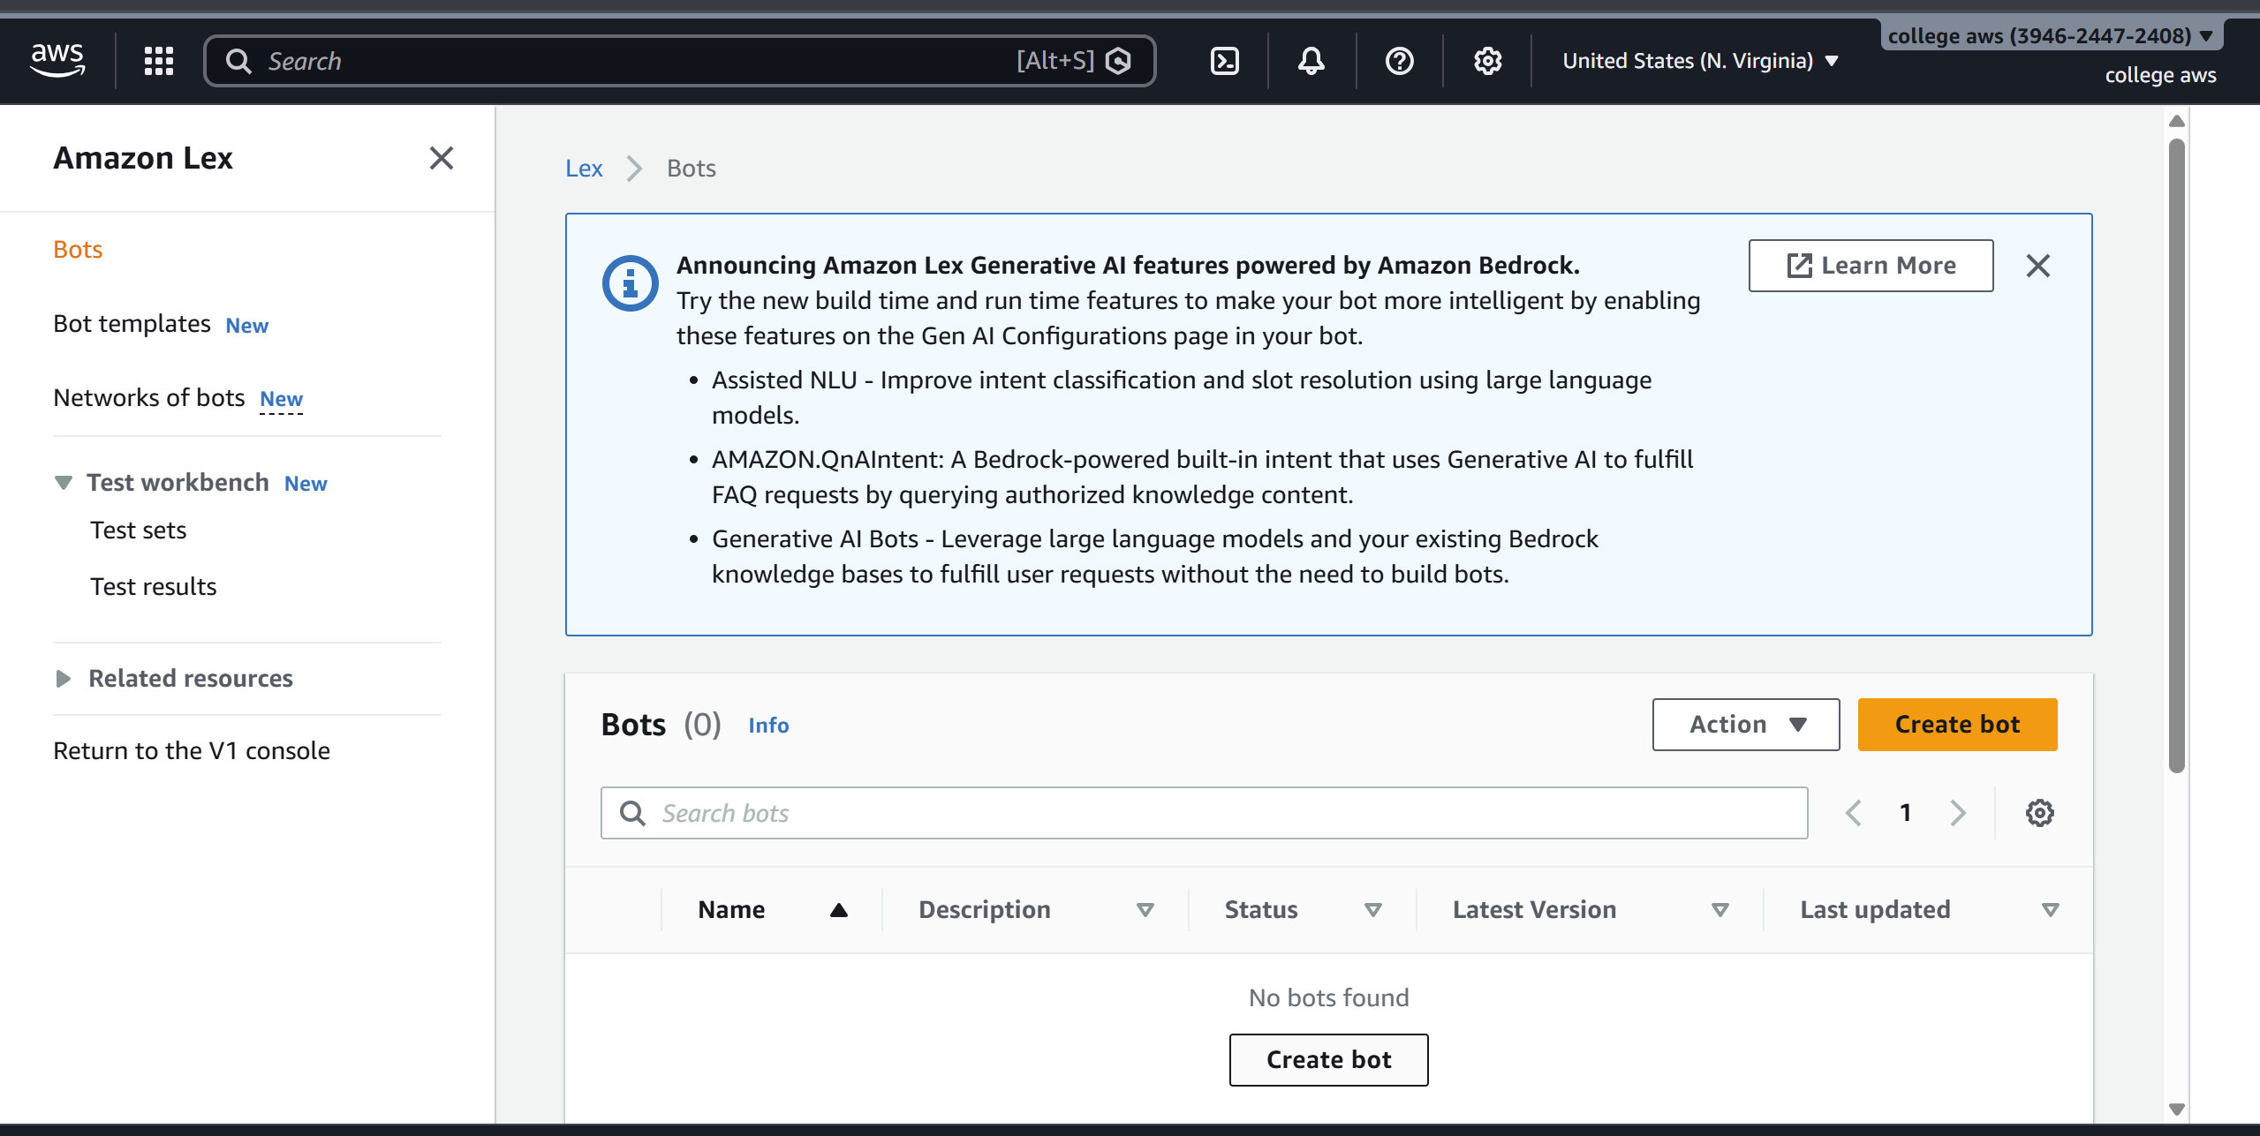

Step 2: Create Bot
- Choose:
  - Create a blank bot
- Enter:
  - Bot name: HotelBookingBot
- IAM role → Create new role
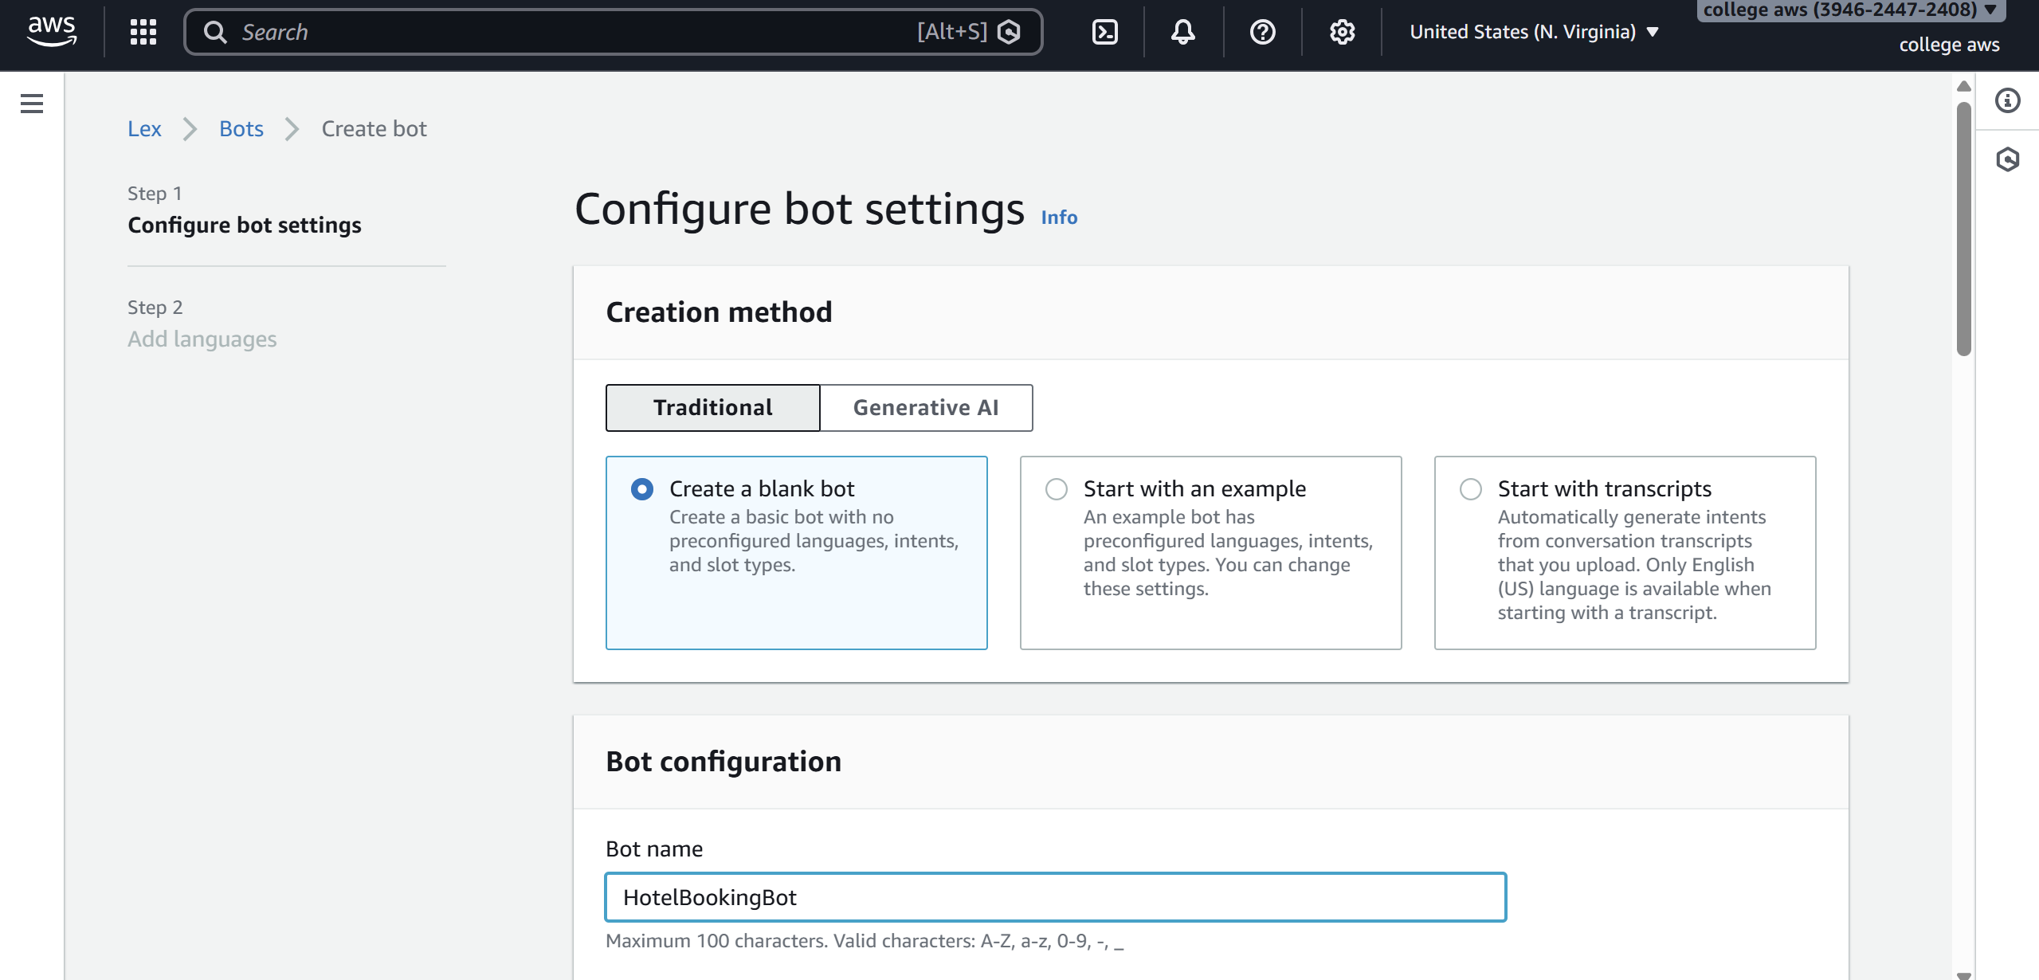
- Remaining defaultnext
- Language: English
- Voice (optional)
- Click Done
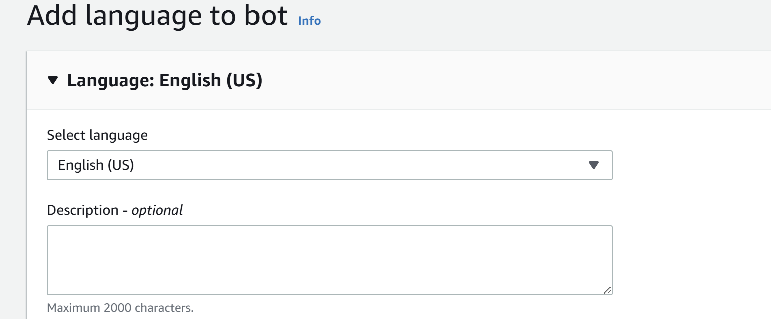

Step 3: Create Intent
- Go to Intents
- Name: BookHotel
- Click Create
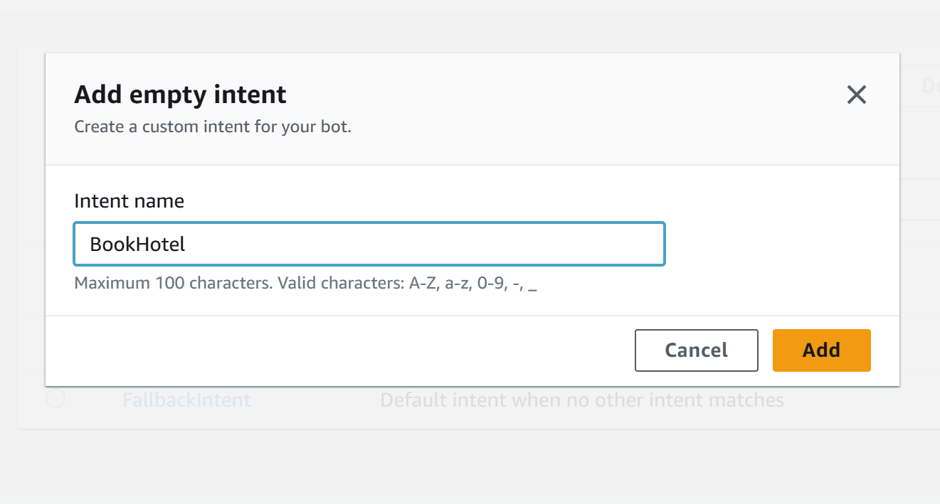

Step 4: Add Sample Utterances
Add user sentences (how user talks):
I want to book a hotel
Book a room
Reserve hotel
I need a room
These are Utterances

Step 5: Create Slots (User Inputs)
Slots collect user information.
Add Slot
- Click Add slot
- Fill:
  - Slot name: age
  - Slot type: AMAZON.Number
  - Prompt: Which city do you want?
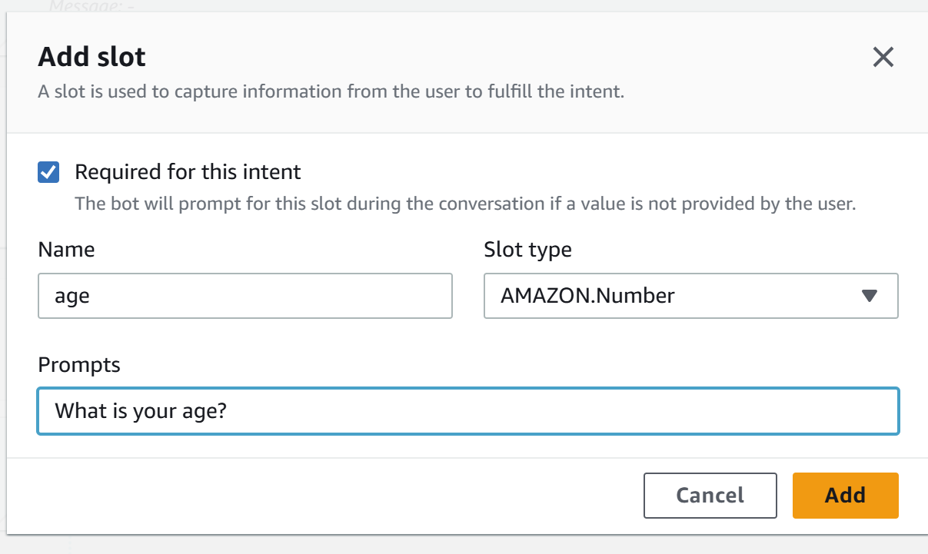
Mark as Required
Add IF Conditions (Conditional Logic)
Used to control flow based on slot values
Example Condition:
If {age} < 18
Steps:
- Go to Intent → Slots -> under Advance options
- Scroll to Slot capture: success response ->Conditional branching
- Click Add condition
Example:
Condition:
If {age} < 18
Response:
Your not eligible for hoot booking?

Step 6: Create Slots (User Inputs)
Slots collect user information.
Add Slot
- Click Add slot
- Fill:
  - Slot name: location
  - Slot type: AMAZON.City
  - Prompt: Which city do you want?
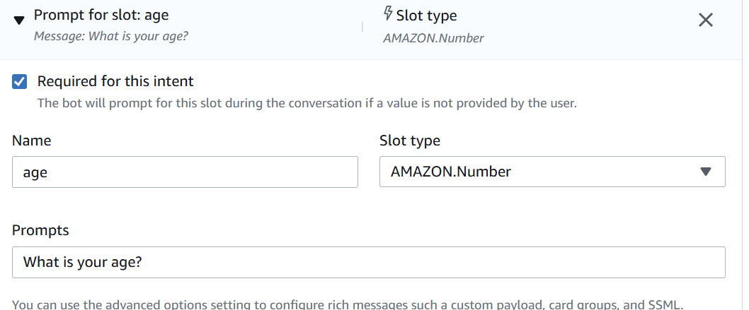
- Mark as Required

Repeat for other slots.
- Click Add slot
- Fill details:
  - Slot name: checkin
  - Slot type: AMAZON.Date
  - Prompt:
"What is your check-in date?"
- Mark as Required
(Optional but recommended)
  - Add Retry prompt:
"Please provide a valid date (e.g., 2026-03-25)"
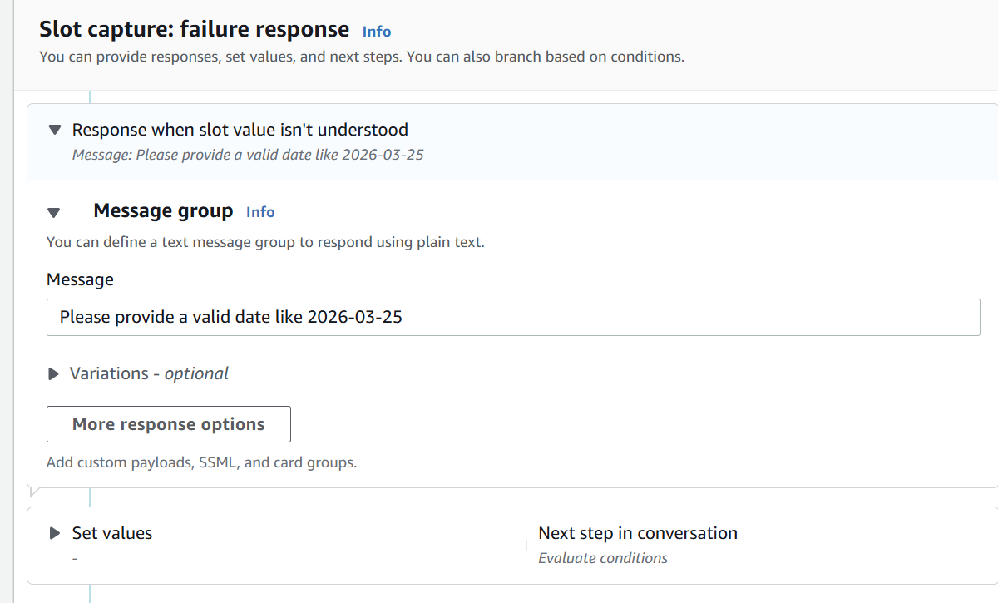
- Click Save

Slot 7: Number of Nights (nights)
Steps:
- Click Add slot again
- Fill details:
  - Slot name: nights
  - Slot type: AMAZON.Number
  - Prompt:
"How many nights will you stay?"
- Mark as Required
- Click Save
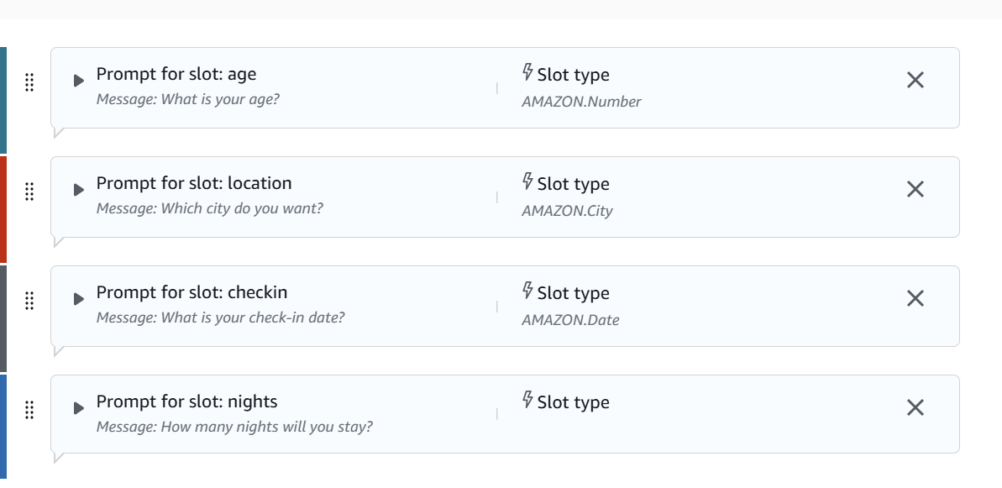

Step 7: Create Custom Slot Type

Save intent

Click on Back to intents
If you want custom values:
- Go to Slot Types
- Click Add slot type ->add blank slot type
- Name: RoomType
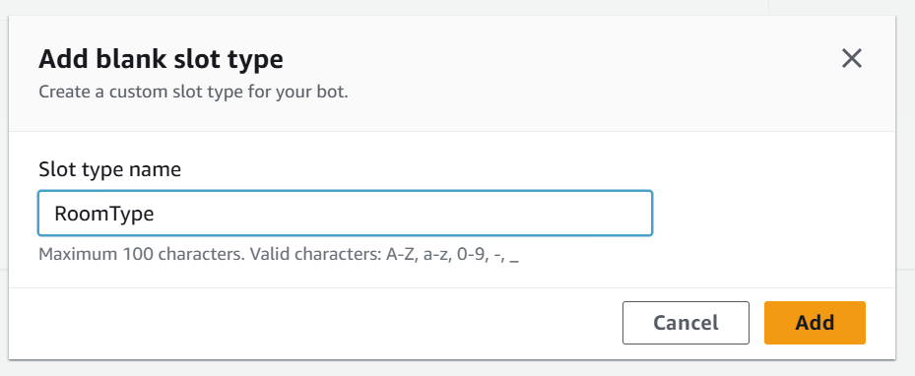
Add values:
Single
Double
Suite
Save slot type
Now use this in slot: go back to intent
- Slot name: RoomType
- Slot type: RoomType

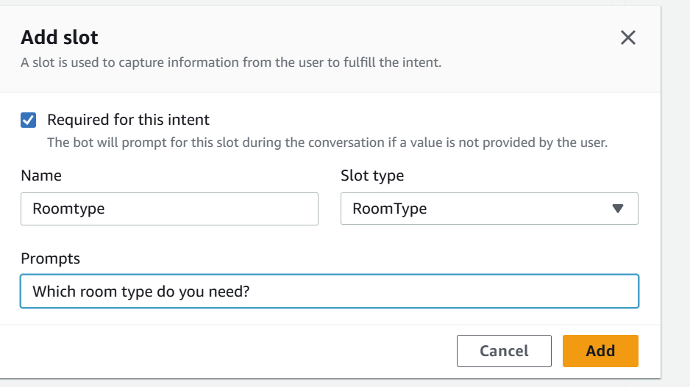

Step 9: Add Response Cards (Card Groups)
Used for buttons (quick replies)
Steps:
- Go to slot prompts -> more prompt options
- Click Add -> add card groups
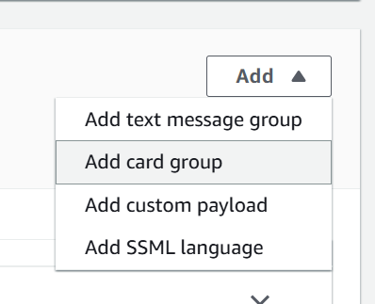
Example:
Card Title: Select Room Type
click on add Buttons:
- Single → "Single"
- Double → "Double"
- Suite → "Suite"
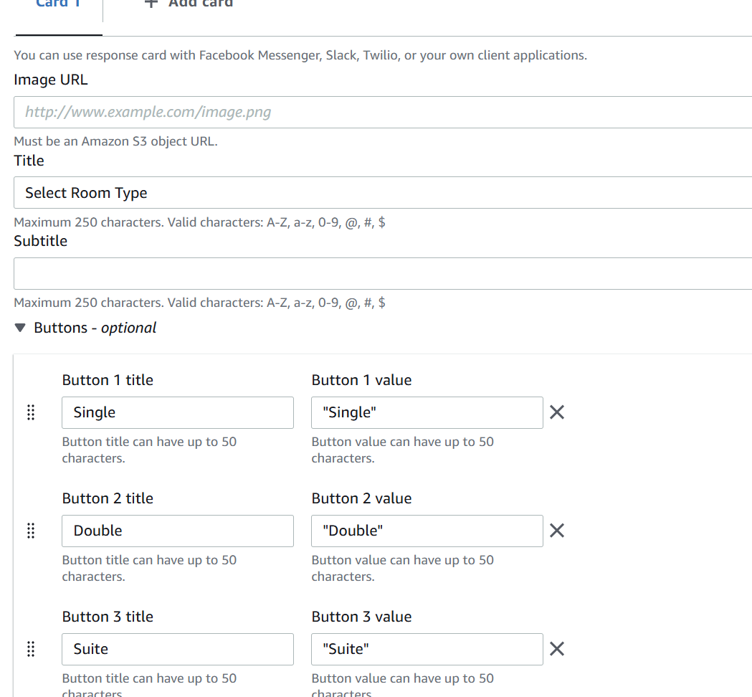

Step 10: Configure Responses
Initial Response:
Welcome to Hotel Booking! What is your name?
Confirmation:
Do you want to confirm booking in {location} for {nights} nights?
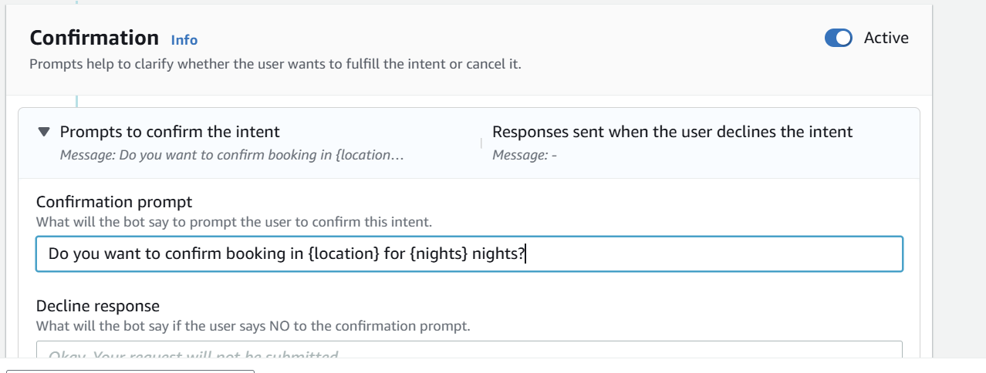

Step 11: Build & Test
- Click Build
- Use Test chatbot panel
- Try:
Book a hotel

Sample output
User: Book a hotel
Bot: What is your age?
User: 25
Bot: Which city do you want?
User: Hyderabad
Bot: Check-in date?
User: Tomorrow
Bot: Number of nights?
User: 2
Bot: Select room type
User: Double
Bot: Do you want to confirm booking in Hyderabad for 2 nights?
User: Yes
Bot: Booking confirmed.
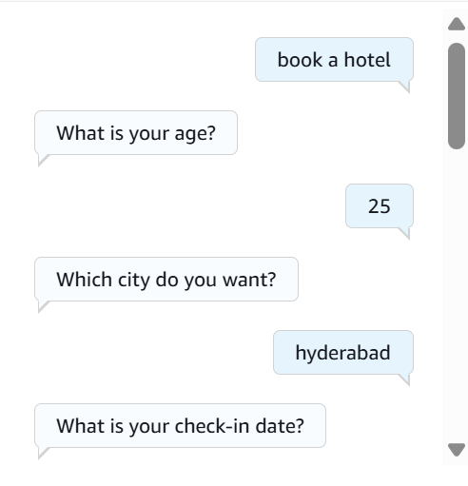
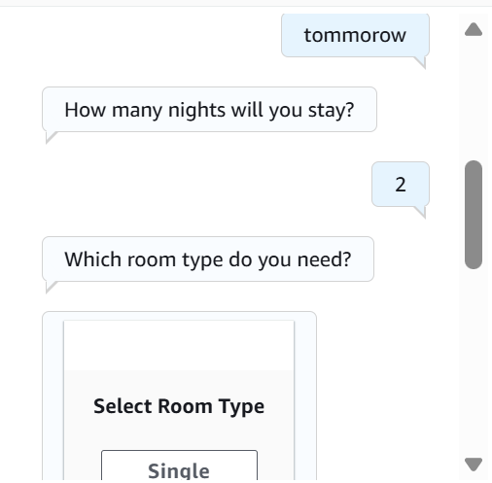
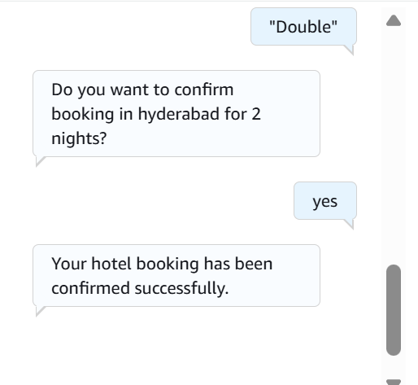

SCENARIO BASED QUESTIONS
AMAZON LEX — SCENARIO BASED QUESTIONS WITH ANSWERS
Scenario 1: Bot Not Responding
Q: You created a chatbot, but when you test it, the bot does not respond to user input.
- What could be the possible reason for no response?
- Did you build and publish the bot correctly?
- How would you troubleshoot this issue?
Answer:
Possible reasons include the bot not being built, missing sample utterances, wrong test alias, or the intent not being saved. Sometimes the selected language draft may still show Not built.
Troubleshooting steps:
- Check whether the intent is saved.
- Click Build and confirm status shows Built.
- Verify sample utterances are present.
- Test using the correct bot alias.
- Check CloudWatch logs if Lambda is used.

Scenario 2: Incorrect Intent Matching
Answer:
Incorrect intent recognition happens when the bot has too few or very similar utterances.
Utterances train Lex’s NLP model. If only one or two phrases are added, Lex may confuse intents.
Improve accuracy by:
- adding more utterances
- adding natural variations
- avoiding overlapping phrases
- using slot hints and contexts
Example:
- Book a hotel
- Reserve a room
- Need hotel in Hyderabad

Scenario 3: Missing Slot Values
Answer:
A slot is a variable input collected from the user, such as city, age, or check-in date.
Slot values may fail because:
- wrong slot type selected
- prompt missing
- slot not marked required
- invalid retry prompts
- unsupported user format
Fix:
- use correct slot types like AMAZON.City, AMAZON.Date, AMAZON.Number
- add retry prompts
- make the slot required
- validate slot order

Scenario 4: Fulfillment Not Working
Answer:
Fulfillment means performing the final backend action after collecting all slots.
Usually this is done using AWS Lambda.
Possible issues:
- wrong Lambda ARN
- Lambda timeout
- invalid JSON response
- IAM permission issues
Verify backend:
- test Lambda separately
- check CloudWatch logs
- confirm Lex is calling Lambda
- validate response format

Scenario 5: Bot Not Accessible
Answer:
Users may not access the bot if:
- bot version not published
- alias not created
- channel integration missing
- IAM permission denied
Fix:
- Create bot version
- Create alias
- Connect channel (web/mobile/Connect)
- Grant required permissions

Scenario 6: Wrong Language Understanding
Answer:
Amazon Lex uses Natural Language Processing (NLP) and machine learning to understand user phrases.
Training with multiple utterances is important because users ask the same thing in many ways.
Improve NLP performance:
- add diverse utterances
- use synonyms
- test real user phrases
- reduce ambiguity
- use fallback intent carefully

Scenario 7: Versioning Issue
Answer:
This happens when the updated draft version is not published.
Users still access the old alias version.
Fix:
- Create new bot version
- Update alias to latest version
- Test using the updated alias
Alias is important because users interact through aliases, not directly through draft.

Scenario 8: Lambda Permission Error
Answer:
A common error is:
Lex is not authorized to invoke Lambda
This happens when Lambda resource policy does not allow Lex.
IAM roles are used so Lex can securely invoke Lambda.
Fix:
- add Lambda permission for Lex
- verify execution role
- check trust relationship
- confirm correct function ARN

Scenario 9: Bot Gives Default Response
Answer:
The fallback intent is triggered when Lex cannot match user input to any intent.
Reasons:
- too few utterances
- spelling variations
- unsupported phrases
- poor intent design
Fix:
- add more utterances
- improve fallback response
- separate similar intents
- use sample training phrases from real users

Scenario 10: Multi-turn Conversation Issue
Answer:
Dialog management controls how the conversation continues step by step.
Slots enable multi-turn conversation by collecting values in order.
Conversation flow improves when:
- slot priority is correct
- retry prompts are added
- confirmation prompts are enabled
- conditional branching is used
Example:
Age → City → Check-in → Nights → Room Type

Scenario 11: Integration with Web Application
Answer:
Amazon Lex can be integrated with web applications using:
- AWS SDK
- Lex Runtime API
- API Gateway
- Lambda
- JavaScript frontend
Required services:
- Amazon Lex
- API Gateway
- IAM
- Lambda
- frontend framework
Challenges:
- CORS issues
- authentication
- session management
- latency

Scenario 12: Performance Issue
Answer:
Slow response can happen because of:
- Lambda cold starts
- backend API delays
- high traffic
- database latency
- poor scaling
Amazon Lex itself is scalable, but backend services must also scale.
AWS services for high traffic:
- Lambda
- API Gateway
- DynamoDB
- SQS
- CloudFront
- Auto Scaling
These help support many simultaneous chatbot users.

