PROJECT 55
DESIGN AND IMPLEMENTATION OF A DATABASE MANAGEMENT SYSTEM FOR BANK ACCOUNT AND TRANSACTION MANAGEMENT SYSTEM
Review 1 Report | Week 7 | 5 Marks

1. Problem Statement
Banks handle a very large volume of customer, account, and transaction data across multiple branches every day. When this data is managed inconsistently — through manual records or loosely structured systems — it becomes easy to introduce balance errors, duplicate transaction or account identifiers, unbalanced transfers, and unreliable audit trails. This project designs and implements a relational database management system that models the core entities of retail banking (customers, branches, accounts, transactions, transfers, beneficiaries, charges, loans, and statements) and enforces the business rules that keep that data consistent, auditable, and trustworthy.

2. Scope
In scope for this project:
- Conceptual (ER) and logical (relational) design covering customers, branches, account types, accounts, account holders, transactions, transfers, beneficiaries, charges, loans, loan schedules, repayments, and statements.
- Normalization of the schema up to Third Normal Form (3NF).
- Implementation in MySQL / PostgreSQL / Oracle with primary keys, foreign keys, UNIQUE, NOT NULL, CHECK, and DEFAULT constraints.
- Realistic sample data and SQL queries for retrieval, joins, aggregation, nested queries, views, and reports.
- A small Java or Python front-end application supporting account opening, deposit, withdrawal, transfer, beneficiary management, service charges, loan repayment, statements, and reporting.
Out of scope: mobile applications, integration with real-time external payment gateways, multi-currency accounts, and regulatory/compliance certification.

3. Objectives
- Analyse banking requirements and identify the major entities, attributes, relationships, and user roles.
- Produce a conceptual ER model and convert it into a normalized (3NF) relational schema.
- Implement the schema with constraints that enforce key business rules — unique account/transaction IDs, sufficient balance, balanced debit/credit, active-account requirement, and positive amounts.
- Populate the database with realistic sample data and validate it with meaningful SQL queries and reports.
- Build a small front-end application to demonstrate CRUD operations, search, validation, and error handling.
- Demonstrate data integrity, transaction awareness, and indexing of frequently searched attributes through systematic testing.

4. Intended Users
- Bank Customer — the account holder whose accounts, transactions, and statements are recorded.
- Teller / Branch Staff — opens accounts, records deposits/withdrawals/transfers, registers beneficiaries, applies service charges.
- Loan Officer — originates loans, sets repayment schedules, records repayments.
- Branch Manager — reviews branch-level summaries and reports.
- Database Administrator — maintains the database, manages access, and ensures data integrity.

5. Functional Requirements
- The system shall register and maintain customer profiles, including identity-proof details.
- The system shall allow opening of accounts under a branch and account type, including joint accounts with multiple holders.
- The system shall record deposit and withdrawal transactions and update account balances accordingly.
- The system shall process transfers between accounts such that every transfer is balanced (debit = credit).
- The system shall maintain a list of registered beneficiaries per account.
- The system shall apply and log service charges against accounts.
- The system shall originate loans against a customer and account, and generate an installment repayment schedule.
- The system shall record repayments against the loan schedule and track outstanding balances.
- The system shall generate account statements for a given date range.
- The system shall produce reports for account balances, transaction audit trails, transfers, loan outstanding, repayments, and branch-wise summaries.
- The system shall enforce that account/transaction identifiers are unique, transaction amounts are positive, withdrawals do not exceed available balance, and transactions only post against active accounts.
- The system shall support search on frequently queried attributes such as account number, customer identifier, and transaction date.

6. Conceptual Design — Entity-Relationship Diagram
The diagram below models the principal entities identified in the project brief — customers, branches, account types, accounts, account holders, transactions, transfers, beneficiaries, charges, loans, loan schedules, repayments, and statements — along with their relationships and cardinalities.
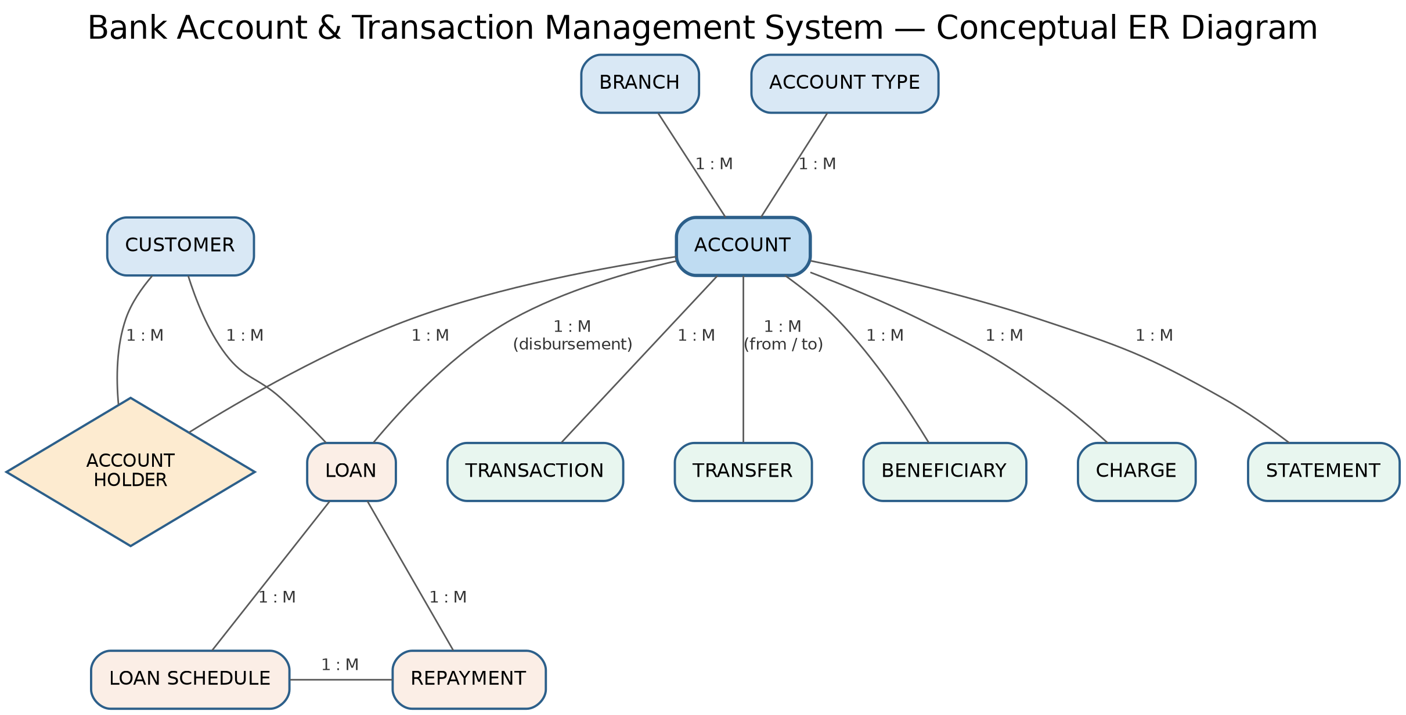
Relationship notes:
- Customer ↔ Account is many-to-many, resolved through the associative entity Account Holder (supports joint accounts and a customer holding several accounts).
- Account is the central entity: every transaction, transfer, beneficiary, charge, loan disbursement, and statement is tied back to an account.
- Loan Schedule and Repayment are separated so that each installment can be tracked independently of when (or whether) it was actually paid.

7. Initial Relational Schema
The tables below give the first-cut relational schema derived from the ER diagram — table names, columns, and key structure. This has not yet been normalized to 3NF; that step, along with full data types and CHECK/DEFAULT constraints, is planned for Review 2.
BRANCH
Column | Key | Notes
BranchID | PK | Unique branch identifier
BranchName
Address
Phone
IFSCCode | UNIQUE | Branch routing code
ACCOUNT_TYPE
Column | Key | Notes
AccountTypeID | PK | e.g. Savings, Current, Fixed
TypeName | UNIQUE
InterestRate
MinBalance
CUSTOMER
Column | Key | Notes
CustomerID | PK | Unique customer identifier
FullName
DOB
Address
Phone
Email | UNIQUE
IDProofType, IDProofNumber | UNIQUE (pair) | KYC document
ACCOUNT
Column | Key | Notes
AccountID | PK | Unique account identifier
AccountNumber | UNIQUE | Customer-facing number
BranchID | FK → BRANCH
AccountTypeID | FK → ACCOUNT_TYPE
OpenDate
Status |  | Active / Closed / Frozen
Balance |  | Must remain ≥ 0
ACCOUNT_HOLDER
Column | Key | Notes
AccountID | PK (composite), FK → ACCOUNT
CustomerID | PK (composite), FK → CUSTOMER
HolderRole |  | Primary / Joint
TRANSACTION
Column | Key | Notes
TransactionID | PK | Unique transaction identifier
AccountID | FK → ACCOUNT
TransactionType |  | Deposit / Withdrawal
Amount |  | Must be positive
TransactionDate
BalanceAfter
TRANSFER
Column | Key | Notes
TransferID | PK
FromAccountID | FK → ACCOUNT | Must be active, sufficient balance
ToAccountID | FK → ACCOUNT | Must be active
Amount |  | Debit = credit, positive
TransferDate
Status
BENEFICIARY
Column | Key | Notes
BeneficiaryID | PK
AccountID | FK → ACCOUNT | Owning account
BeneficiaryName
BeneficiaryAccountNumber
BeneficiaryBank, IFSCCode
AddedDate
CHARGE
Column | Key | Notes
ChargeID | PK
AccountID | FK → ACCOUNT
ChargeType
Amount |  | Positive
ChargeDate
LOAN
Column | Key | Notes
LoanID | PK
CustomerID | FK → CUSTOMER
AccountID | FK → ACCOUNT | Disbursement account
LoanType, PrincipalAmount, InterestRate, TermMonths
StartDate, Status
LOAN_SCHEDULE
Column | Key | Notes
ScheduleID | PK
LoanID | FK → LOAN
InstallmentNumber
DueDate, DueAmount, Status
REPAYMENT
Column | Key | Notes
RepaymentID | PK
LoanID | FK → LOAN
ScheduleID | FK → LOAN_SCHEDULE
PaymentDate, AmountPaid, Mode
STATEMENT
Column | Key | Notes
StatementID | PK
AccountID | FK → ACCOUNT
PeriodStart, PeriodEnd, GeneratedDate
OpeningBalance, ClosingBalance

8. Next Steps (Review 2 preview)
- Apply normalization (1NF → 2NF → 3NF) with a functional-dependency analysis and data dictionary.
- Finalize data types and add UNIQUE, NOT NULL, CHECK, and DEFAULT constraints.
- Write DDL scripts, load sample data, and build the reporting SQL (joins, subqueries, aggregates, views).

