SCHOOL OF TECHNOLOGY | 

DATABASE MANAGEMENT SYSTEMS
PROJECT-BASED LEARNING (PBL) REPORT
Small Database Application Development using Java / Python

PROJECT TITLE
DESIGN AND IMPLEMENTATION OF A DATABASE MANAGEMENT SYSTEM FOR BANK ACCOUNT AND TRANSACTION MANAGEMENT SYSTEM
(Project 55)

Program | AI-ML
Section | AI-ML RHINOS
Faculty | Prof. Sahithi Chennamadhavun
Date of Submission | 14 October 2026
Academic Year | 2026 – 27

Submitted by
Roll Number | Student Name | Mobile | Email ID
25WU0102140 | M. Srilakshmi Reddy | 8918595029 | reddy14srilakshmi@gmail.com

ACKNOWLEDGEMENT
I express my sincere gratitude to Woxsen University, School of Technology, for providing me with the opportunity to undertake this Project-Based Learning (PBL) activity as part of the Database Management Systems (DBMS) course.
I thank my course faculty, Prof. Sahithi Chennamadhavun, for the guidance, suggestions, and support throughout the design and development of this project. The guidance helped me understand the practical application of database concepts such as ER modelling, relational schema design, normalization, SQL, constraints, queries, and database application development.
This PBL activity has strengthened my understanding of DBMS concepts and provided valuable experience in applying them to a real-world problem.

UNDERTAKING
I hereby declare that the project entitled “Design and Implementation of a Database Management System for Bank Account and Transaction Management System”, submitted as part of the Project-Based Learning activity for the Database Management Systems (DBMS) course, is my individual work carried out under the guidance of the course faculty.
I undertake that the project report, database design, SQL scripts, application source code, results, and supporting materials submitted by me have been prepared for academic purposes. Wherever information, ideas, tools, datasets, or other resources have been referred to, appropriate acknowledgement has been provided.
I further undertake that I am responsible for the correctness and authenticity of the work submitted and that I have followed the academic and project guidelines prescribed by the University.
 |  |  |  | Signature
Date | : | 14 October 2026 | Name: | M. Srilakshmi Reddy
Place | : | Hyderabad | Roll Number: | 25WU0102140
 |  |  | Program: | AI-ML

TABLE OF CONTENTS
Contents | Page No.
Abstract | 8
LIST OF TABLES | 5
LIST OF FIGURES | 6
LIST OF ACRONYMS | 7
1. PROBLEM STATEMENT, SOLUTION STRATEGY AND ER DIAGRAM | 9
1.1 Problem Statement | 9
1.2 Objectives | 9
1.3 Scope and Assumptions | 10
1.4 Proposed Solution Strategy | 10
1.5 Functional Requirements | 11
1.6 Entity-Relationship Diagram (ERD) | 11
1.7 Entity and Relationship Summary | 12
2. LOGICAL DATABASE DESIGN | 14
2.1 Relational Schema | 14
2.2 Keys and Integrity Constraints | 15
2.3 Functional Dependencies | 17
2.4 Normalization up to Third Normal Form (3NF) | 17
2.5 Data Dictionary | 18
2.6 Implementation of Logical Design: DDL and Sample Data | 20
3. APPLICATION DEVELOPMENT USING LOGICAL DATABASE DESIGN | 23
3.1 Application Overview | 23
3.2 Development Environment and Database Connectivity | 23
3.3 Application Modules and Database Mapping | 24
3.4 CRUD Operations | 24
3.5 Business Rules, Validation and Error Handling | 24
3.6 Reports and Database Operations | 25
3.7 Application Screens | 26
3.8 Testing and Results | 31
4. CONCLUSION | 34
4.1 Limitations and Future Enhancements | 34
5. REFERENCES | 35
6. APPENDICES | 36

LIST OF TABLES
Table No. | Table Title | Page No.
Table 1 | Scope and Assumptions | 10
Table 2 | Proposed Solution Strategy | 10
Table 3 | Functional Requirements | 11
Table 4 | Entity and Relationship Summary | 12
Table 5 | Relational Schema | 14
Table 6 | Keys and Integrity Constraints | 15
Table 7 | Normalization Status up to 3NF | 18
Table 8 | Data Dictionary | 18
Table 9 | Database Implementation Environment | 20
Table 10 | Application Development Environment | 23
Table 11 | Application Module-to-Database Mapping | 24
Table 12 | CRUD Operations | 24
Table 13 | Business Rules, Validation and Error Handling | 25
Table 14 | Reports and Database Operations | 25
Table 15 | Test Cases | 31

LIST OF FIGURES
Figure No. | Figure Title | Page No.
Figure 1 | Entity-Relationship Diagram of the Proposed System | 12
Figure 2 | The 14 base tables in the bank_db database (MySQL) | 22
Figure 3 | Staff Sign-in Screen | 26
Figure 4 | Manager Dashboard with Live Totals and Branch Summary | 27
Figure 5 | Account Search and Display | 27
Figure 6 | Cash Deposit Posted to an Account (Data Entry) | 28
Figure 7 | Withdrawal Beyond the Balance Rejected by the Database | 28
Figure 8 | Atomic Transfer Between Two Accounts | 29
Figure 9 | Loan Schedule After an EMI Repayment (Update) | 29
Figure 10 | Account Statement Report with Running Balance | 30
Figure 11 | Rule Tester: Illegal Operations Refused and Rolled Back | 31
Figure 12 | Trigger Rejection and Unchanged Balances in MySQL | 32

LIST OF ACRONYMS
Acronym | Expansion
3NF | Third Normal Form
AI | Auto Increment
API | Application Programming Interface
BCNF | Boyce-Codd Normal Form
CRUD | Create, Read, Update, Delete
DBMS | Database Management System
DDL | Data Definition Language
DF | Default
EMI | Equated Monthly Instalment
ER | Entity-Relationship
ERD | Entity-Relationship Diagram
FK | Foreign Key
FR | Functional Requirement
GUI | Graphical User Interface
HTTP | HyperText Transfer Protocol
IDE | Integrated Development Environment
IFSC | Indian Financial System Code
INR | Indian Rupee
JSON | JavaScript Object Notation
JWT | JSON Web Token
KYC | Know Your Customer
NEFT | National Electronic Funds Transfer
NN | Not Null
PBL | Project-Based Learning
PDF | Portable Document Format
PK | Primary Key
REST | Representational State Transfer
SMS | Short Message Service
SQL | Structured Query Language
UNF | Unnormalised Form
UPI | Unified Payments Interface
UQ | Unique

ABSTRACT
Banks record thousands of customer, account and transaction entries daily, and manual or loosely structured record keeping leads to balance errors, duplicated identifiers, unbalanced transfers and weak audit trails. This project aims to design and implement a relational database system for bank account and transaction management that enforces these business rules inside the database itself. The conceptual model was drawn as an entity-relationship diagram and converted into a fourteen-table logical schema normalised to third normal form, with primary key, foreign key, unique, check and default constraints. It was implemented in MySQL with three triggers, two stored procedures, seven reporting views and five indexes, and loaded with realistic multi-branch sample data. A Node.js and Express application with role-based staff login sits on top of the database and provides customer and account maintenance, deposits, withdrawals, atomic transfers, loan disbursement with EMI schedules, repayments, statements and a rule tester. Sixteen test cases show that illegal operations such as overdrawing, posting to frozen or closed accounts and unbalanced transfers are rejected and rolled back, while every stored balance equals its ledger. The system demonstrates a dependable, auditable core for small-scale retail banking.

KEYWORDS
Keywords: Relational Database, ER Diagram, Normalization (3NF), MySQL, Triggers and Stored Procedures, Banking Transactions

CHAPTER 1

PROBLEM STATEMENT, SOLUTION STRATEGY AND ER DIAGRAM

1.1 Problem Statement
A retail bank serves thousands of customers through several branches, and every deposit, withdrawal, transfer, service charge and loan instalment changes the money held on someone's behalf. When these records are kept in spreadsheets, paper registers or loosely structured files, the same customer or account can be entered twice, account numbers and transaction references can be duplicated, a withdrawal can be accepted although it takes the balance below the permitted minimum, and the two halves of a transfer can be posted unevenly. Tellers, loan officers and branch managers then have no single trustworthy source from which to answer balance, statement and loan-outstanding questions.
The affected stakeholders are account holders, who depend on correct balances and statements; tellers and loan officers, who post transactions and collect repayments; and branch managers, who need branch-level summaries and an audit trail. The manual process is slow, depends on the care of the person posting, cannot stop a rule violation at the moment it is made, and turns reconciliation into a periodic clean-up instead of a property of the data. A relational database that enforces the banking rules itself, together with a small application that uses it, is therefore needed so that invalid operations are refused before they reach the ledger and every balance can be traced back to its postings.

1.2 Objectives
The objectives of the project are to:
- Design an entity-relationship model for retail banking that covers customers, branches, account types, accounts, joint holders, transactions, transfers, beneficiaries, service charges, loans, loan schedules, repayments and statements.
- Develop a relational schema of 14 tables, normalised to Third Normal Form, with primary key, foreign key, unique, not-null, check and default constraints.
- Implement the business rules inside MySQL through 3 triggers and 2 stored procedures so that illegal postings (non-positive amounts, overdrawing, frozen or closed accounts and unbalanced transfers) are rejected and rolled back.
- Automate loan EMI scheduling, repayment allocation and overdue marking, and generate account statements and branch reports through 7 views and 12 verified queries.
- Validate the design through a working web application with role-based login and 16 positive and negative test cases, confirming zero balance mismatches.

1.3 Scope and Assumptions
Table 1 defines what the project covers, what it deliberately leaves out, and the assumptions on which the design rests.
Table 1. Scope and Assumptions
Item | Description
In Scope | Customer, branch and account-type master data; account opening with primary and joint holders; deposits, withdrawals, transfers between accounts, beneficiaries and service charges; personal, vehicle, education and home loans with EMI schedules, repayments and overdue tracking; account statements; branch summary and audit reports; staff login with Teller, Loan Officer and Manager roles.
Out of Scope / Exclusions | Mobile banking apps, real-time payment gateways (UPI, NEFT, card networks), multi-currency accounts, periodic interest-posting runs, customer self-service login, regulatory and KYC verification, and settlement of transfers to accounts held at other banks.
Assumptions | Single currency (INR); one bank with four branches; account balances change only through ledger postings; a joint account has one primary holder and any number of joint holders; EMIs follow the reducing-balance formula and are paid in full from the linked account; the database server is MySQL 8; staff use only the role they are issued.

1.4 Proposed Solution Strategy
The solution stores all banking facts in a normalised relational database and keeps the rules next to the data, following the relational model [1]. A thin application layer only collects input and displays results, so every access path, whether the web application, a script or a manual SQL session, meets the same rules. Table 2 summarises the proposed solution.
Table 2. Proposed Solution Strategy
Solution Element | Project-Specific Description
Primary Users / Roles | Teller: customers, accounts, cash postings, transfers, beneficiaries, statements.  Loan Officer: loan creation and repayment collection.  Branch Manager: all functions, plus the audit log and account-status control (freeze, close).
Major Application Modules | Login, Dashboard, Customers, Accounts, Transactions, Transfers, Statements, Loans, and Rule Tester.
Proposed Workflow | Staff sign in; a customer is registered; an account is opened (with joint holders if needed) and funded; deposits, withdrawals and transfers post to the ledger; loans are disbursed into the account with an EMI schedule and repaid instalment by instalment; statements and reports are generated from views.
Important Business Rules | Amounts must be positive; a debit may not take the balance below the account type's minimum; only ACTIVE accounts accept postings; a transfer needs two different accounts and equal debit and credit legs; account numbers, e-mails and ID proofs are unique; an instalment is closed only when fully paid; failed operations leave no partial data.
Expected Reports / Outputs | Account statement with running balance, branch summary, loan outstanding and overdue instalments, repayment history, transfer register, transaction audit and monthly deposit/withdrawal totals.

1.5 Functional Requirements
Table 3 lists the functional requirements. Priority reflects how central each requirement is to a correct banking ledger.
Table 3. Functional Requirements
Req. ID | Functional Requirement | Remarks / Priority
FR-01 | Register, search and update customer profiles with unique e-mail and ID proof. | High
FR-02 | Open an account for one or more holders at a branch with a chosen account type and optional opening deposit. | High
FR-03 | Post deposits and withdrawals; reject non-positive amounts, overdrawing and postings to non-ACTIVE accounts. | High
FR-04 | Transfer money between two accounts as one atomic unit with equal debit and credit legs. | High
FR-05 | Maintain beneficiaries (internal and external) for each customer. | Medium
FR-06 | Apply service charges (SMS, ATM, cheque book, penalty, maintenance) as ledger postings. | Medium
FR-07 | Create loans with disbursement and an automatic reducing-balance EMI schedule. | High
FR-08 | Record repayments against an instalment, mark it PAID, close the loan after the last instalment. | High
FR-09 | Mark unpaid instalments past their due date as OVERDUE. | Medium
FR-10 | Generate account statements for a date range with opening, closing balance and running balance. | High
FR-11 | Provide branch summary, loan outstanding, transfer, repayment and audit reports. | Medium
FR-12 | Authenticate staff and restrict each role to its permitted functions. | High
FR-13 | Show every database rejection to the user exactly as the database reports it, and leave data unchanged. | High

1.6 Entity-Relationship Diagram (ERD)
Figure 1 shows the approved entity-relationship diagram, generated from the implemented schema so that entity names, keys and cardinalities match the database exactly. The notation is crow's foot: a line ending in three prongs is the 'many' side, a bar is 'one', and a circle marks optional participation. The ER model [2] has 14 entities. TRANSFER, SERVICE_CHARGE and LOAN_REPAYMENT are specialisations of TRANSACTION, and ACCOUNT_HOLDER resolves the many-to-many relationship between CUSTOMER and ACCOUNT. Table 4 lists the entities and their relationships.
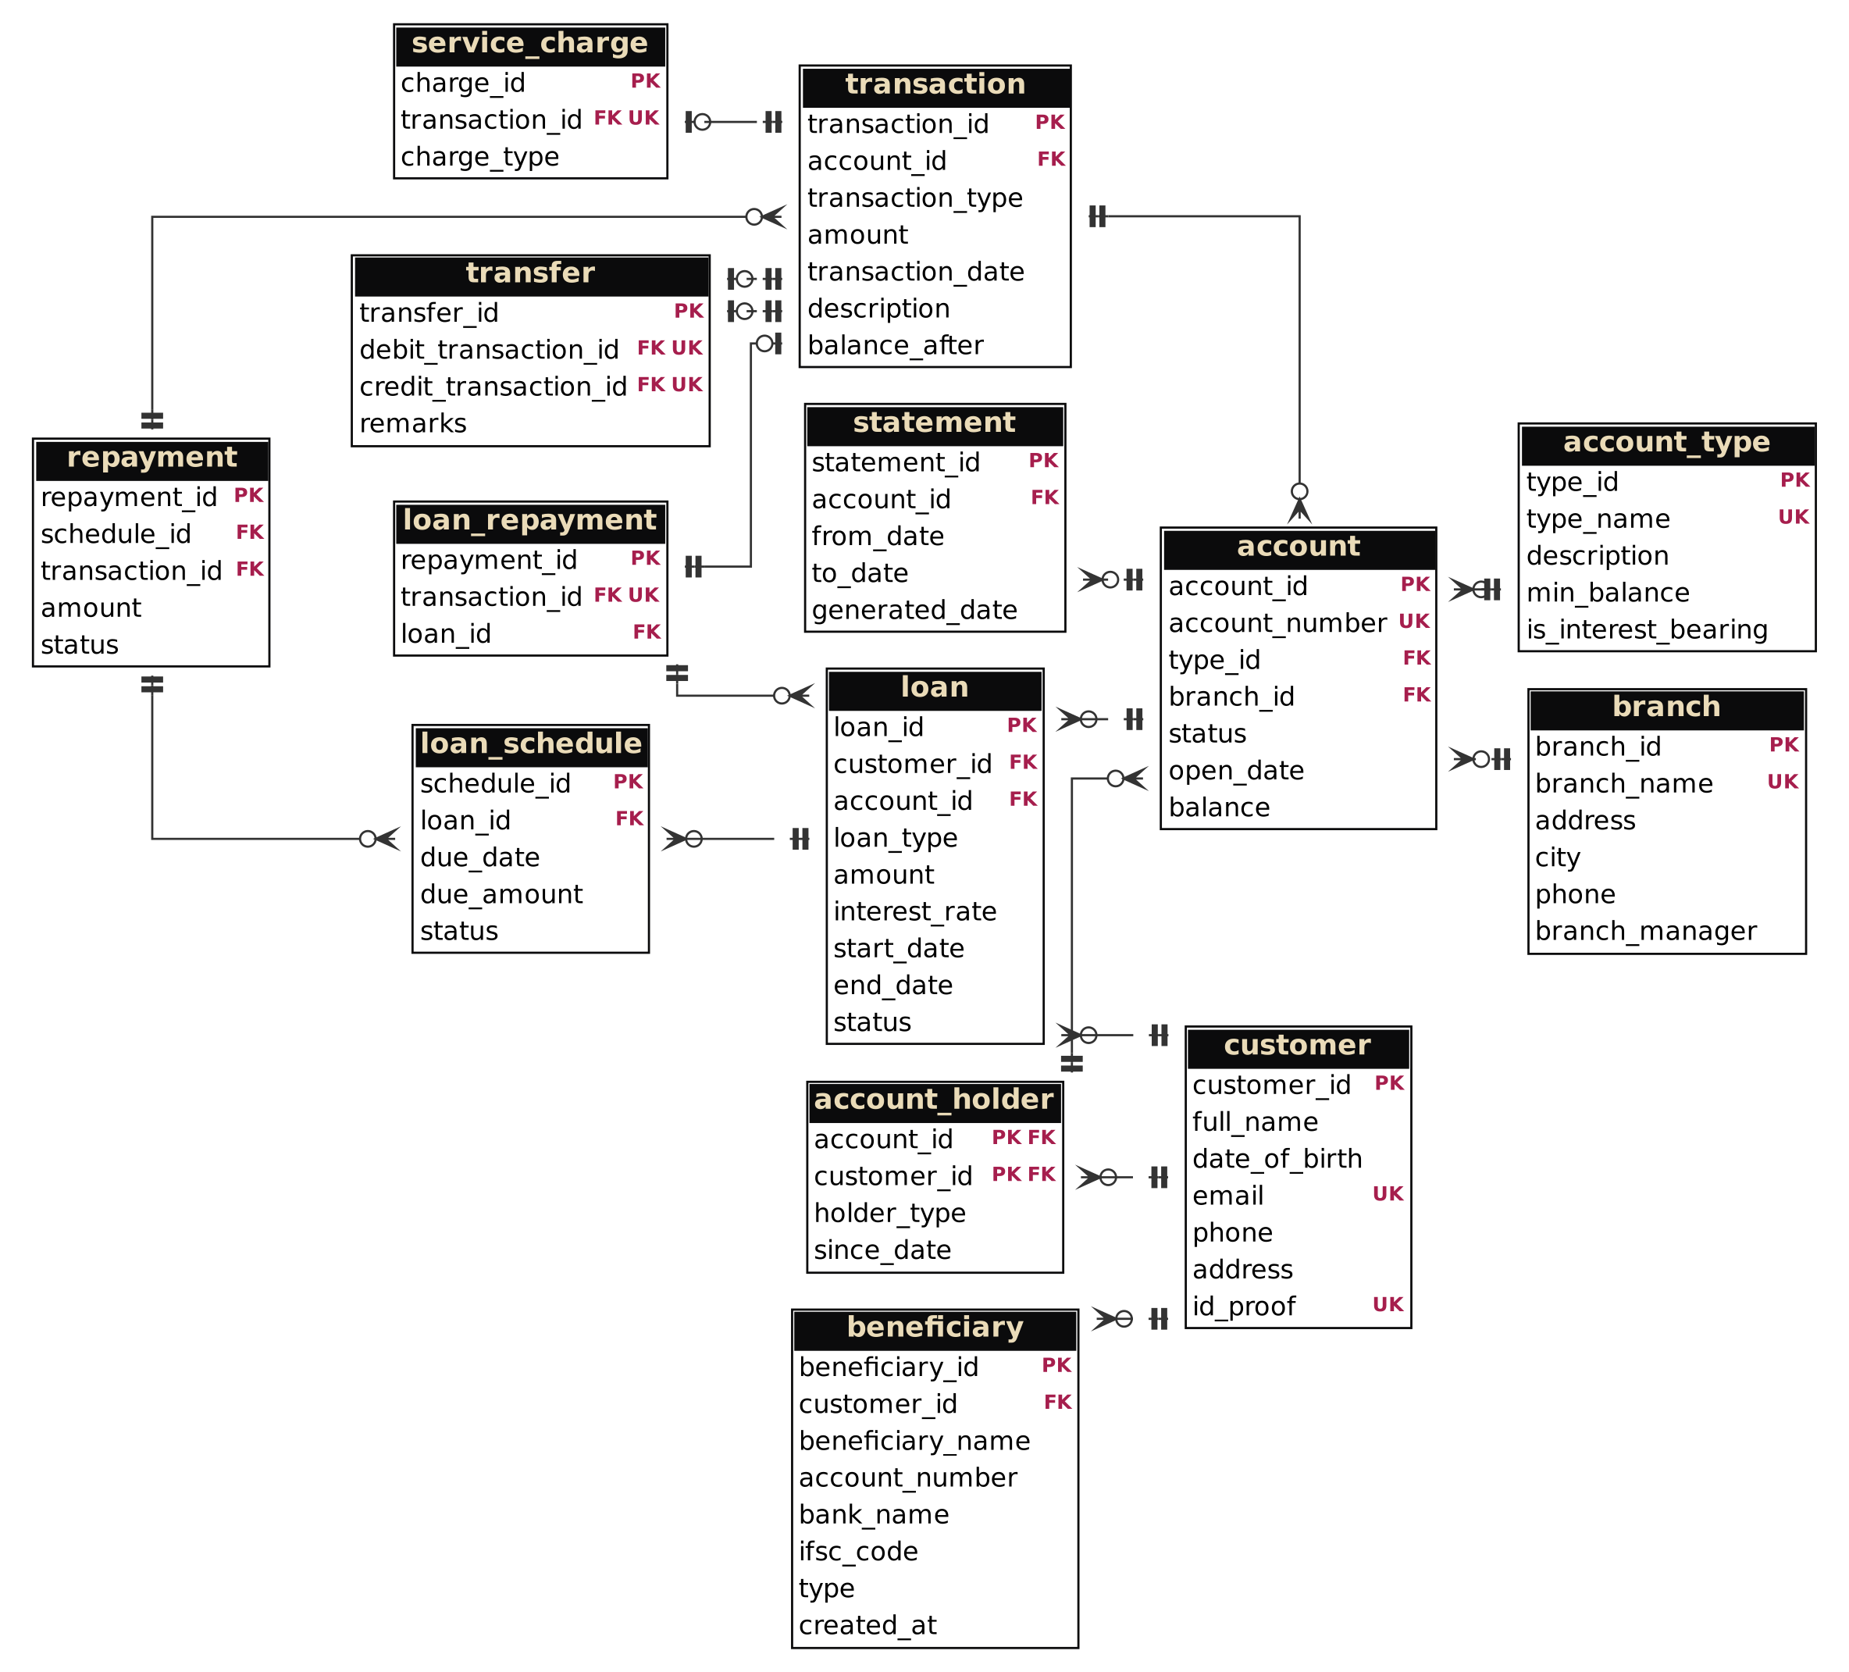
Figure 1. Entity-Relationship Diagram of the Proposed System

1.7 Entity and Relationship Summary
Table 4 summarises the entities and the relationships between them.
Table 4. Entity and Relationship Summary
Entity / Relationship | Major Attributes / Cardinality | Purpose / Rule
BRANCH | branch_id (PK), branch_name, address, city, phone, branch_manager | Bank branch; 1 branch : N accounts
ACCOUNT_TYPE | type_id (PK), type_name, min_balance, is_interest_bearing | Savings, Current, Salary, Fixed Deposit rules; 1 : N accounts
CUSTOMER | customer_id (PK), full_name, date_of_birth, email, phone, id_proof | Person who banks here; e-mail and ID proof unique
ACCOUNT | account_id (PK), account_number, type_id (FK), branch_id (FK), status, open_date, balance | Holds money; balance maintained only by trigger
ACCOUNT_HOLDER | (account_id, customer_id) (PK), holder_type, since_date | Resolves customer M : N account; PRIMARY or JOINT holder
TRANSACTION | transaction_id (PK), account_id (FK), transaction_type, amount, transaction_date, balance_after | Every money movement; supertype of transfer, charge, loan repayment
TRANSFER | transfer_id (PK), debit_transaction_id (FK), credit_transaction_id (FK), remarks | One transfer = one debit leg + one credit leg
SERVICE_CHARGE | charge_id (PK), transaction_id (FK), charge_type | Fee posted as a transaction
BENEFICIARY | beneficiary_id (PK), customer_id (FK), beneficiary_name, account_number, ifsc_code, type | Saved payee; unique per customer, account and IFSC
STATEMENT | statement_id (PK), account_id (FK), from_date, to_date, generated_date | Log of generated statements; period must be valid
LOAN | loan_id (PK), customer_id (FK), account_id (FK), loan_type, amount, interest_rate, start_date, end_date, status | Loan master; end date after start date
LOAN_SCHEDULE | schedule_id (PK), loan_id (FK), due_date, due_amount, status | One EMI per row; unique per loan and due date
LOAN_REPAYMENT | repayment_id (PK), transaction_id (FK), loan_id (FK) | Cash payment made against a loan
REPAYMENT | repayment_id (PK), schedule_id (FK), transaction_id (FK), amount, status | Allocation of a payment to an instalment
BRANCH 1 : N ACCOUNT | branch_id in ACCOUNT | Total participation of ACCOUNT; a branch may have no account
ACCOUNT_TYPE 1 : N ACCOUNT | type_id in ACCOUNT | Every account has exactly one type
CUSTOMER M : N ACCOUNT | through ACCOUNT_HOLDER | A joint account has several holders; a customer may hold several accounts
ACCOUNT 1 : N TRANSACTION | account_id in TRANSACTION | Ledger of the account; every posting belongs to one account
TRANSACTION 1 : 0..1 TRANSFER (two roles) | debit_ and credit_transaction_id | A transfer owns exactly two postings, one per role
CUSTOMER 1 : N LOAN, ACCOUNT 1 : N LOAN | customer_id, account_id in LOAN | A loan has one borrower and one disbursement account
LOAN 1 : N LOAN_SCHEDULE | loan_id in LOAN_SCHEDULE | Instalments of the loan
LOAN_SCHEDULE 1 : N REPAYMENT | schedule_id in REPAYMENT | A payment can be allocated to several instalments

CHAPTER 2

LOGICAL DATABASE DESIGN

2.1 Relational Schema
Every entity in Figure 1 became one relation, giving the 14 tables in Table 5. Relationships became foreign keys, and the many-to-many relationship between customers and accounts became the ACCOUNT_HOLDER table. The relational schema is also written in compact notation below the table, with primary key columns tagged PK and foreign key columns tagged FK.
Table 5. Relational Schema
S.No. | Table Name | Purpose
1 | branch | Bank branches and their managers
2 | account_type | Account products and their minimum balance rules
3 | customer | Customer profile and identity data
4 | account | Bank accounts with status and trigger-maintained balance
5 | account_holder | Links customers to accounts (primary and joint holders)
6 | transaction | Ledger of every posting with balance snapshot
7 | transfer | Pairs a debit posting with a credit posting
8 | service_charge | Marks a posting as a service charge and its type
9 | beneficiary | Saved payees of a customer
10 | statement | Log of generated account statements
11 | loan | Loan master record
12 | loan_schedule | EMI schedule, one row per instalment
13 | loan_repayment | Marks a posting as a loan payment
14 | repayment | Allocates a payment to a schedule instalment

Relational schema in compact notation:
branch(branch_id [PK], branch_name, address, city, phone, branch_manager)
account_type(type_id [PK], type_name, description, min_balance, is_interest_bearing)
customer(customer_id [PK], full_name, date_of_birth, email, phone, address, id_proof)
account(account_id [PK], account_number, type_id [FK], branch_id [FK], status, open_date, balance)
account_holder(account_id [PK FK], customer_id [PK FK], holder_type, since_date)
transaction(transaction_id [PK], account_id [FK], transaction_type, amount, transaction_date, description, balance_after)
transfer(transfer_id [PK], debit_transaction_id [FK], credit_transaction_id [FK], remarks)
service_charge(charge_id [PK], transaction_id [FK], charge_type)
beneficiary(beneficiary_id [PK], customer_id [FK], beneficiary_name, account_number, bank_name, ifsc_code, type, created_at)
statement(statement_id [PK], account_id [FK], from_date, to_date, generated_date)
loan(loan_id [PK], customer_id [FK], account_id [FK], loan_type, amount, interest_rate, start_date, end_date, status)
loan_schedule(schedule_id [PK], loan_id [FK], due_date, due_amount, status)
loan_repayment(repayment_id [PK], transaction_id [FK], loan_id [FK])
repayment(repayment_id [PK], schedule_id [FK], transaction_id [FK], amount, status)

2.2 Keys and Integrity Constraints
Table 6 lists, for every table, the keys and integrity constraints declared in the DDL. Foreign keys use the default RESTRICT action, so a parent row cannot be deleted while children exist; accounts and loans are therefore closed by changing their status rather than deleted. Not-null and default constraints are shown in aggregate for each table.
Table 6. Keys and Integrity Constraints
Table Name | Key / Constraint | Attribute(s) | Business Rule Enforced
branch | Primary Key | branch_id | Unique identity of each row
 | Unique | branch_name | No duplicate values
 | Not Null | All columns | Mandatory data must be supplied
account_type | Primary Key | type_id | Unique identity of each row
 | Unique | type_name | No duplicate values
 | Check | min_balance >= 0 | Minimum balance cannot be negative
 | Not Null | All columns except description | Mandatory data must be supplied
 | Default | min_balance = 0.00; is_interest_bearing = 1 | Sensible value when none is given
customer | Primary Key | customer_id | Unique identity of each row
 | Unique | email | No duplicate values
 | Unique | id_proof | No duplicate values
 | Check | email LIKE '%_@_%._%' | E-mail must look like name@domain.tld
 | Not Null | All columns | Mandatory data must be supplied
account | Primary Key | account_id | Unique identity of each row
 | Foreign Key | branch_id -> branch | Referential integrity (RESTRICT): no orphan rows
 | Foreign Key | type_id -> account_type | Referential integrity (RESTRICT): no orphan rows
 | Unique | account_number | No duplicate values
 | Check | balance >= 0 | Stored balance never negative
 | Not Null | All columns | Mandatory data must be supplied
 | Default | status = ACTIVE; balance = 0.00 | Sensible value when none is given
account_holder | Primary Key | account_id, customer_id | Unique identity of each row (composite)
 | Foreign Key | account_id -> account | Referential integrity (RESTRICT): no orphan rows
 | Foreign Key | customer_id -> customer | Referential integrity (RESTRICT): no orphan rows
 | Not Null | All columns | Mandatory data must be supplied
 | Default | holder_type = PRIMARY | Sensible value when none is given
transaction | Primary Key | transaction_id | Unique identity of each row
 | Foreign Key | account_id -> account | Referential integrity (RESTRICT): no orphan rows
 | Check | amount > 0 | Every posting amount is positive
 | Not Null | All columns except description, balance_after | Mandatory data must be supplied
 | Default | transaction_date = current_timestamp() | Sensible value when none is given
transfer | Primary Key | transfer_id | Unique identity of each row
 | Foreign Key | credit_transaction_id -> transaction | Referential integrity (RESTRICT): no orphan rows
 | Foreign Key | debit_transaction_id -> transaction | Referential integrity (RESTRICT): no orphan rows
 | Unique | credit_transaction_id | No duplicate values
 | Unique | debit_transaction_id | No duplicate values
 | Check | debit_transaction_id <> credit_transaction_id | Debit and credit legs are different postings
 | Not Null | All columns except remarks | Mandatory data must be supplied
service_charge | Primary Key | charge_id | Unique identity of each row
 | Foreign Key | transaction_id -> transaction | Referential integrity (RESTRICT): no orphan rows
 | Unique | transaction_id | No duplicate values
 | Not Null | All columns | Mandatory data must be supplied
beneficiary | Primary Key | beneficiary_id | Unique identity of each row
 | Foreign Key | customer_id -> customer | Referential integrity (RESTRICT): no orphan rows
 | Unique | customer_id, account_number, ifsc_code | No duplicate values
 | Not Null | All columns | Mandatory data must be supplied
 | Default | type = INTERNAL; created_at = current_timestamp() | Sensible value when none is given
statement | Primary Key | statement_id | Unique identity of each row
 | Foreign Key | account_id -> account | Referential integrity (RESTRICT): no orphan rows
 | Check | to_date >= from_date | Statement end date is not before start date
 | Not Null | All columns | Mandatory data must be supplied
 | Default | generated_date = current_timestamp() | Sensible value when none is given
loan | Primary Key | loan_id | Unique identity of each row
 | Foreign Key | account_id -> account | Referential integrity (RESTRICT): no orphan rows
 | Foreign Key | customer_id -> customer | Referential integrity (RESTRICT): no orphan rows
 | Check | amount > 0 | Loan amount is positive
 | Check | interest_rate > 0 | Interest rate is positive
 | Check | end_date > start_date | Loan ends after it starts
 | Not Null | All columns | Mandatory data must be supplied
 | Default | status = ACTIVE | Sensible value when none is given
loan_schedule | Primary Key | schedule_id | Unique identity of each row
 | Foreign Key | loan_id -> loan | Referential integrity (RESTRICT): no orphan rows
 | Unique | loan_id, due_date | No duplicate values
 | Check | due_amount > 0 | EMI amount is positive
 | Not Null | All columns | Mandatory data must be supplied
 | Default | status = PENDING | Sensible value when none is given
loan_repayment | Primary Key | repayment_id | Unique identity of each row
 | Foreign Key | loan_id -> loan | Referential integrity (RESTRICT): no orphan rows
 | Foreign Key | transaction_id -> transaction | Referential integrity (RESTRICT): no orphan rows
 | Unique | transaction_id | No duplicate values
 | Not Null | All columns | Mandatory data must be supplied
repayment | Primary Key | repayment_id | Unique identity of each row
 | Foreign Key | schedule_id -> loan_schedule | Referential integrity (RESTRICT): no orphan rows
 | Foreign Key | transaction_id -> transaction | Referential integrity (RESTRICT): no orphan rows
 | Check | amount > 0 | Allocated amount is positive
 | Not Null | All columns | Mandatory data must be supplied
 | Default | status = APPLIED | Sensible value when none is given

2.3 Functional Dependencies
The functional dependencies below were used to justify the decomposition [3]. In each relation the left-hand side is a key (primary or candidate), so no non-key attribute depends on another non-key attribute.
BRANCH: branch_id → branch_name, address, city, phone, branch_manager
ACCOUNT_TYPE: type_id → type_name, description, min_balance, is_interest_bearing
CUSTOMER: customer_id → full_name, date_of_birth, email, phone, address, id_proof; email → customer_id; id_proof → customer_id
ACCOUNT: account_id → account_number, type_id, branch_id, status, open_date, balance; account_number → account_id
ACCOUNT_HOLDER: (account_id, customer_id) → holder_type, since_date
TRANSACTION: transaction_id → account_id, transaction_type, amount, transaction_date, description, balance_after
TRANSFER: transfer_id → debit_transaction_id, credit_transaction_id, remarks
SERVICE_CHARGE: charge_id → transaction_id, charge_type
BENEFICIARY: beneficiary_id → customer_id, beneficiary_name, account_number, bank_name, ifsc_code, type, created_at; (customer_id, account_number, ifsc_code) → beneficiary_id
STATEMENT: statement_id → account_id, from_date, to_date, generated_date
LOAN: loan_id → customer_id, account_id, loan_type, amount, interest_rate, start_date, end_date, status
LOAN_SCHEDULE: schedule_id → loan_id, due_date, due_amount, status; (loan_id, due_date) → schedule_id
LOAN_REPAYMENT: repayment_id → transaction_id, loan_id
REPAYMENT: repayment_id → schedule_id, transaction_id, amount, status

2.4 Normalization up to Third Normal Form (3NF)
Normalisation started from one bank sheet (UNF) that repeated customer, branch, account, joint holders, many transactions and loan instalments in a single record. First normal form [3] was reached by making every value atomic, moving the repeating groups (holders, transactions, instalments) into their own rows and giving every table a primary key. Second normal form removed partial dependencies: branch and account-type data were split out of ACCOUNT, and ACCOUNT_HOLDER was created because holder details depend on the pair (account, customer). Third normal form removed transitive dependencies: TRANSFER, SERVICE_CHARGE and LOAN_REPAYMENT became subtypes of TRANSACTION, and REPAYMENT allocates a payment to a LOAN_SCHEDULE instalment.
An example of an anomaly that disappeared: before decomposition each account row carried the branch name, city and manager, so changing a manager meant editing every account of that branch; now ACCOUNT stores only branch_id and BRANCH holds the details once. Because every determinant in Table 7 is a candidate key, each relation also satisfies Boyce-Codd normal form [4]. Two values are deliberately redundant: account.balance and transaction.balance_after are derived from the ledger and are written only by triggers, which keeps balance look-ups fast; an audit query confirms they never disagree with the ledger.
Table 7 records the normal form reached by every relation.
Table 7. Normalization Status up to 3NF
Relation Name | 1NF | 2NF | 3NF | BCNF | Remarks / Decomposition
branch | Yes | Yes | Yes | Yes | Atomic; single-attribute key; no transitive dependency.
account_type | Yes | Yes | Yes | Yes | Product rules stored once, not per account.
customer | Yes | Yes | Yes | Yes | email and id_proof are candidate keys.
account | Yes | Yes | Yes | Yes | Branch and type split out; balance is controlled redundancy.
account_holder | Yes | Yes | Yes | Yes | Created to resolve customer M : N account; composite key.
transaction | Yes | Yes | Yes | Yes | balance_after is a trigger-set audit snapshot.
transfer | Yes | Yes | Yes | Yes | Subtype of TRANSACTION; two UNIQUE legs.
service_charge | Yes | Yes | Yes | Yes | Subtype of TRANSACTION; charge_type depends on the key only.
beneficiary | Yes | Yes | Yes | Yes | Candidate key (customer_id, account_number, ifsc_code).
statement | Yes | Yes | Yes | Yes | Request log; no derived values stored.
loan | Yes | Yes | Yes | Yes | Customer and account referenced by key only.
loan_schedule | Yes | Yes | Yes | Yes | Candidate key (loan_id, due_date); one row per EMI.
loan_repayment | Yes | Yes | Yes | Yes | Subtype of TRANSACTION for loan payments.
repayment | Yes | Yes | Yes | Yes | Allocation row splits a payment across instalments.

2.5 Data Dictionary
Table 8 is the data dictionary of all 14 tables, generated from the live schema. Types are those of MySQL; PK, FK, UQ, NN and DF mean primary key, foreign key, unique, not null and default.
Table 8. Data Dictionary
Table | Attribute | Data Type | Key / Constraint | Description
branch | branch_id | INT | PK, AI | Branch identifier
branch | branch_name | VARCHAR(80) | UQ, NN | Branch name
branch | address | VARCHAR(150) | NN | Street address
branch | city | VARCHAR(50) | NN | City
branch | phone | VARCHAR(15) | NN | Contact number
branch | branch_manager | VARCHAR(80) | NN | Name of the manager
account_type | type_id | INT | PK, AI | Account type identifier
account_type | type_name | VARCHAR(40) | UQ, NN | Savings, Current, Salary, Fixed Deposit
account_type | description | VARCHAR(150) |  | Short description of the product
account_type | min_balance | DECIMAL(12,2) | NN, DF 0.00 | Minimum balance that must remain after a debit
account_type | is_interest_bearing | TINYINT(1) | NN, DF 1 | 1 if the product earns interest
customer | customer_id | INT | PK, AI | Customer identifier
customer | full_name | VARCHAR(100) | NN | Customer name
customer | date_of_birth | DATE | NN | Date of birth
customer | email | VARCHAR(120) | UQ, NN | Unique e-mail address
customer | phone | VARCHAR(15) | NN | Mobile number
customer | address | VARCHAR(150) | NN | Residential address
customer | id_proof | VARCHAR(30) | UQ, NN | Unique ID proof number (PAN, Aadhaar, passport)
account | account_id | INT | PK, AI | Account identifier
account | account_number | VARCHAR(16) | UQ, NN | Unique 14-digit account number
account | type_id | INT | FK, NN | Account type of this account
account | branch_id | INT | FK, NN | Branch holding the account
account | status | ENUM | NN, DF ACTIVE | ACTIVE, DORMANT, FROZEN or CLOSED
account | open_date | DATE | NN | Date the account was opened
account | balance | DECIMAL(15,2) | NN, DF 0.00 | Current balance, maintained only by trigger
account_holder | account_id | INT | PK, FK | Account held
account_holder | customer_id | INT | PK, FK | Customer who holds it
account_holder | holder_type | ENUM | NN, DF PRIMARY | PRIMARY or JOINT
account_holder | since_date | DATE | NN | Date the holder was added
transaction | transaction_id | BIGINT | PK, AI | Posting identifier
transaction | account_id | INT | FK, NN | Account that is posted to
transaction | transaction_type | ENUM | NN | Deposit, withdrawal, transfer leg, charge, loan item
transaction | amount | DECIMAL(15,2) | NN | Posting amount, always positive
transaction | transaction_date | DATETIME | NN, DF NOW | Date and time of posting
transaction | description | VARCHAR(150) |  | Free-text narration
transaction | balance_after | DECIMAL(15,2) |  | Account balance after this posting (trigger-set)
transfer | transfer_id | INT | PK, AI | Transfer identifier
transfer | debit_transaction_id | BIGINT | FK, UQ, NN | Posting that debited the source
transfer | credit_transaction_id | BIGINT | FK, UQ, NN | Posting that credited the target
transfer | remarks | VARCHAR(150) |  | Reference or remark
service_charge | charge_id | INT | PK, AI | Charge identifier
service_charge | transaction_id | BIGINT | FK, UQ, NN | Posting that carried the charge
service_charge | charge_type | ENUM | NN | SMS_ALERT, ATM_FEE, MIN_BALANCE_PENALTY, CHEQUE_BOOK, ANNUAL_MAINTENANCE
beneficiary | beneficiary_id | INT | PK, AI | Beneficiary identifier
beneficiary | customer_id | INT | FK, NN | Customer who saved the payee
beneficiary | beneficiary_name | VARCHAR(100) | NN | Payee name
beneficiary | account_number | VARCHAR(20) | NN | Payee account number
beneficiary | bank_name | VARCHAR(80) | NN | Payee bank
beneficiary | ifsc_code | VARCHAR | NN | Payee branch IFSC
beneficiary | type | ENUM | NN, DF INTERNAL | INTERNAL (this bank) or EXTERNAL
beneficiary | created_at | DATETIME | NN, DF NOW | When the payee was saved
statement | statement_id | INT | PK, AI | Statement request identifier
statement | account_id | INT | FK, NN | Account of the statement
statement | from_date | DATE | NN | Period start
statement | to_date | DATE | NN | Period end
statement | generated_date | DATETIME | NN, DF NOW | When it was generated
loan | loan_id | INT | PK, AI | Loan identifier
loan | customer_id | INT | FK, NN | Borrower
loan | account_id | INT | FK, NN | Disbursement and repayment account
loan | loan_type | ENUM | NN | PERSONAL, VEHICLE, EDUCATION or HOME
loan | amount | DECIMAL(15,2) | NN | Principal
loan | interest_rate | DECIMAL(5,2) | NN | Annual interest rate in percent
loan | start_date | DATE | NN | Disbursement date
loan | end_date | DATE | NN | Date of the last instalment
loan | status | ENUM | NN, DF ACTIVE | ACTIVE, CLOSED or DEFAULTED
loan_schedule | schedule_id | INT | PK, AI | Instalment identifier
loan_schedule | loan_id | INT | FK, NN | Loan of the instalment
loan_schedule | due_date | DATE | NN | Due date
loan_schedule | due_amount | DECIMAL(15,2) | NN | EMI amount
loan_schedule | status | ENUM | NN, DF PENDING | PENDING, PAID or OVERDUE
loan_repayment | repayment_id | INT | PK, AI | Loan payment identifier
loan_repayment | transaction_id | BIGINT | FK, UQ, NN | Posting of the payment
loan_repayment | loan_id | INT | FK, NN | Loan paid
repayment | repayment_id | INT | PK, AI | Allocation identifier
repayment | schedule_id | INT | FK, NN | Instalment paid
repayment | transaction_id | BIGINT | FK, NN | Payment posting
repayment | amount | DECIMAL(15,2) | NN | Amount allocated to the instalment
repayment | status | ENUM | NN, DF APPLIED | APPLIED or REVERSED

2.6 Implementation of Logical Design: DDL and Sample Data
The design was implemented in MySQL 8 [5] using the InnoDB engine. Table 9 describes the environment. The script was also verified on MariaDB 10.11 during development. Representative DDL is shown below; the complete script is in Appendix A.
Table 9. Database Implementation Environment
Item | Details
DBMS | MySQL 8.x (InnoDB); script also verified on MariaDB 10.11
DBMS Version | MySQL 8.0 or later (CHECK constraints are enforced from 8.0.16)
Number of Tables | 14 base tables, 7 views, 3 triggers, 2 stored procedures, 5 secondary indexes (plus the application table staff_user)
Sample Data | 4 branches, 10 customers, 11 accounts, 54 ledger postings, 8 transfers, 3 loans, 27 instalments, 7 beneficiaries, 6 statements, 4 service charges

DDL of the ACCOUNT and TRANSACTION tables:
CREATE TABLE account (
account_id INT AUTO_INCREMENT PRIMARY KEY,
account_number VARCHAR(16) NOT NULL UNIQUE,
type_id INT NOT NULL,
branch_id INT NOT NULL,
status ENUM('ACTIVE','DORMANT','FROZEN','CLOSED')
NOT NULL DEFAULT 'ACTIVE',
open_date DATE NOT NULL,
balance DECIMAL(15,2) NOT NULL DEFAULT 0.00,
CONSTRAINT ck_account_balance CHECK (balance >= 0),
CONSTRAINT fk_account_type FOREIGN KEY (type_id)
REFERENCES account_type(type_id),
CONSTRAINT fk_account_branch FOREIGN KEY (branch_id)
REFERENCES branch(branch_id)
) ENGINE=InnoDB;

CREATE TABLE `transaction` (
transaction_id BIGINT AUTO_INCREMENT PRIMARY KEY,
account_id INT NOT NULL,
transaction_type ENUM('DEPOSIT','WITHDRAWAL','TRANSFER_DEBIT',
'TRANSFER_CREDIT','SERVICE_CHARGE','LOAN_DISBURSEMENT',
'LOAN_REPAYMENT') NOT NULL,
amount DECIMAL(15,2) NOT NULL,
transaction_date DATETIME NOT NULL DEFAULT CURRENT_TIMESTAMP,
description VARCHAR(150),
balance_after DECIMAL(15,2) NULL,
CONSTRAINT ck_txn_amount_positive CHECK (amount > 0),
CONSTRAINT fk_txn_account FOREIGN KEY (account_id)
REFERENCES account(account_id)
) ENGINE=InnoDB;

The BEFORE INSERT trigger on TRANSACTION is the heart of the rule engine. It locks the account row, rejects bad postings with SIGNAL SQLSTATE '45000' [5], and writes the balance snapshot; an AFTER INSERT trigger copies the snapshot into account.balance.
CREATE TRIGGER trg_txn_before_insert BEFORE INSERT ON `transaction`
FOR EACH ROW BEGIN
... SELECT a.status, a.balance, t.min_balance
INTO v_status, v_bal, v_min
FROM account a JOIN account_type t ON t.type_id = a.type_id
WHERE a.account_id = NEW.account_id FOR UPDATE;
IF NEW.amount IS NULL OR NEW.amount <= 0 THEN
SIGNAL SQLSTATE '45000'
SET MESSAGE_TEXT = 'Transaction amount must be positive';
END IF;
IF v_status <> 'ACTIVE' THEN
SIGNAL SQLSTATE '45000'
SET MESSAGE_TEXT = 'Account is not ACTIVE - transaction rejected';
END IF;
... debit: IF v_bal - NEW.amount < v_min THEN
SIGNAL SQLSTATE '45000'
SET MESSAGE_TEXT = 'Insufficient balance (minimum balance rule)';
SET NEW.balance_after = v_new;
END;

The database is loaded with realistic sample data (record counts in Table 9): four branches in Telangana, ten customers, eleven accounts including one joint account, one FROZEN and one CLOSED account, 54 ledger postings, 8 transfers, three loans with 27 instalments (8 paid, 2 overdue) and 7 saved beneficiaries. Deposits across all accounts total INR 15,73,925. Figure 2 shows the 14 base tables in MySQL.
mysql> SELECT account_number, type_name, branch_name, status, balance
FROM v_account_balances ORDER BY balance DESC LIMIT 5;
+----------------+---------------+-------------------+--------+-----------+
| account_number | type_name | branch_name | status | balance |
+----------------+---------------+-------------------+--------+-----------+
| 50010000001003 | Fixed Deposit | Hanamkonda Main | ACTIVE | 500000.00 |
| 50010000003001 | Current | Hyderabad Banjara | ACTIVE | 445438.88 |
| 50010000004002 | Savings | Karimnagar Town | ACTIVE | 150624.28 |
| 50010000001001 | Savings | Hanamkonda Main | ACTIVE | 110157.22 |
| 50010000003002 | Savings | Hyderabad Banjara | ACTIVE | 98000.00 |
+----------------+---------------+-------------------+--------+-----------+

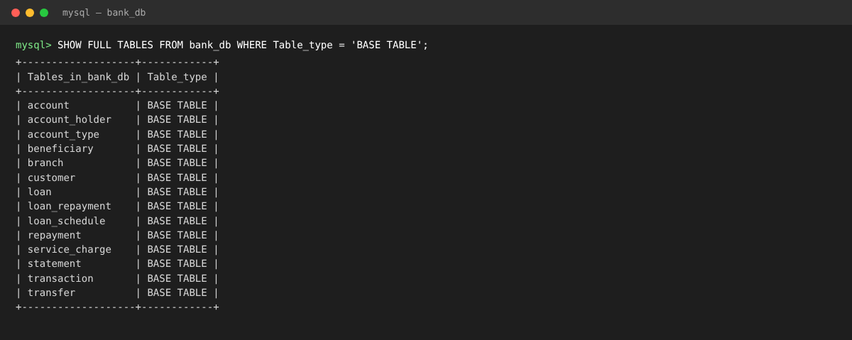
Figure 2. The 14 base tables in the bank_db database (MySQL)

CHAPTER 3

APPLICATION DEVELOPMENT USING LOGICAL DATABASE DESIGN

3.1 Application Overview
The application is a web system named 'Woxsen Co-operative Bank' for bank staff. Tellers, loan officers and branch managers sign in with their own role and use nine screens: Login, Dashboard, Customers, Accounts, Transactions, Transfers, Statements, Loans and Rule Tester. The application contains no banking data of its own. Every screen reads from and writes to the MySQL database through a REST API; balances, statements and loan figures are always taken from the tables and views of Chapter 2, and every monetary rule is enforced by the database triggers and procedures, not by the browser. The Rule Tester screen deliberately tries seven illegal operations inside a transaction that is always rolled back, which lets a user watch the database refuse each one.

3.2 Development Environment and Database Connectivity
Table 10 lists the development environment. Connectivity is centralised in one module, db.js, which creates a pool of ten connections and exposes two helpers: query() runs a prepared statement, and withTransaction() runs a block on one connection and commits on success or rolls back on any error. Dates and DECIMAL values are returned as strings, which avoids time-zone shifts and floating-point errors in money. Besides the 14 banking tables, the application creates one extra table, staff_user, at start-up to hold staff logins (username, role and a bcrypt hash).
Table 10. Application Development Environment
Item | Details
Programming Language | JavaScript: Node.js 18+ on the server, vanilla JavaScript (ES modules) in the browser
DBMS | MySQL 8 (InnoDB)
IDE / Framework / GUI Toolkit | Express 5 web framework [6]; HTML5, CSS3 and a hand-written single-page front end; Visual Studio Code
Database Connector / Driver | mysql2 (promise API, connection pool of 10, prepared statements); JSON Web Tokens [7] in an HTTP-only cookie; bcryptjs for password hashes
Operating Environment | macOS and Linux; the browser needs no plug-ins; configuration through a .env file
Repository Link | https://github.com/srilakshmireddy-byte/bank-dbms-pbl

3.3 Application Modules and Database Mapping
Table 11 maps each application module to the tables and views it uses. Every module goes through the database; none keeps data in the browser.
Table 11. Application Module-to-Database Mapping
Module / Screen | Purpose | Tables Used | Main Operations
Login | Authenticate staff and issue a signed session | staff_user | Read, verify bcrypt hash
Dashboard | Totals, monthly deposits and withdrawals, latest postings, branch cards | v_branch_summary, v_account_balances, v_loan_outstanding, transaction | Read, aggregate
Customers | Search, register and update customers | customer, account_holder, account | Create, read, update
Accounts | List and search accounts, open an account with holders, change status | account, account_holder, account_type, branch, customer | Create, read, update status
Transactions | Post deposits and withdrawals; audit log | transaction, account, v_transaction_audit | Create, read
Transfers | Atomic transfer; manage beneficiaries | transfer, transaction, beneficiary, v_transfers | Create, read, delete beneficiary (CALL sp_transfer)
Statements | Statement for any period with running balance | statement, transaction, account | Create log row, read
Loans | Create loan with schedule; collect repayments | loan, loan_schedule, loan_repayment, repayment, v_loan_outstanding, v_repayment_history | Create, read, update (CALL sp_loan_repayment)
Rule Tester | Run seven illegal operations inside a rolled-back transaction | transaction, transfer, account | Attempted writes, all rolled back

3.4 CRUD Operations
Table 12 shows how the four CRUD operations are realised. Financial records are never physically deleted.
Table 12. CRUD Operations
Operation | Application Feature / Screen | Table(s) Affected | Evidence
Create | Register customer; open account; post deposit; transfer money; create loan; generate statement; save beneficiary | customer, account, account_holder, transaction, transfer, loan, loan_schedule, statement, beneficiary | Figures 6 and 8; TC-04, TC-09
Read / Search | Customer and account search; dashboard; statements; loan list and schedule; audit log | customer, account, transaction, loan, loan_schedule and the 7 views | Figures 4, 5 and 10; TC-03, TC-14
Update | Edit customer details; freeze or close an account; repay an instalment (marks it PAID and may close the loan) | customer, account, loan_schedule, loan, repayment | Figure 9; TC-12
Delete / Controlled Removal | Money records are never deleted: accounts are closed by status and foreign keys are RESTRICT; only a saved beneficiary can be removed | account (status), beneficiary | TC-08; Table 6

3.5 Business Rules, Validation and Error Handling
All SQL in the application uses parameterised (prepared) statements, so user input is never concatenated into a query; this is the primary defence against SQL injection [8]. The application checks only the shape of the input (a number, a date, an identifier). Business rules are left to the database on purpose, so that the same rule applies to every client. When the database rejects an operation, the SQLSTATE 45000 message is returned as HTTP 422 and shown to the user verbatim. Multi-step actions such as a transfer, a loan creation or a repayment run as one transaction, and any failure rolls everything back. Table 13 lists the rules.
Table 13. Business Rules, Validation and Error Handling
Rule / Validation | How Implemented | Evidence / Message
Amount must be positive | BEFORE INSERT trigger on transaction (plus CHECK ck_txn_amount_positive) | 'Transaction amount must be positive' (HTTP 422)
No overdrawing / minimum balance | Trigger compares balance minus amount with the account type's min_balance, row locked with FOR UPDATE | 'Insufficient balance (minimum balance rule)'
Only ACTIVE accounts accept postings | Trigger checks account.status | 'Account is not ACTIVE - transaction rejected'
Transfer needs two different accounts | sp_transfer raises SIGNAL before any posting | 'Cannot transfer to the same account'
Transfer legs must balance | trg_transfer_before_insert and stored procedure in one transaction with EXIT HANDLER ROLLBACK | 'Unbalanced transfer: debit must equal credit'
Duplicate customer, account number | UNIQUE constraints; error code 1062 mapped to HTTP 409 | 'Duplicate entry ...' shown to the user
Malformed input (amount, date, id) | Shape validation in lib/validate.js before the query | 'Amount must be a number with at most 2 decimals' (HTTP 400)
Statement period valid | CHECK ck_statement_period on statement | Constraint violation reported as HTTP 422
Instalment cannot be paid twice | Application guard before sp_loan_repayment | 'This instalment is already fully paid' (HTTP 409)
Role-based access | Permission table in lib/permissions.js checked on every route | 'Your role (teller) is not allowed to do this' (HTTP 403)

3.6 Reports and Database Operations
Table 14 lists the reports and the SQL concepts behind them. The statement, dashboard and loan reports are computed by the database, not in the browser.
Table 14. Reports and Database Operations
Report / Operation | SQL / Database Concept Used | Application Output
Dashboard totals | Aggregation (SUM, COUNT) over views v_branch_summary and v_loan_outstanding | Cards: deposits held, active accounts, loans outstanding, overdue instalments
Account statement | JOIN of transaction and account; running balance rebuilt in date order; opening and closing balance by subquery | Statement of Account (Figure 10)
Loan outstanding | View with SUM of repayments grouped by loan; total payable less repaid | Loans table with progress bars
Overdue instalments | WHERE status = 'OVERDUE' on index idx_schedule_status; overdue marking at start-up and hourly | Overdue card and loan filter
Branch summary | GROUP BY branch with COUNT, SUM, AVG over accounts | Branch cards on the dashboard
Monthly deposits and withdrawals | Conditional aggregation: SUM(CASE WHEN type = ...) GROUP BY month | Bar chart on the dashboard
Transaction audit | View joining ledger, account, holders and branch; filters and paging | Audit log on the Transactions page (Manager)
Ledger integrity check | Correlated subquery: balance versus last ledger balance_after | 0 rows returned when consistent (Section 3.8)

3.7 Application Screens
Figures 3 to 11 are screenshots of the running application connected to the MySQL database. Figure 3 is the staff login. Figure 4 is the manager's dashboard. Figure 5 searches accounts. Figure 6 shows data entry: a cash deposit posted to an account, which the database confirms as a new transaction. Figure 7 shows the database refusing a withdrawal larger than the balance. Figure 8 is a transfer between two accounts, a project-specific transaction. Figure 9 shows a loan after an instalment is repaid (an update). Figure 10 is the statement report, and Figure 11 is the Rule Tester.
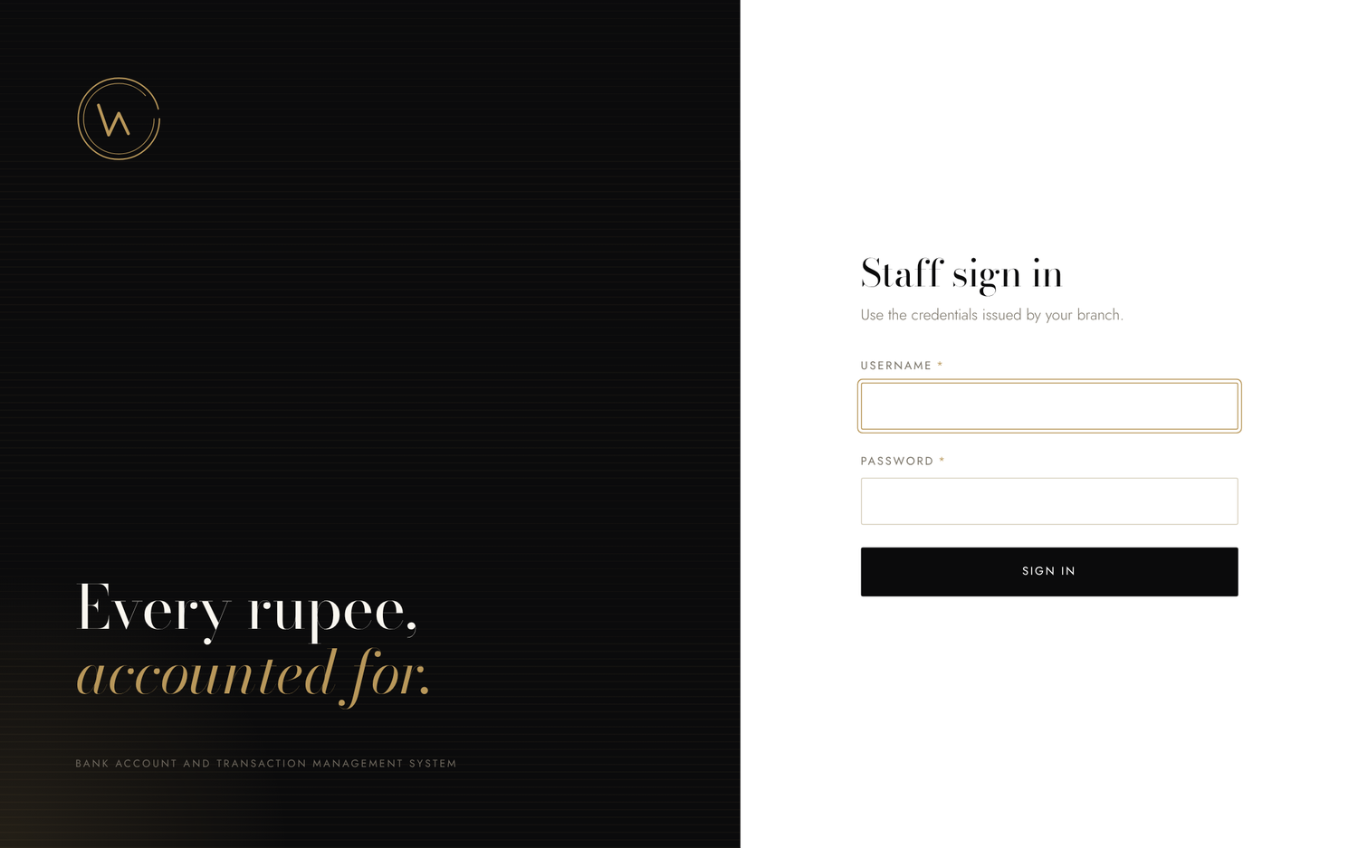
Figure 3. Staff Sign-in Screen
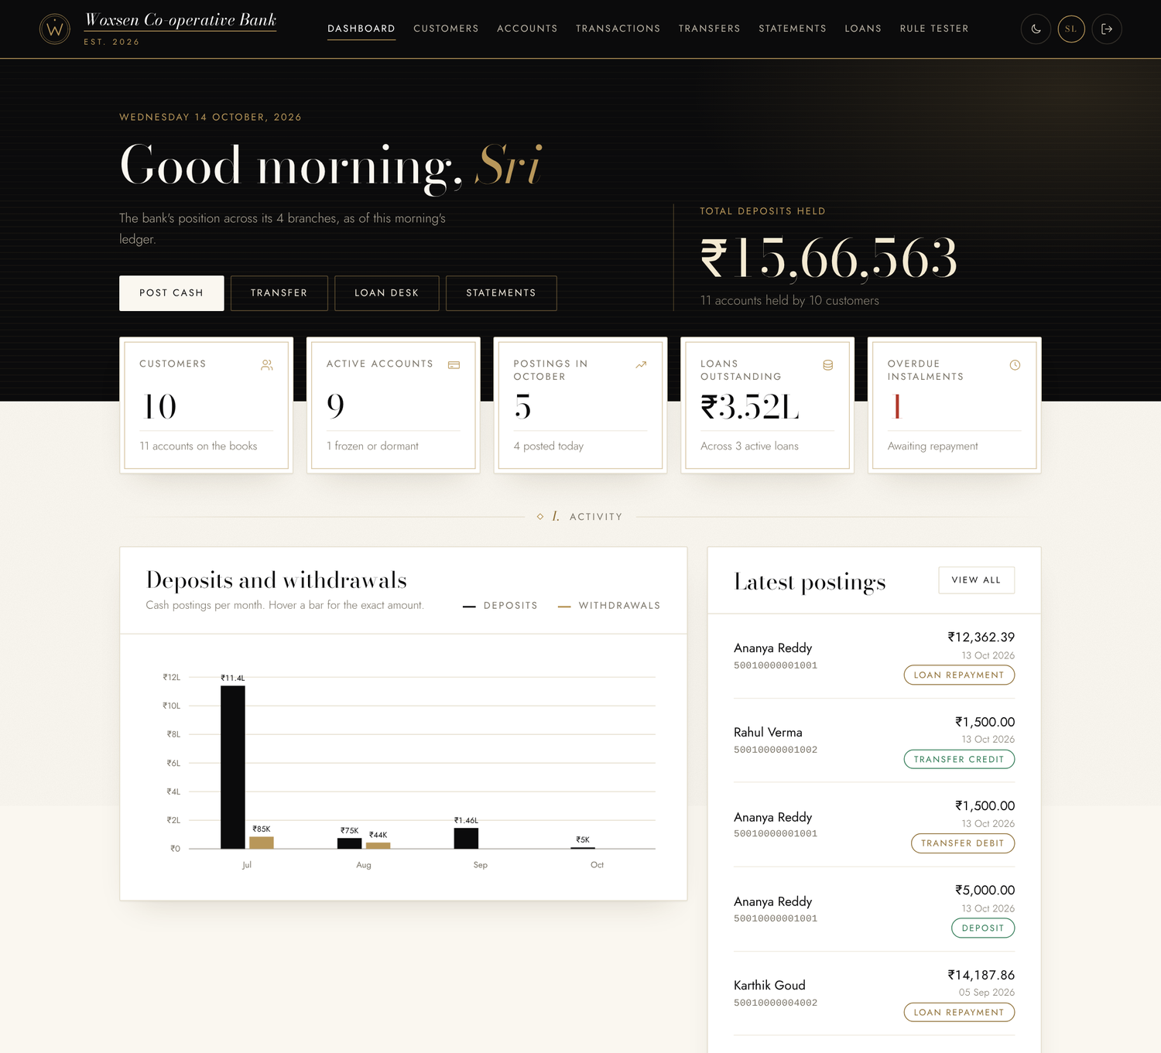
Figure 4. Manager Dashboard with Live Totals and Branch Summary
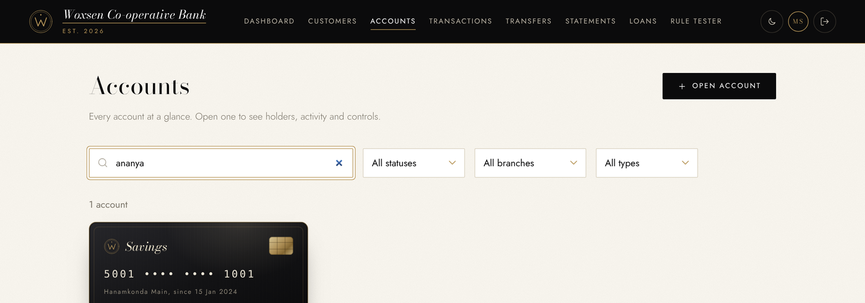
Figure 5. Account Search and Display
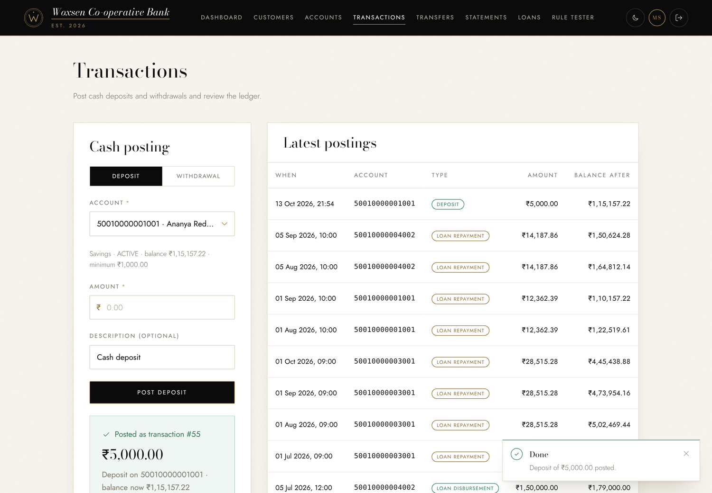
Figure 6. Cash Deposit Posted to an Account (Data Entry)
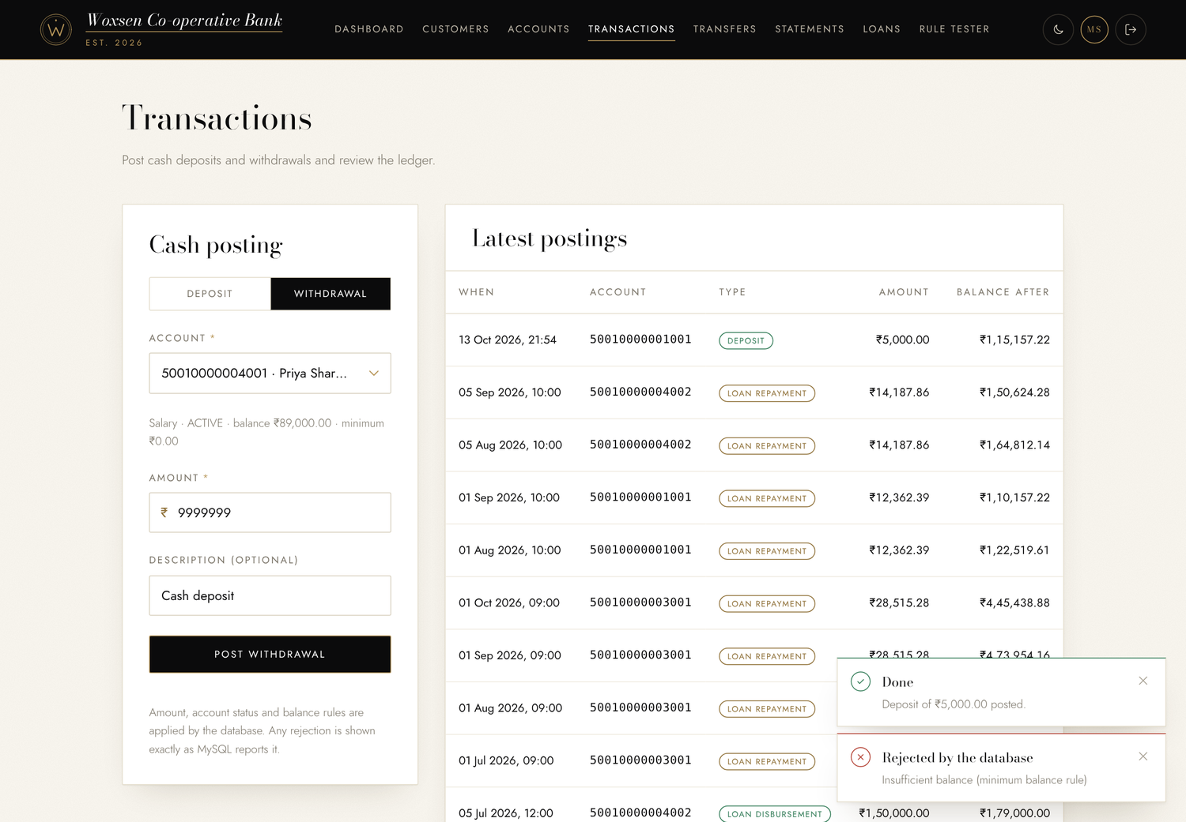
Figure 7. Withdrawal Beyond the Balance Rejected by the Database
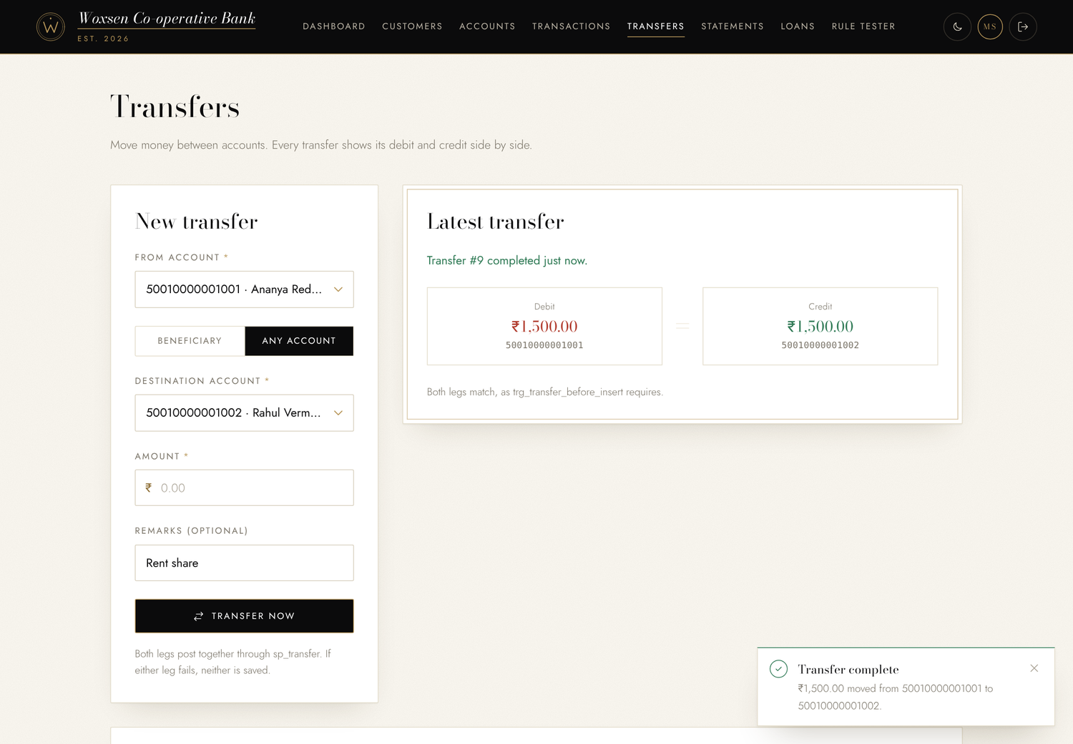
Figure 8. Atomic Transfer Between Two Accounts
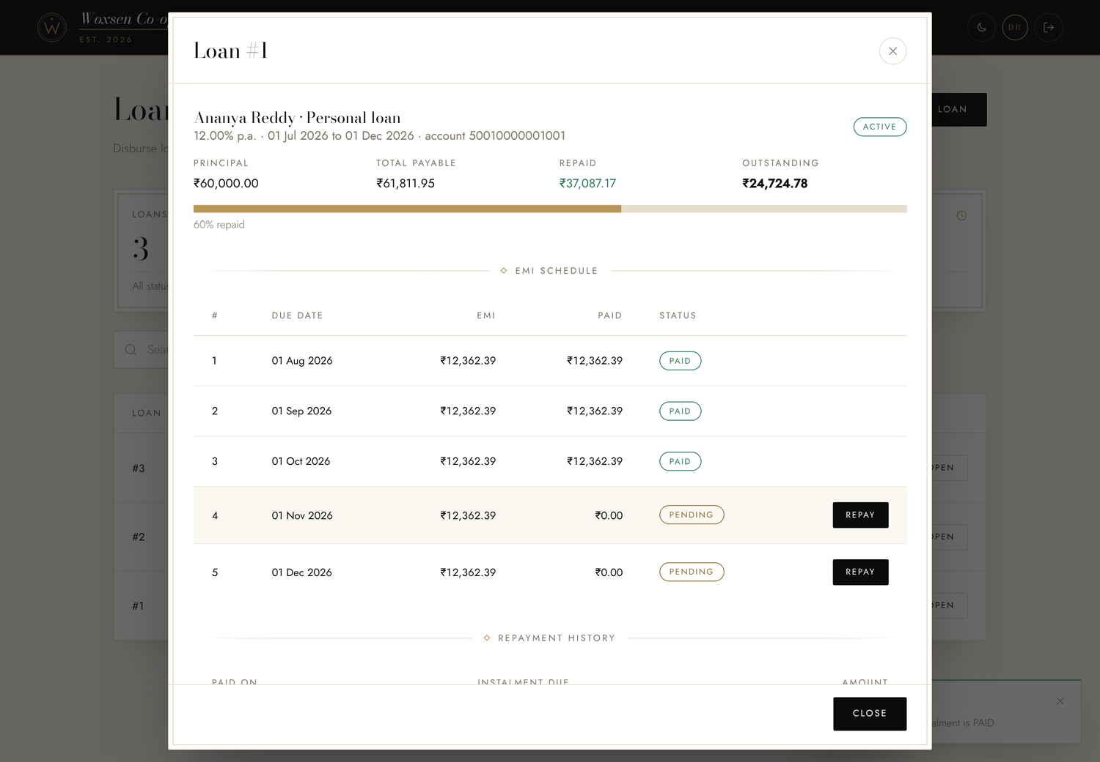
Figure 9. Loan Schedule After an EMI Repayment (Update)
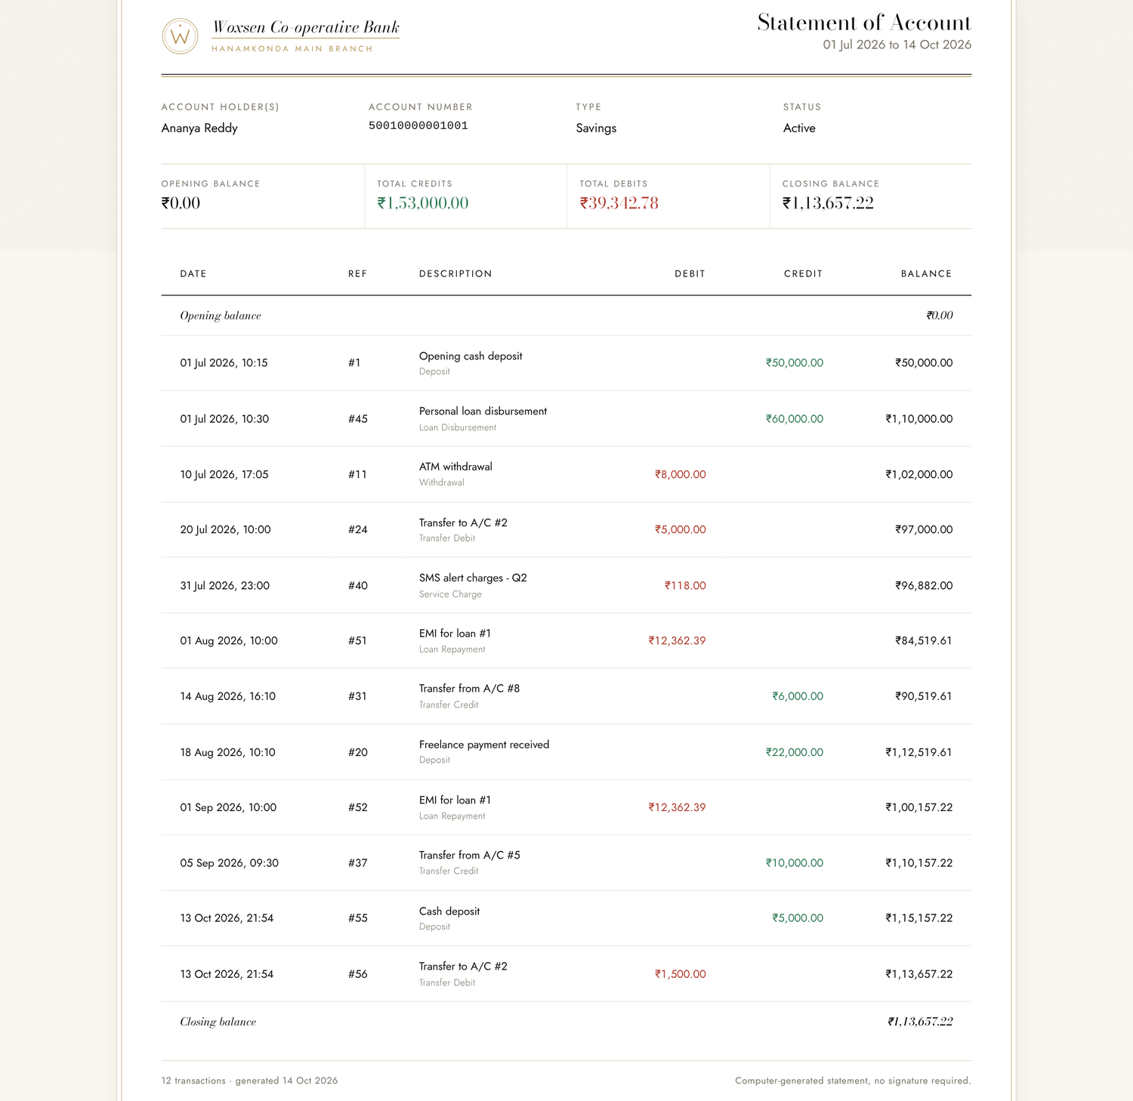
Figure 10. Account Statement Report with Running Balance
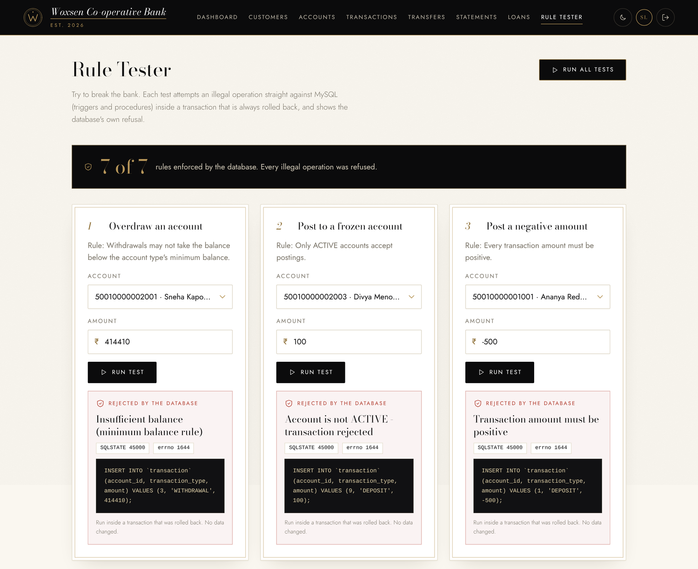
Figure 11. Rule Tester: Illegal Operations Refused and Rolled Back

3.8 Testing and Results
Table 15 lists 16 test cases that were executed against the running application and the live database. The cases mix positive and negative inputs; actual results are the messages and values observed.
Table 15. Test Cases
Test ID | Feature | Input / Action | Expected Result | Actual Result | Status
TC-01 | Staff login | Sign in as teller with the correct password | Session starts; dashboard opens | HTTP 200; dashboard loaded for role TELLER | Pass
TC-02 | Staff login (negative) | Sign in with a wrong password | Login refused | HTTP 401 'Incorrect username or password' | Pass
TC-03 | Customer search | Search customers for 'ananya' | Only matching customer returned | 1 row: Ananya Reddy, 1 account | Pass
TC-04 | Deposit | Deposit INR 5,000 to account 50010000001001 | Posting created; balance increases by 5,000 | Transaction #55; balance 1,10,157.22 → 1,15,157.22 | Pass
TC-05 | Overdraw (negative) | Withdraw INR 99,99,999 from account 50010000004001 | Rejected; balance unchanged | 422 'Insufficient balance (minimum balance rule)'; balance stays 89,000.00 | Pass
TC-06 | Negative amount | Deposit INR -500 | Rejected | 422 'Transaction amount must be positive' | Pass
TC-07 | Frozen account | Deposit INR 1,000 to FROZEN account 9 | Rejected | 422 'Account is not ACTIVE - transaction rejected' | Pass
TC-08 | Closed account | Deposit INR 1,000 to CLOSED account 11 | Rejected | 422 'Account is not ACTIVE - transaction rejected' | Pass
TC-09 | Transfer | Transfer INR 1,500 from ...1001 to ...1002 | Debit = credit; both balances move | Transfer #9 balanced; 1,15,157.22 → 1,13,657.22 and 73,764.00 → 75,264.00 | Pass
TC-10 | Same-account transfer | Transfer INR 100 from account 1 to account 1 | Rejected | 422 'Cannot transfer to the same account' | Pass
TC-11 | Oversized transfer | Transfer INR 9,99,99,999 from a small account | Rejected and rolled back; no half transfer | 422 'Insufficient balance (minimum balance rule)'; no rows added | Pass
TC-12 | Loan repayment | Repay EMI INR 12,362.39 of loan #1 | Instalment PAID; account debited; outstanding falls | 200; outstanding 37,087.17 → 24,724.78 (after the 3rd EMI); account debited by 12,362.39 | Pass
TC-13 | Repay paid instalment | Repay an instalment already PAID | Refused | 409 'This instalment is already fully paid' | Pass
TC-14 | Statement | Statement of 50010000001001, 01 Jul to 14 Oct 2026; then an invalid range | Opening, closing and running balance; bad range refused | Opening 0.00, credits 1,53,000.00, debits 39,342.78, closing 1,13,657.22; reversed dates: 422 ck_statement_period | Pass
TC-15 | Role enforcement | Teller creates a loan; loan officer posts a deposit; teller opens audit log | All refused | HTTP 403 'Your role (...) is not allowed to do this' in all three | Pass
TC-16 | Ledger integrity | Run balance-versus-ledger audit; 6 parallel withdrawals; Rule Tester 'Run all' | 0 mismatches; no overdraw; 7 of 7 refused | 0 rows mismatched; 0 unbalanced transfers; parallel-withdrawal test passed; 7 of 7 refused | Pass

All 16 test cases passed. Positive cases (TC-01, 03, 04, 09, 12, 14) changed the database as expected, and every negative case (TC-02, 05 to 08, 10, 11, 13, 15) was refused with the exact message of the rule it breaks while balances stayed unchanged. Figure 12 shows the same behaviour directly in MySQL, outside the application: the trigger rejects the overdraw and the frozen-account deposit and the balances are unchanged.
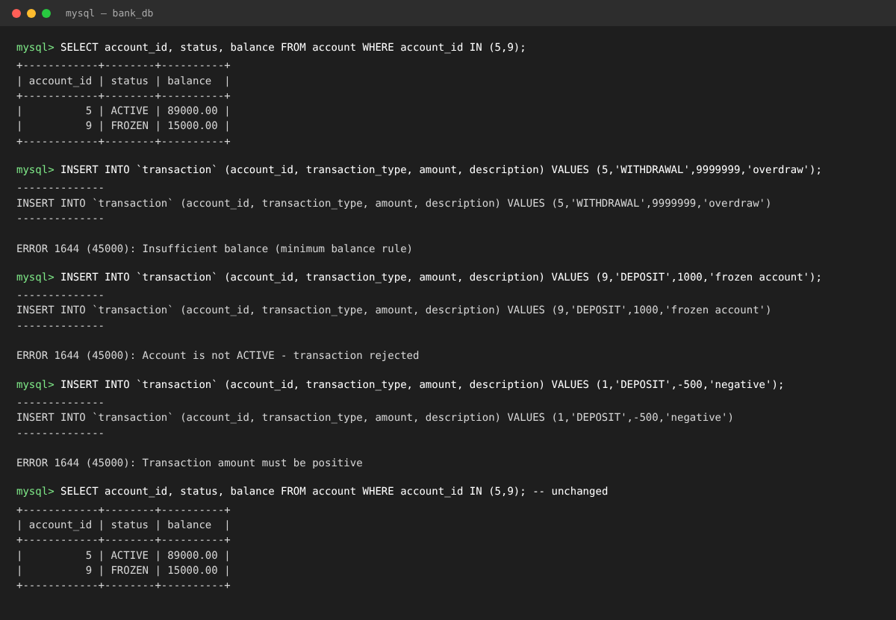
Figure 12. Trigger Rejection and Unchanged Balances in MySQL
Besides these cases, an automated end-to-end suite of 15 tests (npm test) runs against the real database. It passed 15 of 15 on a freshly loaded database; it covers atomic rollback of failed transfers and loans, role enforcement, loan closure after the last instalment, and parallel withdrawals that never overdraw an account. The suite assumes a freshly loaded database, so it is run after reloading the script. The application therefore uses the designed database correctly and enforces the important business rules in the database itself.

CHAPTER 4

CONCLUSION
This project addressed the problem of keeping bank accounts and transactions correct, consistent and auditable. An entity-relationship model with 14 entities was converted into a 3NF relational schema with 17 foreign keys, 11 unique and 11 check constraints, and implemented in MySQL with 3 triggers, 2 stored procedures, 7 views and 5 indexes. The business rules (positive amounts, minimum balance, active accounts only, balanced transfers, one payment per instalment) live in the database, so no client can bypass them.
On top of this design a role-based Node.js and Express application was built for customers, accounts, deposits, withdrawals, transfers, loans, repayments, statements and reports, and it was validated with 16 test cases and an automated suite. The main learning was that placing rules in triggers and procedures, and running multi-step operations as transactions, gives stronger guarantees than validating in the application alone.

4.1 Limitations and Future Enhancements
The current application is deliberately small in scope. Its main limitations and realistic enhancements are:
- Limitation: interest on savings and fixed deposits is not posted automatically; a scheduled job could credit interest and apply minimum-balance penalties each month.
- Limitation: transfers to external banks can be saved as beneficiaries but are not settled; integration with a payment network (for example UPI or NEFT) would be needed for real settlement.
- Enhancement: add customer self-service login with one-time passwords, e-mail or SMS alerts, and downloadable statements in PDF.
- Enhancement: add table partitioning of the transaction ledger by month and reporting for fraud detection on large or unusual transfers.

REFERENCES
[1] E. F. Codd, “A relational model of data for large shared data banks,” Commun. ACM, vol. 13, no. 6, pp. 377-387, Jun. 1970, doi: 10.1145/362384.362685.
[2] P. P.-S. Chen, “The entity-relationship model—toward a unified view of data,” ACM Trans. Database Syst., vol. 1, no. 1, pp. 9-36, Mar. 1976, doi: 10.1145/320434.320440.
[3] R. Elmasri and S. B. Navathe, Fundamentals of Database Systems, 7th ed. Hoboken, NJ, USA: Pearson, 2016.
[4] A. Silberschatz, H. F. Korth, and S. Sudarshan, Database System Concepts, 7th ed. New York, NY, USA: McGraw-Hill, 2020.
[5] Oracle Corporation, “MySQL 8.0 Reference Manual: SIGNAL Statement,” MySQL Documentation. Accessed: Oct. 14, 2026. [Online]. Available: https://dev.mysql.com/doc/refman/8.0/en/signal.html
[6] OpenJS Foundation, “Routing,” Express.js Documentation. Accessed: Oct. 14, 2026. [Online]. Available: https://expressjs.com/en/guide/routing.html
[7] M. Jones, J. Bradley, and N. Sakimura, “JSON Web Token (JWT),” RFC 7519, Internet Engineering Task Force, May 2015. [Online]. Available: https://www.rfc-editor.org/rfc/rfc7519
[8] OWASP Foundation, “SQL Injection Prevention Cheat Sheet,” OWASP Cheat Sheet Series. Accessed: Oct. 14, 2026. [Online]. Available: https://cheatsheetseries.owasp.org/cheatsheets/SQL_Injection_Prevention_Cheat_Sheet.html

APPENDICES

APPENDIX A - COMPLETE DATABASE SCRIPT
The complete database script (DDL, triggers, stored procedures, sample data, views and queries) is submitted as bank_review2.sql and, split by purpose, in the repository folder review-2/sql/ (01_schema.sql, 02_triggers.sql, 03_sample_data.sql, 04_views_reports.sql, 05_queries.sql). Run order: 01 to 04, then 05. The expected output of the queries is in queries_output.txt, and the seven validation tests are in validation_tests.md.

APPENDIX B - APPLICATION SOURCE CODE
The application source code is in the GitHub repository https://github.com/srilakshmireddy-byte/bank-dbms-pbl, folder review-3/ (server.js, db.js, routes/, lib/, middleware/, public/, test/). A live demonstration that runs in the browser on built-in sample data is available at https://srilakshmireddy-byte.github.io/bank-dbms-pbl/. To run the full MySQL-backed version: load the SQL script, copy .env.example to .env, run npm install, then npm start (default port 3000). Demo logins: teller, loans and manager.

APPENDIX C - ADDITIONAL TEST DATA AND OUTPUTS
Supporting output. The seven validation tests below were run directly in MySQL; each statement was rejected by the database and the balances stayed unchanged.
# | Test | Result (actual MySQL error)
1 | Negative amount deposit | Transaction amount must be positive
2 | Withdrawal larger than balance | Insufficient balance (minimum balance rule)
3 | Deposit to FROZEN account | Account is not ACTIVE - transaction rejected
4 | Deposit to CLOSED account | Account is not ACTIVE - transaction rejected
5 | Transfer to the same account | Cannot transfer to the same account
6 | Transfer larger than balance (rolled back) | Insufficient balance (minimum balance rule)
7 | Duplicate account number | Duplicate entry '50010000001001' for key 'account_number'

Consistency checks after the sample load: 0 accounts whose stored balance differs from the last ledger balance; 0 transfers whose debited amount differs from the credited amount; 54 ledger transactions loaded.

