WOXSEN UNIVERSITY
B.Tech Artificial Intelligence and Machine Learning | Design and Analysis of Algorithms
HackerRank Profile
Name | Student ID | Platform / username | Profile link
M. Srilakshmi Reddy | 25WU0102140 | HackerRank / srilakshmi_redd2 | hackerrank.com/profile/srilakshmi_redd2

1. Profile login screenshot
HackerRank profile of srilakshmi_redd2 (Srilakshmi Reddy). Badges earned: Problem Solving (4 star) and SQL (1 star).
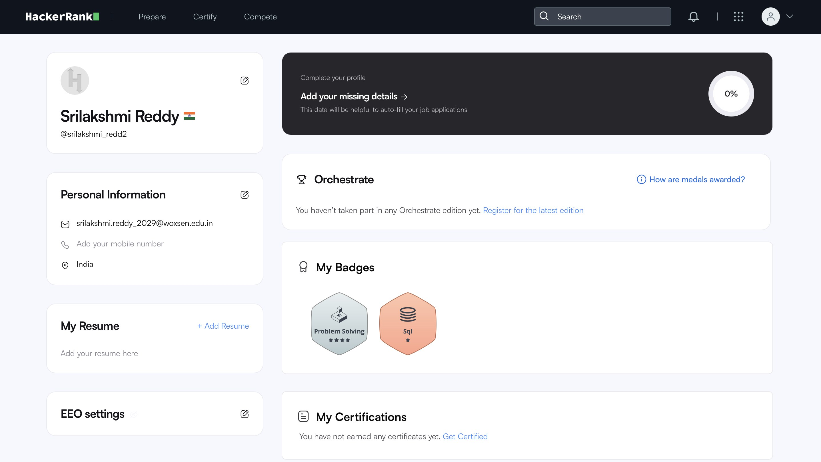

2. Problems solved (8)
Every problem below shows Accepted on HackerRank, solved in MySQL. The submissions page is in section 3.
No. | Problem name | Score | Topic / technique | Language
1 | Revising the Select Query I | 10.0 | SELECT with WHERE | MySQL
2 | Select All | 10.0 | SELECT * | MySQL
3 | Select By ID | 10.0 | Filtering by ID | MySQL
4 | Japanese Cities' Names | 10.0 | SELECT with WHERE | MySQL
5 | Japanese Cities' Attributes | 10.0 | SELECT * with WHERE | MySQL
6 | Weather Observation Station 1 | 15.0 | Selecting columns | MySQL
7 | Weather Observation Station 3 | 10.0 | DISTINCT / MOD | MySQL
8 | Weather Observation Station 4 | 10.0 | COUNT / DISTINCT | MySQL

3. Accepted submissions
Submissions page - all Accepted (MySQL)
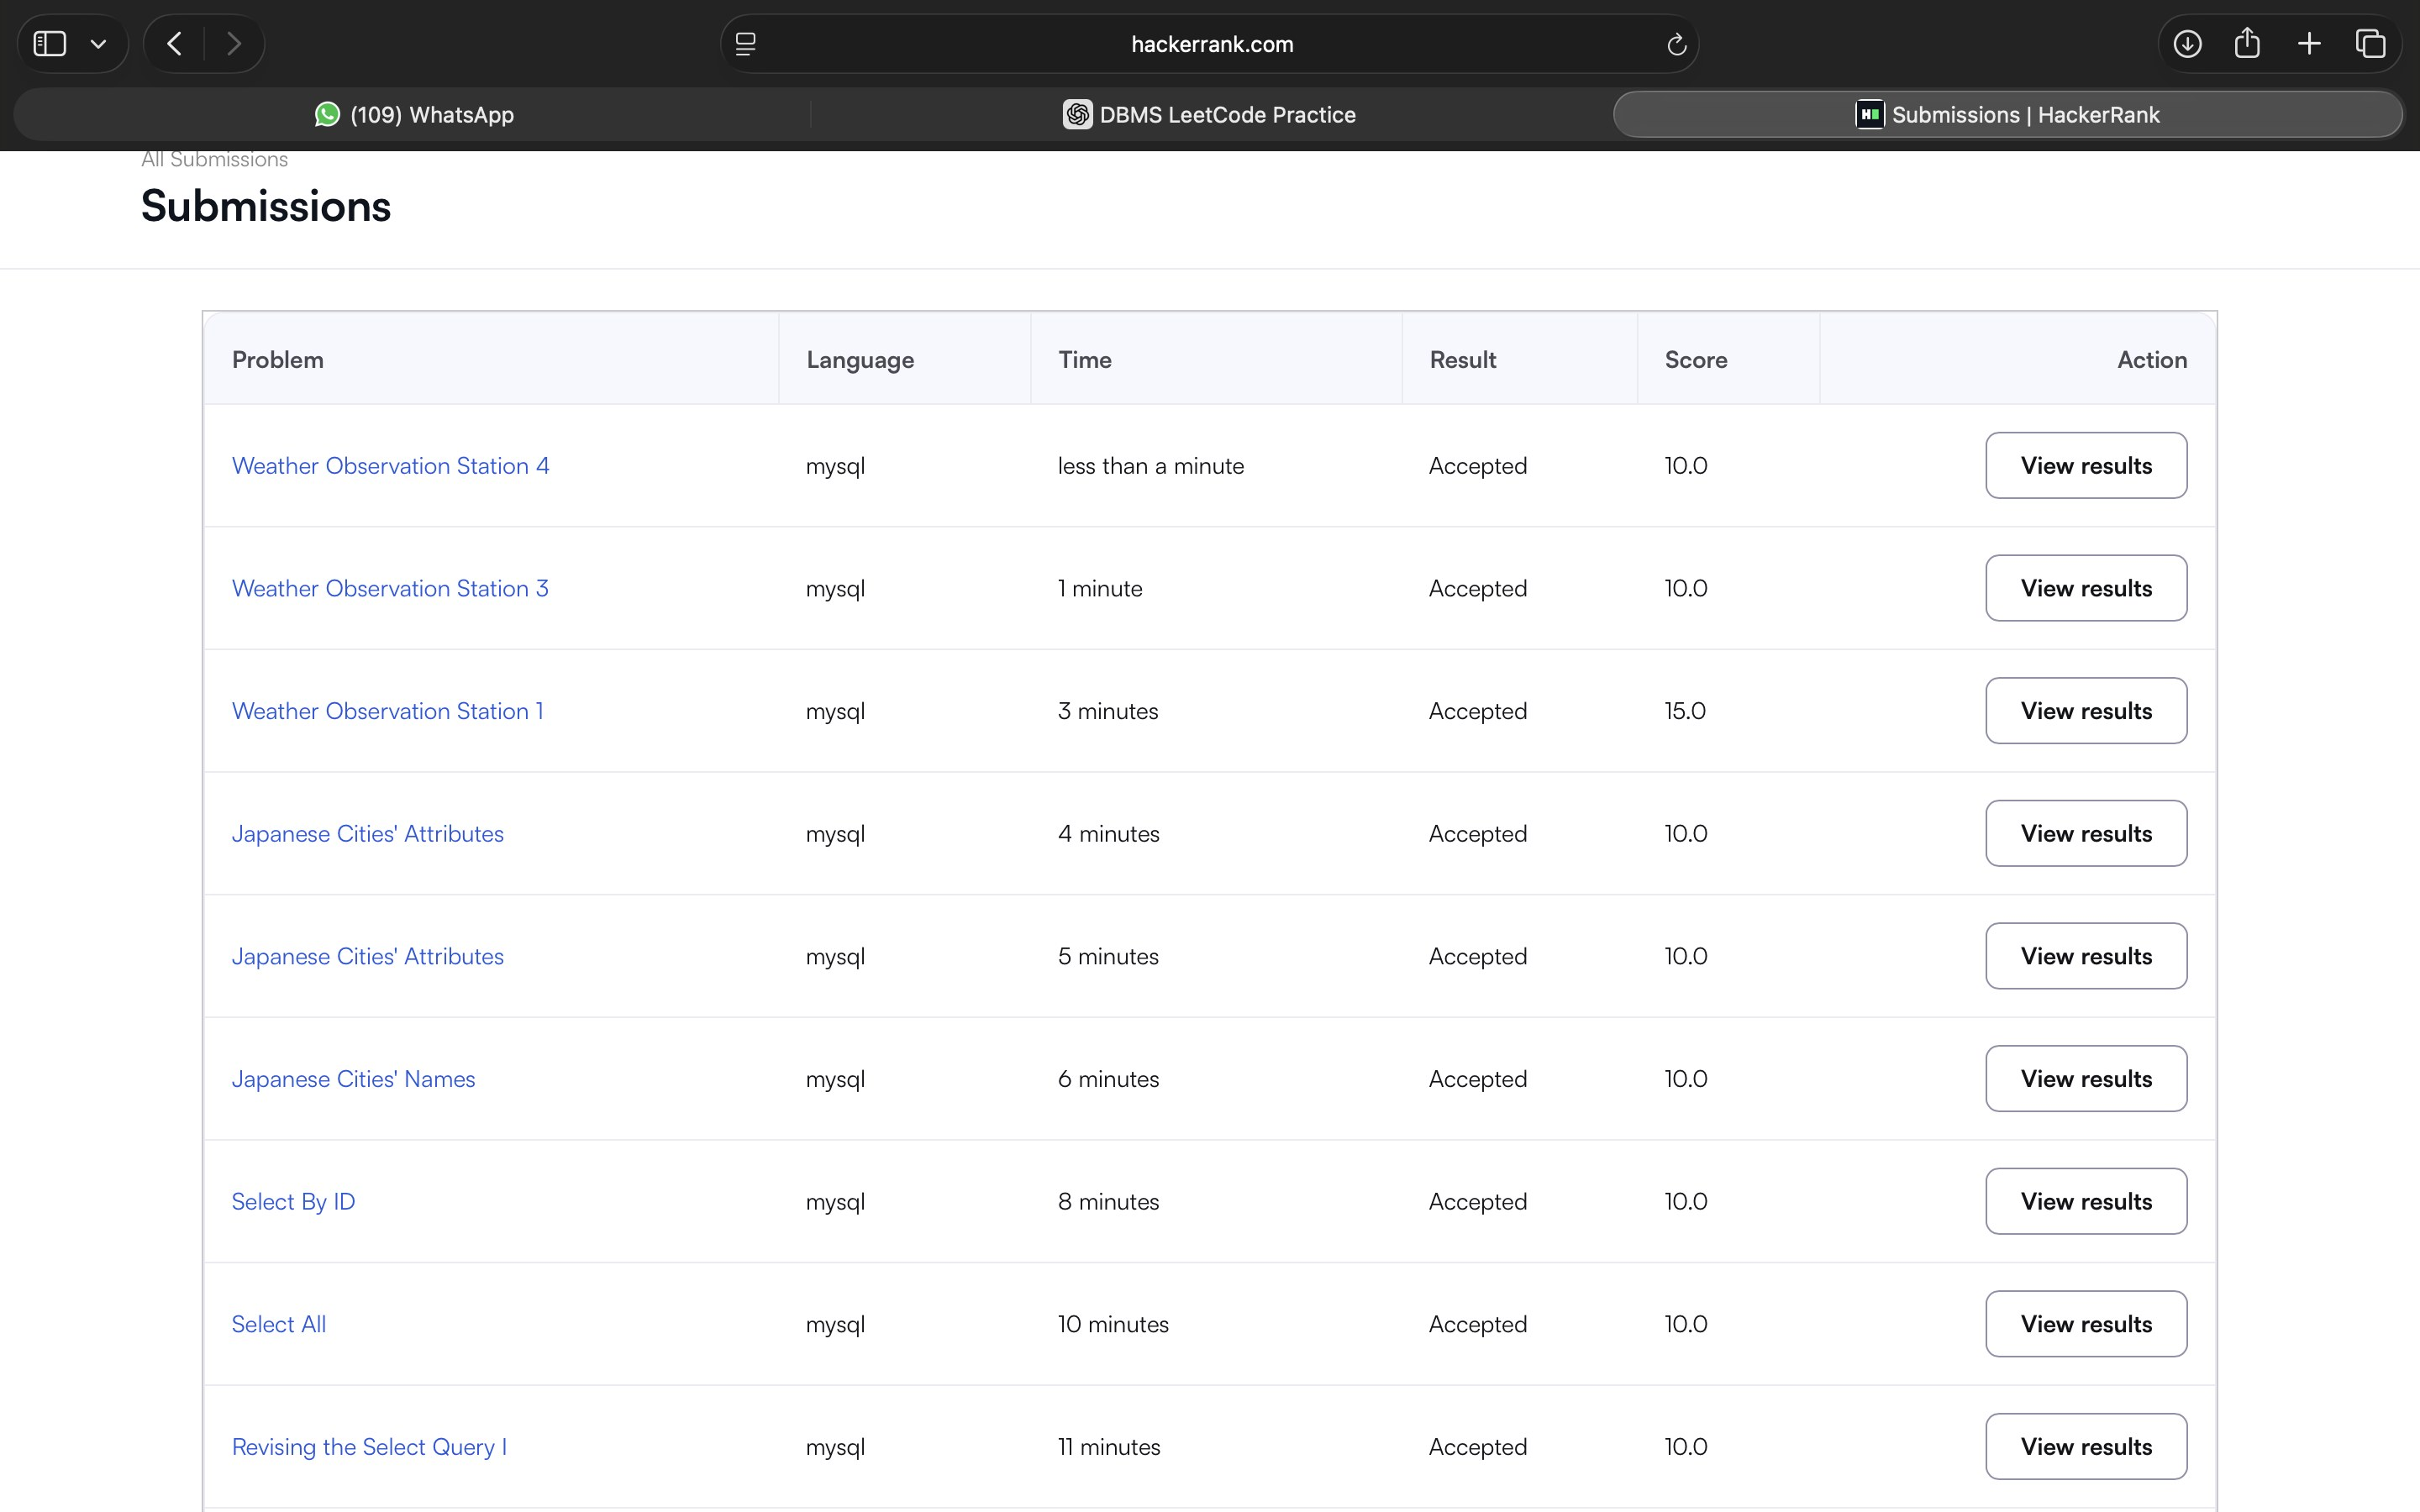

4. Certificates
No HackerRank certificate earned yet.

