WOXSEN UNIVERSITY
B.Tech Artificial Intelligence and Machine Learning | Database Management Systems
LeetCode Profile
Name | Student ID | Platform / username | Profile link
M. Srilakshmi Reddy | 25WU0102140 | LeetCode / Srilakshmi__Reddy | leetcode.com/u/Srilakshmi__Reddy

1. Profile login screenshot
LeetCode profile of Srilakshmi__Reddy: 16 problems solved (13 Easy, 2 Medium, 1 Hard). The SQL problems are solved in MySQL.
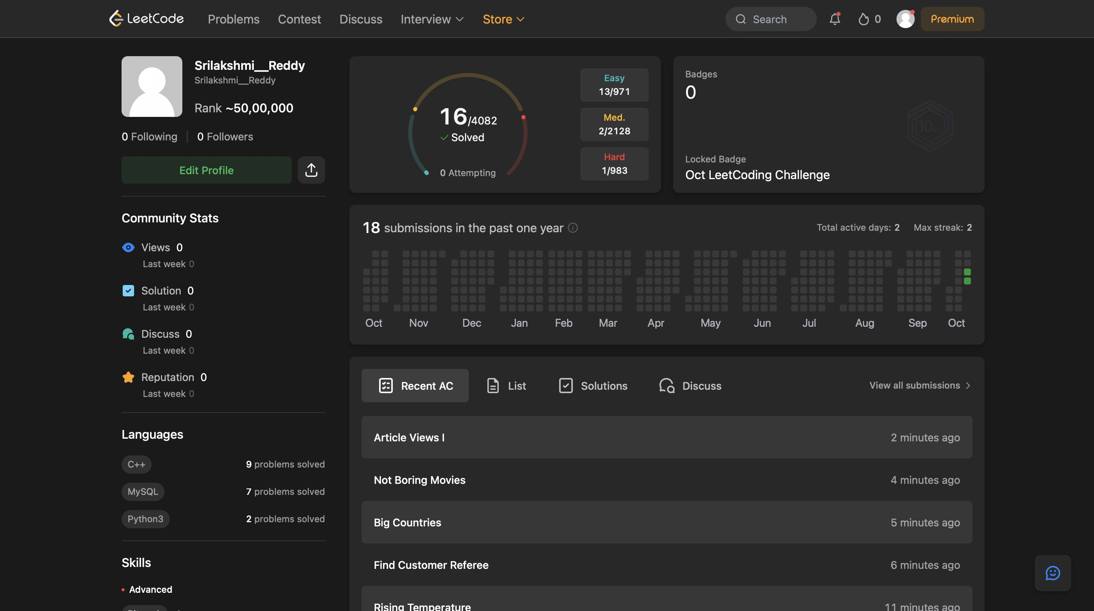

2. SQL problems solved (7)
Every problem below shows Accepted on LeetCode, solved in MySQL. Each screenshot is in section 3, in the same order.
No. | Problem name | Difficulty | Topic / technique | Language
1 | Combine Two Tables | Easy | SQL joins (LEFT JOIN) | MySQL
2 | Customers Who Never Order | Easy | Subquery (NOT IN) | MySQL
3 | Rising Temperature | Easy | Self join / DATEDIFF | MySQL
4 | Find Customer Referee | Easy | Filtering / NULL handling | MySQL
5 | Big Countries | Easy | Filtering (OR condition) | MySQL
6 | Not Boring Movies | Easy | Filtering / ORDER BY | MySQL
7 | Article Views I | Easy | DISTINCT / ORDER BY | MySQL

3. Accepted submission screenshots
1. Combine Two Tables (Easy) - Accepted
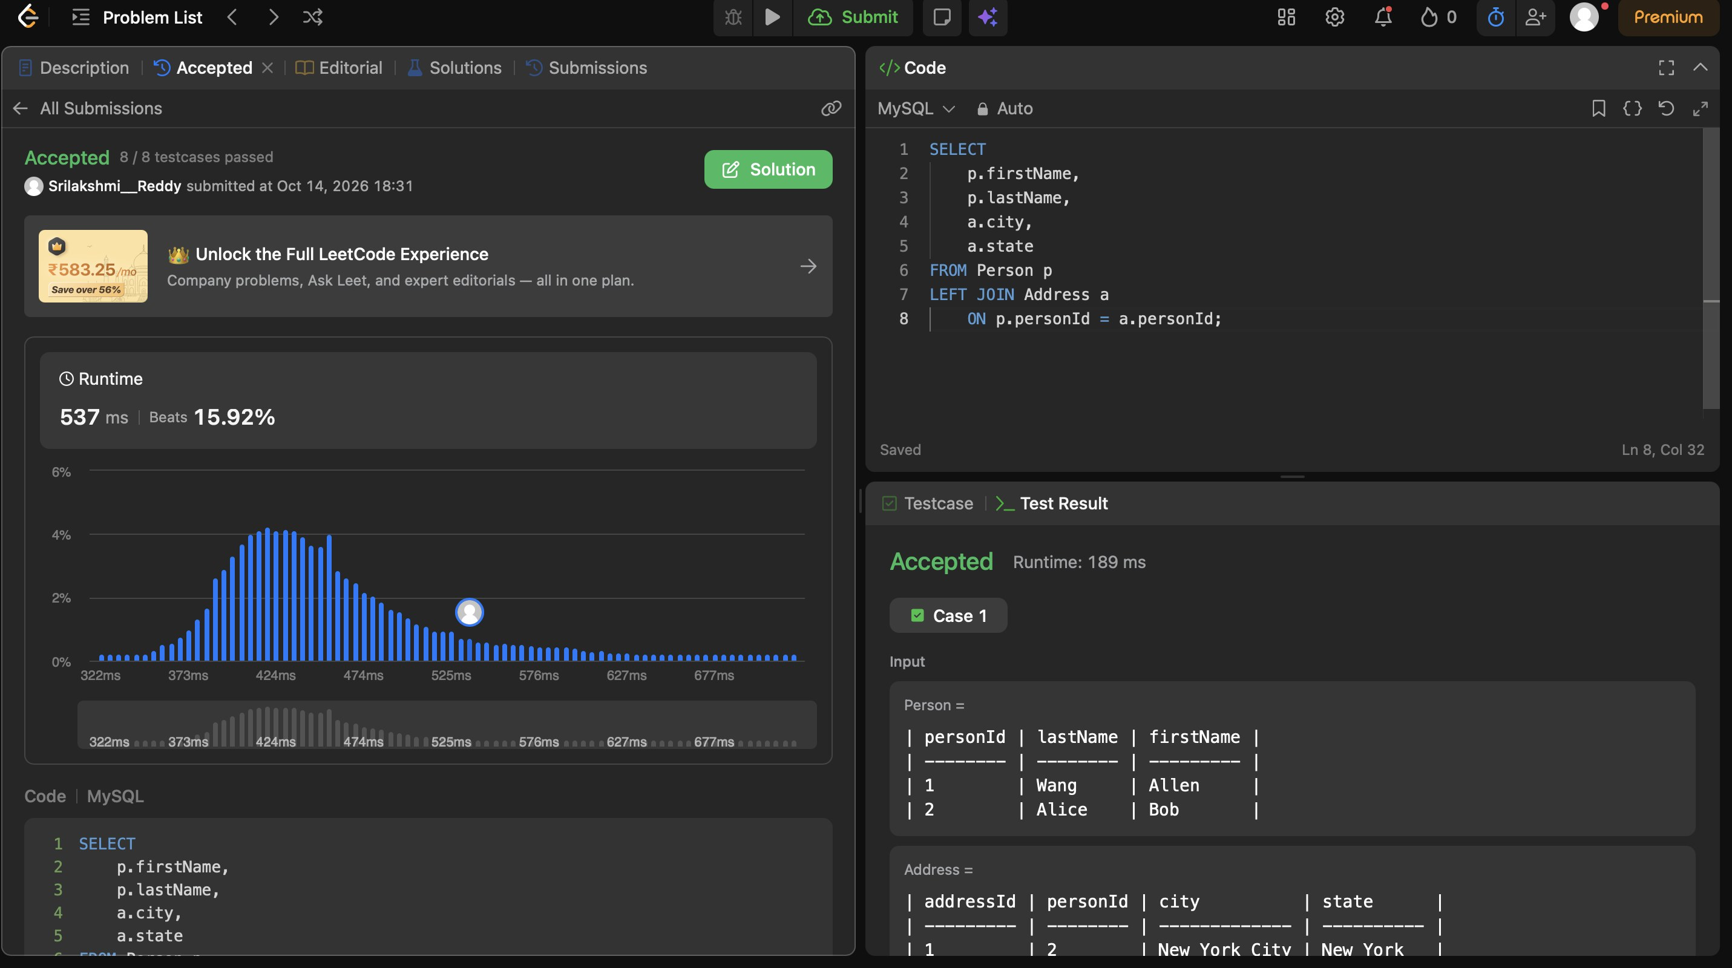
2. Customers Who Never Order (Easy) - Accepted
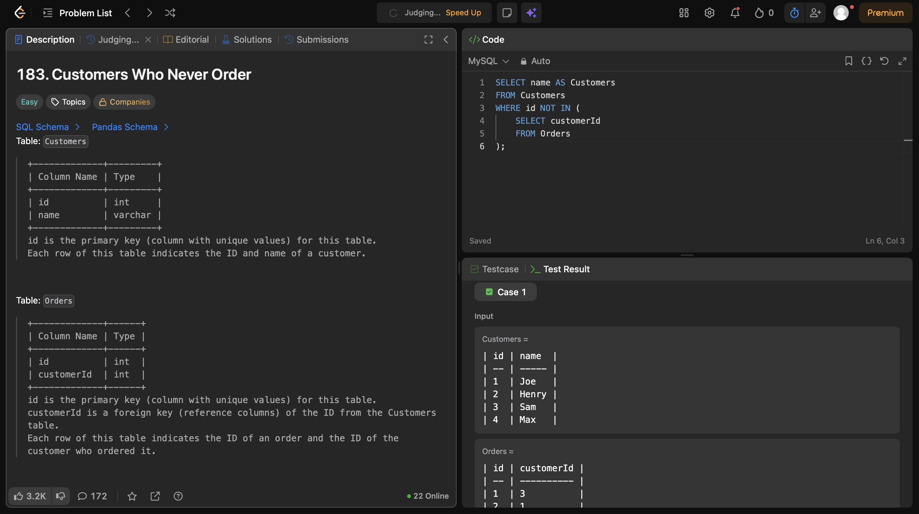
3. Rising Temperature (Easy) - Accepted
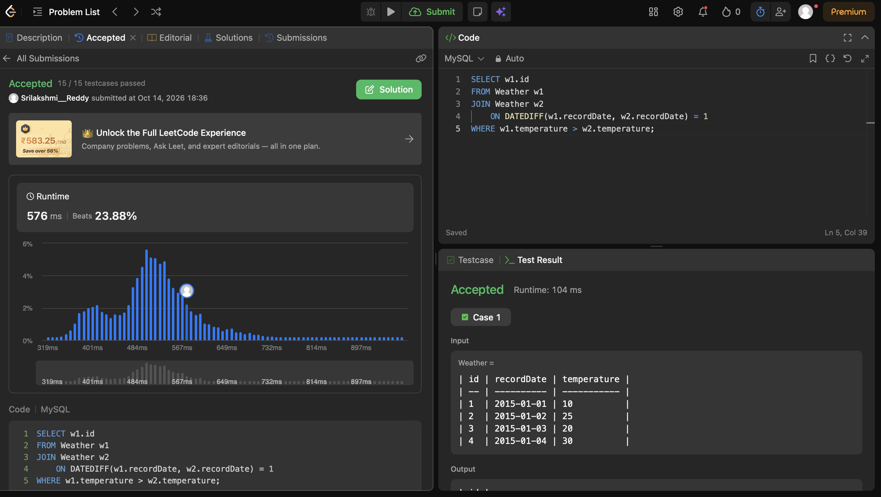
4. Find Customer Referee (Easy) - Accepted
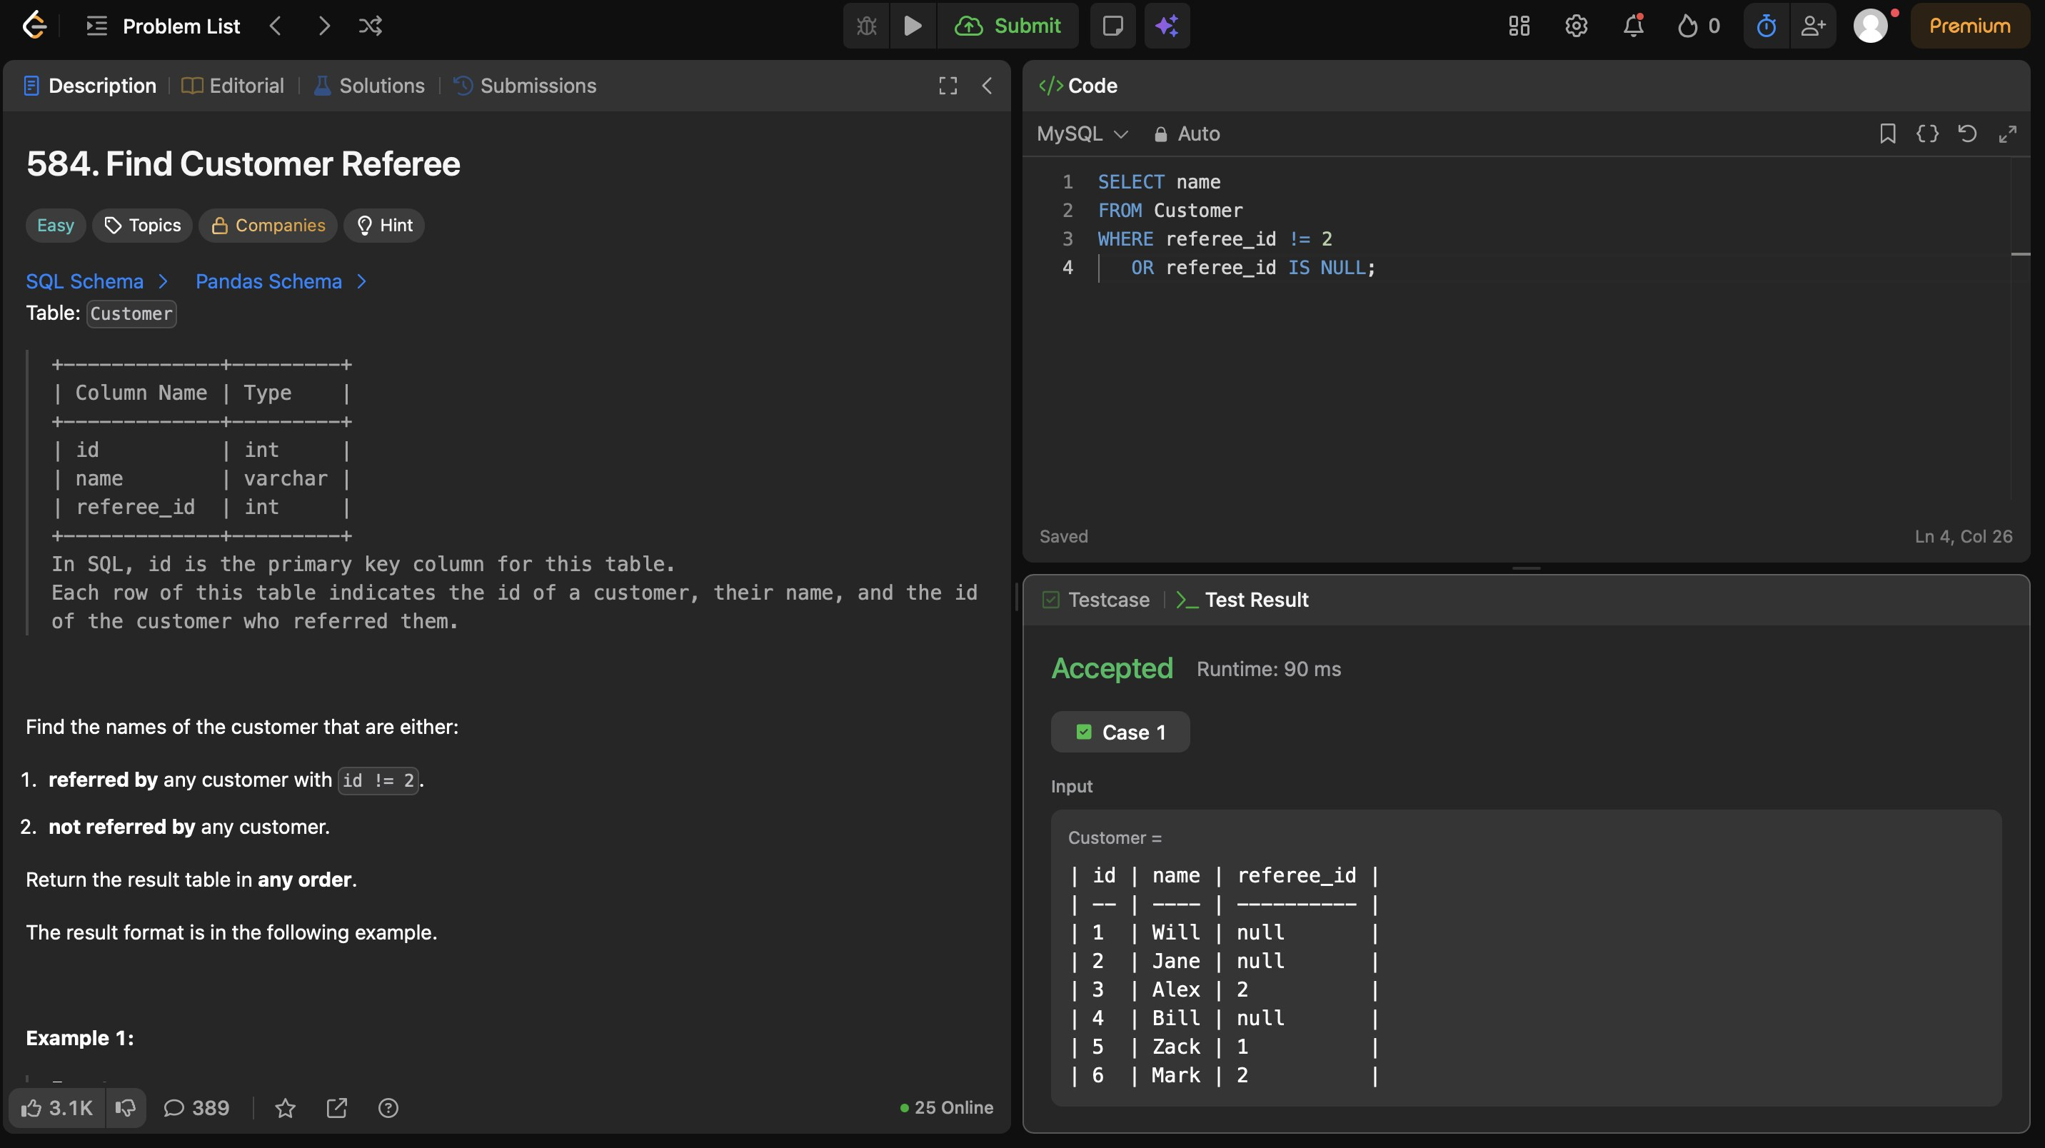
5. Big Countries (Easy) - Accepted
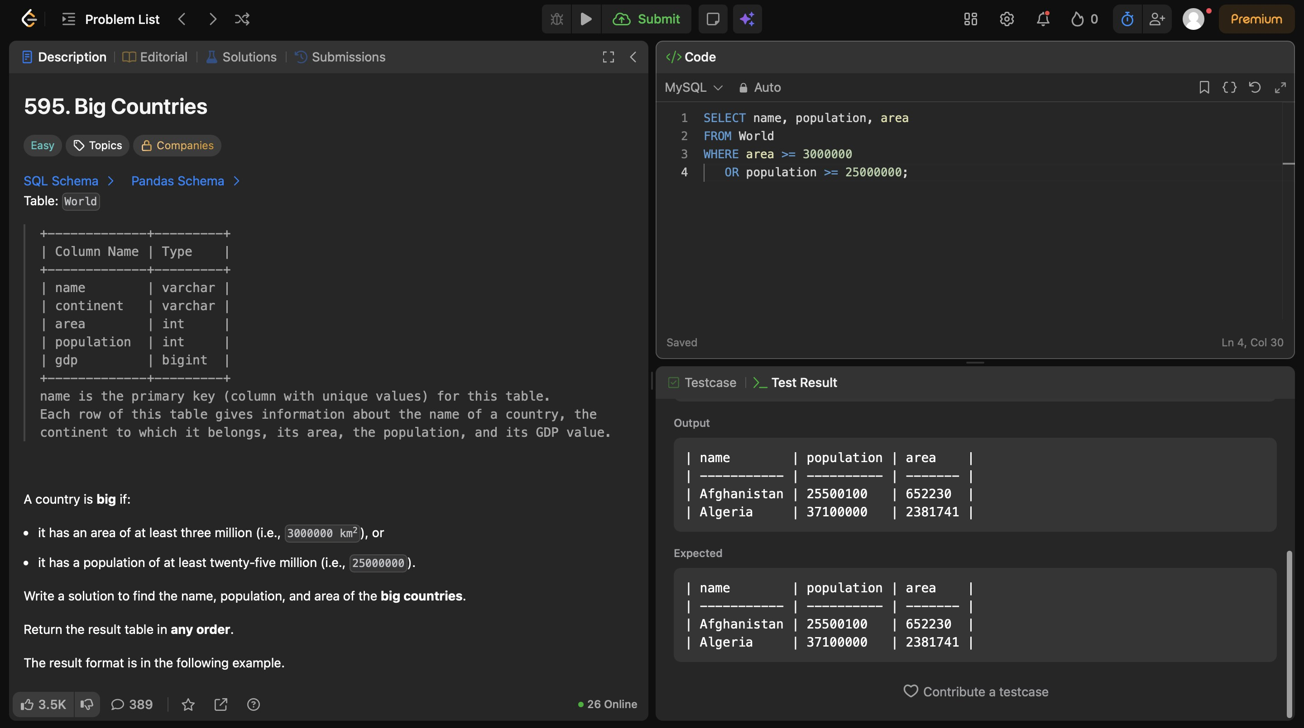
6. Not Boring Movies (Easy) - Accepted
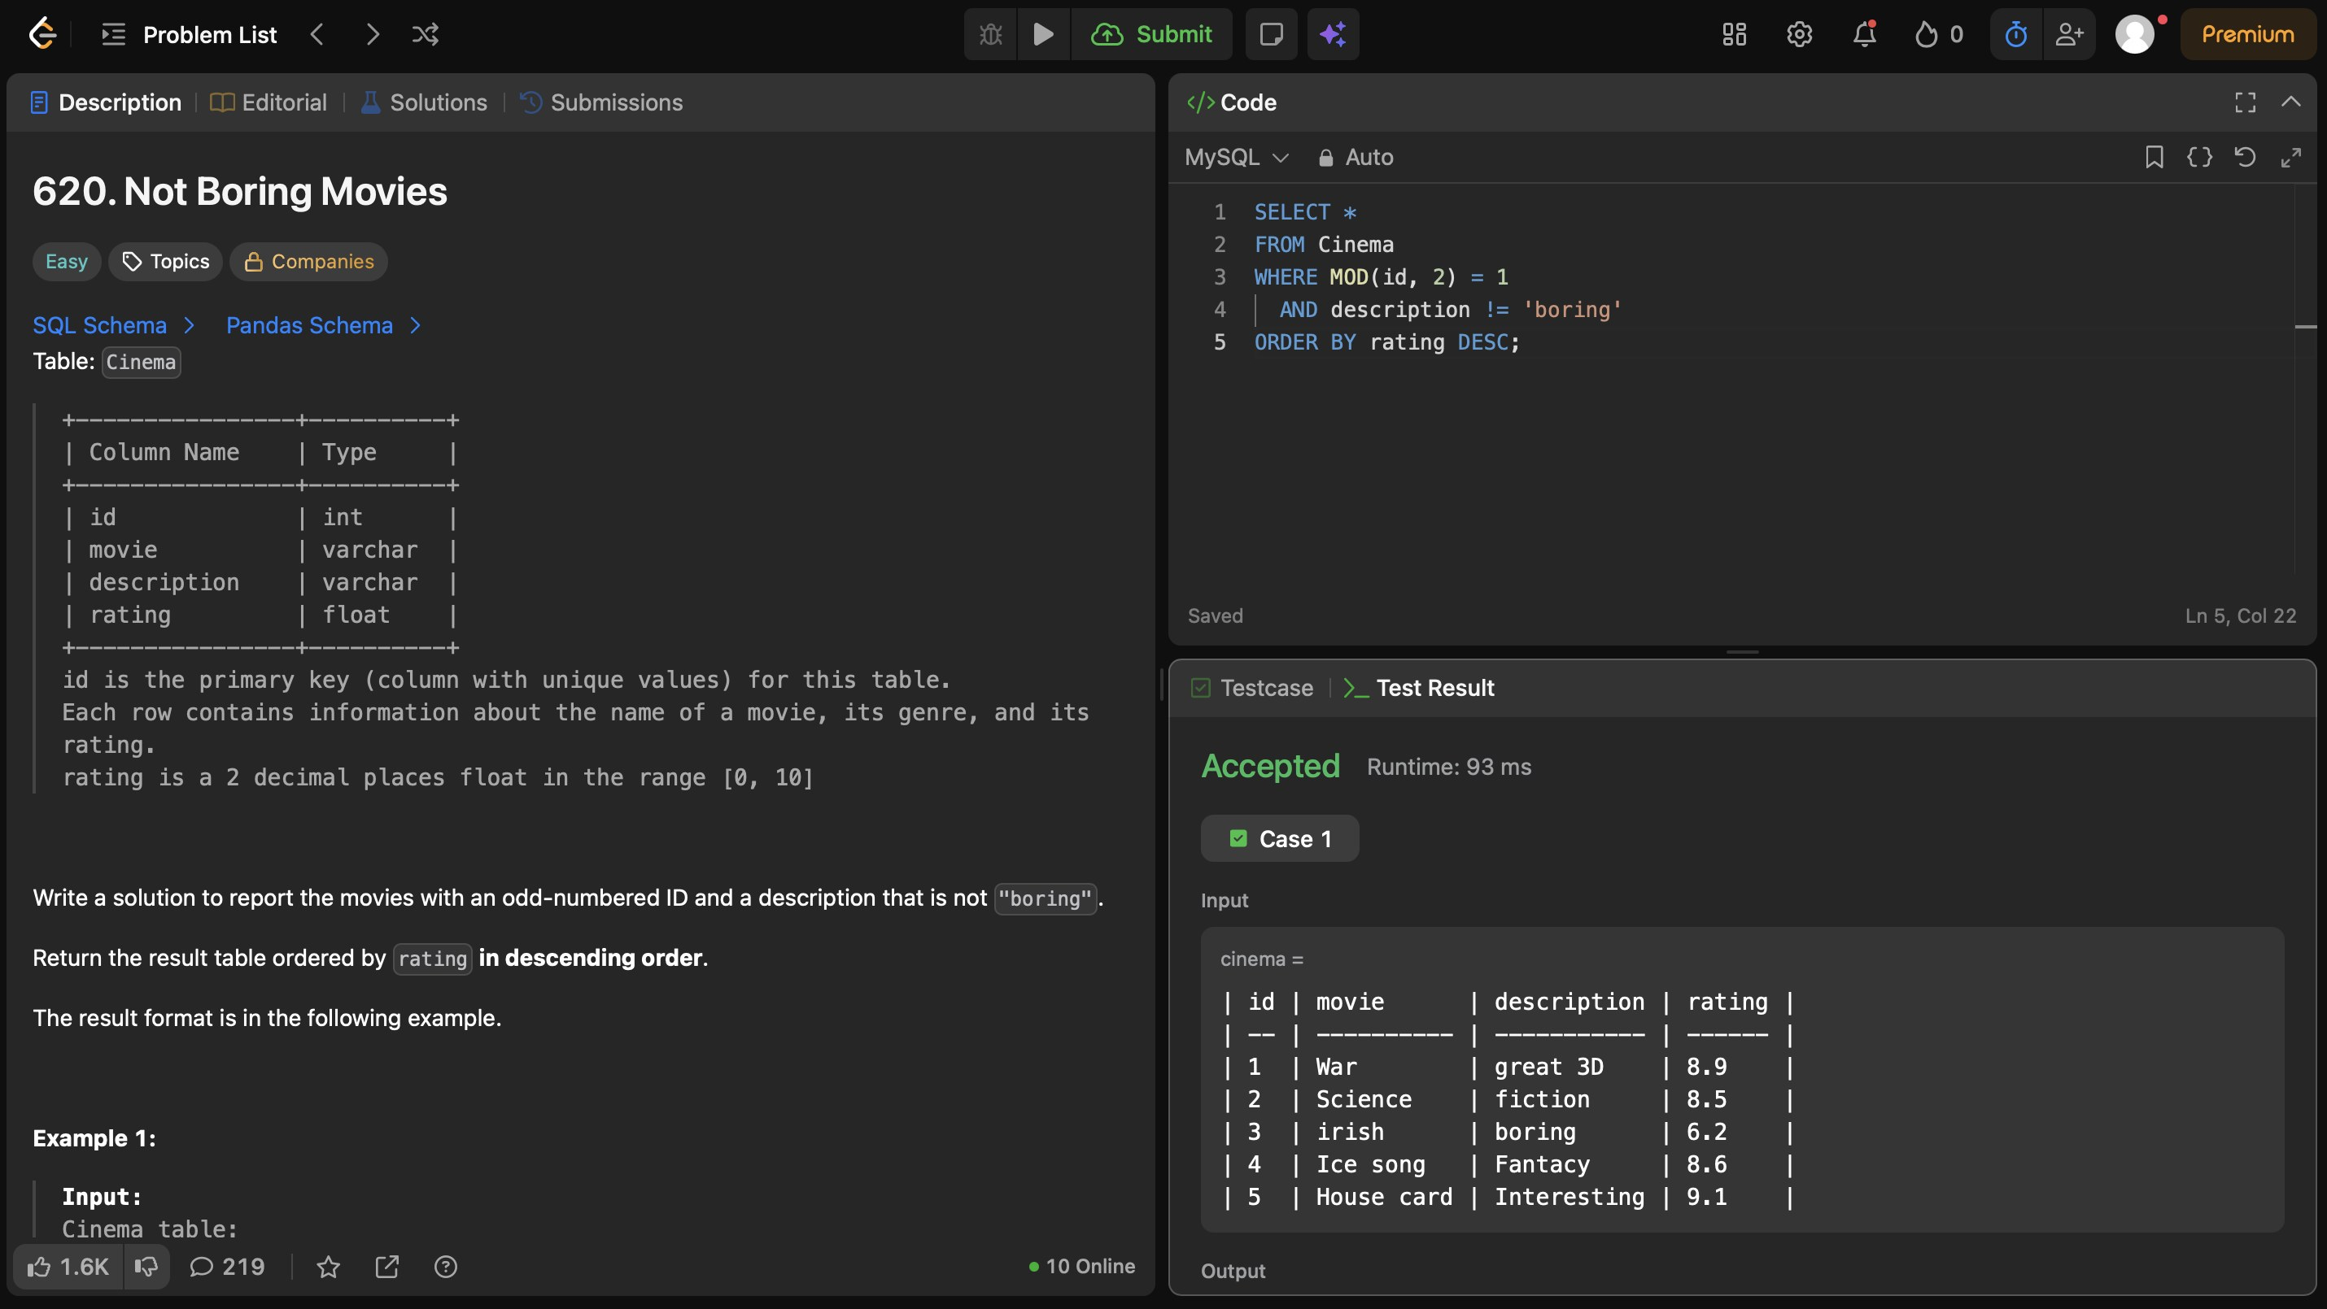
7. Article Views I (Easy) - Accepted
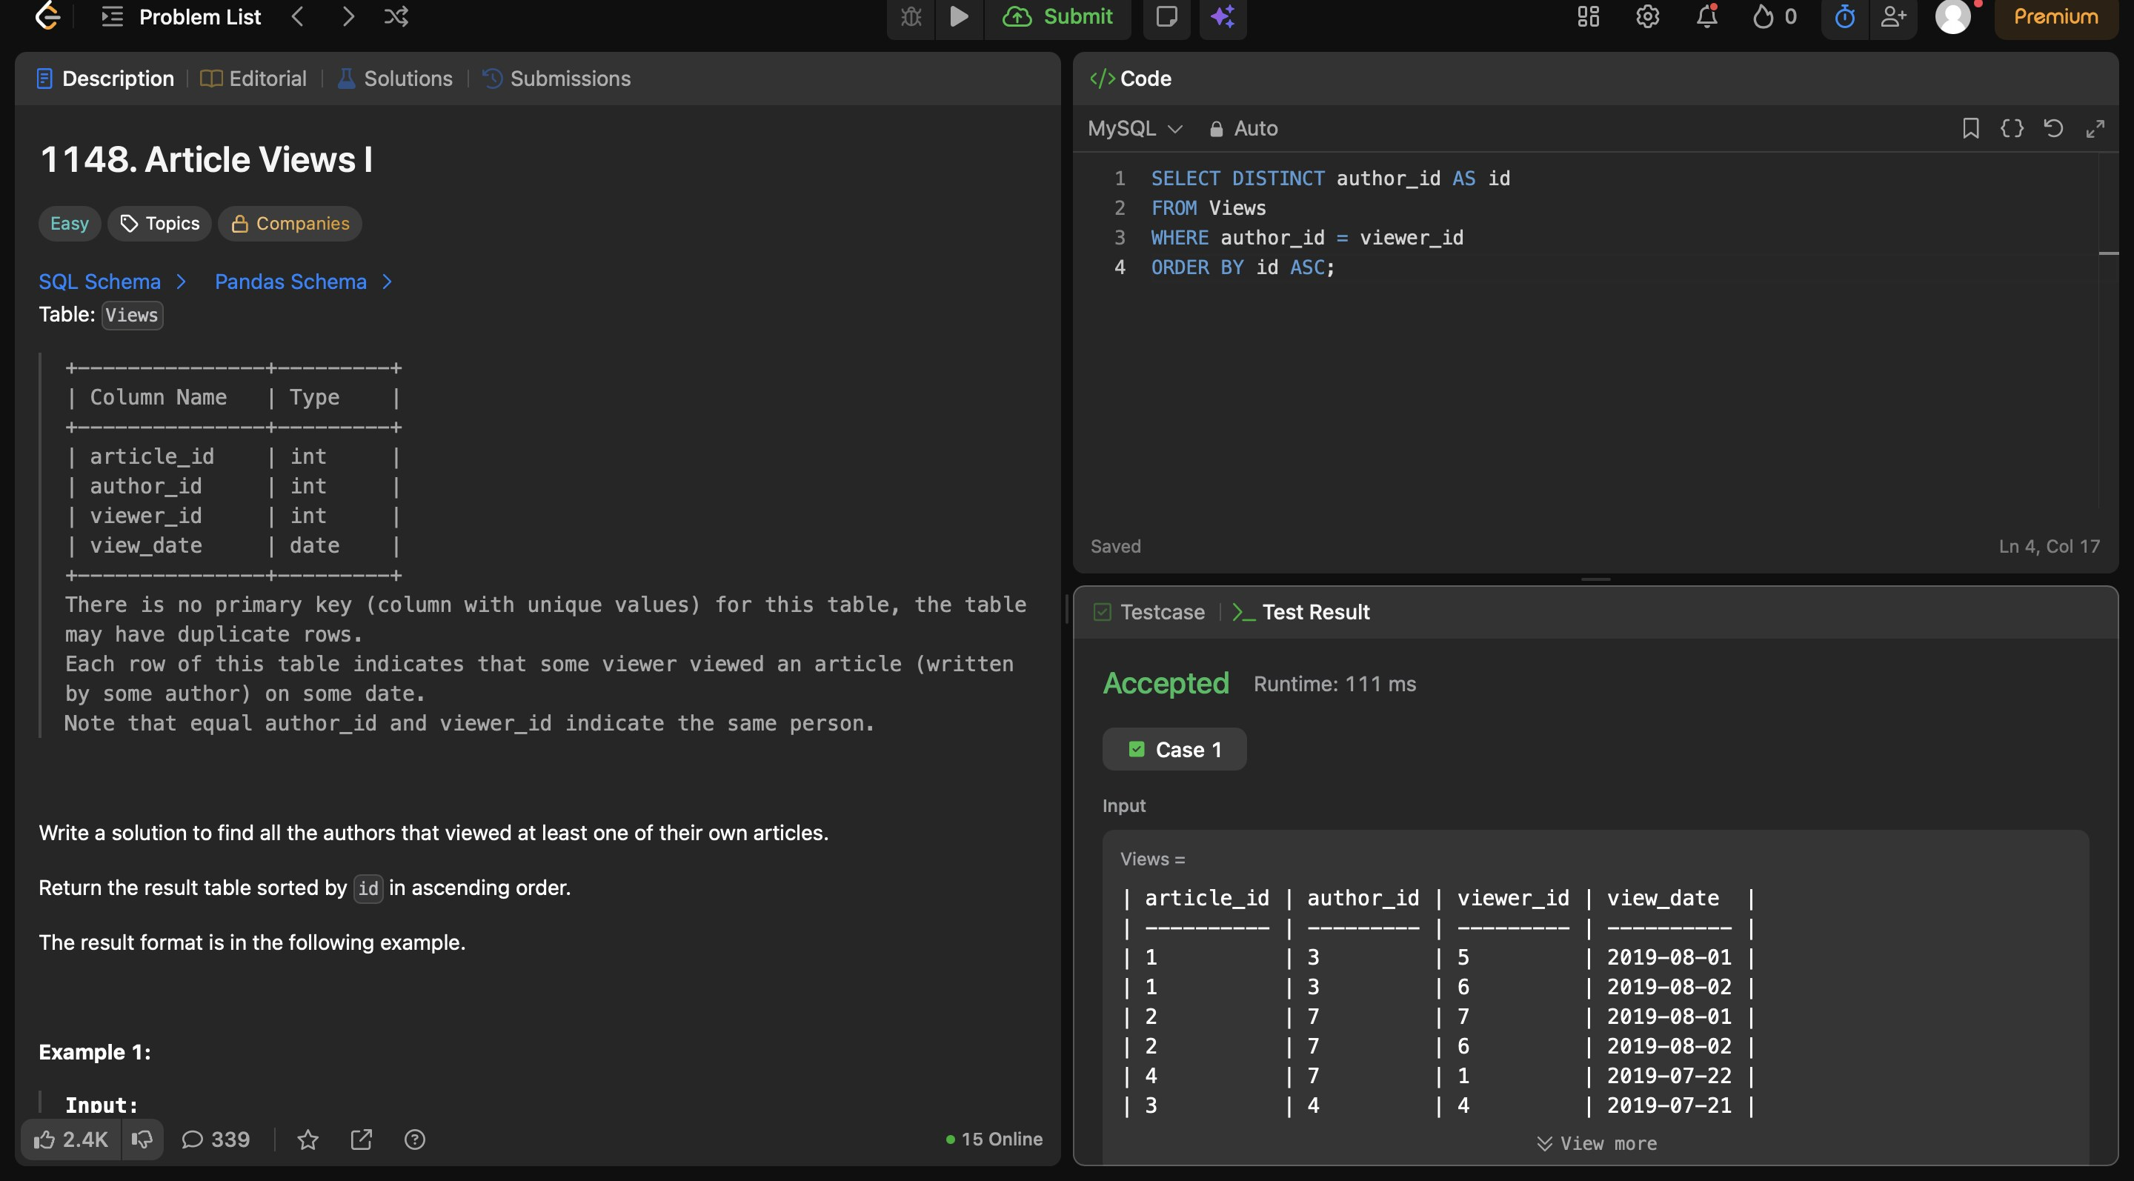

4. Certificates
No LeetCode certificate or badge earned yet.

