
Report

Team ID | MCA
Project Name | Heart Disease Risk and Patient Health Analysis
Maximum Marks | 5 Marks

The Power BI report provides a detailed and structured analysis of heart disease risk among 9,000 patients. It helps clinical teams, healthcare managers, and population-health stakeholders understand the overall prevalence of heart disease, which affects 2,727 patients (30.3%), and identify the patient characteristics associated with higher risk.
The report includes KPI cards for total patients, heart disease cases, and average age. Interactive charts analyze prevalence by smoking status, family history, chest pain type, gender, Age Group, and BMI Category. Additional visuals examine the relationship between clinical factors such as cholesterol, blood pressure, stress level, exercise, and heart disease diagnosis.
Filters and slicers allow users to explore specific patient groups and compare risk patterns. The report is designed with clear titles, consistent colours, meaningful labels, and a logical layout so that users can quickly interpret insights. These findings support targeted preventive screening, patient outreach, and better allocation of healthcare resources.

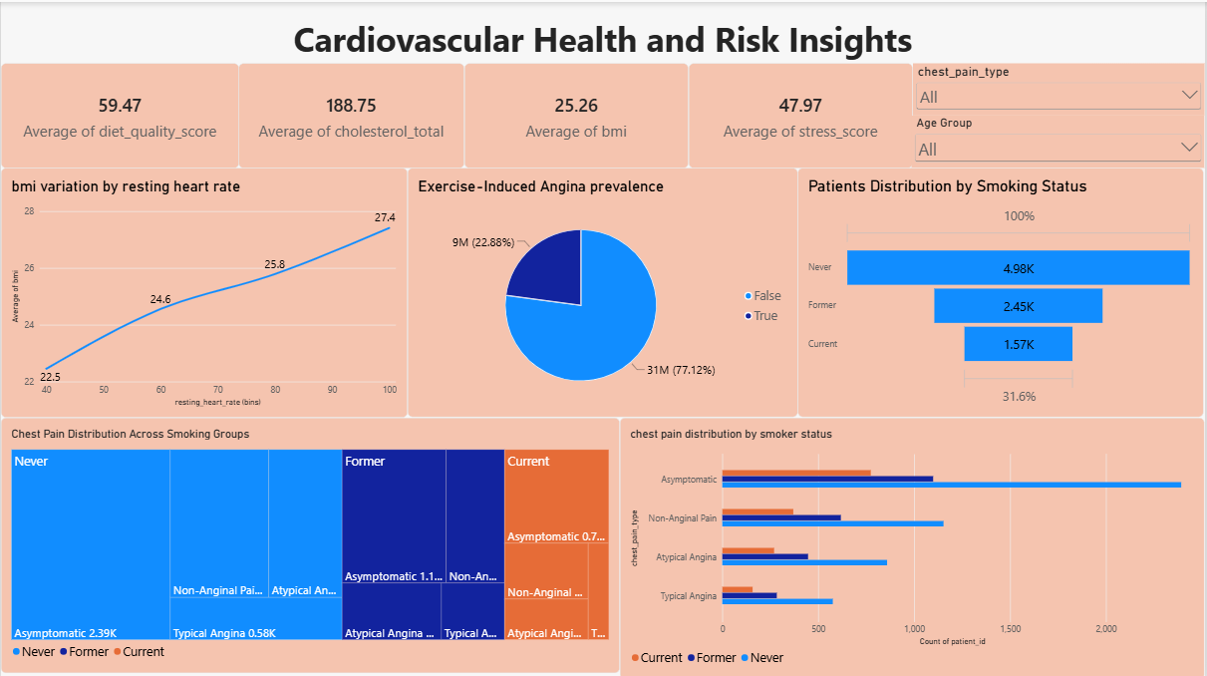

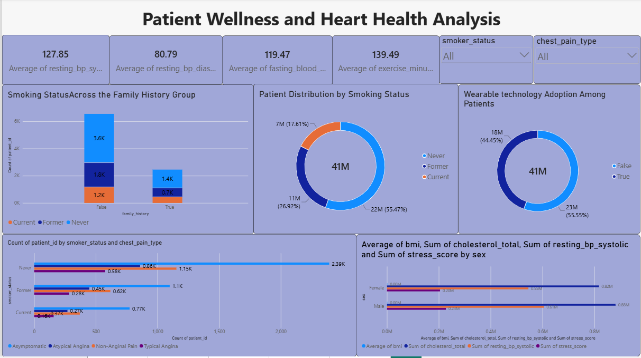

Observations from the Heart Disease Power BI Report
1. Heart Disease Prevalence
- Out of 9,000 patients, 2,727 patients (30.3%) have heart disease.
- This indicates a significant need for preventive screening and patient outreach.
2. Smoking Status Comparison
- Patients who never smoked form the largest patient group.
- Smoking status can be compared with heart disease diagnosis to identify higher-risk smoking groups.
3. Family History Impact
- Around 27.24% of patients have a family history of heart disease.
- Family history is an important factor for identifying patients who may need early screening.
4. Chest Pain Type Analysis
- Asymptomatic chest pain is the most common chest pain category, representing approximately 47.39% of patients.
- This group should be reviewed carefully because heart disease may not always be associated with obvious symptoms.

5. Clinical Risk Factors
- BMI, cholesterol, blood pressure, stress level, and exercise habits can be analyzed to identify factors associated with heart disease.
- These findings help healthcare teams prioritize high-risk patient groups for preventive care.

Example :
1. Heart Disease Prevalence:
- Out of 9,000 patients, 2,727 (30.3%) have been diagnosed with heart disease. This shows a significant need for preventive screening and targeted healthcare interventions.
2. Family History Analysis:
- Around 2,450 patients (27.24%) have a family history of heart disease. These patients can be considered an important group for early screening and preventive follow-up.
3. Chest Pain Type Analysis:
- The asymptomatic chest pain category has the highest number of patients, with approximately 4,270 patients (47.39%). This indicates that many patients may not show typical chest-pain symptoms, making regular risk assessment important.
4. Smoking Status Distribution:
- The never-smoked group has the largest number of patients, followed by former smokers and current smokers. The dashboard can be used to compare heart disease prevalence across these groups and support smoking-related prevention programs.
5. Stress-Level Observation:
- Current smokers have the highest average ST-depression level compared with former and never smokers. This may indicate a higher cardiac-risk pattern and supports targeted clinical assessment for current smokers.

