**Movie Landing Page Website Design**

**name : Srilatha Chandanala**

**email : srilathachandanala2003@gmail.com**

**phone no : 7093217289**

**Roll NO : 20NN1A0506**

**College Name : Vignan’s Nirula Institute of Technology and Science For Women**

**Source code:**

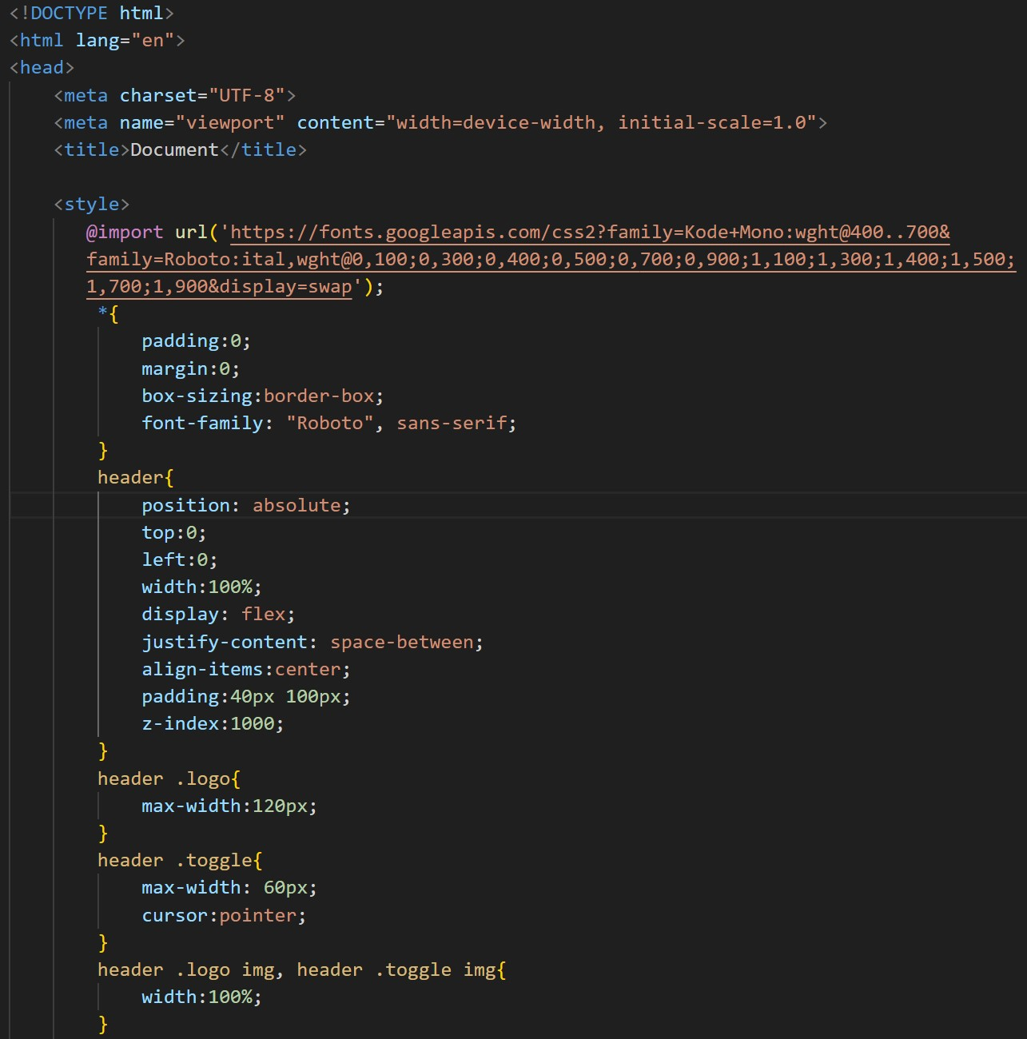

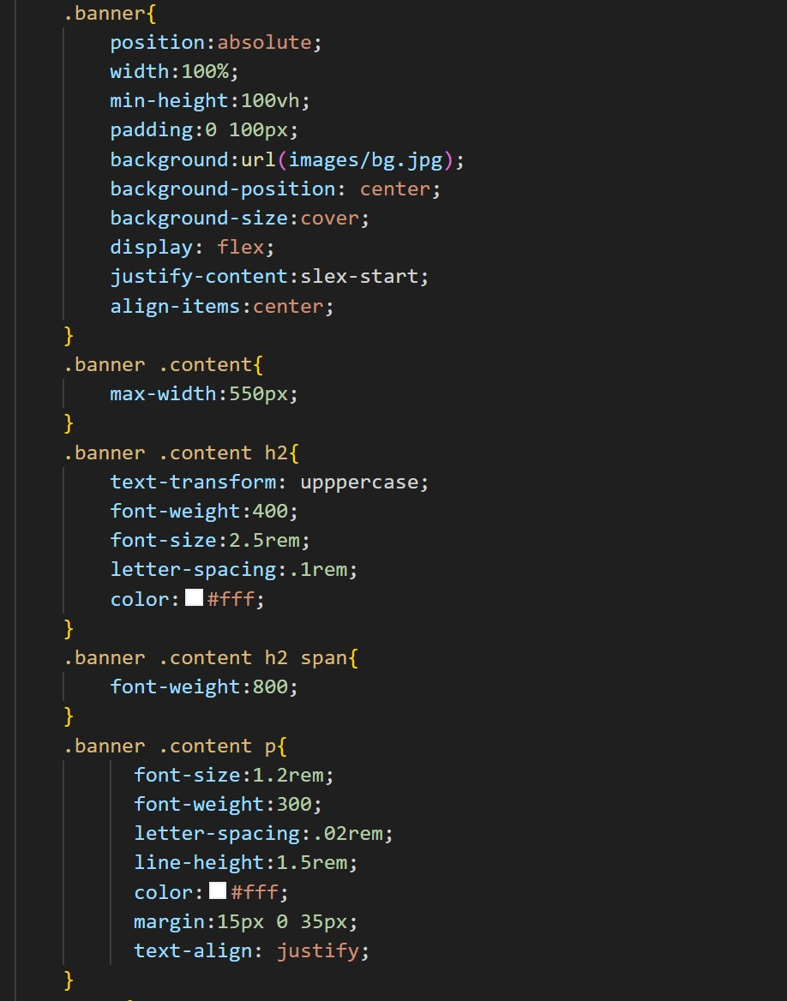

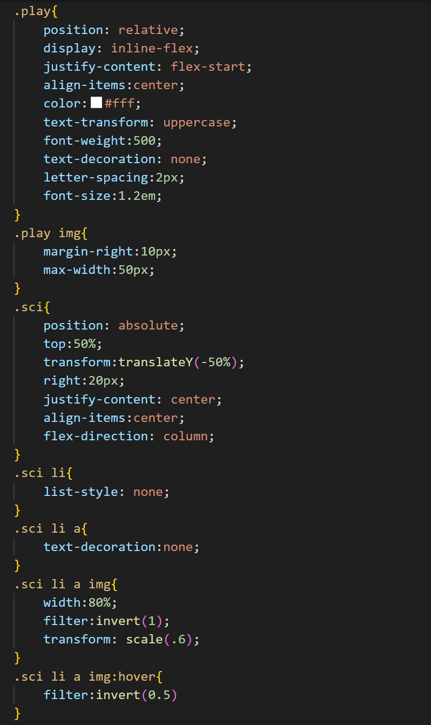

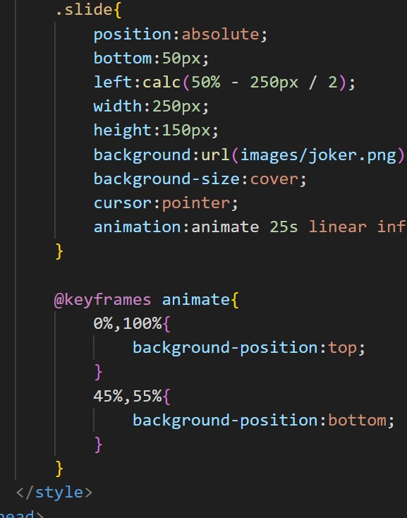

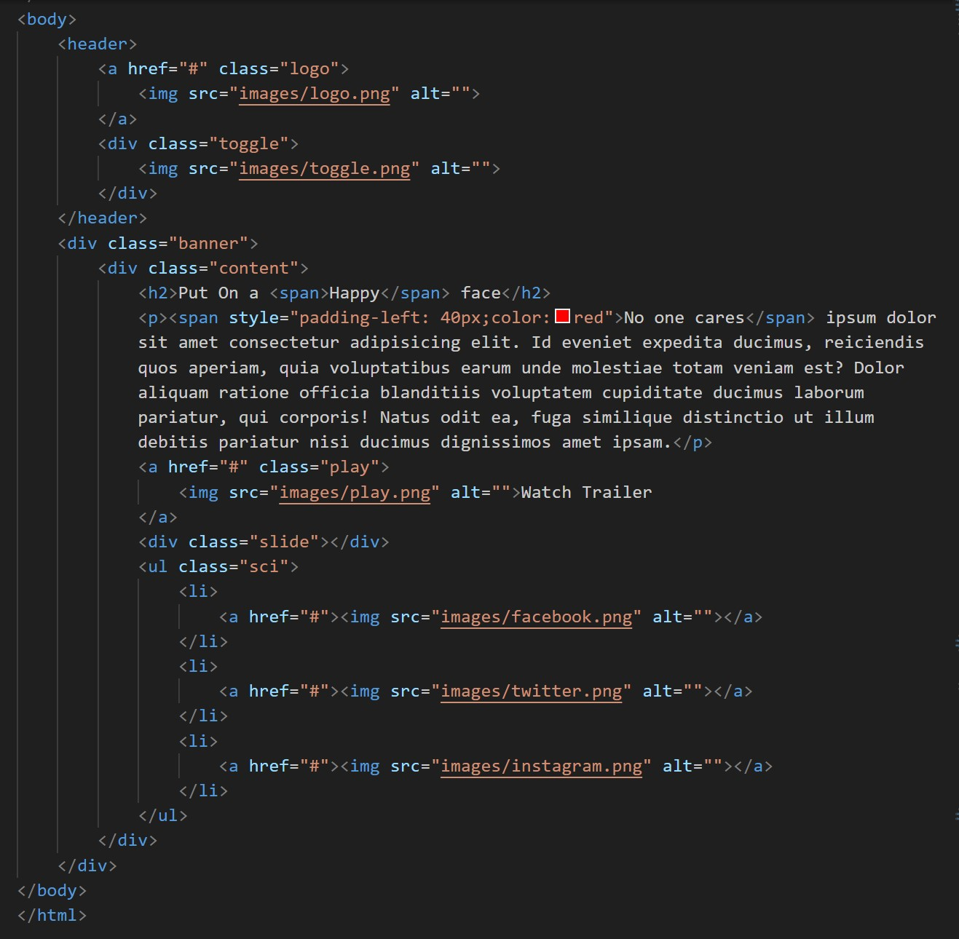

**final output :**

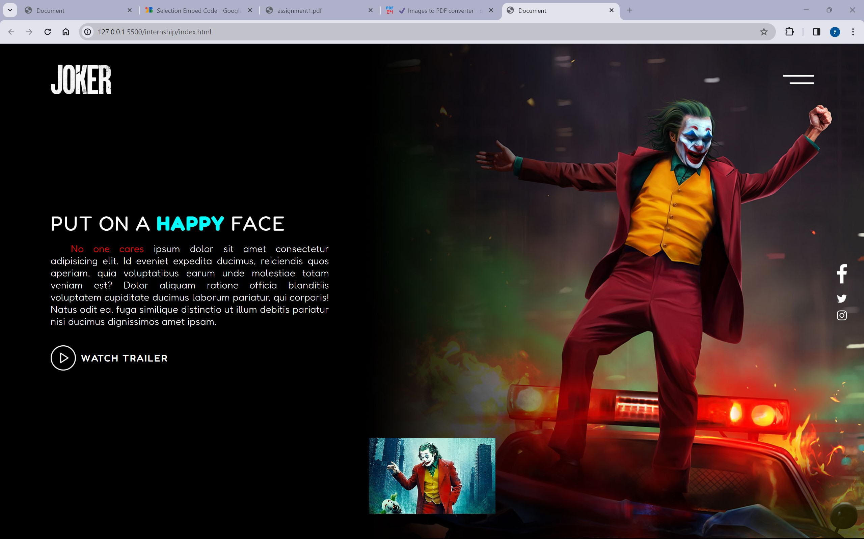

source code : <https://github.com/srilathachandanala/Assignment-1/blob/main/index.html>