Automatic Detection of Genetic Diseases in Pediatric Age Using Pupillometry

In this paper author is describing concept to detect eyes pediatric age genetic diseases using Pupillometry device data as this device is very accurate and it’s not require huge number of clinical test to detect disease. All existing techniques require huge number of clinical test to diagnose eye pupil disease in children’s and it’s not good for children’s health, so author using Pupillometry device which capture pupil diameters continuously and records that data in raw format in the file. Later we can analyse that data using Machine Learning SVM algorithm to detect presence of disease. Here author using two different SVM classifiers to train right and left eye pupil data and then performing OR operations between two classifier using ENSEMBLE VOTING classifier to get classifier with better accuracy. SVM will assign disease class label as 1 to train data if pupils size diameter is huge and if its size is normal then classifier will assign value 0.

To implement this data author using Pupillometry raw data and perform below functions to diagnose pupils disease.

Upload Pupillometry Data: Using this module we will upload raw data which contains continuous recording of pupils data.

Filtering: Raw data contains huge number of buggy values and we will filter that raw data to extract only useful information such as pupil min and max diameter

Features Extraction: Using this module all pupil min and max features extracted from raw data.

Features Reduction: Using this module we will remove unnecessary features from raw data such as camera name, position etc to reduce features set. In this module we will extract features such as Patient ID, MAX, MIN, DELTA, CH etc. Extracted data can be used to split into train and test data

Right SVM: Using this module we will train SVM with right pupil data

Left SVM: using this module we will train SVM with left Pupil data and then apply SVM on test data to calculate prediction accuracy, sensitivity and specificity.

Ensemble Algorithm (Left & Right SVM): Using this module we will combine both classifier to get classifier with high prediction accuracy.

Predict Disease: using this module we will upload test data and then apply SVM classifier to predict disease.

Screen shots

To run project double click on ‘run.bat’ file to get below screen

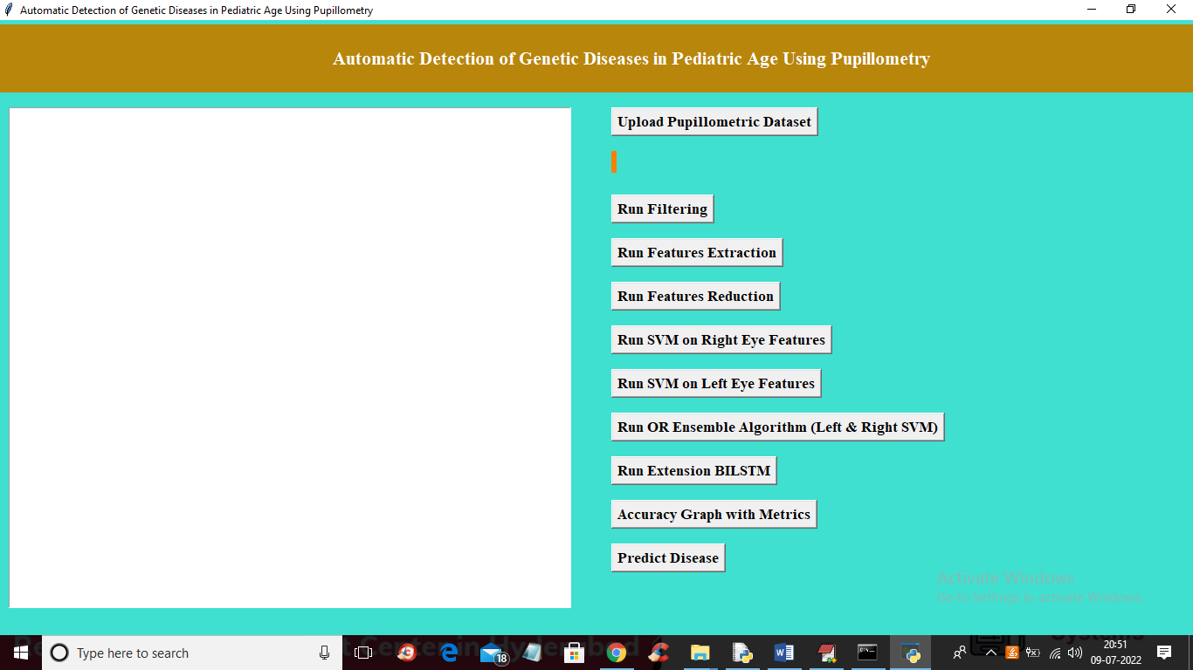

In above screen click on ‘Upload Pupillometric Dataset’ button to load dataset

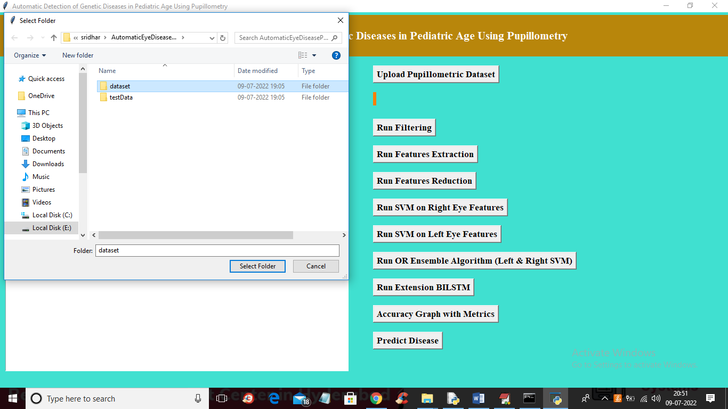

In above screen uploading ‘dataset’ folder and after upload will get below screen

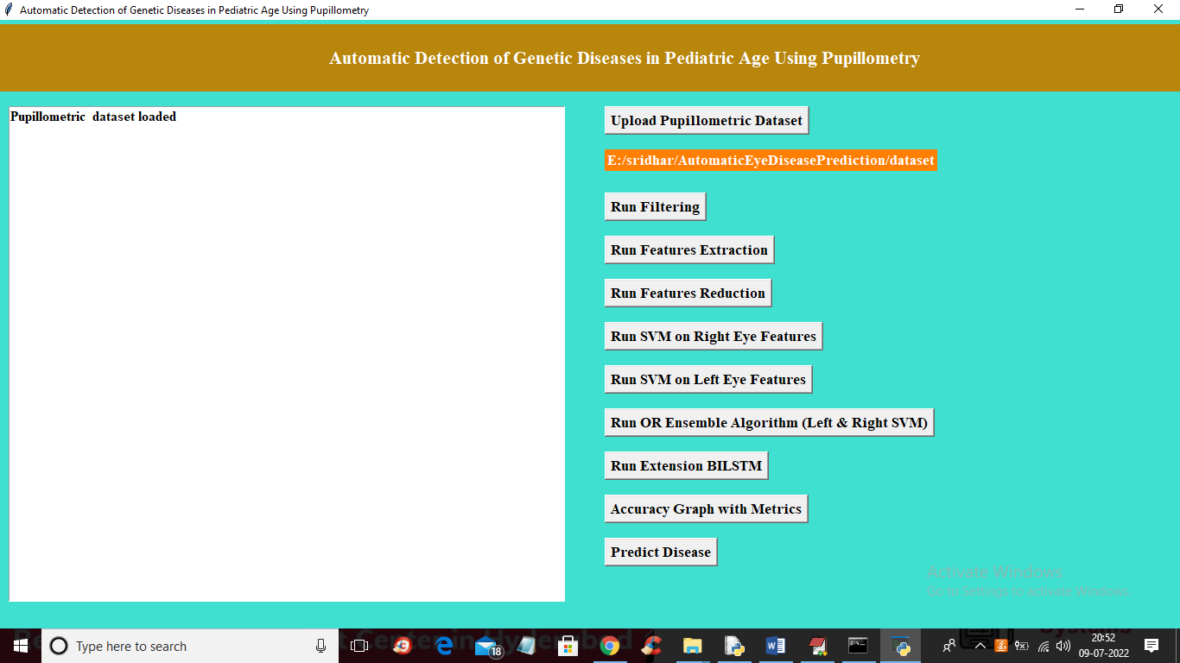

Now click on ‘Run Filtering’ button to perform filtering on dataset to ignore raw data

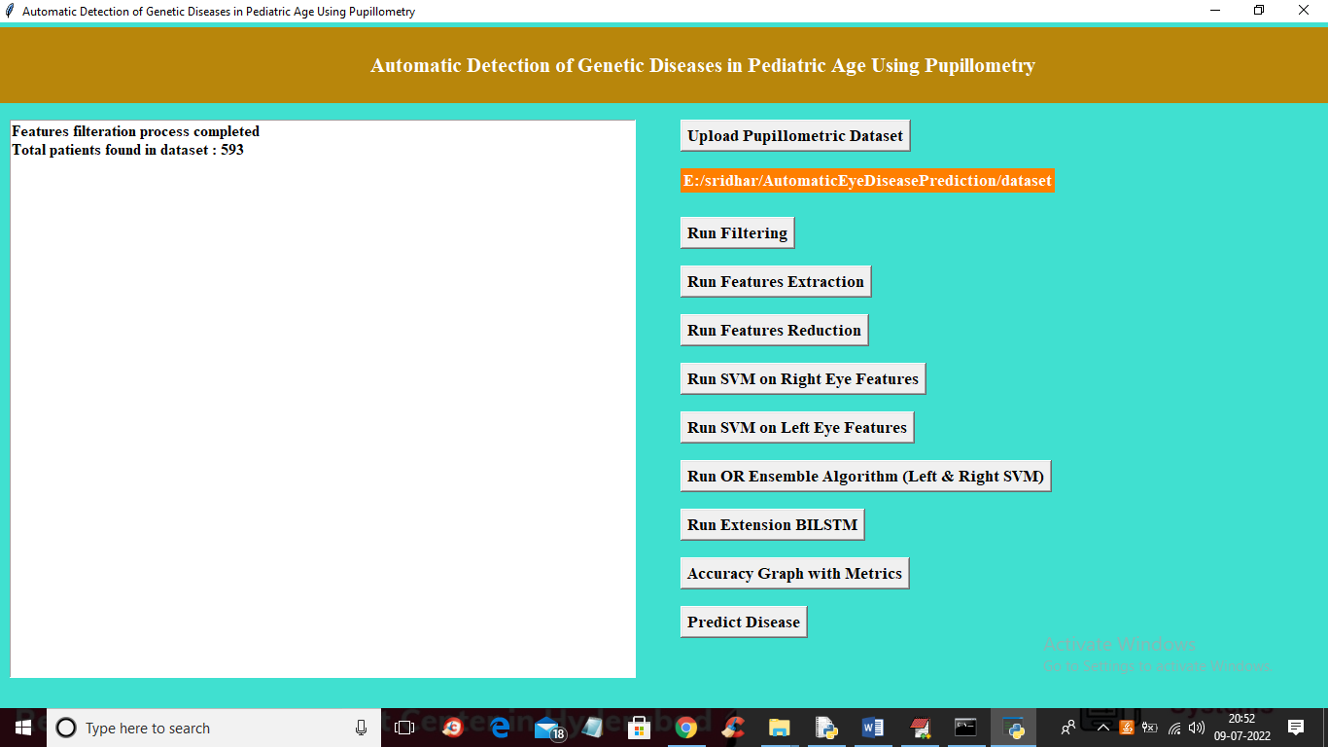

In above screen after filtering we got 593 patients data and now click on ‘Run Features Extraction’ button to read features from raw file

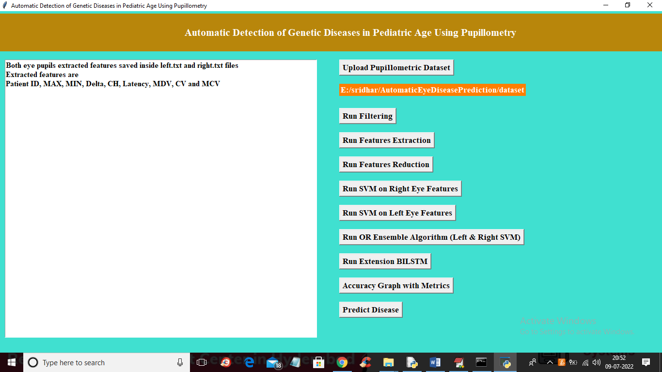

In above screen extracted features such as MIN, MAX pupil diameter etc. now click on ‘Run Features Reduction’ button to remove unimportant features and then generate train and test model for classification and to get pupil diameter graph below

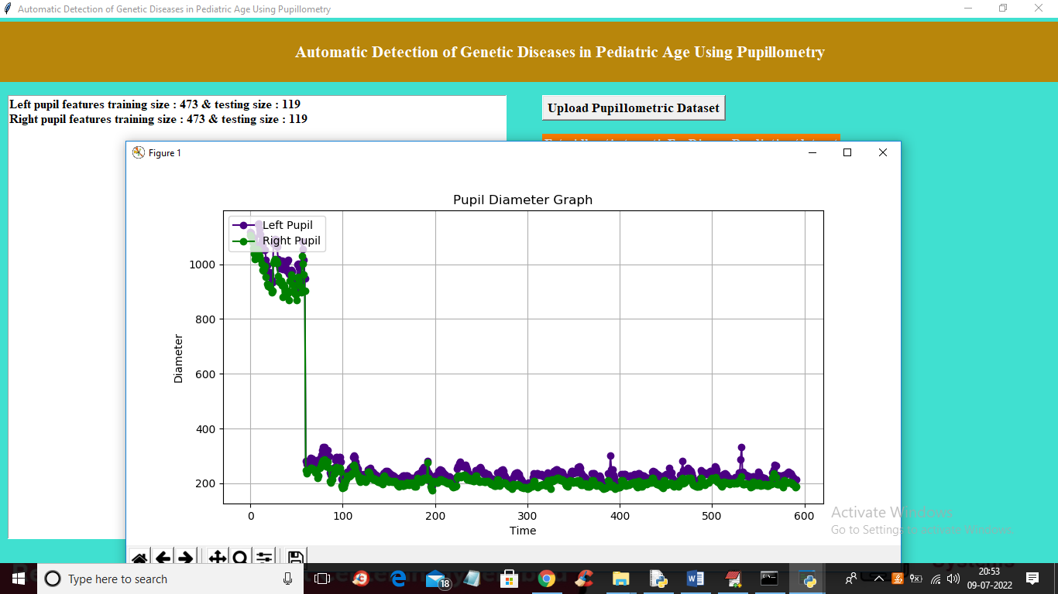

In above graph x-axis represents time of pupil capture and y-axis represents diameter of pupils. Blue line represents left pupil and green line represents right pupil. Close above graph to get below screen

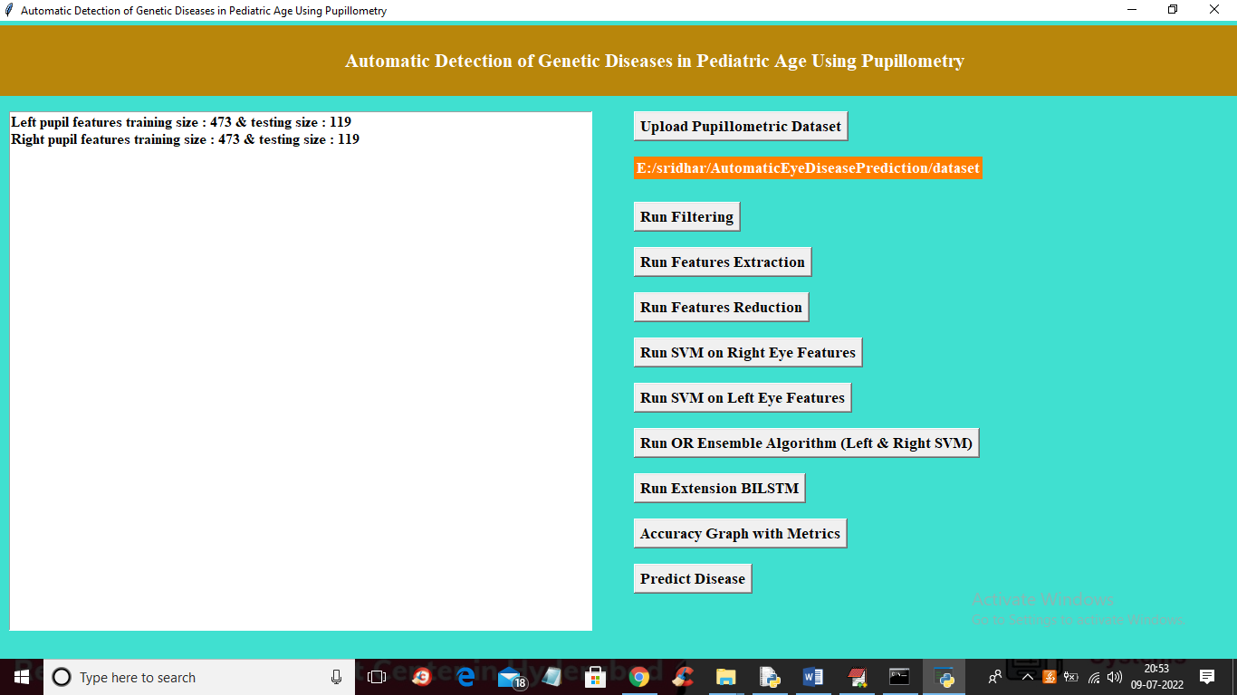

In above screen application using 473 records for training and 119 records for testing from total 593 records. Now click on ‘Run SVM on Right Eye Features’ to run SVM classifier

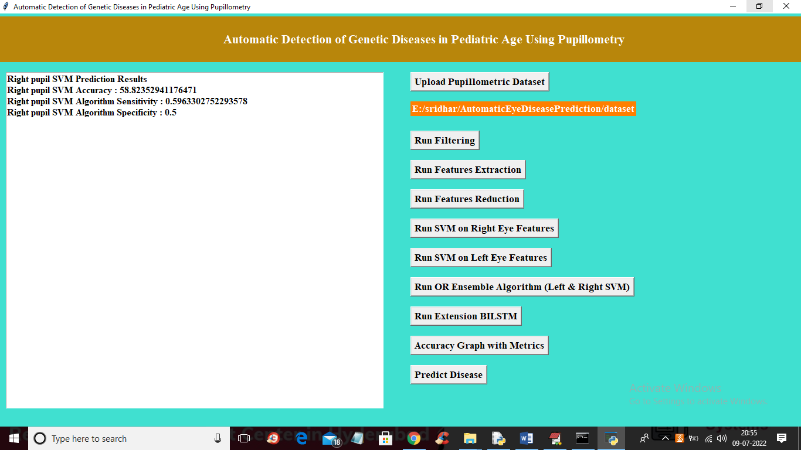

In above screen with right pupil SVM got 58% accuracy and now click on ‘Run SVM on Left Eye Features’ button to run SVM classifier on left eye data

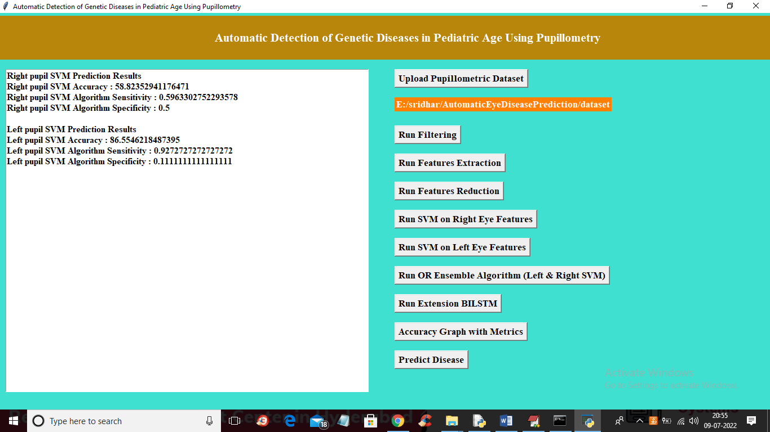

In above screen with left pupil data we got 86% accuracy and now click on ‘Run OR Ensemble Algorithm (Left & Right SVM)’ button to combine both classifier to choose classifier with better accuracy

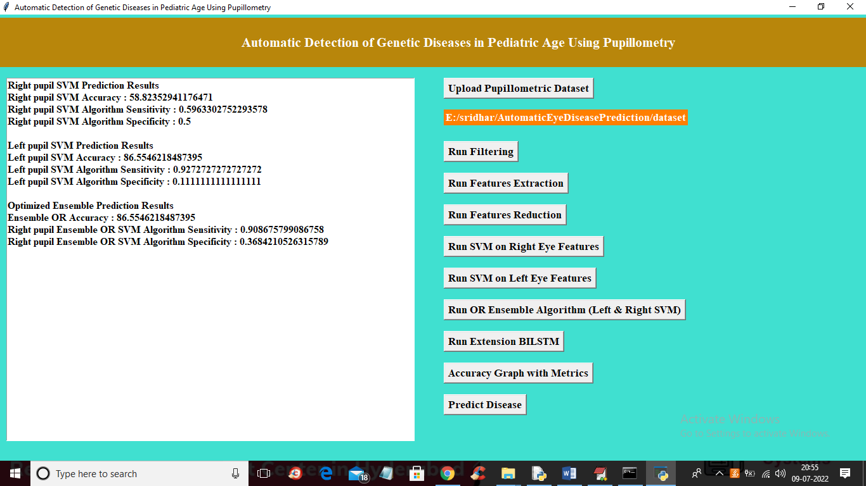

In above screen with Ensemble OR SVM we got 86% accuracy and now click on ‘Run Extension BILSTM’ button to run BILSTM algorithm and get below output

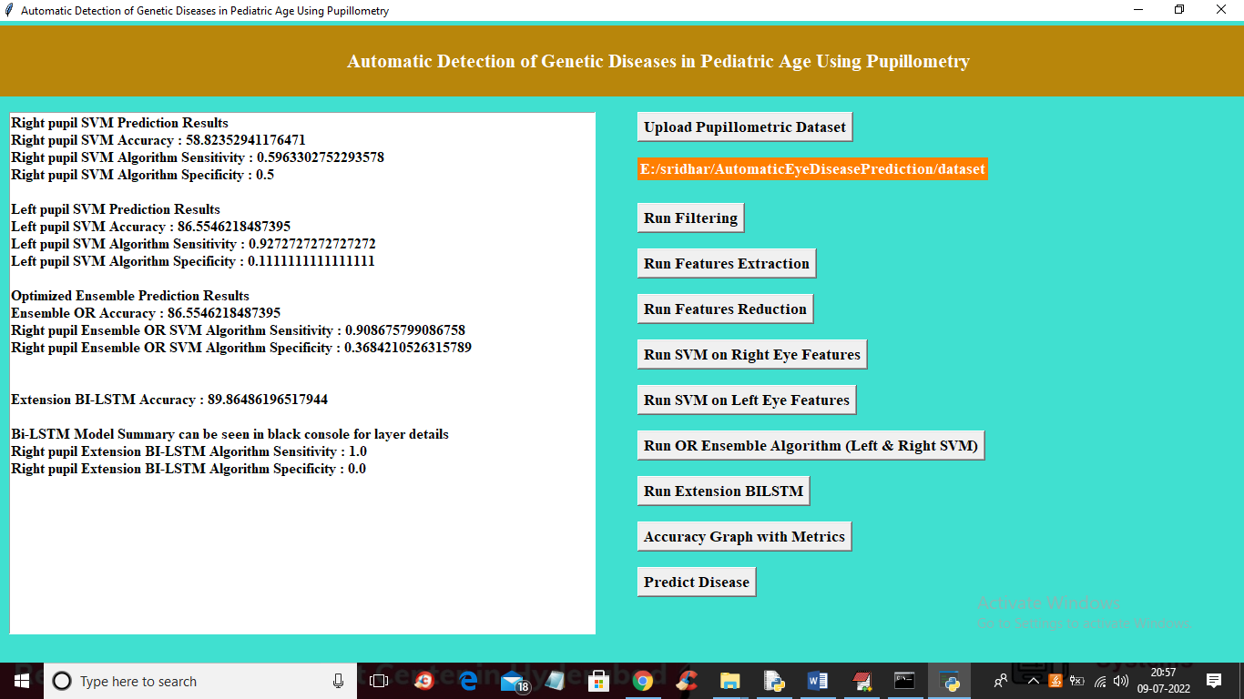

In above screen with extension ‘BILSTM’ we got 89% accuracy and now click on ‘Accuracy Graph with Metrics’ to get below accuracy graph

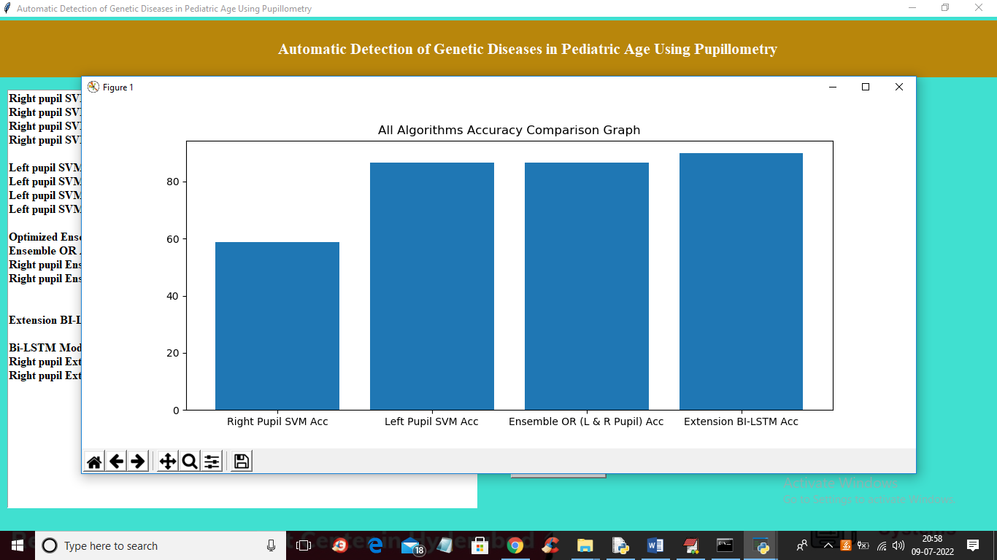

In above graph x-axis represents algorithm name and y-axis represents accuracy and in all algorithms extension BILSTM got high accuracy and now click on ‘Predict Disease’ button to upload test data and predict disease. In below test data we can see only pupil values are there but not disease information and classifier will predict disease information after applying classifier on it.

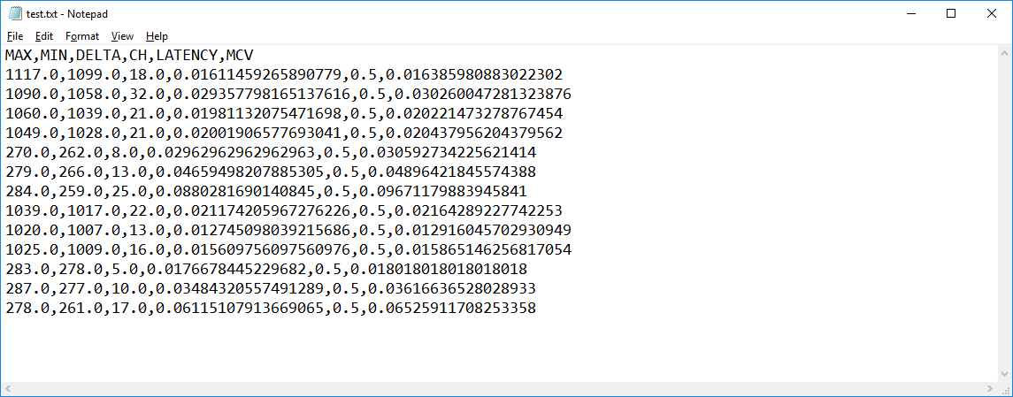

In above test data ‘test.txt’ we have only features values and after uploading classifier will predict disease

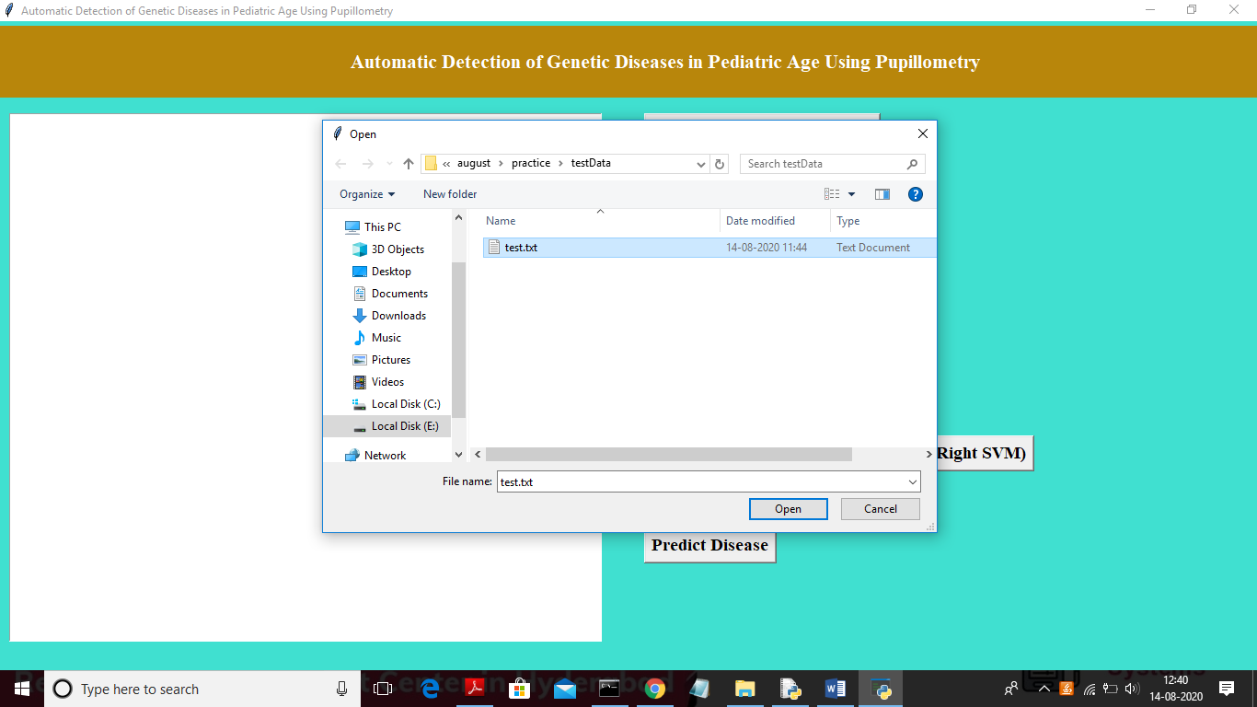

In above screen uploading test data and after upload will get below screen

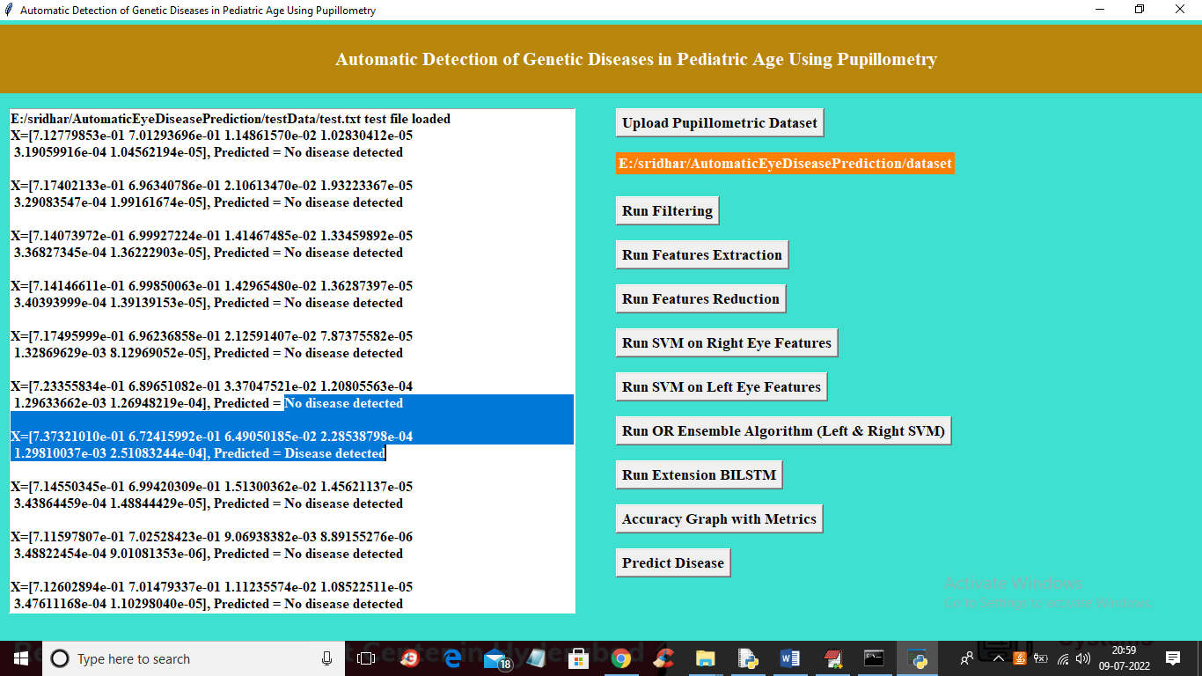

In above screen for each test record classifier displaying predicted result as ‘disease detected’ or ‘no disease detected’. In above screen in square bracket we can see TEST values and after square bracket we can see predicted result as pupillometri disease detected or not.

Here we are extracting data from binocular device data and we are splitting train and test data as random so accuracy may vary for each run based on collected data from binocular device data.