# Assignment 2: Local LLM Installation and Testing

## Objective

Install a local LLM and test its functionality.

## Steps Performed

- Installed Ollama locally on my system.

- Pulled and used the LLaMA 3.2 model.

- Ran the prompt: “Write a short poem about AI.”

- Measured the response time using PowerShell's Measure-Command.

- No errors were encountered during the installation or execution.

## Sample Prompt and Output

Prompt: Write a short poem about AI.

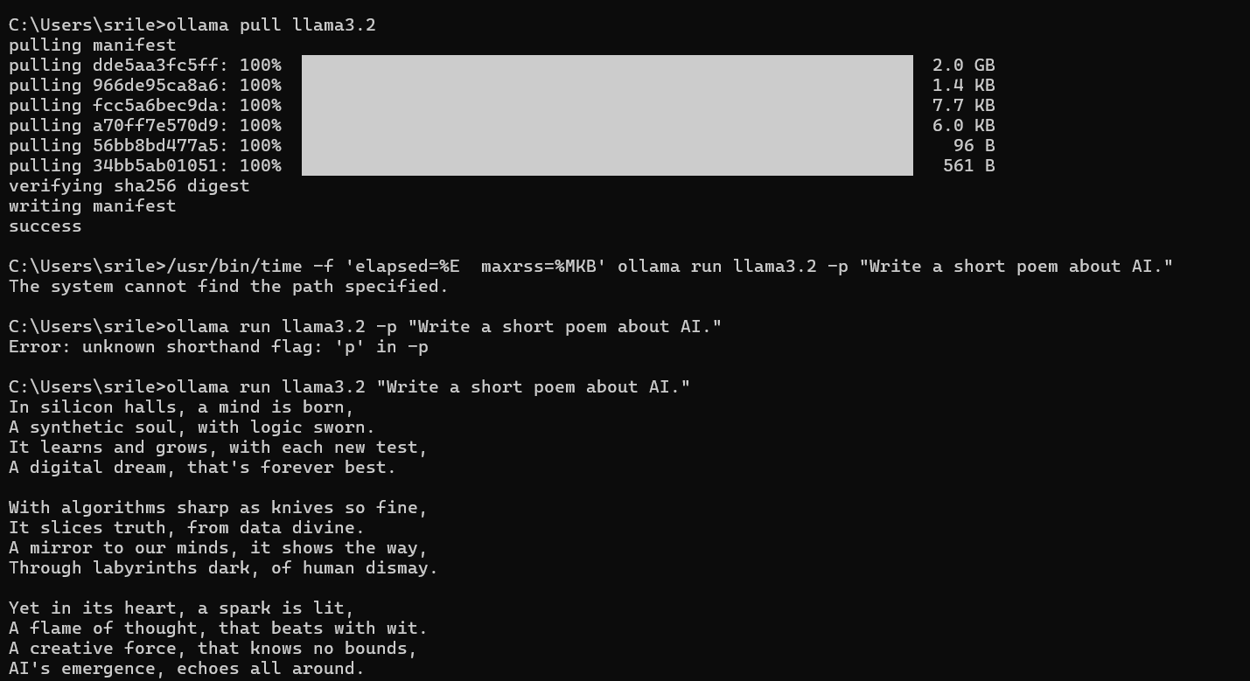

## Response Time Measurement

Command Used: Measure-Command { ollama run llama3.2 "Write a short poem about AI." }

The output was generated within a few seconds. Exact timing can be seen in the PowerShell measurement screenshot.

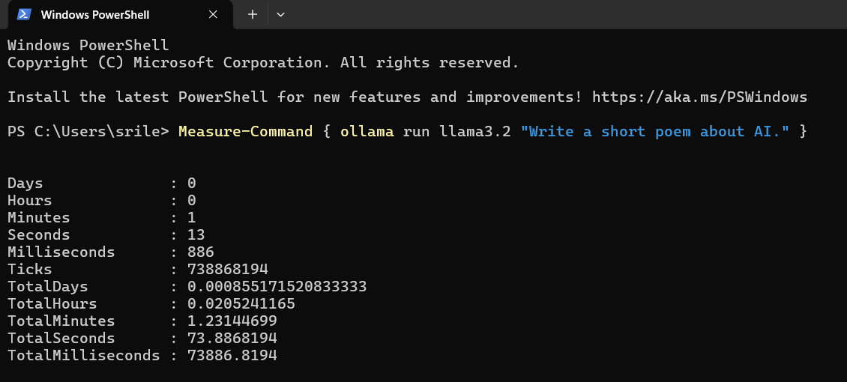

## Reflection

The installation and execution process was straightforward. Ollama made it easy to run the LLaMA 3.2 model locally without additional setup complexities. The performance was smooth, and the model responded quickly after initial loading. I did not face any errors or crashes, and the output quality was impressive for a locally run model.