**Abstract**

Srilekha Palleboyina, @01430480

Traditional hardware multiplication is performed in the same way multiplication is done by hand: partial products are computed, shifted appropriately, and summed. This algorithm can be slow if there are many partial products (i.e. many bits) because the output must wait until each sum is performed. Booth’s algorithm cuts the number of required partial products in half. This increases the speed by reducing the total number of partial product sums that must take place.

The algorithm exploits the fact that multiplication by a sequence of 1’s can be computed simply with inversions and shifts, simpler operations than adding. This algorithm first encodes the start, middle, end, or absence of a sequence of 1’s in the multiplier term from groupings of three bits, each with an overlapping bit from the previous grouping. These encodings are then used to compute the partial products from the multiplicand by either multiplying it by 1 (i.e. no change), multiplying it by 2 (shift left one bit), or multiplying it by -1 (2’s complement). The encodings are shown in Table 1. These partial products are shifted by two bits for each partial product after the first. The product is equal to the sum of these terms.

Block Diagram:

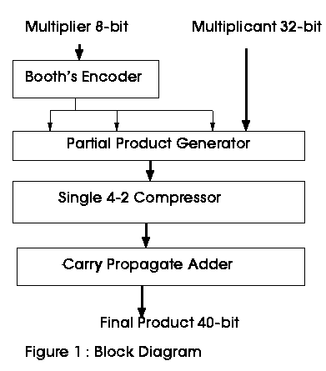

Truth Table:

|  |  |
| --- | --- |
| Grouping | Partial Product |
| 0 0 0 | 0 x Multiplicand |
| 0 0 1 | 1 x Multiplicand |
| 0 1 0 | 1 x Multiplicand |
| 0 1 1 | 2 x Multiplicand |
| 1 0 0 | -2 x Multiplicand |
| 1 0 1 | -1 x Multiplicand |
| 1 1 0 | -1 x Multiplicand |
| 1 1 1 | 0 x Multiplicand |

Conclusions for Booth Algorithm:

• Booth algorithm can reduce number of non-zero summands considerably

• Worst case: May double the number of non-zero summands

• Bit-pairing can reduce the number of summands further

• For the sequential shift/add hardware, bit-pairing reduces the summation effort substantially, with or without Booth recoding

• Booth’s Algorithm reduces the time required to compute partial products and consequently increases the speed of combinational multipliers.