1.implementing patient service using restful webservices with springboot.

2.created a class for patient data giving the required objects and implementing getters and setters.

3.cretaed an interface to define the path to access our webservices for crud operations.

4.implemented the interface in a class.

5.used the hashmap datastructure to store our patients data as a key value pair.

6.performed a test to get all the patient details

7.getting one patient detail.write one more method declaration in interface and implement the method in PatientServiceImpl class to get only one patient details by giving id.

8.creating one more patient details/adding one more patient details and giving response.we declare a method in the interface with @POST annotation as we are creating,and implement the method in the PatientServiceImpl class.we will give the name of the patient and id gets incremented automatically and store details in the hashmap and return the response and the object.

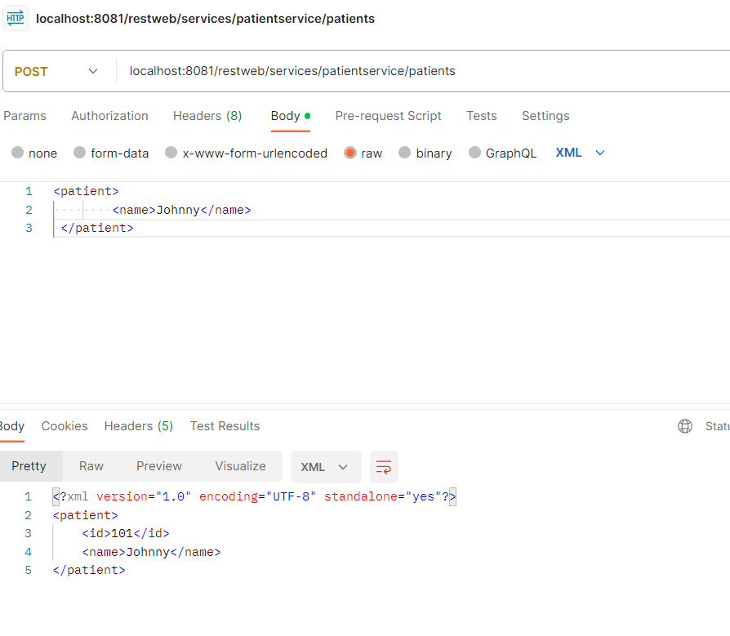

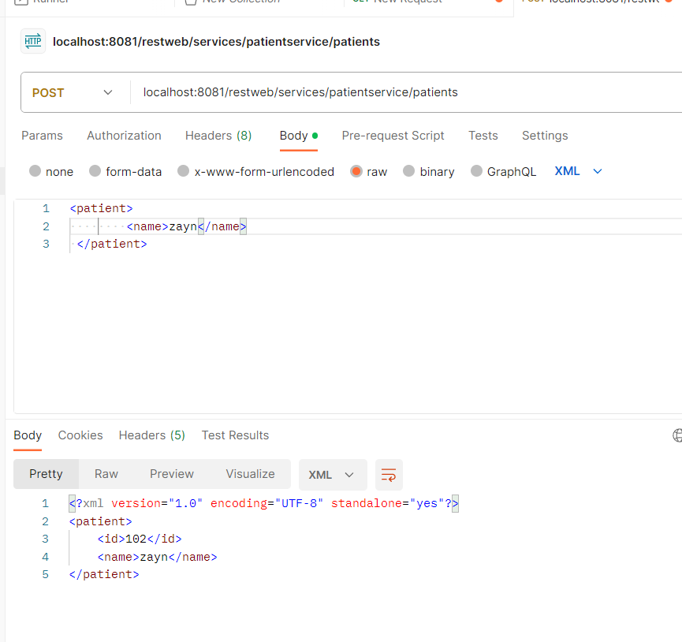

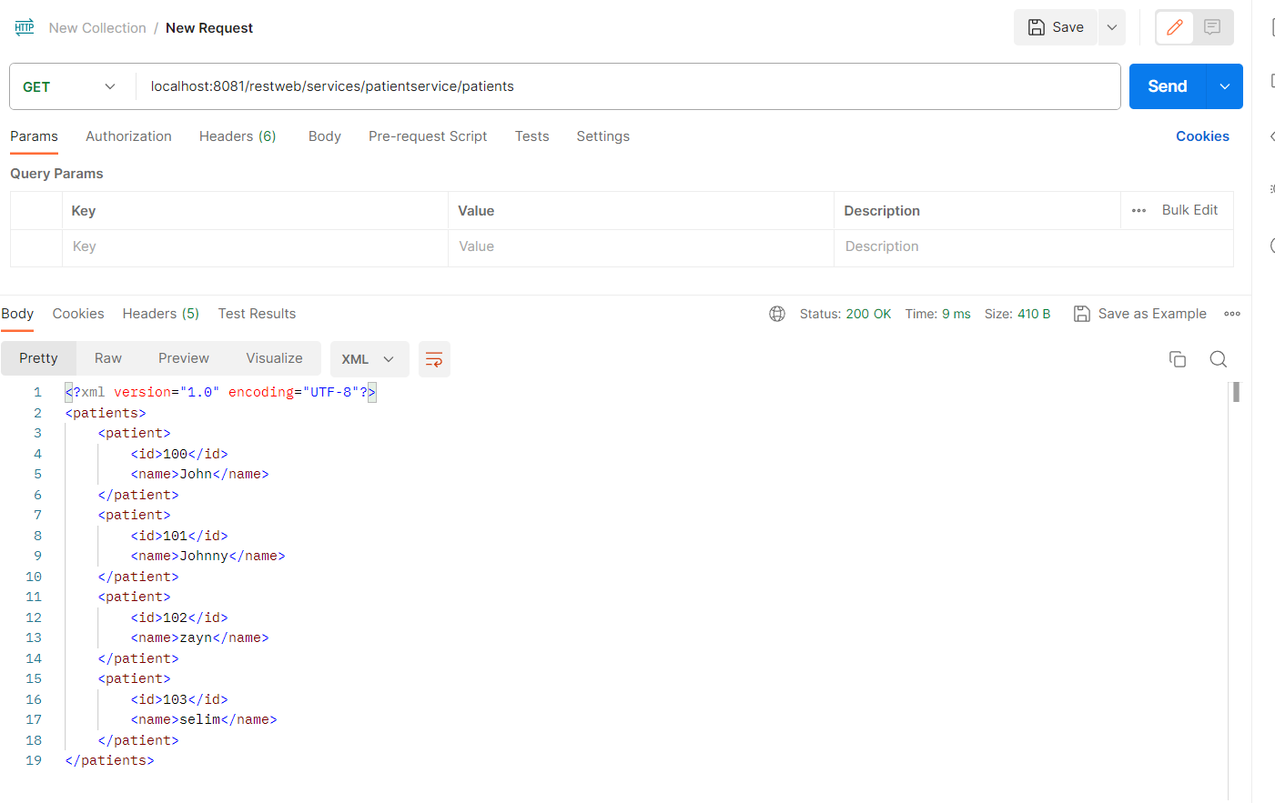

Update:(@PUT)

Updating patient details:changing patient name from john to rose.we get status as 200 as response if patient is found.

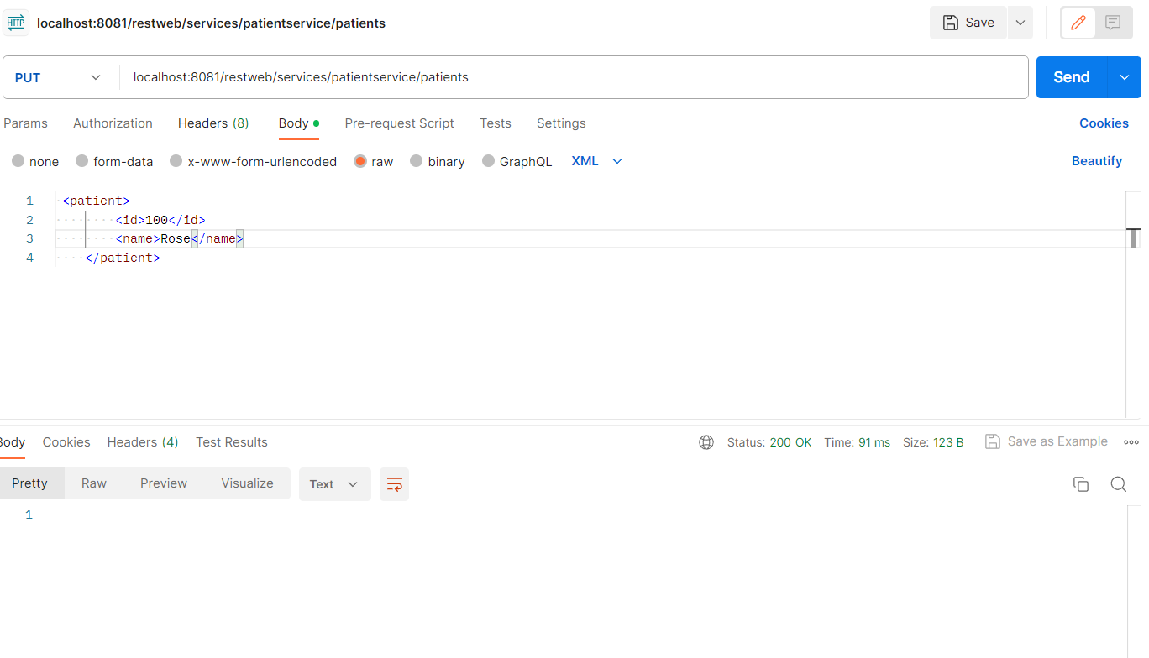

If the patient is not found we get response as not modified.

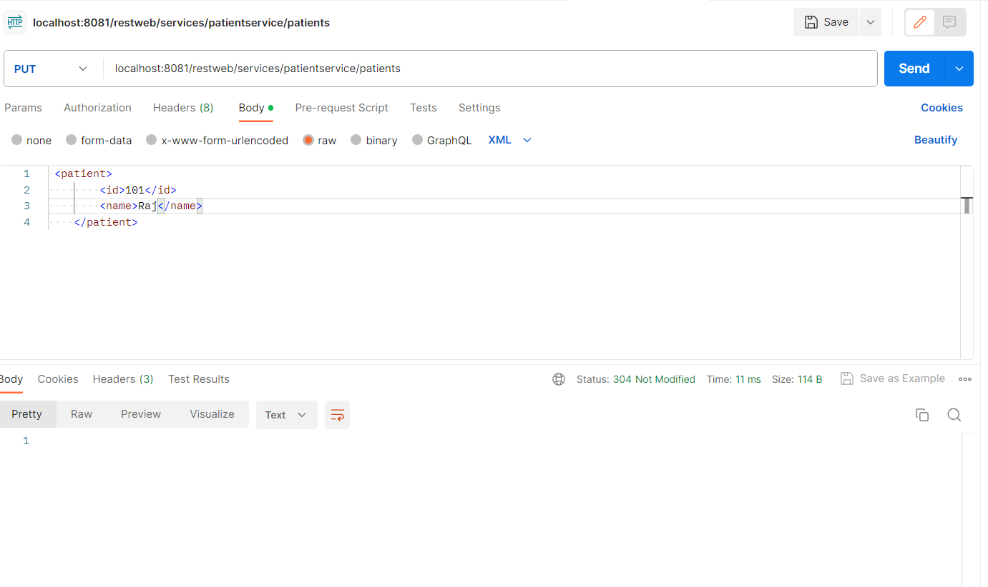

Delete:by giving the patient id we write a method declaration in the interface and implement it in the implementation class by taking id dynamically.we write a method to delete the respective patient details.we receive 200 ok response and the details get deleted of the respective patient and if that id is not found we receive not modified response.

First,check the details of patient by get operation and perform delete operation.

