A Survey on Vision Transformer
In this paper author is giving survey on numerous Transformer algorithms which are designed to classify text data such as predicting sentiments, extracting summary from large text etc. High success of transformer in text processing fetch interest of researchers in image classifications.
Numerous number of Vision Transformer (VIT) algorithms exists for image classification and author is giving survey on all those algorithms but here we are implementing VIT and YOLO. YOLO will detect and recognized object while VIT will detect and recognize/classify what type of object in the image. For example if we input DOG image then YOLO will detect and recognize as ‘DOG’ but VIT will recognized what type of DOG it is.
Vision Transformers (VIT) is an architecture that uses self-attention mechanisms to process images. The Vision Transformer Architecture consists of a series of transformer blocks. Each transformer block consists of two sub-layers: a multi-head self-attention layer and a feed-forward layer. All layers will train itself to extract optimized features which can give best prediction accuracy. VIT take input as Encoder and then given predicted output as decoder.
To implement this project we have designed following modules
- Load Vision Transformer Model: using this module we will load VIT model and YOLO model
- Upload Image: using this module we will upload input image
- Classify Image using VIT: using this module we will classify input image using VIT transformer model and then calculate classification accuracy
- Classify Image using YOLO: using this module we will classify input image using YOLO transformer model and then calculate classification accuracy
- Comparison Graph: using this module we will plot accuracy comparison graph between both algorithms
SCREEN SHOTS
To run project double click on ‘run.bat’ file to get below screen
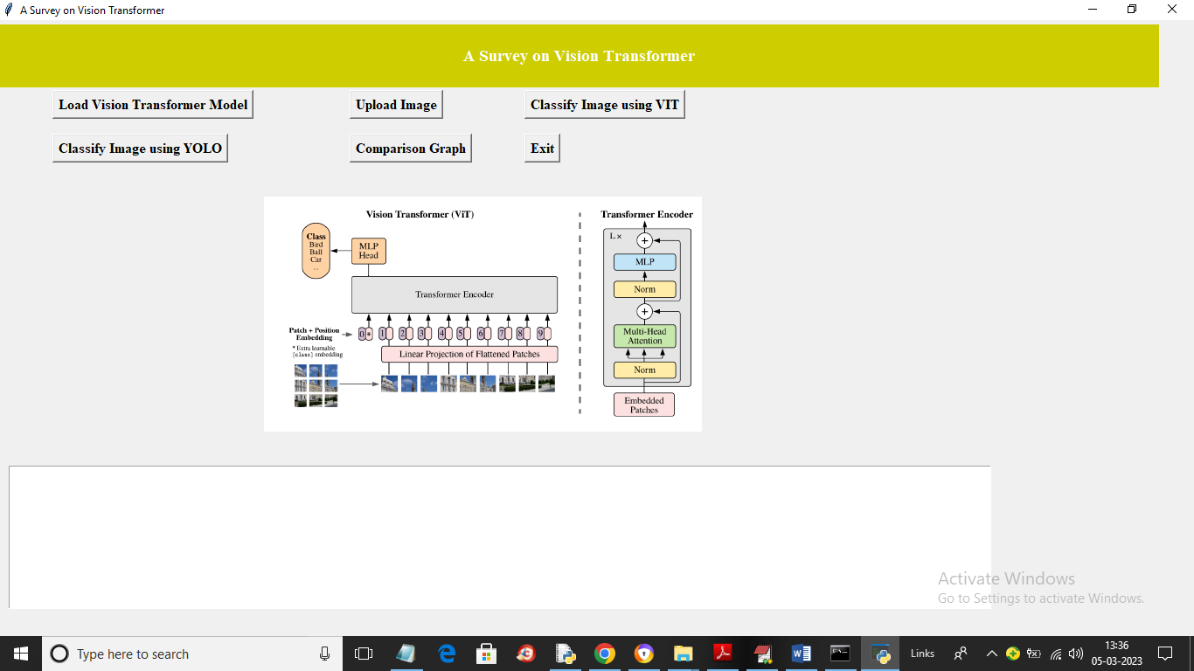
In above screen click on ‘Load Vision Transformer Model’ button to load VIT and YOLO Models and get below output
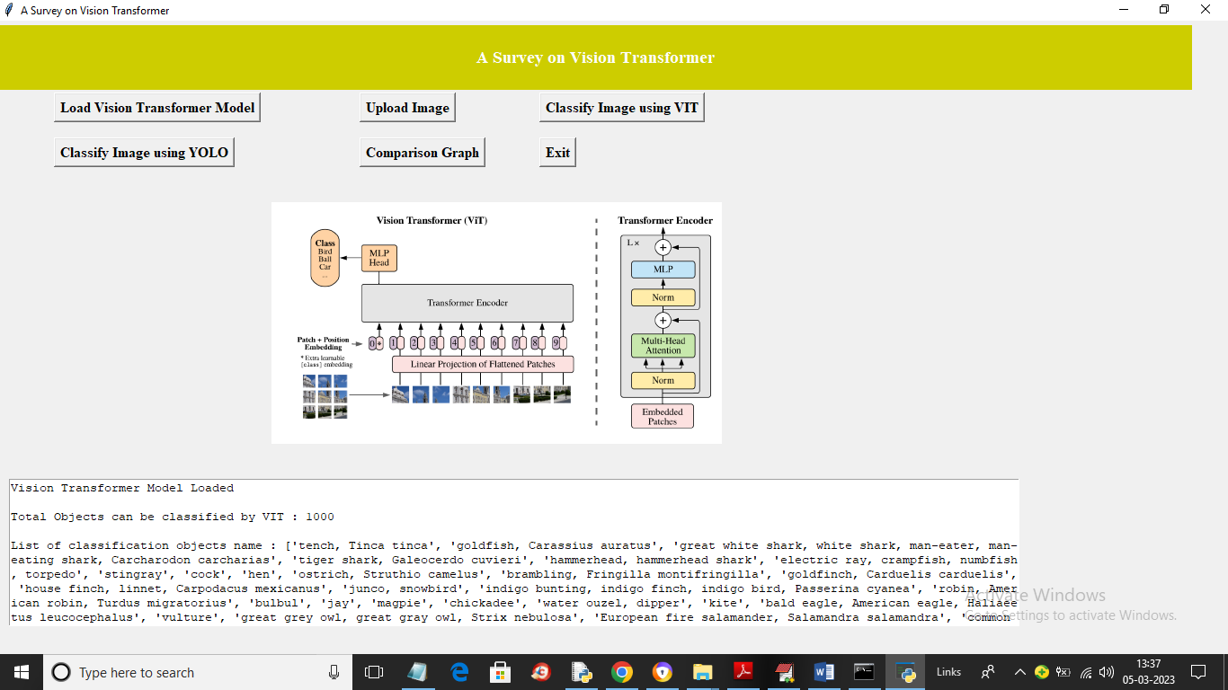
In above screen we can see both models loaded and in text area we can see names of classes which can classifiy by both models. Now click on ‘Upload Image’ button to load image and get below output
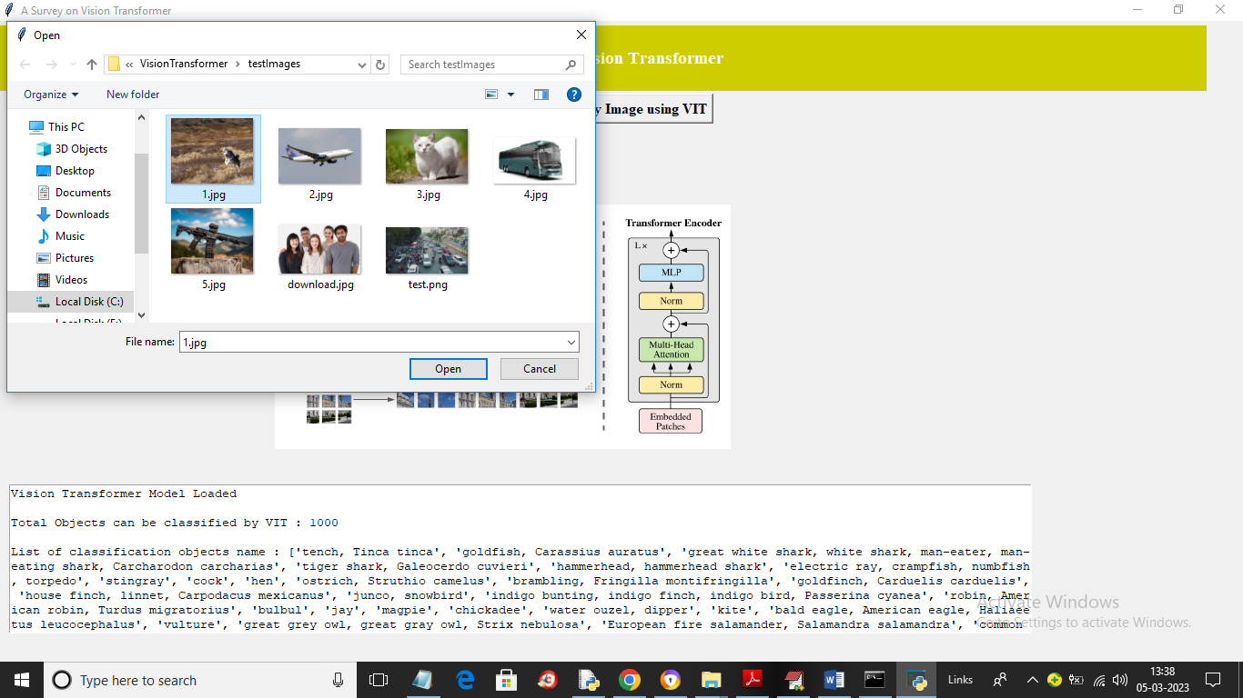
In above screen selecting and uplaoding ‘1.jpg’ file and then click on open button to load image and then click on ‘Classify Image using VIT’ to get below output
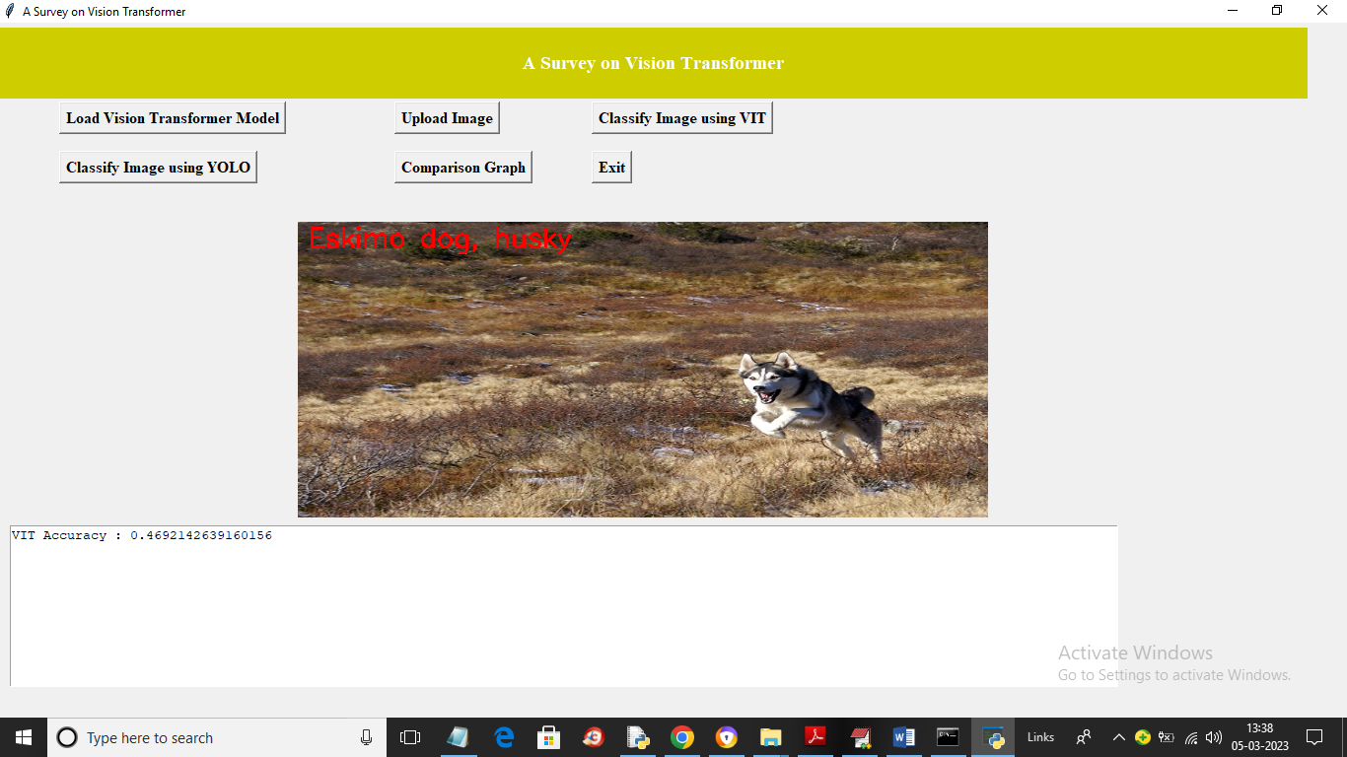
In above screen VIT detected image object as DOG and also showing type of dog and in text area we can see VIT detection accuracy as 0.44% and now click on ‘Clasify Image using YOLO’ button to get below output
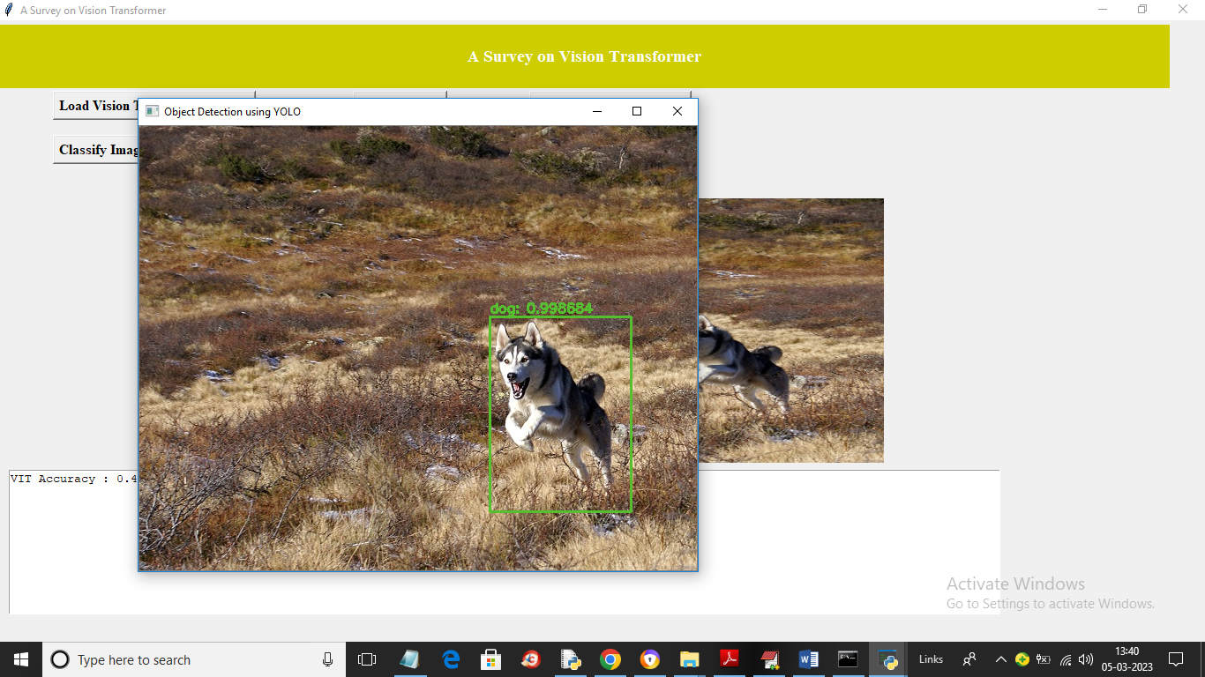
In above screen yolo classify detected object as ‘Dog’ but not type of object and now click on ‘Comparison Graph’ button to get below graph
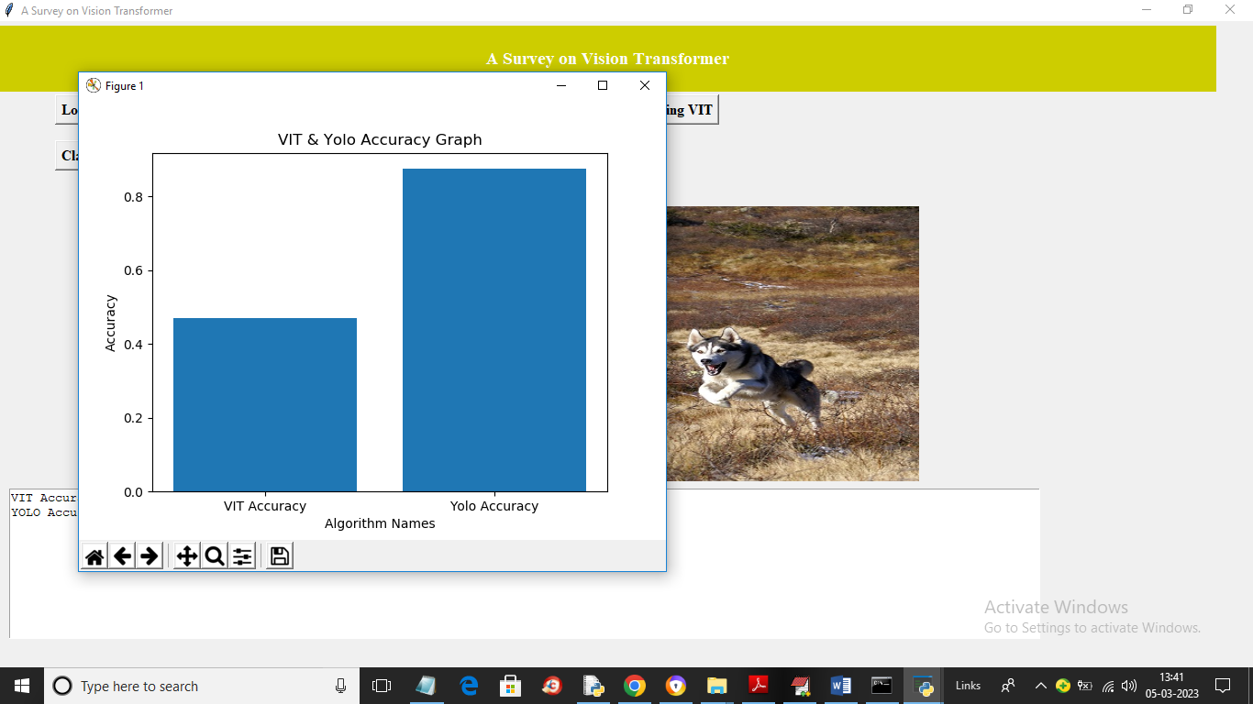
In above screen x-axis represnets algorithm names an y-axis represents accuracy and in both algorithms YOLO got high accuracy but its not classifying type and VIT classifying type but accuracy is less. So one algortihm is having some advantages and dissadvantages over other algorithm and in this paper author is giving such survey on all algorithms and in below screen we are testing another image
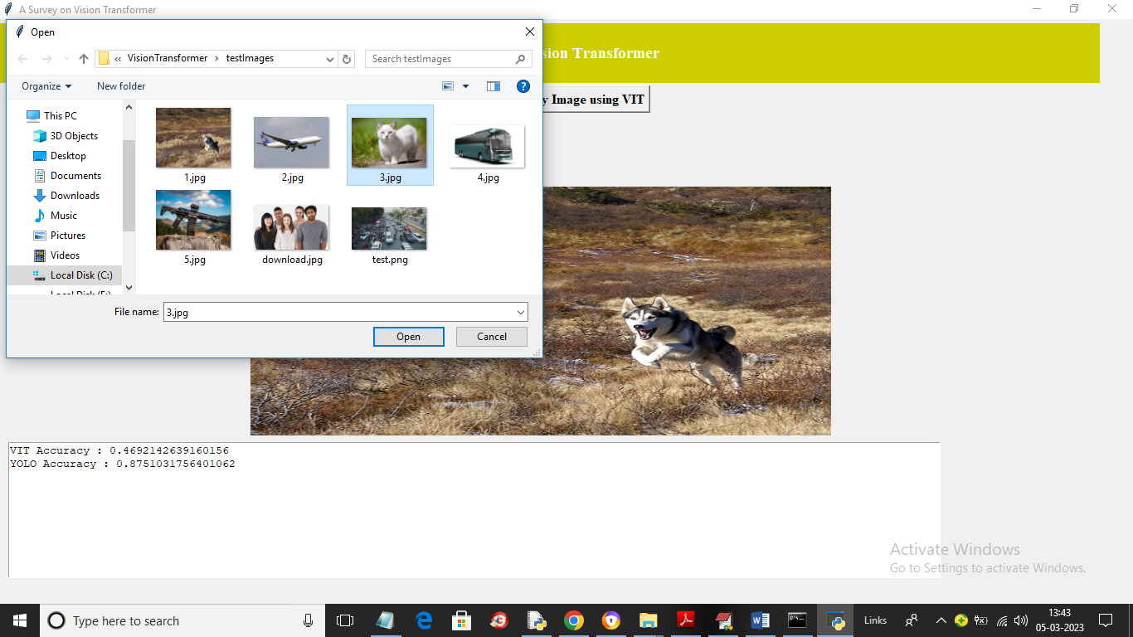
In above screen uploading another image as 3.jpg and below is the output
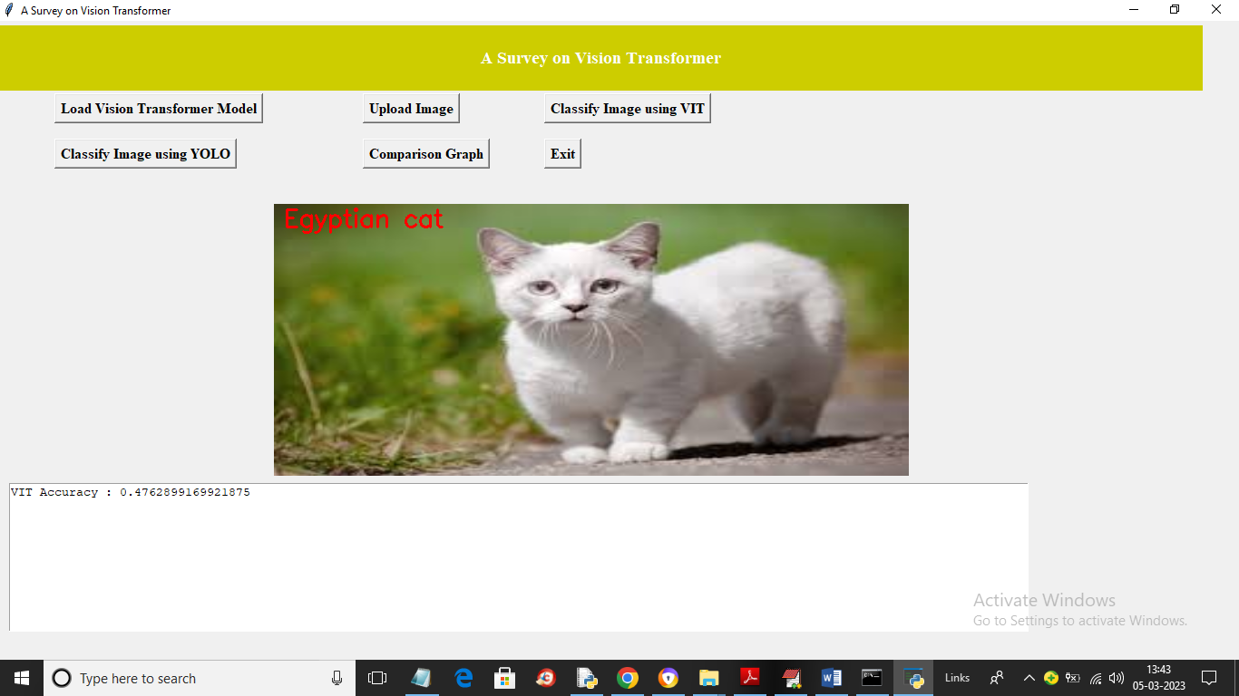
In above screen we got VIT classified output as ‘Egyptian Cat’ and now run YOLO button to get below output
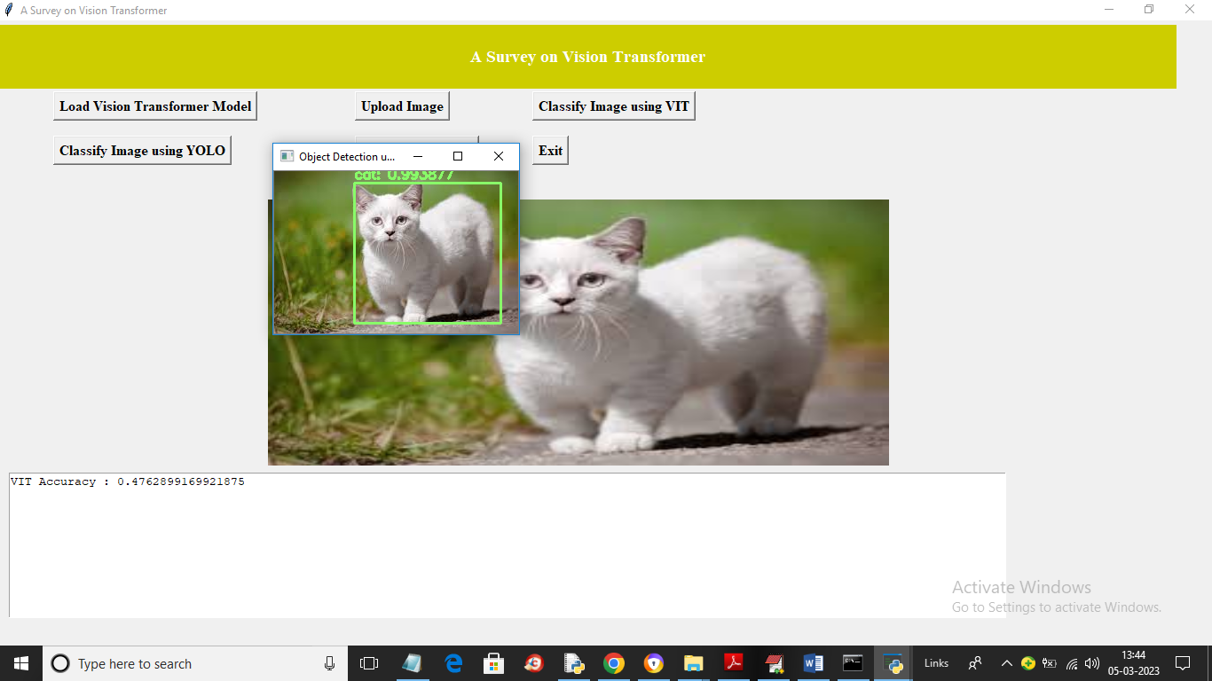
In above screen in second image YOLO detected object as ‘Cat’ only. Similarly you can uplaod and test other images

