**INDEX:**

**>>****Video(homepage)**

**>>****Milestones & Achievements**

**>>****Photo gallery**

**>>****Environmental Monitoring**

**>>Tidal PDF**

**>>Volumes handled**

**>>****Operating procedures**

**>>****Current vessels**

**>>****Expected vessels**

**>>****Organizational Chart**

**>>****Annual Report PDF**

**>>****Current openings**

**>>****Applications for jobs**

# 

# To update the video in home page:

Follow the navigation,

vspl(folder) >> video(folder) >>Final.mp4

Then replace the existing video by saving the new one with the same name.

# To change the video type/format:

Inorder to change the video format(if uploaded a new video other than mp4 format),please do follow the navigations

vspl(folder) >>navbar (a “.html” extension file which has to be opened with some text editor)

In the above mentioned file, find the highlighted area in the below screenshot and change the ‘**type**’ and ‘**src**’ attributes of “**source**” tag. ( Note: In “src” , video specifies the folder name where we uploaded the video).

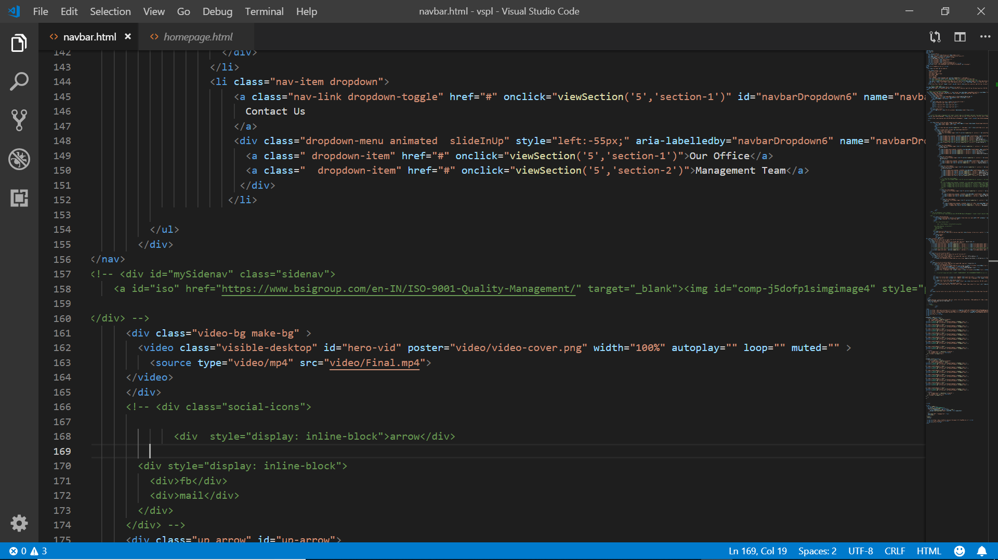

**Note: ‘poster’** attribute in the **“video”** tag indicates the image that will be displayed while the video is being loaded. So it is advisable to change the **‘poster’** also, when ever the video is changed.

**To change the poster:**

vspl(folder) >> video(folder)

Find **‘video-cover.png’** and replace that with the new image.

# To update the “Milestones & Achievements” in home page:

Follow the navigation,

vspl>> homepage.html(a “.html” extension file which has to be opened with some text editor)

* To **add new achievements, to be displayed along with the existing one’s**

Find the highlighted area in the **below** screenshot >> copy that >> paste that in the next line(that is after line:80 according to reference image)>> and then change the **“h6”** and **“p”** tags accordingly.

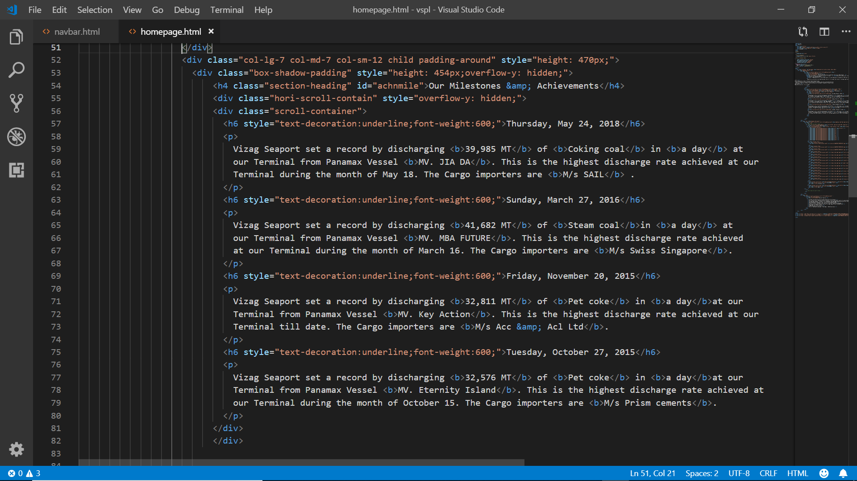

# To add photos in “Photo Gallery” of home page:

The photos that are currently being displayed in home page are available in the folder named “KAARTHIK PHOTOS” of “vspl pics” folder.

vspl >> vspl pics >> KAARTHIK PHOTOS.

Inorder to add new photos or replace the photos, do follow these steps,

* Open homepage.html

vspl >> homepage(a “.html” extension file which has to be opened with some text-editor).

* To **add new photos in place of existing one’s**

Find the highlighted area in the below screenshot and change the ‘**src**’ attribute of “**img**” tag.

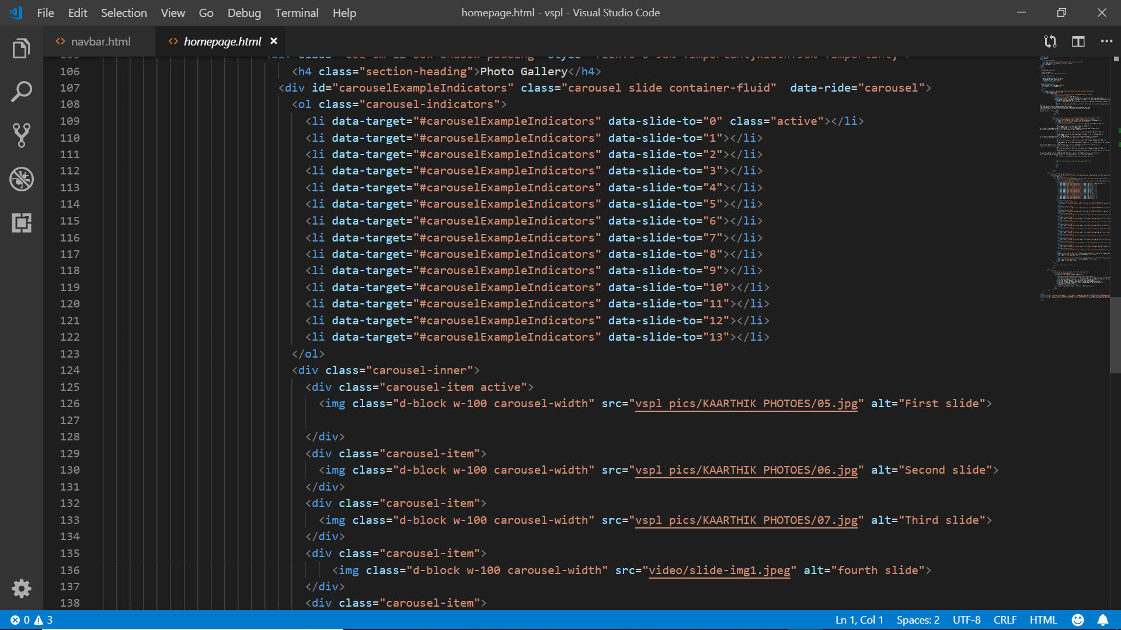

* To **add new photos to be displayed along with the existing one’s**

Find the highlighted area in the **below** screenshot >> copy that >> paste that in the next line >> and then change the **‘src’** of **‘img’** tag accordingly.



**Note**: The **‘active’** keyword highlighted in the below screenshot, is required to play slideshow. So, do not remove it.

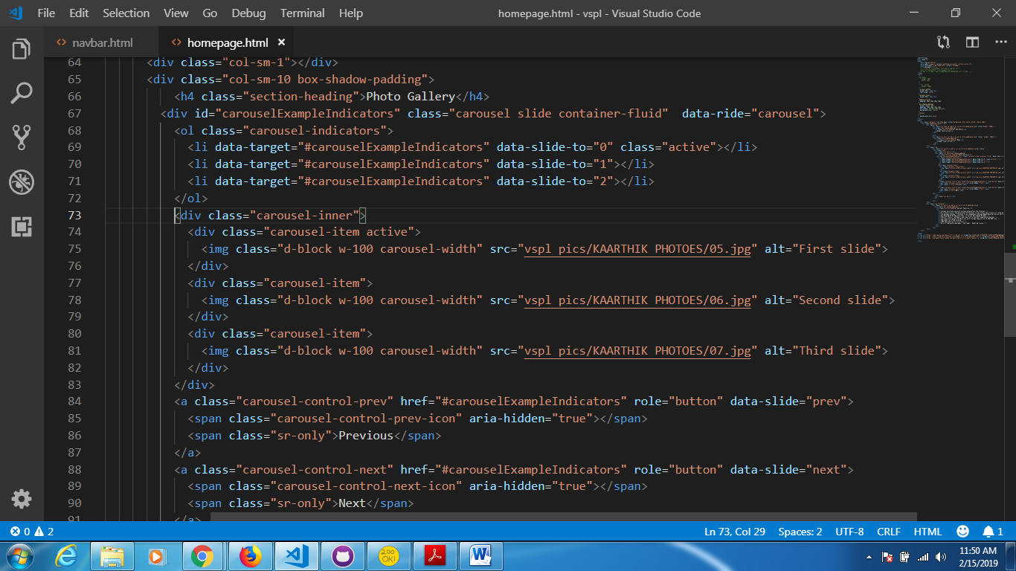

# To update ‘Environmental monitoring’ data in COMPANY:

The photos that are currently being displayed are available in the folder named “video”.

vspl >> video >>**emr.png, emr1.JPG, em2. JPG**

Inorder to add new photos and replace the existing photos, do follow these steps,

* Open navbar.html

vspl >> navbar (a “.html” extension file which has to be opened with some text-editor).

* To **add new photo in place of existing one**

Find the highlighted area in the below screenshot and change the ‘**src**’ attribute of “**img**” tags(as per requirement).

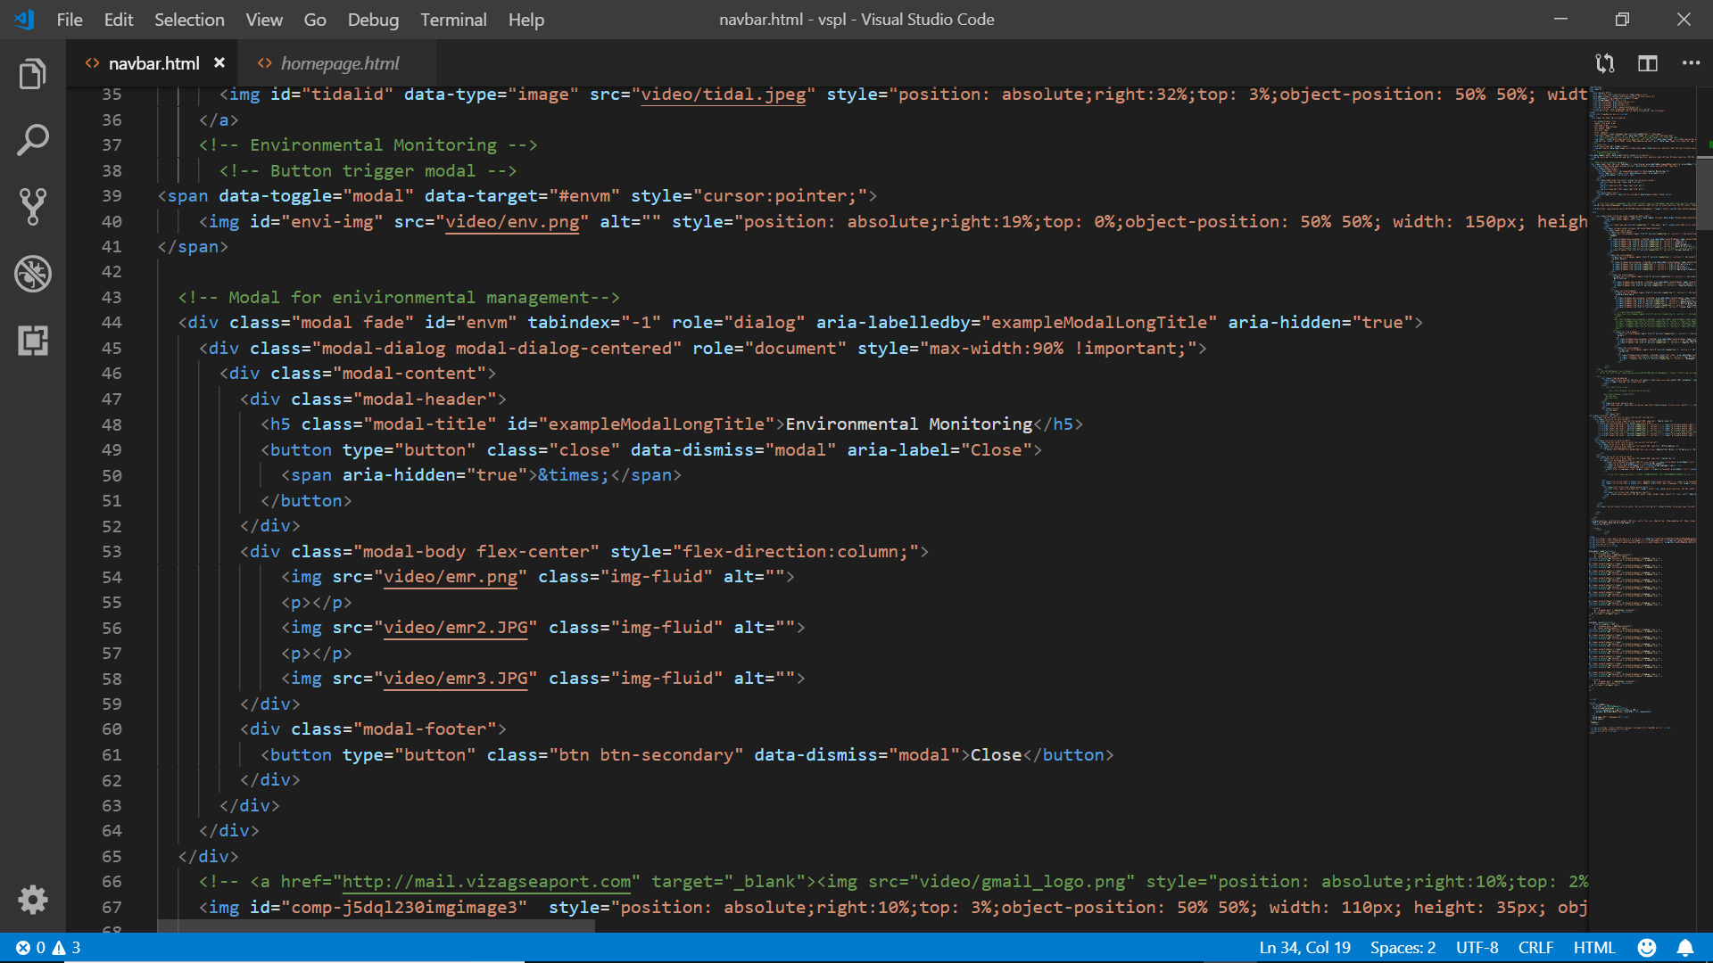

# To update ‘Tidal” PDF:

Follow the navigation,

vspl >> docs >> Tidal.pdf

and replace the existing pdf by saving the new one with the same name.

# To update ‘Volumes handled’ data in COMPANY:

The photo that is currently being displayed is available in the folder named “video”.

vspl >> video >>volumes_handled.png.

Inorder to add new photo and replace the existing photo, do follow these steps,

* Open vspl_company.html

vspl >> vspl_company(a “.html” extension file which has to be opened with some text-editor).

* To **add new photo in place of existing one**

Find the highlighted area in the below screenshot and change the ‘**src**’ attribute of “**img**” tag.

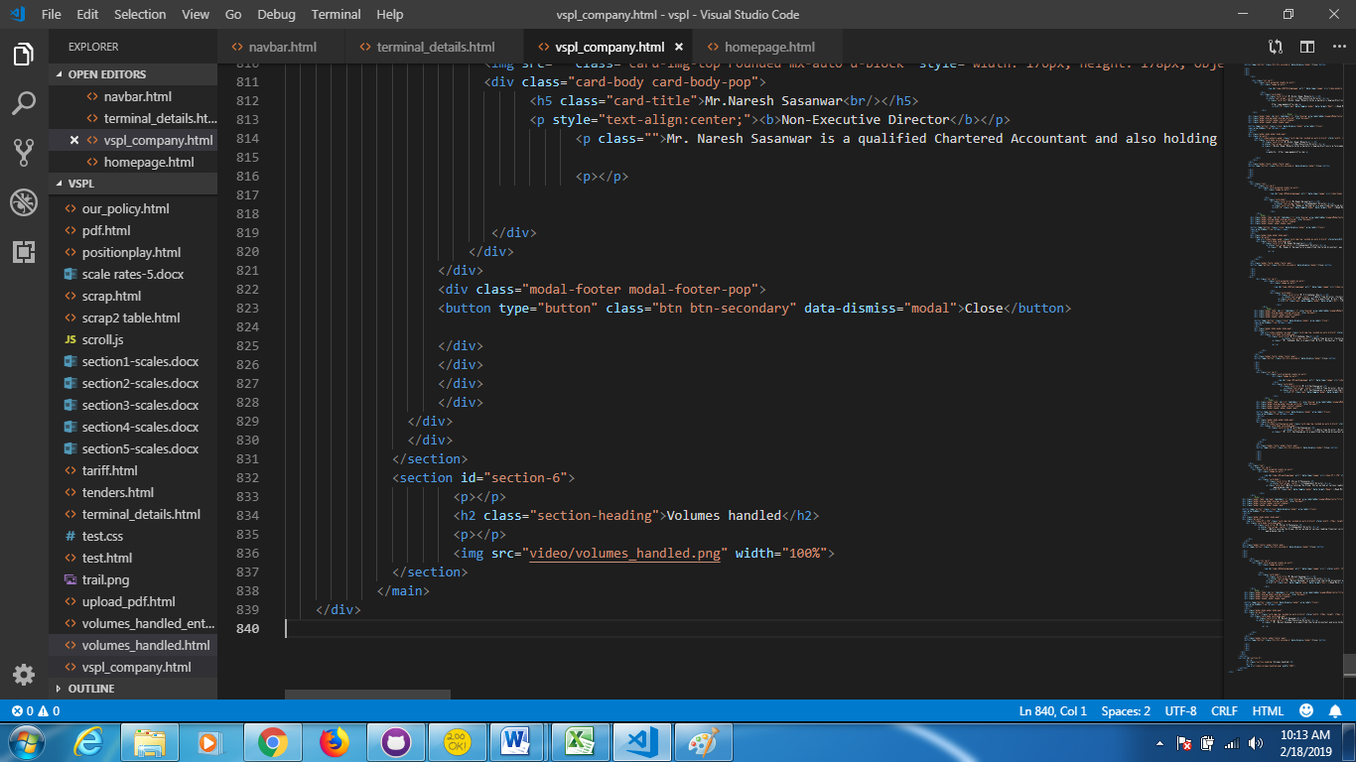

# To upload ‘Operating Procedures’ pdf in INFRASTRUCTURE:

Follow the navigation,

vspl >> docs >> VSPL-operating procedures.pdf

and replace the existing pdf by saving the new one with the same name.

# To update ‘Current Vessels’ data in BERTH POSITION:

Inorder to edit Current Vessels data,

* Visit the portal specified by the following URL,

<http://171.171.168.24:8080/jw/web/userview/vspl_website/admin_userview/_/curr_list>

* Tap on the **‘Add New’** button provided at top-left and bottom-left of list, to add new Vessel data.

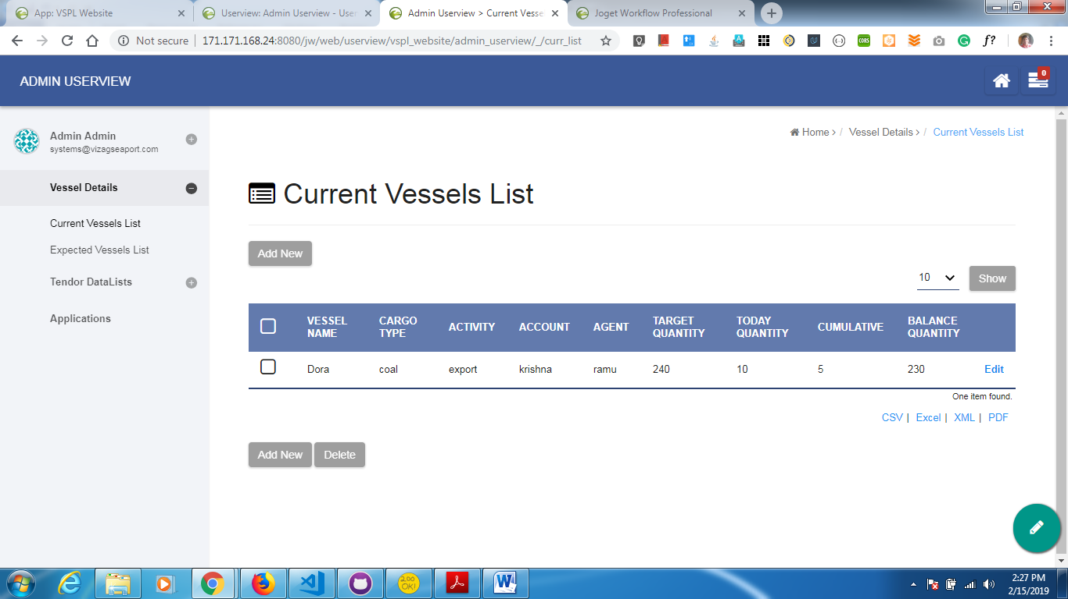

* Tap on the **‘Edit’** link corresponding to each vessel inorder to edit Vessel data.



* Inorder to show only the current vessels and delete the details regarding the vessels left, a delete button is also provided at the bottom-left of list as shown in image.



# To update ‘Expected Vessels’ data in BERTH POSITION:

Inorder to edit Current Vessels data,

* Visit the portal specified by the following URL,

<http://171.171.168.24:8080/jw/web/userview/vspl_website/admin_userview/_/exp_list>

* Tap on the **‘Add New’** button provided at top-left and bottom-left of list, to add new

Vessel data.

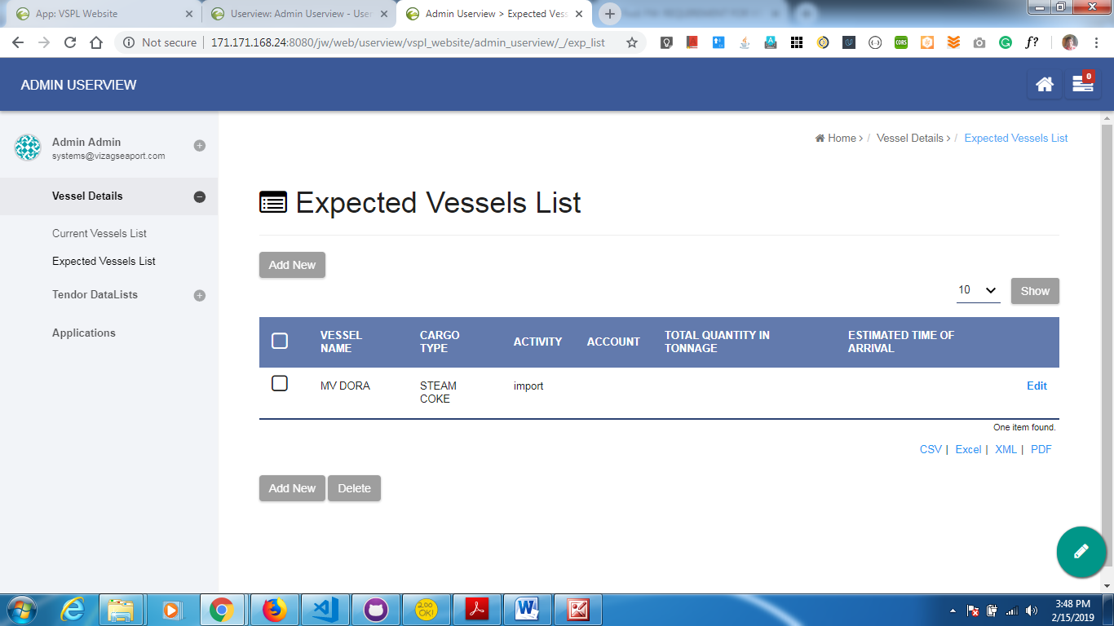

* Tap on the **‘Edit’** link corresponding to each vessel inorder to edit Vessel data.



* Inorder to show the updated data, a delete button is also provided at the bottom-left of list as shown in image.



# To update “Organizational Chart” PDF:

The photo that is currently being displayed is available in the folder named “video”.

vspl >> video >>org_chart.jpeg

Inorder to add new photo and replace the existing photo, do follow these steps,

* Open contact_us.html

vspl >> contact_us (a “.html” extension file which has to be opened with some text-editor).

* To **add new photo in place of existing one**

Find the highlighted area in the below screenshot and change the ‘**src**’ attribute of “**img**” tag.

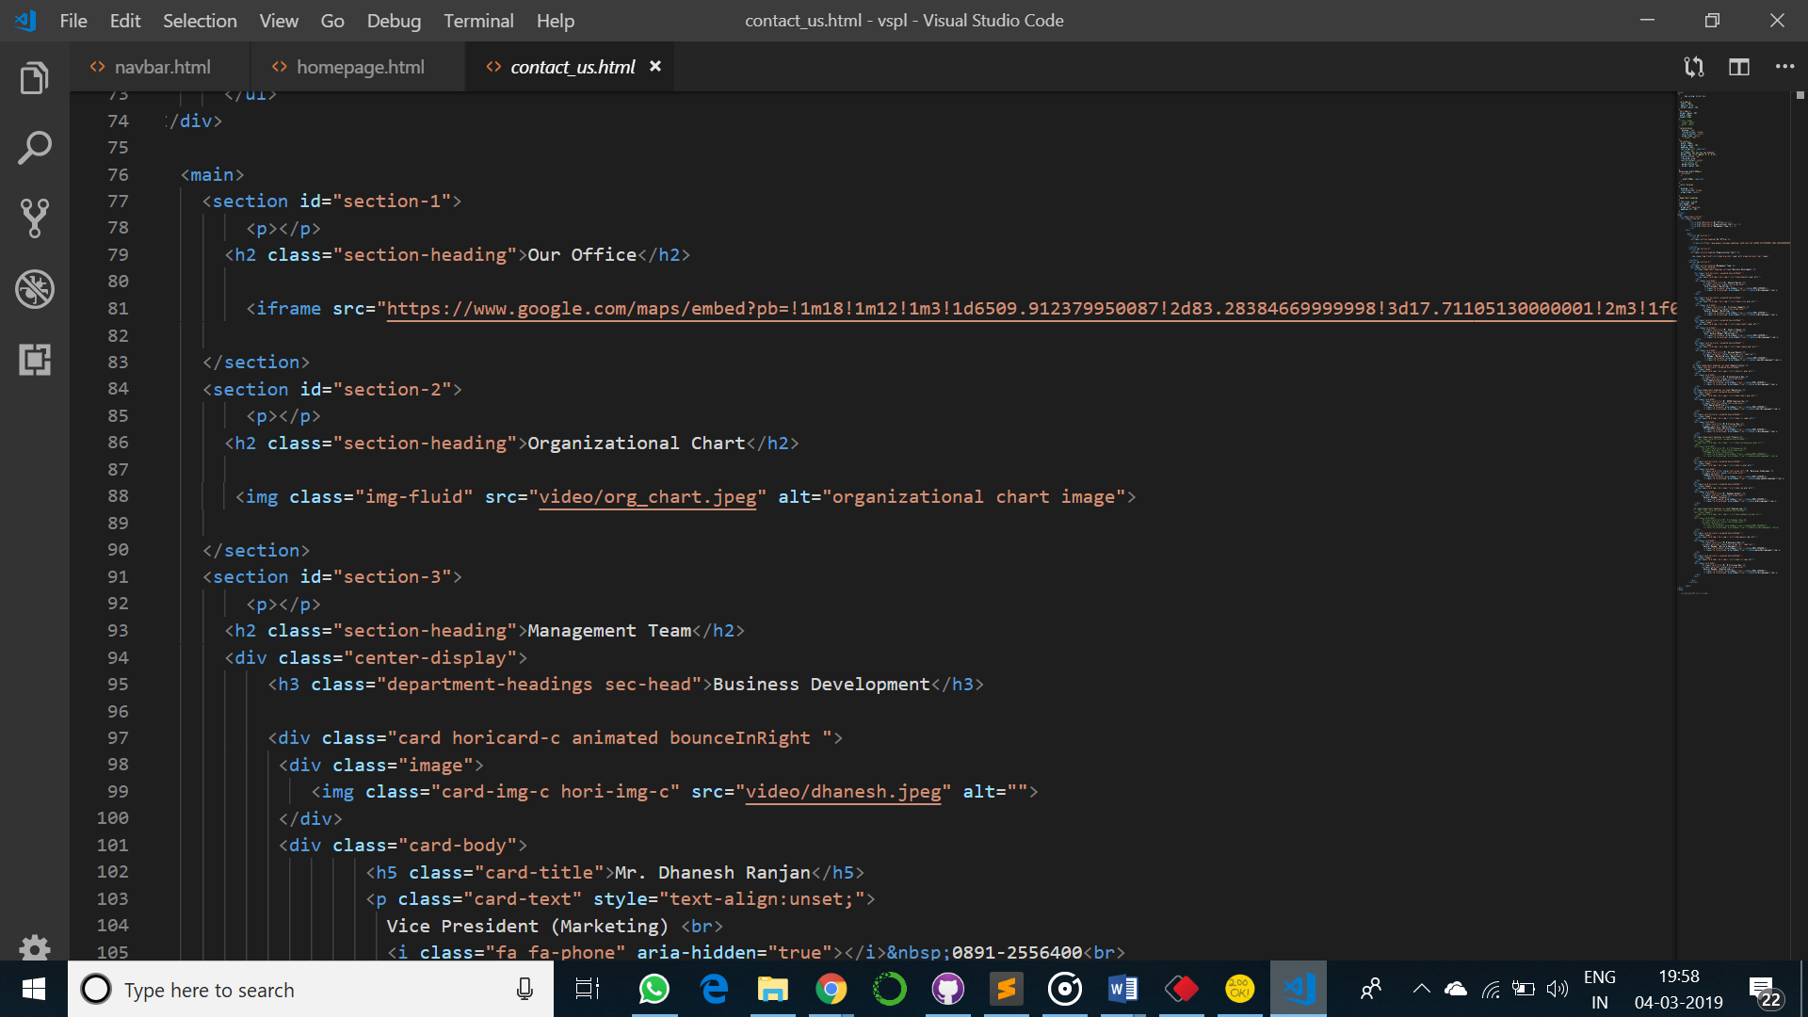

# To update “Annual Reports” PDF:

Follow the navigation,

vspl >> docs >>annual-report.pdf

and replace the existing pdf by saving the new one with the same name.

# To update ‘Current Openings’ in CAREERS:

Inorder to edit Current Openings data,

* Visit the portal specified by the following URL,

<http://171.171.168.24:8080/jw/web/userview/vspl_website/admin_userview/_/curr_open>

* Tap on the **‘Add New’** button provided at top-left and bottom-left of list, to add new data. 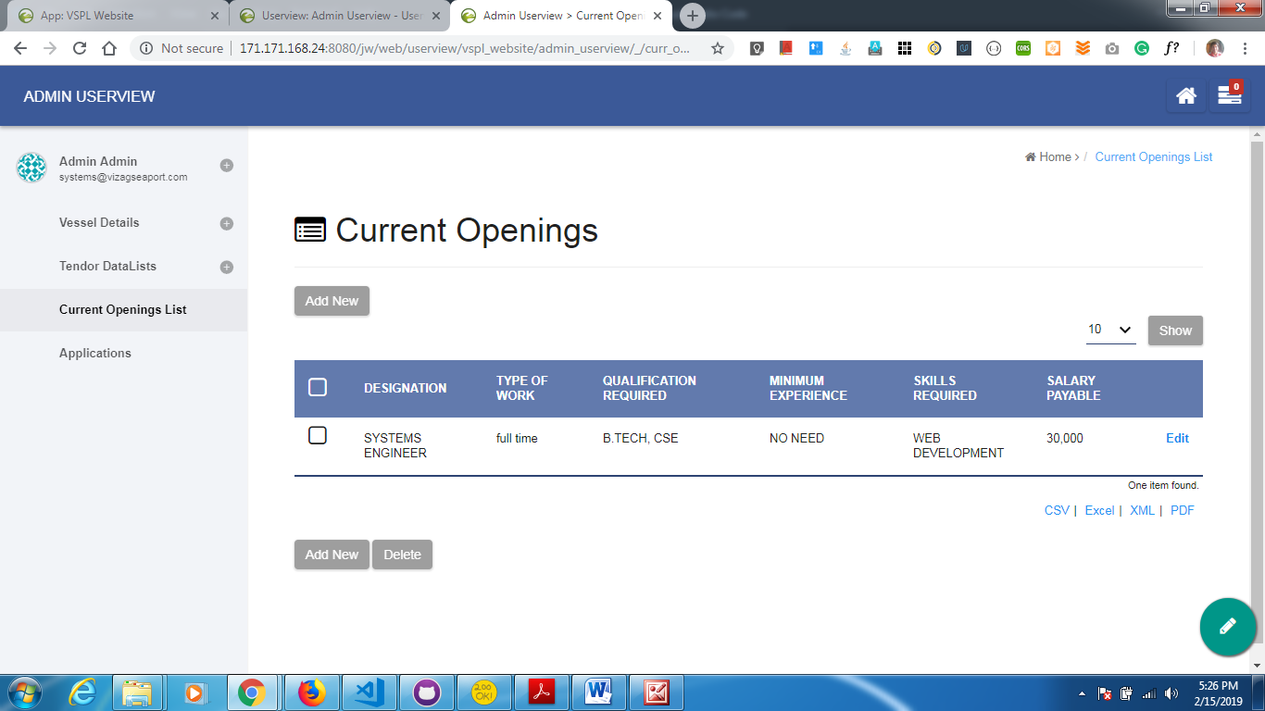
* Tap on the **‘Edit’** link corresponding to each row, inorder to edit the data.



* Inorder to show the updated data, a delete button is also provided at the bottom-left of list as shown in image.



# 

# To check JOB APPLICANTS data:

Inorder to check Job Applicants data,

* Visit the portal specified by the following URL,

<http://171.171.168.24:8080/jw/web/userview/vspl_website/admin_userview/>

* Tap on the Applications provided in the side navbar, which displays the list of applicant details as shown in the following screenshot.

