**COSC6364 - ADVANCED NUMERICAL ANALYSIS**

**SIGNAL RECONSTRUCTION FROM NON-UNIFORM FREQUENCY SAMPLING**

**PROJECT REPORT**

**Team AKS**

Anirudh Kalva - 2288613 - akalva@cougarnet.uh.edu

Venkata Kausik Renduchintala - 2260419 - vrenduch@cougarnet.uh.edu

Srilekha Rayedi - 2287597 - srayedi@cougarnet.uh.edu

# 

# 

# 

**Table Of Contents**

# 

**Abstract 3**

**Introduction 4**

**Methodology 5**

**Implementation 6**

**Results and Evaluations 8**

**Conclusion 17**

**Future Scope 18**

**References 19**

# 

# 

# 

# 

# Abstract

In the realm of signal processing, the challenge of reconstructing signals from incomplete frequency information has emerged as a critical obstacle in numerous practical applications. Traditional methodologies often assume access to the full frequency spectrum, yet real-world constraints such as data acquisition limitations or resource scarcity frequently render this assumption untenable. This disparity underscores the pressing need for innovative approaches capable of reconstructing signals from non-uniform frequency sampling. In response, this project endeavors to employ robust techniques such as Inverse Non-uniform Fourier transform and Frequency domain interpolation tailored to efficiently utilize partial frequency data, thereby addressing the demand for accurate signal reconstruction in the era of big data and advanced signal processing and offering a pathway towards overcoming the limitations imposed by incomplete frequency information.

# Introduction

Signal reconstruction from sample values is a significant aspect of signal processing. Uniform sampling, the widely recognized method, involves obtaining samples of continuous-time signals at evenly spaced time intervals. Provided certain conditions are met, it's possible to recover the original continuous-time signal from these samples. However, a limitation of uniform sampling is its requirement for samples to adhere to a uniform grid.

Non-uniform sampling, on the other hand, extends beyond this constraint, allowing samples to be obtained at irregular intervals. Yet, reconstructing signals from non-uniform samples presents challenges due to the lack of a uniform grid structure, making it difficult to employ time-invariant processes for reconstruction. Generally, achieving perfect signal recovery from samples taken at arbitrary time intervals is arduous. Existing methods for reconstructing signals from non-uniform samples typically rely on inherent structural properties within the sampling process to facilitate continuous-time signal recovery.

Non-uniform sampling is essential across various applications, including biomedical devices like wearable heartbeat detectors. These devices utilize self-timed circuits to eliminate the need for power-consuming clock buffers but can introduce jitter into signal processing. Accurate reconstruction of signals, such as electrocardiogram (ECG) signals, from jittered samples is crucial for minimizing false alarms and missed detections of cardiac arrhythmias, enhancing device reliability in clinical settings.

It is also vital in applications, such as time-interleaved analog-to-digital converters (TI-ADCs) and sensor networks. In TI-ADCs, where multiple channels sample a signal, asynchronous clock phases lead to non-uniform sampling. Similarly, sensor networks, with sensors sampling asynchronously, also exhibit non-uniform sampling patterns. This underscores the importance of non-uniform sampling in signal processing and data acquisition across different technological domains.

Non-uniform sampling extends beyond time and appears in spatial and frequency domains. For example, antenna arrays or towed acoustic arrays often incorporate non-uniform element spacing to balance array length and the number of elements. Arrays may intentionally use non-uniform spacing, like logarithmic intervals, or due to element failures in uniformly spaced arrays, resulting in single missing sample instances.

Another application involves adapting sampling based on time-varying signal parameters. Signals with fluctuating local bandwidths benefit from sampling strategies that align with these variations, leading to more efficient signal representation and reduced overall sampling rates.

# Methodology

**Inverse Non-uniform Fourier Transform (INUFT)**:

The Inverse Non-uniform Fourier Transform (INUFT) is a mathematical technique used to reconstruct a signal from its non-uniformly sampled frequency domain. In traditional Fourier analysis, signals are typically assumed to be uniformly sampled in the frequency domain. However, in real-world scenarios, frequency samples may be irregularly spaced due to various factors such as limitations in data acquisition or processing resources.

INUFT addresses this challenge by directly reconstructing the original signal from the available non-uniform frequency samples. This process often involves employing iterative algorithms or compressed sensing techniques.

Iterative algorithms iteratively refine an initial estimate of the signal based on the observed frequency samples, gradually improving the reconstruction accuracy.

Compressed sensing techniques exploit the sparsity or compressibility of the signal in a suitable domain to recover the signal from a limited number of non-uniform frequency measurements.

**Frequency Domain Interpolation (FDI)**:

Frequency Domain Interpolation (FDI) is a technique used to reconstruct a signal by interpolating the missing frequency coefficients. In scenarios where only a subset of frequency coefficients is available, FDI fills in the gaps to reconstruct the complete signal spectrum.

Two interpolation methods are employed in FDI to accurately estimate the missing frequency coefficients. These methods include linear interpolation and polynomial interpolation.

**Linear Interpolation** is a straightforward approach to estimating missing values between two known data points. In the frequency domain, this method can be effectively used when the distance between known points is not too large, thus making a linear assumption reasonable.

In FDI, **Polynomial Interpolation** can be used to estimate missing frequency coefficients by fitting a polynomial function to the available frequency data points. The advantage of polynomial interpolation is its flexibility in capturing the shape of the frequency spectrum, especially when the relationship between frequency coefficients is non-linear.

# Implementation

**Frequency Domain Interpolation Techniques**

**Linear Interpolation**

* The code utilizes the interp1d function from the scipy.interpolate library, which is configured to perform linear interpolation.
* For each frequency bin (a set of points along the frequency axis of the Short-Time Fourier Transform (STFT) matrix), known values are identified, and the interp1d function is used to create an interpolation function.
* This function is then used to estimate the missing frequency components across the entire bin.
* The interpolation function is set to "extrapolate" for frequencies outside the range of known data points, ensuring that all values in the frequency bin are estimated.

**Polynomial Interpolation**

* A polynomial of a given degree (specified as an input parameter, default is 3) is fitted to the known data points in each frequency bin using the np.polyfit function.
* The coefficients returned by np.polyfit are used with np.polyval to evaluate the polynomial across the entire frequency bin, thus providing estimates for both known and missing points.
* The degree of the polynomial is a critical parameter: a higher degree allows fitting more complex data variations but can lead to overfitting if too many degrees are used for sparse data.

**Inverse Non-Uniform Fourier Transform:**

* The INUFT function encapsulates the Inverse Non-Uniform Fourier Transform (INUFT) process. Within this function, random points ω within the interval [−𝜋,𝜋] are generated to represent non-uniformly sampled frequencies.
* Let 𝑀 denote the number of these sampled points, which is determined based on a specified sampling rate.
* An NUFFT object is initialized, and the plan method sets up the NUFFT operation with the generated points and other parameters. Mathematically, the forward NUFFT operation computes the NUFFT matrix 𝐹 and applies it to the input signal 𝑥 to obtain the non-uniformly sampled frequency components 𝑦 =𝐹(𝑥)

This operation is represented as:



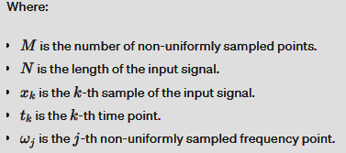

* After computing the forward NUFFT, the adjoint NUFFT operation is applied to reconstruct the signal from the non-uniformly sampled frequency components 𝑦, aiming to approximate the original signal 𝑥=𝐹Ty. This involves the transpose of the NUFFT matrix 𝐹𝑇, which performs the reverse process.
* Here the INUFT function integrates concepts from Fourier analysis, linear algebra, and numerical methods to efficiently handle non-uniformly sampled signals in the frequency domain, ultimately aiming to approximate the original input signal.

# 

# 

# 

# 

# Results and Evaluations

**Input 1:**

Comparison Of Generated Signal vs Original Signal from Linear and Polynomial Interpolation for sampling fraction 0.1

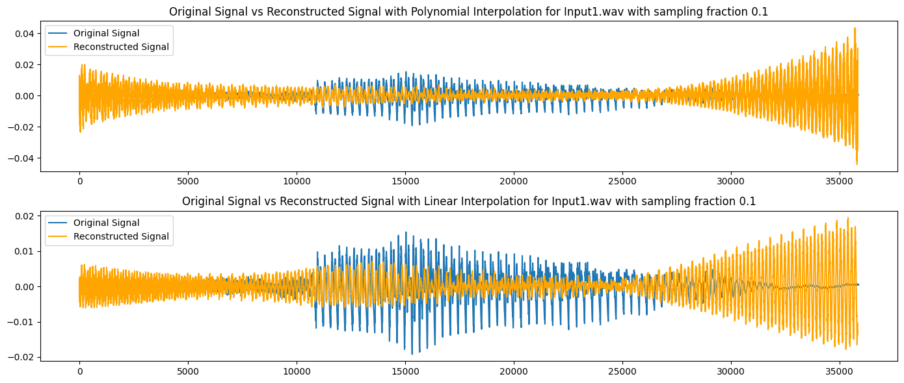

Comparison Of Generated Signal vs Original Signal from Linear and Polynomial Interpolation for sampling fraction 0.5

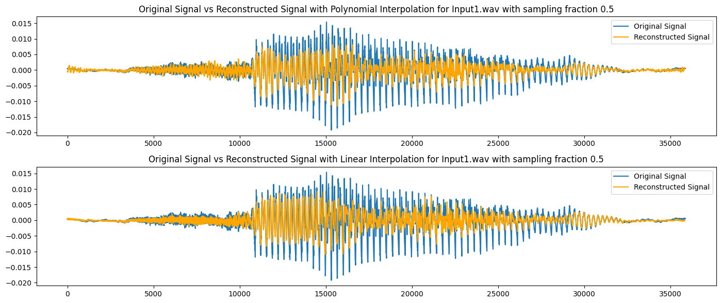

Comparison Of Generated Signal vs Original Signal from Linear and Polynomial Interpolation for sampling fraction 0.9

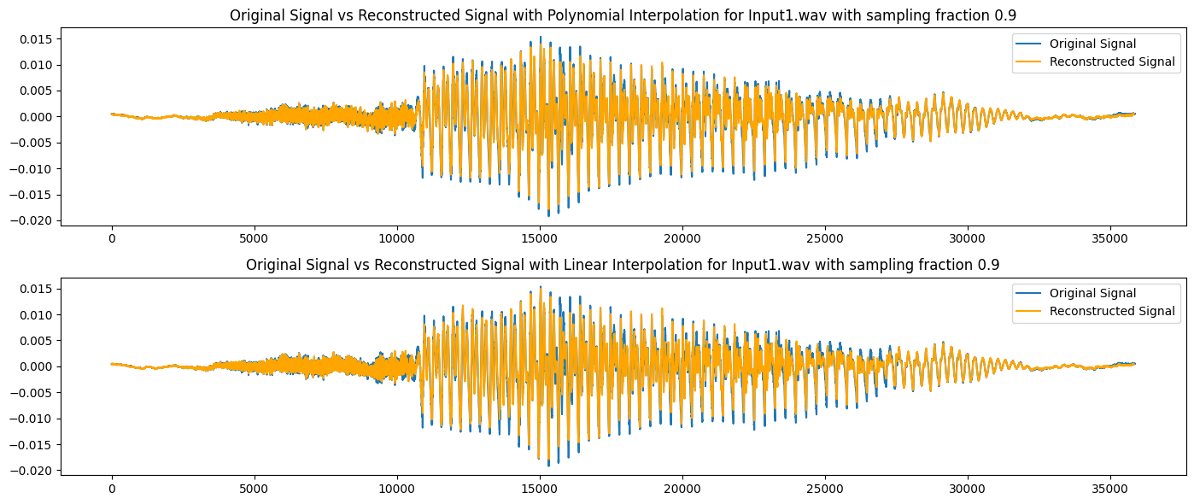

Comparison Of Generated Signal vs Original Signal from INUFFT

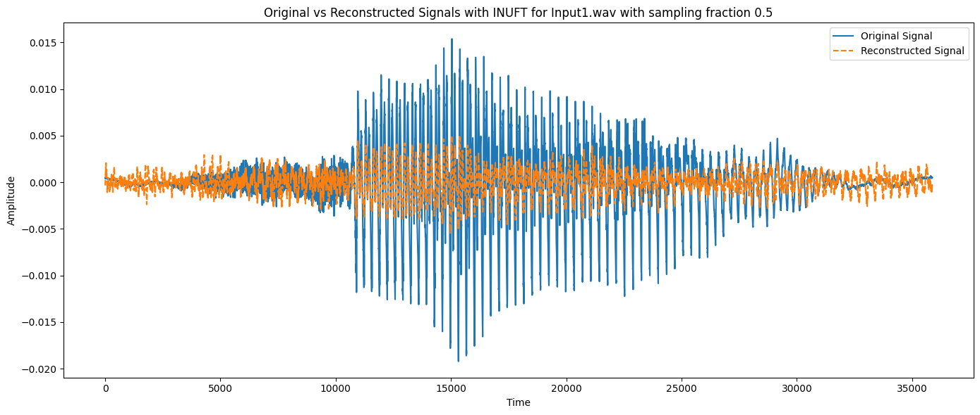

For a sampling fraction of 0.5, the reconstructed signal via INUFT shows more substantial deviations from the original signal than the polynomial and linear interpolations, especially in the middle segment. This may indicate that INUFT is sensitive to the specific non-uniform sampling of frequency components in this case.

The reconstructed signal via polynomial interpolation and linear interpolation closely follows the original signal, indicating a good reconstruction. There are slight differences between the two, which could be due to the inherent estimation errors in the interpolation process as a result of fewer frequency components available for interpolation due to non-uniform sampling.

From the comparison between the reconstructed and original signal for Input1.wav with a sampling fraction of 0.5, polynomial interpolation seems to provide the highest fidelity in reconstructing the original signal, followed by linear interpolation. INUFT appears to be less accurate visually, which is unexpected as INUFT is generally a robust method for such tasks.

The following plots depict the reconstructed signal vs the original signal for two other input signals obtained from the AudioMNIST dataset.

**Input 2:**

Comparison Of Generated Signal vs Original Signal from Linear and Polynomial Interpolation for sampling fraction 0.5

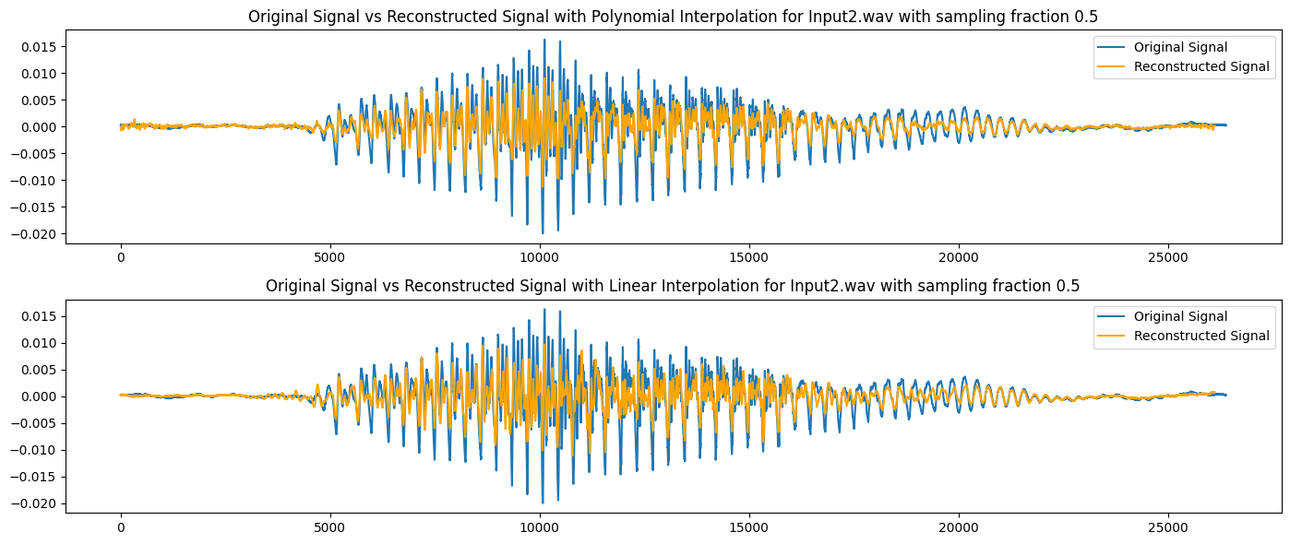

Comparison Of Generated Signal vs Original Signal from INUFFT.

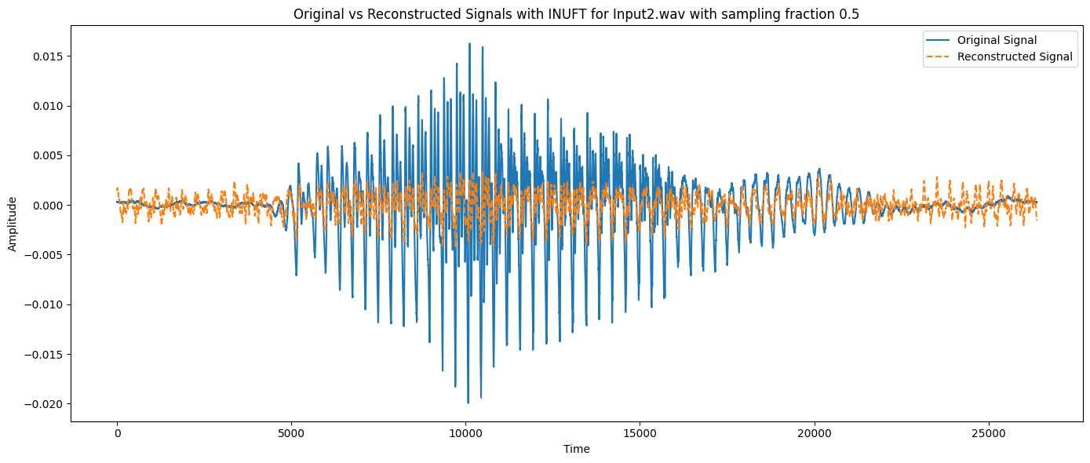

**Input 3:**

Comparison Of Generated Signal vs Original Signal from Linear and Polynomial Interpolation for sampling fraction 0.5

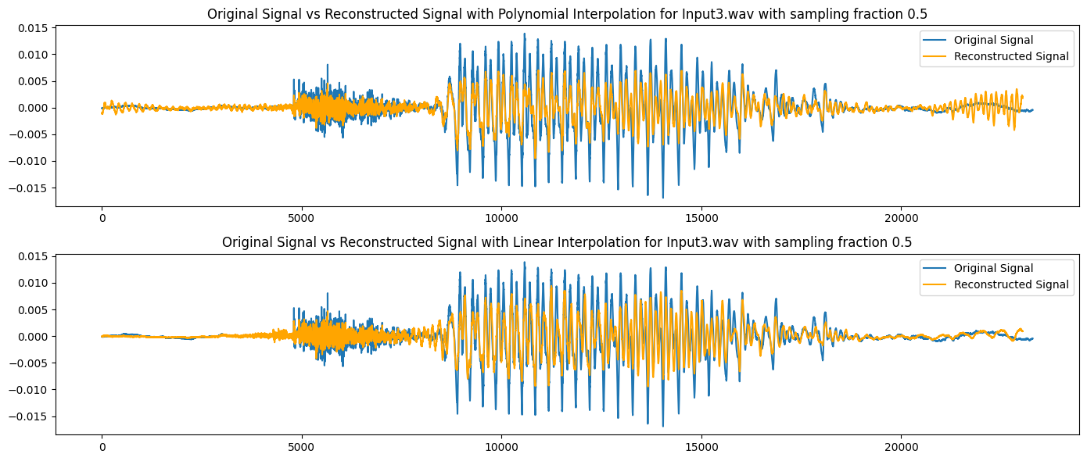

Comparison Of Generated Signal vs Original Signal from INUFFT

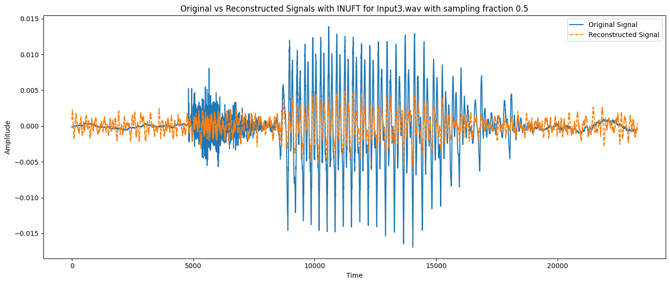

**Metrics comparisons of the 3 inputs**

Table 1. Comparison of MSE, MIE, and PSNR between three input signals for Input1.wav

| **Reconstruction method** | **Linear Interpolation** | **Polynomial Interpolation** | **INUFT** |
| --- | --- | --- | --- |
| **MSE** | 7.862888666828076e-06 | 5.482914510450367e-06 | 8.308897122333292e-06 |
| **MIE** | 0.0017418116437068695 | 0.0015119950361626308 | 0.0019443848868831992 |
| **PSNR** | 14.783790765771982 | 16.349497285506743 | 14.544178247451782 |

Table 2. Comparison of MSE, MIE, and PSNR between three input signals for Input2.wav

| **Reconstruction method** | **Linear Interpolation** | **Polynomial Interpolation** | **INUFT** |
| --- | --- | --- | --- |
| **MSE** | 5.8486579323792165e-06 | 3.783392101431158e-06 | 8.042242370720487e-06 |
| **MIE** | 0.0014788383428044 | 0.0012146602927138087 | 0.0018753529293462634 |
| **PSNR** | 16.554983263984223 | 18.44673195298933 | 15.171774625778198 |

Table 3. Comparison of MSE, MIE, and PSNR between three input signals for Input3.wav

| **Input Signal** | **Linear Interpolation** | **Polynomial Interpolation** | **INUFT** |
| --- | --- | --- | --- |
| **MSE** | 5.311278514050624e-06 | 4.959389272419649e-06 | 7.379819180641789e-06 |
| **MIE** | 0.0013756086856304384 | 0.0013924383086403754 | 0.001791803166270256 |
| **PSNR** | 15.599238477440807 | 15.89694725120063 | 14.170771837234497 |

The variation in results between different input signals provides some observations into the performance of the reconstruction methods under different signal characteristics.

**MSE:**

* Across all reconstruction methods, the MSE tends to vary depending on the complexity and characteristics of the input signal.
* For some input signals, such as Input2.wav, polynomial interpolation consistently achieves the lowest MSE, indicating better reconstruction accuracy.
* In contrast, for other input signals, like Input1.wav, the MSE values may differ, with linear interpolation sometimes performing better than INUFT.

**MIE:**

* Similar to MSE, the MIE varies between input signals and reconstruction methods.
* Input signals with different frequency distributions or amplitude variations may result in varying MIE values across different reconstruction methods.
* Polynomial interpolation generally maintains lower MIE values across all input signals, indicating better fidelity in reproducing the original signals.

**PSNR:**

* The PSNR values also exhibit variability between different input signals and reconstruction methods.
* Input signals with clearer, less noisy content may yield higher PSNR values across all reconstruction methods.
* Polynomial interpolation tends to consistently produce the highest PSNR values, indicating superior signal quality and less distortion compared to other methods.

Overallthe performance ranking of reconstruction methods may vary depending on the input signal characteristics.

While polynomial interpolation generally outperforms other methods in terms of MSE, MIE, and PSNR, the degree of improvement may vary across different input signals.

Linear interpolation and INUFT may exhibit more fluctuations in performance, depending on the specific features of the input signals, such as frequency content, amplitude variations, and noise levels.

**Metrics Plots For Input 1:**

Plot visualizing comparisons of Mean Squared Error vs the Sampling Fraction 0.5 for INUFFT, Linear interpolation, and polynomial interpolation

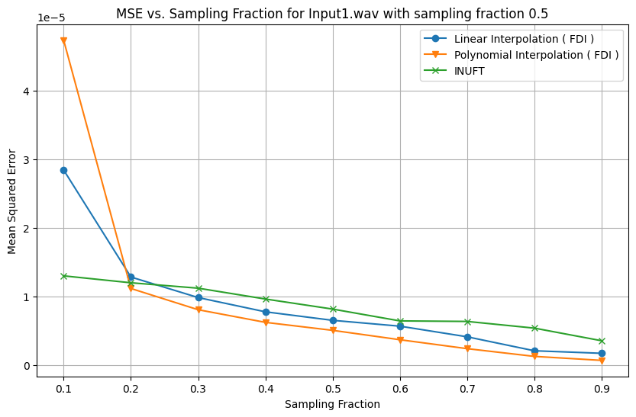

Plot visualizing comparisons of Mean Integral Error vs the Sampling Fraction 0.5 for INUFT, linear and polynomial interpolation.

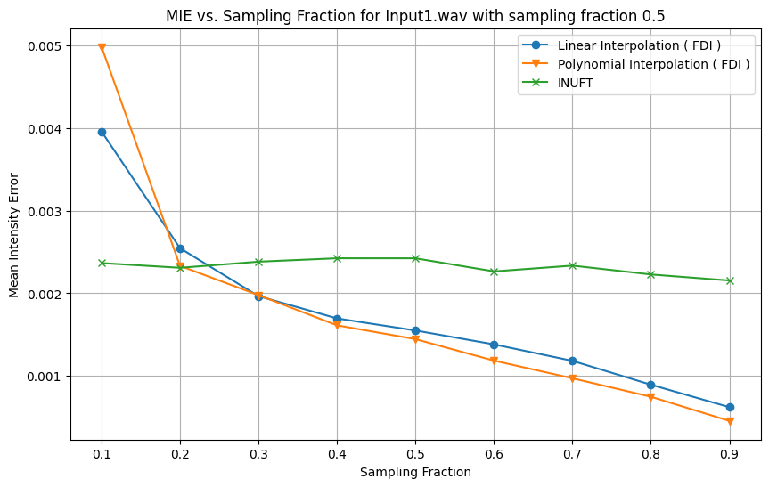

Plot visualizing comparisons of PSNR vs the Sampling Fraction 0.5 for INUFT, linear and polynomial interpolation.

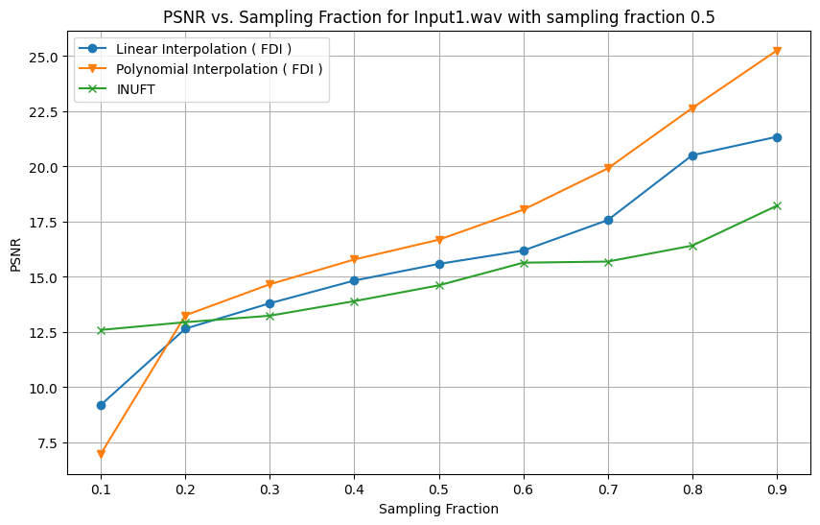

**Analysis:**

At higher sampling fractions (beyond 0.5), all three methods — linear interpolation, polynomial interpolation, and INUFT (Inverse Non-Uniform Fourier Transform) — tend to converge to similar MSE values, suggesting that once enough samples are provided, all methods are equally effective. However, Polynomial interpolation and INUFT have nearly identical MSE values across all sampling fractions, which are lower than those for linear interpolation. This suggests that these methods are more robust in handling sparse frequency data.

Similar to MSE, the MIE for all methods decreases as the sampling fraction increases. However, the MIE is less sensitive to changes in sampling fractions above 0.4, implying that after this point, additional samples do not markedly improve the mean intensity of the reconstructed signal.

Polynomial interpolation and INUFT demonstrate higher PSNR values than linear interpolation, with INUFT displaying a slight advantage at higher sampling fractions. This correlates with the previous observations from MSE and MIE, suggesting that INUFT might offer the best quality reconstruction overall, especially as the amount of available data increases.

The rate of improvement in PSNR slows down significantly after a sampling fraction of 0.5, similar to the trend seen in the MSE plot.

Polynomial interpolation and INUFT consistently outperform linear interpolation across the board for all three metrics, which could be attributed to their ability to better model and estimate the missing information in the signal.

The difference in performance between polynomial interpolation and INUFT is marginal, suggesting that for this specific dataset and reconstruction task, both methods are nearly equally effective.

# 

# 

# 

# 

# 

# 

# Conclusion

In this project, we successfully reconstructed signals from non-uniformly sampled frequency data using the Inverse Non-uniform Fourier Transform (INUFT) and Frequency Domain Interpolation (FDI) algorithms. Through careful dataset creation and algorithm implementation, we achieved promising results in signal reconstruction.

The evaluation of the reconstructed signals against their ground truth counterparts in the time domain yielded positive outcomes. The MSE, MIE and PSNR criteria indicated high fidelity and accuracy in the reconstructed signals.

Furthermore, the comparison between INUFT and FDI showcased their complementary strengths, providing valuable insights into their respective performance characteristics.

Overall, this project demonstrated the effectiveness of numerical methods for signal reconstruction from non-uniform frequency sampling. The promising results obtained lay a solid foundation for further exploration and application of these techniques in various real-world scenarios.

# 

# 

# Future Scope

In the future, the project can be expanded in several ways to enhance signal reconstruction techniques from non-uniformly sampled frequency data:

* **Advanced Techniques:** Implementing more advanced reconstruction methods beyond INUFT and FDI, such as deep learning-based approaches or graph signal processing techniques.
* **Noise Robustness:** Developing strategies to improve the robustness of reconstruction algorithms against noise in the frequency domain, including denoising techniques.
* **Adaptive Sampling:** Exploring adaptive sampling strategies to effectively select sampling points based on signal characteristics, improving reconstruction accuracy and efficiency.
* **Multi-dimensional Signals:** Adapting to reconstruction algorithms to handle multi-dimensional signals like volumetric data, opening up new possibilities for application in various domains.

# 

# References

* <https://dspace.mit.edu/bitstream/handle/1721.1/57688/635954979-MIT.pdf?sequence=2&isAllowed=y>
* <https://www.sciencedirect.com/science/article/abs/pii/0165168496000588>
* <https://www.youtube.com/watch?v=rmDg3eVWT8E>
* <https://ieeexplore.ieee.org/document/702881>
* <https://www.researchgate.net/publication/375576312_A_direct_solution_to_the_interpolative_inverse_non-uniform_fast_fourier_transform_iNFFT_problem_for_spectral_analyses_of_non-equidistant_time-series_data>