Project 3 report GROUP23
1. Your names and UCO email addresses: SRI LEKHYA PULLURU; spulluru1@uco.edu
2. A brief discussion of your project implementation, and the key steps
3. Task1
Vs code – install java (version 8 already installed), extension pack for java ,
install maven by downloading zip file, extract to C drive
Add this path to system env & vs code – maven executable path: C:\apache-maven-3.9.9\apache-maven\src\bin
For windows download & install Aws CLI
In aws console: Create accesskey : IAM > create Users> Go to Security credentials tab> Click "Create access key"> Copy:Access key ID , Secret access key
Install AWS CDK CLI : npm install -g aws-cdk
>aws configure
AWS Access Key ID [None]: AKIA6GSNGTUNNH*******
AWS Secret Access Key [None]: w8GnBpwrN/aFP+Ks5SZQq*************
Default region name [None]: us-east-1
Default output format [None]: json
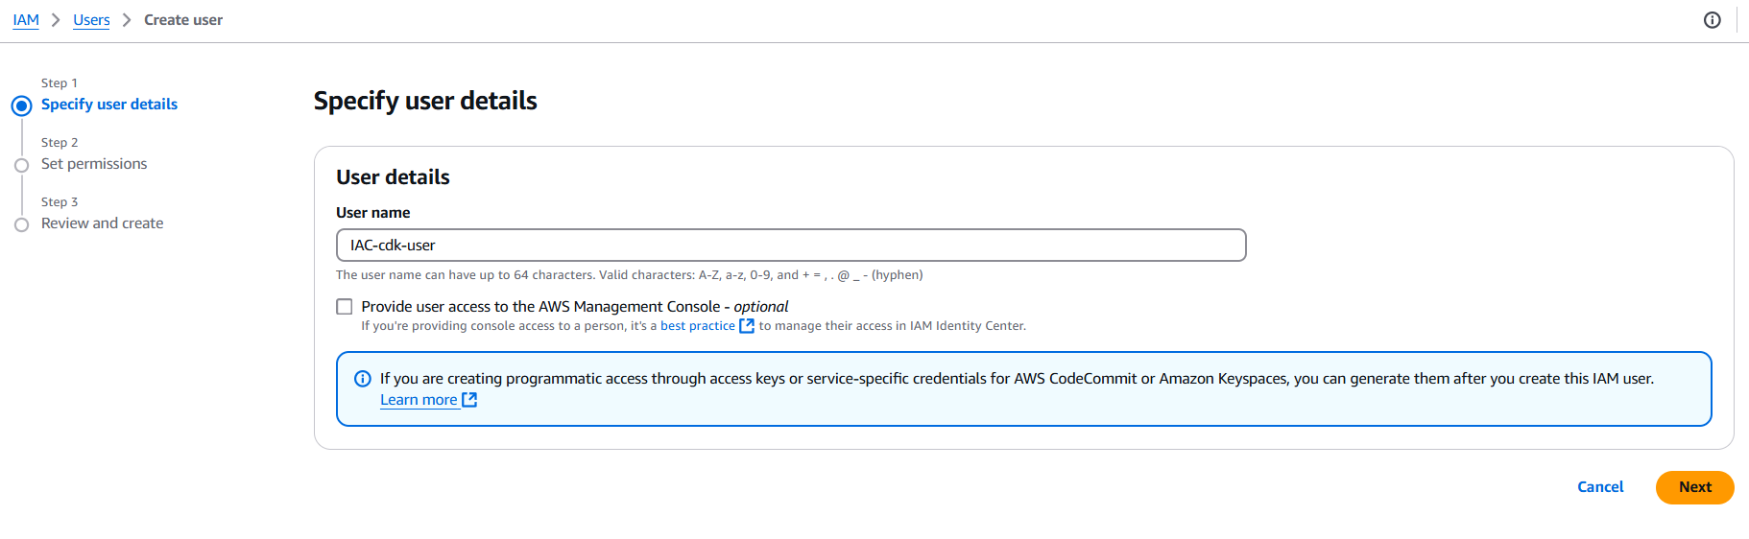
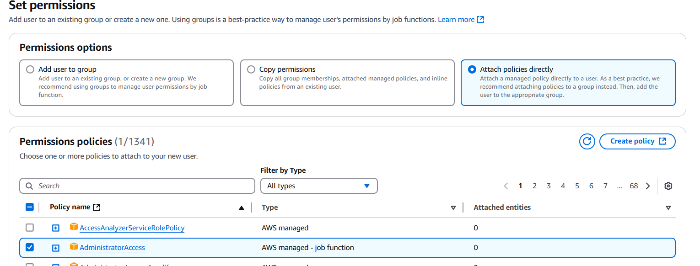
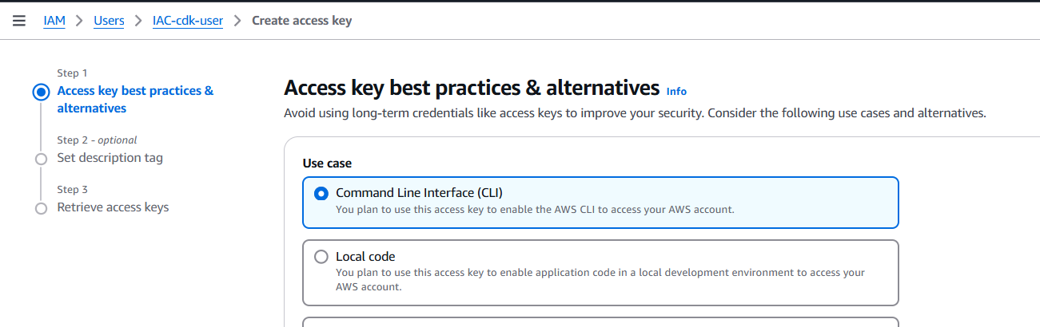
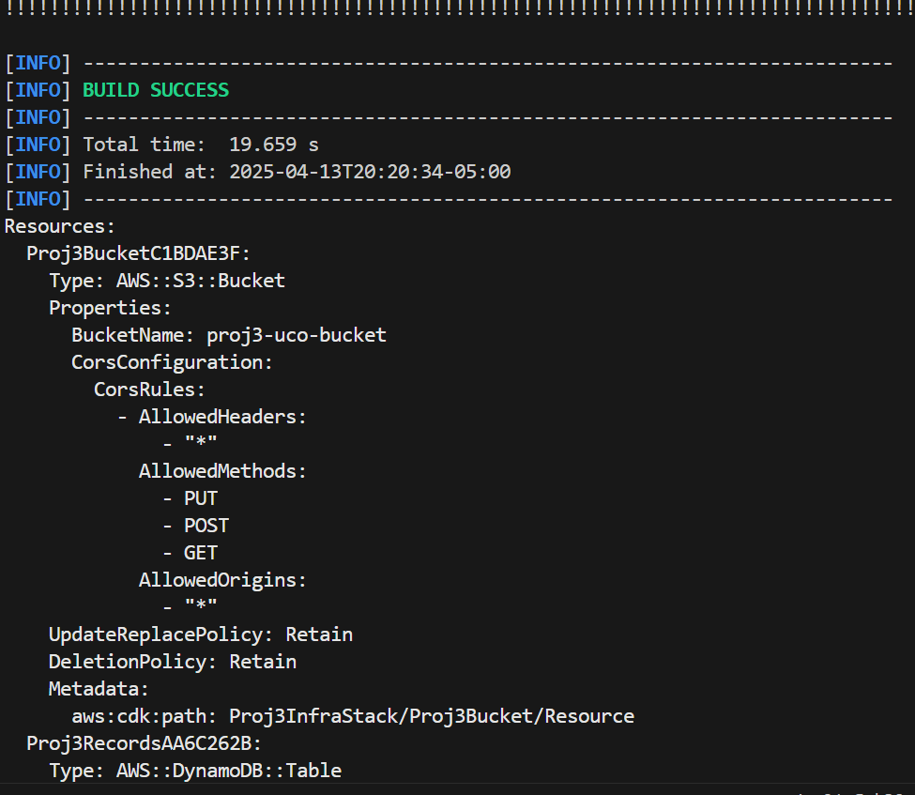
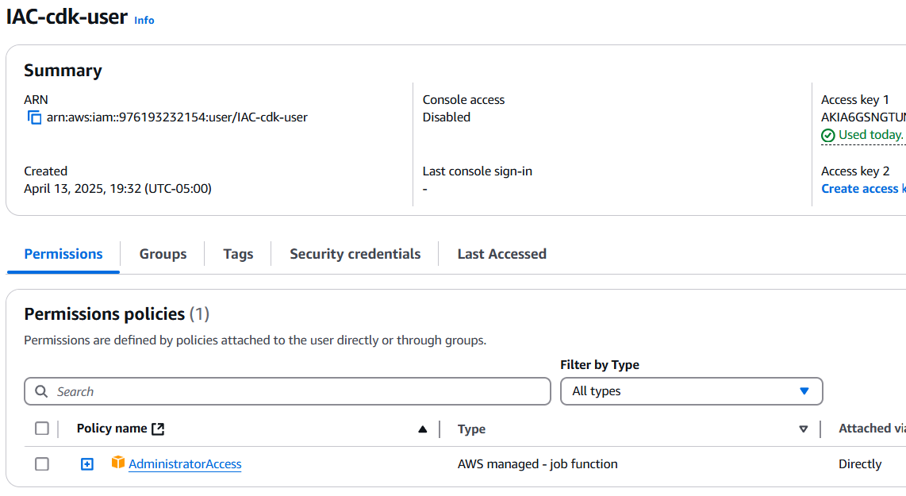
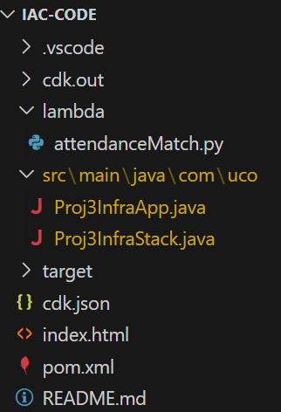
Task2
- Create java files required build cdk stack of required resources: lambda function, s3 bucket, api gateway, dynamo db, cognito identity pool, amplify
- Create pom.xml to run complie java code
- Project structure
- run commands
- cdk synth #pom build success , creates Iam roles , policy on stack
  - cdktoolkit is created in stack
- cdk deploy # deploys all resources
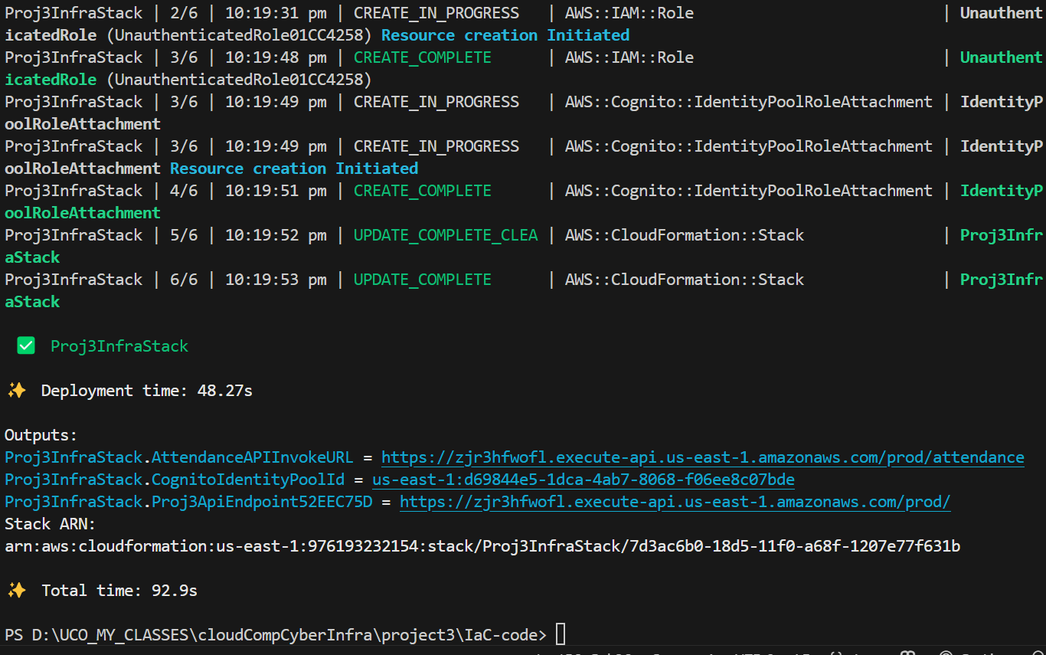
All are created except amplify
- cdk destroy # to delete
- cdk bootstrap aws://976193232154/us-east-1
IAC as stack created
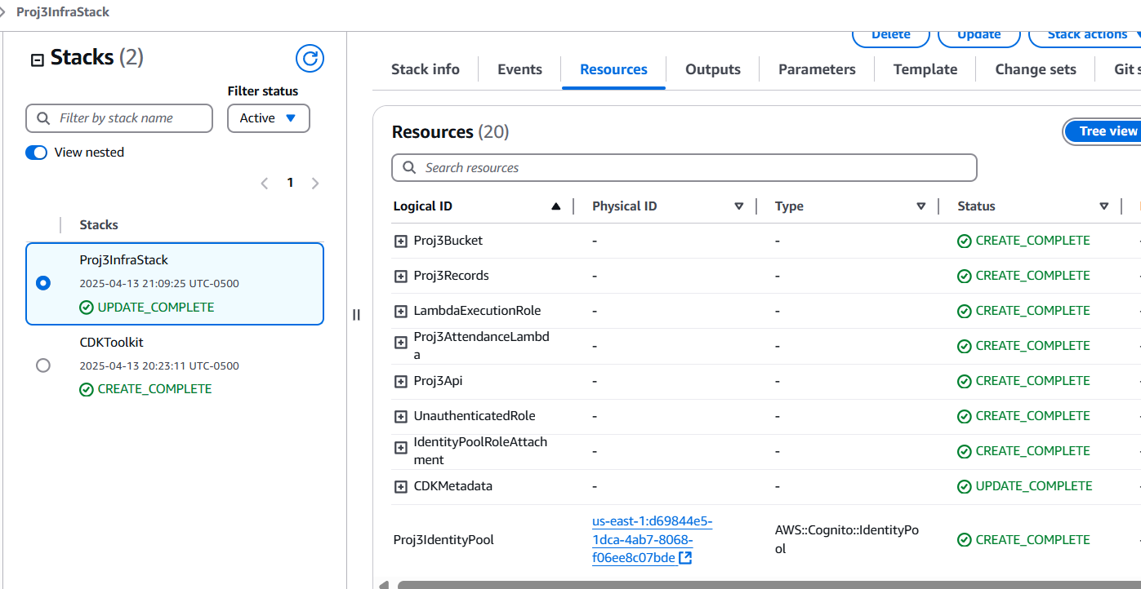
Lambdafn
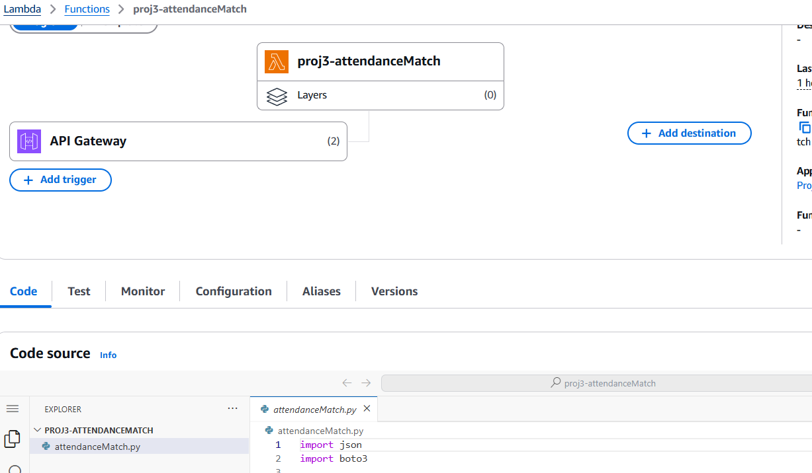
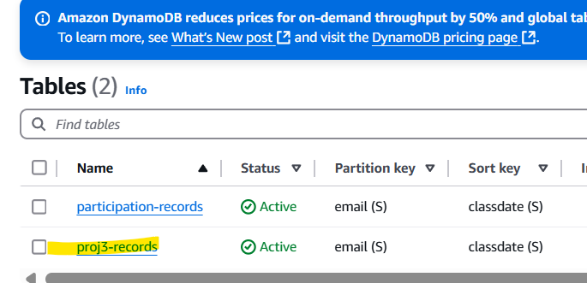
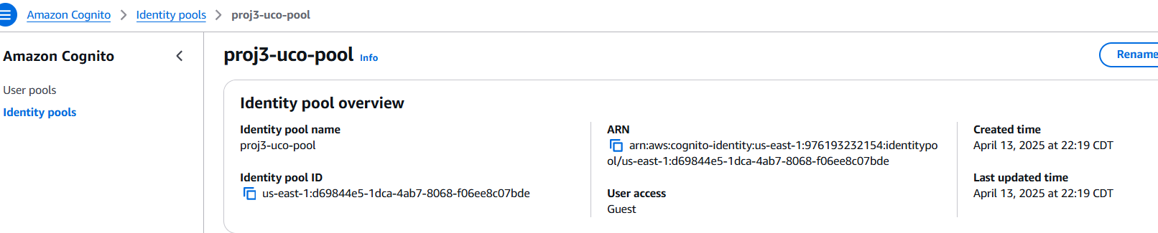
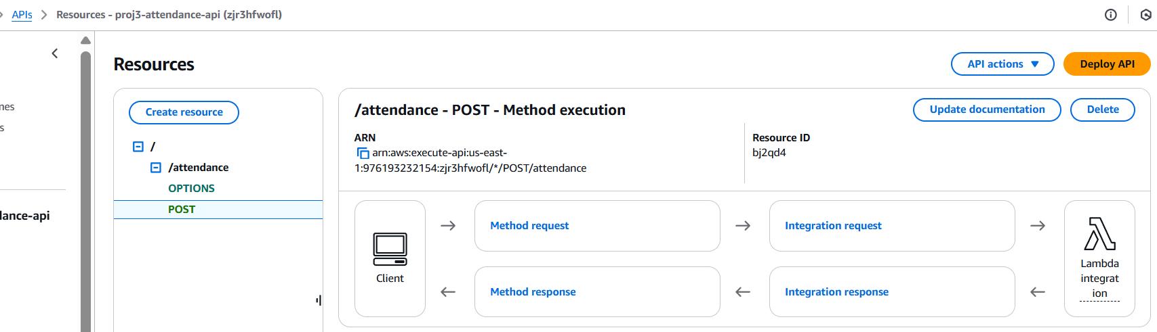
Task3
- create github repo – create aws secrets to its setting
- following the ci-cd demo git reference, add same .github/workflow/ci-cd.yaml to repo, add all files
- GITHUB REPO URL : git@github.com:spulluru1/project3-cicd-Iac.git
- verify that index.zip is created in s3 – done by github
- Create amplify app > github> chose repo, branch> create app
- Amplifydeploys the app, test the app. Amplify CI-CD is done

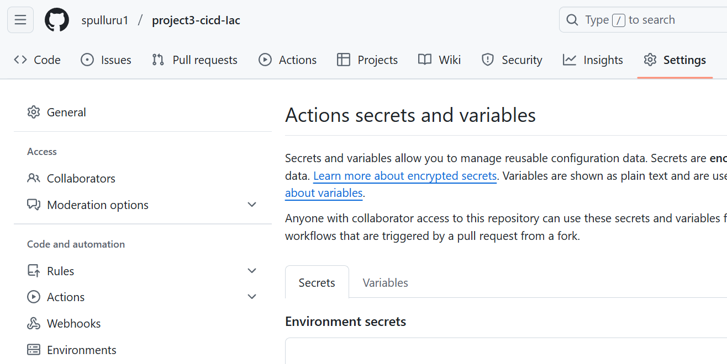
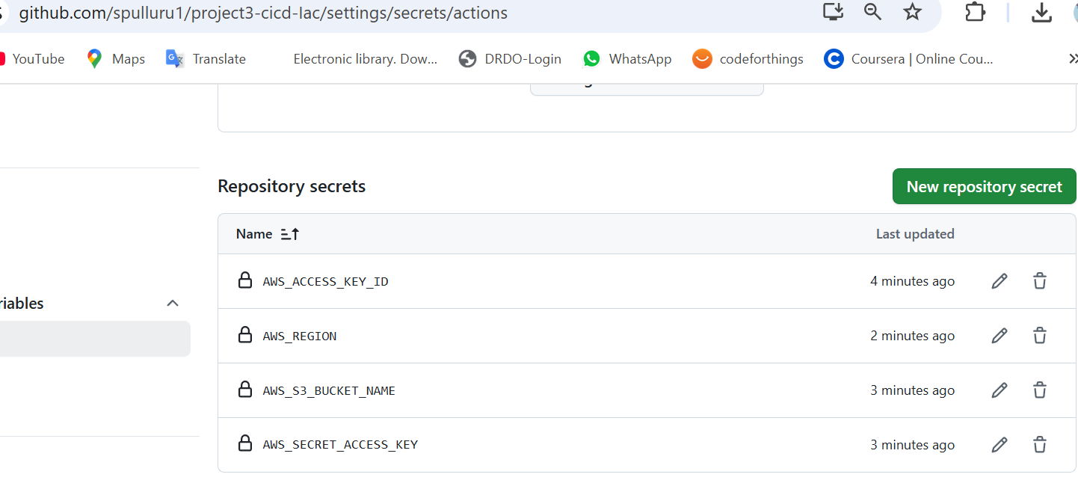
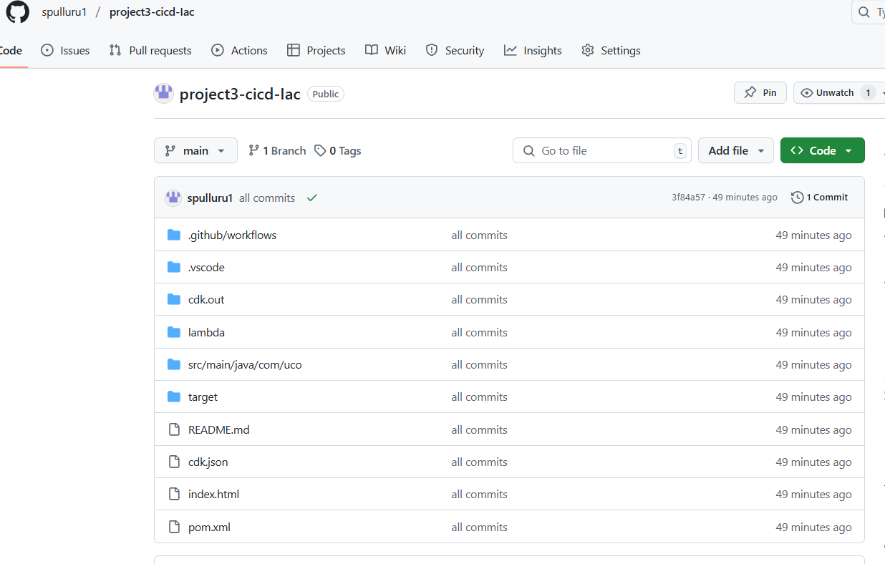
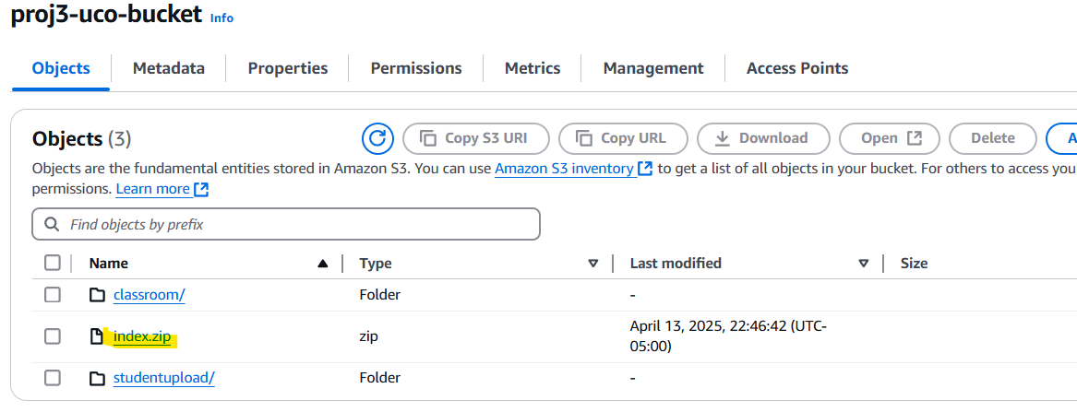
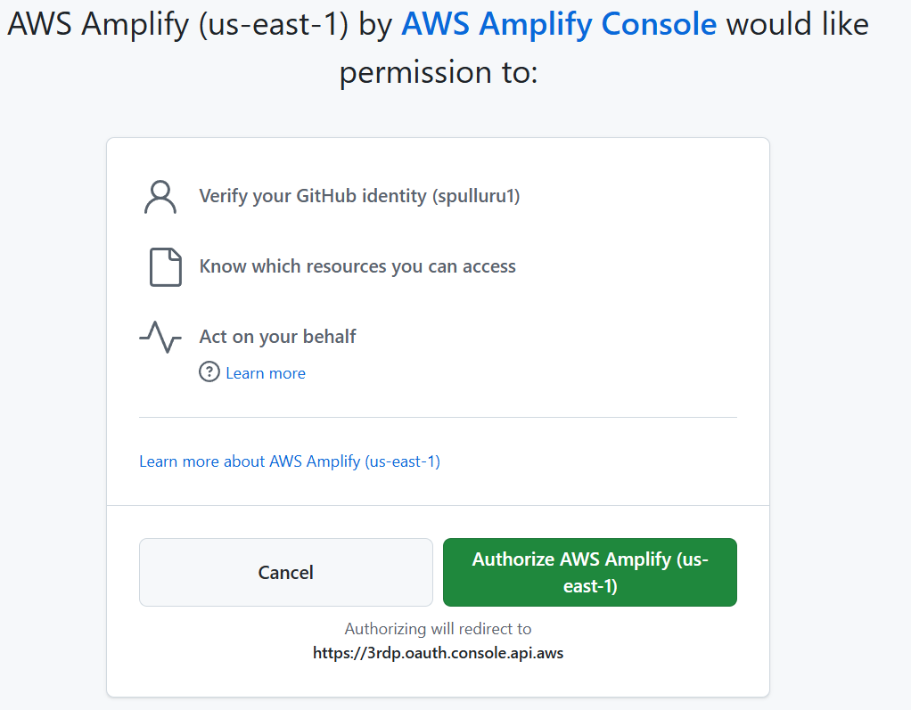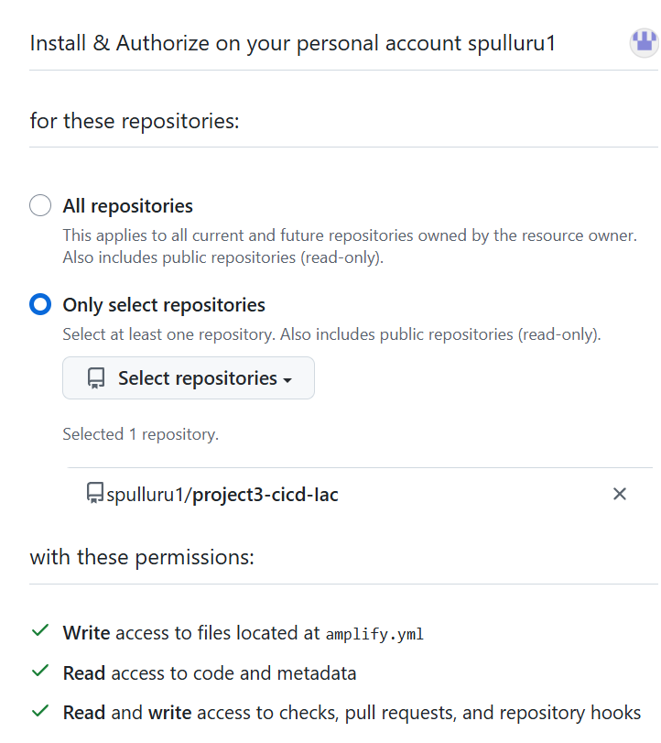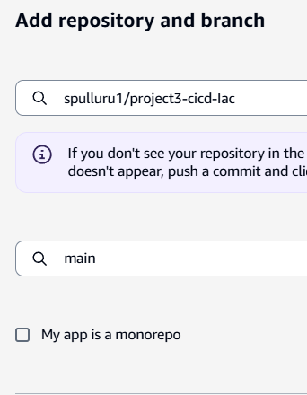
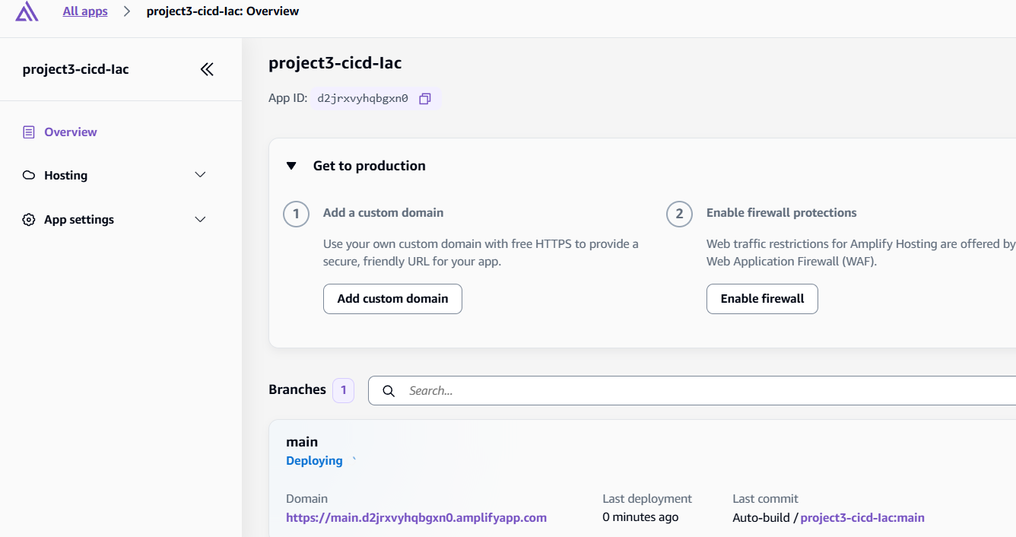
RESULTS:
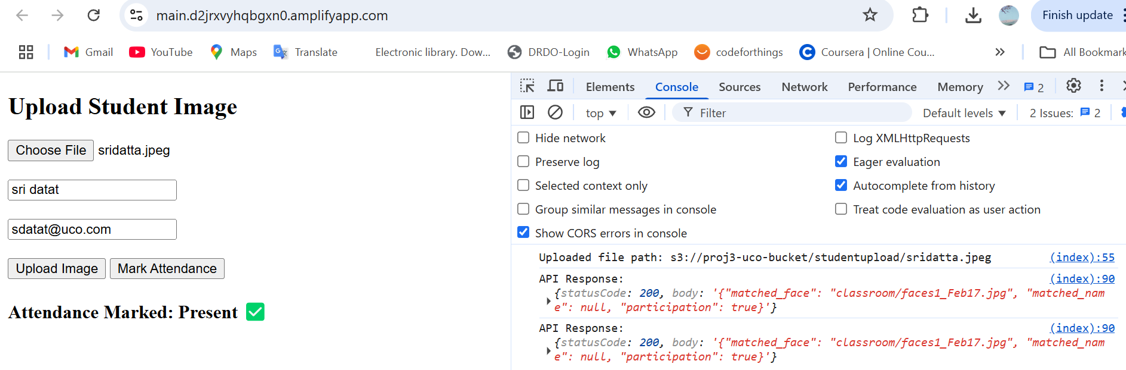
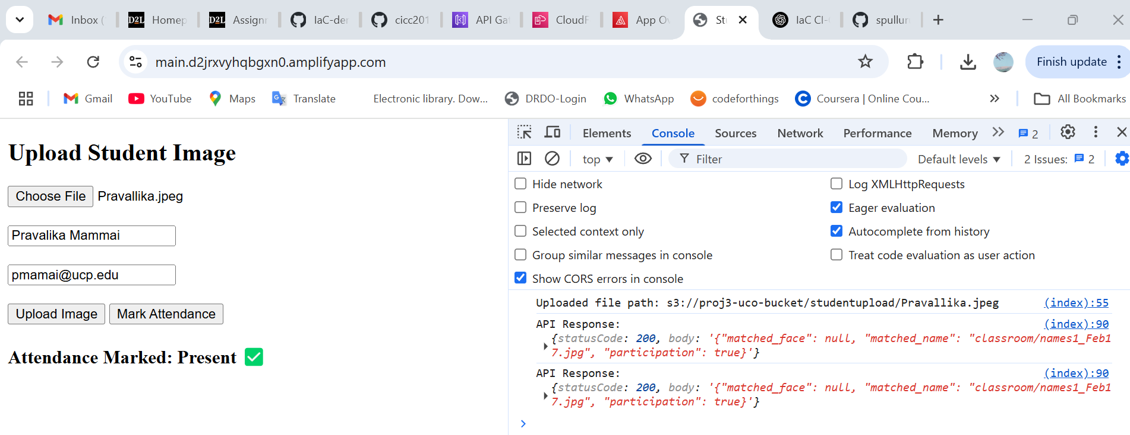
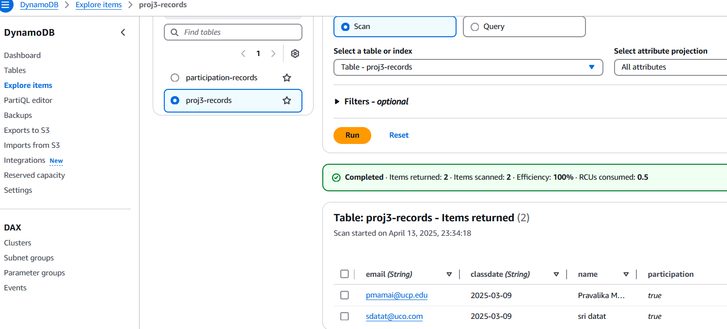

4. Answers to the following questions:
a. What makes you believe the AWS services you used are free for this project? How to ensure your trace of our project on AWS won’t cause you any charge in the future?
Services used are CloudFormation- Stack , S3 bucket, Lambda, DynamoDB, Textract, Rekognition, Cognito, Amplify. Billing of those services are seen in Free tier.
b. What is your configuration to set CI-CD for your lambda functions?
c. How many times you need to visit your AWS consoles? Please list all the visits here, e.g., “2. Set up Amplify CICD for index.html”, etc.
1. create access key for cdk to get access to my aws account
2. verify stack is created – verify all resources
3. upload classroom photos on s3 bucket
4. Set up Amplify CICD for index.html
d. What is your approach to set CORS for your API gateway endpoint, so that only required resource and methods are created?
I have integrated the CORS policy for api in Java code that use aws CDK
