Local host setup:

You’ll need to install python and Selenium for python.

This link has some instructions:

<https://www.youtube.com/watch?v=CriSHYMtg9M>

Configuring Scripts:

You’ll need to change the ZONE and PROJ variables to your preferences in each script. They are located near the top under #variables.

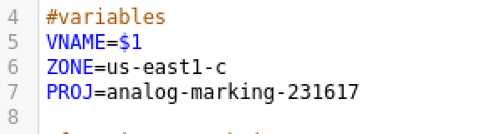

I’ve managed the directories on the host machine to require minimum alterations. You’ll need to change the home directory to your own in each script.

In the phpAuto.sh script you’ll want to manage the directories on line 36, 41, and 51.

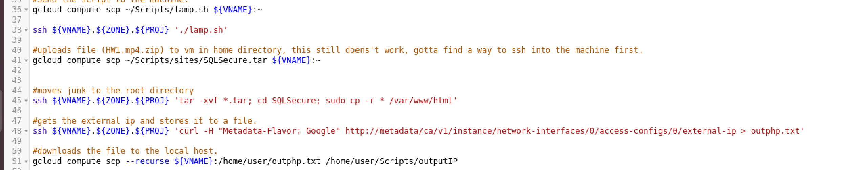

On line 51, the first directory is on the cloud machine. You’ll want to change the username to your own username. The second directory is on your local machine, you’ll want to adjust that to match as well.

As of this writing, I don’t have an automation script for the React-django environment, I hope to add it later.

You’ll want to change all of the directories in CloudComputing.sh to match your home directories.

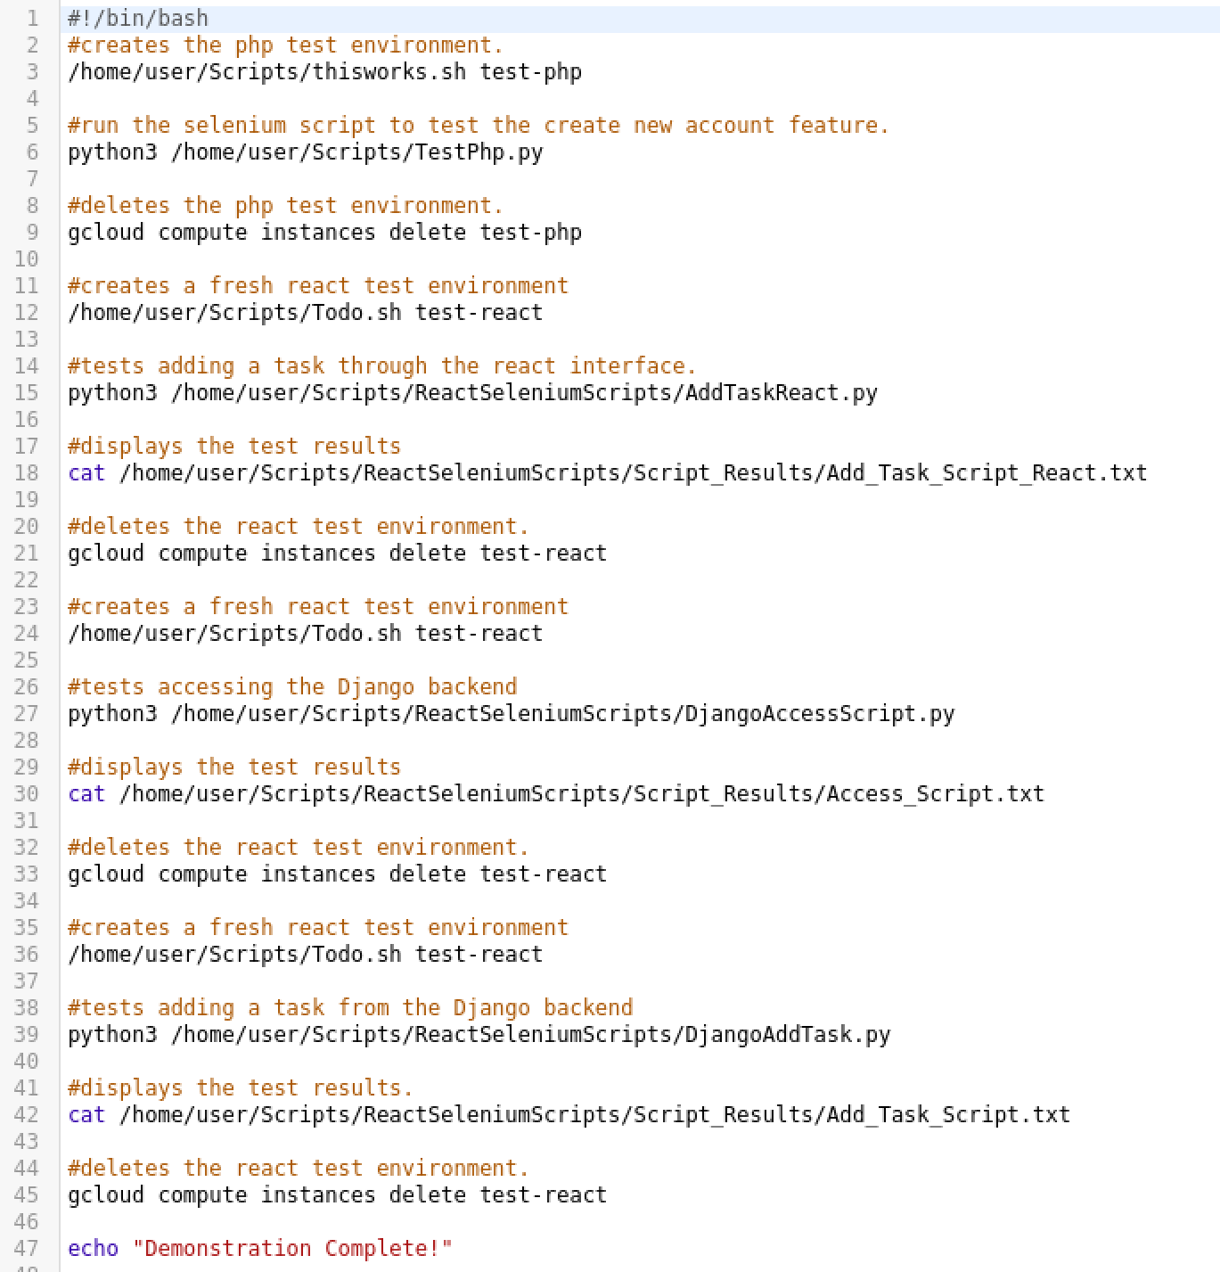

The directories for the python scripts will need to be altered as well.

In TestPhp.py you’ll want to handle the directory on line 5 and line 13 to your own home directories.

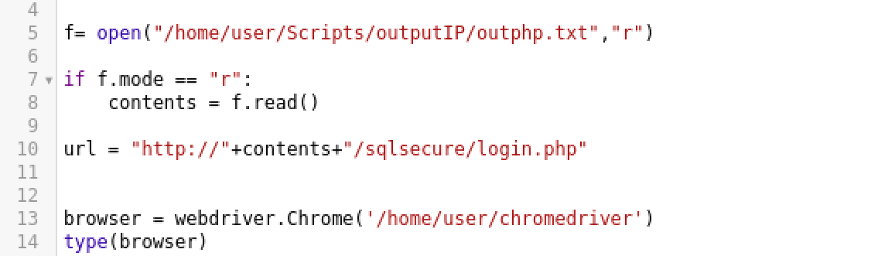

Normal HTML and bootstrap sites are easiest, that’s located in the thisworks.sh script and like the others, you’ll want to adjust the ZONE and PROJ variables along with the directories to match yours. Then writing a python script to test it would be simple.