**RESUME**

**SRIMAN.D**

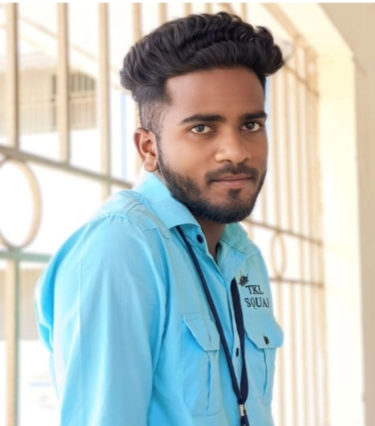

Cell :9345385190

email.id:sriman.d420@gmail.com

ADDRESS:

3/242Thaikkal street,

Ammaiyappan,

Thiruvarur post

CAREER OBJECTIVES:

*To achieve excellence by applying my knowledge &skills in profession and continuously improving my knowledge base by learning through work experience and to make significant contribution in the growth of organization.*

EDUATION:

*CLASS X:*

*GHSS: Ammaiyappan*

*Medium: Tamil*

*Year of passing:2020*

*Grade:341*

*CLASS XII:*

*GHSS: Ammaiyappan*

*Medium: Tamil*

*Year of passing:2021*

*Grade:455*

*COLLEGE:*

*III-B.sc (Computer science) final year student*

*Thiru.Vi.Ka.Govt arts &S*cience, *college thiruvarur*

*Bharadhidasan university*

AMBHITION:

* *I Try to well salary for government job*
* *I Will be create App developer*

HOBBIES:

*Listening music, Watching thriller movie, Drawing , Play settle cork, tailoring, cooking, reading books.*

DECLARATION:

*I hereby declare that all above mentioned information is true to the best of my knowledge and belief.*

YOUR’S FAITHFULLY:-

D.SRIMAN