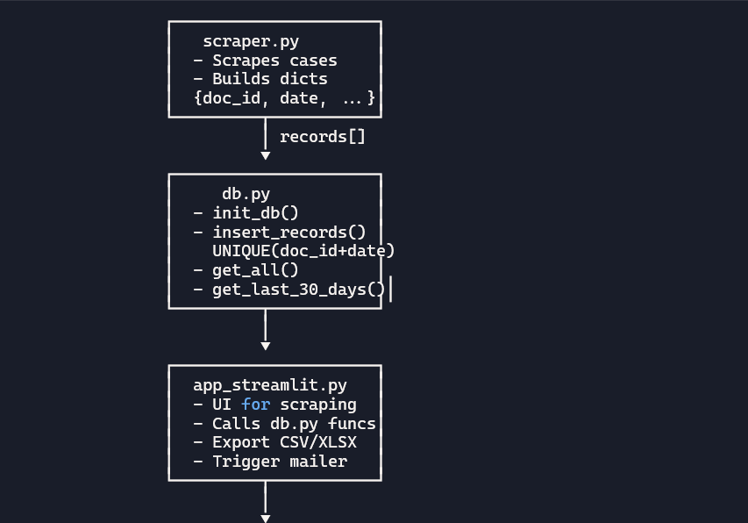
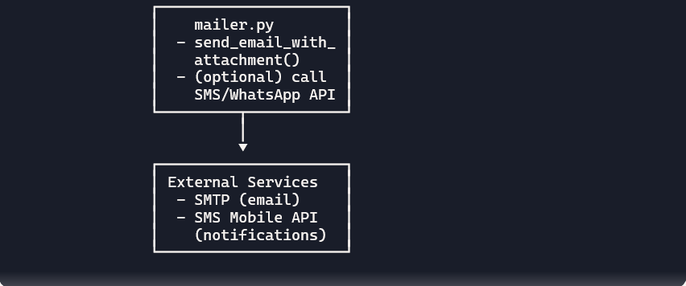

File Responsibilities
- scraper.py → Collects judgments, builds structured records with doc_id.
- db.py → Stores records, enforces uniqueness on (doc_id, judgment_date).
- app_streamlit.py → User interface: scrape, view, export, send mail.
- mailer.py → Handles email sending, can also trigger SMS/WhatsApp notification.
🚀 Flow in words
- scraper.py scrapes judgments and outputs dictionaries with doc_id.
- db.py inserts them into SQLite, enforcing uniqueness.
- app_streamlit.py provides UI for scraping, viewing, exporting, and emailing.
- mailer.py sends the email with attachments.
- Optionally, mailer.py or app_streamlit.py calls the SMS Mobile API to notify “Check your judgments mail.”

