Infrastructure Operations
Technical Reference Document
SIEM Integration | Backup Management | Alert Configuration

1. SIEM Integration Setup
Security Information and Event Management (SIEM) integration enables centralized log collection, real-time monitoring, and threat detection across all servers. The following section outlines the integration status and use cases configured for each environment.

1.1 Red Hat OpenShift Logging
Red Hat OpenShift Logging provides a unified logging stack for containerized workloads. It aggregates logs from application pods, nodes, and infrastructure components, forwarding them to the SIEM for correlation and alerting.
- Collects logs from all OpenShift node types (master, infra, worker)
- Supports log forwarding via Fluentd/Vector pipelines to external SIEM endpoints
- Enables structured JSON log parsing for faster query and alert rule creation
- Integrated with cluster audit logs for security and compliance use cases

1.2 Data Center (DC) SIEM Servers

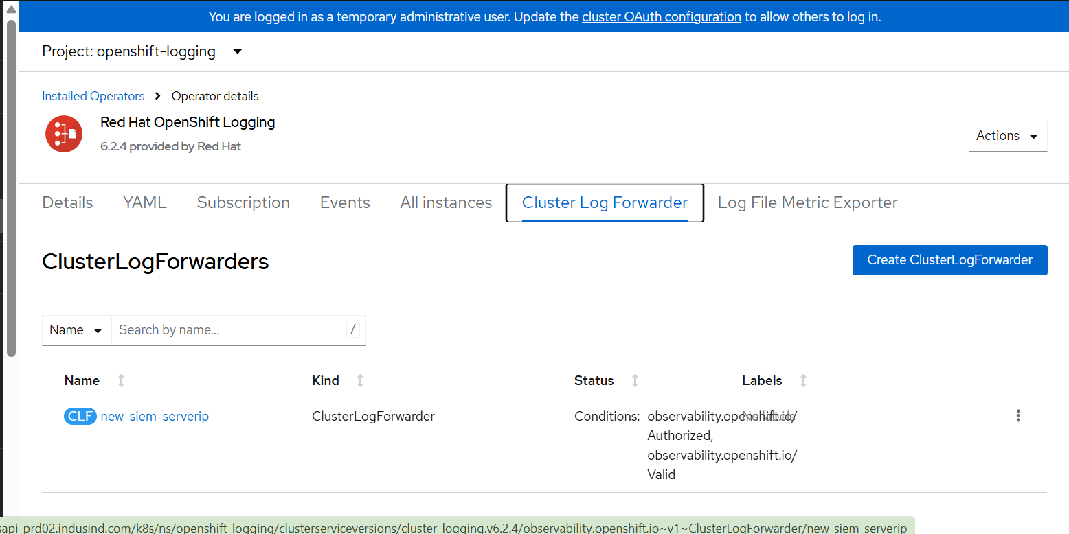

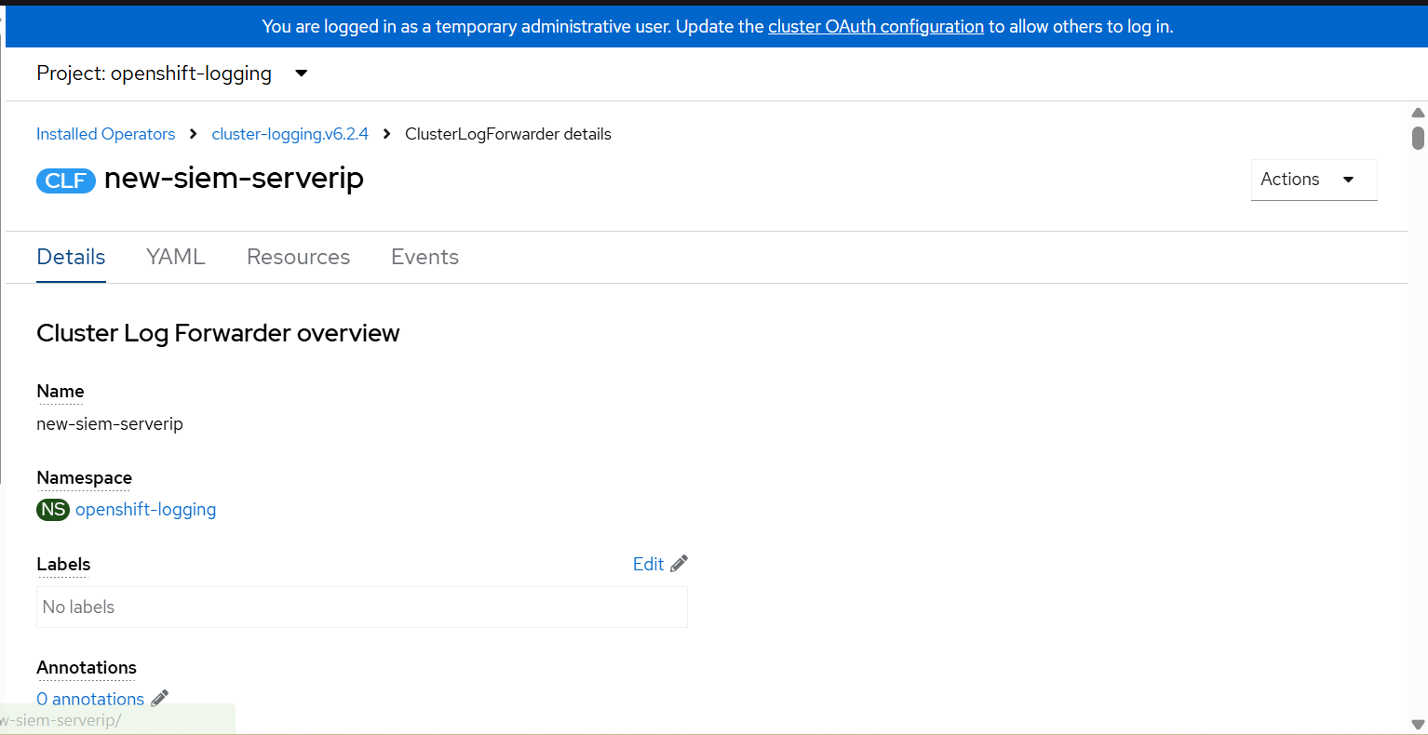

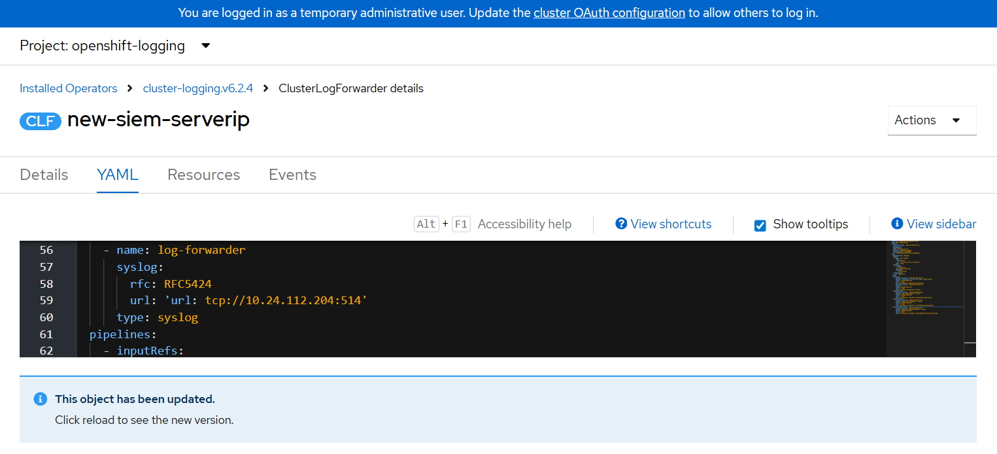

1.3 Disaster Recovery (DR) SIEM Servers
The DR environment maintains dedicated SIEM server nodes to ensure log continuity during failover scenarios. Each server handles specific log collection and forwarding responsibilities.
There are three SIEM servers in DR. The screenshots as follows as on below for reference,

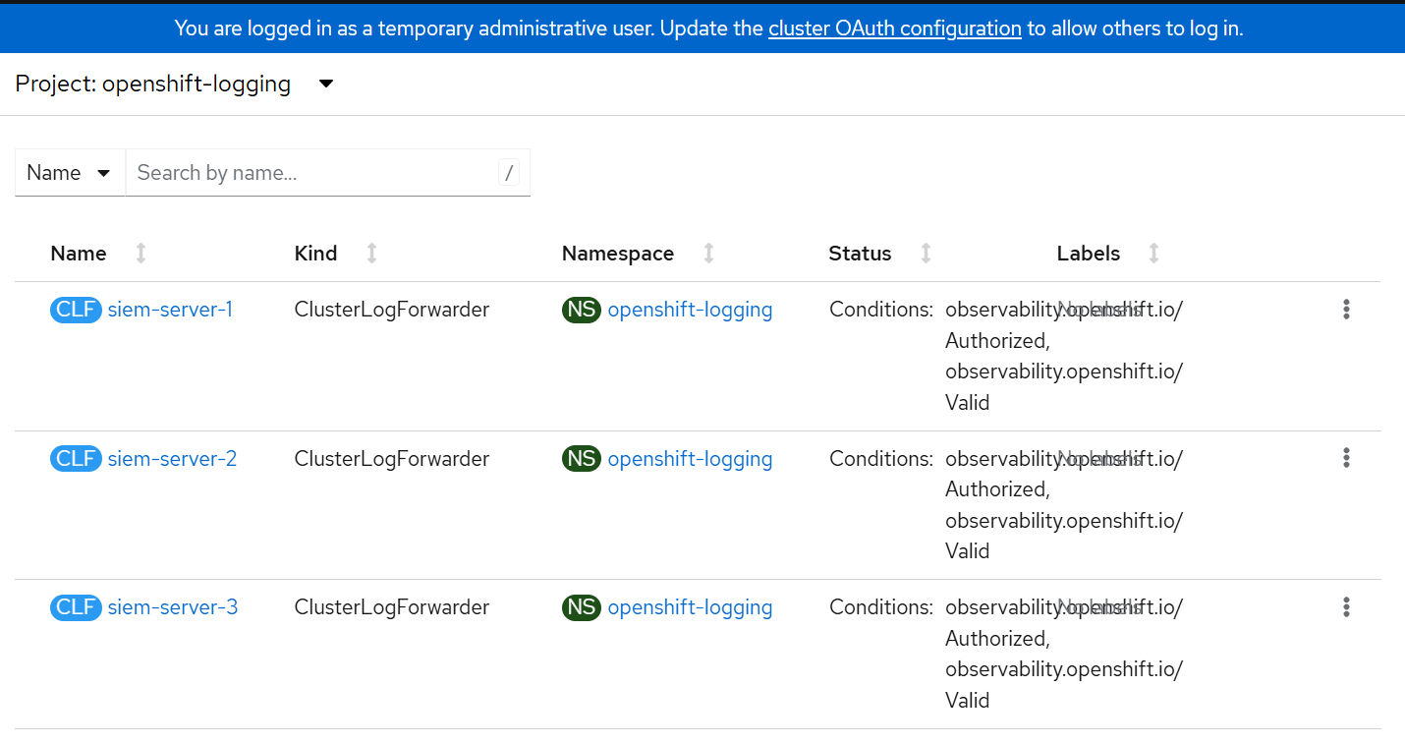

Server | Role / Use Case
DR-siem-server-1 | Primary SIEM ingestion node for DR environment. Receives forwarded logs from all DR workloads and indexes events for real-time correlation.  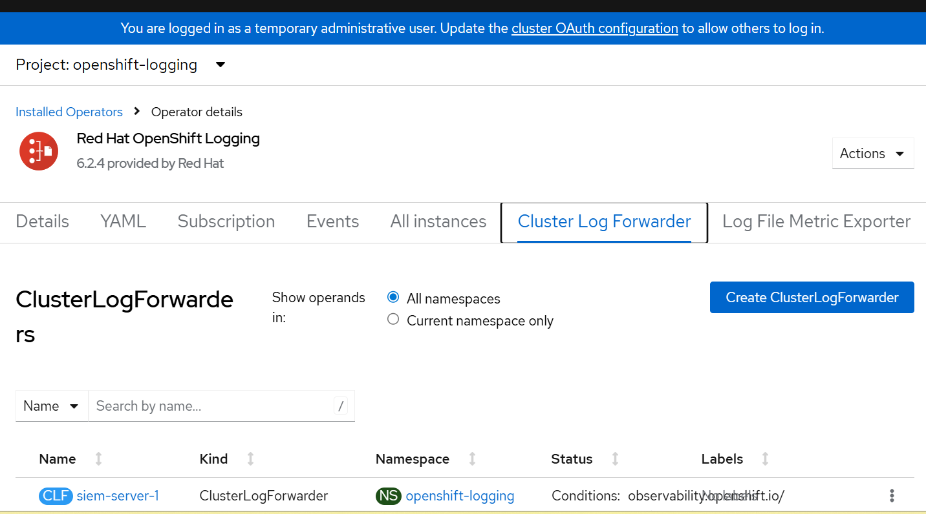  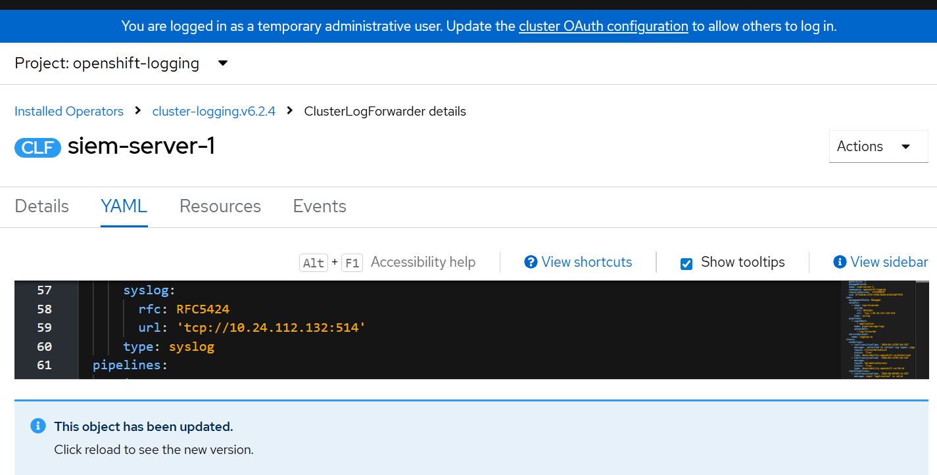
DR-siem-server-2 | Secondary ingestion node providing high availability. Acts as failover receiver when DR-siem-server-1 is unavailable; handles load-balanced log streams.  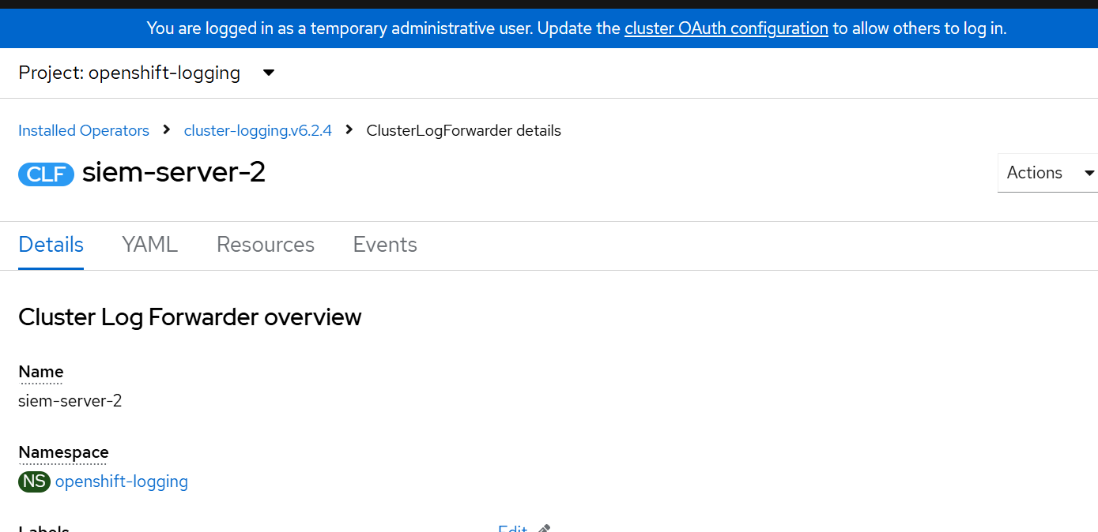  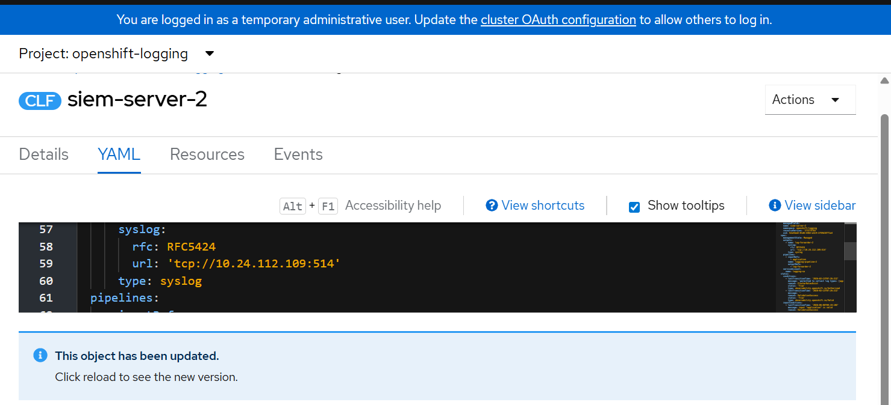
DR-siem-server-3 | Dedicated audit and compliance log collector. Stores long-retention logs for regulatory reporting and forensic investigation in the DR site.  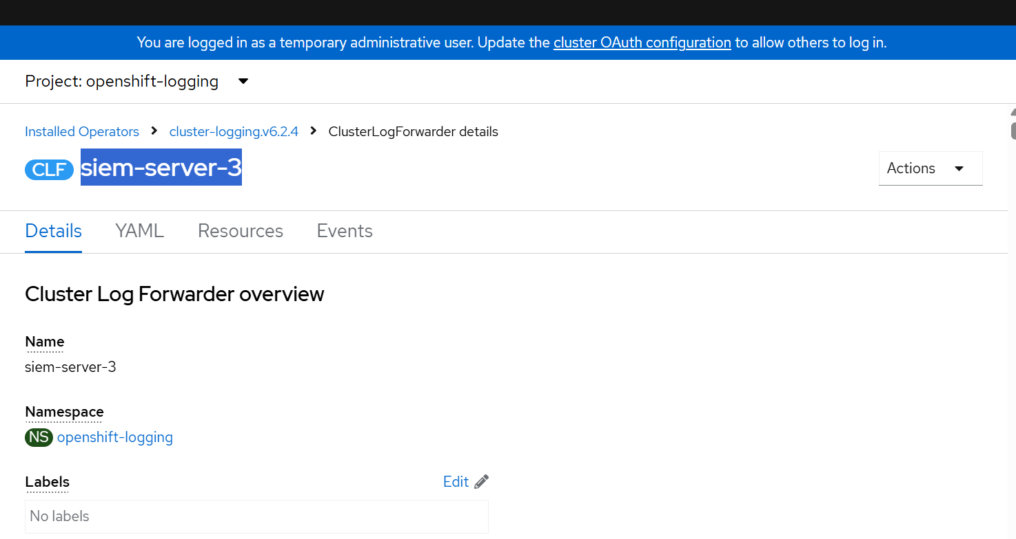  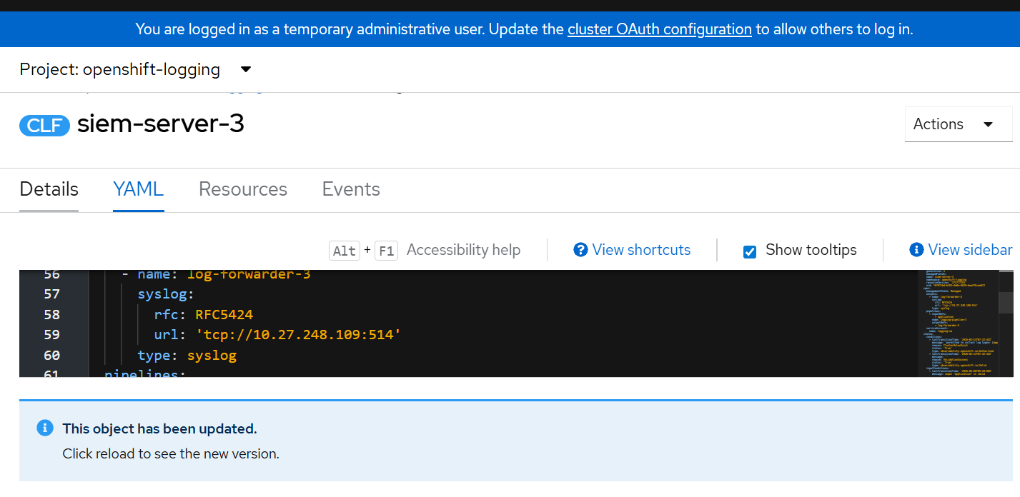

2. Backup Checking
Regular backup verification ensures data integrity and recoverability for critical APIC (API Connect) components. Backups are maintained across both the Data Center (DC) and Disaster Recovery (DR) sites.

2.1 Data Center Backups (DC)
Server IP: 10.90.46.4
Management Backup
The management backup preserves API Connect management subsystem configuration, including gateway policies, catalogs, and runtime settings.
Backup Path: /bkp/apicbackup/mgmtbackup/prod-apimg-be787dd1-be787dd1-db-2025-07-21T102701Z/base
The screenshots as follows as on below for reference,
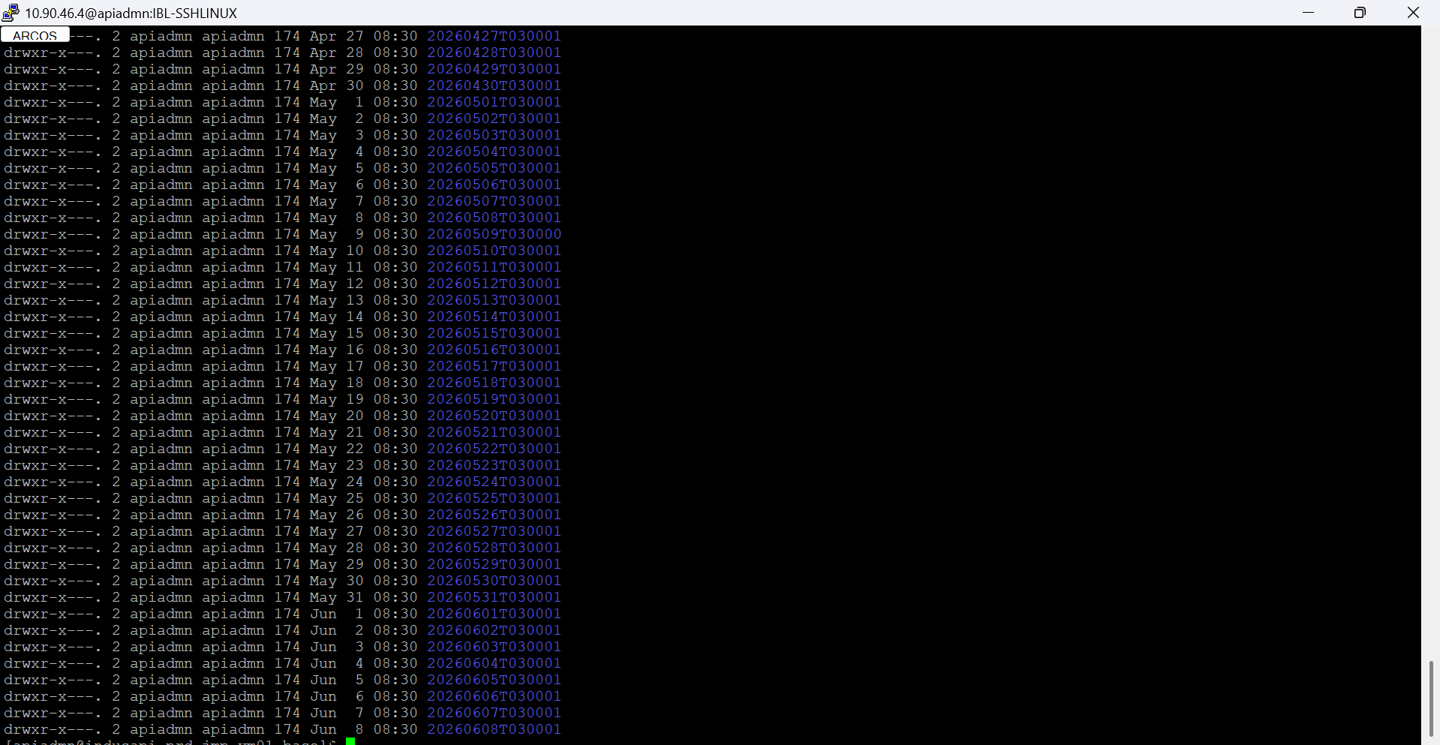
Portal Backup
The portal backup captures the Developer Portal content, user data, and site configuration needed to restore the consumer-facing API portal.
Backup Path: /bkp/apicbackup/portalbackup

The screenshots as follows as on below for reference,

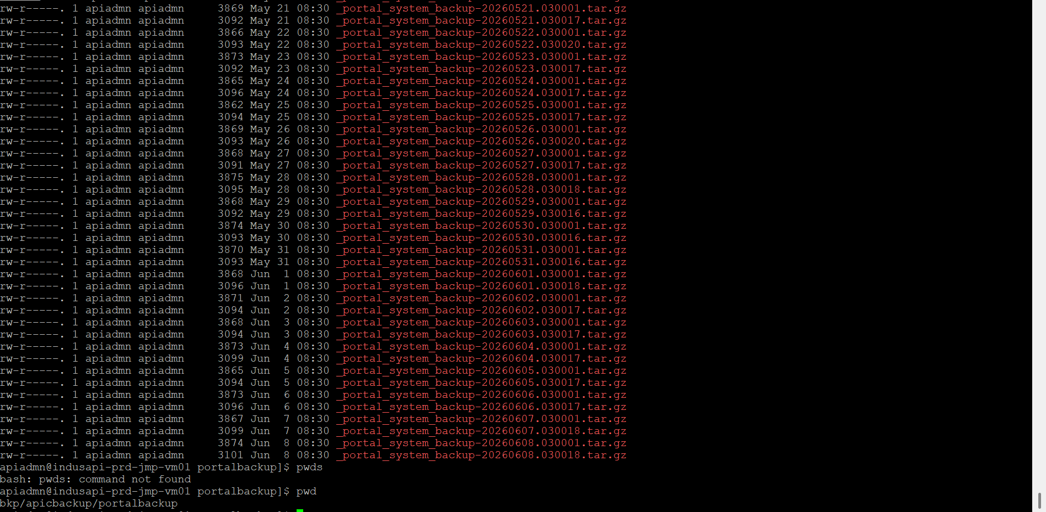

2.2 Portal Backup – Disaster Recovery (DR)
A mirrored portal backup is maintained at the DR site to ensure the Developer Portal can be restored independently during a datacenter failover event.
Server IP: 10.90.46.4
Backup Path: /bkp/apicbackup/portalbackup
- Backup files should be verified for size and timestamp after each scheduled run
- Restoration tests should be conducted periodically to confirm backup integrity
- Retention policy should align with organizational RPO/RTO requirements

The screenshots as follows as on below for reference,

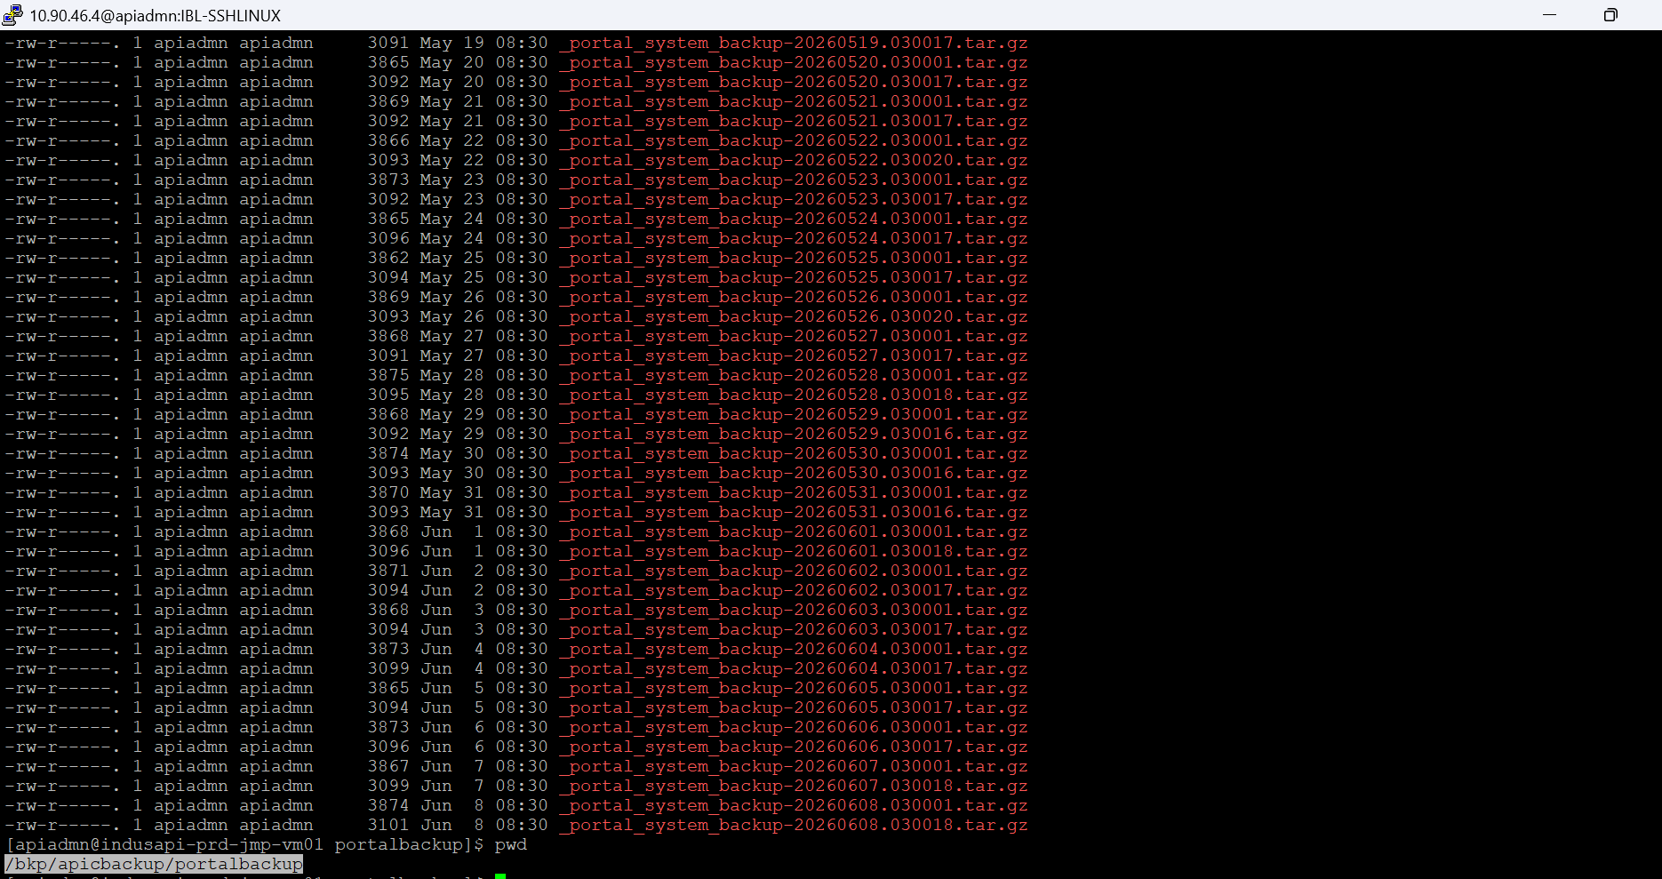

3. Alert Manager Setup
Alert Manager is configured to monitor Kubernetes/OpenShift pod resource utilization. When any pod exceeds 70% of its allocated CPU or memory resources, an automated alert is triggered and dispatched to the registered email address.

3.1 Alerting Threshold & Trigger Condition
Parameter | Value
Trigger Condition | Pod resource utilization exceeds 70% (CPU or Memory)
Alert Channel | Email notification to registered mail ID
Monitored Pod | upi-is-f66687976-7ftk9  beneficiary-is-578679df65-k7ljv  cbsv4-ir-858b479545-55nm5
Configuration File | alertConfiguration.yaml

The screenshots as follows as on below for reference,

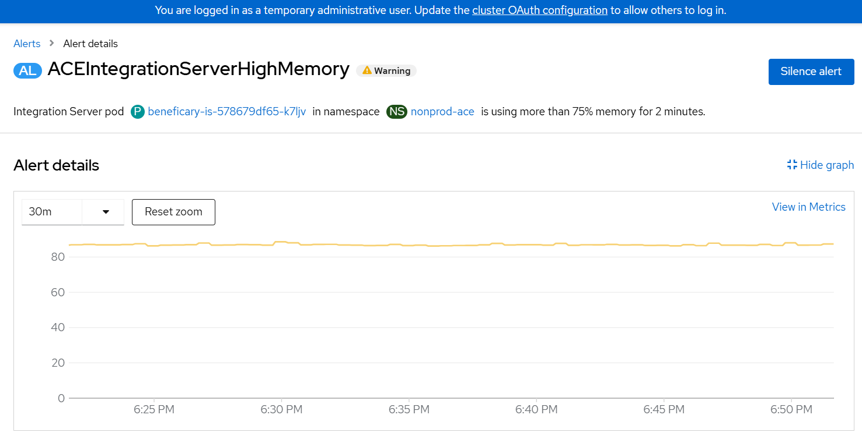

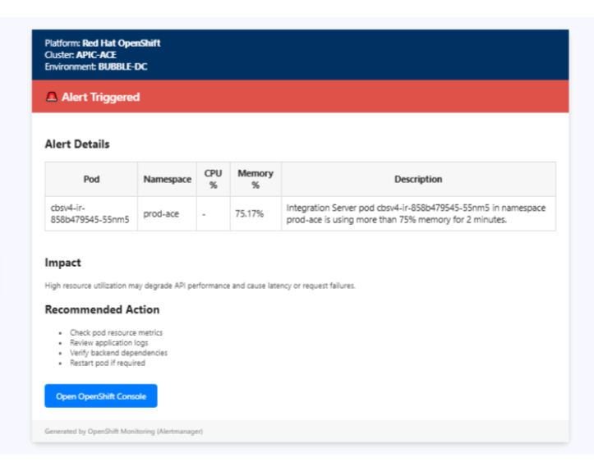
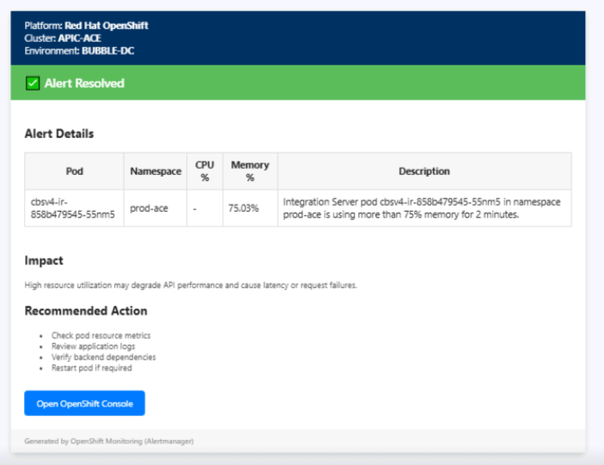

3.2 Configuration Overview
The alert rules are defined in alertConfiguration.yaml. Key configuration elements include:
- Prometheus-compatible alerting rules with expr thresholds set at 0.70 (70%)
- Alert labels include severity, namespace, and pod name for easy triage
- Annotations provide a summary and description for the alert email body
- Receiver configuration in Alertmanager routes firing alerts to the SMTP email endpoint
- Repeat interval and group wait settings prevent alert flooding during sustained high utilization

Added alertConfiguration.yaml screenshot for reference as follows as on below,
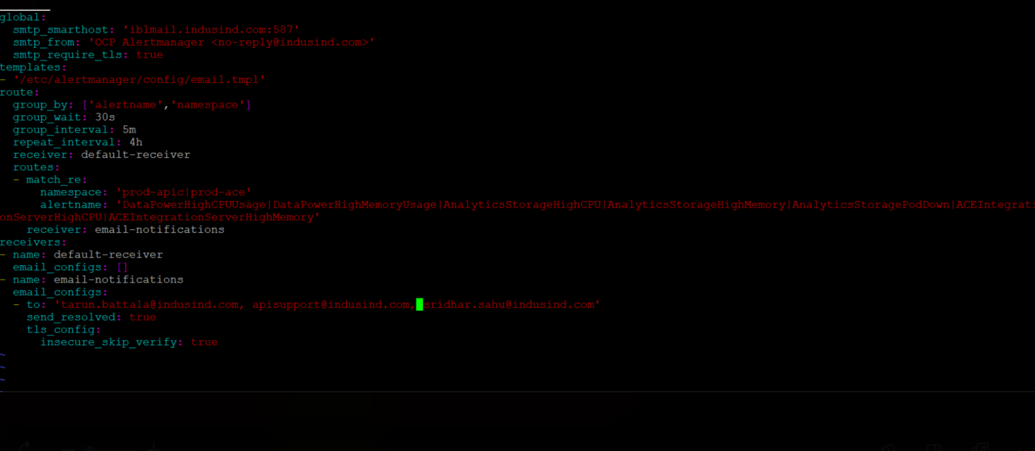

3.3 Alert Lifecycle
Stage | Description
Pending | Utilization crossed 70% but hasn't persisted long enough to fire
Firing | Threshold exceeded for the configured duration; email alert sent
Resolved | Utilization dropped below 70%; resolution notification dispatched

End of Document

