IBM MQ
Kubernetes Deployment
Enterprise Installation & Configuration Document

Organization | Morrocco
Project | IBM MQ on Kubernetes (Namespace: prod)
Environment | DMZ Production Cluster
Cluster FQDN | *.sahir-api.dgsn.gov.ma
Document Date | June 4, 2026
Version | 1.0 — Initial Release
Classification | INTERNAL / RESTRICTED
Prepared By | Infrastructure & Middleware Team

Table of Contents

- Executive Summary
- Infrastructure Overview
2.1 Kubernetes Cluster Topology
2.2 Cluster Specifications
- IBM MQ Installation Details
3.1 Deployment Namespace
3.2 Installation Method
3.2.1 Image handling
3.2.2 Deploying MQ
3.3 Storage Backend
3.4 Queue Manager Name
- Queue Manager Configuration
4.1 Application Queues
4.2 Dead-Letter Queue Strategy
4.3 System Queues
- Channel Configuration
5.1 Application Channels (SVRCONN)
5.2 System Channels
5.3 Channel Security Notes
- Listener Configuration
6.1 Defined Listeners
6.2 Kubernetes Service Exposure
- Integration Workload Summary
- Post-Installation Verification
8.1 MQSC Verification Commands
8.2 Queue Verification Output
8.3 Channel Verification Output
8.4 Listener Verification Output
8.5 Verification Summary
- Operational Procedures
9.1 Accessing the MQ Pod
9.2 Checking Queue Depth
9.3 Monitoring Dead-Letter Queues
9.4 Checking Channel Status
9.5 Checking Listener Status
- Security Hardening Checklist
- Document Change Log

1. Executive Summary

This document provides a comprehensive record of the IBM MQ deployment on Kubernetes within the production (prod) namespace of the DGSN DMZ cluster. It covers the infrastructure topology, installation details, queue manager configuration, channel definitions, queue inventory, listener setup, and post-installation verification.
The IBM MQ instance is configured to serve multiple integration workloads including the ATLASAPI FlightRadar interface and RAM PAX/PNR government messaging pipelines. The deployment leverages a highly available, three-node control-plane Kubernetes cluster running version 1.32.13 on Ubuntu 22.04 LTS.

2. Infrastructure Overview

2.1 Kubernetes Cluster Topology
The cluster spans six nodes across two roles — control-plane and worker — all operating on the DMZ network segment (10.121.10.0/24).

Hostname | Role | Internal IP | K8s Version | OS | Container Runtime | Status
dmz-mas-1.sahir-api.dgsn.gov.ma | control-plane | 10.121.10.100 | v1.32.13 | Ubuntu 22.04.5 LTS | containerd://2.2.1 | Ready
dmz-mas-2.sahir-api.dgsn.gov.ma | control-plane | 10.121.10.101 | v1.32.13 | Ubuntu 22.04.5 LTS | containerd://2.2.1 | Ready
dmz-mas-3.sahir-api.dgsn.gov.ma | control-plane | 10.121.10.102 | v1.32.13 | Ubuntu 22.04.5 LTS | containerd://2.2.1 | Ready
dmz-ceph-1.sahir-api.dgsn.gov.ma | worker | 10.121.10.103 | v1.32.13 | Ubuntu 22.04.5 LTS | containerd://2.2.1 | Ready
dmz-ceph-2.sahir-api.dgsn.gov.ma | worker | 10.121.10.104 | v1.32.13 | Ubuntu 22.04.5 LTS | containerd://2.2.1 | Ready
dmz-ceph-3.sahir-api.dgsn.gov.ma | worker | 10.121.10.105 | v1.32.13 | Ubuntu 22.04.5 LTS | containerd://2.2.1 | Ready

2.2 Cluster Specifications
Parameter | Value
Kubernetes Version | v1.32.13
Control-Plane Nodes | 3 (HA configuration)
Worker Nodes | 3 (Ceph-backed storage)
Container Runtime | containerd 2.2.1
Host OS | Ubuntu 22.04.5 LTS
Kernel (Masters) | 5.15.0-176-generic
Kernel (Workers) | 5.15.0-119-generic
Network Segment | 10.121.10.0/24 (DMZ)
Domain | sahir-api.dgsn.gov.ma
IBM MQ Namespace | prod

3. IBM MQ Installation Details

3.1 Deployment Namespace
IBM MQ is deployed in the prod namespace. This namespace isolates MQ resources from other workloads and enforces network policies, RBAC, and resource quotas appropriate for production-grade middleware.

3.2 Installation Method and Execution
IBM MQ on Kubernetes is deployed using the StatefulSet Method(IBM provided) included services and service account(both provided by IBM officially).

3.2.1 Image handling
Pull the Image from the online IBM official production image from the registry cp.icr.io(requires username and password must)

see the below command for reference:-
podman pull cp.icr.io /cp/ibm-mqadvanced-server:9.4.0.20-r1

Then tag the image to local private registry - registry.sahir-api.dgsn.gov.ma:5000

see the below command for reference:-
podman tag cp.icr.io/cp/ibm-mqadvanced-server:9.4.0.20-r1 registry.sahir- \ api.dgsn.gov.ma:5000/ibm-mqadvanced-server:9.4.0.20-r1

Then push the image to the local registry,
see the below command for reference:-
podman push --tls-verify=false --remove-signatures registry.sahir-api.dgsn.gov.ma:5000/ibm- \ mqadvanced-server:9.4.0.20-r1

verification command:-
podman images | grep mqadvanced
OR
curl -k https://registry.sahir-api.dgsn.gov.ma:5000/v2/_catalog

storage:-
kubectl get sc

Note: Storage (Ceph) is already configured in this setup

see the following below YAML for reference:-
statefulset.yaml(along with service)

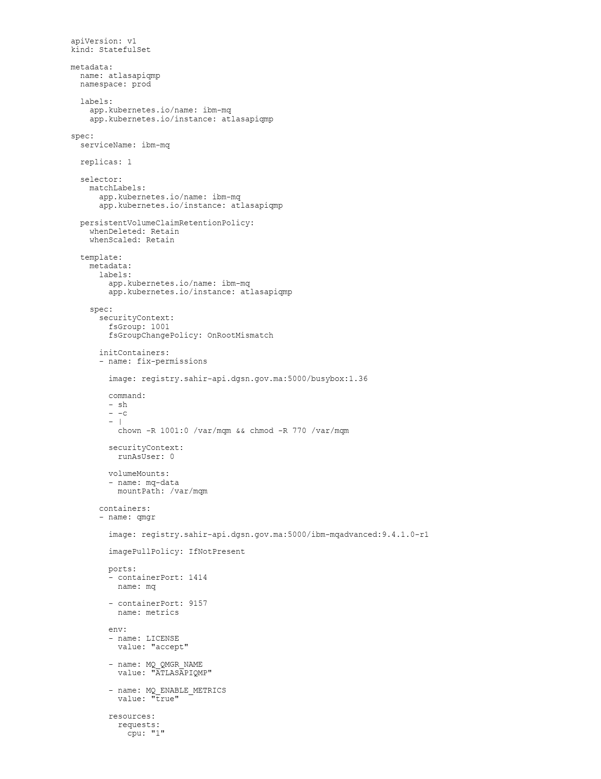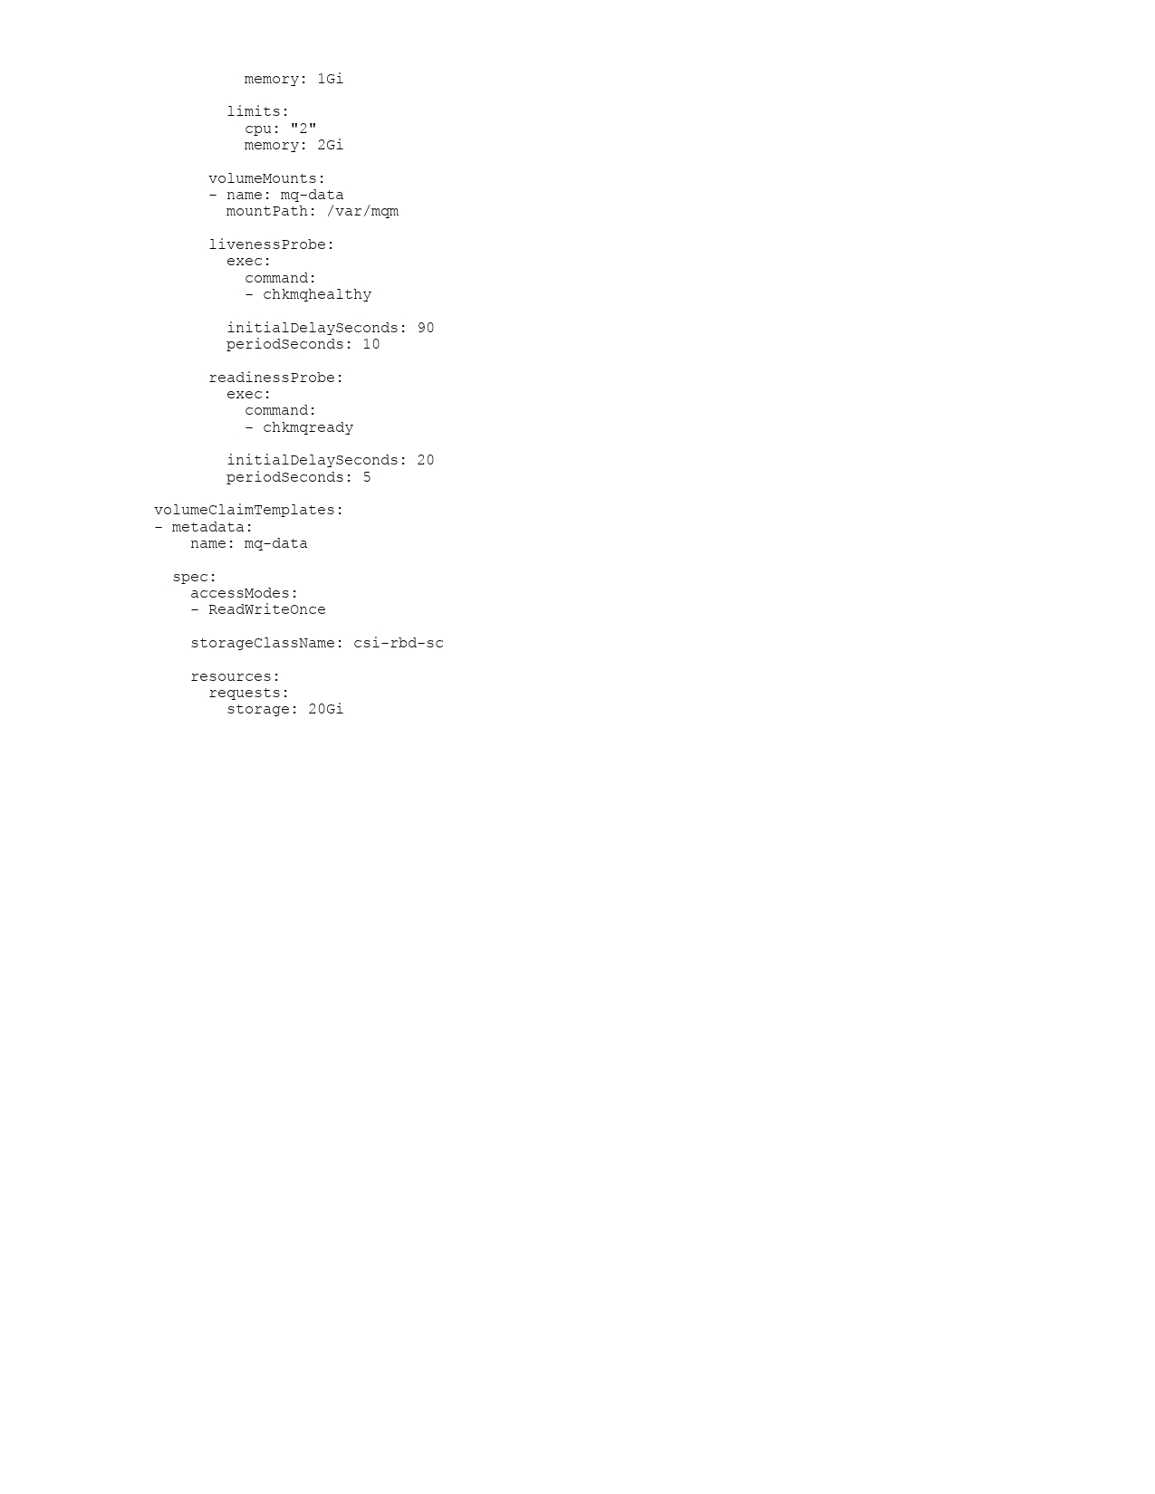

3.2.2 Deploying MQ

Execute the following commands one by one in the appropriate namespaces listed below.

kubectl get ns
uat
prod
prod-cert

Note: Secret usage is not required in this setup. If needed, the secret can be created using the below-mentioned command and used through a ServiceAccount by adding it as an additional parameter in the StatefulSet YAML.

UAT---------------------------

kubectl create secret docker-registry registry \
--docker-server=registry.sahir-api.dgsn.gov.ma:5000 \
--docker-username=user \
--docker-password='user' -n uat
kubectl get secret -n uat

kubectl apply -f serviceaccount.yaml -n uat (optional)
kubectl apply -f statefulset.yaml -n uat

PROD-CERT-------------------

kubectl create secret docker-registry registry \
--docker-server=registry.sahir-api.dgsn.gov.ma:5000 \
--docker-username=user \
--docker-password='user' -n prod-cert
kubectl get secret -n prod-cert

kubectl apply -f serviceaccount.yaml -n prod-cert (optional)
kubectl apply -f statefulset.yaml -n prod-cert

PROD----------------------------

kubectl create secret docker-registry registry \
--docker-server=registry.sahir-api.dgsn.gov.ma:5000 \
--docker-username=user \
--docker-password='user' -n prod
kubectl get secret -n prod

kubectl apply -f serviceaccount.yaml -n prod (optional)
kubectl apply -f statefulset.yaml -n prod

Verification commands to check the execution status in all namespaces by adding -n for the namespaces (uat, prod-cert, prod).

kubectl get sa
kubectl get svc
kubectl get pods

3.3 Storage Backend
Persistent storage for the queue manager is provided by Ceph RBD (RADOS Block Device), hosted on the three dedicated Ceph worker nodes (dmz-ceph-1/2/3). This provides resilient, replicated block storage for the MQ data directory and logs.

3.4 Queue Manager Name
The Queue Manager is configured as ATLASAPIQMC, identified through the presence of the ATLASAPIQMC local queue. This queue manager handles all message routing for the ATLASAPI and RAM integration workloads.

4. Queue Manager Configuration

4.1 Application Queues
The following application queues are configured for business integration workloads. These are defined under the ATLASAPI and RAM namespacing conventions.

Queue Name | Type | Purpose | DLQ
ATLASAPI.FLIGHTRADAR.REQ | QLOCAL | Inbound FlightRadar API requests | No
ATLASAPI.FLIGHTRADAR.REQ.DLQ | QLOCAL | Dead-letter queue for FR requests | Yes
ATLASAPI.FLIGHTRADAR.REPLY | QLOCAL | Outbound FlightRadar API replies | No
ATLASAPI.FLIGHTRADAR.REPLY.DLQ | QLOCAL | Dead-letter queue for FR replies | Yes
ATLASAPI.RAM.PAXLST.IN | QLOCAL | Inbound RAM PAXLST messages | No
ATLASAPI.RAM.PAXLST.DLQ | QLOCAL | Dead-letter queue for PAXLST | Yes
ATLASAPI.RAM.PNRGOV.IN | QLOCAL | Inbound RAM PNRGOV messages | No
ATLASAPI.RAM.PNRGOV.DLQ | QLOCAL | Dead-letter queue for PNRGOV | Yes
ATLASAPIQMC | QLOCAL | Queue Manager Command Queue | No
AMQ.6A146DA925513401 | QLOCAL | Temporary/dynamic reply queue | No

4.2 Dead-Letter Queue Strategy
Each application queue pair has a corresponding Dead-Letter Queue (DLQ). Messages that cannot be delivered or processed are routed to the DLQ for manual inspection and reprocessing.

ATLASAPI.FLIGHTRADAR.REQ.DLQ — for unprocessable FlightRadar request messages
- ATLASAPI.FLIGHTRADAR.REPLY.DLQ — for undeliverable FlightRadar reply messages
- ATLASAPI.RAM.PAXLST.DLQ — for failed PAXLST inbound messages
- ATLASAPI.RAM.PNRGOV.DLQ — for failed PNRGOV inbound messages
- SYSTEM.DEAD.LETTER.QUEUE — system-level DLQ for unroutable messages

4.3 System Queues
System queues are created automatically by IBM MQ during queue manager initialization. The following system queues are present and confirm a correctly initialized queue manager.

System Queue | Purpose
SYSTEM.DEAD.LETTER.QUEUE | Default dead-letter queue for unroutable messages
SYSTEM.ADMIN.COMMAND.QUEUE | Remote administration command input
SYSTEM.ADMIN.ACCOUNTING.QUEUE | Accounting/statistics data collection
SYSTEM.ADMIN.ACTIVITY.QUEUE | Activity trace event recording
SYSTEM.ADMIN.CHANNEL.EVENT | Channel state-change event notification
SYSTEM.ADMIN.QMGR.EVENT | Queue manager event notification
SYSTEM.CLUSTER.TRANSMIT.QUEUE | Cluster message transmission holding queue
SYSTEM.CLUSTER.COMMAND.QUEUE | Cluster repository command input
SYSTEM.CLUSTER.REPOSITORY.QUEUE | Full cluster repository data storage
SYSTEM.CHANNEL.INITQ | Channel initiator trigger queue
SYSTEM.CHANNEL.SYNCQ | Channel synchronization data
SYSTEM.BROKER.CONTROL.QUEUE | Publish/subscribe broker control messages
SYSTEM.BROKER.DEFAULT.STREAM | Default publish/subscribe topic stream
SYSTEM.DEAD.LETTER.QUEUE | Undeliverable message dead-letter store
SYSTEM.REST.REPLY.QUEUE | REST API reply message queue
SYSTEM.PENDING.DATA.QUEUE | Pending uncommitted message data

5. Channel Configuration

5.1 Application Channels (SVRCONN)
Server-connection (SVRCONN) channels are used by client applications to connect to the queue manager over the network. The following channels are defined for application workloads.

Channel Name | Type / Purpose
API.FR.SVRCONN | SVRCONN — FlightRadar API client connections
RAM.PAXLST.SVRCONN | SVRCONN — RAM PAXLST integration client connections
RAM.PNRGOV.SVRCONN | SVRCONN — RAM PNRGOV integration client connections

5.2 System Channels
System channels are created during queue manager initialization. They define default behaviours for channel types and support internal MQ functions.

Channel Name | Type / Purpose
SYSTEM.AUTO.RECEIVER | RCVR — Automatic inbound receiver channel
SYSTEM.AUTO.SVRCONN | SVRCONN — Automatic server-connection channel
SYSTEM.DEF.AMQP | AMQP — Default AMQP protocol channel
SYSTEM.DEF.CLUSRCVR | CLUSRCVR — Default cluster receiver
SYSTEM.DEF.CLUSSDR | CLUSSDR — Default cluster sender
SYSTEM.DEF.RECEIVER | RCVR — Default receiver channel template
SYSTEM.DEF.REQUESTER | RQSTR — Default requester channel template
SYSTEM.DEF.SENDER | SDR — Default sender channel template
SYSTEM.DEF.SERVER | SVR — Default server channel template
SYSTEM.DEF.SVRCONN | SVRCONN — Default server-connection template
SYSTEM.DEF.CLNTCONN | CLNTCONN — Default client-connection template

5.3 Channel Security Notes
All application SVRCONN channels should be configured with CHLAUTH rules to restrict access by IP address, user ID, or certificate. The following hardening actions are recommended post-installation:
- Disable SYSTEM.DEF.SVRCONN and SYSTEM.AUTO.SVRCONN to prevent unauthenticated access.
- Enable TLS (SSLCIPH) on all application SVRCONN channels using a minimum of TLS_AES_256_GCM_SHA384.
- Define CHLAUTH rules to map certificate DNs to MQ usernames.
- Enable CONNAUTH to enforce username/password or certificate-based authentication.
- Review and restrict MCAUSER on each channel to a least-privilege service account.

6. Listener Configuration

6.1 Defined Listeners
Three TCP listeners are configured on the queue manager. Listeners accept inbound channel connections from remote clients and applications.

Listener Name | Notes
LISTENER1415 | Custom listener — likely bound to port 1415 for application workloads
SYSTEM.DEFAULT.LISTENER.TCP | Default MQ listener — standard port 1414
SYSTEM.LISTENER.TCP.1 | System TCP listener — secondary or administrative listener

6.2 Kubernetes Service Exposure
In a Kubernetes deployment, MQ listeners are exposed via Kubernetes Service objects of type LoadBalancer, NodePort, or ClusterIP, depending on the network access requirements. The following service configuration is recommended for this deployment:
- ClusterIP: for internal microservice-to-MQ communication within the cluster
- LoadBalancer or NodePort: for external application integration (FlightRadar API, RAM)
- NetworkPolicy: restrict inbound traffic to the MQ pod to authorised source namespaces and CIDRs only

7. Integration Workload Summary

The queue manager supports the following integration workloads identified from the queue and channel naming conventions:

Workload | Description
ATLASAPI FlightRadar | Request/reply integration with FlightRadar API. Uses REQ and REPLY queues with dedicated SVRCONN channel (API.FR.SVRCONN). Dead-letter queues are configured for both directions.
RAM PAXLST | Inbound Passenger List (PAXLST) message processing for the RAM airline integration. Messages arrive on ATLASAPI.RAM.PAXLST.IN via RAM.PAXLST.SVRCONN. Failed messages are held in the DLQ.
RAM PNRGOV | Inbound Passenger Name Record Government (PNRGOV) message processing. Ingested via ATLASAPI.RAM.PNRGOV.IN through the RAM.PNRGOV.SVRCONN channel.

8. Post-Installation Verification

8.1 MQSC Verification Commands
The following MQSC commands were executed against the queue manager to confirm the post-installation state. All output was captured and is documented in this section.

MQSC Command | Purpose
DISPLAY QLOCAL(*) | List all local queues defined on the queue manager
DISPLAY CHANNEL(*) | List all channels (all types) defined on the queue manager
DISPLAY LISTENER(*) | List all listeners defined on the queue manager

8.2 Queue Verification Output
Result of DISPLAY QLOCAL(*) — all 57 local queues confirmed present including 9 application queues and 48 system queues.
DISPLAY QLOCAL(*)
AMQ8409I: Display Queue details.
QUEUE(ATLASAPI.FLIGHTRADAR.REQ) TYPE(QLOCAL)
QUEUE(ATLASAPI.FLIGHTRADAR.REQ.DLQ) TYPE(QLOCAL)
QUEUE(ATLASAPI.FLIGHTRADAR.REPLY) TYPE(QLOCAL)
QUEUE(ATLASAPI.FLIGHTRADAR.REPLY.DLQ) TYPE(QLOCAL)
QUEUE(ATLASAPI.RAM.PAXLST.IN) TYPE(QLOCAL)
QUEUE(ATLASAPI.RAM.PAXLST.DLQ) TYPE(QLOCAL)
QUEUE(ATLASAPI.RAM.PNRGOV.IN) TYPE(QLOCAL)
QUEUE(ATLASAPI.RAM.PNRGOV.DLQ) TYPE(QLOCAL)
QUEUE(ATLASAPIQMC) TYPE(QLOCAL)
QUEUE(SYSTEM.DEAD.LETTER.QUEUE) TYPE(QLOCAL)
... [48 system queues confirmed]

8.3 Channel Verification Output
Result of DISPLAY CHANNEL(*) — all 14 channels confirmed present including 3 application SVRCONN channels and 11 system channels.
DISPLAY CHANNEL(*)
AMQ8414I: Display Channel details.
CHANNEL(API.FR.SVRCONN) CHLTYPE(SVRCONN)
CHANNEL(RAM.PAXLST.SVRCONN) CHLTYPE(SVRCONN)
CHANNEL(RAM.PNRGOV.SVRCONN) CHLTYPE(SVRCONN)
CHANNEL(SYSTEM.AUTO.RECEIVER) CHLTYPE(RCVR)
CHANNEL(SYSTEM.AUTO.SVRCONN) CHLTYPE(SVRCONN)
... [9 additional system channels confirmed]

8.4 Listener Verification Output
Result of DISPLAY LISTENER(*) — all 3 listeners confirmed present.
DISPLAY LISTENER(*)
AMQ8630I: Display listener information details.
LISTENER(LISTENER1415)
LISTENER(SYSTEM.DEFAULT.LISTENER.TCP)
LISTENER(SYSTEM.LISTENER.TCP.1)

8.5 Verification Summary

Check | Expected | Actual | Result
Application queues | 9 | 9 | PASS
System queues | 48 | 48 | PASS
Application channels | 3 | 3 | PASS
System channels | 11 | 11 | PASS
Listeners | 3 | 3 | PASS
Queue Manager running | Yes | Yes | PASS

9. Operational Procedures

9.1 Accessing the MQ Pod
To run MQSC commands against the running queue manager in Kubernetes:
# Get the MQ pod name in the prod namespace
kubectl get pods -n prod

# Open an interactive shell into the MQ container
kubectl exec -it atlasapiqmp-0 -n prod -- /bin/bash

# Launch the MQSC interactive console
runmqsc ATLASAPIQMP

9.2 Checking Queue Depth
To check how many messages are waiting on a queue (depth), run from within the MQSC shell:
DISPLAY QLOCAL(ATLASAPI.FLIGHTRADAR.REQ) CURDEPTH
DISPLAY QLOCAL(ATLASAPI.RAM.PAXLST.IN) CURDEPTH
DISPLAY QLOCAL(ATLASAPI.RAM.PNRGOV.IN) CURDEPTH

9.3 Monitoring Dead-Letter Queues
DLQ depth should be polled regularly. Any non-zero depth indicates processing failures:
DISPLAY QLOCAL(ATLASAPI.FLIGHTRADAR.REQ.DLQ) CURDEPTH
DISPLAY QLOCAL(ATLASAPI.FLIGHTRADAR.REPLY.DLQ) CURDEPTH
DISPLAY QLOCAL(ATLASAPI.RAM.PAXLST.DLQ) CURDEPTH
DISPLAY QLOCAL(ATLASAPI.RAM.PNRGOV.DLQ) CURDEPTH
DISPLAY QLOCAL(SYSTEM.DEAD.LETTER.QUEUE) CURDEPTH

9.4 Checking Channel Status
To verify all application channels are running (RUNNING state expected):
DISPLAY CHSTATUS(API.FR.SVRCONN)
DISPLAY CHSTATUS(RAM.PAXLST.SVRCONN)
DISPLAY CHSTATUS(RAM.PNRGOV.SVRCONN)

9.5 Checking Listener Status
DISPLAY LSSTATUS(LISTENER1415)
DISPLAY LSSTATUS(SYSTEM.DEFAULT.LISTENER.TCP)

10. Security Hardening Checklist

The following security hardening items should be completed and signed off before the deployment is considered production-ready:

# | Security Control | Status
1 | Enable TLS on all SVRCONN channels | PENDING
2 | Define CHLAUTH rules restricting access by IP/certificate | PENDING
3 | Disable SYSTEM.DEF.SVRCONN and SYSTEM.AUTO.SVRCONN | PENDING
4 | Configure CONNAUTH for application connections | PENDING
5 | Restrict MCAUSER on each channel to a service account | PENDING
6 | Apply Kubernetes NetworkPolicy to the MQ pod | PENDING
7 | Configure resource requests/limits on the MQ pod | PENDING
8 | Enable IBM MQ audit logging to SIEM | PENDING
9 | Rotate default passwords and certificates | PENDING
10 | Define PodSecurityPolicy / OPA constraints for prod ns | PENDING

11. Document Change Log

Version | Date | Author | Description
1.0 | 04/06/2026 | Infrastructure Team | Initial post-installation documentation

