AI ASSISTED CODING ASSIGNMENT 8.1

Task Description #1 (Password Strength Validator – Apply AI in Security Context)

* Task: Apply AI to generate at least 3 assert test cases for is_strong_password(password) and implement the validator function.
* Requirements:
* Password must have at least 8 characters.
* Must include uppercase, lowercase, digit, and special character.
* Must not contain spaces. Example Assert Test Cases:

assert is_strong_password("Abcd@123") == True assert is_strong_password("abcd123") == False assert is_strong_password("ABCD@1234") == True Expected Output #1:

* Password validation logic passing all AI-generated test cases.

# Prompt:

Task: Implement a password strength validator function Requirements:

-Password must have at least 8 characters

* Must include uppercase, lowercase, digit, and special character
* Must not contain spaces

Also generate at least 3 assert test cases for is_strong_password(password). Expected Output:

Password validation logic passing all AI-generated test cases.

# Code and Output:

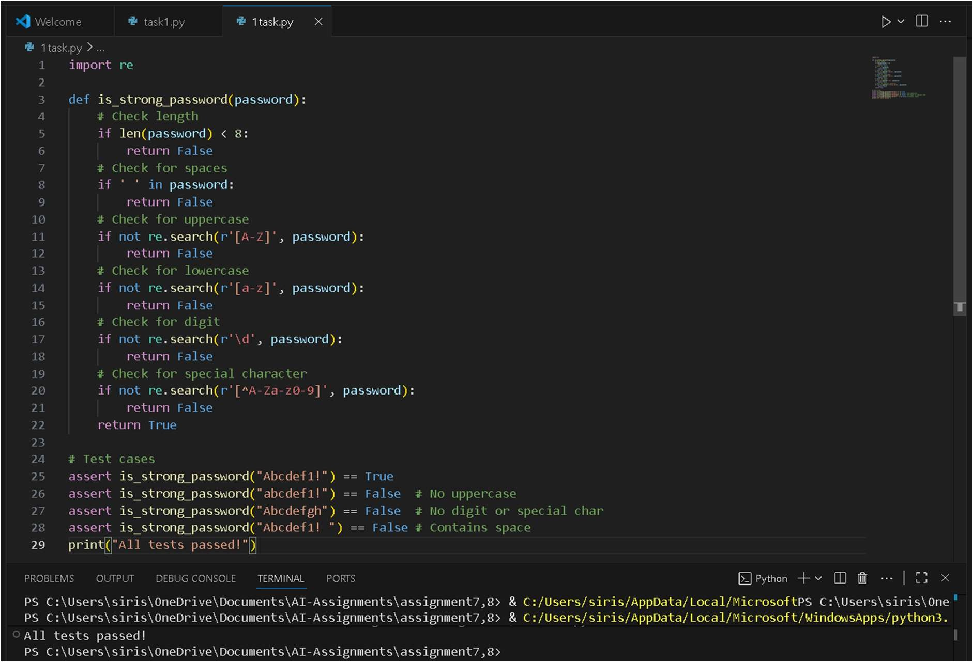

Task Description #2 (Number Classification with Loops – Apply AI for Edge Case Handling)

* Task: Use AI to generate at least 3 assert test cases for a classify_number(n) function. Implement using loops.
* Requirements:
* Classify numbers as Positive, Negative, or Zero.
* Handle invalid inputs like strings and None.
* Include boundary conditions (-1, 0, 1). Example Assert Test Cases:

assert classify_number(10) == "Positive" assert classify_number(-5) == "Negative" assert classify_number(0) == "Zero" Expected Output #2:

* Classification logic passing all assert tests

# Prompt:

Task: Implement a Number Classification function with Loops Requirements:

* Classify numbers as Positive, Negative, or Zero.
* Handle invalid inputs like strings and None.

Also generate at least 3 assert test cases for classify_number(n) Expected Output:

Password validation logic passing all AI-generated test cases.

# Code and output:

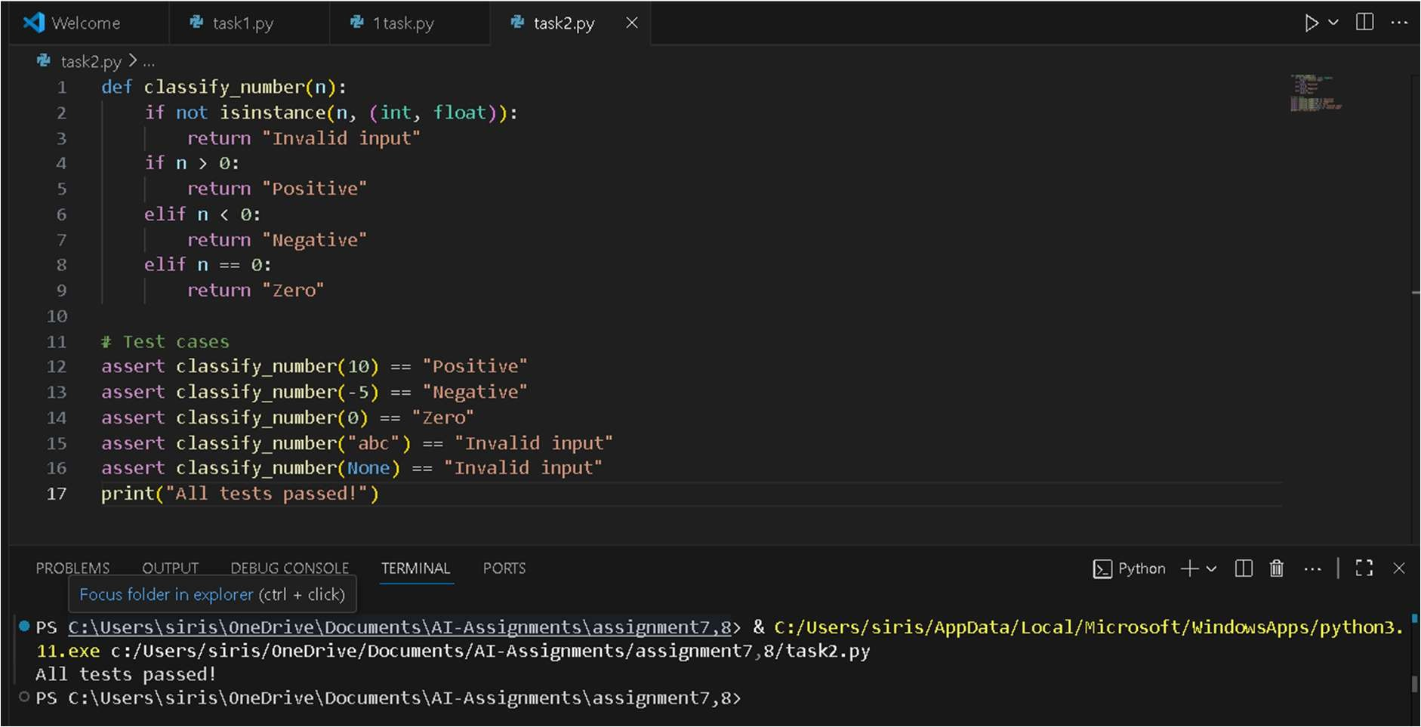

Task Description #3 (Anagram Checker – Apply AI for String Analysis)

* Task: Use AI to generate at least 3 assert test cases for is_anagram(str1, str2) and implement the function.
* Requirements:
* Ignore case, spaces, and punctuation.
* Handle edge cases (empty strings, identical words). Example Assert Test Cases:

assert is_anagram("listen", "silent") == True assert is_anagram("hello", "world") == False

assert is_anagram("Dormitory", "Dirty Room") == True Expected Output #3:

* Function correctly identifying anagrams and passing all AI-

generated tests

# prompt:

Task: Implement an Anagram Checker function is_anagram(str1, str2) Requirements:

* Ignore case, spaces, and punctuation
* Handle edge cases (empty strings, identical words) Generate at least 3 assert test cases.

Expected Output: Function correctly identifying anagrams and passing all AI-generated tests.

# Code and output:

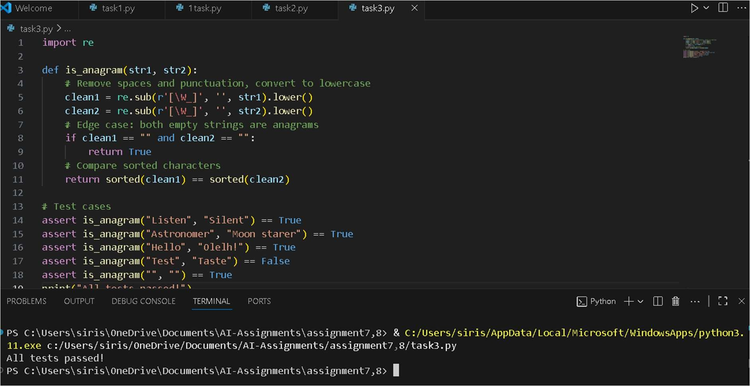

Task Description #4 (Inventory Class – Apply AI to Simulate Real- World Inventory System)

* Task: Ask AI to generate at least 3 assert-based tests for an Inventory class with stock management.
* Methods:

o add_item(name, quantity)

o remove_item(name, quantity)

o get_stock(name) Example Assert Test Cases: inv = Inventory() inv.add_item("Pen", 10)

assert inv.get_stock("Pen") == 10

inv.remove_item("Pen", 5) assert inv.get_stock("Pen") == 5 inv.add_item("Book", 3)

assert inv.get_stock("Book") == 3 Expected Output #4:

* Fully functional class passing all assertions.

# Prompt:

Task: Implement an Inventory class with methods add_item, remove_item, get_stock. Requirements:

* Manage stock quantities for items
* Generate at least 3 assert test cases

Expected Output: Fully functional class passing all assertions.

# Code and output:

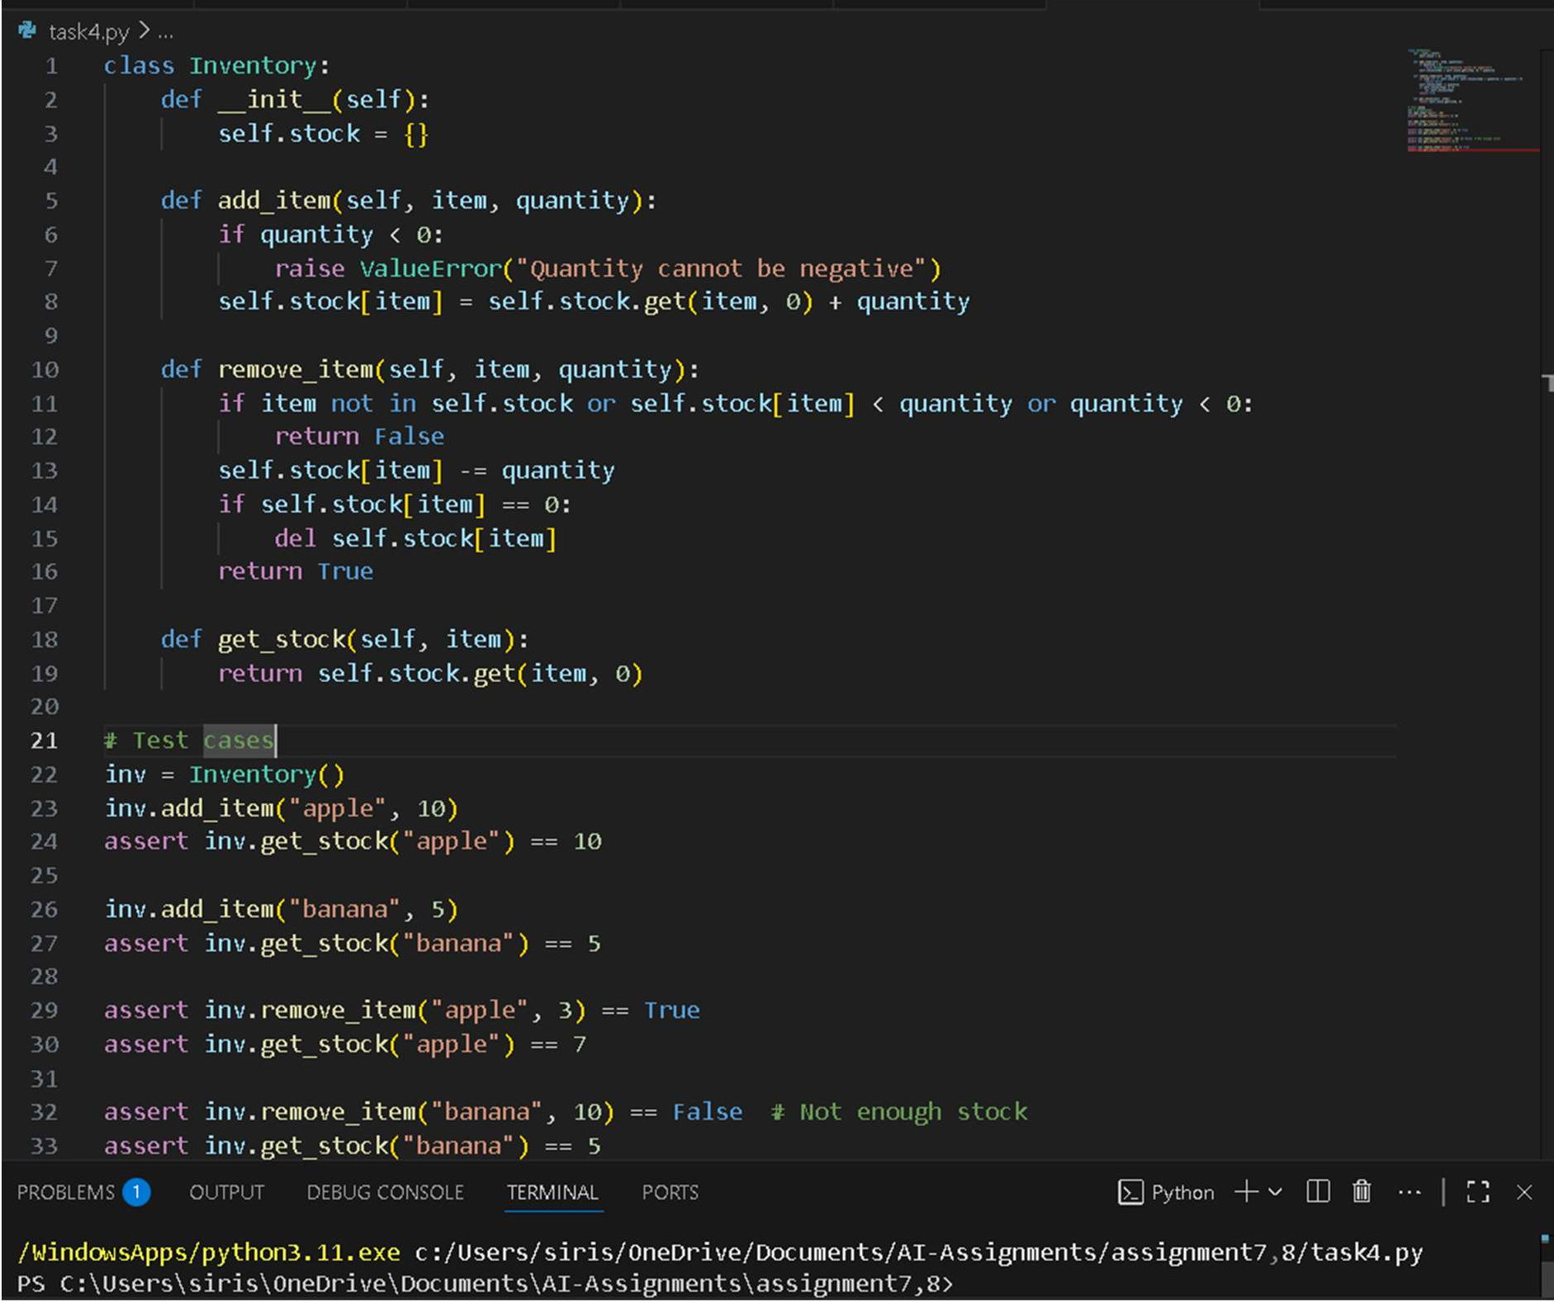

Task Description #5 (Date Validation C Formatting – Apply AI for Data Validation)

* Task: Use AI to generate at least 3 assert test cases for validate_and_format_date(date_str) to check and convert dates.
* Requirements:
* Validate "MM/DD/YYYY" format.
* Handle invalid dates.
* Convert valid dates to "YYYY-MM-DD". Example Assert Test Cases:

assert validate_and_format_date("10/15/2023") == "2023-10-15" assert validate_and_format_date("02/30/2023") == "Invalid Date" assert validate_and_format_date("01/01/2024") == "2024-01-01" Expected Output #5:

* Function passes all AI-generated assertions and handles edge cases.

# Prompt:

Task: Implement validate_and_format_date(date_str) Requirements:

* Validate "MM/DD/YYYY" format
* Handle invalid dates
* Convert valid dates to "YYYY-MM-DD" Generate at least 3 assert test cases

Expected Output: Function passes all AI-generated assertions and handles edge cases.

Code and output:

