ASSIGNMENT-10.2

SRIMANI

2403A51275

BATCH-12

**TASK-1**

**GIVEN CODE-**

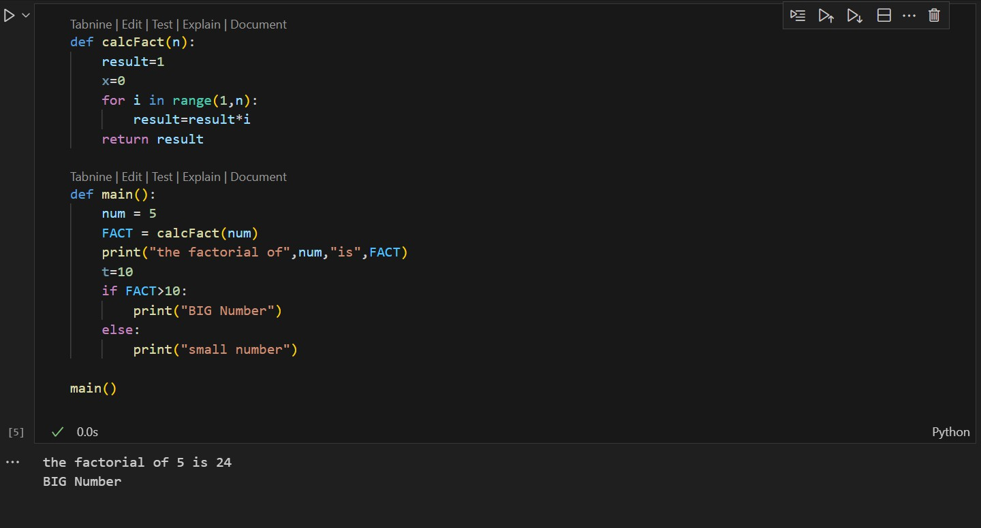

**PROMPT-**

review the above code and suggest correctionS.

**AI GENERATED CODE-**

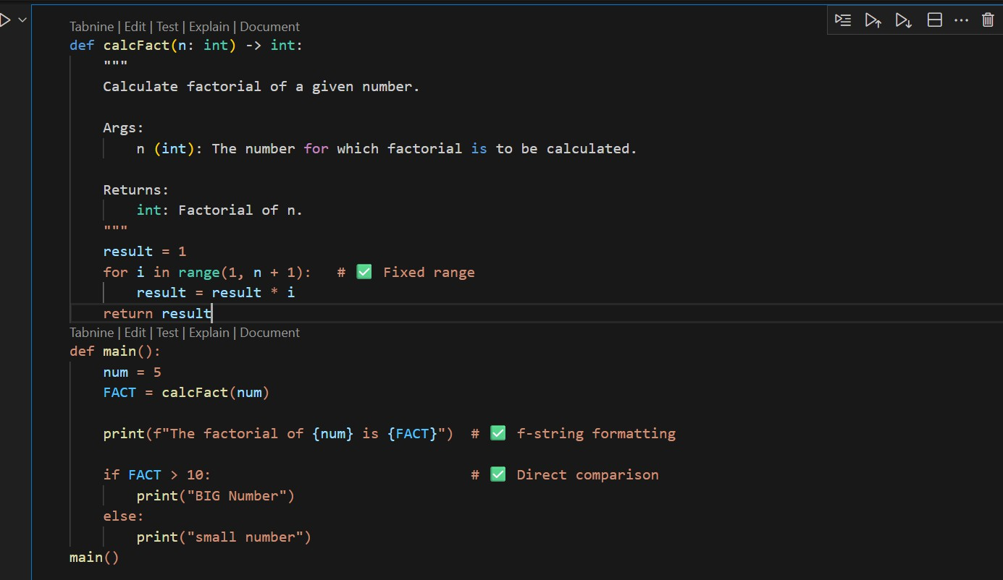

**OUTPUT-**



**TASK-2**

**GIVEN CODE-**

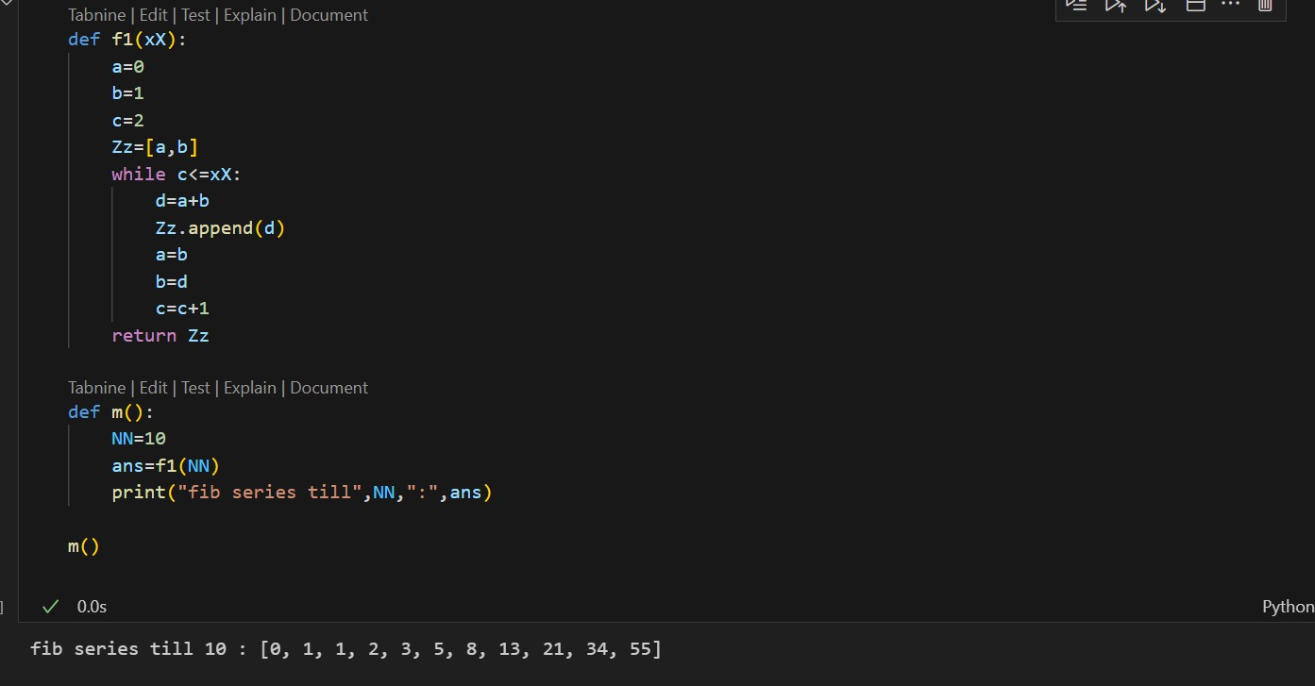

**PROMPT-**

Improve variable names, add comments, and apply PEP8 formatting.

**AI GENERATED CODE-**

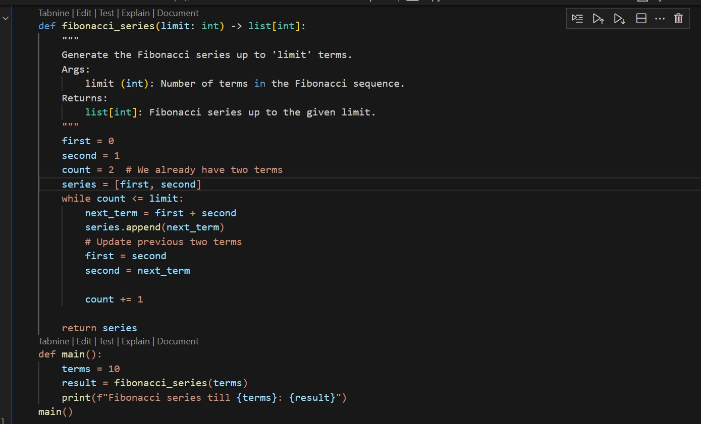

**OUTPUT-**



**TASK 3-**

* Write a Python script with 3–4 functions (e.g., calculator: add, subtract, multiply, divide).
* Incorporate manual docstring in code with NumPy Style
* Use AI assistance to generate a module-level docstring + individual function docstrings.
* Compare the AI-generated docstring with your manually written one.

**CODE WRITTEN WITH MANUAL DOCSTRING-**

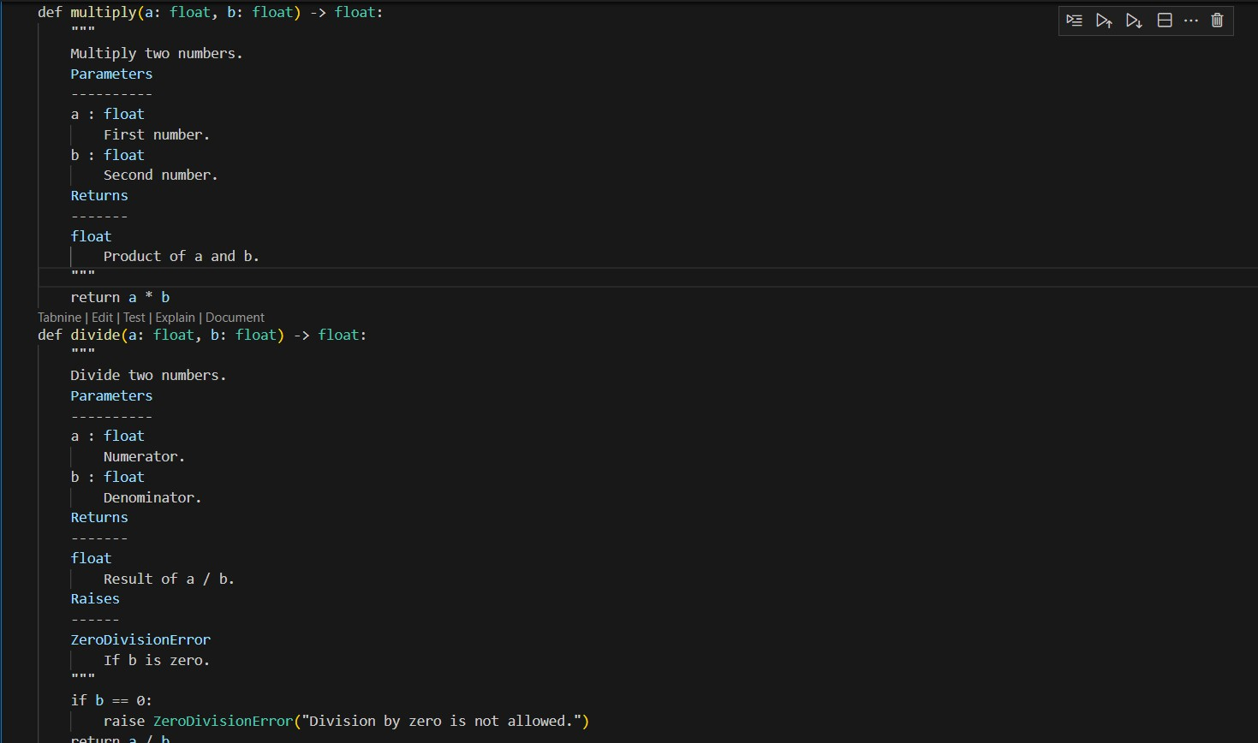

**PROMPT-**

Generate a module-level docstring + individual functiondocstrings for the above code.

**Module-Level Docstring (AI):**

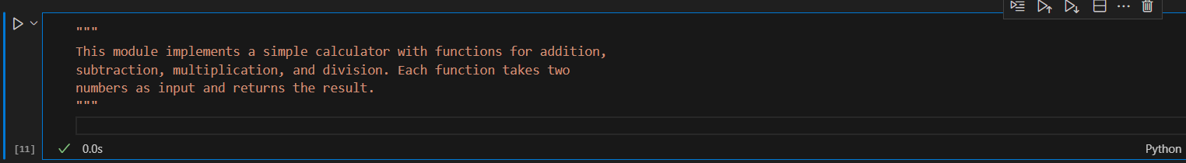

**Function Docstring (AI Example for add):**

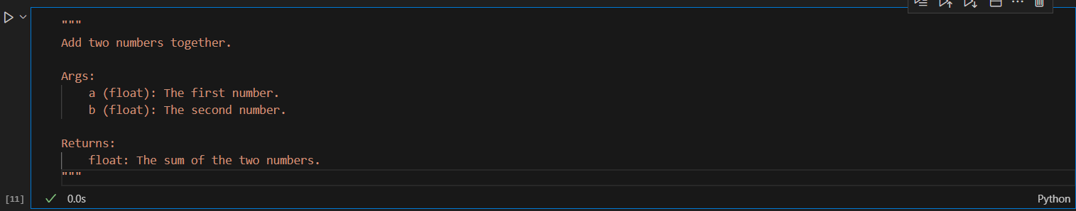

**COMPARISON-**

1. Manual NumPy-style docstrings are detailed and structured with clear sections (Parameters, Returns, Raises).
2. AI-generated docstrings are simpler, shorter, and easier for beginners to read.
3. Manual ones follow professional/academic standards, while AI ones may skip error handling or details.
4. AI saves time, but manual writing ensures accuracy and completeness.