AI ASSISTED CODING

**ASSIGNMENT-1.1**

**Task 1: Factorial without Functions**

Description:

**SRIMANI 2403A51275 BATCH-12**

Use GitHub Copilot to generate a Python program that calculates the factorial of a number without defining any functions (using loops

directly in the main code).

* Expected Output:
* A working program that correctly calculates the factorial for user-provided input.
* Screenshots of the code generation process

**Prompt:** Write a Python program that calculates the factorial of a

user-provided non-negative integer using a loop directly in the main code, without defining any functions. Include input validation for

negative numbers and print the result.

**Code:**

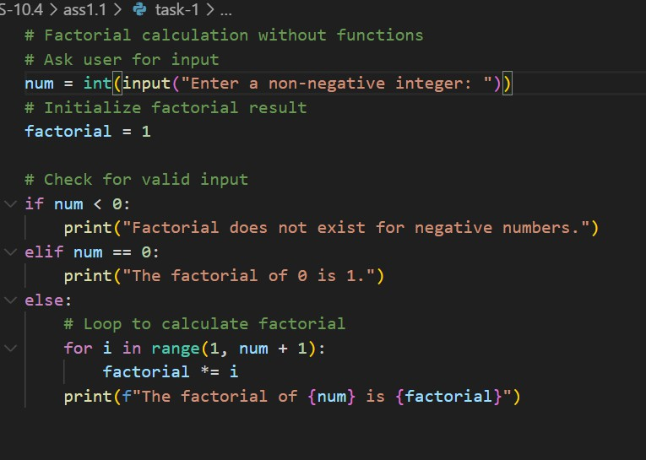

**Output:**

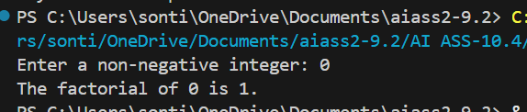

**Task 2: Improving Efficiency**

Description:

Examine the Copilot-generated code from Task 1 and demonstrate how its efficiency can be improved (e.g., removing unnecessary

variables, optimizing loops).

* Expected Output:
* Original and improved versions of the code.
* Explanation of how the improvements enhance performance. Without Functions.

**Prompt**: Improve the following Python code that calculates factorial without using functions. Optimize it by removing unnecessary

variables and redundant operations, and make the loop more efficient while keeping the output correct.

**Code:**

**Original Copilot-Generated Code**

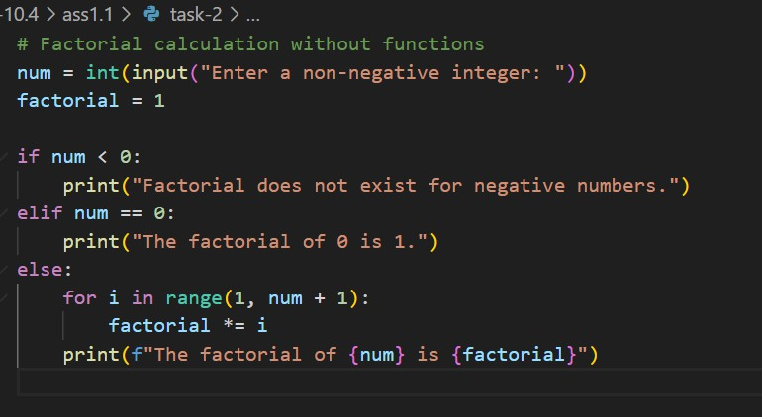

**Improved Version**

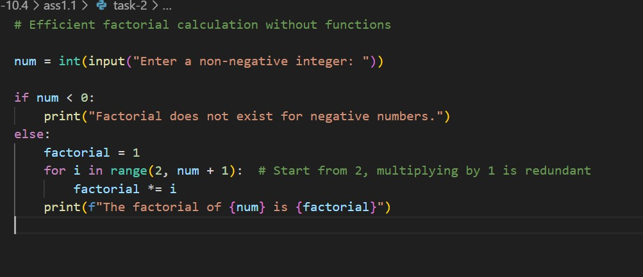

**Output:**

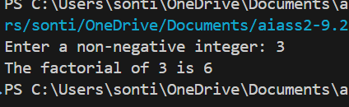

**Task-3: Factorial with Functions**

Description:

Use GitHub Copilot to generate a Python program that calculates the factorial of a number using a user-defined function.

* Expected Output:
* Correctly working factorial function with sample outputs.
* Documentation of the steps Copilot followed to generate the function.

**Prompt:** Write a Python program that calculates the factorial of a user-provided non-negative integer using a user-defined function. Include input validation for negative numbers and print the result. Provide clear comments**.**

**Code:**

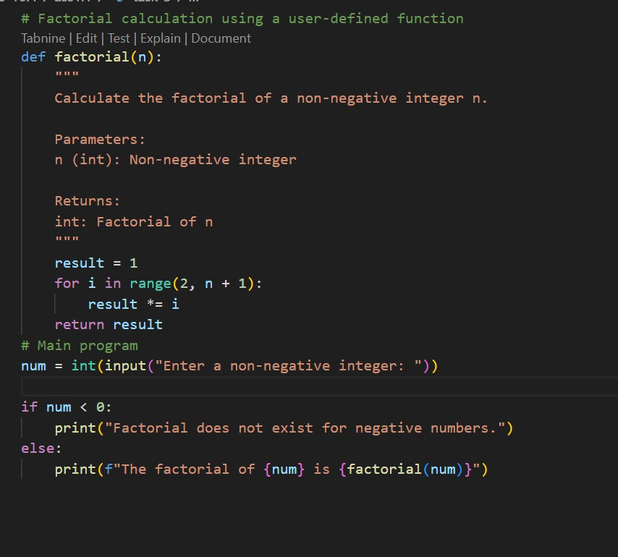

**Output:**

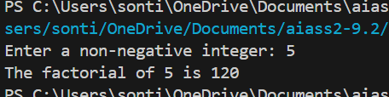

**Task 4: Comparative Analysis – With vs Without Functions**

Description:

Differentiate between the Copilot-generated factorial program with functions and without functions in terms of logic, reusability, and execution.

* Expected Output:
* A comparison table or short report explaining the differences.

**Prompt:** Compare two Python programs: one that calculates factorial without using functions and one that uses a user-defined factorial

function. Explain the differences in terms of logic, reusability, and execution, and provide a short report.

**Code:**

**Without Functions:**

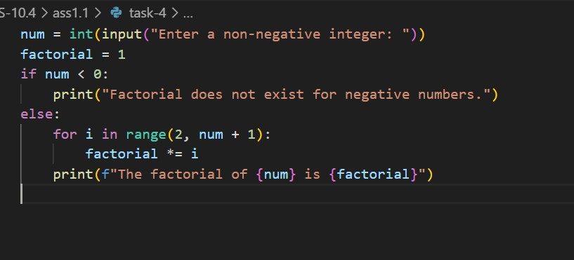

**With Functions:**

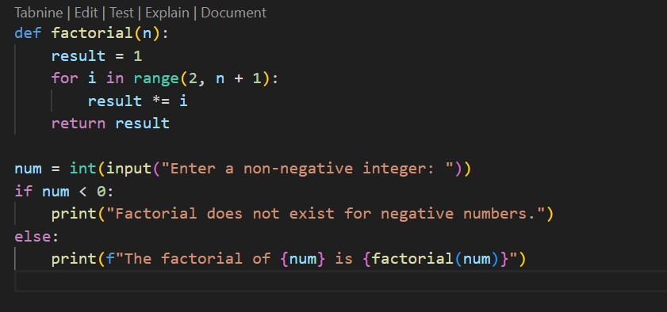

**Output:**

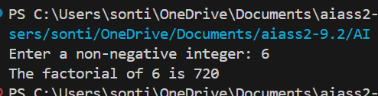

**Task 5: Iterative vs Recursive Factorial**

Description:

Prompt GitHub Copilot to generate both iterative and recursive versions of the factorial function.

* Expected Output:
* Two correct implementations.
* A documented comparison of logic, performance, and

execution flow between iterative and recursive approaches.

**Prompt:** Write two Python programs that calculate the factorial of a non-negative integer: one using an iterative approach with a loop, and one using recursion. Include input validation and comments

explaining the logic. Provide a comparison of the two approaches in terms of logic, performance, and execution flow.

**Code:**

**Iterative Factorial:**

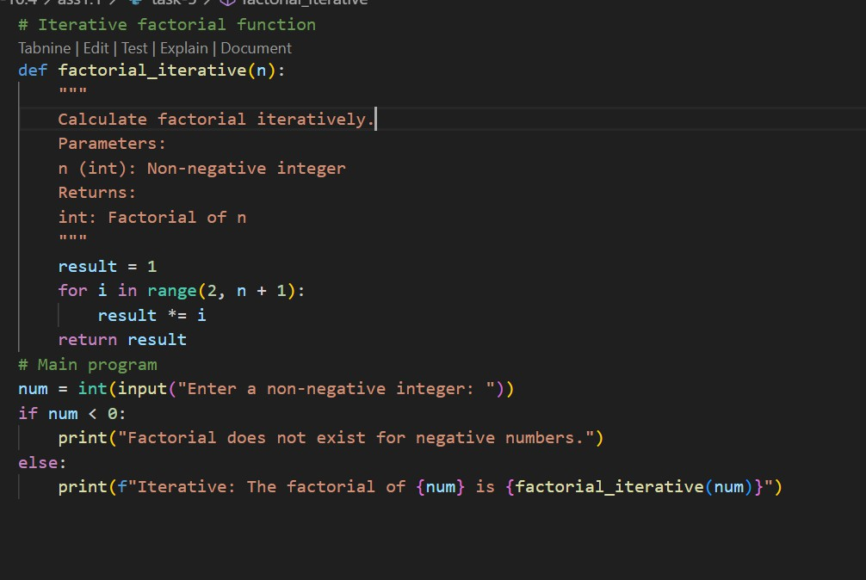

**Recursive Factorial:**

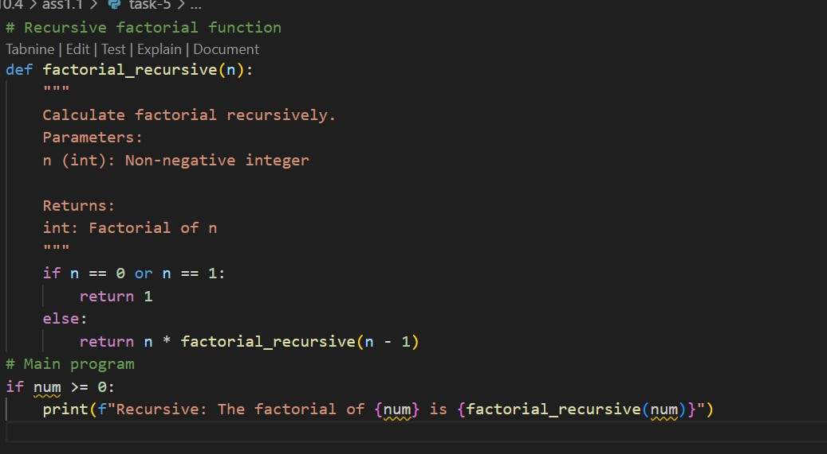

**Output:**

