ASSIGNMENT-1.3

K SRIMANI

2403A51275

BATCH-12

Task Description#1

* Install and configure GitHub Copilot in VS Code. Take screenshots of each step. Expected Output#1
* Install and configure GitHub Copilot in VS Code. Take screenshots of each step.

Task2:



Code with output:

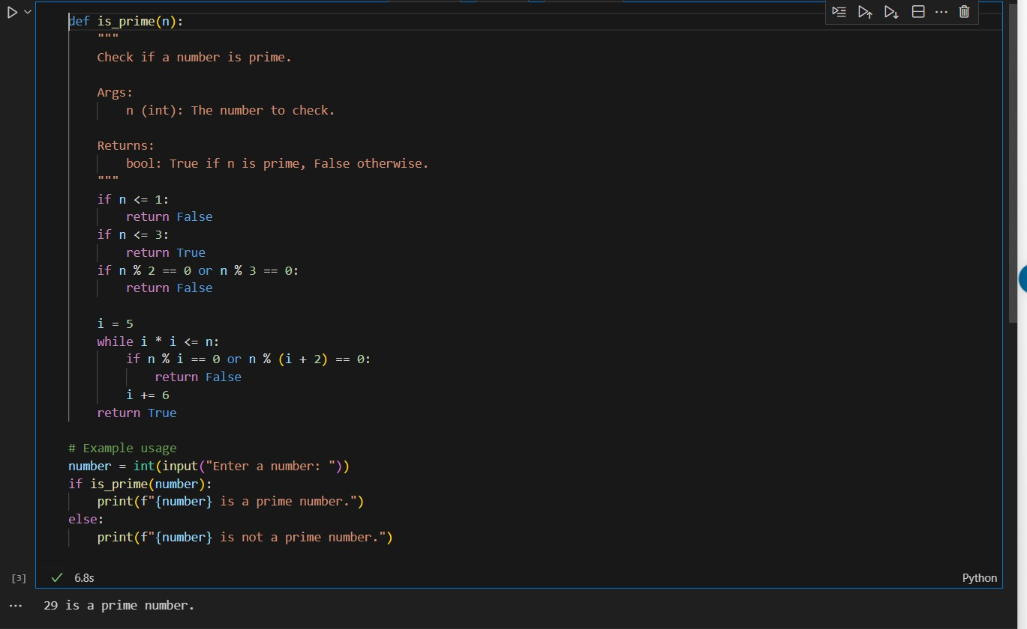

Task-3: Prompt:

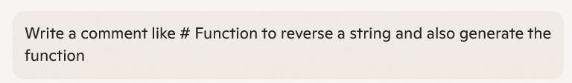

Code with output:

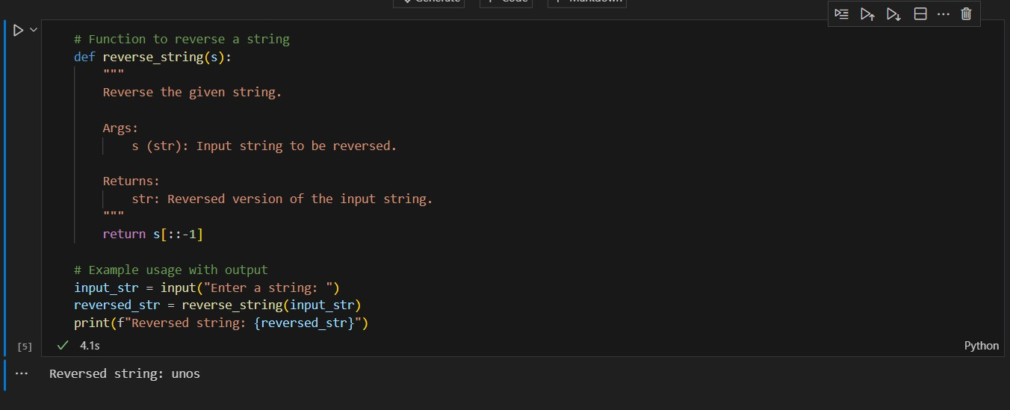

Task-4:

Prompt:

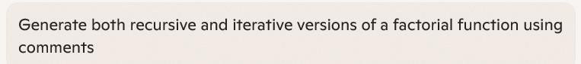

Code with output:

Recursive Version:

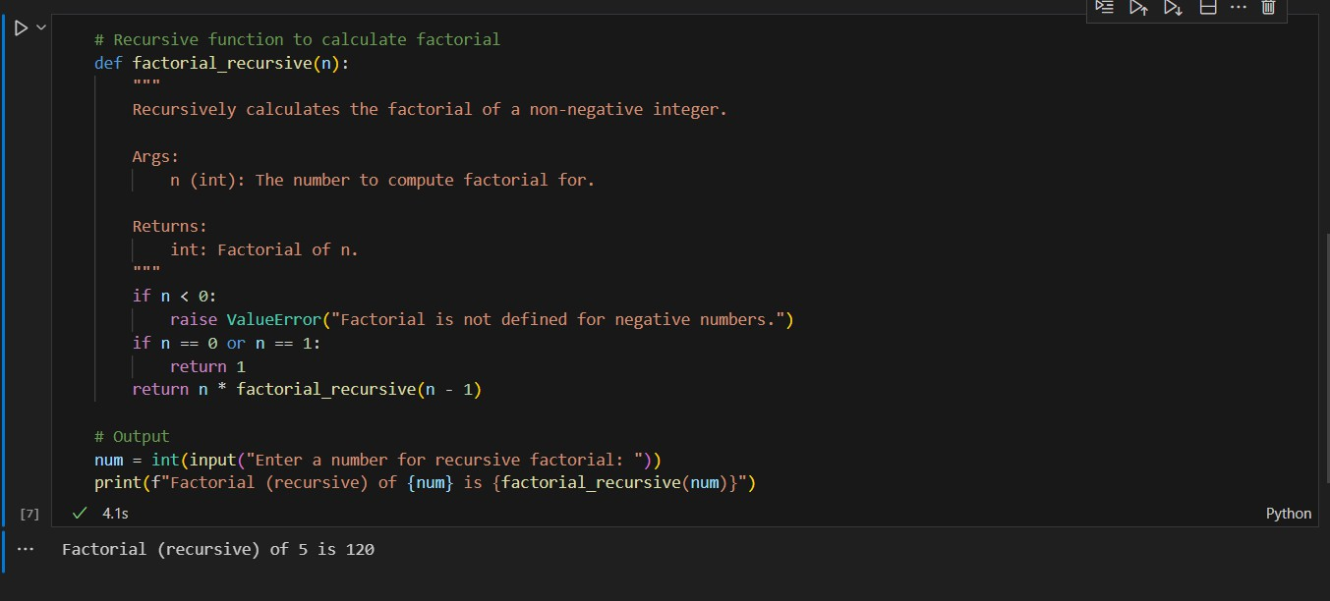

Iterative Factorial Function:

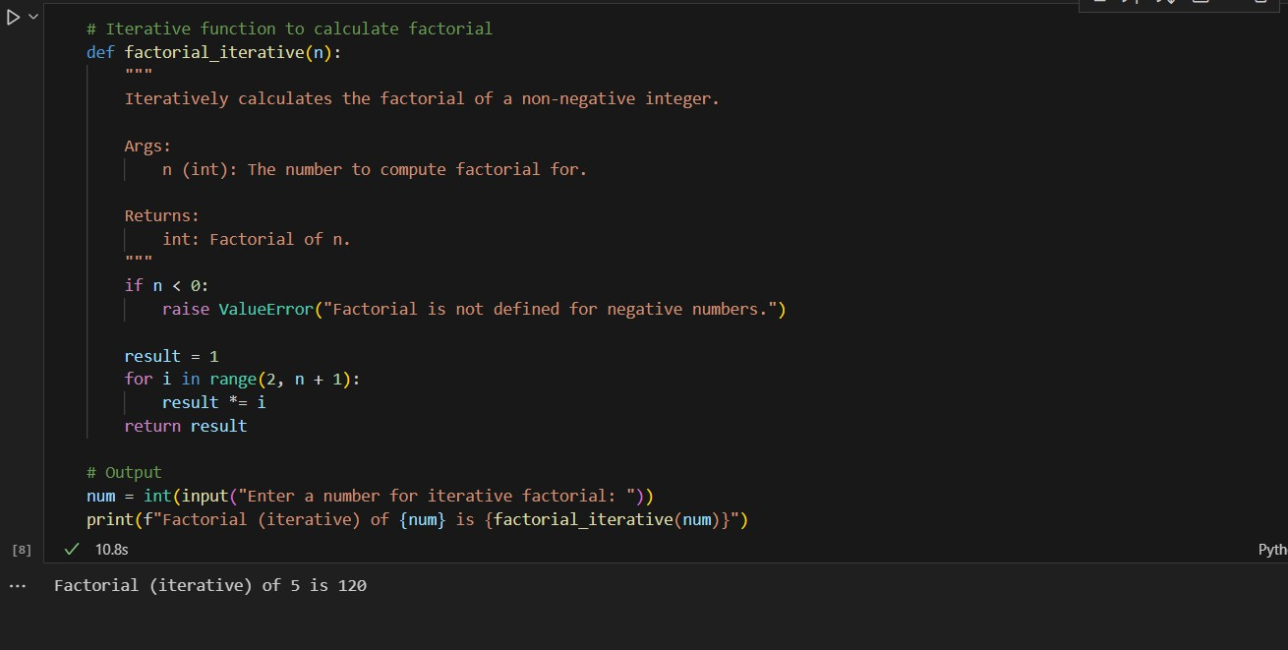

Task-5:

Prompt:



Code with output:

